Supporting Information
Aqueous Asymmetric Pseudocapacitor Featuring High Areal Energy and Power Using Conjugated Polyelectrolytes and Ti₃C₂T_{x} MXene

Benjamin Rui Peng Yip^{ab}, Chaofan Chen^{c}, Yan Jiang^{ab}, David Ohayon^{ab}, Guillermo C. Bazan^{ab}*, Xuehang Wang^{c}*

ª Departments of Chemistry and Chemical & Biomolecular Engineering, National University of Singapore, Singapore 119077.
^{b} Institute for Functional Intelligent Materials, National University of Singapore, Singapore 117544
^{c} Department of Radiation Science and Technology, Delft University of Technology, Delft 2629 JB, The Netherlands

* Corresponding Authors: Professor Guillermo C. Bazan (chmbgc@nus.edu.sg); Dr Xuehang Wang (x.wang-22@tudelft.nl)

Keywords: asymmetric pseudocapacitors, MXenes, conjugated polyelectrolytes, high-rate capability, high areal capacitance, large mass loading

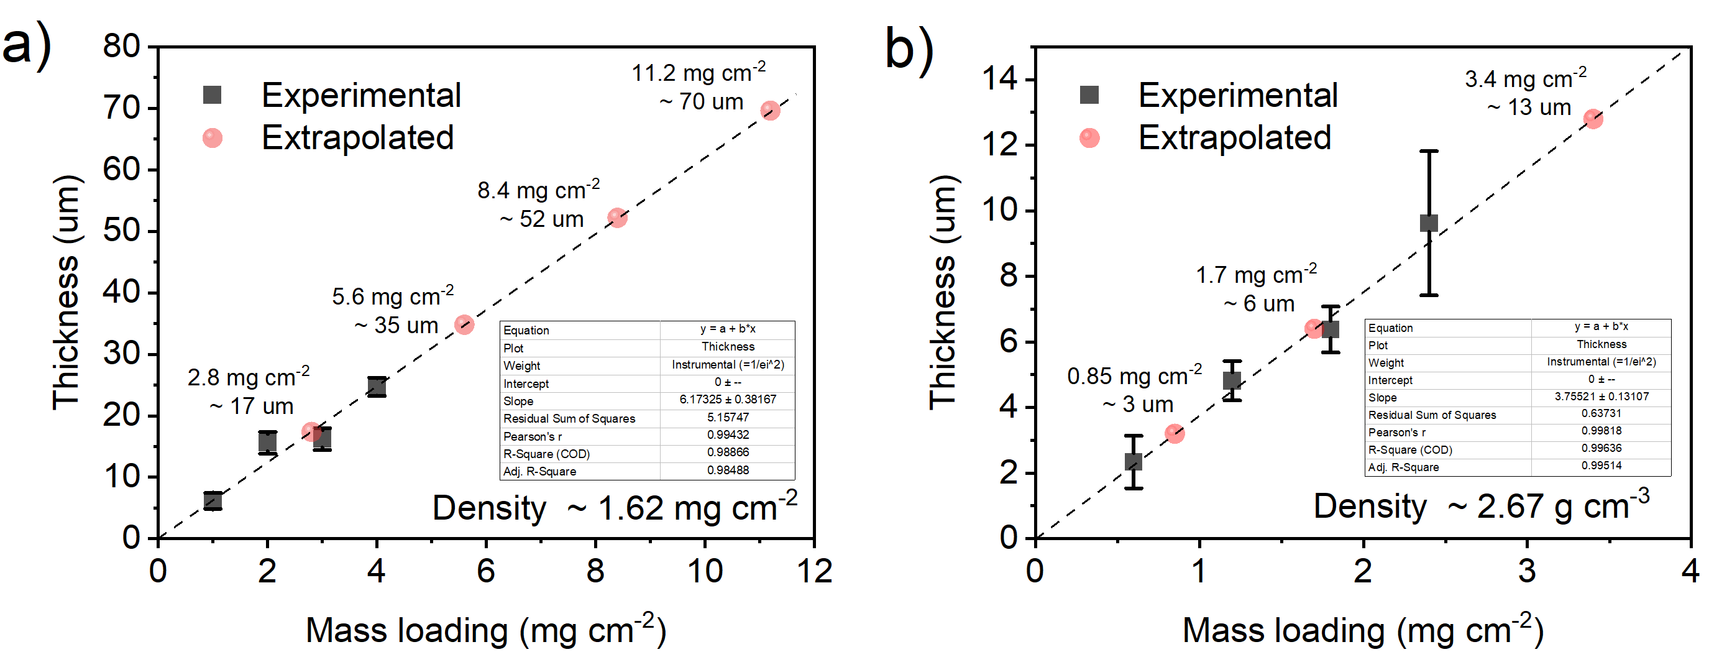
Figure S1. Experimental thickness measurements from cross-sectional SEM and extrapolation to obtain the thicknesses that are used in this work for electrochemical characterization. a) For CPE-K and b) for Ti₃C₂T_{x}.
 | C=N | C-S | C-C | C=C
Pristine | 0.16 | 0.35 | 1.00 | 1.24
Doped | 0.06 | 0.46 | 1.00 | 0.18
Dedoped | 0.13 | 1.00 | 1.00 | 1.46
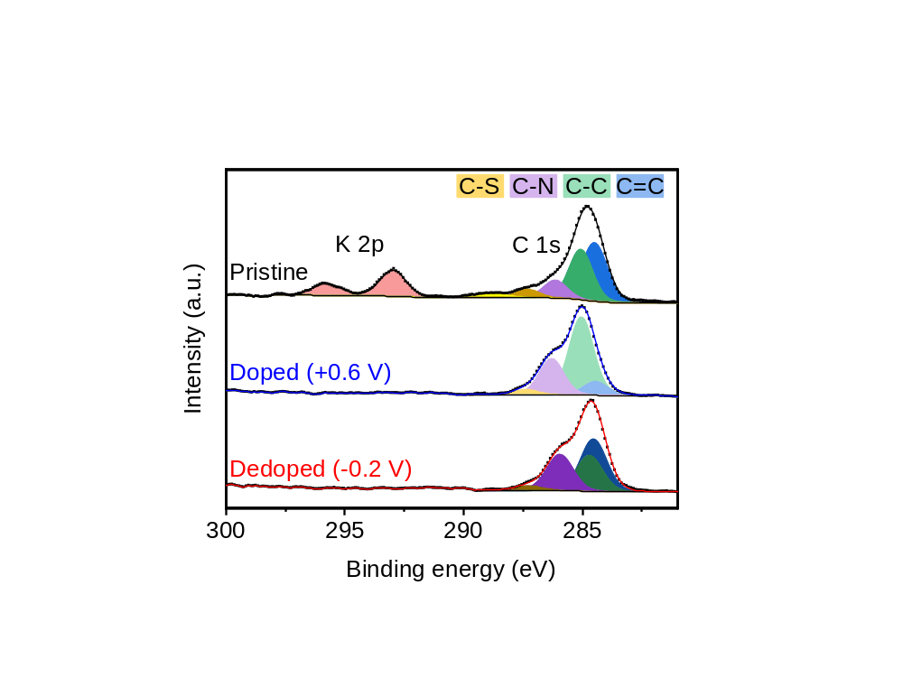
Figure S2. Peak fitting of XPS C 1s data with a table (right) of peak intensity ratios C=N : C-S : C-C : C=C normalized to C-C.

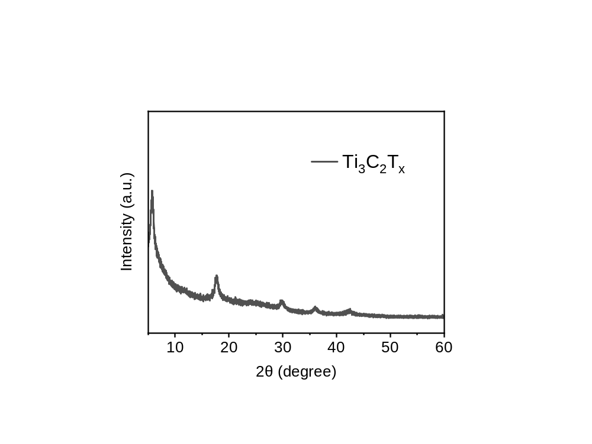
Figure S3. X-ray diffractogram of drop cast 1.0 mg cm⁻² Ti₃C₂T_{x} on a silicon substrate.

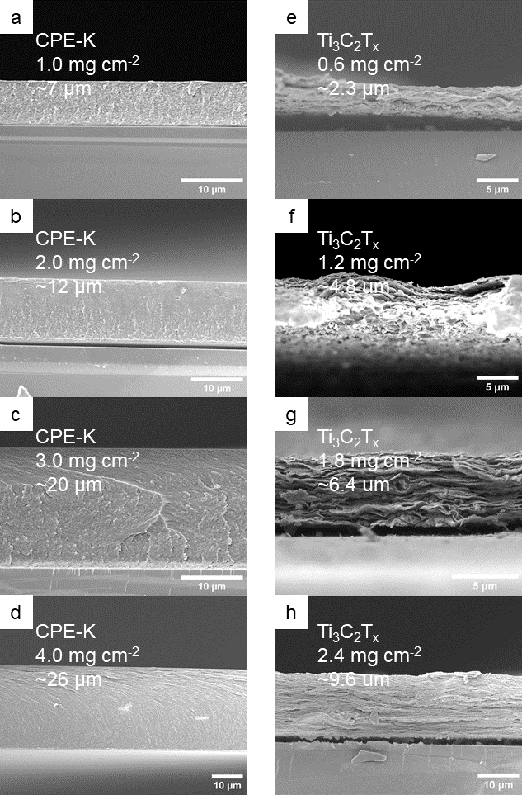
Figure S4. Cross-sectional SEM of drop cast CPE-K and Ti₃C₂T_{x} on silicon substrates.

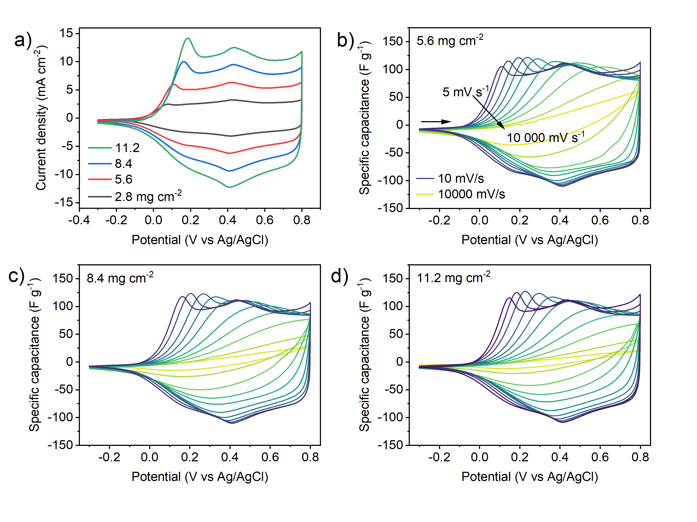
Figure S5. Cyclic voltammograms of drop cast CPE-K film at various mass loading. a) CV normalized to current density for 2.8, 5.6, 8.4, and 11.2 mg cm⁻² at 10 mV s⁻¹. CVs for CPE-K films at increasing scan rates from 5 – 10,000 mV s⁻¹ for b) 2.8, c) 5.6 and d) 8.4 mg cm⁻².
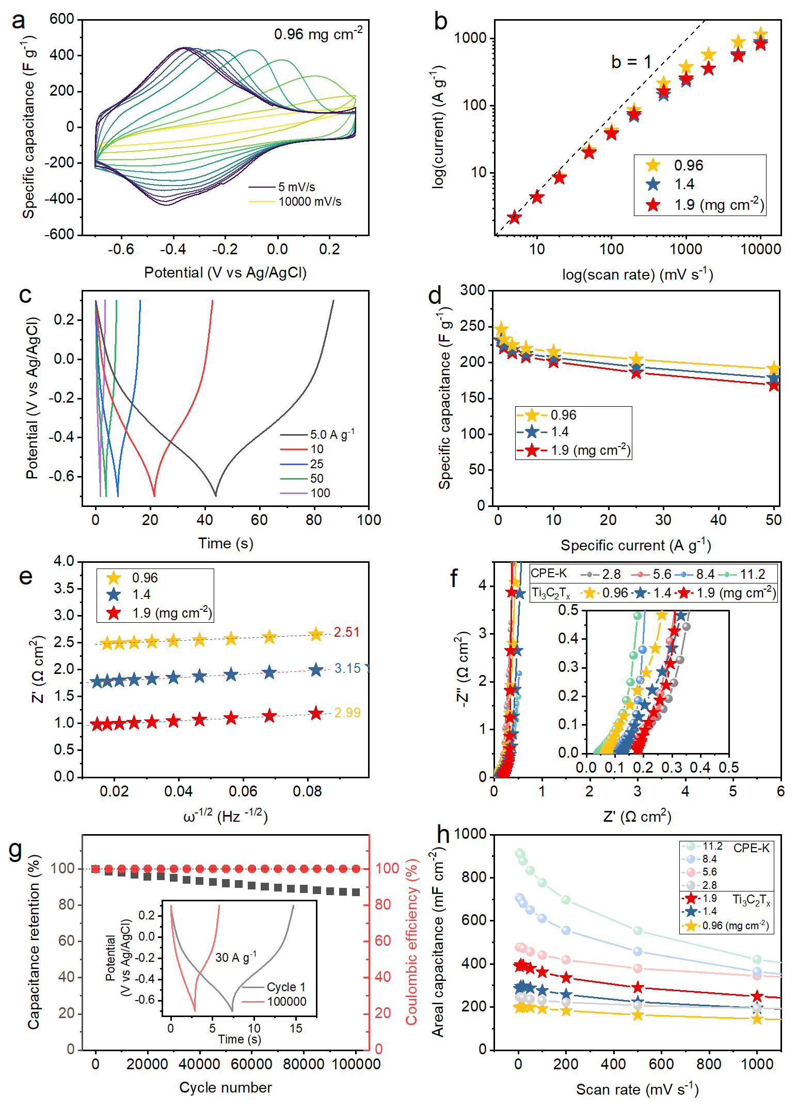
Figure S6. Electrochemical characterization of drop cast Ti₃C₂T_{x} film at various mass loading. a) CV from 5 to 10,000 mV s⁻¹ of drop cast Ti₃C₂T_{x} at a mass loading of 0.96 mg cm⁻². b) log current versus log scan rate for Ti₃C₂T_{x} films. c) Representative GCD trace of Ti₃C₂T_{x} at 0.96 mg cm⁻² from 5 to 100 A g⁻¹. d) Specific capacitance as a function of specific current for Ti₃C₂T_{x} films. e) Linear fit of Z’ versus ω^{-1/2} to obtain the Warburg coefficient, σ. f) Nyquist plot of EIS data for Ti₃C₂T_{x} films. g) Cycling stability of Ti₃C₂T_{x} (1.9 mg cm⁻²). h) Areal capacitance as a function of scan rate of drop cast Ti₃C₂T_{x} compared to drop cast CPE-K showing comparable capacitance.
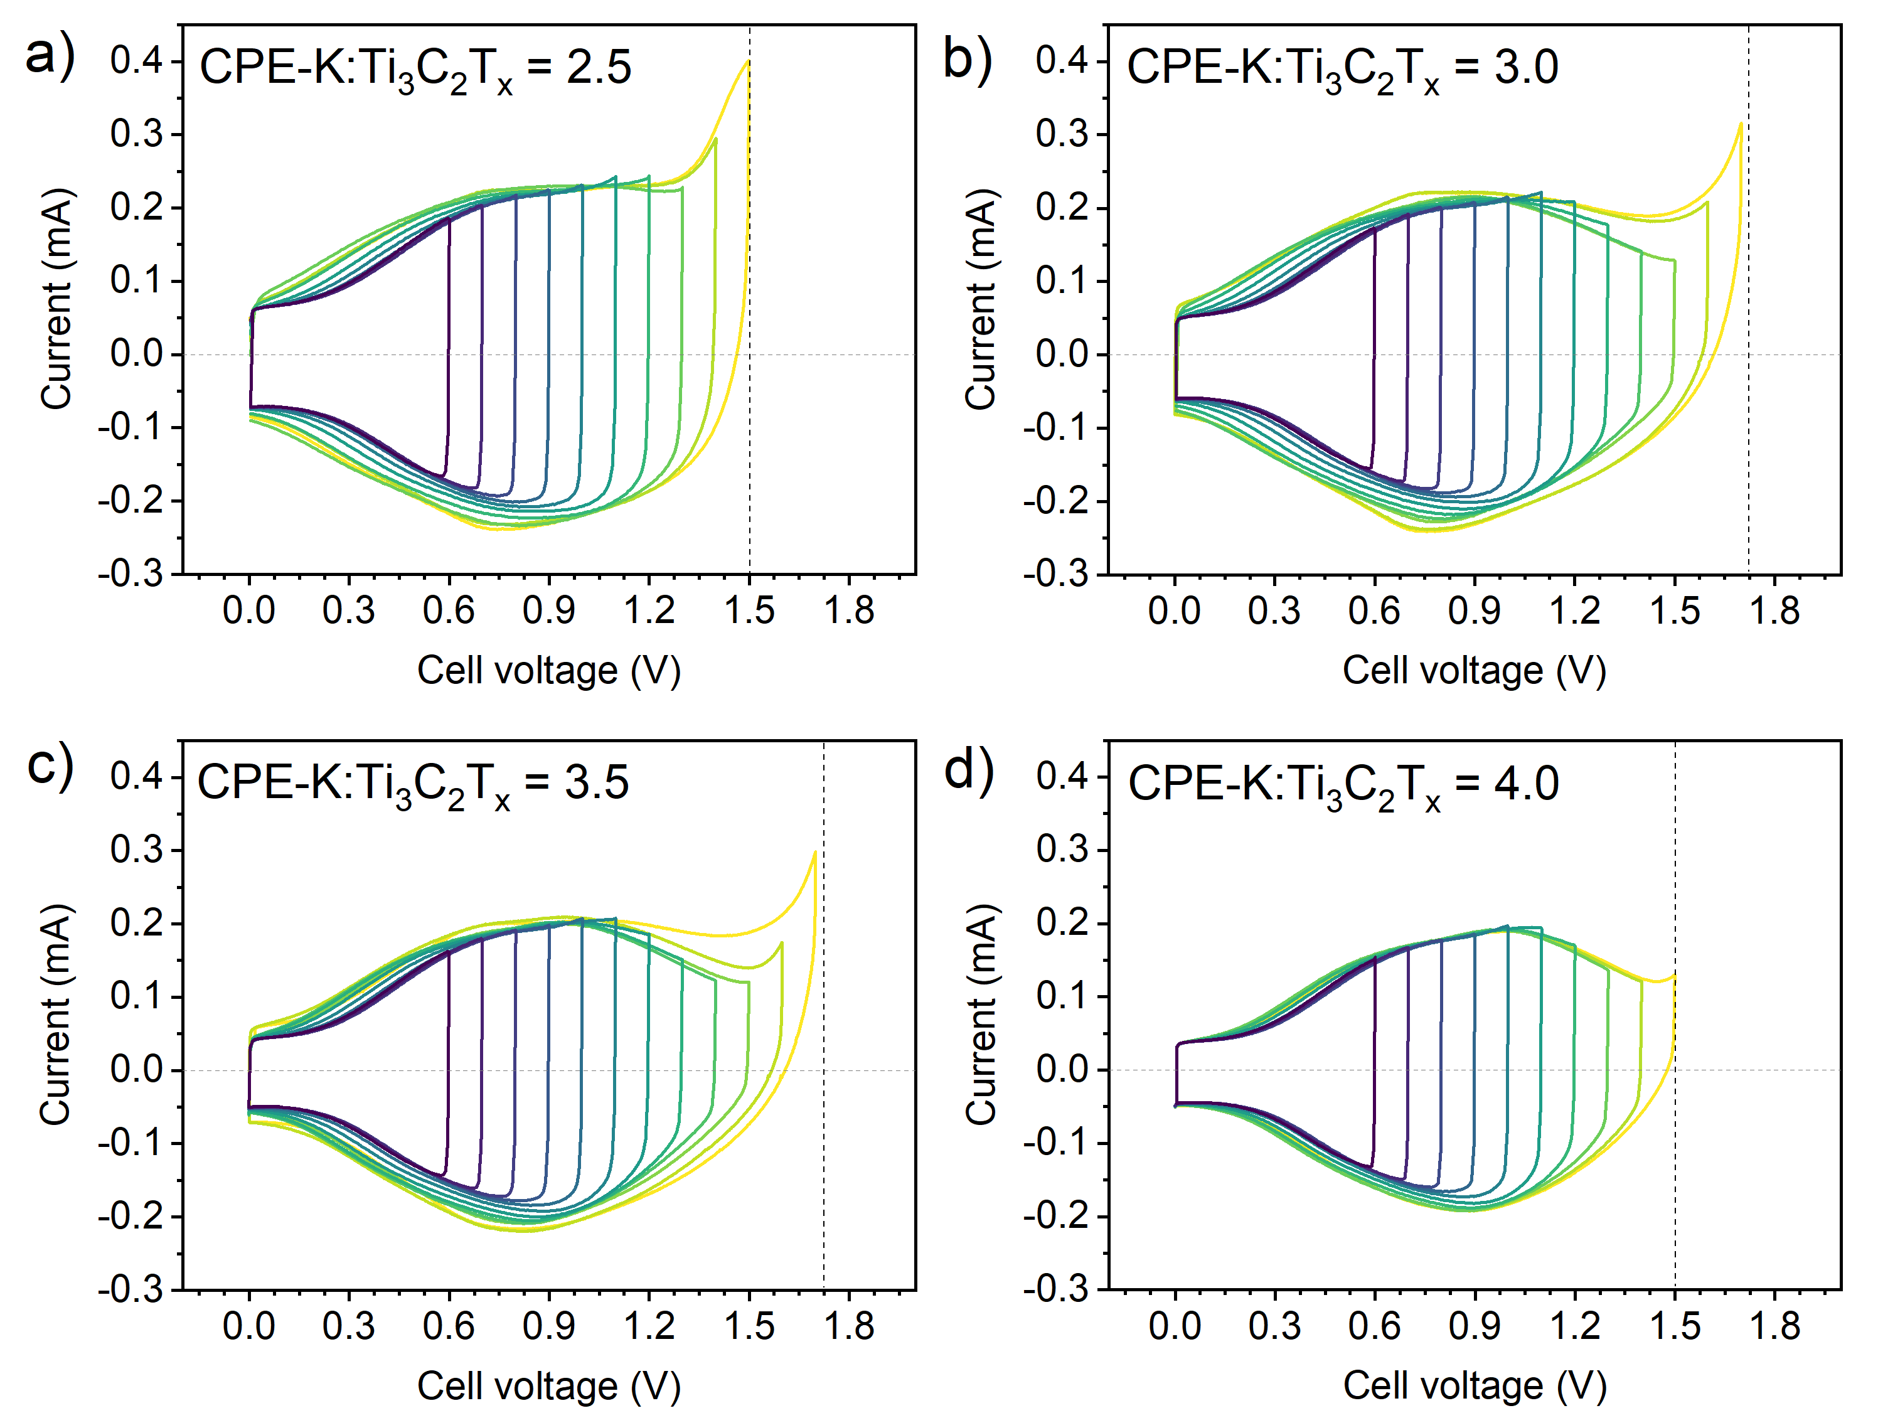
Figure S7. Mass balancing experiment to obtain optimum voltage window for Ti₃C₂T_{x}//CPE-K asymmetric pseudocapacitor.

Table S1. Coulombic efficiencies of Ti₃C₂T_{x}//CPE-K at different mass ratios and voltage windows.
Ratio  CPE-K :Ti₃C₂T_{x} | CPE-K Mass (ug) | Ti₃C₂T_{x}  Mass  (ug) | Potential window (V)
Ratio  CPE-K :Ti₃C₂T_{x} | CPE-K Mass (ug) | Ti₃C₂T_{x}  Mass  (ug) | 0.6 | 0.7 | 0.8 | 0.9 | 1.0 | 1.1 | 1.2 | 1.3 | 1.4 | 1.5 | 1.6 | 1.7
Ratio  CPE-K :Ti₃C₂T_{x} | CPE-K Mass (ug) | Ti₃C₂T_{x}  Mass  (ug) | Coulombic efficiency (%)
4.0 | 200 | 50 | 98 | 98 | 98 | 97 | 97 | 96 | 97 | 97 | 95 | 92 | - | -
3.5 | 200 | 57 | 98 | 98 | 97 | 97 | 97 | 97 | 97 | 97 | 97 | 95 | - | -
3.0 | 200 | 67 | 99 | 98 | 98 | 98 | 98 | 97 | 97 | 98 | 98 | 97 | 90 | 84
2.5 | 200 | 80 | 99 | 98 | 98 | 98 | 98 | 97 | 97 | 97 | 93 | 84 | - | -
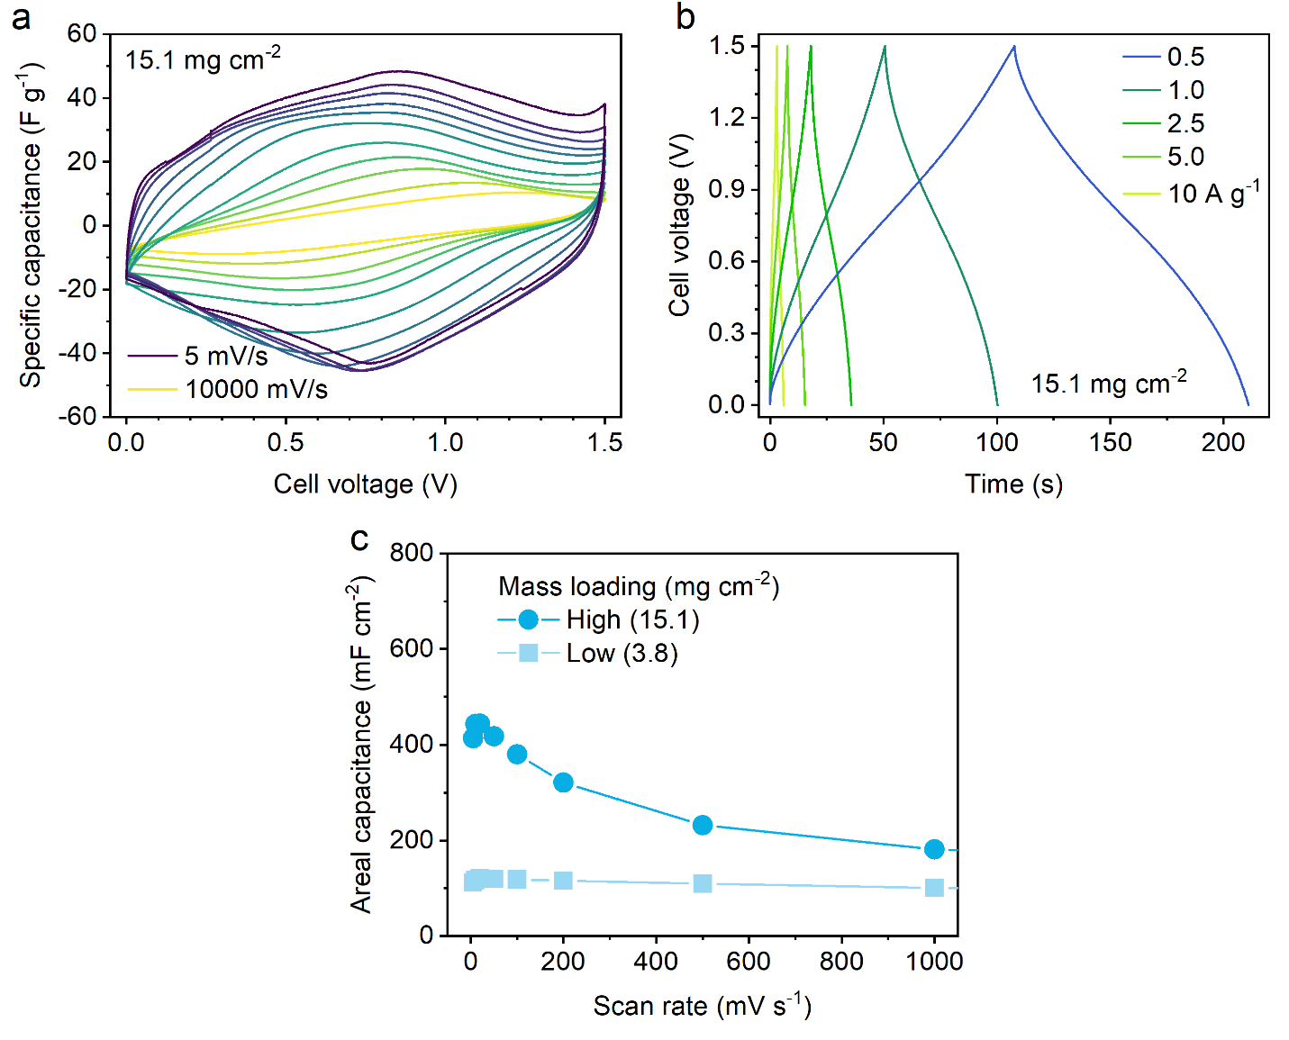
Figure S8. Electrochemical characterization of high mass loading (15.1 mg cm⁻²) Ti₃C₂T_{x}//CPE-K. a) Cyclic voltammograms from 5 to 10,000 mV s⁻¹. b) GCD trace at 0.5 – 10 A g⁻¹. c) Areal capacitance (normalized to the area of one glassy carbon electrode) as a function of scan rate.
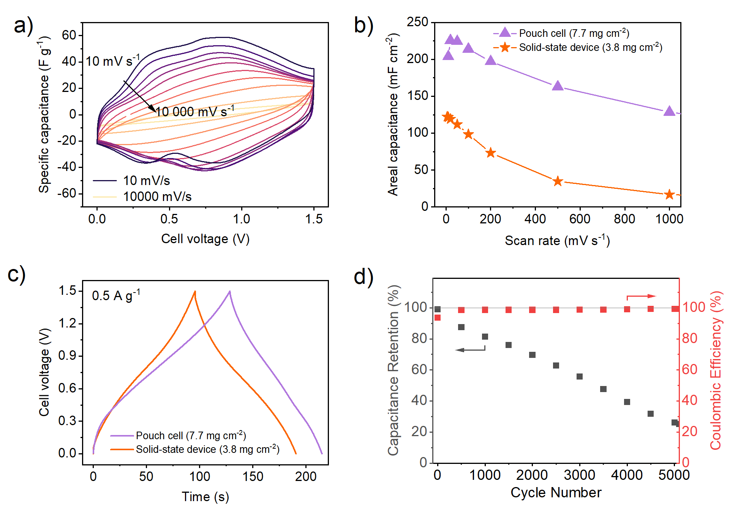
Figure S9. Further electrochemical characterization of CPE-K//Ti₃C₂T_{x} devices a) Cyclic voltammetry of CPE-K//Ti₃C₂T_{x} pouch cell from 5 – 10,000 mV s⁻¹. b) Areal capacitance of pouch cell and solid-state device as a function of scan rate. c) Constant current charge/discharge trace of pouch cell and solid-state device. d) Cycling stability measurements of CPE-K//Ti₃C₂T_{x} pouch cell cycled repeatedly at 20 A g⁻¹.

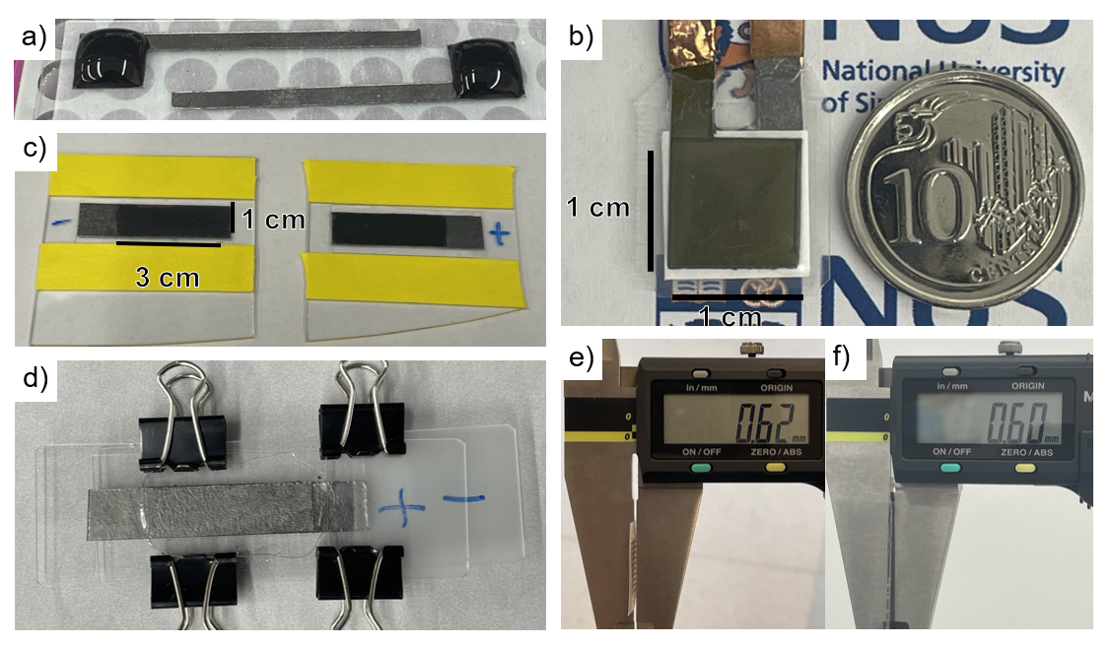
Figure S10. Photographs of the device-making process. a) Aqueous droplet of CPE-K on 1x1 cm graphite foil current collectors. b) Photograph of 7.7 mg cm⁻² pouch cell beside a Singapore 10 cent coin. c) Ti₃C₂T_{x} (left) and CPE-K (right) film on graphite foils meant for solid-state devices. d) Electrodes sandwiched and clamped using two glass slides to apply pressure on the gel electrolyte during drying. Thicknesses of e) pouch cell and f) solid-state device.

