Additional file 1
Conversion Therapy Strategy: A Novel GPC3-Targeted Multimodal Organic Phototheranostics Platform for Mid-late-stage Hepatocellular Carcinoma
Fan Wu^{1,2,3}, Xin Kuang^{1,2,3}, Sanlin Deng^{1,2,3}, Shuo Qi^{1,2}, Jian Xiong^{1,2,3}, Bibo Zhao^{1,2,3}, Chuanfu Li^{1,2,3}, Senyou Tan^{1,2}, Qiang Kang¹, Hao Xiao¹, Xiaofeng Tan^{1*}, Gui-long Wu^{1,2,3*}, Guodong Chen^{1,2,3*}, Qinglai Yang^{1,2,3*}
¹Center for Molecular Imaging Probe Hengyang Medical School, University of South China, Hengyang, Hunan, 421001, China.
²Department of Hepatopancreatobiliary Surgery, The First Affiliated Hospital, Hengyang Medical School, University of South China, Hengyang, Hunan, 421001, China.
³Hunan Engineering Research Center for Early Hengyang Medical School, University of South China, Hengyang, Hunan, 421001, China.
*Correspondence: chenguodong@usc.edu.cn (Guodong Chen), qingyu513@usc.edu.cn (Qinglai Yang), 2018000014@usc.edu.cn (Gui-long Wu), tanxiaofeng@usc.edu.cn (Xiaofeng Tan).
Table
Scheme S1. Synthetic route of IGD NPs 4
Fig. S1 ¹H NMR of compound 1. 10
Fig. S2 13C NMR of compound 1. 10
Fig. S3 HRMS NMR of compound 1 11
Fig. S4 ¹H NMR of compound 2. 11
Fig. S5 ¹³C NMR of compound 2. 12
Fig. S6 HRMS of compound 2. 12
Fig. S7 ¹H NMR of compound 3. 13
Fig. S8 ¹³C NMR of compound 3. 13
Fig. S9 ¹H NMR of IGD. 14
Fig. S10 ¹³C NMR of IGD. 14
Fig. S11 The SEC traces results show that different molecules. 15
Fig. S12 Zeta potential of IGD NPs, Error bars: mean ± SD (n = 3). 15
Fig. S13 (a) Photothermal warming curves of IR820 and IGD NPs. (b) Photothermal warming curves of IGD NPs with different power. 16
Fig. S14 After 5 min of laser irradiation, the DCF fluorescence values in aqueous solution of PBS, IR820, and IGD NPs (488 nm). 16
Fig. S15 (a, b) In vivo FLI and fluorescence values of subcutaneous tumor-bearing mice at different time points after tail vein injection of free ICG and IGD NPs probes. Error bars: mean ± SD (n = 4). 17
Fig. S16 Signal values of in vivo magnetic resonance T1-weighted imaging in mice at different time points.ST: subcutaneous tumors, PIS: in situ tumors, Error bars: mean ± SD (n =4), ***p < 0.001. 17
Fig. S17 Surgical excision procedure. 18
Fig. S18 Pre- and post-treatment bioluminescence imaging for monitoring hepatocellular carcinoma in situ in different groups. 18
Fig. S19 Difference plots of routine hematological and biochemical assays in mice of different treatment groups, Error bars: mean ± SD (n = 4). 19
Fig. S20 H&E staining of each organ in mice of different treatment groups; scale bar: 200 μm. 19
Table S1 Molecule weight determined by SEC-MALLS. 19

General measurements
Nuclear magnetic resonance (NMR) spectra were recorded on an AVANCE NEO 500 spectrometer (Bruker, Germany) using CDCl₃ as the internal reference. High-resolution mass spectra (HRMS) and size exclusion chromatography (SEC) were obtained on a Thermo Scientific Q Exactive Combined quadrupole Orbitrap mass spectrometer (Thermo Fisher Scientific Co, USA) in a Positive ion mode. Confocal laser scanning microscopy (CLSM) images were collected on Zeiss LSM880 (Zeiss, Germany). Transmission electron microscopy (TEM) images were performed on an HT7800 transmission electron microscope (Hitachi Electronics, accelerating voltage 80 kV). The size distributions of the NPs were obtained from Nano-ZS90 (Malvern, China). The size distribution of IR820-GPC3-Gd NPs (IGD NPs) was measured by a nanometer particle size potentiometer (Malvern Nano-ZS90). Fluorescence spectra were measured on a Thermo Scientific Lumina fluorescence spectrometer (Thermo Fisher Scientific Co, USA), Ultra violet-visible-near infrared (UV-Vis-NIR) absorption spectra were measured by a UA-3200S spectrometer (MAPADA, China). The pathological sections were observed via Pannoramic DESK (3D HISTECH, HUN). Fluorescence spectroscopy was measured with the In Vivo Imaging System for Small Animals (IVIS Spectrum, USA). MRI signal using 3.0T ultra-high field magnetic resonance (SIEMENS, Germany). Temperature evolution curves were tested by an infrared thermal imaging camera (Fotric 225s, China) upon irradiation with an 808 nm near-infrared (NIR) laser (1.0 W/cm², MDL-XF-808nm/10W, Changchun New Industries Optoelectronics Technology Co, Ltd.).

Synthesis and characterization of IGD NPs
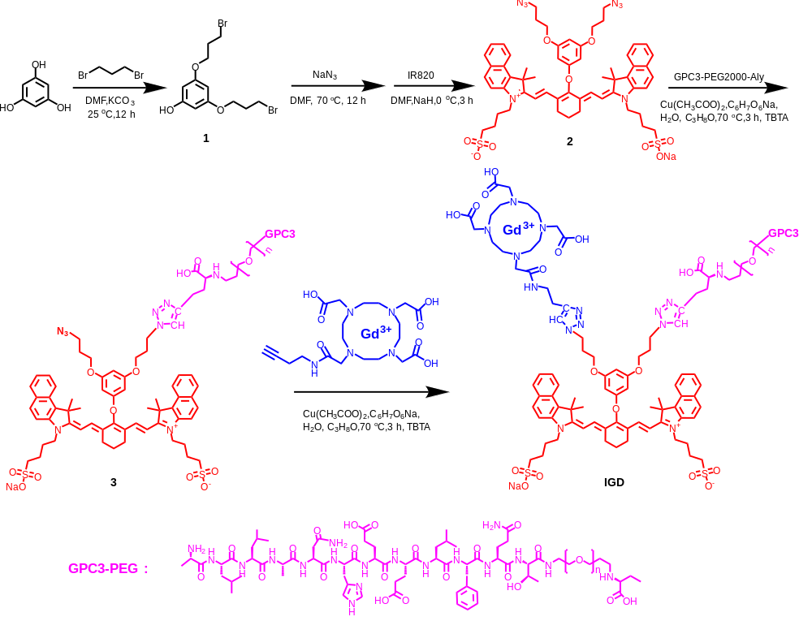

Scheme S1. Synthetic route of IGD NPs
Compound 1: 2.0 g of phloroglucinol and 6.4 g of 1,3-Dibromopropane were added to a 100 mL dry round-bottomed flask, and 4.4 g of K₂CO₃ and 10 mL of N,N-Dimethylformamide (DMF) were added sequentially, and the reaction was carried out for 12 h at room temperature. The product was extracted with equal volumes of water and ethyl acetate (EA) to remove excess K₂CO₃ and DMF. Rotary evaporation removed the EA, and then the product was separated by adding it to a chromatographic column filled with silica gel powder. After separation using a solution of petroleum ether (PE)/EA = 8, rotary evaporation yielded 3.8 g (65.0%) of white solid compound 1. ¹H NMR (500 MHz, CDCl₃) δ 6.01 (t, J = 2.1 Hz, 1H), 5.96 (d, J = 2.1 Hz, 2H), 3.98 (dd, J = 7.1, 4.5 Hz, 6H), 3.52 (t, J = 6.4 Hz, 6H). ¹³C NMR (126 MHz, CDCl₃) δ 160.75, 157.38, 95.23, 95.05, 94.50, 94.30, 77.27, 77.01, 76.76, 65.44, 32.29, 29.90. HRMS (ESI) calcd for C₁₂H₁₇O₃Br₂⁺, ([M+H⁺]) 368.9512, Found 368.9518.
Compound 2: The crude product of the reaction was obtained by adding 0.8 g Compound 1, 0.4 g NaN₃, and 10 mL of DMF to a 100 mL dry round bottom flask and stirring overnight at 70℃ in the absence of water and oxygen. The reaction was separated using a solution chromatography column with PE/EA = 4, and 0.6 (94.5%) of clear light yellow liquid product was obtained after rotary evaporation and drying. Then 0.2 g of IR820, 35 mg of NaH, and 10 mL of DMF were added and the reaction was carried out at low temperature for 3 h under anhydrous and oxygen-free conditions. The product was filtered through a hydrophobic filter centrifuged twice with an equal ratio of PE/EA = 1, and dried to give a final 0.2 g (77.0%) of dark green solid compound 2. ¹H NMR (500 MHz, CD₃OD_SPE) δ 8.09 (s, 3H), 7.94 (d, J = 2.8 Hz, 4H), 7.57 (d, J = 3.7 Hz, 4H), 7.43 (s, 2H), 7.33 (s, 1H), 7.14 (s, 1H), 6.21 (d, J = 14.3 Hz, 4H), 4.25 (d, J = 4.5 Hz, 2H), 3.45 (d, J = 5.4 Hz, 2H), 3.31 (dd, J = 10.5, 8.9 Hz, 16H), 2.89 (s, 4H), 2.79 (d, J = 5.8 Hz, 4H), 2.03 – 1.94 (m, 18H). ¹³C NMR (500 MHz, CD₃OD_SPE) δ 160.75, 157.38, 95.23, 95.05, 94.50, 94.30, 77.27, 77.01, 76.76, 65.44, 32.29, 29.90. HRMS (ESI) calcd for C₅₈H₆₅O₉N₈S₂⁺, ([M+H⁺]) 1081.4321, Found 1081.4373.
Compound 3: 20 mg of compound 2 with 65 mg of GPC3 peptide was added to a 25 mL dry flask. 0.46 mg of sodium ascorbate and 0.24 mg of copper acetate were added to a centrifuge tube of 1 mL of water and 1 mL of isopropanol, respectively, and the centrifuge tube was shaken using an ultrasonic cleaner for 5 min before being added to the reaction flask and stirred for 3 h at anhydrous and anaerobic and 70℃. The reaction product was then dried and lyophilized. The reaction product was dialyzed through a 2 kd dialysis bag for 24 h and lyophilized to give a final 65 mg (78.1%) of black solid compound 3. ¹H NMR (500 MHz, CD₃OD_SPE) δ 8.26 (d, J = 8.5 Hz, 3H), 7.99 (d, J = 10.7 Hz, 4H), 7.62 (s, 4H), 7.51 (s, 2H), 7.22 (s, 1H), 7.10 (s, 1H), 6.21 (d, J = 14.0 Hz, 4H), 4.22 (d, J = 51.9 Hz, 18H), 3.87 (s, 188H), 2.73 (d, J = 50.8 Hz, 18H). ¹³C NMR (500 MHz, CD₃OD_SPE) δ 160.75, 157.38, 95.23, 95.05, 94.50, 94.30, 77.27, 77.01, 76.76, 65.44, 32.29, 29.90.
IGD: Using the same reaction conditions and purification method as for compound 3, IR820-GPC3 (65 mg) was reacted with 10 mg of DOTA-Gd, resulting in 68 mg (92.3%) of black solid IGD NPs. ¹H NMR (500 MHz, CD₃OD_SPE) δ 8.26 (s, 3H), 7.98 (s, 4H), 7.62 (s, 8H), 6.21 (s, 4H), 4.22 – 3.33 (m, 287H), 2.91 – 2.65 (m, 21H). ¹³C NMR (500 MHz, CD₃OD_SPE) δ 160.75, 157.38, 95.23, 95.05, 94.50, 94.30, 77.27, 77.01, 76.76, 65.44, 32.29, 29.90.
In vitro fluorescence and MR signals of IGD NPs
Prepare 200 μL of ultrapure water solution of molecular probe IGD NPs with different concentrations (0, 25, 50, 75, 100 μM) and add it into the EP tube. The EP tube was placed into the elevator of the in vivo imaging system for small animals (IVIS) to obtain images and quantitative fluorescence values. The EP tube was placed into the center of the magnetic field of the 3.0 T MRI. T1 relaxivity measurements and T1-weighted MRI at 25℃. The relaxivity values of r₁ were calculated by fitting the 1/T1 relaxation time (s⁻¹) versus the IGD NPs concentration (mM) curves.
Cell uptake experiments
The experiment was divided into IR820 and IGD NPs groups. Hep-G2 cells (2×10⁵ cells/dish) grown in the logarithmic phase were selected and inoculated into colocalization for culture. 12 h later, the supernatant was washed off, and the probe (75 μM) was added and co-incubated with the cells for 0, 3, and 6 h. Subsequently, the probe uptake was observed under confocal laser scanning microscopy (CLSM).
Live/Dead Cells Staining
To assess nanoparticle toxicity, a live/dead cell staining assay was conducted. Hep-G2 cells (3×10⁵ cells/dish) were cultured in Dulbecco's modified eagle medium (DMEM) with 10% FBS and 1% PS at 37°C with 5% CO₂. After overnight incubation, the medium was replaced with fresh solutions containing various treatments (PBS, PBS + NIR, IGD NPs, IGD NPs + NIR) at 75 µM concentration. After 4 h of incubation, cells were rinsed with PBS, stained with a Living/Dead cell double staining kit (Calcein AM/PI), and analyzed by CLSM.
Intracellular ROS Detection
To assess ROS generation, DCFH-DA was used. Hep-G2 cells (2×10⁵ cells/mL) were cultured overnight and then treated with 75 μM nanoparticles for 4 h. After washing with PBS, the cells were treated with DCFH-DA (10 μM) for 30 min. CLSM analysis was performed with excitation at 488 nm and emission was collected between 490-550 nm.
Establishment of Hep-G2 Tumor Models
Hep-G2 cells (1×10⁷ cells/mL) were injected subcutaneously into the left thigh of mice to create a tumor model. Tumor growth was monitored regularly, and further experiments were conducted once the tumor reached approximately 80 mm³. Similarly, Hep-G2 cells (2×10⁷ cells/mL) were injected subcutaneously under the peritoneum of the lower segment of the left outer lobe of the liver in mice to establish an in situ transplantation tumor model, and the tumor was determined by intraperitoneal injection of the substrate D-Luciferin potassium salt, and bioluminescence assay was carried out under the IVIS to determine whether or not the tumor had become a tumor. Follow-up experiments were performed when the tumor grew to about 50 mm³.
Phototherapy of subcutaneous tumor mice
Mice were categorized into three groups: PBS, ICG, and IGD NPs, with four mice in each group. After injecting the materials via the tail vein, tumors were irradiated with an 808 nm laser (1.0 W/cm², 10 min) at the optimal time. Body weight and tumor volume were recorded every three days to assess treatment effects and tumor recurrence, with volumes calculated using a specific formula.
$\text{Tumor volume(V)=}\frac{{\text{W}}^{\text{2}}\text{×}\text{L}}{\text{2}}$， $\text{R}\text{elative tumor volume=}\frac{\text{V}}{\text{V0}}$

Pathologic analysis
Tissues removed surgically were subjected to staining with hematoxylin and eosin (H&E), Ki-67, and TUNEL. On the 15th day post-treatment, the mice were euthanized, and blood samples, including whole blood and serum, were collected for routine blood tests and evaluation of liver and kidney functions. Additionally, vital organs and tumor tissues were excised, stained with H&E, and examined under a light microscope to assess their morphology and structure.

Fig. S1 ¹H NMR of compound 1.

Fig. S2 13C NMR of compound 1.
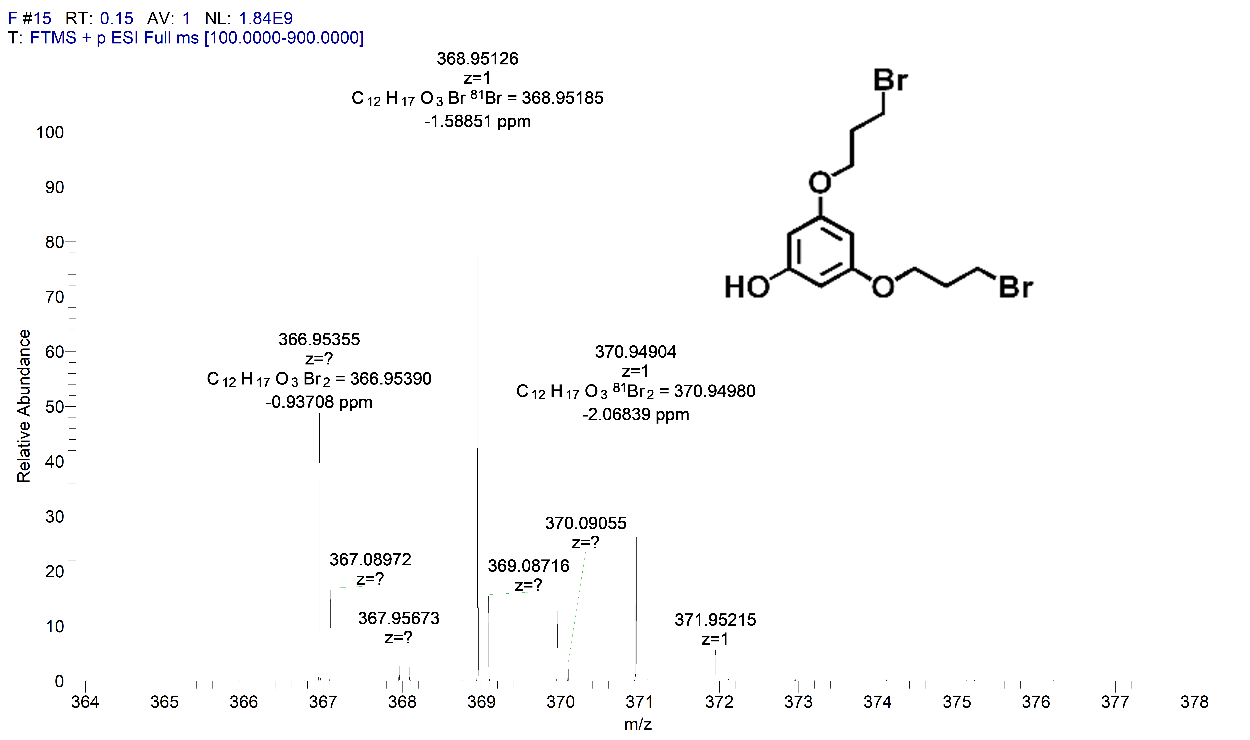

Fig. S3 HRMS NMR of compound 1

Fig. S4 ¹H NMR of compound 2.

Fig. S5 ¹³C NMR of compound 2.
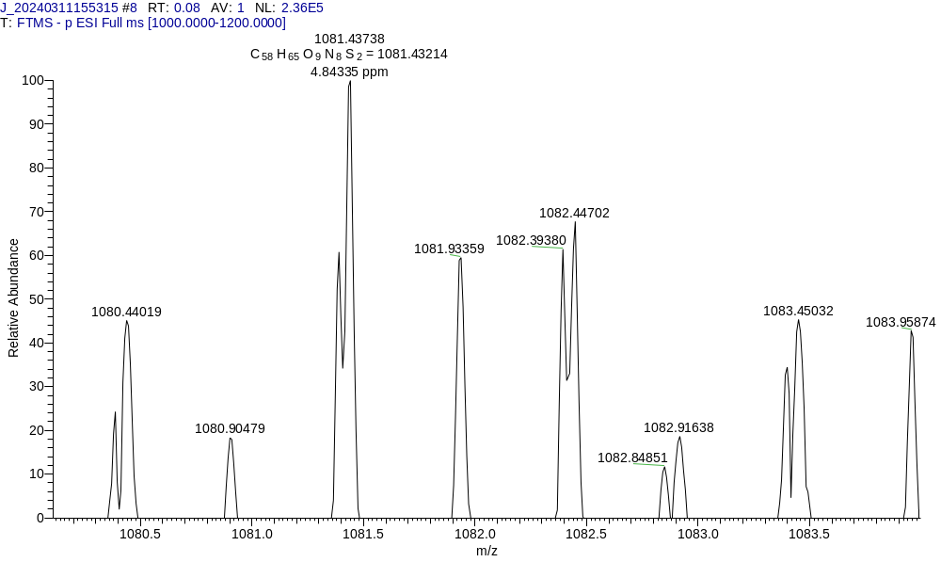

Fig. S6 HRMS of compound 2.

Fig. S7 ¹H NMR of compound 3.

Fig. S8 ¹³C NMR of compound 3.

Fig. S9 ¹H NMR of IGD.

Fig. S10 ¹³C NMR of IGD.
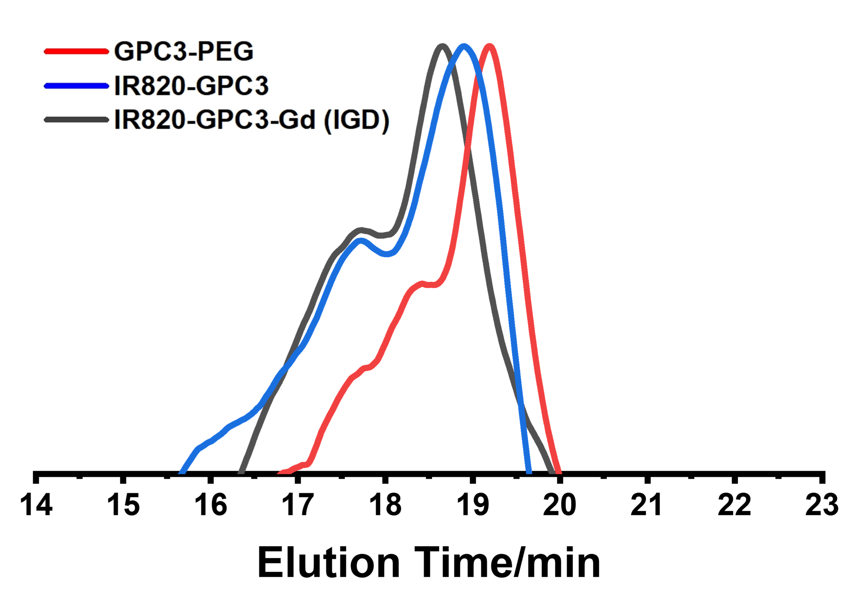

Fig. S11 The SEC traces results show that different molecules.

Fig. S12 Zeta potential of IGD NPs, Error bars: mean ± SD (n = 3).

Fig. S13 (a) Photothermal warming curves of IR820 and IGD NPs. (b) Photothermal warming curves of IGD NPs with different power.

Fig. S14 After 5 min of laser irradiation, the DCF fluorescence values in aqueous solution of PBS, IR820, and IGD NPs (488 nm).

Fig. S15 (a, b) In vivo FLI and fluorescence values of subcutaneous tumor-bearing mice at different time points after tail vein injection of free ICG and IGD NPs probes. Error bars: mean ± SD (n = 4).

Fig. S16 Signal values of in vivo magnetic resonance T1-weighted imaging in mice at different time points.ST: subcutaneous tumors, PIS: in situ tumors, Error bars: mean ± SD (n =4), ***p < 0.001.

Fig. S17 Surgical excision procedure.
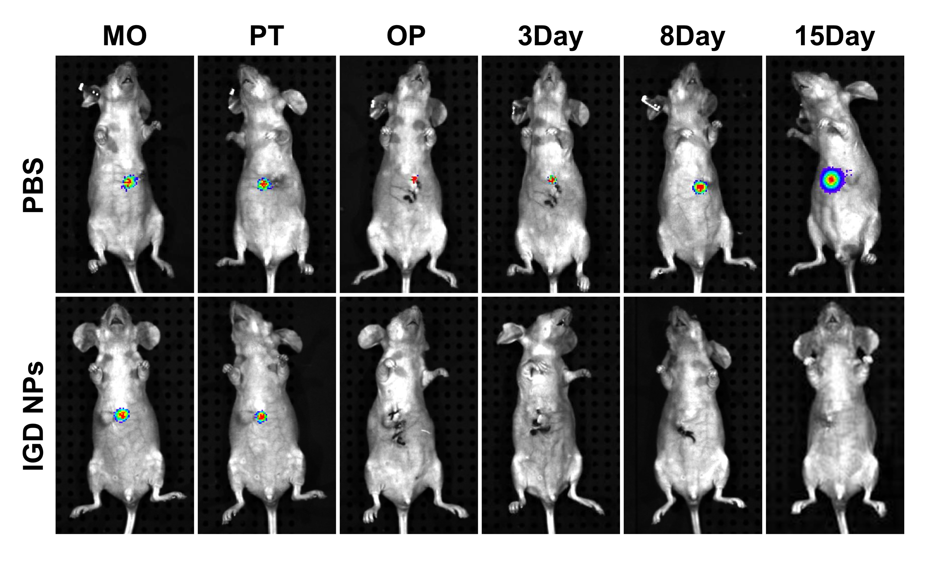

Fig. S18 Pre- and post-treatment bioluminescence imaging for monitoring hepatocellular carcinoma in situ in different groups.

Fig. S19 Difference plots of routine hematological and biochemical assays in mice of different treatment groups, Error bars: mean ± SD (n = 4).

Fig. S20 H&E staining of each organ in mice of different treatment groups; scale bar: 200 μm.

Table S1 Molecule weight determined by SEC-MALLS.
Dye | dn/dc (mL/g) | M_{n} (Daltons) | M_{w} (Daltons) | M_{w}/M_{n}
GPC3-PEG | 0.030 | 3200 | 2900 | 1.103
IR820-GPC3 | 0.046 | 4300 | 4100 | 1.048
IR820-GPC3-Gd | 0.042 | 4900 | 4700 | 1.043

