Supplementary Information
One-fifth of the world’s population at high risk from climate-related hazards
This Supplementary Information provides additional details to describe the methodology and support our results.
Defining exposed locations from probabilistic hazard maps
Figure S1 demonstrates how exposed locations are identified from the hazard data sources. The probabilistic hazard maps depict the maximum intensity of a hazard with a given return period (frequency). The figure shows: (a) the maximum depth of a 100-year return period flood, as depicted by the hazard map data, (b) the area where a flood with a return period of 100 years exceeds 50 cm, (c) the annual frequency of a flood exceeding 50 cm, and d) the area where the annual frequency of a flood exceeding 50cm is at least 1%. The area defined as exposed in b and d is equivalent by definition using our approach and includes locations where floods are relatively more intense or more frequent than the thresholds used.
Figure S1: Defining exposed locations from probabilistic hazard maps
a  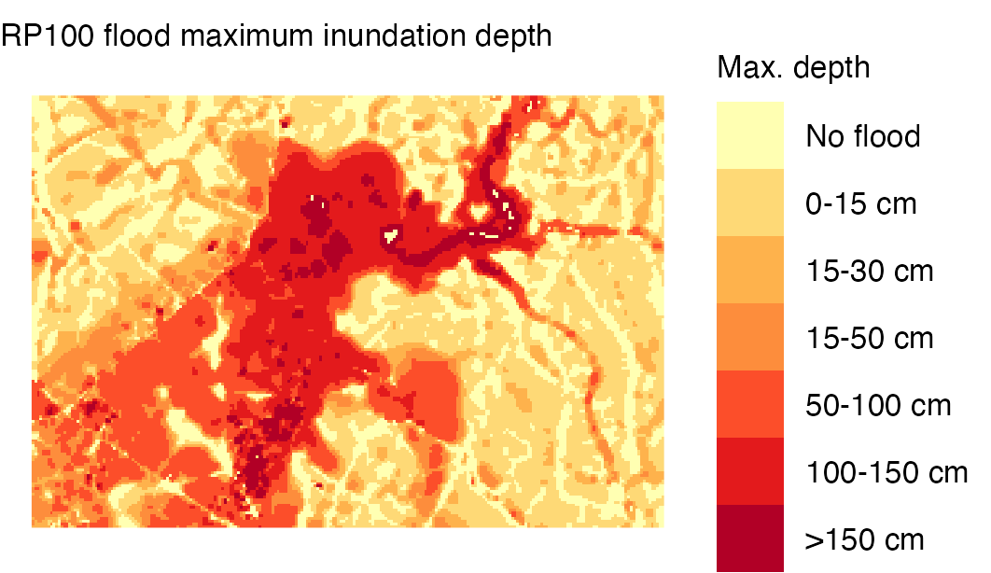 | b  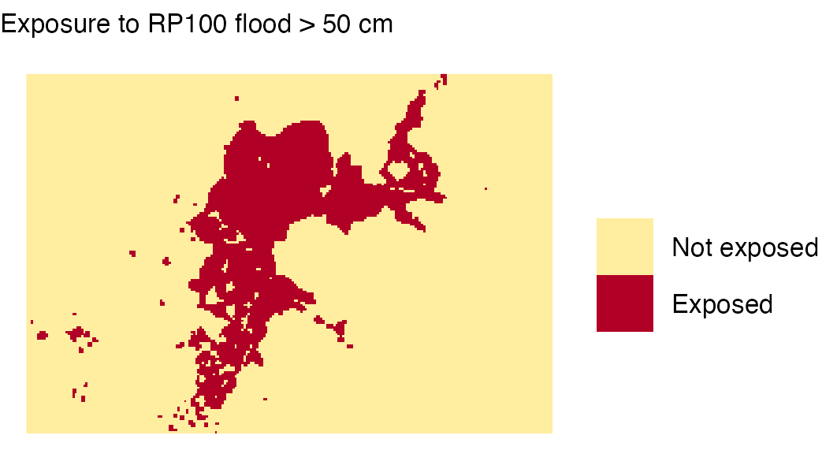
c  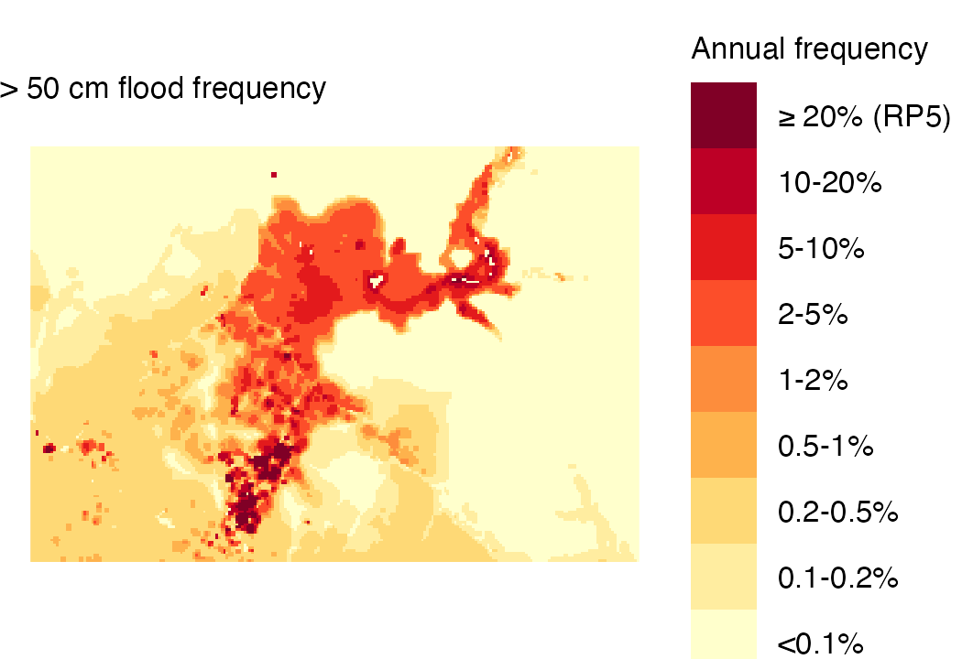 | d  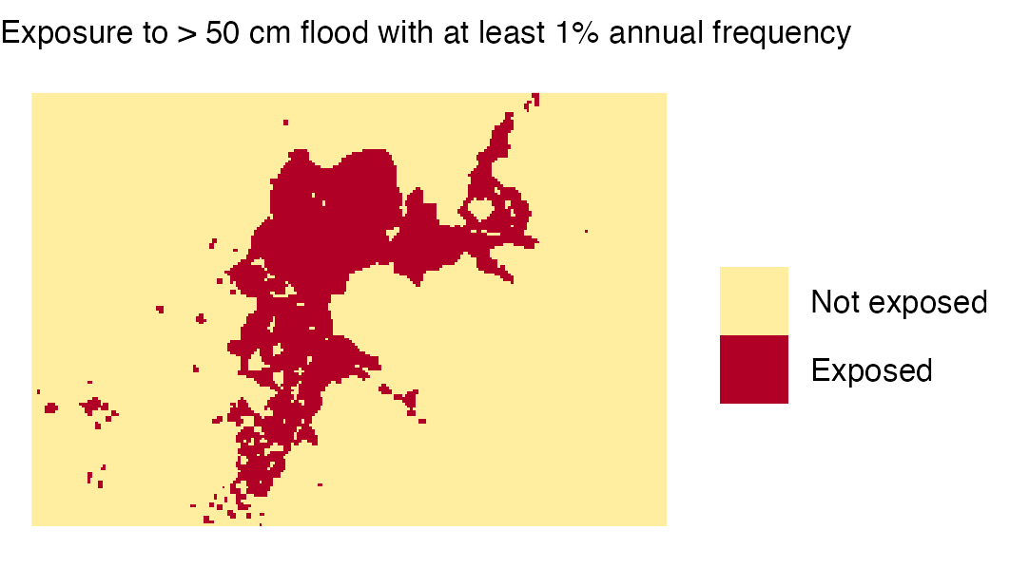

Adjusting estimates of financial account ownership from individual to household level
Since Findex data is collected at individual level, we adjust estimates to household level to be consistent with other indicators. We require the share of households without access to a financial account or mobile money. We apply an adjustment based on the number of adults in a household and a factor derived from examining countries where data on both household and individual ownership of accounts is available. A constant adjustment factor of 0.6 was found to predict household level access to finance across income quintiles, based on validation against surveys in 11 countries with complete data. The share of households without access is therefore calculated at income quintile level as:
$${hh}_{fin}={{ind}_{fin}}^{0.6N}$$
where ${hh}_{fin}$ is the share of households without access to a financial or mobile money account in each quintile (required for the analysis), ${ind}_{fin}$ is the share of individuals (15+) without access, as measured by Findex surveys, and $N$ is the average number of individuals (15+) in a household in each quintile, based on GMD surveys. Results from validation in eleven countries where surveys collected individual level data for all household members is shown in Figure S2.
Figure S2: Findex household level adjustment

Merging spatially defined degree of urbanization with survey rural-urban definitions
Degree of urbanization method (DoU) is a consistent way to classify the exposed population (based on population cluster size and density). However, this classification may not align well with the definition of rural/urban in household surveys and corresponding vulnerability rates. In particular, some countries report rural population shares much higher than those estimated using DoU. Without any adjustment, applying the (lower) urban vulnerability rates to a larger urban population classified by DoU will underestimate the total number of people who are highly vulnerable. Therefore, we reclassify the DoU categories to match population shares in the survey such that the overall vulnerability rate does not change. Figure S3 demonstrates the method.
Figure S3: Aligning rural and urban definitions
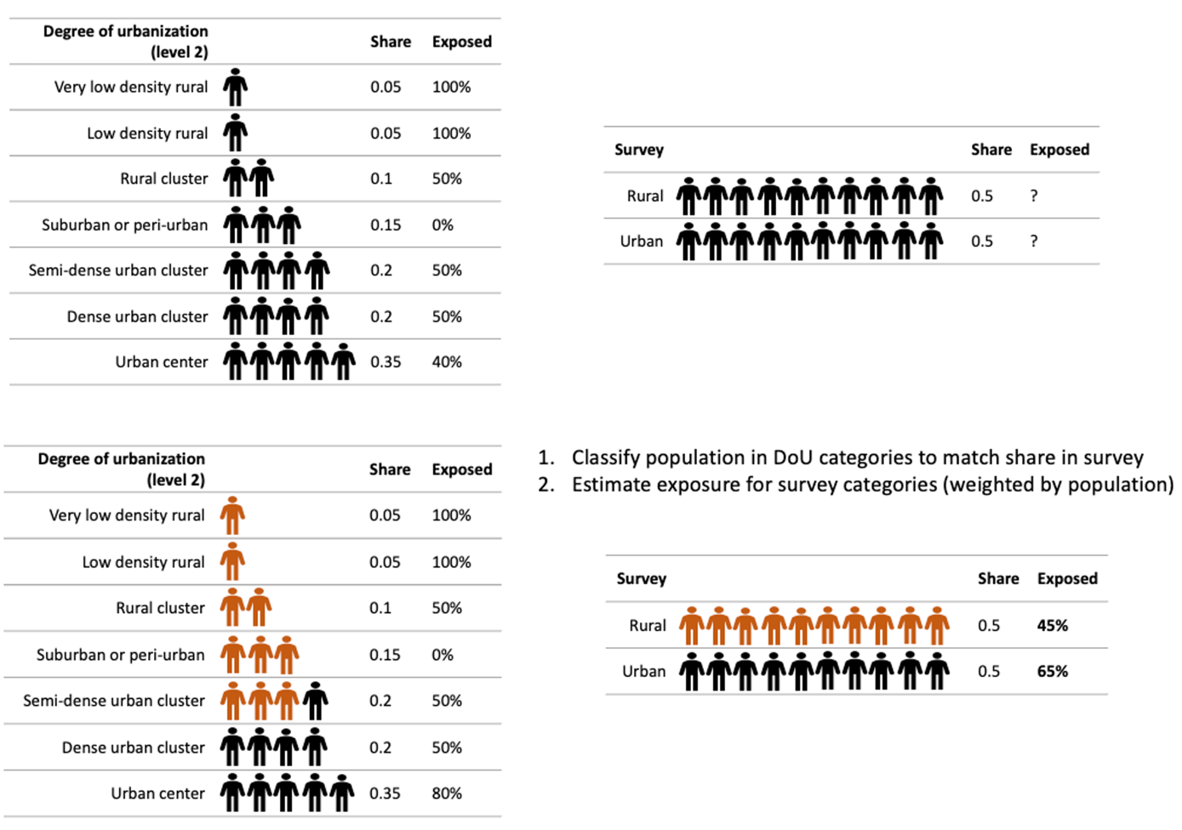
The method was validated on data from India, using maps delineating rural and urban areas for the 2011 population census as a benchmark. The population defined as rural using the national definition is known to be significantly larger than that classified by DoU in India. Figure S4 shows results from the validation. The population exposed and poor in each state would be substantially underestimated if we assume DoU aligns with the national classification when merging population exposure and vulnerability estimates. However, the bias is almost completely corrected when using our reclassification method.

Figure S4: Rural-urban adjustment
Robustness to survey data collection period and overlap assumptions
Table S1 shows estimates of the population at high risk from climate related hazards when restricting the sample to countries with data on all dimensions of vulnerability from within 3 years of both 2010 and 2021.
We also estimate upper and lower bounds by assuming the minimum and maximum possible overlap between the exposed and vulnerable population, rather than assuming that the vulnerable population are just as likely to be exposed as those not vulnerable within a spatial unit (zero correlation). It should be noted that these represent “100% confidence intervals” for one source of uncertainty and therefore do not correspond with typical statistical inference levels. It is unlikely that the extent of overlap approaches the theoretical maximum or minimum based on the empirical evidence available.
The levels and trends of the main results using our preferred specification are robust in all cases.

Table S1: Sensitivity to survey data collection period and population overlap assumption
 | Share of population at high risk (%)
 | 2010 | 2021 | ∆
Main  (full sample, zero correlation) | 35.7 | 19.4 | -16.3
Countries with recent data  (+/- 3 years, N = 89) | 36.5 | 17.1 | -19.4
Sensitivity to overlap assumption
Upper bound  (maximum overlap) | 39.7 | 22.5 | -17.2
Lower bound  (minimum overlap) | 31.7 | 16.1 | -15.6

Figure S5 maps the range between these extreme upper and lower bound estimates at subnational level. This represents the maximum possible uncertainty due to the overlap assumption. Due to the mechanics of assuming zero correlation, the range increases where exposure and vulnerability rates approach 50% of the population.

Figure S5: Range between upper and lower bounds
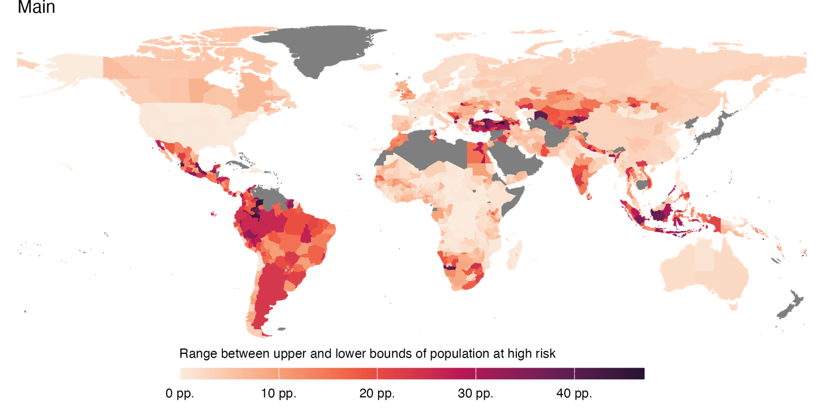

Using alternate hazard thresholds to define exposed locations
Identifying the who is exposed to climate related hazards (and at high risk) for a population headcount indicator requires selecting thresholds. The choice of thresholds for the indicator is based on prior literature, as discussed in the main paper. Here we estimate results using a wide range of alternate thresholds to explore the sensitivity to primary choice of thresholds. For exposure to multiple hazards, we consider 5 alternate combinations of thresholds as defined in Table S2. These include using either higher and lower intensity thresholds and/or higher frequency thresholds (at least 5% annual frequency).
Table S2: Alternate multi-hazard thresholds
Threshold scenario | Hazard | Annual frequency | Intensity
Main  (used for indicator) | Agricultural drought | ≥ 1/39 (historical) | > 30% cropland or pasture affected and rural
Main  (used for indicator) | Flood | ≥ 1% | > 0.5 m inundation depth
Main  (used for indicator) | Heatwave | ≥ 1% | > 33°C 5-day mean of daily maximum WBGT
Main  (used for indicator) | Tropical cyclone | ≥ 1% | ≥ Category 2 wind speed
Higher intensity | Agricultural drought | ≥ 2/39 (historical) | > 50% cropland or pasture affected and rural
Higher intensity | Flood | ≥ 1% | > 1 m inundation depth
Higher intensity | Heatwave | ≥ 1% | > 34°C 5-day mean of daily maximum WBGT
Higher intensity | Tropical cyclone | ≥ 1% | ≥ Category 3 wind speed
Lower intensity | Agricultural drought | ≥ 1/39 (historical) | > 30% cropland or pasture affected and rural
Lower intensity | Flood | ≥ 1% | > 0.15 m inundation depth
Lower intensity | Heatwave | ≥ 1% | > 32°C 5-day mean of daily maximum WBGT
Lower intensity | Tropical cyclone | ≥ 1% | ≥ Category 1 wind speed
Higher frequency | Agricultural drought | ≥ 2/39 (historical) | > 30% cropland or pasture affected and rural
Higher frequency | Flood | ≥ 5% | > 0.5 m inundation depth
Higher frequency | Heatwave | ≥ 5% | > 33°C 5-day mean of daily maximum WBGT
Higher frequency | Tropical cyclone | ≥ 5% | ≥ Category 2 wind speed
Higher intensity &  higher frequency | Agricultural drought | ≥ 2/39 (historical) | > 50% cropland or pasture affected and rural
Higher intensity &  higher frequency | Flood | ≥ 5% | > 1 m inundation depth
Higher intensity &  higher frequency | Heatwave | ≥ 5% | > 34°C 5-day mean of daily maximum WBGT
Higher intensity &  higher frequency | Tropical cyclone | ≥ 5% | ≥ Category 3 wind speed
Lower intensity &  higher frequency | Agricultural drought | ≥ 2/39 (historical) | > 30% cropland or pasture affected and rural
Lower intensity &  higher frequency | Flood | ≥ 5% | > 0.15 m inundation depth
Lower intensity &  higher frequency | Heatwave | ≥ 5% | > 32°C 5-day mean of daily maximum WBGT
Lower intensity &  higher frequency | Tropical cyclone | ≥ 5% | ≥ Category 1 wind speed

Results are summarized in Figures S6, S7 and S8. Using higher thresholds reduces the number of people considered at high risk, as anticipated. However, we find that the relative ranking of regions and countries is insensitive to alternate threshold choices. Figure S8 shows that at country level, the Spearman’s rank correlation coefficient is greater than 0.9 for most comparisons. The analysis suggests our main results highlighting regional inequalities in the the share of population at high risk are robust to using different thresholds to define exposed areas.

Figure S6: Population at high risk using alternate exposure thresholds (2021)
a
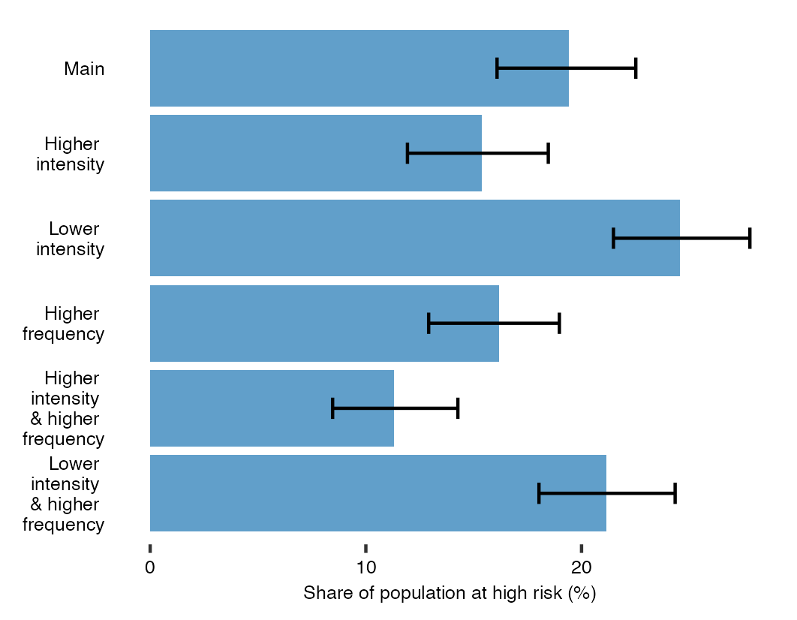
b
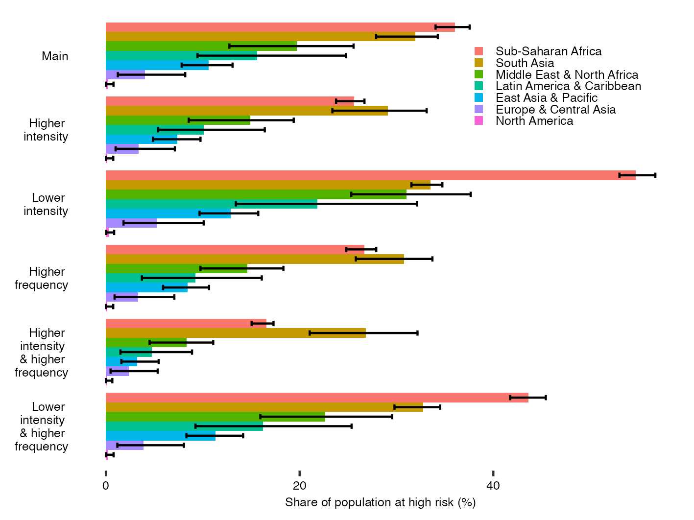
a. Global. b. By region. Intervals show the full extent of uncertainty (100% confidence interval) from assuming zero correlation between exposure and vulnerability within survey statistical regions.

Figure S7: Population exposed and at high risk using alternate exposure thresholds (2021)
a  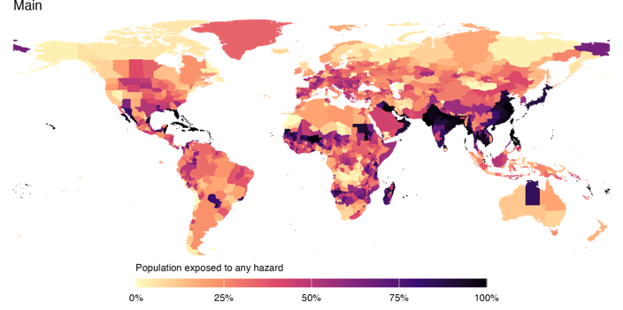 | b  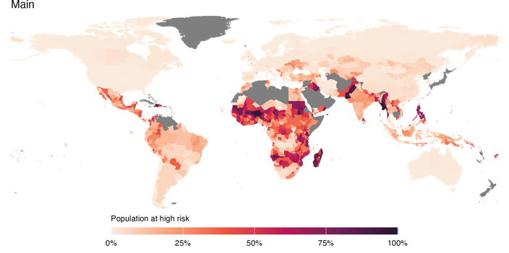
c  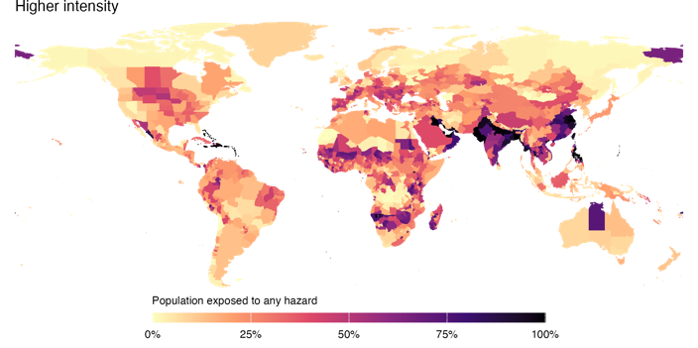 | d  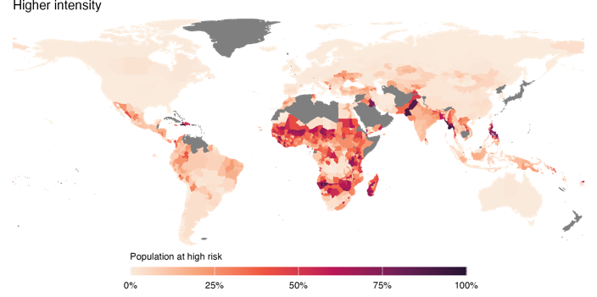
e  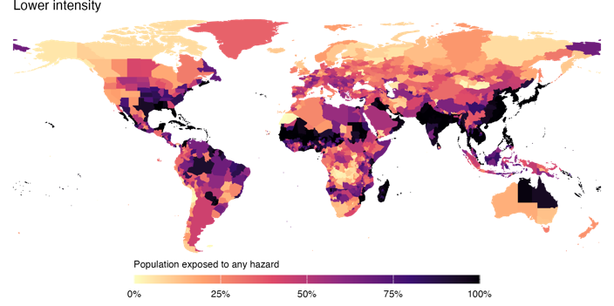 | f  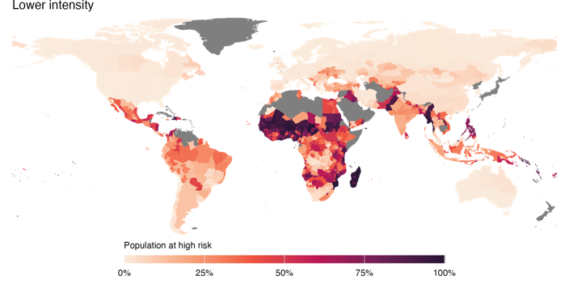
g  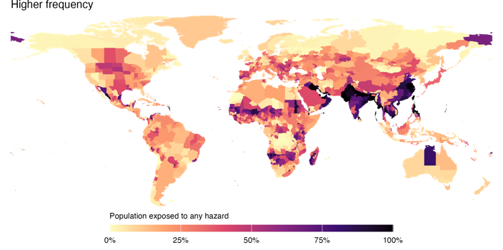 | h  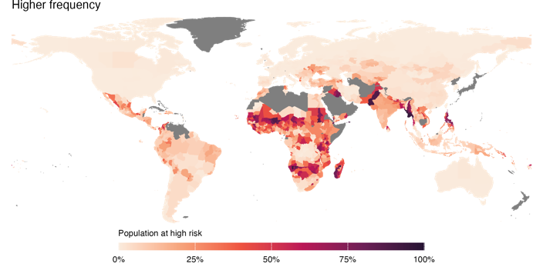
i  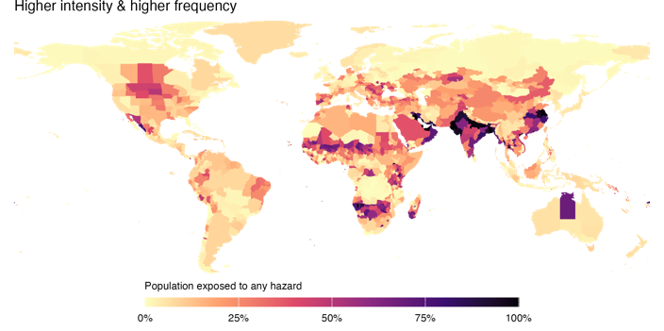 | j  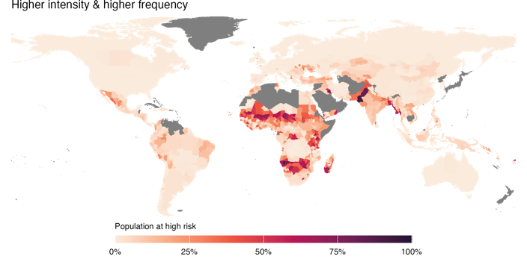
k  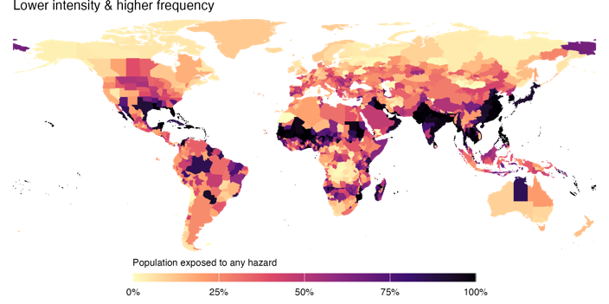 | l  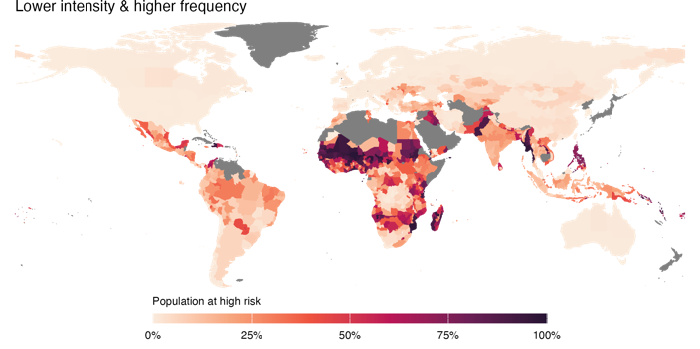

Figure S8: Population at high risk using alternate thresholds – country level comparisons (2021)
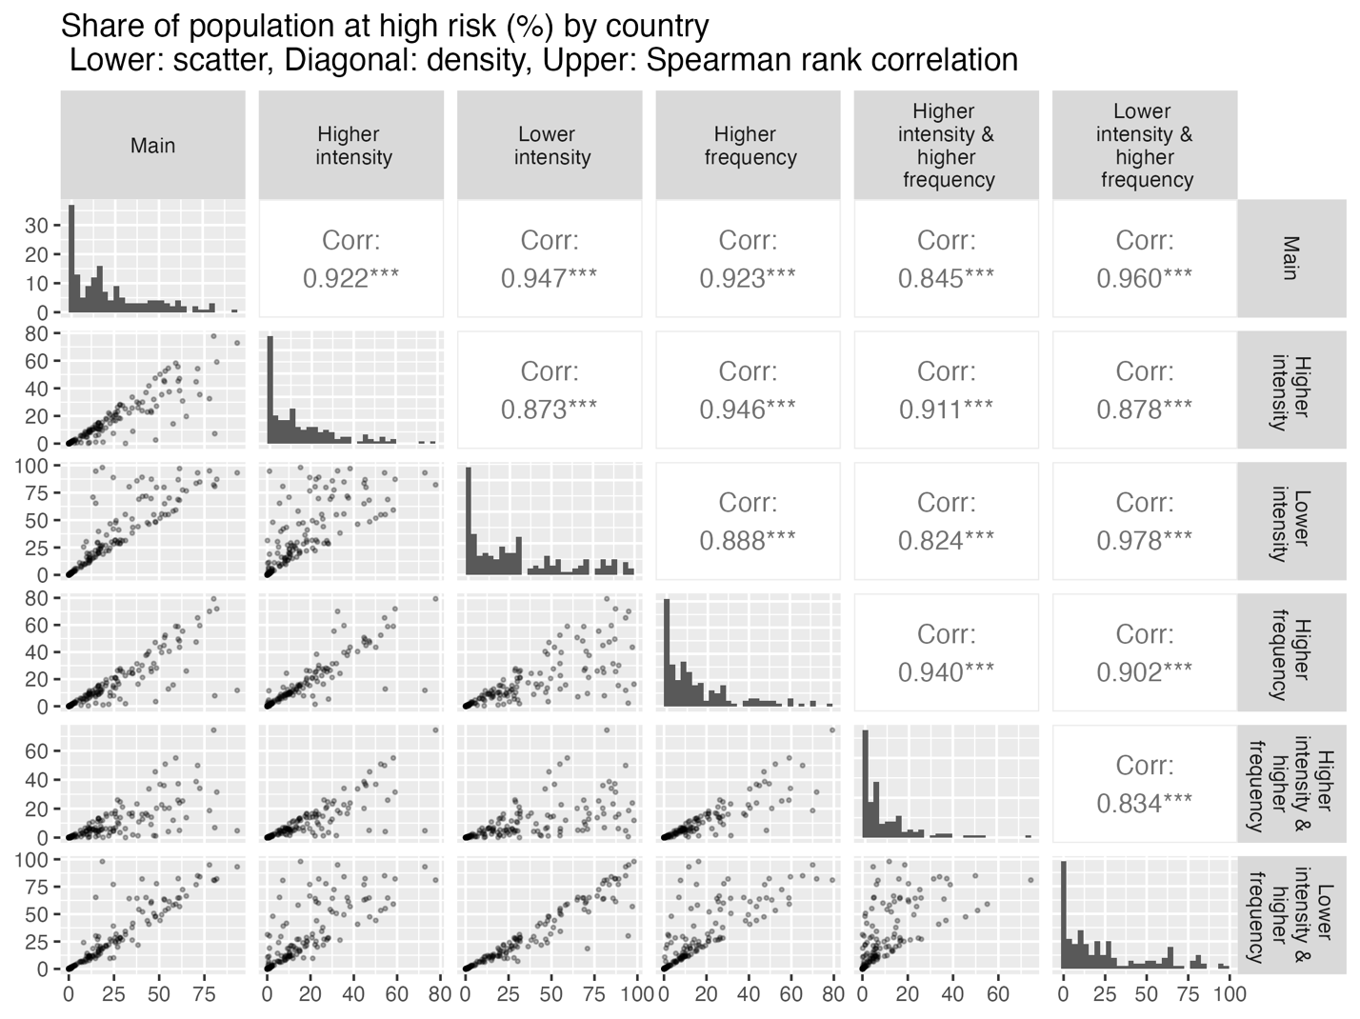

For completeness, we also estimate the share of population exposed to each type of hazard when using a larger range of intensity and frequency thresholds to define exposed locations. Results highlight the different relationships between event intensity, frequency and exposure for each type of hazard. Figure S9 shows exceedance probability curves at global level and Figure S10 maps the population exposed to hazard events exceeding various intensities and annual probabilities of occurrence.
Figure S9: Global population exposed by hazard exceedance probability and intensity threshold (2021)
a  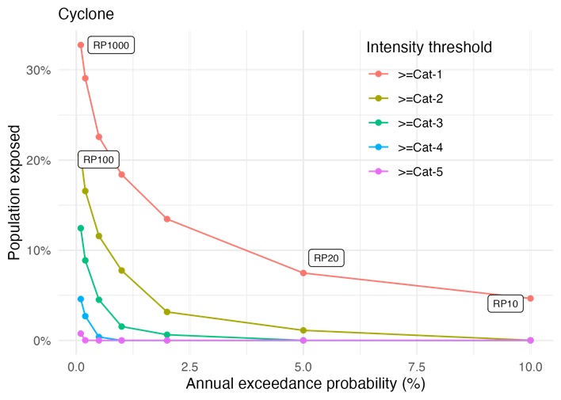 | b  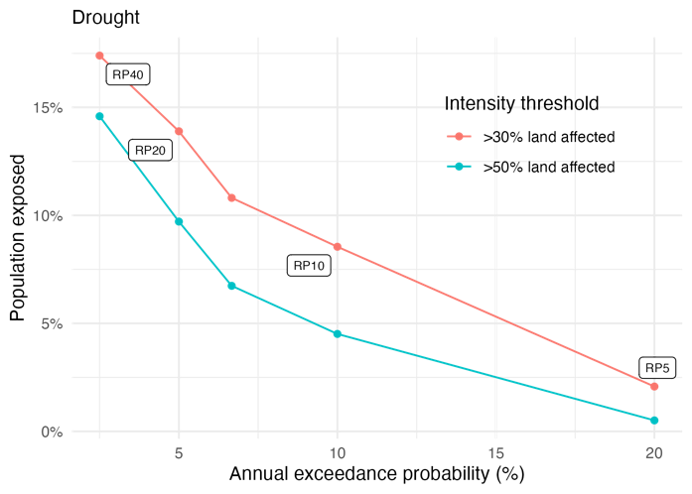
c  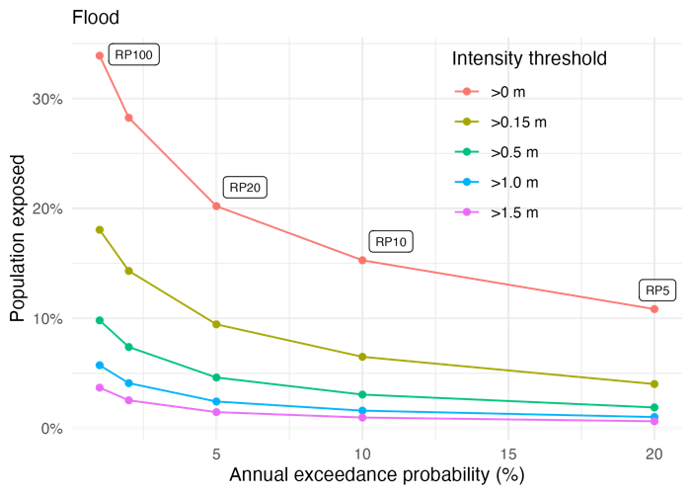 | d  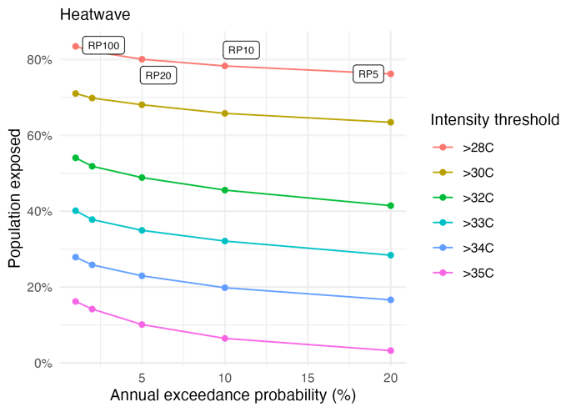

Figure S10: Population exposed to tropical cyclones, by frequency and intensity thresholds
a  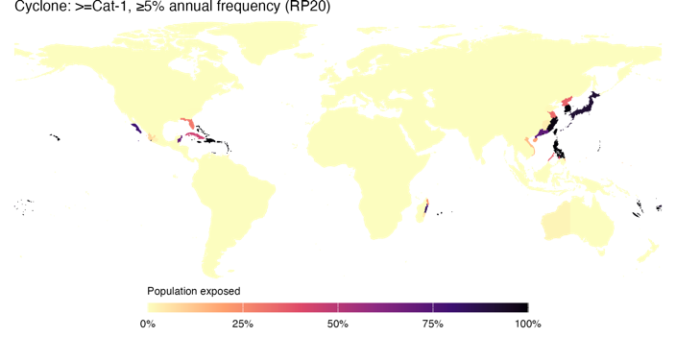 | b  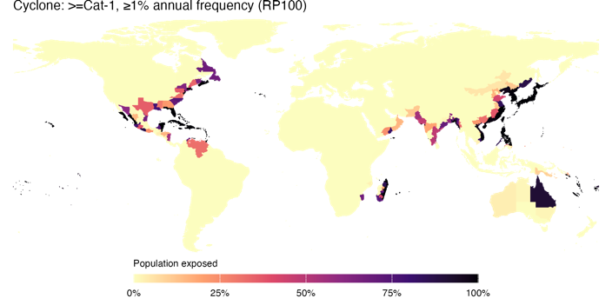 | c  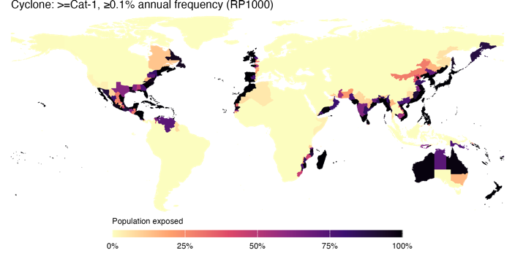
d  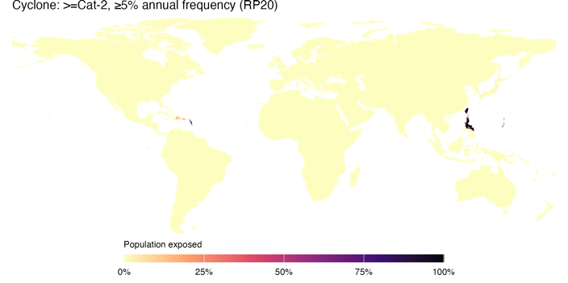 | e  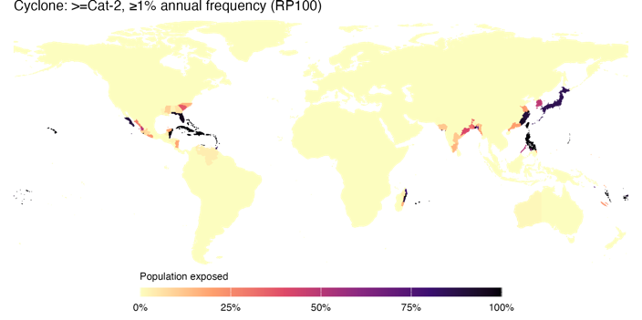 | f  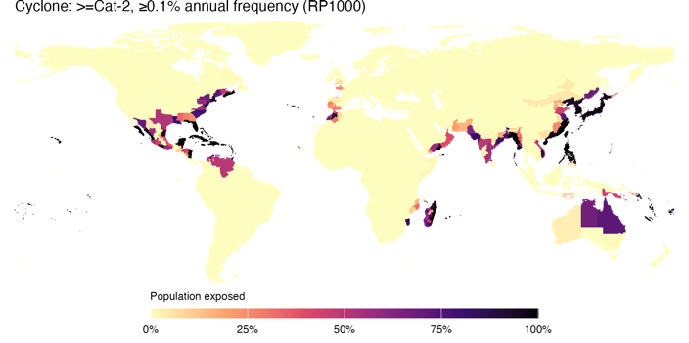
g  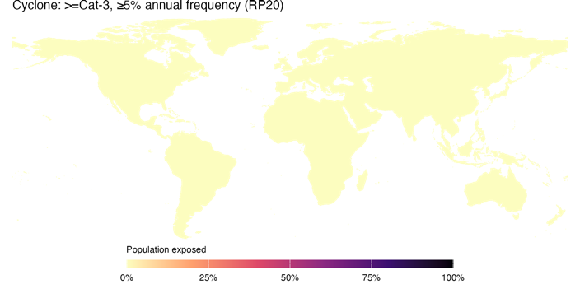 | h  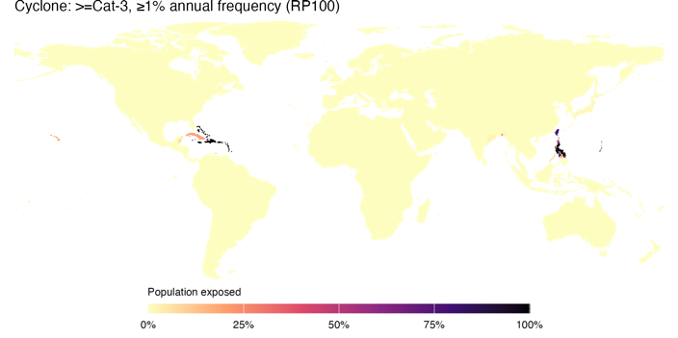 | i  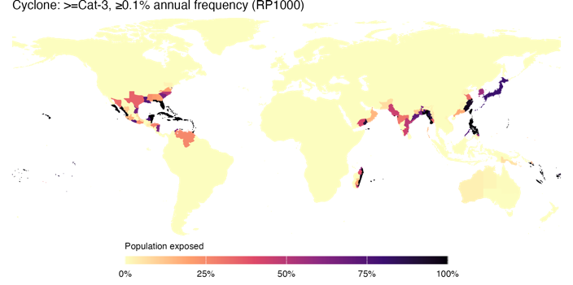

Figure S11: Population exposed to agricultural droughts, by frequency and intensity thresholds
a  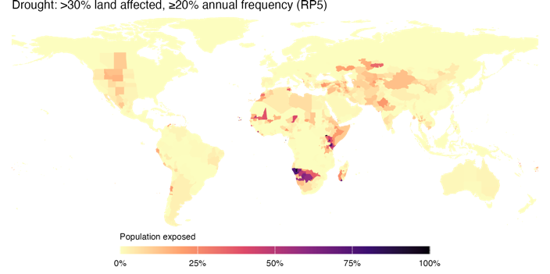 | b  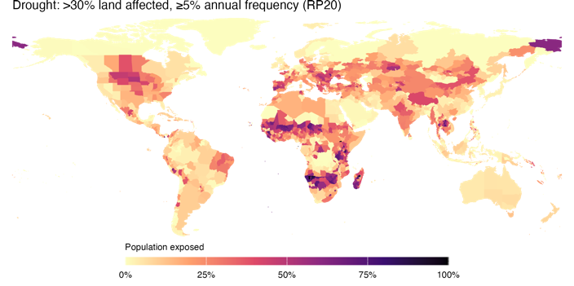 | c  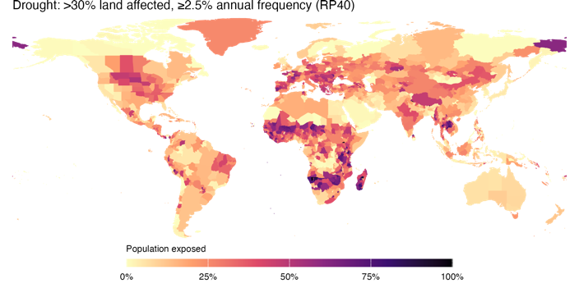
d  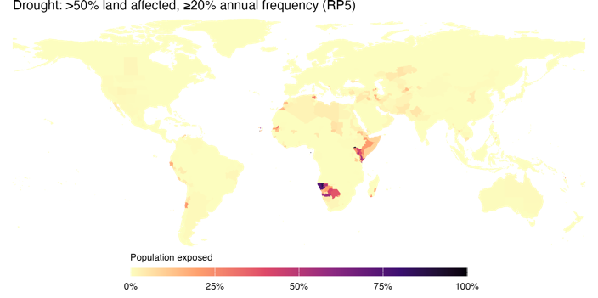 | e  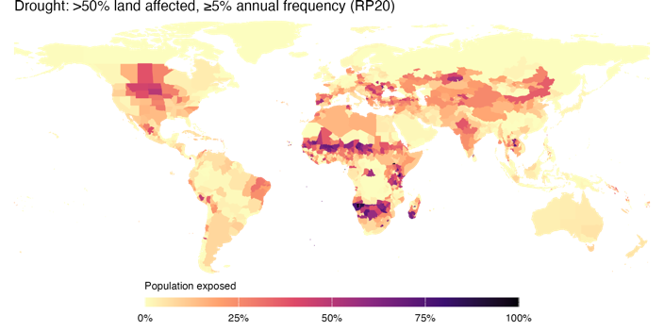 | f  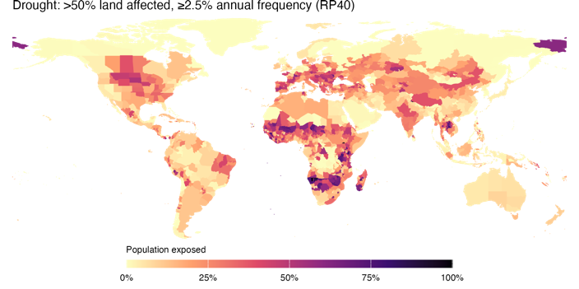

Figure S12: Population exposed to floods, by frequency and intensity thresholds
a  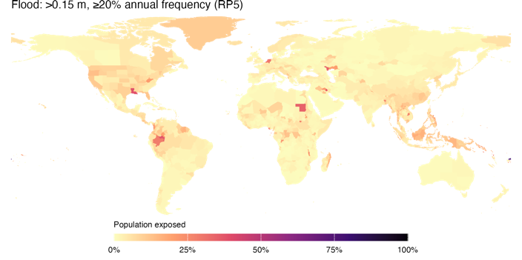 | b  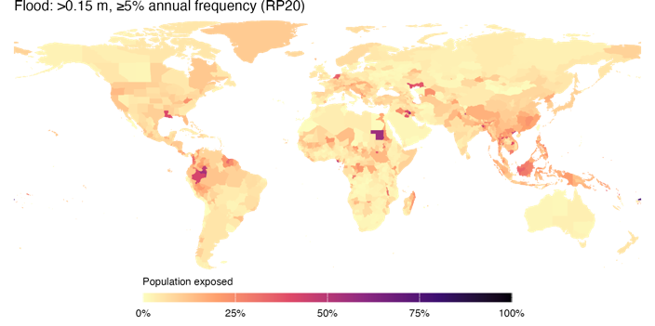 | c  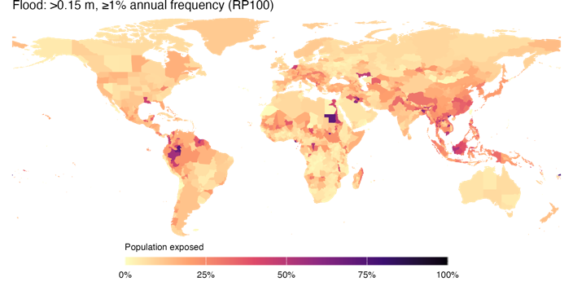
d  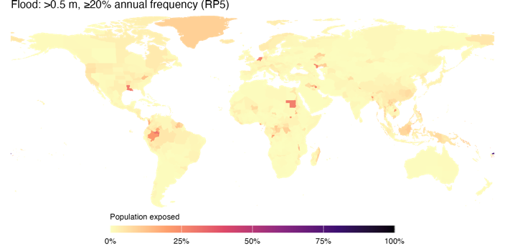 | e  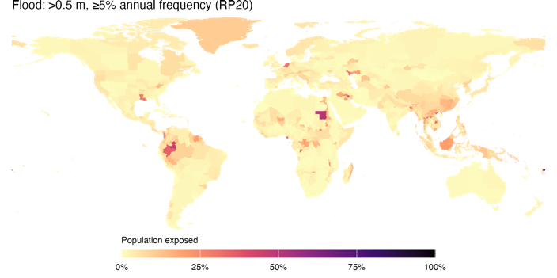 | f  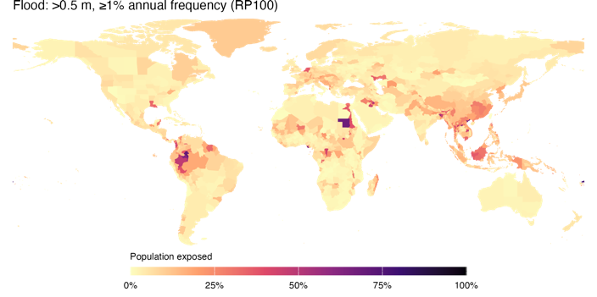
g  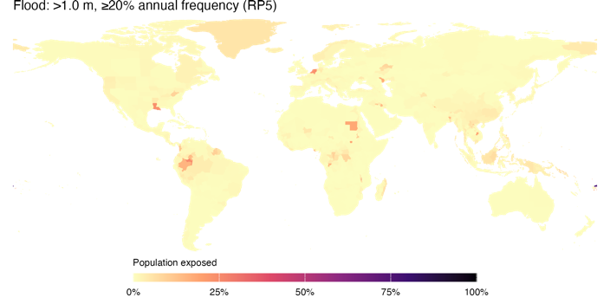 | h  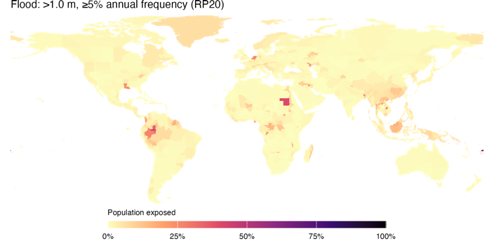 | i  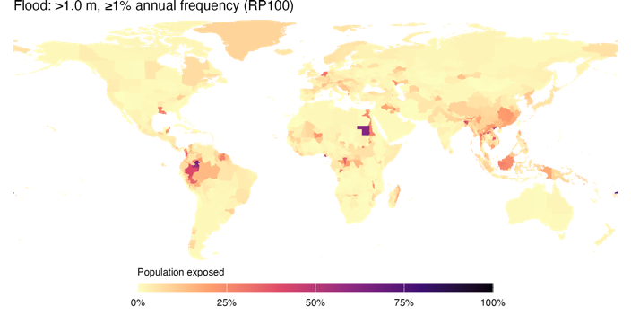

Figure S13: Population exposed to heatwaves, by frequency and intensity thresholds
a  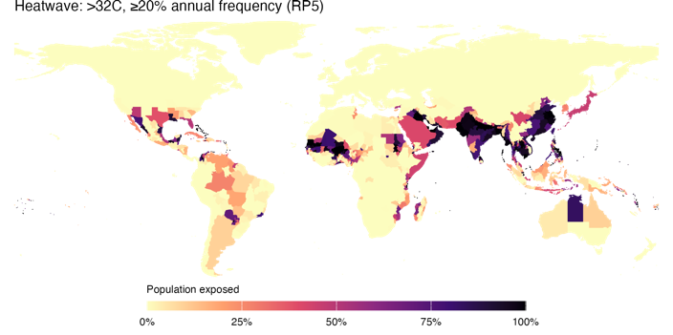 | b  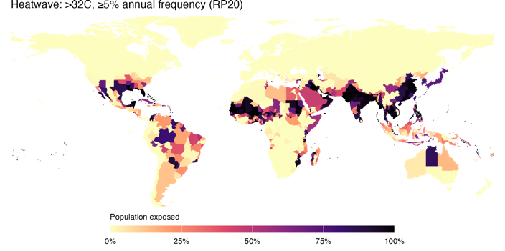 | c  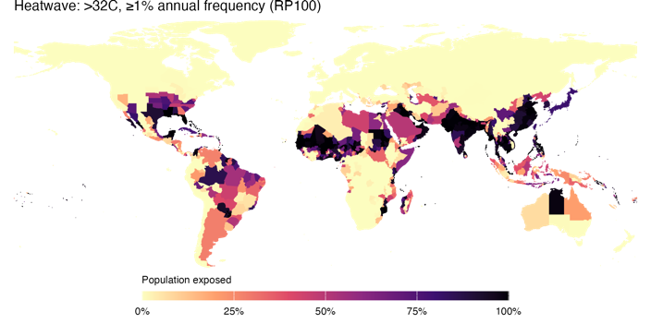
d  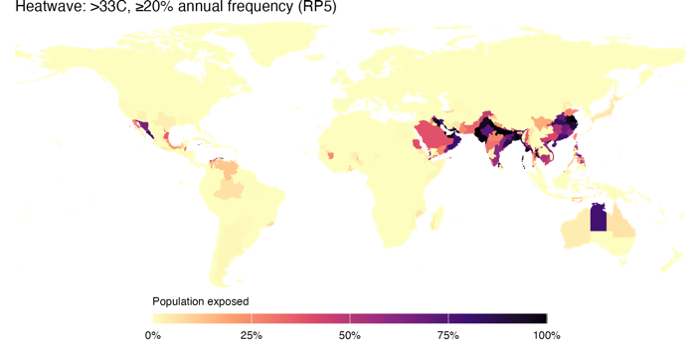 | e  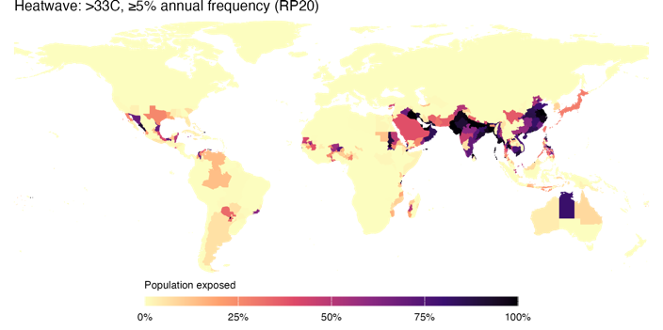 | f  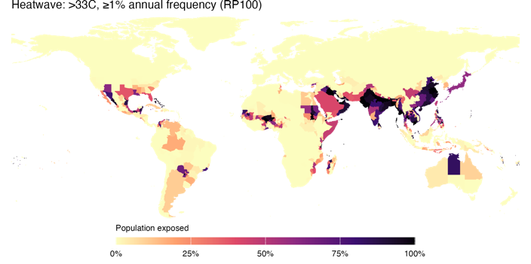
g  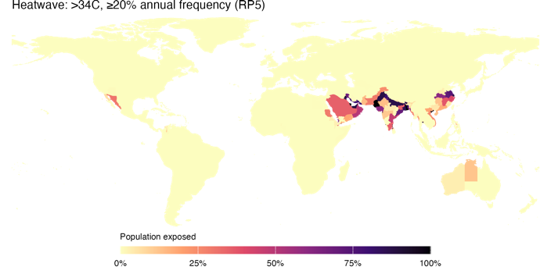 | h  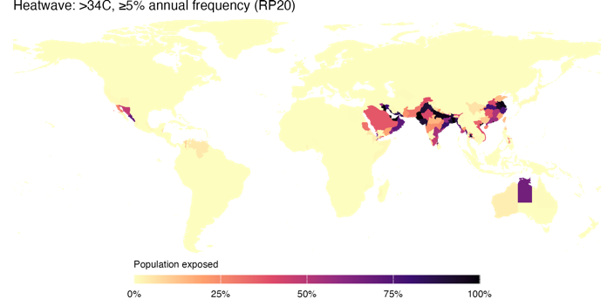 | i  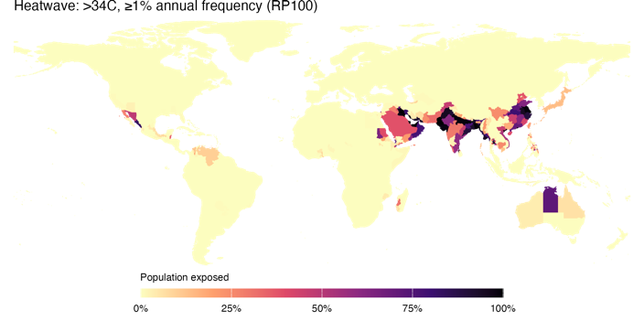

Household surveys
Table S3 lists household surveys from the World Bank’s Global Monitoring Database that were used for the analysis. The lineup year refers to the reference year of the indicator (2010 and 2021 respectively).
Table S3: List of household survey data sources
Lineup year | Country name | Survey year | Survey acronym | Survey title | Survey producer | Sample size
2010 | Albania | 2012 | LSMS | Living Standards Measurement Survey 2012 | Institute of Statistics of Albania | 25,335
2010 | Angola | 2008 | IBEP-MICS | Inquérito Integrado sobre o Bem-Estar da População 2008-2009, IDR II e MICS III | Instituto Nacional de EstatÍstica | 45,398
2010 | Argentina | 2010 | EPHC-S2 | Encuesta Permanente de Hogares Continua - semestre II | Instituto Nacional de Estadãstica y Censos (INDEC) | 118,729
2010 | Armenia | 2010 | ILCS | Integrated Living Conditions Survey 2010 | National Statistical Service of the Republic of Armenia | 32,353
2010 | Australia | 2010 | SIH-HES-LIS | Survey of Income and Housing (SIH) and Household Expenditure Survey (HES) | Australian Bureau of Statistics (ABS) | 42,595
2010 | Austria | 2011 | EU-SILC | European Union Statistics on Income and Living Conditions 2011 | Statistics Austria | 13,933
2010 | Azerbaijan | 2005 | HBS | Household Budget Survey 2005 | State Statistical Committee of the Republic of Azerbaijan | 32,875
2010 | Bangladesh | 2010 | HIES | Household Income and Expenditure Survey 2010 | Bangladesh Bureau of Statistics | 55,580
2010 | Belarus | 2010 | HHS | Household Sample Survey 2010 | National Statistical Committee of the Republic of Belarus | 14,546
2010 | Belgium | 2011 | EU-SILC | European Union Statistics on Income and Living Conditions 2011 | Statistics Belgium - Statbel | 14,300
2010 | Benin | 2011 | EMICOV | Enquête Modulaire Intégrée sur les Conditions de Vie des Ménages 2011 | Institut National de la Statistique et de l'Analyse Économique (INSAE) | 17,974
2010 | Bhutan | 2012 | BLSS | Living Standards Survey 2012 | National Statistics Bureau (NSB) | 40,212
2010 | Bolivia | 2011 | EH | Encuesta de Hogares - MECOVI | Instituto Nacional de Estadãstica | 33,654
2010 | Bosnia and Herzegovina | 2011 | HBS | Household Budget Survey 2011 | Bosnia and Herzegovina Agency for Statistics | 22,853
2010 | Botswana | 2009 | CWIS | Core Welfare Indicators Survey 2009-2010 | Central Statistics Office (CSO) | 27,211
2010 | Brazil | 2011 | PNAD | Pesquisa Nacional por Amostra de Domicilios 2011 | Instituto Brasileiro de Geografia e EstatÍstica | 345,653
2010 | Bulgaria | 2011 | EU-SILC | European Union Statistics on Income and Living Conditions 2011 | National Statistical Institute (NSI) | 17,180
2010 | Burkina Faso | 2009 | ECVM | Enquête Intégrale sur les Conditions de Vie des Ménages Burkinabè en 2009 | Institut National de la Statistique et de la Démographie | 57,155
2010 | Burundi | 2013 | ECVMB | The correct spelling is "Enquête sur les conditions de vie des ménages 2013 | Institut de Statistiques et d’Études Économiques du Burundi (ISTEEBU) | 32,647
2010 | Cabo Verde | 2007 | QUIBB | Questionário Unificado de Indicadores Básicos de Bem-Estar 2007 | Instituto Nacional de EstatÍstica (INE) | 33,756
2010 | Cameroon | 2007 | ECAM-III | Troisième Enquête Camerounaise Auprès des Ménages 2007 | Institut National de la Statistique (INS) | 51,190
2010 | Canada | 2010 | SLID-LIS | Survey of Labour and Income Dynamics (SLID) | Statistics Canada | 60,362
2010 | Central African Republic | 2008 | ECASEB | Enquête Centrafricaine pour le Suivi-Evaluation du Bien-être 2008 | Institut Centrafricain des Statistiques et des Etudes Economiques et Sociales, Ministère du plan, de l'Économie et de la Coopération internationale | 31,966
2010 | Chad | 2011 | ECOSIT-III | Enquête sur la Consommation des Ménages et le Secteur Informel au Tchad 2011 | Institut National de la Statistique, des Etudes Economiques et Démographiques (INSEED) | 49,985
2010 | Chile | 2011 | CASEN | Encuesta de Caracterización Socioeconómica Nacional | Ministerio de Desarrollo Social - Gobierno de Chile | 197,408
2010 | China | 2013 | CHIP | China Household Income Project | National Bureau of Statistics of China, National Bureau of Statistics | 61,162
2010 | Colombia | 2010 | GEIH | Gran Encuesta Integrada de Hogares 2010 | Departamento Administrativo Nacional de Estadistica (DANE) | 814,189
2010 | Comoros | 2013 | EESIC | Enquête sur l’Emploi, le Secteur Informel et la Consommation des Ménages aux Comores 2014 | Direction de la Statistique | 10,671
2010 | Congo, Dem. Rep. | 2012 | E123 | Enquête sur l’Emploi, le Secteur Informel et sur la Consommation des Ménages 2012, Enquête 1-2-3 | Institut National de la Statistique (INS) | 110,529
2010 | Congo, Rep. | 2011 | ECOM | Enquête Congolaise Auprès des Ménages pour le Suivi et l'Evaluation de la Pauvreté 2011 | Centre National de la Statistique et des Études Économiques (CNSEE) | 44,736
2010 | Costa Rica | 2010 | ENAHO | Encuesta Nacional de Hogares 2010, Julio | Instituto Nacional de Estadãstica y Censos (INEC) | 41,098
2010 | Croatia | 2011 | EU-SILC | European Union Statistics on Income and Living Conditions 2011 | Croatian Bureau of Statistics - CBS | 16,896
2010 | Cyprus | 2011 | EU-SILC | European Union Statistics on Income and Living Conditions 2011 | The Statistical Service of Cyprus | 11,443
2010 | Czech Republic | 2011 | EU-SILC | European Union Statistics on Income and Living Conditions 2011 | Czech Statistical Office | 20,629
2010 | Côte d'Ivoire | 2008 | ENV | Enquête sur le Niveau de Vie des Ménages 2008 | Institut National de la Statistique | 59,083
2010 | Denmark | 2011 | EU-SILC | European Union Statistics on Income and Living Conditions 2011 | Statistics Denmark | 13,151
2010 | Djibouti | 2012 | EDAM | Enquête Djiboutienne Auprès des Ménages | Direction de la Statistique et des Etudes Démographiques (DISED) | 31,683
2010 | Dominican Republic | 2010 | ENFT | Encuesta Nacional de Fuerza de Trabajo | Banco Central de la República Dominicana | 29,901
2010 | Ecuador | 2010 | ENEMDU | Encuesta de Empleo, Desempleo y Subempleo | Instituto Nacional de Estadãstica y Censo (INEC) | 82,356
2010 | Egypt, Arab Rep. | 2010 | HIECS | Household Income, Expenditure, and Consumption Survey 2010 | Central Agency for Public Mobilization and Statistics | 34,069
2010 | El Salvador | 2010 | EHPM | Encuesta de Hogares de Propósitos Múltiples | Dirección General de Estadãstica y Censos (DIGESTYC) | 85,087
2010 | Estonia | 2011 | EU-SILC | European Union Statistics on Income and Living Conditions 2011 | Statistics Estonia | 13,426
2010 | Eswatini | 2009 | HIES | Household Income and Expenditure Survey 2009-2010 | Central Statistical Office | 14,145
2010 | Ethiopia | 2010 | HICES | Household Income, Consumption and Expenditure Survey 2010-2011 | Central Statistical Agency (CSA) - Ministry of Finance and Economic Development | 118,991
2010 | Fiji | 2008 | HIES | Household Income and Expenditure Survey 2008-2009 | Fiji Islands Bureau of Statistics (FIBoS) - Government of Fiji | 16,814
2010 | Finland | 2011 | EU-SILC | European Union Statistics on Income and Living Conditions 2011 | Statistics Finland | 23,018
2010 | France | 2011 | EU-SILC | European Union Statistics on Income and Living Conditions 2011 | INSEE - National Institute for Statistics and Economic Studies | 27,071
2010 | Gabon | 2005 | EGEP | Enquête Gabonaise pour l'Evaluation et le Suivi de la Pauvreté 2005 | Direction Générale de la Statistique et des Etudes Economiques (DGSEE) | 37,601
2010 | Gambia, The | 2010 | IHS | Integrated Household Survey 2010 | The Gambia Bureau of Statistics | 37,224
2010 | Georgia | 2010 | HIS | Household Integrated Survey 2010 | National Statistics Office of Georgia | 79,471
2010 | Germany | 2010 | GSOEP-LIS | German Social Economic Panel Study (GSOEP) | German Institute for Economic Research / Deutsches Institut für Wirtschaftsforschung (DIW) | 44,134
2010 | Ghana | 2012 | GLSS-VI | Ghana Living Standards Survey 6 | Ghana Statistical Service | 72,372
2010 | Greece | 2011 | EU-SILC | European Union Statistics on Income and Living Conditions 2011 | Hellenic Statistical Authority (ELSTAT) | 15,067
2010 | Grenada | 2018 | SLCHB | Survey of Living Conditions and Household Budgets 2018 | Central Statistics Office of Grenada | 2,256
2010 | Guatemala | 2014 | ENCOVI | Encuesta Nacional de Condiciones de Vida | Instituto Nacional de Estadãstica de Guatemala | 54,688
2010 | Guinea | 2012 | ELEP | Enquête Légère pour l'Evaluation de la Pauvreté 2012 | Institut National de la Statistique | 49,572
2010 | Guinea-Bissau | 2010 | ILAP-II | Inquerito Ligeiro para a Avaliação da Pobreza 2010 | Instituto Nacional de EstatÍstica e Censos (INEC) | 26,134
2010 | Haiti | 2012 | ECVMAS | Enquête sur les Conditions de Vie des Ménages après Séisme 2012 | Haitian Institute of Statistics and Information (IHSI) | 23,398
2010 | Honduras | 2010 | EPHPM | Encuesta Permanente de Hogares de Propósitos Múltiples | Instituto Nacional de Estadãstica de Honduras | 31,724
2010 | Hungary | 2011 | EU-SILC | European Union Statistics on Income and Living Conditions 2011 | Hungarian Central Statistical Office | 29,474
2010 | Iceland | 2011 | EU-SILC | European Union Statistics on Income and Living Conditions 2011 | Statistics Iceland | 8,851
2010 | India | 2011 | NSS-SCH1 | National Sample Survey 2011-2012 (68th round) | National Sample Survey Organisation (NSSO) | 464,960
2010 | Indonesia | 2010 | SUSENAS | National Socio-Economic Survey 2010 | Central Bureau of Statistics (BPS) of Indonesia | 262,901
2010 | Iran, Islamic Rep. | 2009 | HEIS | Households Income and Expenditure Survey 2009-2010 | Statistical Center of Iran | 150,462
2010 | Iraq | 2012 | IHSES | Household Socio-Economic Survey 2012 | Organization for Statistics and Information Technology (COSIT), Kurdistan Regional Statistics Office (KRSO) | 174,863
2010 | Ireland | 2011 | EU-SILC | European Union Statistics on Income and Living Conditions 2011 | Central Statistics Office Ireland | 11,005
2010 | Israel | 2010 | HES-LIS | Household Expenditure Survey | National Insurance Institute of Israel | 20,137
2010 | Italy | 2011 | EU-SILC | European Union Statistics on Income and Living Conditions 2011 | Italian National Institute of Statistics | 47,841
2010 | Japan | 2010 | JHPS-LIS | Japan Household Panel Survey Data (JHPS) | Keio University Joint Research Center for Panel Studies | 20,101
2010 | Jordan | 2010 | HEIS | Household Expenditure and Income Survey 2010 | Department of Statistics (DoS) | 61,051
2010 | Kazakhstan | 2010 | HBS | Household Budget Survey 2010 | The Agency of Statistics of the Republic of Kazakhstan | 167,313
2010 | Kenya | 2015 | IHBS | Integrated Household Budget Survey 2015-2016 | Kenya National Bureau of Statistics | 92,846
2010 | Kiribati | 2006 | HIES | Household Income and Expenditure Survey 2006 | National Statistical Office | 6,725
2010 | Korea, Rep. | 2010 | HIES-FHES-LIS | Household Income and Expenditure Survey (HIES) and Farm Household Income and Expenditure Survey (FHES) | Statistics Korea | 37,823
2010 | Kosovo | 2010 | HBS | Household Budget Survey 2010 | Kosovo Agency of Statistics | 13,721
2010 | Kyrgyz Republic | 2010 | KIHS | Kyrgyz Integrated Household Survey 2010 | National Statistical Committee of the Kyrgyz Republic | 73,865
2010 | Lao PDR | 2012 | LECS | Expenditure and Consumption Survey 2012-2013 | Lao Statistics Bureau | 43,641
2010 | Latvia | 2011 | EU-SILC | European Union Statistics on Income and Living Conditions 2011 | Central Statistical Bureau of Latvia | 15,891
2010 | Lebanon | 2011 | HBS | Household Budget Survey 2011-2012 | Central Administration for Statistics | 11,535
2010 | Lesotho | 2017 | CMSHBS | Continuous Multipurpose Household Survey/ Household Budget Survey 2017 - 2018 | Bureau of Statistics (BoS) - Ministry of Finsnce and development Planning | 17,288
2010 | Liberia | 2007 | CWIQ | Core Welfare Indicators Questionnaire 2007 | Liberia Institute of Statistics and Geo_Information Services | 20,034
2010 | Lithuania | 2011 | EU-SILC | European Union Statistics on Income and Living Conditions 2011 | Statistics Lithuania | 12,492
2010 | Luxembourg | 2011 | EU-SILC | European Union Statistics on Income and Living Conditions 2011 | Luxembourg Institute of Socio-Economic Research (LISER) | 14,891
2010 | Madagascar | 2010 | EPM | Enquête Périodique auprès des Ménages 2010 | Institut National de la Statistique de Madagascar | 59,374
2010 | Malawi | 2010 | IHS-III | Third Integrated Household Survey 2010-2011 | National Statistical Office (NSO) | 54,664
2010 | Malaysia | 2012 | HIS | Household Income/Basic Amenities Survey | Department of Statistics | 185,911
2010 | Maldives | 2009 | HIES | Household Income and Expenditure Survey 2009-2010 | Department of National Planning | 11,565
2010 | Mali | 2009 | ELIM | Enquête Légère Intégrée auprès des Ménages 2009 | Direction Nationale de la Statistique et Information | 86,936
2010 | Malta | 2011 | EU-SILC | European Union Statistics on Income and Living Conditions 2011 | National Statistics Office - Malta | 11,207
2010 | Marshall Islands | 2019 | HIES | Household Income and Expenditure Survey 2019/2020 | National Statistical Office | 4,769
2010 | Mauritania | 2008 | EPCV | Enquête Permanente sur les Conditions de Vie des Ménages 2008 | Office National de la Statistique | 74,801
2010 | Mauritius | 2012 | HBS | Household Budget Survey 2012 | Central Statistics Office | 23,741
2010 | Mexico | 2010 | ENIGH | Encuesta Nacional de Ingresos y Gastos de los Hogares 2010 (Tradicional) | Instituto Nacional de Estadãstica, Geografía e Informática (INEGI) | 105,146
2010 | Micronesia, Fed. Sts. | 2013 | HIES | Household Income and Expenditure Survey 2013 | Divison of Statistics - Office of Statistics, Budget and Economic Management, Overseas Development Assistance and Compact Management (SBOC) | 9,934
2010 | Moldova | 2010 | HBS | Household Budget Survey 2010 | National Bureau of Statistics of the Republic of Moldova | 14,379
2010 | Mongolia | 2010 | HSES | Household Socio Economic Survey 2010 | National Statistical Office | 43,355
2010 | Montenegro | 2013 | SILC-C | Survey on Income and Living Conditions 2013 | Statistical Office of Montenegro | 11,725
2010 | Morocco | 2013 | ENCDM | Enquête Nationale sur la Consommation et les Dépenses des Ménages 2013-2014 | Direction de la statistique | 75,691
2010 | Mozambique | 2008 | IOF | Inquérito sobre Orçamento Familiar 2008-2009 | Direcção de Censos e Inquéritos | 51,177
2010 | Myanmar | 2015 | MPLCS | Myanmar Poverty and Living Conditions Survey 2015 | National Statistics Office, Myanmar | 16,651
2010 | Namibia | 2009 | NHIES | National Household Income and Expenditure Survey - NHIES | Central Bureau of Statistics National Planning Commission | 44,614
2010 | Nauru | 2012 | HIES | Household Income and Expenditure Survey 2012/2013 | Bureau of Statistics, Department of Finance | 3,150
2010 | Nepal | 2010 | LSS-III | Living Standards Survey 2010-2011, Third Round | Central Bureau of Statistics | 28,474
2010 | Netherlands | 2011 | EU-SILC | European Union Statistics on Income and Living Conditions 2011 | Statistics Netherlands | 25,461
2010 | Nicaragua | 2009 | EMNV | Encuesta Nacional de Hogares sobre Medición de Nivel de Vida | Instituto Nacional de Estadãsticas, Geografía e Informática (INIDE) | 30,189
2010 | Niger | 2011 | ECVMA | National Survey on Household Living Conditions and Agriculture 2011 | Survey and Census Division, National Institute of Statistics | 24,791
2010 | Nigeria | 2010 | GHSP-W1 | General Household Survey, Panel 2010-2011, Wave 1 | National Bureau of Statistics (NBS) | 55,782
2010 | North Macedonia | 2011 | SILC-C | Survey of Income and Living Conditions 2011 | State Statistical Office of the Republic of Macedonia | 15,328
2010 | Norway | 2011 | EU-SILC | European Union Statistics on Income and Living Conditions 2011 | Statistics Norway | 11,730
2010 | Pakistan | 2010 | HIES | Household Integrated Economic Survey (HIES) 2010-2011 | Federal Bureau of Statistics | 108,931
2010 | Panama | 2010 | EH | Encuesta de Mercado Laboral 2010 | Instituto Nacional de Estadãstica y Censos | 48,759
2010 | Papua New Guinea | 2009 | HIES | Household Income and Expenditure Survey 2009-2010 | National Statistical Office | 20,369
2010 | Paraguay | 2010 | EPH | Encuesta Permanente de Hogares | Dirección General de Estadãstica, Encuestas y Censos | 20,316
2010 | Peru | 2010 | ENAHO | Encuesta Nacional de Hogares sobre Condiciones de Vida y Pobreza 2010 | Instituto Nacional de Estadãstica e Informática (INEI) | 87,428
2010 | Philippines | 2009 | FIES | Family Income and Expenditure Survey 2009 | Philippine Statistics Authority | 186,826
2010 | Poland | 2011 | EU-SILC | European Union Statistics on Income and Living Conditions 2011 | Central Statistical Office of Poland | 36,720
2010 | Portugal | 2011 | EU-SILC | European Union Statistics on Income and Living Conditions 2011 | Statistics Portugal | 14,662
2010 | Romania | 2011 | EU-SILC | European Union Statistics on Income and Living Conditions 2011 | National Institute of Statistics - NIS | 17,864
2010 | Russian Federation | 2010 | HBS | Household Budget Survey 2010 | Federal State Statistics Service of the Russian Federation | 540,091
2010 | Rwanda | 2010 | EICV-III | Integrated Household Living Conditions Survey 2010-2011 | National Institute of Statistics of Rwanda (NISR) | 67,415
2010 | Samoa | 2008 | HIES | Household Income and Expenditure Survey 2008 | Bureau of Statistics - Government of Samoa | 14,651
2010 | Senegal | 2011 | ESPS-II | Enquête de Suivi de la Pauvreté au Sénégal 2011 | Agence Nationale de la Statistique et de la Démographie | 55,017
2010 | Serbia | 2010 | HBS | Household Budget Survey 2010 | Statistical Office of the Republic of Serbia | 13,547
2010 | Seychelles | 2013 | HBS | Household Budget Survey 2013 | National Bureau of Statistics | 6,514
2010 | Sierra Leone | 2011 | SLIHS | Integrated Household Survey 2011 | Statistics Sierra Leone (SSL) | 37,921
2010 | Slovak Republic | 2011 | EU-SILC | European Union Statistics on Income and Living Conditions 2011 | Statistical Office of the Slovak Republic | 15,335
2010 | Slovenia | 2011 | EU-SILC | European Union Statistics on Income and Living Conditions 2011 | Statistical Office of the Republic of Slovenia | 28,747
2010 | Solomon Islands | 2012 | HIES | Household Income and Expenditure Survey 2012-2013 | Solomon Islands Statistics Office (SISO) - Ministry of Finance - Government of Solomon Islands | 25,110
2010 | South Africa | 2010 | IES | Income and Expenditure Survey 2010-2011 | Statistics South Africa | 95,042
2010 | South Sudan | 2009 | NBHS | National Baseline Household Survey 2009, First Round | Southern Sudan Center for Census, Statistics and Evaluation | 33,660
2010 | Spain | 2011 | EU-SILC | European Union Statistics on Income and Living Conditions 2011 | National Statistics Institute (INE-Spain) | 34,756
2010 | Sri Lanka | 2009 | HIES | Household Income and Expenditure Survey 2009-2010 | Department of Census and Statistics | 80,872
2010 | St. Lucia | 2015 | SLCHBS | Survey of Living Conditions and Household Budgets 2015-2016 | Central Statistical Office of Saint Lucia | 4,569
2010 | Sudan | 2009 | NBHS | National Baseline Household Survey 2009 | Central Bureau of Statistics (CBS), Southern Sudan Centre for Census Statistics and Evaluation (SSCCSE) | 48,822
2010 | Sweden | 2011 | EU-SILC | European Union Statistics on Income and Living Conditions 2011 | Statistics Sweden | 16,665
2010 | Switzerland | 2011 | EU-SILC | European Union Statistics on Income and Living Conditions 2011 | Swiss Federal Statistical Office | 17,602
2010 | São Tomé and Príncipe | 2010 | IOF | Inquérito Orçamento Familiar 2010 | Instituto Nacional de EstatÍsticas | 13,757
2010 | Taiwan, China | 2010 | FIDES-LIS | Survey of Family Income and Expenditure, Taiwan Area | Directorate General of Budget, Accounting and Statistics (DGBAS) | 47,900
2010 | Tajikistan | 2009 | TLSS | Living Standards Survey 2009 | Statistical Agency under President of the Republic of Tajikistan - TAJSTAT | 10,069
2010 | Tanzania | 2011 | HBS | Household Budget Survey 2011-2012 | National Bureau of Statistics (NBS) | 46,593
2010 | Thailand | 2010 | SES | Household Socio-Economic Survey and Village/Community Fund Survey 2010 | National Statistical Office, Social Statistics Bureau | 137,976
2010 | Timor-Leste | 2007 | TLSLS | Survey of Living Standards 2007 and Extension 2008 | National Statistics Directorate | 25,000
2010 | Togo | 2011 | QUIBB | Questionnaire des Indicateurs de Base du Bien-être 2011 | Direction Générale de la Statistique et de la Comptabilité Nationale | 29,676
2010 | Tonga | 2009 | HIES | Household Income and Expenditure Survey 2009 | Statistics Department - Government of The Kingdom of Tonga | 10,168
2010 | Tunisia | 2010 | NSHBCSL | Enquête Nationale sur le Budget, la Consommation et le Niveau de Vie des Ménages 2010 | Institut National de la Statistique - Ministère de la Planification et de la Coopération Internationale | 50,371
2010 | Tuvalu | 2010 | HIES | Household Income and Expenditure 2010 | Central Statistics Division - Ministry of Finance and Economic Development - Government of Tuvalu | 2,927
2010 | Türkiye | 2010 | HICES | Household Income and Consumption Expenditures Survey 2010 | Turkish Statistical Institute | 38,198
2010 | Uganda | 2009 | UNHS | National Household Survey 2009-2010 | Uganda Bureau of Statistics (UBOS) | 6,775
2010 | Ukraine | 2010 | HLCS | Household Living Conditions Survey 2010 | State Statistics Committee of Ukraine | 25,095
2010 | United Kingdom | 2010 | FRS-LIS | Family Resources Survey (FRS) | Department for Work and Pensions (DWP) | 57,928
2010 | United States | 2010 | CPS-ASEC-LIS | Current Population Survey – ASEC (Annual Social and Economic Supplement) | U.S. Census Bureau | 204,342
2010 | Uruguay | 2010 | ECH | Encuesta Continua de Hogares | Instituto Nacional de Estadãstica (INE) | 131,943
2010 | Uzbekistan | 2003 | HBS | Household Budget Survey 2003 | The State Committee of the Republic of Uzbekistan on Statistics | 49,307
2010 | Vanuatu | 2010 | HIES | Household Income and Expenditure Survey 2010 | Vanuatu National Statistics Office | 20,337
2010 | Viet Nam | 2010 | VHLSS | Vietnam Household Living Standards Survey 2010 | General Statistics Office (GSO) | 36,999
2010 | West Bank and Gaza | 2010 | PECS | Palestinian Expenditure and Consumption Survey 2010 | Palestinian Central Bureau of Statistics | 22,605
2010 | Yemen, Rep. | 2014 | HBS | Household Budget Survey 2014 | Central Statistical Organization of the Republic of Yemen | 67,178
2010 | Zambia | 2010 | LCMS-VI | Living Conditions Monitoring Survey VI 2010 | Central Statistical Office (CSO) | 19,376
2010 | Zimbabwe | 2017 | PICES | Poverty, Income, Consumption and Expenditure Survey 2017 | The Zimbabwe National Statistics Agency (ZIMSTAT) | 130,074
2021 | Albania | 2020 | HBS | Household Budget Survey 2020 | Institute of Statistics of Albania | 18,771
2021 | Angola | 2018 | IDREA | Inquérito Sobre Despesas, Receitas e Emprego 2018-2019 | Instituto Nacional de EstatÍstica (INE) | 60,504
2021 | Argentina | 2021 | EPHC-S2 | Encuesta Permanente de Hogares Continua - semestre II | Instituto Nacional de Estadãstica y Censos (INDEC) | 98,794
2021 | Armenia | 2021 | ILCS | Integrated Living Conditions Survey 2021 | National Statistical Service of the Republic of Armenia | 17,194
2021 | Australia | 2018 | SIH-LIS | Survey of Income and Housing Costs and Amenities | Australian Bureau of Statistics (ABS) | 33,439
2021 | Austria | 2021 | EU-SILC | European Union Statistics on Income and Living Conditions 2021 | Statistics Austria | 12,340
2021 | Azerbaijan | 2005 | HBS | Household Budget Survey 2005 | State Statistical Committee of the Republic of Azerbaijan | 32,875
2021 | Bangladesh | 2022 | HIES | Household Income and Expenditure Survey 2022 | Bangladesh Bureau of Statistics (BBS) | 61,849
2021 | Belarus | 2020 | HHS | Household Sample Survey 2020 | National Statistical Committee of the Republic of Belarus | 13,461
2021 | Belgium | 2021 | EU-SILC | European Union Statistics on Income and Living Conditions 2021 | Statistics Belgium - Statbel | 16,919
2021 | Benin | 2021 | EHCVM | Enquête Harmonisee sur les Conditions de Vie des Menages | Institut National de la Statistique et de l’Analyse Économique (INSAE) | 48,798
2021 | Bhutan | 2022 | BLSS | Living Standards Survey 2022 | National Statistics Bureau (NSB) | 52,822
2021 | Bolivia | 2021 | EH | Encuesta de Hogares 2021 | Instituto Nacional de Estadãstica | 41,984
2021 | Bosnia and Herzegovina | 2011 | HBS | Household Budget Survey 2011 | Bosnia and Herzegovina Agency for Statistics | 22,853
2021 | Botswana | 2015 | BMTHS | Multi-Topic Household Survey 2015 - 2016 | Statistics Botswana | 24,714
2021 | Brazil | 2021 | PNADC-E5 | Pesquisa Nacional por Amostra de Domicilios Continua - entrevista 5 | Instituto Brasileiro de Geografia e EstatÍstica | 334,253
2021 | Bulgaria | 2021 | EU-SILC | European Union Statistics on Income and Living Conditions 2021 | National Statistical Institute (NSI) | 17,249
2021 | Burkina Faso | 2021 | EHCVM | Enquête Harmonisee sur les Conditions de Vie des Menages | Institut National de la Statistique et de la Démographie | 47,090
2021 | Burundi | 2020 | EICVMB | Enquête intégrée sur les conditions de vie des ménages du Burundi (EICVMB, 2020-2021) | Institut de Statistiques et d’Études Économiques du Burundi (ISTEEBU) | 40,073
2021 | Cabo Verde | 2015 | IDRF | Inquérito às Despesas e Receitas Familiares 2014-2015 | Instituto Nacional de EstatÍstica de Cabo Verde | 24,395
2021 | Cameroon | 2021 | ECAM-V | Cinquième Enquête Camerounaise Auprès des Ménages 2021-2022 | Institut National de la Statistique | 49,244
2021 | Canada | 2019 | CIS-LIS | Canadian Income Survey (CIS) | Statistics Canada | 72,354
2021 | Central African Republic | 2021 | EHCVM | Enquête Harmonisée sur les Conditions de Vie des Ménages 2021 | Institut Centrafricain des Statistiques et des Etudes Economiques et Sociales, Ministère du plan, de l'Économie et de la Coopération internationale | 32,368
2021 | Chad | 2022 | EHCVM | Enquête Harmonisee sur les Conditions de Vie des Menages | Institut National de la Statistique, des Etudes Economiques et Démographiques (INSEED) | 45,060
2021 | Chile | 2022 | CASEN | Encuesta de Caracterización Socioeconómica Nacional en Pandemia | Ministerio de Desarrollo Social - Gobierno de Chile | 198,133
2021 | China | 2018 | CHIP | China Household Income Project | National Bureau of Statistics of China, National Bureau of Statistics | 71,266
2021 | Colombia | 2021 | GEIH | Gran Encuesta Integrada de Hogares 2021 | Departamento Administrativo Nacional de Estadistica (DANE) | 709,694
2021 | Comoros | 2013 | EESIC | Enquête sur l'Emploi, le Secteur Informel et la Consommation des Ménages aux Comores 2014 | Direction de la Statistique | 10,671
2021 | Congo, Dem. Rep. | 2020 | EGI-ODD | Enquête par Grappes à Indicateurs des ODD (EGI-ODD) | Observatoire Congolais du Développement Durable (OCDD) en collaboration avec Institut National de la Statistique (INS) | 52,199
2021 | Congo, Rep. | 2011 | ECOM | Enquête Congolaise Auprès des Ménages pour le Suivi et l'Évaluation de la Pauvreté 2011 | Centre National de la Statistique et des Études Économiques (CNSEE) | 44,736
2021 | Costa Rica | 2021 | ENAHO | Encuesta Nacional de Hogares 2021, Julio | Instituto Nacional de Estadãstica y Censos (INEC) | 31,918
2021 | Croatia | 2021 | EU-SILC | European Union Statistics on Income and Living Conditions 2021 | Croatian Bureau of Statistics - CBS | 19,331
2021 | Cyprus | 2021 | EU-SILC | European Union Statistics on Income and Living Conditions 2021 | The Statistical Service of Cyprus | 10,605
2021 | Czech Republic | 2021 | EU-SILC | European Union Statistics on Income and Living Conditions 2021 | Czech Statistical Office | 18,595
2021 | Côte d'Ivoire | 2021 | EHCVM | Enquête Harmonisee sur les Conditions de Vie des Menages | Institut National de la Statistique | 64,491
2021 | Denmark | 2021 | EU-SILC | European Union Statistics on Income and Living Conditions 2021 | Statistics Denmark | 15,629
2021 | Djibouti | 2017 | EDAM | Enquete Djiboutienne Aupres des Menages | Direction de la Statistique et des Etudes Demographiques | 21,489
2021 | Dominican Republic | 2021 | ECNFT-Q03 | Encuesta Nacional Continua de Fuerza de Trabajo - Trimestre III | Banco Central de la República Dominicana | 19,232
2021 | Ecuador | 2021 | ENEMDU | Encuesta de Empleo, Desempleo y Subempleo | Instituto Nacional de Estadãstica y Censo (INEC) | 29,841
2021 | Egypt, Arab Rep. | 2019 | HIECS | Household Income, Expenditure and Consumption Survey 2019 | Central Agency for Public Mobilization and Statistics (CAPMAS) | 45,200
2021 | El Salvador | 2021 | EHPM | Encuesta de Hogares de Propósitos Múltiples | Dirección General de Estadãstica y Censos (DIGESTYC) | 64,905
2021 | Estonia | 2021 | EU-SILC | European Union Statistics on Income and Living Conditions 2021 | Statistics Estonia | 15,143
2021 | Eswatini | 2016 | HIES | Household Income and Expenditure Survey 2016-2017 | Central Statistical Office | 14,410
2021 | Ethiopia | 2015 | HICES | Household Income, Consumption and Expenditure Survey 2015-2016 | Central Statistical Authority (CSA) - Ministry of Finance and Economic Development | 125,149
2021 | Fiji | 2019 | HIES | Household Income and Expenditure Survey 2019-2020 | Fiji Islands Bureau of Statistics (FIBoS) - Government of Fiji | 26,274
2021 | Finland | 2021 | EU-SILC | European Union Statistics on Income and Living Conditions 2021 | Statistics Finland | 22,360
2021 | France | 2021 | EU-SILC | European Union Statistics on Income and Living Conditions 2021 | INSEE - National Institute for Statistics and Economic Studies | 31,606
2021 | Gabon | 2017 | EGEP | Enquête Gabonaise pour l'Evaluation et le Suivi de la Pauvreté 2017 | Direction Générale de la Statistique et des Etudes Economiques (DGSEE) | 27,934
2021 | Gambia, The | 2020 | IHS | Integrated Household Survey 2020 | The Gambia Bureau of Statistics | 113,910
2021 | Georgia | 2021 | HIS | Household Integrated Survey 2021 | National Statistics Office of Georgia | 45,244
2021 | Germany | 2020 | GSOEP-LIS | German Social Economic Panel Study (GSOEP) | German Institute for Economic Research / Deutsches Institut für Wirtschaftsforschung (DIW) | 31,205
2021 | Ghana | 2016 | GLSS-VII | Ghana Living Standards Survey 7 | Ghana Statistical Service | 59,864
2021 | Greece | 2021 | EU-SILC | European Union Statistics on Income and Living Conditions 2021 | Hellenic Statistical Authority (ELSTAT) | 27,710
2021 | Grenada | 2018 | SLCHB | Survey of Living Conditions and Household Budgets 2018 | Central Statistics Office of Grenada | 2,256
2021 | Guatemala | 2014 | ENCOVI | Encuesta Nacional de Condiciones de Vida | Instituto Nacional de Estadãstica de Guatemala | 54,688
2021 | Guinea | 2018 | EHCVM | Enquête Harmonisee sur les Conditions de Vie des Menages | Institut National de la Statistique | 41,434
2021 | Guinea-Bissau | 2021 | EHCVM | Enquête Harmonisee sur les Conditions de Vie des Menages | Instituto Nacional de EstatÍstica e Censos (INEC) | 41,160
2021 | Haiti | 2012 | ECVMAS | Enquête sur les Conditions de Vie des Ménages après Séisme 2012 | Haitian Institute of Statistics and Information (IHSI) | 23,398
2021 | Honduras | 2019 | EPHPM | Encuesta Permanente de Hogares de Propósitos Múltiples | Instituto Nacional de Estadãstica de Honduras | 22,665
2021 | Hungary | 2021 | EU-SILC | European Union Statistics on Income and Living Conditions 2021 | Hungarian Central Statistical Office | 17,031
2021 | Iceland | 2018 | EU-SILC | European Union Statistics on Income and Living Conditions 2018 | Statistics Iceland | 8,652
2021 | India | 2021 | CPHS | Consumer Pyramid Household Survey | Centre for Monitoring Indian Economy | 608,262
2021 | Indonesia | 2021 | SUSENAS | National Socio-Economic Survey 2021 | Central Bureau of Statistics (BPS) of Indonesia | 1,277,497
2021 | Iran, Islamic Rep. | 2021 | HEIS | Households Income and Expenditure Survey 2021-2022 | Statistical Center of Iran | 128,913
2021 | Iraq | 2012 | IHSES | Household Socio-Economic Survey 2012 | Organization for Statistics and Information Technology (COSIT), Kurdistan Regional Statistics Office (KRSO) | 174,863
2021 | Ireland | 2021 | EU-SILC | European Union Statistics on Income and Living Conditions 2021 | Central Statistics Office Ireland | 12,291
2021 | Israel | 2021 | HES-LIS | Household Expenditure Survey | National Insurance Institute of Israel | 20,334
2021 | Italy | 2021 | EU-SILC | European Union Statistics on Income and Living Conditions 2021 | Italian National Institute of Statistics | 38,450
2021 | Jamaica | 2021 | JSLC | Jamaica Survey of Living Conditions 2021 | Statistical Institute of Jamaica | 6,200
2021 | Jordan | 2010 | HEIS | Household Expenditure and Income Survey 2010 | Department of Statistics (DoS) | 61,051
2021 | Kazakhstan | 2018 | HBS | Household Budget Survey 2018 | The Agency of Statistics of the Republic of Kazakhstan | 166,026
2021 | Kenya | 2021 | KCHS | Kenya Continuous Household Survey (KCHS) - 2021 | Kenya National Bureau of Statistics | 68,585
2021 | Kiribati | 2019 | HIES | Household Income and Expenditure Survey 2019-2020 | National Statistical Office | 12,481
2021 | Korea, Rep. | 2021 | SHFLC-LIS | The Survey of Household Finances and Living Conditions (SFLC) (South Korea) | Statistics Korea | 42,464
2021 | Kosovo | 2017 | HBS | Household Budget Survey 2017 | Kosovo Agency of Statistics | 11,364
2021 | Kyrgyz Republic | 2021 | KIHS | Kyrgyz Integrated Household Survey 2021 | National Statistical Committee of the Kyrgyz Republic | 76,655
2021 | Lao PDR | 2018 | LECS | Expenditure and Consumption Survey 2018-2019 | Lao Statistics Bureau | 41,103
2021 | Latvia | 2021 | EU-SILC | European Union Statistics on Income and Living Conditions 2021 | Central Statistical Bureau of Latvia | 13,998
2021 | Lebanon | 2011 | HBS | Household Budget Survey 2011-2012 | Central Administration for Statistics | 11,535
2021 | Lesotho | 2017 | CMSHBS | Continuous Multipurpose Household Survey/ Household Budget Survey 2017 - 2018 | Bureau of Statistics (BoS) - Ministry of Finsnce and development Planning | 17,288
2021 | Liberia | 2016 | HIES | Household Income and Expenditure Survey 2016 | Liberia Institute for Statistics and Geo-Information Services | 36,303
2021 | Lithuania | 2021 | EU-SILC | European Union Statistics on Income and Living Conditions 2021 | Statistics Lithuania | 12,118
2021 | Luxembourg | 2021 | EU-SILC | European Union Statistics on Income and Living Conditions 2021 | Luxembourg Institute of Socio-Economic Research (LISER) | 11,018
2021 | Madagascar | 2012 | ENSOMD | Enquête Nationale sur le Suivi des Objectifs du Millénaire pour le Développement 2012-2013 | Institut National de la Statistque, Office National de Nutrition | 77,560
2021 | Malawi | 2019 | IHS-V | Fifth Integrated Household Survey 2019-2020 | National Statistical Office (NSO) | 50,476
2021 | Malaysia | 2019 | HIESBA | Household Income, Expenditure and Basic Amenities Survey 2019 | Department of Statistics | 325,199
2021 | Maldives | 2019 | HIES | Household Income and Expenditure Survey 2019-2020 | Maldives National Bureau of Statistics | 24,845
2021 | Mali | 2021 | EHCVM | Enquête Harmonisee sur les Conditions de Vie des Menages | Direction Nationale de la Statistique et Information | 43,472
2021 | Malta | 2021 | EU-SILC | European Union Statistics on Income and Living Conditions 2021 | National Statistics Office - Malta | 10,110
2021 | Marshall Islands | 2019 | HIES | Household Income and Expenditure Survey 2019/2020 | National Statistical Office | 4,769
2021 | Mauritania | 2019 | EPCV | Enquête Permanente sur les Conditions de Vie des Ménages 2019-2020 | Office National de la Statistique | 60,594
2021 | Mauritius | 2017 | HBS | Household Budget Survey 2017 | Statistics Mauritius | 23,781
2021 | Mexico | 2022 | ENIGHNS | Encuesta Nacional de Ingresos y Gastos de los Hogares 2022 | Instituto Nacional de Estadãstica, Geografía e Informática (INEGI) | 304,495
2021 | Micronesia, Fed. Sts. | 2013 | HIES | Household Income and Expenditure Survey 2013 | Divison of Statistics - Office of Statistics, Budget and Economic Management, Overseas Development Assistance and Compact Management (SBOC) | 9,934
2021 | Moldova | 2021 | HBS | Household Budget Survey 2021 | National Bureau of Statistics of the Republic of Moldova | 9,515
2021 | Mongolia | 2022 | HSES | Household Socio Economic Survey 2022 | National Statistical Office | 78,299
2021 | Montenegro | 2022 | SILC-C | Survey on Income and Living Conditions 2022 | Statistical Office of Montenegro | 12,309
2021 | Morocco | 2013 | ENCDM | Enquete Nationale sur la Consommation et les DÃ©pense des Ménages 2013-2014 | Direction de la statistique | 75,691
2021 | Mozambique | 2019 | IOF | Inquérito sobre Orcamento Familiar 2019-2020 | Instituto Nacional de EstatÍstica | 13,307
2021 | Myanmar | 2017 | MLCS | Myanmar Living Conditions Survey 2017 | National Statistics Office, Myanmar | 60,357
2021 | Namibia | 2015 | NHIES | National Household Income and Expenditure Survey - NHIES | Central Bureau of Statistics National Planning Commission | 41,581
2021 | Nauru | 2012 | HIES | Household Income and Expenditure Survey 2012/2013 | Bureau of Statistics, Department of Finance | 3,150
2021 | Nepal | 2022 | LSS-IV | Living Standards Survey 2022-2023, Fourth Round | Central Bureau of Statistics | 38,101
2021 | Netherlands | 2021 | EU-SILC | European Union Statistics on Income and Living Conditions 2021 | Statistics Netherlands | 32,614
2021 | Nicaragua | 2014 | EMNV | Encuesta Nacional de Hogares sobre Medición de Nivel de Vida 2014 | Instituto Nacional de Información de Desarrollo | 29,073
2021 | Niger | 2021 | EHCVM | Enquête Harmonisee sur les Conditions de Vie des Menages | Survey and Census Division, National Institute of Statistics | 44,080
2021 | Nigeria | 2018 | LSS | Living Standards Survey 2018 | National Bureau of Statistics (NBS) | 112,564
2021 | North Macedonia | 2020 | SILC-C | Survey of Income and Living Conditions 2020 | State Statistical Office of the Republic of Macedonia | 16,801
2021 | Norway | 2020 | EU-SILC | European Union Statistics on Income and Living Conditions 2020 | Statistics Norway | 14,601
2021 | Pakistan | 2018 | HIES | Household Integrated Economic Survey (HIES) 2018-2019 | Pakistan Bureau of Statistics | 159,949
2021 | Panama | 2021 | EH | Encuesta de Hogares | Instituto Nacional de Estadãstica y Censos (INEC) | 38,570
2021 | Papua New Guinea | 2009 | HIES | Household Income and Expenditure Survey 2009-2010 | National Statistical Office | 20,369
2021 | Paraguay | 2021 | EPH | Encuesta Permanente de Hogares | Dirección General de Estadãstica, Encuestas y Censos | 16,457
2021 | Peru | 2021 | ENAHO | Encuesta Nacional de Hogares sobre Condiciones de Vida y Pobreza 2021 | Instituto Nacional de Estadãstica e Informática (INEI) | 114,023
2021 | Philippines | 2021 | FIES | Family Income and Expenditure Survey 2021 | Philippine Statistics Authority | 716,393
2021 | Poland | 2020 | EU-SILC | European Union Statistics on Income and Living Conditions 2020 | Central Statistical Office of Poland | 38,835
2021 | Portugal | 2021 | EU-SILC | European Union Statistics on Income and Living Conditions 2021 | Statistics Portugal | 26,822
2021 | Romania | 2021 | EU-SILC | European Union Statistics on Income and Living Conditions 2021 | National Institute of Statistics - NIS | 16,630
2021 | Russian Federation | 2020 | HBS | Household Budget Survey 2020 | Federal State Statistics Service of the Russian Federation | 450,293
2021 | Rwanda | 2016 | EICV-V | Integrated Household Living Conditions Survey 2016-2017 | National Institute of Statistics Rwanda (NISR) | 63,439
2021 | Samoa | 2013 | HIES | Household Income and Expenditure Survey 2013 | Bureau of Statistics - Government of Samoa | 16,134
2021 | Senegal | 2021 | EHCVM | Enquête Harmonisee sur les Conditions de Vie des Menages | Agence Nationale de la Statistique et de la Démographie | 63,530
2021 | Serbia | 2022 | EU-SILC | European Union Statistics on Income and Living Conditions 2022 | Statistical Office of the Republic of Serbia | 15,398
2021 | Seychelles | 2018 | HBS | Household Budget Survey 2018-2019 | National Bureau of Statistics | 7,129
2021 | Sierra Leone | 2018 | SLIHS | Integrated Household Survey 2018 | Statistics Sierra Leone, The World Bank | 40,462
2021 | Slovak Republic | 2020 | EU-SILC | European Union Statistics on Income and Living Conditions 2020 | Statistical Office of the Slovak Republic | 13,800
2021 | Slovenia | 2021 | EU-SILC | European Union Statistics on Income and Living Conditions 2021 | Statistical Office of the Republic of Slovenia | 19,677
2021 | Solomon Islands | 2012 | HIES | Household Income and Expenditure Survey 2012-2013 | Solomon Islands Statistics Office (SISO) - Ministry of Finance - Government of Solomon Islands | 25,110
2021 | South Africa | 2014 | LCS | Living Conditions Survey | Statistics South Africa | 88,906
2021 | South Sudan | 2016 | HFS-W3 | High Frequency Survey 2016, Wave 3 | Southern Sudan Center for Census, Statistics and Evaluation | 11,623
2021 | Spain | 2021 | EU-SILC | European Union Statistics on Income and Living Conditions 2021 | National Statistics Institute (INE-Spain) | 52,325
2021 | Sri Lanka | 2019 | HIES | Household Income and Expenditure Survey 2019 | Department of Census and Statistics (DCS) | 74,285
2021 | St. Lucia | 2015 | SLCHBS | Survey of Living Conditions and Household Budgets 2015-2016 | Central Statistical Office of Saint Lucia | 4,569
2021 | Sudan | 2014 | NBHS | National Baseline Household Survey 2014 | Central Bureau of Statistics (CBS) | 71,608
2021 | Suriname | 2022 | SSLC | Suriname Survey of Living Conditions 2022 | Inter American Development Bank | 7,713
2021 | Sweden | 2021 | EU-SILC | European Union Statistics on Income and Living Conditions 2021 | Statistics Sweden | 21,715
2021 | Switzerland | 2019 | EU-SILC | European Union Statistics on Income and Living Conditions 2019 | Swiss Federal Statistical Office | 16,662
2021 | São Tomé and Príncipe | 2017 | IOF | Inquerito Aos Orcamentos Familiares 2017 | Instituto Nacional de EstatÍstica | 11,614
2021 | Taiwan, China | 2021 | FIDES-LIS | Survey of Family Income and Expenditure, Taiwan Area | Directorate General of Budget, Accounting and Statistics (DGBAS) | 46,894
2021 | Tajikistan | 2015 | HSITAFIEN | Household Survey for the Purpose of Improvement, Targeting and Advancing the Formula of Indirect Estimates of Needs 2015 | Ministry of Health of Tajikistan, World Bank | 20,163
2021 | Tanzania | 2018 | HBS | Household Budget Survey 2017-2018 | National Bureau of Statistics (NBS) | 46,568
2021 | Thailand | 2021 | SES | Household Socio-Economic Survey 2021 | National Statistical Office of Thailand (NSO) | 130,580
2021 | Timor-Leste | 2014 | TLSLS | Timor-Leste Living Standards Survey 2014 | National Statistics Directorate | 32,079
2021 | Togo | 2021 | EHCVM | Enquête Harmonisee sur les Conditions de Vie des Menages | Institut National de la Statistique et des Etudes Economiques et Démographiques | 28,815
2021 | Tonga | 2021 | HIES | Household Income and Expenditure 2021 | Statistics Department - Government of The Kingdom of Tonga | 11,061
2021 | Tunisia | 2021 | NSHBCSL | Enquête Nationale sur le Budget, la Consommation et le Niveau de Vie des Ménages 2021 | Institut National de la Statistique - Ministère de la Planification et de la Coopération Internationale | 65,524
2021 | Tuvalu | 2010 | HIES | Household Income and Expenditure 2010 | Central Statistics Division - Ministry of Finance and Economic Development - Government of Tuvalu | 2,927
2021 | Türkiye | 2022 | SILC-C | Survey on Income and Living Conditions 2022 | Turkish Statistical Institute | 85,450
2021 | Uganda | 2019 | UNHS | National Household Survey 2019-2020 | Uganda Bureau of Statistics | 64,731
2021 | Ukraine | 2020 | HLCS | Household Living Conditions Survey 2020 | State Statistics Committee of Ukraine | 16,603
2021 | United Kingdom | 2021 | FRS-LIS | Family Resources Survey (FRS) | Department for Work and Pensions (DWP) | 34,590
2021 | United States | 2021 | CPS-ASEC-LIS | Current Population Survey - ASEC (Annual Social and Economic Supplement) | U.S. Census Bureau | 152,341
2021 | Uruguay | 2021 | ECH-S2 | Encuesta Continua de Hogares - semestre II | Instituto Nacional de Estadãstica (INE) | 28,308
2021 | Uzbekistan | 2022 | HBS | Household Budget Survey 2022 | The State Committee of the Republic of Uzbekistan on Statistics | 72,241
2021 | Vanuatu | 2019 | NSDP | Household Income and Expenditure Survey 2019-2020 | Vanuatu National Statistics Office | 19,000
2021 | Viet Nam | 2022 | VHLSS | Vietnam Household Living Standard Survey 2022 | General Statistics Office (GSO) | 34,498
2021 | West Bank and Gaza | 2016 | PECS | Palestinian Expenditure and Consumption Survey 2016 | Palestinian Central Bureau of Statistics | 20,185
2021 | Yemen, Rep. | 2014 | HBS | Household Budget Survey 2014 | Central Statistical Organization of the Republic of Yemen | 67,178
2021 | Zambia | 2022 | LCMS-VIII | Living Conditions Monitoring Survey VIII 2022 | Central Statistical Office (CSO) | 42,656
2021 | Zimbabwe | 2019 | PICES | Poverty, Income, Consumption and Expenditure Survey (mini) 2019 | The Zimbabwe National Statistics Agency (ZIMSTAT) | 9,877

