Supplementary Information
One-fifth of the world’s population at high risk from climate-related hazards
This Supplementary Information provides additional details to describe the methodology and support our results.
Figure S1 depicts the method used to combine various categorical spatial datasets with the gridded population data, and therefore classify the global population by exposure and degree of urbanization at a high spatial resolution. The population in each category was then aggregated to survey spatial units by overlaying boundary data
Figure S1: Method used to overlay spatial datasets
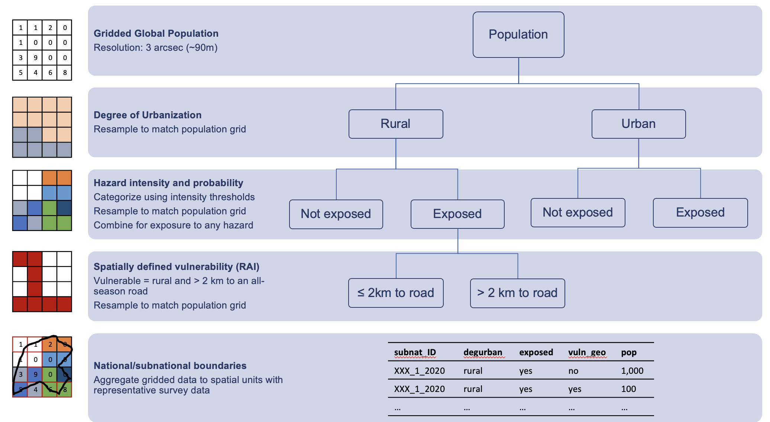

Adjusting estimates of financial account ownership from individual to household level
Since Findex data is collected at individual level, we adjust estimates to household level to be consistent with other indicators. We require the share of households without access to a financial account or mobile money. We apply an adjustment based on the number of adults in a household and a factor derived from examining countries where data on both household and individual ownership of accounts is available. A constant adjustment factor of 0.6 was found to predict household level access to finance across income quintiles, based on validation against surveys in 11 countries with complete data. The share of households without access is therefore calculated at income quintile level as:
$${hh}_{fin}={{ind}_{fin}}^{0.6N}$$
where ${hh}_{fin}$ is the share of households without access to a financial or mobile money account in each quintile (required for the analysis), ${ind}_{fin}$ is the share of individuals (15+) without access, as measured by Findex surveys, and $N$ is the average number of individuals (15+) in a household in each quintile, based on GMD surveys. Results from validation in 11 countries where surveys collected individual level data for all household members is shown in Figure S2.
Figure S2: Findex household level adjustment

Merging spatially defined degree of urbanization with survey definitions
Degree of urbanization method (DoU) is a consistent way to classify the exposed population (based on population cluster size and density). However, this classification may not align well with the definition of rural/urban in household surveys and corresponding vulnerability rates. In particular, some countries report rural population shares much higher than those estimated using DoU. Without any adjustment, applying the (lower) urban vulnerability rates to a larger urban population classified by DoU will underestimate the total number of people who are highly vulnerable. Therefore, we reclassify the DoU categories to match population shares in the survey such that the overall vulnerability rate does not change. Figure S3 demonstrates the method.
Figure S3: Aligning rural and urban definitions
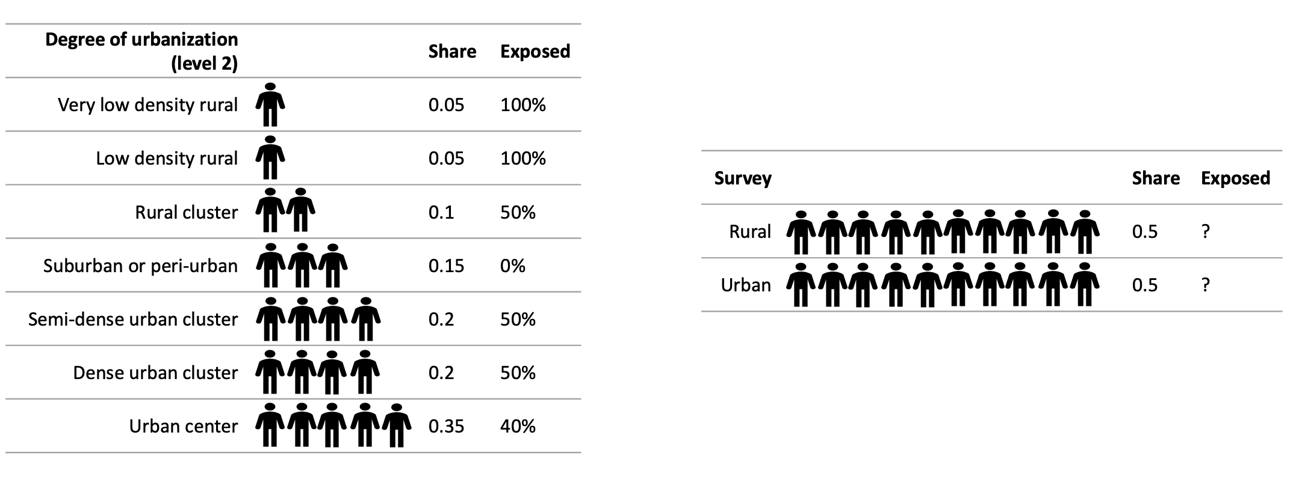
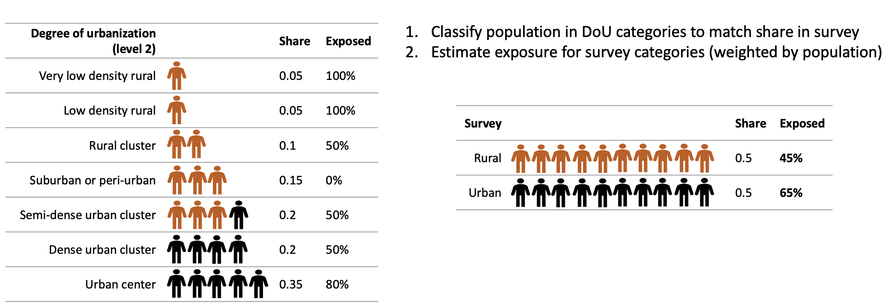

Sensitivity analysis
Table S1 shows estimates of the population at high risk from climate related hazards when restricting the sample to countries with data on all dimensions of vulnerability from within 3 years of both 2010 and 2021. We also estimate upper and lower bounds by assuming the minimum and maximum possible overlap between the exposed and vulnerable population, rather than that the vulnerable population are just as likely to be exposed as those not vulnerable within a spatial unit. The levels and trends using our preferred specification are found to be robust in all cases.

Table S1: Sensitivity analysis – population at high risk (exposed to any hazard, vulnerable on any dimension)
 | Share of population at high risk (%)
 | 2010 | 2021 | ∆
Main  (full sample) | 35.7 | 19.4 | -16.3
Countries with recent data in both years  (+/- 3 years, N = 89) | 36.5 | 17.1 | -19.4
Upper bound  (maximum overlap) | 39.7 | 22.5 | -17.2
Lower bound  (minimum overlap) | 31.7 | 16.1 | -15.6

