Extended data figures and tables

Extended Data Table 1: Population exposed to four hazards, by region (2021, 100-year return period)

Region | Total population (millions) | Share of population exposed (%)
Region | Total population (millions) | Cyclone | Drought | Flood | Heatwave | Any | 2+ | 3+
East Asia & Pacific | 2370 | 17.1 | 13.7 | 13.7 | 53.6 | 69.1 | 25.9 | 3.0
Europe & Central Asia | 924 | 0.2 | 21.5 | 6.6 | 0.4 | 27.1 | 1.5 | 0.0
Latin America & Caribbean | 655 | 8.0 | 14.8 | 6.4 | 9.9 | 33.9 | 4.7 | 0.4
Middle East & North Africa | 486 | 0.0 | 9.0 | 9.8 | 19.5 | 34.5 | 3.6 | 0.2
North America | 370 | 7.2 | 16.9 | 3.9 | 8.8 | 31.1 | 5.3 | 0.4
South Asia | 1902 | 6.5 | 17.1 | 12.4 | 82.1 | 87.0 | 28.6 | 2.4
Sub-Saharan Africa | 1181 | 0.4 | 27.0 | 4.2 | 11.6 | 38.2 | 4.9 | 0.3
World | 7889 | 7.8 | 17.4 | 9.8 | 40.1 | 57.0 | 16.4 | 1.6

Extended Data Table 2: Population exposed to four hazards, by region (2021, 20-year return period)

Region | Total population (millions) | Share of population exposed (%)
Region | Total population (millions) | Cyclone | Drought | Flood | Heatwave | Any | 2+ | 3+
East Asia & Pacific | 2370 | 3.6 | 9.8 | 6.6 | 45.4 | 55.5 | 9.6 | 0.4
Europe & Central Asia | 924 | 0.1 | 15.3 | 3.4 | 0.2 | 18.6 | 0.5 | 0.0
Latin America & Caribbean | 655 | 0.3 | 10.6 | 3.2 | 7.0 | 19.8 | 1.2 | 0.0
Middle East & North Africa | 486 | 0.0 | 8.8 | 3.9 | 17.6 | 28.2 | 1.9 | 0.1
North America | 370 | 0.0 | 13.0 | 3.2 | 2.8 | 18.3 | 0.7 | 0.0
South Asia | 1902 | 0.0 | 15.5 | 5.2 | 77.9 | 83.0 | 15.1 | 0.5
Sub-Saharan Africa | 1181 | 0.0 | 22.6 | 2.1 | 4.9 | 27.7 | 1.8 | 0.0
World | 7889 | 1.1 | 13.9 | 4.6 | 34.9 | 47.2 | 7.1 | 0.3

Extended Data Figure 1: Hazard with the largest share of population exposed (2021, 100-year return period)
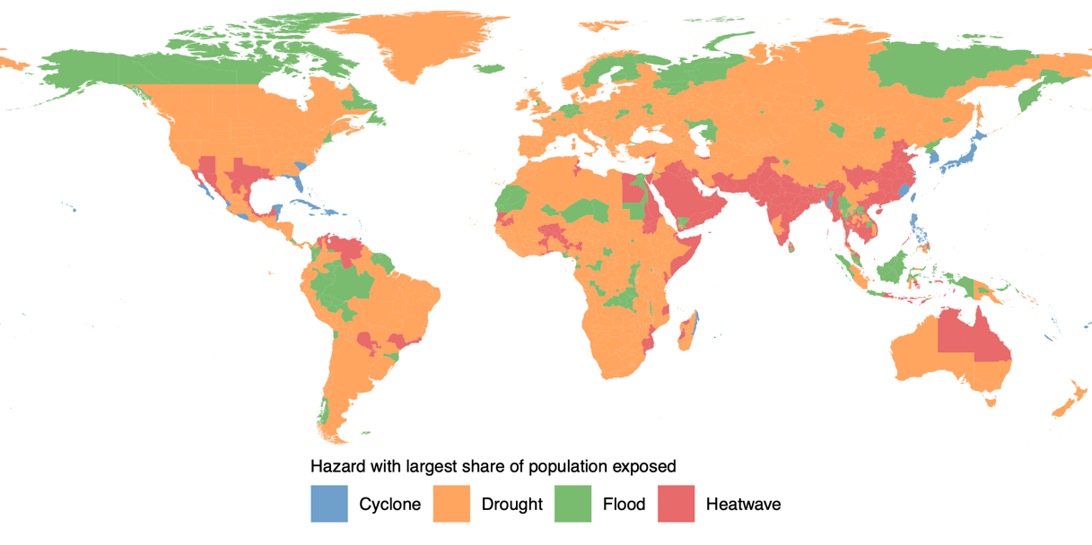

Extended Data Table 3: Population exposed to four hazards by degree or urbanization (2021, 100-year return period)

Degree of urbanization |  | Total Population (millions) | Share of population exposed (%)
 |  | Total Population (millions) | Cyclone | Drought | Flood | Heatwave | Any | 2+ | 3+
Rural | Very low density rural | 465 | 3.6 | 70.1 | 8.2 | 24.2 | 77.5 | 25.2 | 3.3
Rural | Low density rural | 975 | 4.5 | 75.5 | 8.3 | 31.7 | 82.8 | 32.1 | 5.0
Rural | Rural cluster | 414 | 3.3 | 74.9 | 8.1 | 27.4 | 81.8 | 28.6 | 3.3
Urban cluster | Suburban or peri-urban | 1445 | 7.4 | 0.0 | 11.9 | 53.3 | 58.5 | 13.4 | 0.7
Urban cluster | Semi-dense urban cluster | 226 | 4.3 | 0.0 | 8.1 | 28.4 | 35.3 | 5.2 | 0.3
Urban cluster | Dense urban cluster | 907 | 6.2 | 0.0 | 11.2 | 37.9 | 45.2 | 9.6 | 0.6
Urban centre | Urban centre | 3460 | 10.6 | 0.0 | 9.5 | 42.0 | 48.0 | 13.2 | 0.9

Extended Data Table 4: Population vulnerable on seven dimensions, by region (circa 2021)

Region | Total Population (millions) | Share of population vulnerable (%)
Region | Total Population (millions) | Income | Education | Finance | Social protection | Electricity | Water | Access | Any | 2+ | 3+
East Asia & Pacific | 2182 | 1.0 | 2.7 | 7.6 | 6.5 | 1.0 | 1.7 | 1.1 | 17.0 | 3.3 | 0.9
Europe & Central Asia | 917 | 0.4 | 2.0 | 5.9 | 7.0 | 0.0 | 0.7 | 0.2 | 14.7 | 1.3 | 0.1
Latin America & Caribbean | 608 | 4.5 | 8.5 | 17.0 | 17.6 | 2.4 | 1.8 | 0.5 | 40.0 | 9.3 | 2.1
Middle East & North Africa | 356 | 5.6 | 9.1 | 38.4 | 14.4 | 3.2 | 3.4 | 0.7 | 51.5 | 15.3 | 5.2
North America | 370 | 0.0 | 0.9 | 0.0 | 0.0 | 0.0 | 0.0 | 0.0 | 0.9 | 0.0 | 0.0
South Asia | 1862 | 11.4 | 8.6 | 13.1 | 13.8 | 1.5 | 1.0 | 0.3 | 36.1 | 10.1 | 2.6
Sub-Saharan Africa | 1159 | 37.6 | 33.3 | 29.6 | 71.0 | 45.3 | 31.1 | 7.9 | 90.5 | 69.1 | 48.4
World | 7454 | 9.7 | 9.5 | 14.0 | 19.4 | 8.0 | 6.0 | 1.7 | 35.7 | 15.9 | 8.9
Notes: The sample includes 160 countries with vulnerability data available.
Extended Data Figure 2: Dimension with the largest share of population vulnerable (2021)

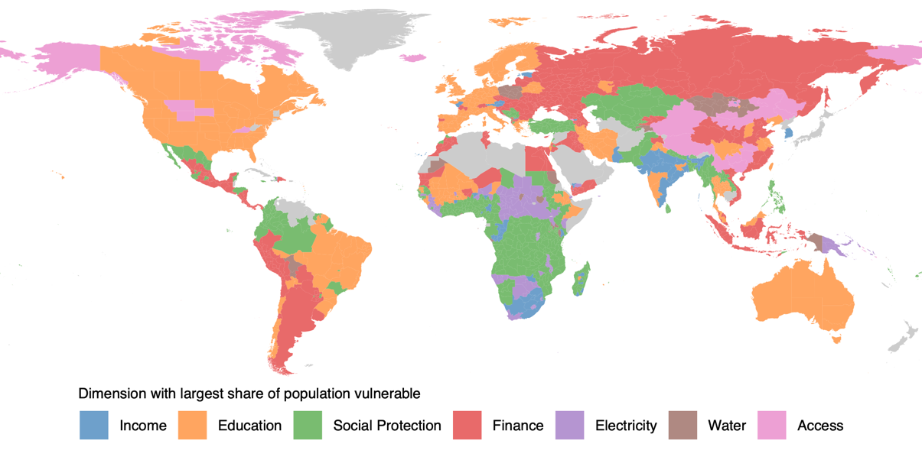

Extended Data Figure 3: Correlation between vulnerability dimensions (2021)
a b
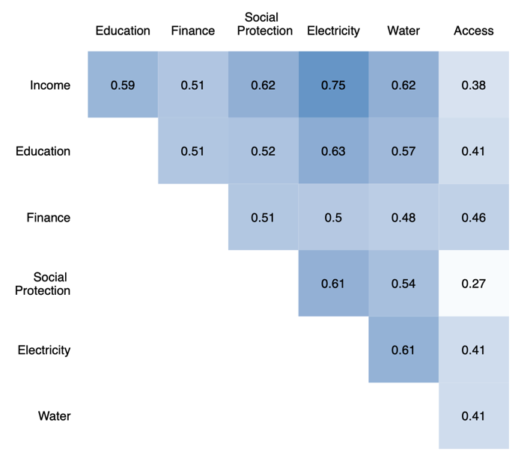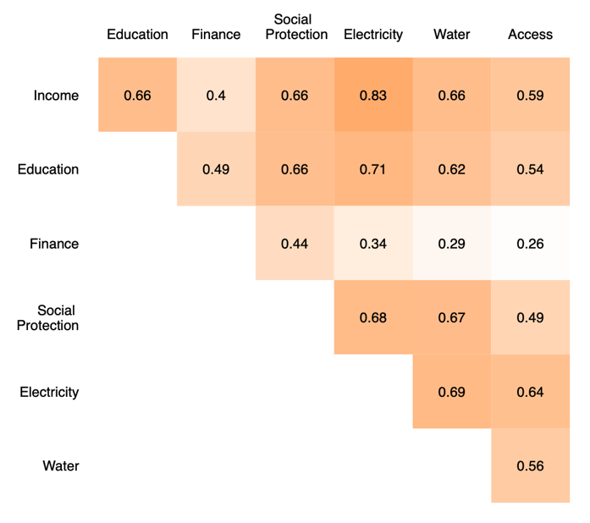

a. Correlation in share of population vulnerable across dimensions at subnational level (N = 3,481). b. Correlation in share of population vulnerable across dimensions at national level (N = 160).

Extended Data Table 5: Population exposed to any hazard and vulnerable, by region

 | 2021
Region | Total Population (millions) | Share of population exposed and vulnerable (%)
Region | Total Population (millions) | Income | Education | Finance | Social protection | Electricity | Water | Access | Any | 2+ | 3+
East Asia & Pacific | 2182 | 0.5 | 1.7 | 4.2 | 4.6 | 0.6 | 0.8 | 0.8 | 10.6 | 1.8 | 0.5
Europe & Central Asia | 917 | 0.1 | 0.5 | 1.6 | 1.8 | 0.0 | 0.2 | 0.1 | 4.0 | 0.4 | 0.0
Latin America & Caribbean | 608 | 2.2 | 3.7 | 6.3 | 7.1 | 1.7 | 1.2 | 0.3 | 15.6 | 4.7 | 1.4
Middle East & North Africa | 356 | 1.6 | 3.9 | 15.2 | 4.5 | 0.9 | 1.8 | 0.2 | 19.7 | 5.8 | 1.7
North America | 370 | 0.0 | 0.2 | 0.0 | 0.0 | 0.0 | 0.0 | 0.0 | 0.2 | 0.0 | 0.0
South Asia | 1862 | 10.5 | 7.4 | 11.6 | 12.0 | 1.2 | 0.6 | 0.2 | 31.9 | 8.8 | 2.1
Sub-Saharan Africa | 1159 | 16.1 | 16.2 | 13.0 | 26.9 | 19.9 | 14.0 | 5.9 | 36.1 | 29.7 | 22.1
World | 7453 | 5.5 | 5.4 | 7.6 | 9.5 | 3.7 | 2.8 | 1.2 | 19.4 | 8.1 | 4.3
 | 2010
Region | Total Population (millions) | Share of population exposed and vulnerable (%)
Region | Total Population (millions) | Income | Education | Finance | Social protection | Electricity | Water | Access | Any | 2+ | 3+
East Asia & Pacific | 2153 | 7.2 | 11.4 | 15.0 | 4.0 | 1.6 | 6.6 | 0.8 | 32.1 | 10.5 | 3.1
Europe & Central Asia | 883 | 0.3 | 3.1 | 6.4 | 1.8 | 0.1 | 0.4 | 0.1 | 9.0 | 3.0 | 0.3
Latin America & Caribbean | 538 | 3.0 | 6.0 | 15.6 | 7.1 | 2.3 | 3.0 | 0.3 | 23.6 | 8.8 | 3.2
Middle East & North Africa | 287 | 0.8 | 4.8 | 19.2 | 4.6 | 0.9 | 2.0 | 0.2 | 24.2 | 6.2 | 1.4
North America | 343 | 0.3 | 0.1 | 0.0 | 0.0 | 0.0 | 0.0 | 0.0 | 0.4 | 0.0 | 0.0
South Asia | 1632 | 23.6 | 18.1 | 39.2 | 11.8 | 21.2 | 8.0 | 0.2 | 66.3 | 36.2 | 14.9
Sub-Saharan Africa | 864 | 18.8 | 17.4 | 25.0 | 28.0 | 29.9 | 15.8 | 5.9 | 39.4 | 35.4 | 29.4
World | 6700 | 10.8 | 11.4 | 20.5 | 8.8 | 9.8 | 6.5 | 1.1 | 35.7 | 18.1 | 8.8
Notes: The sample includes 160 countries with vulnerability data available.

Extended Data Figure 4: Population exposed and vulnerable by hazard and dimension combination 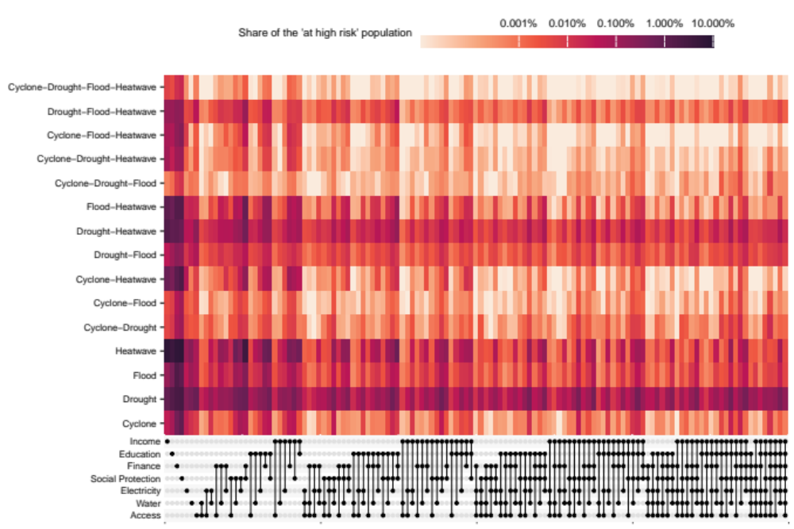
The heatmap illustrates the relative share of the population at high risk exposed to each combination of hazards and vulnerable on each combination of dimensions. Each row corresponds to a specific combination of the four hazard types. The columns represent different combinations of dimensions of vulnerability. The color intensity depicts the share of the population using a logarithmic scale for contrast, darker colors indicate more of the population having a specific hazard exposure and combination of vulnerabilities.

