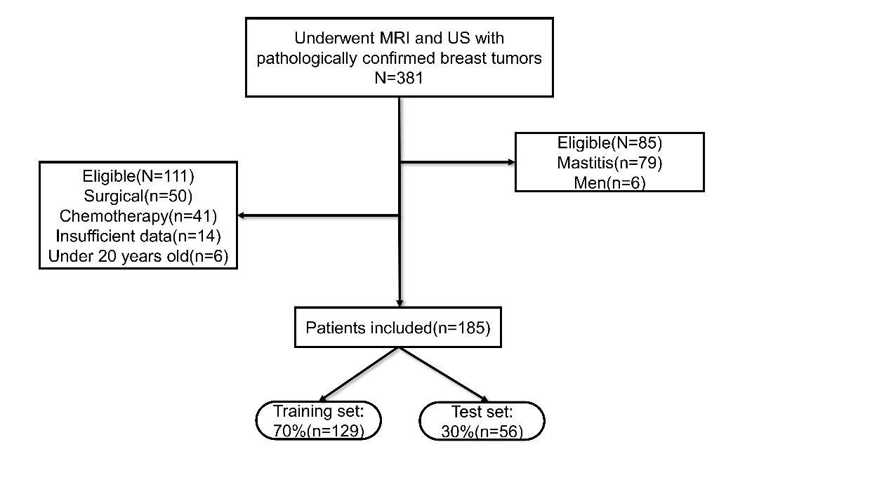
Figure S1: Overview of population inclusion and exclusion

Table S1: Clinical Characteristics of 185 Patients
Character | Total  (n = 185¹) | Benign  (n = 95¹) | Malignant  (n = 90¹) |  | P²
Age, Median (IQR) | 47 (35, 54) | 37 (27, 47.25) |  | 52 (47, 59) | < 0.001
Tumor diameter, Median (IQR) | 2 (1.5, 3) | 1.7 (1.2, 2.55) |  | 2.2(1.8, 3) | 0.002
Family history of BC n (%) |  |  |  |  | 0.748
Yes | 184 (99.5) | 95(100.0) |  | 89(98.9)
No | 1(0.54) | 0(0) |  | 1 (1.11)
Smoking, n (%) |  |  |  |  | 1
Yes | 0 | 0 |  | 0(0)
No | 185 (100) | 95 (100) |  | 90 (100)
History of drinking, n (%) |  |  |  |  | 1
Yes | 1 (1) | 1 (1) |  | 0 (0)
No | 184 (99) | 94 (99) |  | 90 (100)
Location of the tumor, n (%) |  |  |  |  | 0.501
left upper outer quadrant | 32 (17) | 14 (15) |  | 18 (20)
Left lower outer quadrant | 14 (8) | 6 (6) |  | 8 (9)
Left upper inner quadrant | 19 (10) | 10 (11) |  | 9 (10)
Left lower inner quadrant | 8 (4) | 3 (3) |  | 5 (6)
Central area | 17 (9) | 11 (12) |  | 6 (7)
Right Upper outer quadrant | 34 (18) | 20 (21) |  | 14 (16)
Right Lower outer quadrant | 23 (12) | 14 (15) |  | 9 (10)
Right Upper inner quadrant | 27 (15) | 10 (11) |  | 17 (19)
Right Lower inner quadrant | 11 (6) | 7 (7) |  | 4 (4)
CEA50, n (%) |  |  |  |  | 0.113
Normal | 182 (98) | 95 (100) |  | 87 (97)
Abnormal | 3 (2) | 0 (0) |  | 3 (3)
CA199, n (%) |  |  |  |  | 0.486
Normal | 184 (99) | 95 (100) |  | 89 (99)
Abnormal | 1 (1) | 0 (0) |  | 1 (1)
CA125, n (%) |  |  |  |  | 0.676
Normal | 180 (97) | 93 (98) |  | 87 (97)
Abnormal | 5 (3) | 2 (2) |  | 3 (3)
CA153, n (%) |  |  |  |  | 0.054
Normal | 181 (98) | 95 (100) |  | 86 (96)
Abnormal | 4 (2) | 0 (0) |  | 4 (4)
area, n (%) |  |  |  |  | 0.231
Village | 124 (67) | 68 (72) |  | 56 (62)
City | 61 (33) | 27 (28) |  | 34 (38)
menstruation, n (%) |  |  |  |  | 0.155
Under 12 years old | 16 (9) | 5 (5) |  | 11 (12)
Over 12 years old | 169 (91) | 90 (95) |  | 79 (88)
Menopausal status, n (%) |  |  |  |  | < 0.001
Yes | 61 (33) | 13 (14) |  | 48 (53)
No | 124 (67) | 82 (86) |  | 42 (47)
Parity history, n (%) |  |  |  |  | < 0.001
Yes | 155 (84) | 65 (68) |  | 90 (100)
No | 30 (16) | 30 (32) |  | 0 (0)
Density, n (%)
Fatty | 95 (51.4) | 61 (64.2) |  | 34 (46.2) | <0.001
Dense | 90 (48.6) | 34 (37.8) |  | 56 (62.2)
MRI Morphology, n (%) |  |  |  |  | <0.001
Irregular | 89 (48.1) | 14 (15.7) |  | 75 (84.3)
Regular | 96 (51.9) | 81(84.4) |  | 15 (15.6)
MRI border, n (%) |  |  |  |  | <0.001
Unclear | 84 (45.4) | 12 (12.6) |  | 72 (80)
Clear | 101 (54.6) | 83 (87.4) |  | 18 (20.2)
US Morphology, n (%) |  |  |  |  | <0.001
Unclear | 77 (41.6) | 37(38.9) |  | 71 (78.9)
Clear | 108(58.4%) | 58(61.1) |  | 19(21.1)
US border, n (%) |  |  |  |  | <0.001
Irregularity | 83 (45.4) | 18(18.9) |  | 65(72.2)
Regularity | 102 (41.5) | 77(81.1) |  | 25(27.8)
US diagnosis |  |  |  |  | <0.05
Benign | 95(51.3) | 88(47.6) |  | 7(3.8)
malignant | 90(48.7) | 24(13) |  | 66(35.7)
MRI diagnosis |  |  |  |  | <0.05
Benign | 95(51.3) | 87(47) |  | 8(4.3)
malignant | 90(48.7) | 11(5.9) |  | 79(42.7)
US+MRI diagnosis |  |  |  |  | <0.05
Benign | 95(51.3) | 85(45.9) |  | 10(5.4)
malignant | 90(48.7) | 9(4.9) |  | 87(43.8)
¹Median (IQR) or Frequency (%)
²Wilcoxon rank sum test; Fisher's exact test; Pearson's Chi-squared test

Table S2. The coefficients of Lasso regression analysis
Variables | Coefficients
 | -2.241249793
  (Intercept)
US diagnosis | .
MRI diagnosis | 0.713236814
US+MRI diagnosis | 1.593450468
US border | .
US morphology | -0.312609184
density | 0.001145062
MRI border | -1.150474467
MRI morphology | -0.625881986
menopausalstatus | .
parityhistory | -0.311615411
parity | .
Family history of breastcancer | .
smoking | .
History of drinking | .
lymphnodmetastasis | 1.887442288
locationofthenodule | .
CA199 | .
CA125 | .
CA153 | .
area | .
menstruation
age
tumordiameter | 0.001654259

