Hemolysis experiment process:
1. Blood was taken from healthy SD rats and placed in an anticoagulation tube, then centrifuged at a parameter of 8000r-5min, the supernatant was discarded and then added to PBS and centrifuged again to remove the supernatant, washed three times repeatedly and then diluted by adding the appropriate amount of PBS and then sealed and placed in 4℃ for storage.
2. 5ml of each hydrogel of the experimental group was prepared (hydrogel/hydrogel+2mg copper tin sulfur), which was sterilized by UV overnight, and then put into 50ml centrifugal tubes respectively, adding 45mlpbs respectively, and sealed for 48h of immersion;
3. Take 500ul each of extracted pbs and diluted blood in 1.5ml centrifuge tube, and then put it in 37° incubator for 2h, then centrifuged (8000r,5min), take the supernatant in 96-well plate and then use enzyme marker to measure the absorbance at 545nm.
The percentage of hemolysis was calculated as follows.
hemolysis（%）=$\frac{{OD}_{h}-{OD}_{n}}{{OD}_{p}-{OD}_{n}}×100\%$
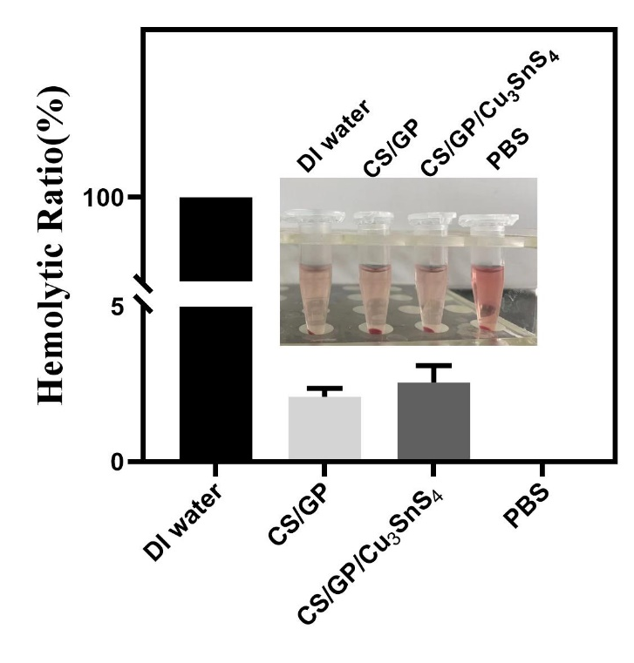
Where OD_{h} is the OD value of each set of hydrogel samples, OD_{n} is the OD value of the PBS negative control group, and OD_{p} is the OD value of the deionized water positive control group.
Supplementary Fig. 1. Hemolysis rate of CS/GP and CS/GP/ Cu₃SnS₄
The data shows that the hemolysis rate of CS/GP and CS/GP hydrogels is less than 5% and according to the American Society for Testing Materials (ASTM) standard, materials with hemolysis rate less than 5% can be used in biomedical applications. This indicates that the prepared hydrogels have good blood compatibility and can be reasonably applied to burn dressings.
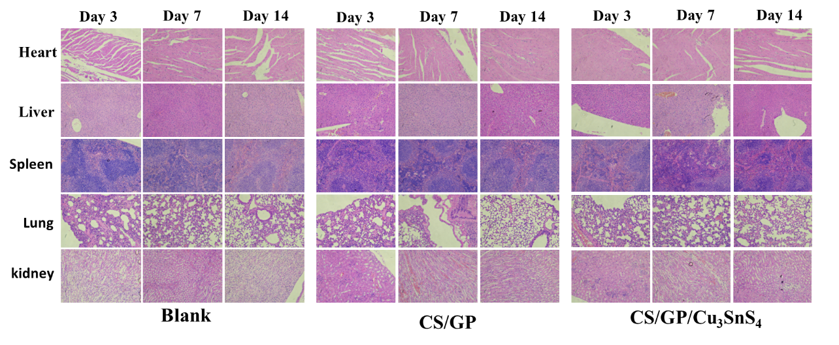
In this work, the heart, liver, spleen, lung and kidney of one mouse from each group were taken on the 3rd, 7th and 14th day after treatment for H&E staining and observed under the microscope to obtain the tissue staining map of each organ.
Supplementary Fig. 2. Photomicrographs of H&E staining of different groups of organs on days 3, 7, 14
From Supplementary Figure 2, it can be seen that none of the hydrogel dressings used throughout the experimental treatments adversely affected the organs of the mice, indicating that they are biocompatible.

blood analysis:
In this study, the blood of mice was analyzed using the Myriad Veterinary Automatic Blood Cell Analyzer (BC-2800vet), and the blood of mice in each group was drawn at the end of the treatment, i.e., the fourteenth day of the experimental treatment, for blood analysis.
Supplementary Table 1. Blood analysis of blank group mice
Parameter | Result | Unit | Reference range
  WBC | 7.7 | 10^9/L
  Lymph# | 3.6 | 10^9/L
  Mon# | 0.8 | 10^9/L
  Gran# | 3.3 | 10^9/L
  Lymph% | 47.2 | %
  Mon% | 10.4 | %
  Gran% | 42.4 | %
  RBC | 8.30 | 10^12/L
  HGB | 126 | g/L
  HCT | 38.2 | %
  MCV | 46.1 | fL
  MCH | 15.1 | pg
  MCHC | 329 | g/L
  RDW | 16.3 | %
  PLT | 1086 | 10^9/L
  MPV | 6.7 | fL
  PDW | 16.8
  PCT | .*** | %
  0.8-10.6
  0.6-8.9
  0.04-1.4
  0.23-3.6
  40-92
  0.9-18
  6.5-50
  6.5-11.5
110-165
35-55
41-55
13-18
300-360
12-19
400-1600
4.0-6.2

 |  |  | 12.0-17.5
 |  |  | 0.100-0.780

Supplementary Table 2. Blood analysis of CS/GP/ Cu₃SnS₄ group mice
Parameter | Result | Unit | Reference range
  WBC | 4.1 | 10^9/L
  Lymph# | 3.6 | 10^9/L
  Mon# | 0.0 | 10^9/L
  Gran# | 0.5 | 10^9/L
  Lymph% | 86.8 | %
  Mon% | 2.1 | %
  Gran% | 11.1 | %
  RBC | 7.68 | 10^12/L
  HGB | 133 | g/L
  HCT | 36.0 | %
  MCV | 47.0 | fL
  MCH | 17.3 | pg
  MCHC | 369 | g/L
  RDW | 26.3 | %
  PLT | 1033 | 10^9/L
  MPV | 5.2 | fL
  PDW | 16.0
  PCT | 0.537 | %
  0.8-10.6
  0.6-8.9
  0.04-1.4
  0.23-3.6
  40-92
  0.9-18
  6.5-50
  6.5-11.5
110-165
35-55
41-55
13-18
300-360
12-19
400-1600
4.0-6.2

 |  |  | 12.0-17.5
 |  |  | 0.100-0.780

Supplementary Table 3. Blood analysis of CS/GP group mice
Parameter | Result | Unit | Reference range
  WBC | 4.8 | 10^9/L
  Lymph# | 4.0 | 10^9/L
  Mon# | 0.1 | 10^9/L
  Gran# | 0.7 | 10^9/L
  Lymph% | 83.9 | %
  Mon% | 2.1 | %
  Gran% | 14.0 | %
  RBC | 2.26 | 10^12/L
  HGB | 86 | g/L
  HCT | 11.0 | %
  MCV | 48.8 | fL
  MCH | 38.0 | pg
  MCHC | 781 | g/L
  RDW | 37.2 | %
  PLT | 2679 | 10^9/L
  MPV | 10.3 | fL
  PDW | 19.4
  PCT | .*** | %
  0.8-10.6
  0.6-8.9
  0.04-1.4
  0.23-3.6
  40-92
  0.9-18
  6.5-50
  6.5-11.5
110-165
35-55
41-55
13-18
300-360
12-19
400-1600
4.0-6.2

 |  |  | 12.0-17.5
 |  |  | 0.100-0.780

As can be seen in Supplementary Tables 1, 2, and 3, all parameters in the blood cell analysis of mice were normal after treatment, indicating that the dressings used did not have adverse effects, demonstrating their good biocompatibility.

