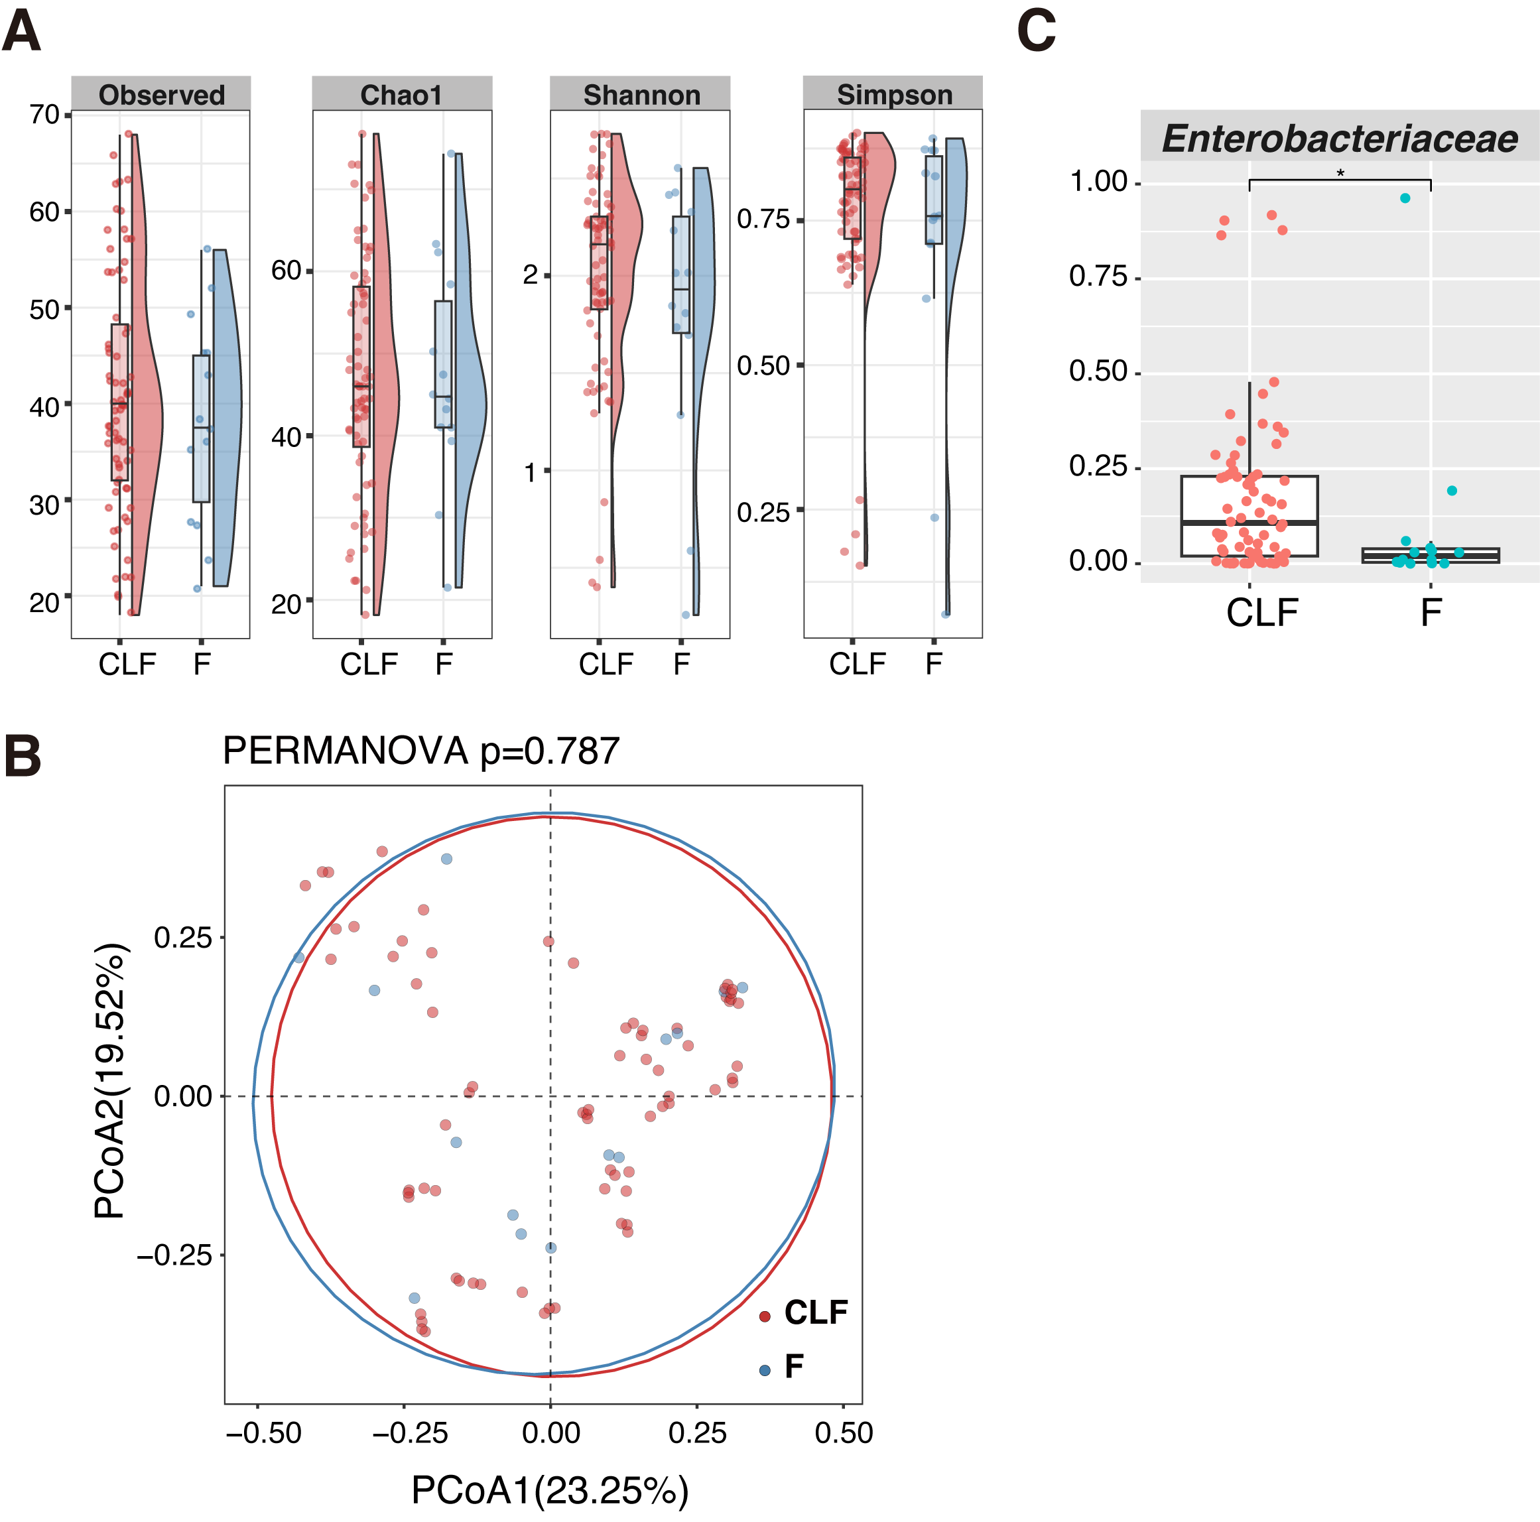
Additional file 4. Difference between microbiota compositions of CLF and feces in pediatric UC patients. Family-level abundance was used for calculation of Bray-Curtis distance. (A) Comparison of diversity indices between the gut microbiomes in CLF and F. (B) PCoA of the gut microbiomes in CLF and F. The statistical difference in β-diversity was evaluated by PERMANOVA (number of permutations = 9,999). (C) Pairwise comparisons of the taxa that were significantly different between CLF and F. Significant difference is shown by * (p<0.05).
Abbreviations: CLF, colon lavage fluids; F, feces; PCoA, principal coordinate analysis

