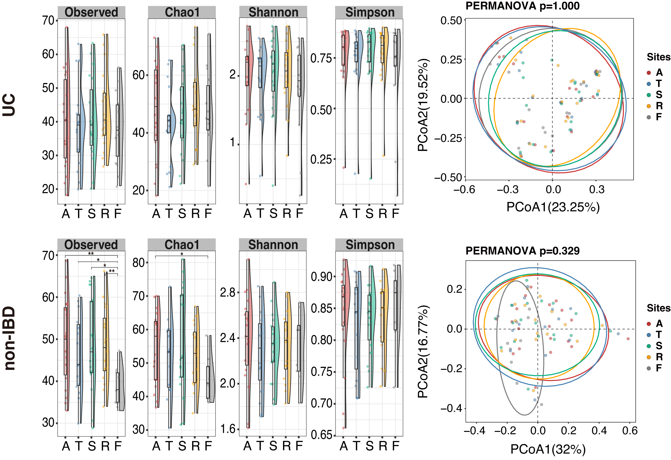
Additional file 2. Comparisons of gut microbiome community structure among the sample sites in pediatric UC and non-IBD patients. Family-level abundance was used for calculation of Bray-Curtis distance. The α-diversity (four kinds of diversity indices) and β-diversity (PCoA plot) of the microbiome were compared among the sample types (A, ascending colon; T, transverse colon; S, sigmoid colon; R, rectum; and F, feces). No significant difference among the sampling sites was detected in UC. In non-IBD patients, MAM contained more types of bacterial groups than did feces. Significant differences are shown by * (p<0.05) or ** (p<0.01).
Abbreviations: IBD, inflammatory bowel disease; MAM, mucosa-associated microbiome; PCoA, principal coordinates analysis; UC, ulcerative colitis

