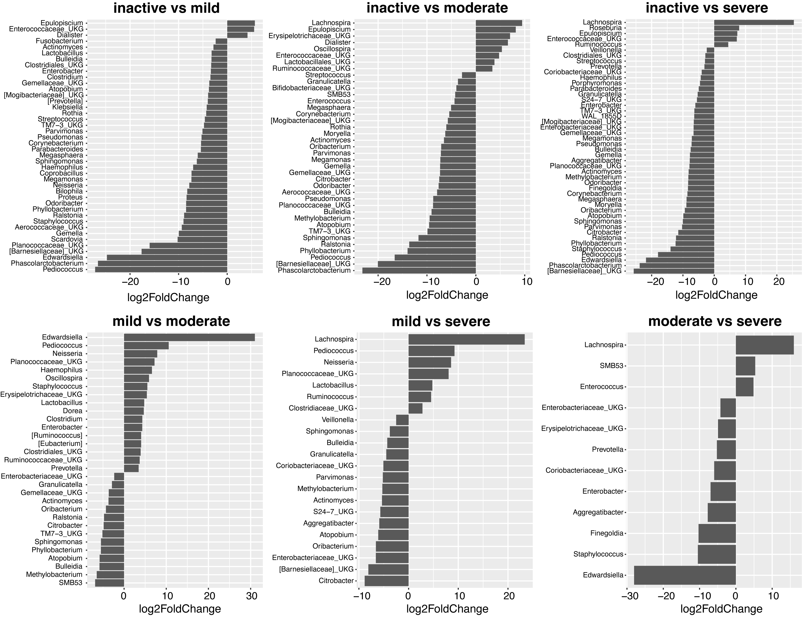
Additional file 6. Pairwise comparisons of community structure among the MAM across different degrees of disease activity. Bacterial genera enriched more than 4-fold in either of the paired disease states were detected by DESeq2 analysis. The fold change in relative abundance was logarithmically transformed and is shown by the bar diagrams.
Abbreviation: MAM, mucosa-associated microbiome

