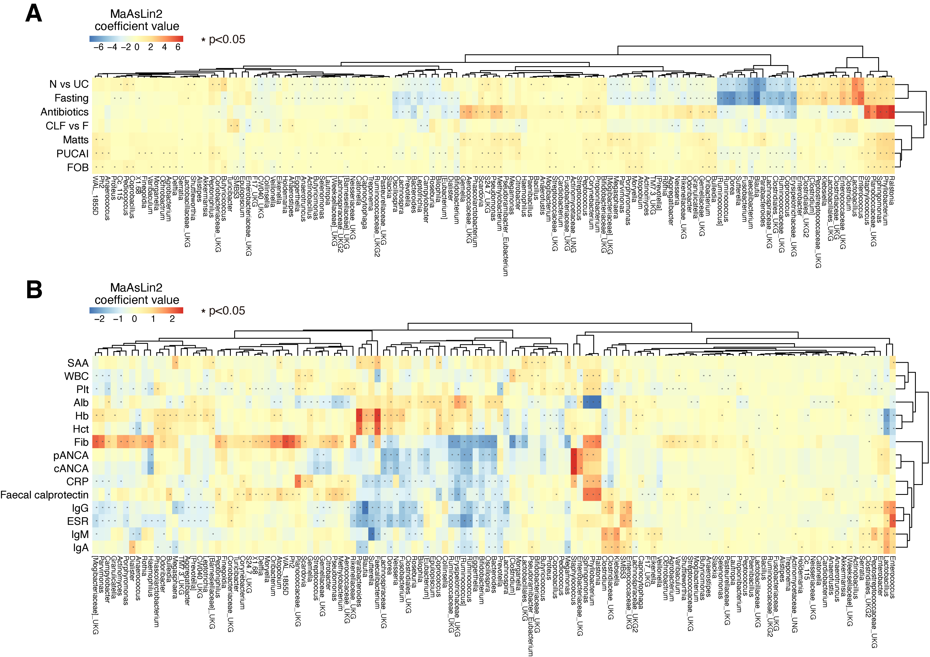
Additional file 3. Association of the bacterial taxa (genus level) detected in CLF and feces with clinical metadata. Association was evaluated by linear model coefficients (MaAsLin). Association strength is shown by coefficient value with color gradation (red, positive; blue, negative). Significant association (p<0.05) is indicated by *. Details of the clinical data are summarized in Additional file 1. (A) Association of each microbial taxon with disease type (non-IBD vs UC), sampling sites, sample types, disease severity (PUCAI), disease activity (remission or active), mucosal integrity (Matts), FOB, fecal calprotectin level or treatment in the pediatric patients. (B) Microbial taxonomic variation plotted against blood and serological analysis data of the pediatric patients.
Abbreviations: Alb, albumin; cANCA, cytoplasmic antineutrophil cytoplasmic antibodies; CLF, colon lavage fluids; CRP, C-reactive protein; ESR, erythrocyte sedimentation rate; F, feces; Fib, fibrinogen; FOB, fecal occult blood; Hb, hemoglobin; Hct, hematocrit; IBD, inflammatory bowel disease; pANCA, peripheral antineutrophil cytoplasmic antibodies; Plt, platelet count; PUCAI, Pediatric Ulcerative Colitis Activity Index; SAA, serum amyloid A protein; UC, ulcerative colitis; WBC, white blood cell count

