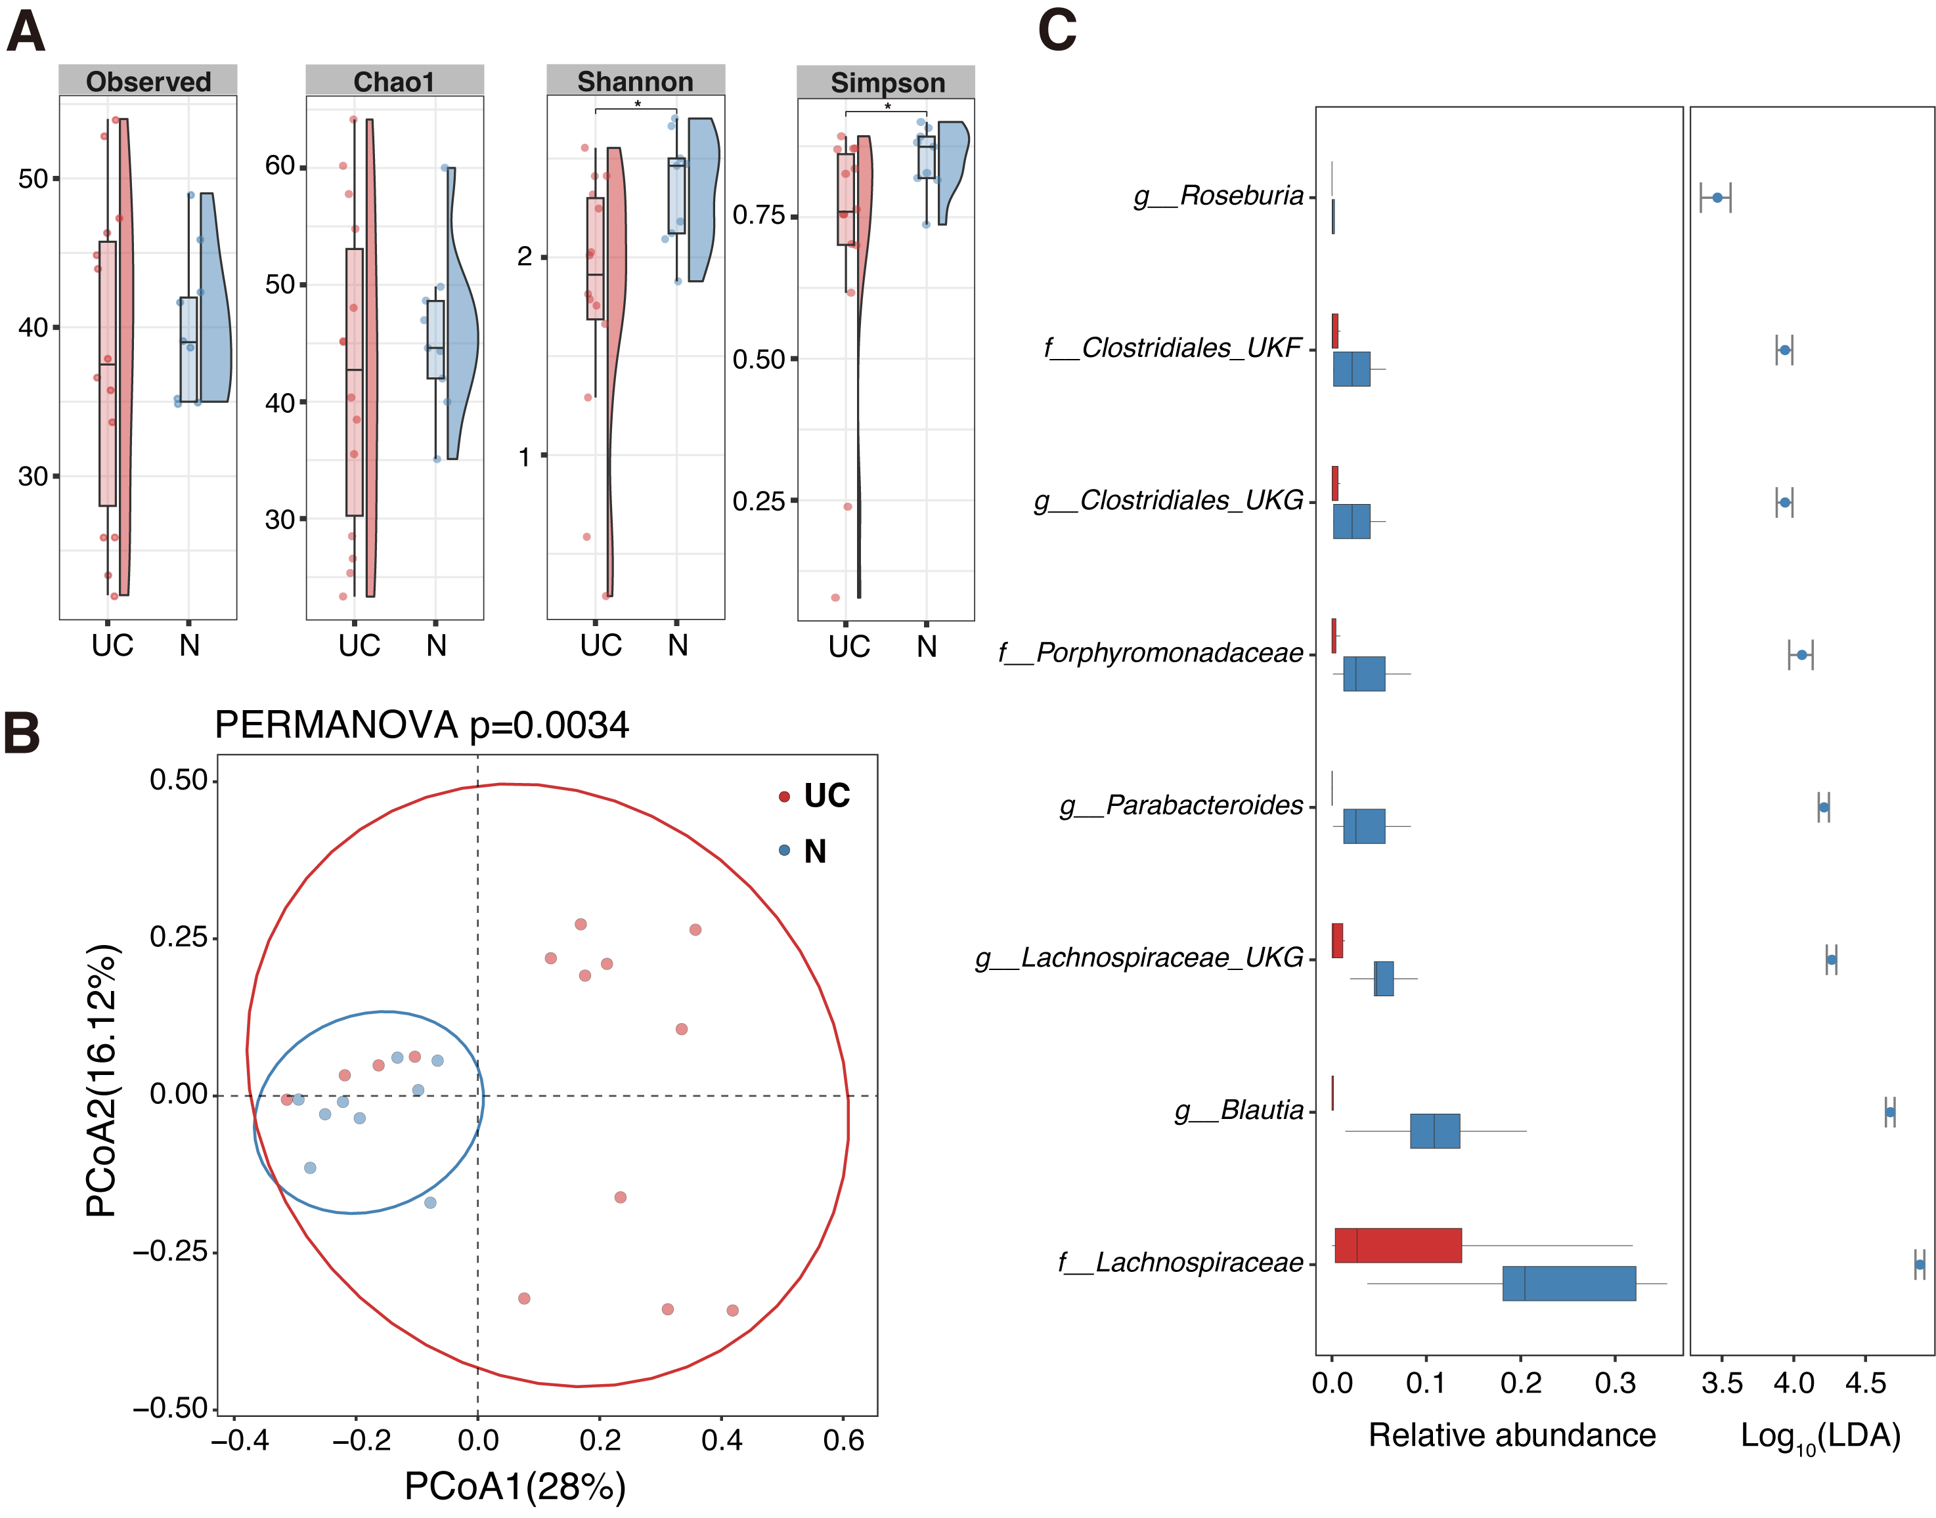
Additional file 5. (A) Comparison of diversity indices among the gut microbiome in feces. (B) PCoA of the gut microbiome in feces. The statistical difference in β-diversity was evaluated by PERMANOVA (number of permutations = 9,999). (C) Pairwise comparisons of the taxa that were significantly different between UC and N.
Abbreviations: LDA, linear discriminant analysis; N, non-IBD (non-inflammatory bowel disease); PCoA, principal coordinate analysis; UC, pediatric ulcerative colitis

