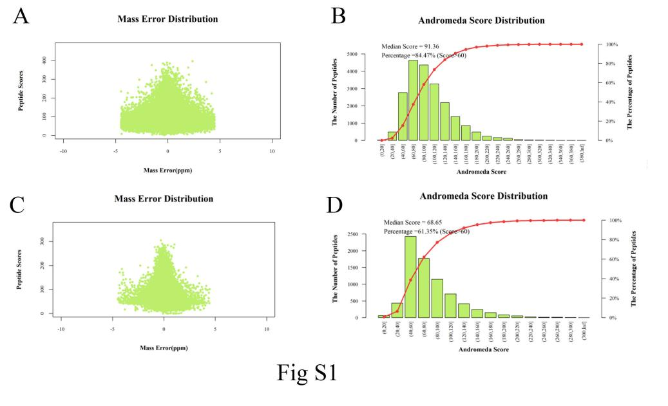
Figure S1. Quality control of the peptide ions. (a) Mass error distribution of the peptide ions in the proteomic data. (b) Andromeda score distribution of the peptide ions in the proteomic data. (c) Mass error distribution of the peptide ions in the phosphoproteomic data. (d) Andromeda score distribution of the peptide ions in the phosphoproteomic data.
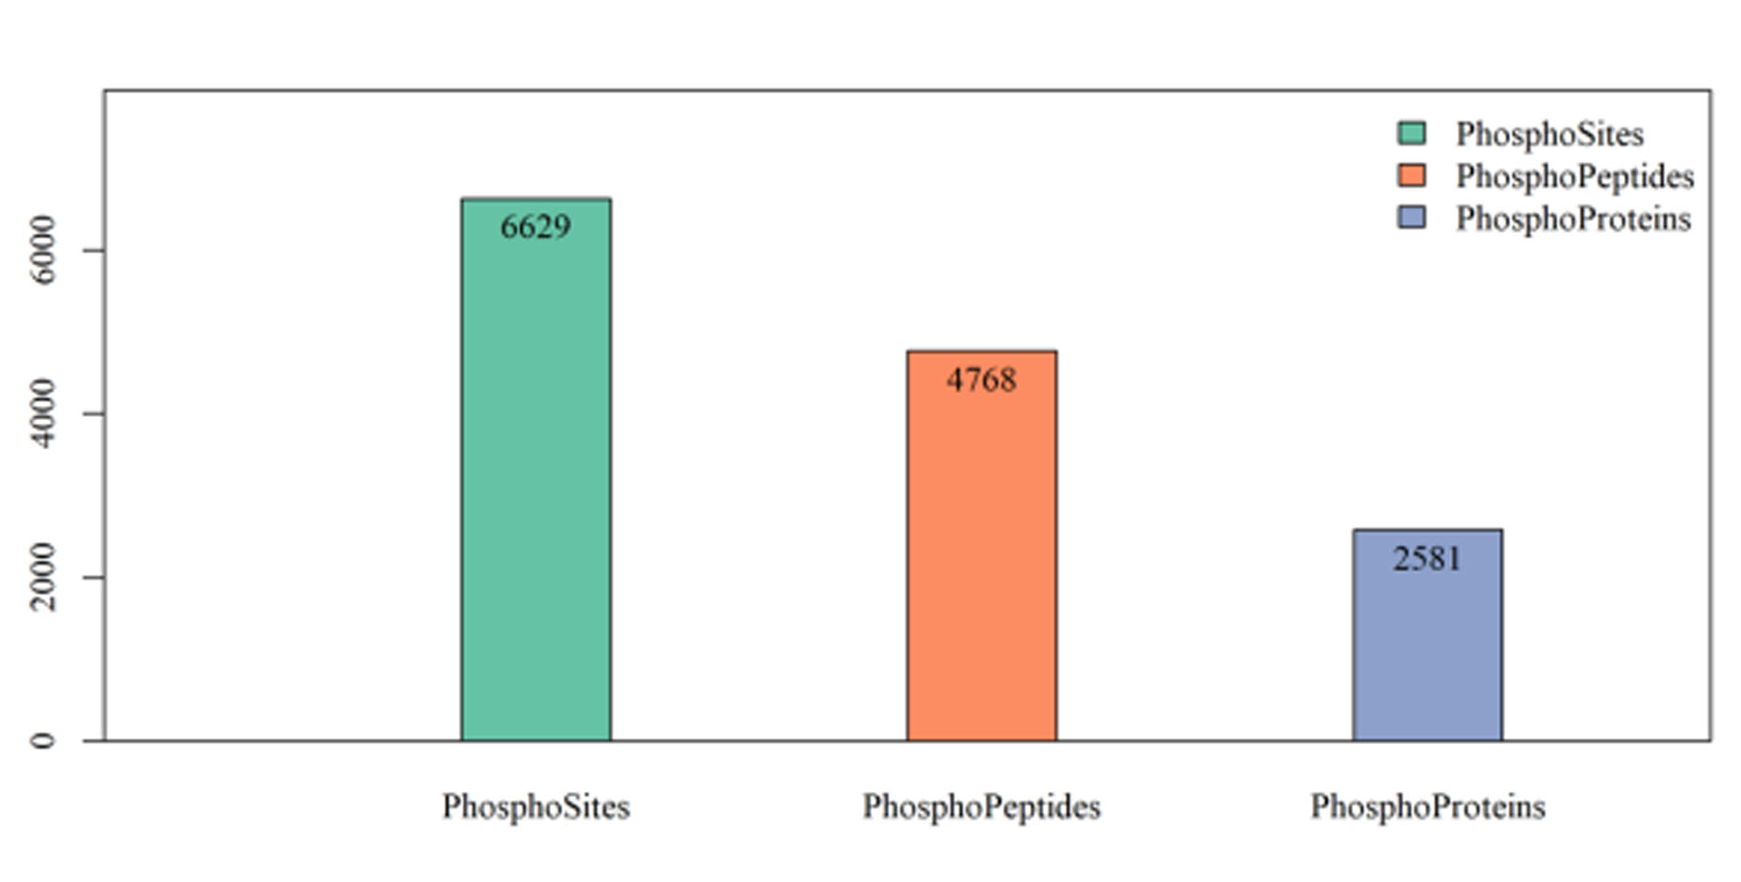
Figure S2. Number of phosphosites, phosphopeptides and phosphoproteins in the phosphoproteomic data.

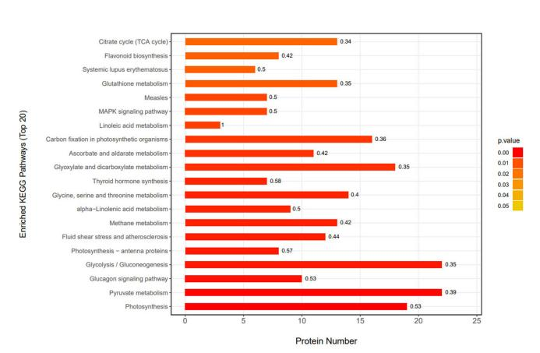
Figure S3. Top 20 enriched KEGG pathways in one-way ANOVA DEPs.

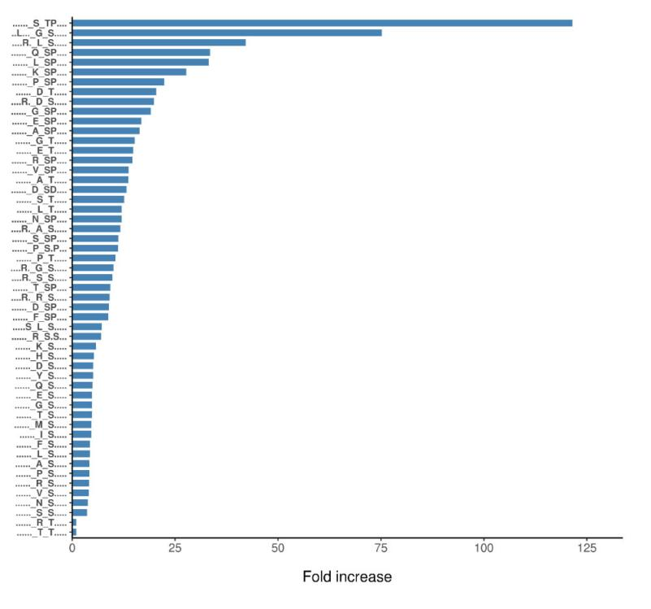
Figure S4. Analysis of the phosphorylation motifs of the one-way ANOVA differentially expressed phosphoproteins.

Table S1. Phosphoproteins related to plant-pathogen interaction.
Phosphoproteins
TEA008308.1
TEA030808.1
TEA006407.1
TEA011880.1
TEA013445.1
TEA024415.1
TEA023488.1
TEA007308.1
TEA018321.1
TEA023547.1
TEA030161.1
TEA021188.1
TEA003091.1
TEA011744.1
TEA008785.1
TEA027748.1
TEA026648.1
TEA012063.1
TEA027510.1
TEA015042.1
TEA001470.1

