Supplementary material
sTable1 The collinearity test of the total exposure factors.
 |  |  | Standardized Coefficients | t | Sig. | Collinearity Statistics
 |  |  | Beta |  |  | Tolerance | VIF
(Constant) | 0.339 | 0.058 |  | 5.848 | 0.000
sex | -0.003 | 0.073 | -0.003 | -0.044 | 0.965 | 0.886 | 1.128
hypertension | 0.026 | 0.165 | 0.010 | 0.161 | 0.873 | 0.892 | 1.121
diabetes | 0.026 | 0.073 | 0.022 | 0.355 | 0.723 | 0.945 | 1.058
abdominal ascites | 0.128 | 0.065 | 0.138 | 1.956 | 0.052 | 0.733 | 1.364
infection | 0.354 | 0.154 | 0.197 | 2.303 | 0.022 | 0.500 | 1.998
thrombosis | 0.155 | 0.198 | 0.052 | 0.783 | 0.434 | 0.817 | 1.224
pleural effusion | -0.061 | 0.068 | -0.064 | -0.892 | 0.373 | 0.711 | 1.406
ACS | -0.135 | 0.221 | -0.042 | -0.611 | 0.542 | 0.784 | 1.276
respiratory failure | -0.028 | 0.066 | -0.031 | -0.429 | 0.668 | 0.690 | 1.449
renal failure | 0.005 | 0.165 | 0.003 | 0.033 | 0.974 | 0.390 | 2.561
circulatory failure | -0.053 | 0.167 | -0.030 | -0.319 | 0.750 | 0.424 | 2.359
AP type | 0.006 | 0.064 | 0.007 | 0.100 | 0.920 | 0.785 | 1.274
drainage-tube | 0.149 | 0.146 | 0.080 | 1.017 | 0.310 | 0.584 | 1.711
Invasive ventilation | -0.160 | 0.164 | -0.079 | -0.978 | 0.329 | 0.564 | 1.772
hemofiltration | 0.022 | 0.167 | 0.010 | 0.129 | 0.897 | 0.589 | 1.697
ICU attendance | 0.074 | 0.081 | 0.073 | 0.918 | 0.359 | 0.571 | 1.751
age stratification | -0.244 | 0.059 | -0.266 | -4.117 | 0.000 | 0.873 | 1.146
Data are presented as medians (interquartile ranges), or absolute numbers (proportions).VIF, variance inflation factor, ACS, abdominal compartment syndrome, AP, acute pancreatitis, ICU, intensive care unit.

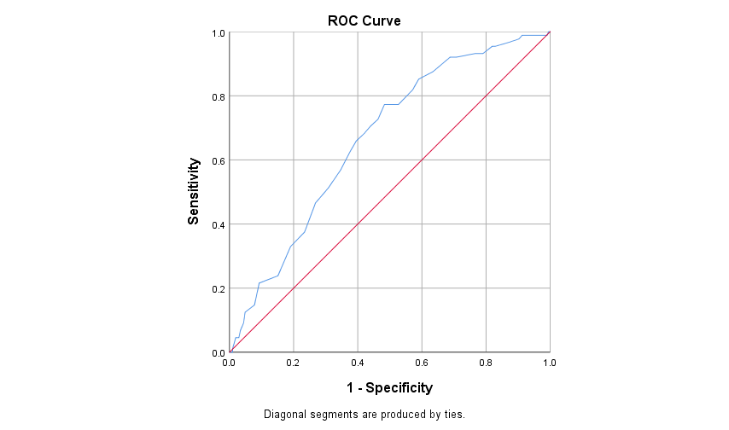

sFig 1 The ROC curve of the age stratification result. The cut-off value is 41.5 and the AUC is 0.665.

Stable2 The univariable analysis of Cox models
event | HR | 95%CI | P value
sex | 0.788 | 0.458-1.354 | 0.388
hypertension | 1.512 | 0.478-4.783 | 0.482
diabetes | 1.247 | 0.751-2.073 | 0.394
history of smoking | 1.173 | 0.773-1.783 | 0.453
history of alcohol | 1.131 | 0.819-2.094 | 0.270
abdominal ascites | 1.699 | 1.117-2.585 | 0.013
infection | 3.162 | 1.680-5.952 | <0.001
thrombosis | 2.092 | 0.661-6.617 | 0.209
pleural effusion | 1.251 | 0.762-2.052 | 0.376
cardiac effusion | 0.233 | 0.032-1.671 | 0.147
ACS | 1.273 | 0.313-5.171 | 0.736
respiratory failure | 1.216 | 0.798-1.854 | 0.363
renal failure | 1.968 | 0.987-3.923 | 0.054
circulatory failure | 1.917 | 0.927-3.967 | 0.079
AP type | 1.334 | 0.864-2.060 | 0.193
drainage-tube | 3.052 | 1.580-5.899 | 0.001
invasive ventilation | 1.961 | 0.856-4.494 | 0.111
hemofiltration | 2.116 | 0.923-4.850 | 0.076
oral hypoglycemic agent | 0.974 | 0.627-1.514 | 0.907
insulin | 1.332 | 0.739-2.399 | 0.339
heparin | 0.874 | 0.569-1.343 | 0.539
ICU attendance | 1.849 | 1.185-2.884 | 0.007
age stratification | 2.98 | 1.809-4.909 | <0.001

Stable3 The univariable analysis of Compete-risk models
event | HR | 95%CI | P value
sex | 0.789 | 0.453-1.376 | 0.405
hypertension | 1.515 | 0.399-5.751 | 0.541
diabetes | 1.25 | 0.759-2.058 | 0.380
history of smoking | 1.168 | 0.770-1.772 | 0.465
history of alcohol | 1.312 | 0.816-2.110 | 0.261
abdominal ascites | 1.688 | 1.109-2.569 | 0.014
infection | 3.167 | 1.651-6.074 | 0.001
thrombosis | 2.095 | 0.773-5.675 | 0.146
pleural effusion | 1.057 | 0.696-1.607 | 0.792
cardiac effusion | 0.237 | 0.033-1.676 | 0.149
ACS | 1.275 | 0.349-4.651 | 0.712
respiratory failure | 1.22 | 0.798-1.864 | 0.358
renal failure | 1.972 | 0.944-4.117 | 0.070
circulatory failure | 1.921 | 0.888-4.153 | 0.097
AP type | 1.331 | 0.860-2.060 | 0.198
drainage-tube | 3.058 | 1.518-6.156 | 0.002
invasive ventilation | 1.965 | 0.839-4.601 | 0.120
hemofiltration | 2.12 | 0.871-5.159 | 0.098
oral hypoglycemic agent | 0.975 | 0.629-1.511 | 0.912
insulin | 1.336 | 0.744-2.402 | 0.331
heparin | 0.875 | 0.570-1.343 | 0.542
ICU attendance | 1.853 | 1.180-2.910 | 0.007
age stratification | 2.98 | 1.798-4.938 | <0.001

Stable4 The multivariable analysis of Cox models
event | SHR | 95%CI | P value
abdominal ascites | 1.424 | 0.901-2.250 | 0.131
infection | 3.066 | 1.192-7.888 | 0.020
drainage tube | 1.337 | 0.482-3.707 | 0.576
renal failure | 0.983 | 0.291-3.347 | 0.986
circulatory failure | 0.735 | 0.220-2.454 | 0.617
ICU attendance | 1.128 | 0.645-1.974 | 0.673
hemofiltration | 1.090 | 0.392-3.031 | 0.868
age stratification | 3.157 | 1.883-5.292 | <0.001

STable5 The multivariable analysis of Compete-risk models
event | SHR | 95%CI | P value
abdominal ascites | 1.413 | 0.897-2.226 | 0.136
infection | 3.064 | 1.161-8.090 | 0.024
drainage tube | 1.339 | 0.405-4.425 | 0.632
renal failure | 0.985 | 0.258-3.759 | 0.983
circulatory failure | 0.738 | 0.188-2.896 | 0.663
ICU attendance | 1.133 | 0.644-1.994 | 0.665
hemofiltration | 1.089 | 0.472-2.512 | 0.841
age stratification | 3.154 | 1.861-5.345 | <0.001
Factors associated with readmission in the univariate analysis (P<0.1) were included in the multivariate analysis. P<0.05 was considered to be the independent factors of unplanned readmission.

