Supplementary Materials for Advancing Robotic Swarms with Blockchain Technology: A Dynamic Two-Factor Authentication Consensus Framework
Marck Herzon C. Barrion^{1,}*, Argel A. Bandala¹, Jose Martin Z. Maningo¹, Elmer P. Dadios¹, and Raouf Naguib²
¹De La Salle University, Department of Electronics and Computer Engineering, Manila 1004, Philippines
²Liverpool Hope University, Liverpool L69 3BX, United Kingdom
*marck.barrion@dlsu.edu.ph; marckbarrion@gmail.com

CONTENTS
This document contains the following:
Supplementary Results
Supplementary Discussion
Supplementary Methods
Experimental Setup Instructions
Supplementary Material References

Supplementary Results

Statistical Results
As a visual aid to the statistical results obtained from the tests conducted, the following supplemental figures are presented in this section. These plot the results of the post hoc tests conducted after the relevant ANOVA tests for each experiment. Post hoc tests are crucial in identifying which specific groups differ after determining that a significant difference exists overall. Tukey's HSD (Honestly Significant Difference) test is used when the data meet the assumptions of normality and homogeneity of variances, allowing for pairwise comparisons between group means. In cases where these assumptions are violated, particularly when variances are unequal, the Games-Howell test is employed as a more robust alternative. Both post hoc tests help to clarify the differences between group means, offering more detailed insights into the experiment's findings. For clarity, an asterisk (*) is placed on the group that outperforms the other in each comparison, visually highlighting the significant differences observed between groups.
Tukey's HSD post hoc test results in supplementary Figure S1 demonstrate that the 2-FBC framework consistently outperforms other consensus approaches, particularly as swarm size increases. For swarm size 24, 2-FBC shows significant improvement over both Blockchain Base (BB) and Single-Factor Authentication (1-FA), with smaller mean differences between 1-FA and 2-FBC compared to the Baseline (BL). As swarm size increases to 48, the performance gap widens further, highlighting the scalability advantage of 2-FBC. Games-Howell results in S1b confirm this trend, with 2-FBC consistently showing better accuracy across different swarm sizes. For swarms of 8 and 16 robots, 2-FBC demonstrates a clear edge over BL, with significant mean differences, reinforcing the effectiveness of the dual-layered approach, especially in larger swarms or more complex environments.
A
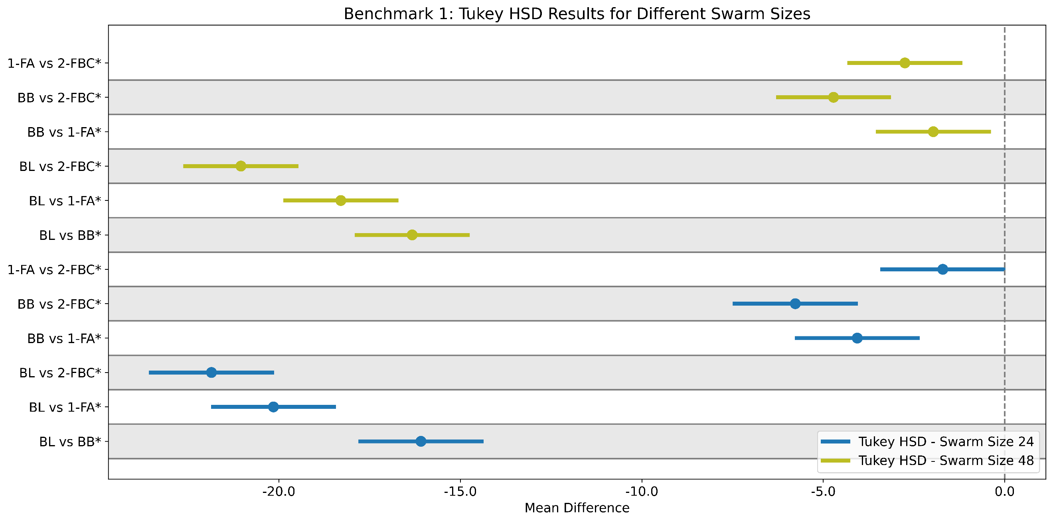
B
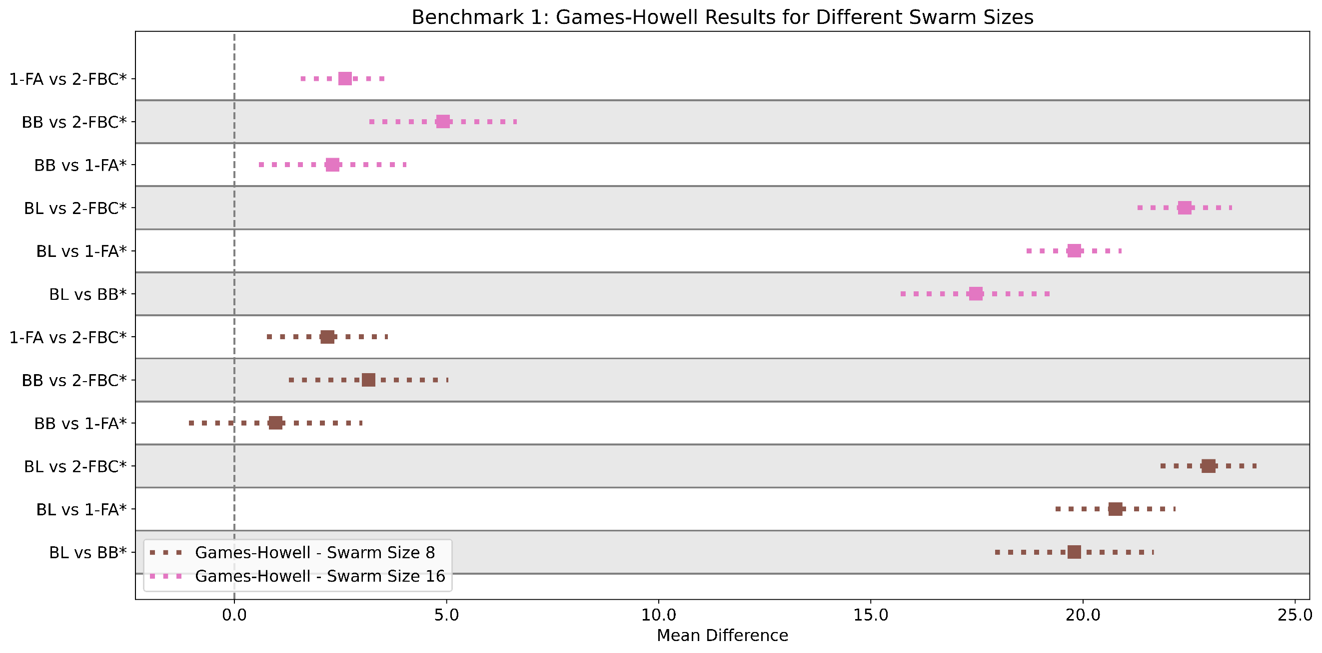
Figure S1. Tukey HSD and Games-Howell Post Hoc Test Results. (S1a) Tukey's HSD test for scalability shows pairwise comparisons of swarm performance across BL, BB, 1-FA, and 2-FBC at swarm sizes of 24 and 48 robots (α = 0.05). For 24 robots, the mean difference between Baseline and 2-FBC was -21.86 (p < 0.001), while 2-FBC outperformed BB with a mean difference of -5.77 (p < 0.001). At 48 robots, the Baseline and 2-FBC difference was -21.05 (p < 0.001). (S1b) Games-Howell test for accuracy shows pairwise comparisons for BL, BB, 1-FA, and 2-FBC at swarm sizes of 8 and 16 robots (α = 0.05). At 8 robots, the mean difference between Baseline and 2-FBC was 22.96 (p < 0.001). For 16 robots, the mean difference between Baseline and 2-FBC was 22.40 (p < 0.001), demonstrating 2-FBC's scalability and accuracy.

The Tukey HSD post hoc test results in Figure S2a reveal that the 2-FBC algorithm consistently outperformed BL and BB across different white tile configurations (5%, 25%, and 45%) for the second benchmark experiment. At the 5% configuration, 2-FBC achieved a significant mean difference against BL, illustrating its effectiveness in filtering erroneous estimates caused by Byzantine faults. This pattern persisted across the 25% and 45% configurations, where 2-FBC continued to demonstrate superior accuracy. Although the blockchain-based approaches (BB, 1-FA, and 2-FBC) performed similarly in some cases, 2-FBC maintained a marginal edge, particularly in challenging conditions. Figure S2b presents the Games-Howell test results for the 75% white tile scenario, further highlighting the robustness of 2-FBC. The largest mean difference of 23.33 between BL and 2-FBC underlines its exceptional ability to handle Byzantine faults. While BB and 1-FA also demonstrated improvements in accuracy, 2-FBC consistently performed better, showcasing the advantage of its dual-layered consensus approach in high-complexity environments.

A
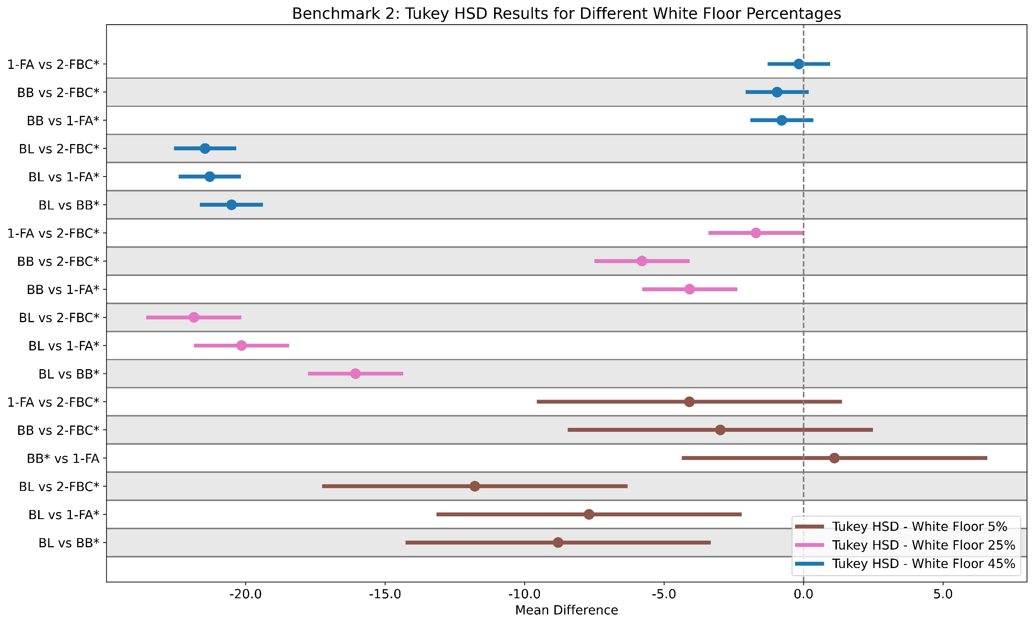
B
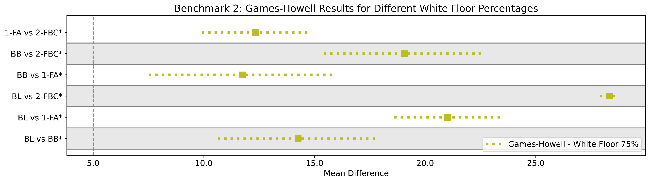
Figure S2. Tukey HSD (S2a) and Games-Howell (S2b) Post Hoc Test Results for Accuracy. (S2a) Tukey's HSD post hoc test results show pairwise comparisons of mean differences between BL, BB, 1-FA, and 2-FBC algorithms across white floor percentages (5%, 25%, 45%). At the 5% white floor configuration, the mean difference between BL and 2-FBC was -11.79 (p < 0.0001). In the 25% white floor scenario, 2-FBC outperformed BL with a mean difference of -21.85 (p < 0.0001). All tests were conducted at an alpha level of 0.05, with significant results showing rejection of the null hypothesis. (S2b) Games-Howell post hoc test results for accuracy under the 75% white floor configuration. The highest mean difference was recorded between BL and 2-FBC at 23.33 (p < 0.001), followed by BL and 1-FA (Mean Difference = 16.01, p < 0.001). Comparisons between BB and 2-FBC yielded a mean difference of 14.07 (p < 0.001). These results affirm that 2-FBC consistently delivers the most accurate performance across various configurations, tested at an alpha level of 0.05.

The robustness of the 2-FBC framework is clearly demonstrated in the Tukey’s HSD and Games-Howell post hoc tests, particularly under varying Byzantine robot counts. In Figure S3a, Tukey's HSD results for Byzantine Robot Count 0 indicate significant differences between Baseline and Blockchain Base (BB), as well as between BB and Two-Factor Authentication (2-FBC), showing that even without malicious agents, 2-FBC maintains improved performance. As the Byzantine robot count increases, particularly at Count 6, all algorithms reveal significant differences, with 2-FBC outperforming both BB and Single-Factor Authentication (1-FA). The increasing gaps in mean differences, especially between Baseline and 2-FBC, highlight the framework's resilience under adversarial conditions.
In Figure S3b, the Games-Howell test further confirms the robustness of 2-FBC under Byzantine attacks. The most notable differences appear at Byzantine Robot Count 9, where 2-FBC demonstrates its clear advantage with a significantly lower error rate compared to the Baseline and other blockchain-based solutions. The results show that 2-FBC is consistently able to mitigate the impact of Byzantine agents, keeping error rates considerably lower than BB and 1-FA as the count increases. The comparisons between BB and 2-FBC show a smaller but still significant performance gap, reinforcing the strength of the dual-layered defense against Byzantine behaviors.

A
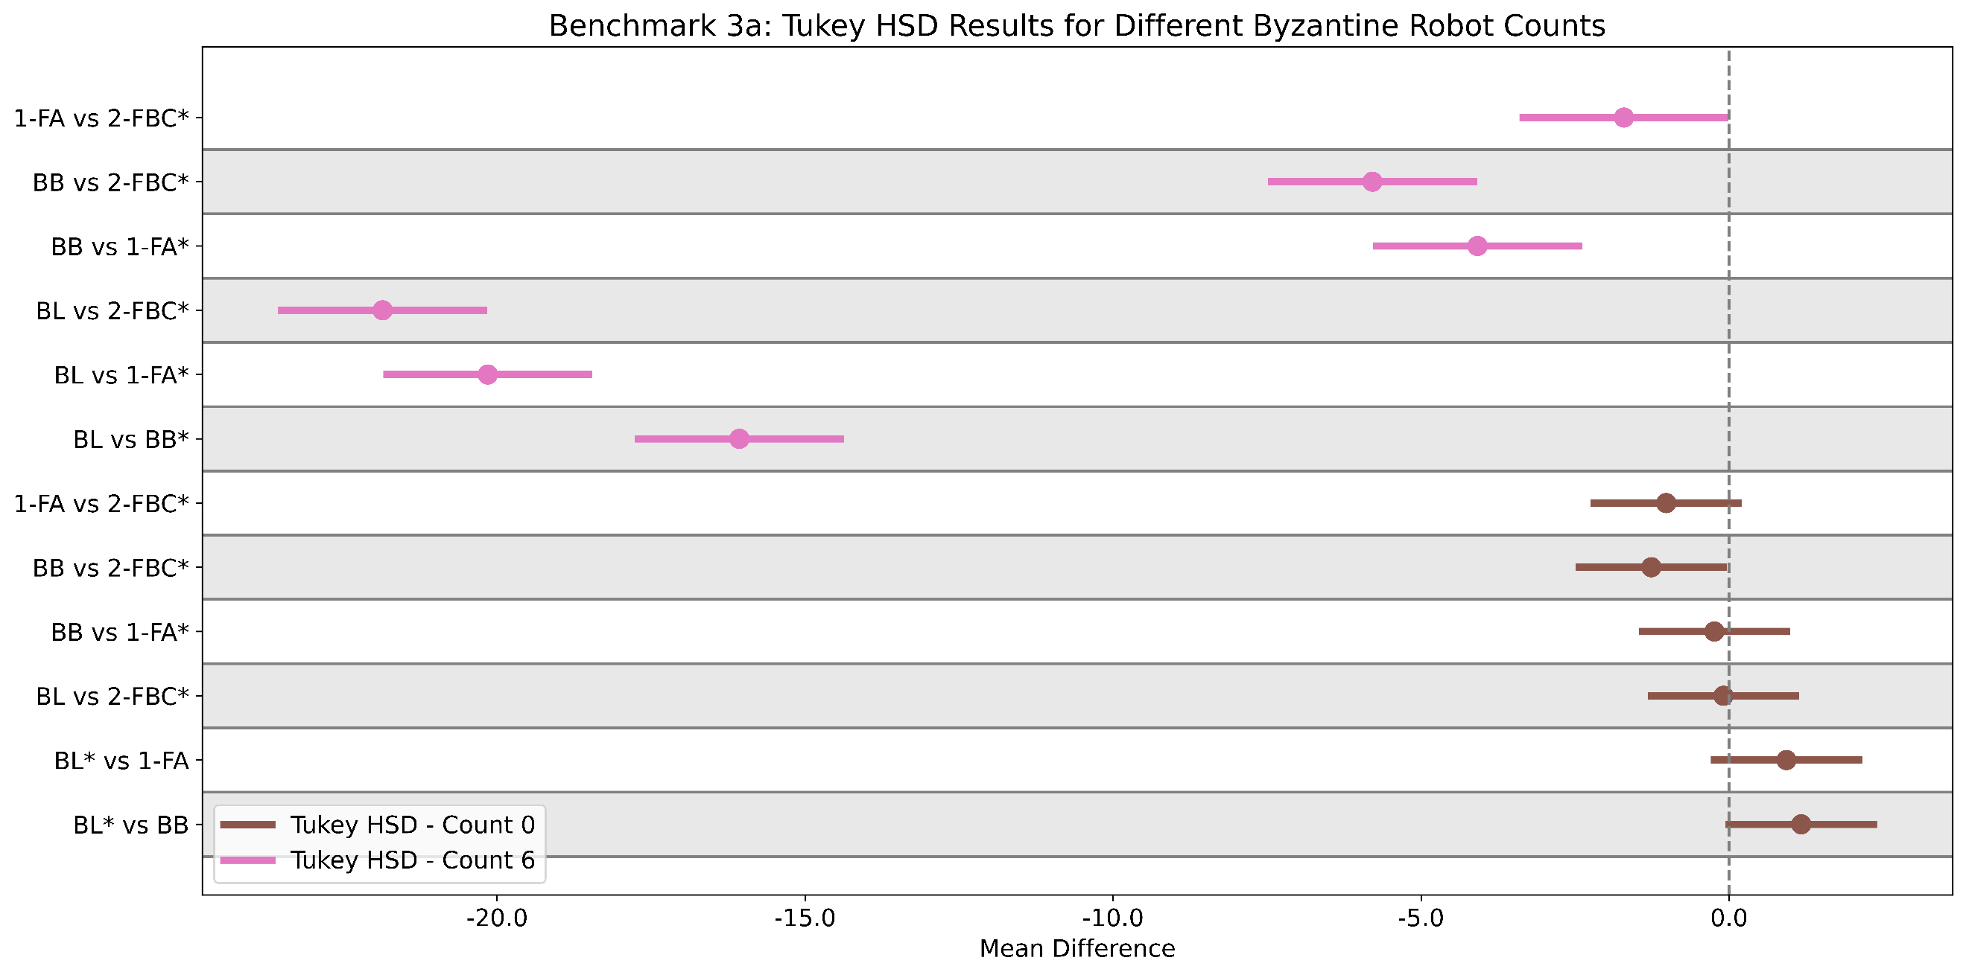
B
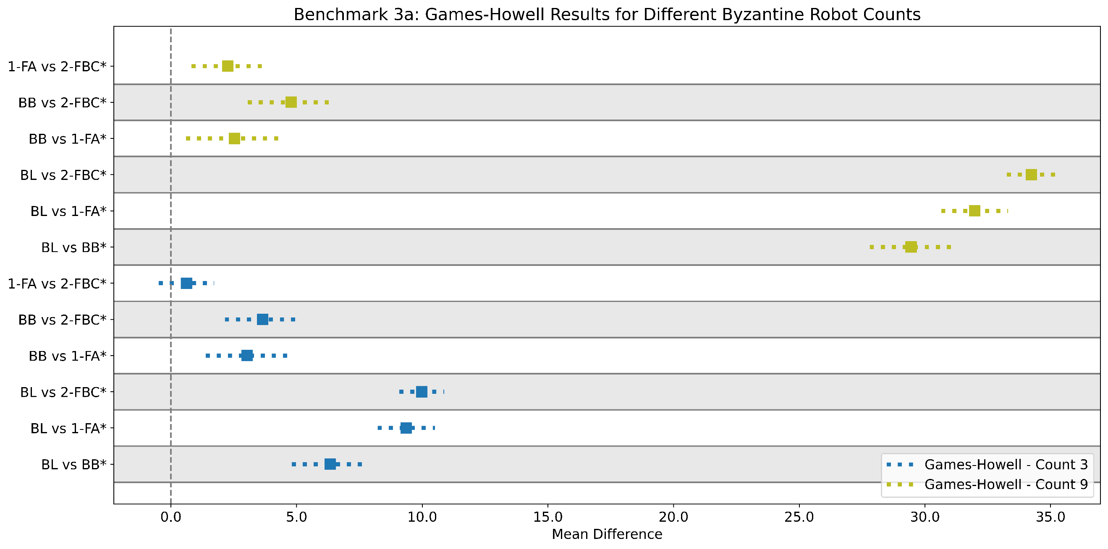
Figure S3. Tukey's HSD and Games-Howell post hoc test results for robustness against Byzantine robot counts. (S3a) Tukey's HSD results show pairwise comparisons between Baseline (BL), Blockchain Base (BB), Single-Factor Authentication (1-FA), and Two-Factor Blockchain Consensus (2-FBC) frameworks for Byzantine Robot Counts 0 and 6. At Count 0, significant differences appear between BL and BB (mean difference = 1.17, p = 0.0495), and between BB and 2-FBC (mean difference = -1.26, p = 0.029). At Count 6, notable differences include BL vs. 2-FBC (mean difference = -21.86, p < 0.001), highlighting 2-FBC’s superior performance. Tests were conducted at an alpha level of 0.05, with significant results indicated for true rejection of the null hypothesis. (S3b) Games-Howell post hoc test results for Byzantine Robot Counts 3 and 9. For Count 3, the highest mean difference was between BL and 2-FBC (mean difference = 9.98, p < 0.001). At Count 9, the mean difference between BL and 2-FBC increased further (mean difference = 34.23, p < 0.001). Comparisons between BB and 2-FBC also showed significant differences, with a mean difference of 4.78 at Count 9 (p < 0.001). These findings confirm the effectiveness of 2-FBC in reducing error across all Byzantine robot configurations.

In Figure S4a, the Tukey HSD post hoc test for Byzantine Attack Style 1 shows that the Baseline (BL) significantly underperforms compared to the blockchain-based methods (BB, 1-FA, and 2-FBC), with the largest mean difference being -21.86 (p < 0.001) for BL vs 2-FBC. This indicates the superior robustness of 2-FBC in mitigating Byzantine attacks. In contrast, for Attack Style 6, no significant differences were found among the methods, suggesting similar performances under certain conditions. These results highlight 2-FBC's consistent advantage in reducing error, especially under more challenging attack scenarios. In Figure S4b, the Games-Howell post hoc test confirms substantial differences across Byzantine attack styles, particularly in Attack Style 2, where the Baseline shows significant underperformance with mean differences of -40.88 (BB), -42.20 (1-FA), and -72.24 (2-FBC) (p < 0.001). Comparisons between BB and 1-FA in Attack Styles 3 and 4 show smaller, non-significant differences, while 2-FBC consistently outperforms the other methods in reducing error, especially in Attack Style 4, where it shows a mean difference of -2.78 (p < 0.01).

A
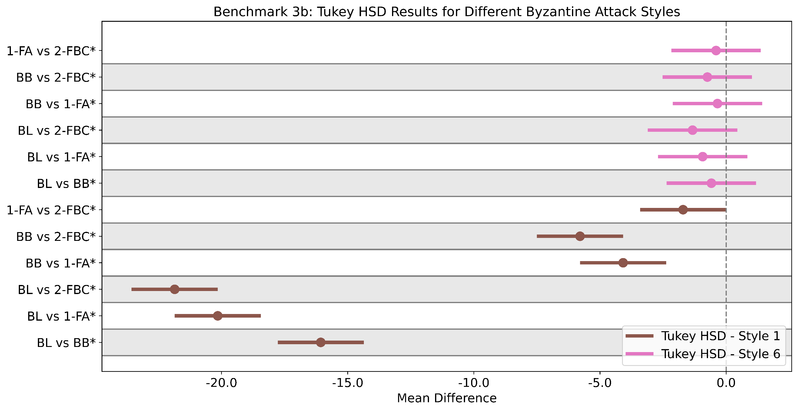
B
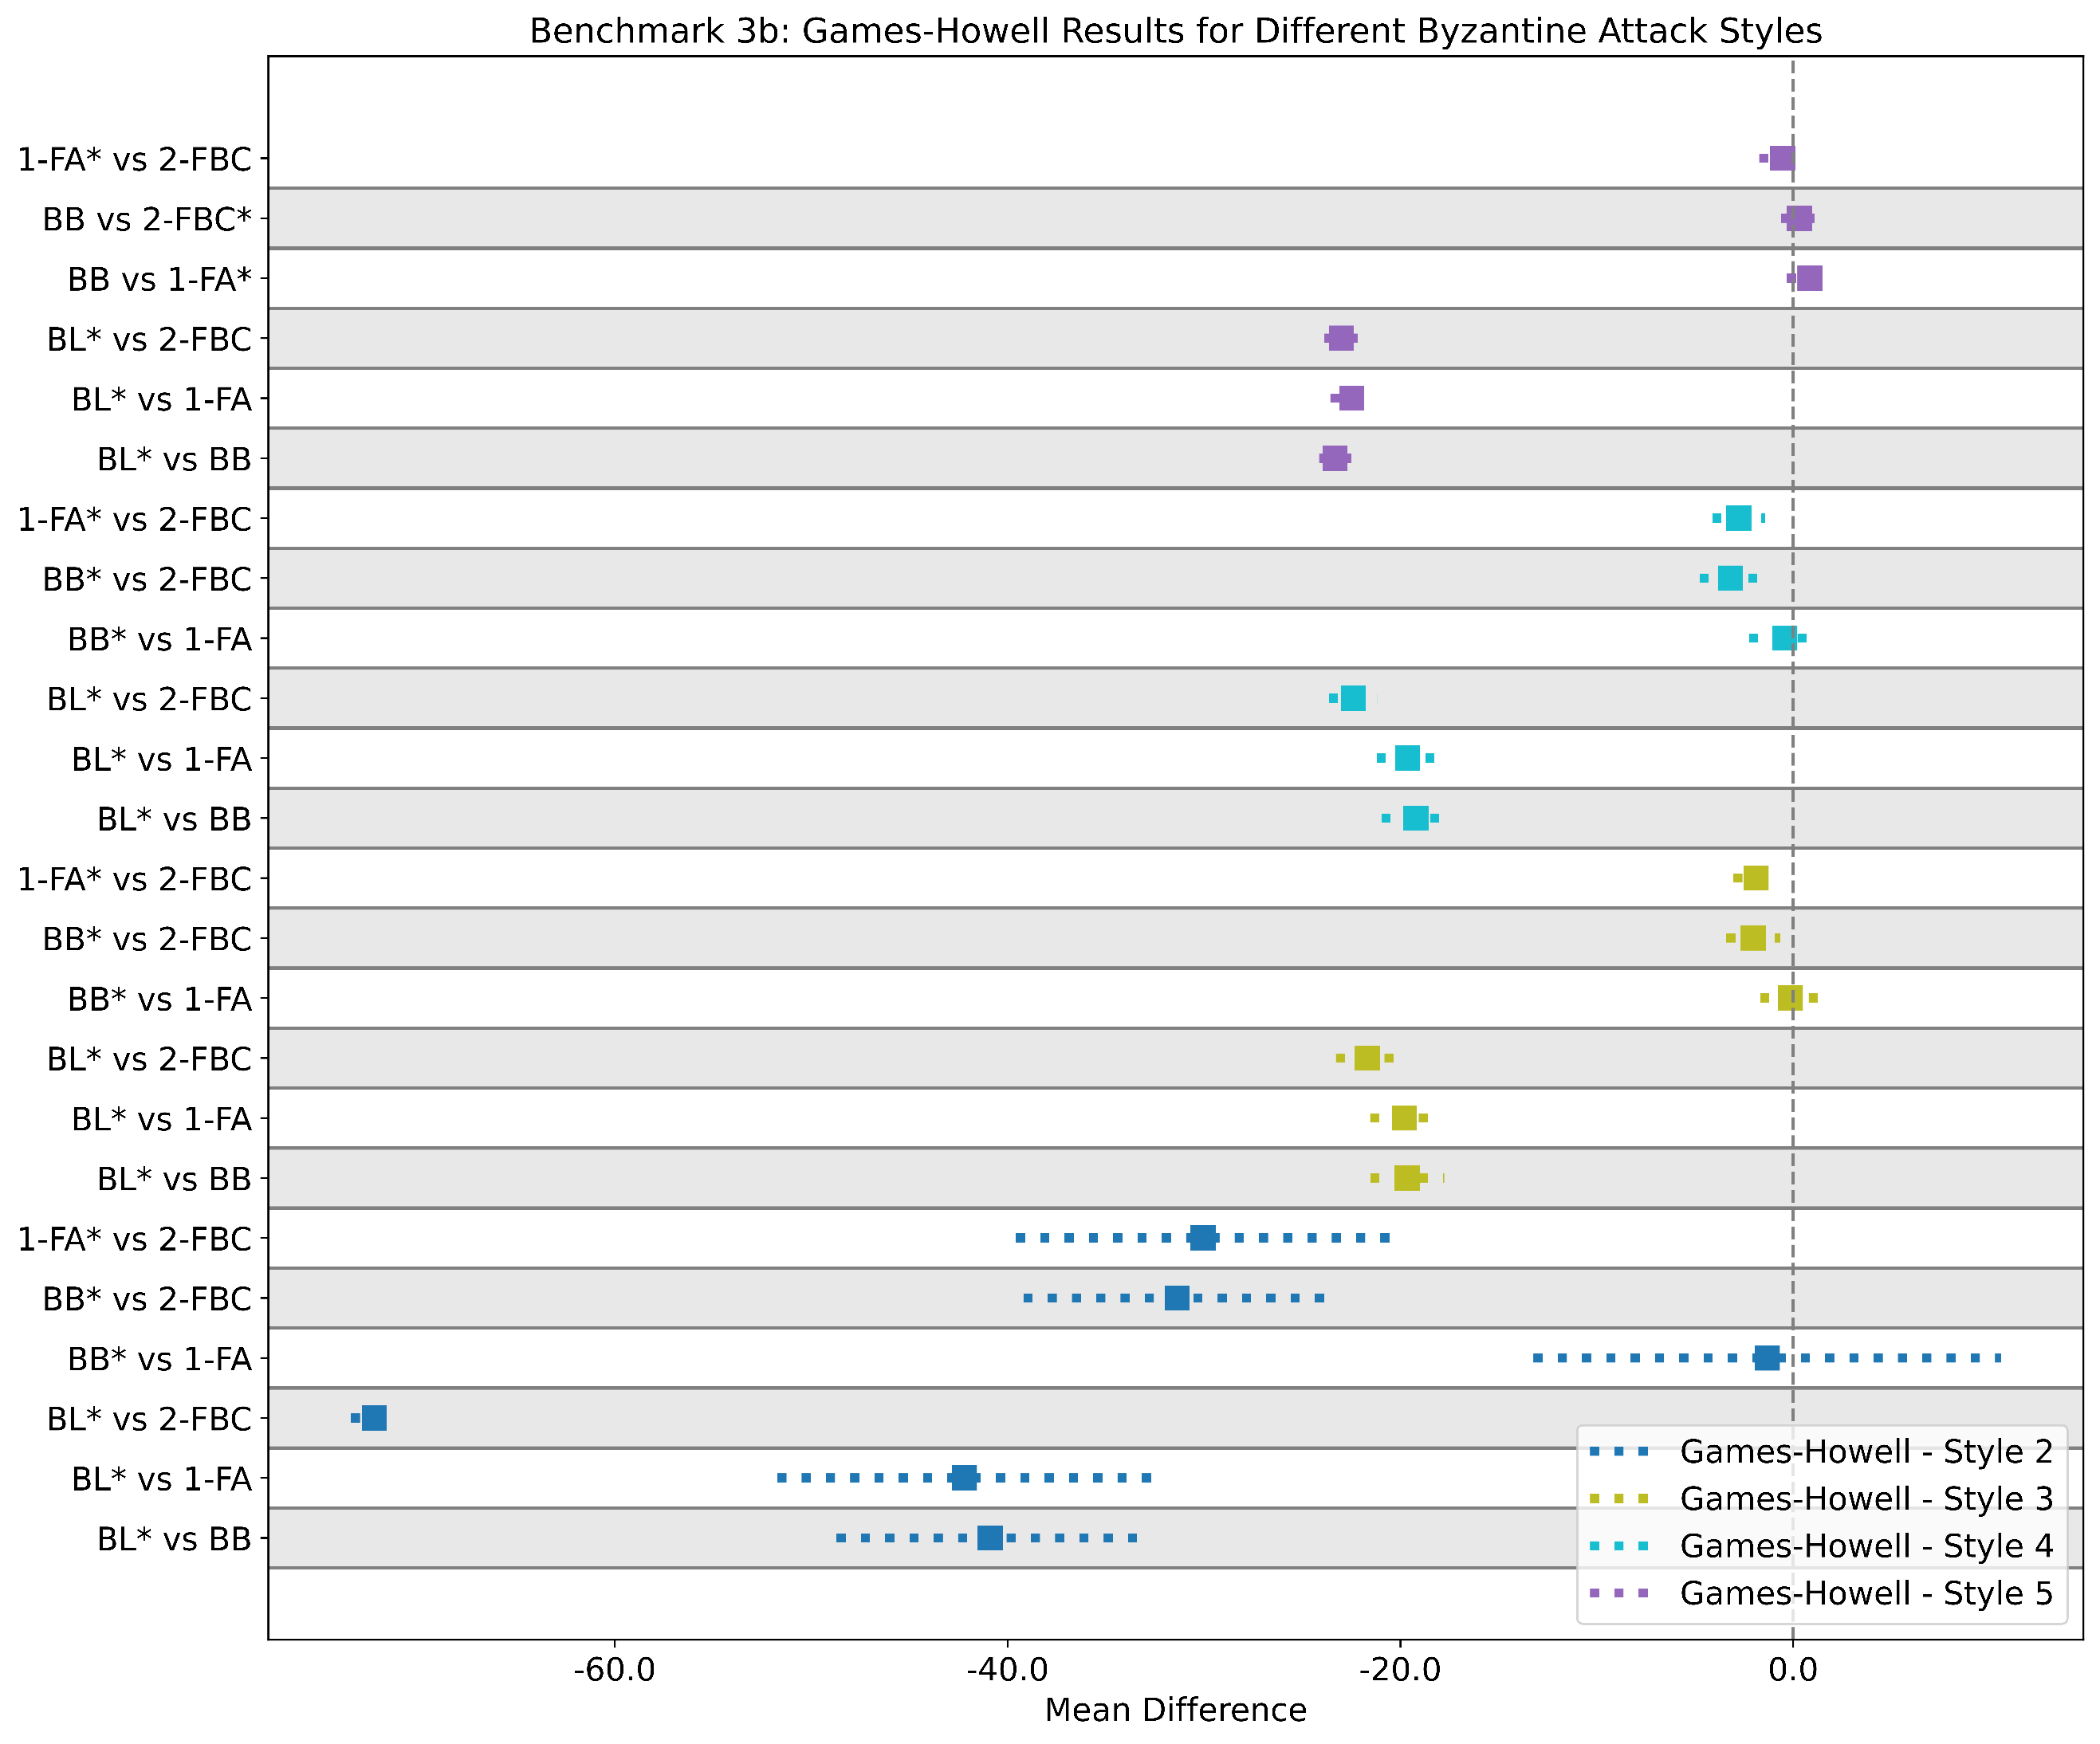
Figure S4. Post hoc test results for robustness under Byzantine attack styles. (S4a) Tukey HSD post hoc test results for Byzantine Attack Styles 1 and 6. In Attack Style 1, the Baseline significantly underperformed, with a mean difference of -21.86 (p < 0.001) compared to 2-FBC. For Attack Style 6, no significant differences were observed among the methods, with p-values > 0.05. (S4b) Games-Howell post hoc test results showing comparisons across various Byzantine attack styles. In Attack Style 2, BL had the highest error rates, with mean differences of -40.88 (BB), -42.20 (1-FA), and -72.24 (2-FBC) (p < 0.001). While comparisons between BB and 1-FA were non-significant in certain styles, 2-FBC consistently showed superior performance, particularly in Attack Style 4, with a mean difference of -2.78 (p < 0.01).

Supplementary Discussion

Dynamic Scalability and Threshold Tuning in OPV
In the experiments conducted, the 2-FBC framework's Off-chain Peer Verification (OPV) phase demonstrated adaptability in dynamically adjusting its thresholds for scalability. This phase is crucial for maintaining low error rates as swarm size increases, as it balances the trade-off between rapid consensus formation and error filtering. One of the key findings was that in larger swarms, the adaptive similarity threshold (θ) used in the OPV phase significantly impacted the system's performance. For instance, by starting with a wider threshold (0.8) and progressively narrowing it as more data was collected, the system effectively filtered out erroneous estimates, which was especially critical in attack scenarios involving uniform distribution and Bernoulli-based false reporting. This aspect of the 2-FBC framework, while hinted at in the main paper, deserves deeper consideration, as the flexibility of θ allows the framework to adapt to real-time environmental changes. A more fine-grained examination of the data shows that swarm sizes beyond 48 robots benefitted from a quicker narrowing of the similarity threshold, which enhanced the system’s ability to detect and eliminate Byzantine robots’ false reports early on, before the OCV phase. Future optimizations may explore refining this threshold, which may follow a more complex function based on robot movement patterns or environmental density.

Computational Load Distribution and Resource Management in OCV
While the primary results showcase 2-FBC’s ability to manage resources efficiently, supplementary tests revealed unique trends in CPU and RAM utilization across different swarm sizes during the OPV and OCV phases. The OCV phase, tasked with finalizing consensus by securing estimates on the blockchain, is inherently computationally intensive. However, the pre-filtering function of the OPV phase, which weeds out erroneous data before it reaches the blockchain, significantly reduces the burden on the OCV phase, preventing excessive CPU usage and limiting ledger bloat. This is especially important when simulating real-world, long-duration deployments. In tests running for over 10 hours, the OCV phase maintained stable CPU and RAM usage, even in the presence of 25% Byzantine robots. However, a notable trend emerged: when the percentage of deceptive robots was reduced to 5% or less, the OCV phase processed blockchain transactions more swiftly, confirming the efficiency of OPV’s pre-screening role in optimizing system performance. These findings highlight the critical task distribution between the OPV and OCV phases to ensure optimal performance, especially in larger swarms or extended deployments.
When analyzing resource consumption, it is evident that the 2-FBC framework, while highly secure, incurs higher CPU usage compared to the Blockchain Base (BB) and Single-Factor Authentication (1-FA) approaches, particularly in larger swarm configurations. For example, in a swarm of 24 robots, 2-FBC required 14.03% CPU resources, compared to 9.10% for BB and 9.57% for 1-FA. This gap widens as swarm size increases, with 2-FBC peaking at 17.07% CPU utilization in a swarm of 120 robots, presenting the computational cost of its enhanced security measures. Similarly, RAM utilization follows a distinct trend. For a 48-robot swarm, 2-FBC consumed 62.12% of available RAM, which is higher than 1-FA’s 46.74%, yet lower than BB’s 78.73%. This demonstrates that although 2-FBC requires more computational power, it strikes a balance by optimizing memory usage, especially when compared to BB, which consumes significantly more RAM as swarm sizes increase. For instance, BB reaches 78.7% RAM utilization at 48 robots, while 2-FBC is better contained at 62.12%.
While 2-FBC incurs a relatively higher computational load, this trade-off is worth considering for environments requiring heightened security. The framework’s increased CPU usage stems from its dual-layered approach—pre-filtering with OPV followed by blockchain validation in OCV—which inherently demands more processing power. However, the security and fault tolerance it brings, particularly in adversarial environments with Byzantine robots, may justify the added resource consumption. The key here is finding the balance: for critical applications like environmental monitoring or disaster response, where security cannot be compromised, the resource trade-off of 2-FBC becomes more acceptable. That said, achieving this balance between security and resource consumption is crucial. For operations requiring higher scalability or in resource-constrained settings, adopting a carefully tuned 2-FBC configuration can ensure security without overwhelming system resources. By adjusting parameters such as swarm size and robot behaviors, organizations can tailor the system to strike the right balance between performance and security, ensuring that no system is overly burdened while still benefiting from the robust protection offered by the blockchain framework. This flexibility makes 2-FBC not just a high-security solution, but a scalable one that can adapt to varying real-world needs.

Examination of Byzantine Attack Styles
The versatility of the 2-FBC framework in responding to various Byzantine attack styles is critical in ensuring swarm reliability and security. While the main paper focuses on the general performance of 2-FBC across these attacks, it is essential to break down the specific attack styles to examine the robustness of the framework. Each of these attacks mimics real-world scenarios where adversarial robots attempt to skew consensus by injecting misleading data into the swarm.
Supplementary discussions are provided in this section, referencing Figure 3b in the main paper. In the Constant 0% estimate (Attack 1) and Constant 100% estimate (Attack 2) attacks, the OPV phase of 2-FBC was highly effective in quickly flagging these extreme values, preventing them from influencing the collective estimate during the OCV phase. These attacks proved challenging for other frameworks—particularly the baseline (BL), where the 100% estimate attack caused an absolute error of 74.96%. In contrast, 2-FBC maintained a low error of 2.71%, showcasing its ability to contain the impact of such extreme values.
The Bernoulli-based attack (Attack 3), where Byzantine robots randomly report either 0% or 100% based on a probability distribution, posed a greater challenge because these robots occasionally report both extreme estimates. Here, the similarity threshold mechanism within the OPV phase was crucial in filtering outliers, preventing them from being accepted as legitimate data. Despite this attack being one of the most deceptive, 2-FBC still managed to maintain a low absolute error of 2.32%, far outperforming the BB (9.55%) and 1-FA (8.54%) frameworks.
In the Uniform distribution-based attack (Attack 4), Byzantine robots reported random percentages between 0% and 100%. This attack style introduced significant variability, yet the 2-FBC framework again outperformed both BB and 1-FA. The adaptive filtering mechanism in OPV, combined with quorum slices in OCV, allowed 2-FBC to filter the noise effectively and finalize consensus with minimal disruption.
The Flooding or spamming of 0% estimate (Attack 5) demonstrated how the OPV phase's ability to quickly identify repetitive or excessively frequent inputs played a pivotal role in maintaining low error rates. The flooding attack overwhelmed other frameworks with excess data, yet 2-FBC’s design successfully mitigated this, showing minimal performance degradation. Not only this, but the use of the token economy has presented itself as an effective means of deterring attacks that try to flood the communication channels. This means that Byzantine robots cannot sustain this type of attack as they would run out of tokens to send out estimates to the swarm.
Finally, in the Eavesdropping attack (Attack 6), which involved passive listening without active data manipulation, all frameworks performed similarly, as this attack did not directly interfere with data transmission. This attack further highlighted the resilience of 2-FBC to passive threats, ensuring that no unnecessary computational resources were wasted in addressing non-invasive adversarial behavior. However, a point of improvement for analyzing this attack is the ability to monitor the wallets or token accounts of the swarm agents over time. Since conforming robots are rewarded for their correct and peer-validated estimates, it is expected that over time, those conforming to the consensus would accumulate more tokens than they initially started with. In contrast, robots engaging in passive eavesdropping would likely show no progression in their token balance, which could signal potentially malicious or unproductive behavior within the swarm.
These observations are further corroborated by the error distributions shown in Figure 3b. The 2-FBC framework consistently achieved the lowest mean absolute error, even in the most challenging scenarios such as the 100% estimate attack (2.71% error compared to 74.96% in BL). These results were statistically significant, as confirmed by Welch’s ANOVA and post hoc tests outlined under the Supplementary Results section.

Supplementary Methods

Materials and Equipment
The simulation utilizes Docker Swarm containers to manage programs running on each swarm agent via a base station, ensuring resource efficiency and establishing blockchain network connectivity. This setup allows for the development, benchmarking, and testing of algorithms within the ARGoS simulator, a widely used platform in swarm robotics. ARGoS facilitates the comparison of the 2-FBC with state-of-the-art algorithms by simplifying analysis through two-dimensional robot movements. To closely emulate physical robots' communication architecture, we implemented a two-layered approach within the ARGoS simulator, using the range-and-bearing module for detecting peers within 10 cm and TCP connections via Docker for data exchange between robots.
We selected the E-Puck robot as the benchmark platform for our proposed algorithm due to its robust design and versatility in both research and educational contexts. The E-Puck robot is equipped with a range of sensors, including infrared proximity sensors, a 3-axis accelerometer, a microphone, and a camera, enabling it to navigate complex environments and collaborate with other robots. Its modular design allows for easy integration of additional sensors and actuators, making it an ideal choice for testing advanced algorithms in swarm robotics. The E-Puck's compatibility with the ARGoS simulation environment, along with its extensive use in swarm robotics research, ensures accurate simulation of real-world scenarios, providing a reliable basis for evaluating the performance of the 2-FBC framework.

Byzantine Faults
Byzantine faults, also referred to as Byzantine robots, drones, failures, or nodes, are entities within the swarm that may appear normal but act maliciously to compromise the system's security. In all experiments, Byzantine faults were randomly chosen to exhibit behaviors that aimed to disrupt and infiltrate the swarm’s security. These faults perform various cyber-attacks, including false message injection, flooding message broadcasts, eavesdropping, and identity spoofing. The specific attacks tested in this study include:
- Attack 1: consistent reporting of 0% white tiles
- Attack 2: consistent reporting of 100% white tiles
- Attack 3: reporting 0% or 100% white tiles based on a Bernoulli distribution
- Attack 4: randomly determining percentages from a uniform distribution
- Attack 5: continuously flooding 0% estimates
- Attack 6: passive eavesdropping without participating in consensus voting
Attacks 1 through 4 are examples of false message injection, attack 5 involves flooding message broadcast, and attack 6 represents eavesdropping. Identity spoofing plays a crucial role in these attacks, allowing Byzantine faults to impersonate legitimate swarm members, disrupt consensus, and infiltrate communication channels, thus testing the resilience and security of the 2-FBC framework.

Two-factor Blockchain Consensus (2-FBC) Algorithms
The Two-Factor Blockchain Consensus (2-FBC) framework combines an off-chain peer verification phase (OPV) with an on-chain consensus validation (OCV) phase, inspired by traditional two-factor authentication models. In 2-FBC, robots first verify the integrity of their sensed data (e.g., the percentage of white tiles detected) off-chain by comparing their estimates with peers in the OPV phase. If consensus is reached based on similarity thresholds, the estimates are signed and submitted to the blockchain for final validation through smart contracts in the OCV phase. This dual-layered approach allows the swarm to reach secure consensus even in dynamic environments and under Byzantine conditions. See Algorithm S1 for the pseudo-code description of 2-FBC.
Algorithm S1: Two-Factor Blockchain Consensus (2FBC) Framework
Input: Robot Data (estimates, public keys), Blockchain Network
Output: Authenticated Estimates on Blockchain, Consensus
1: | FOR each robot $i$ in $swarm$ DO
2: | Perform $OPV Phase (Algorithm 4.2)$
3: | IF OPV successful THEN
4: | Submit estimate to blockchain
5: | Perform $OCV Phase (Algorithm 4.3)$
6: | END IF
7: | END FOR

Off-chain Peer Verification (OPV) Phase Algorithm
The OPV phase ensures that robots in the swarm first achieve local consensus before involving the blockchain. Each robot compares its environmental estimate with its peers and assigns a similarity score. The similarity threshold decreases over time, reflecting improved estimates from increased exploration. Once a robot's similarity score meets a predefined threshold (e.g., 1/12 of the swarm size), it cryptographically signs its estimate and prepares it for the on-chain validation phase. This step helps reduce computational overhead and allows faster agreement among robots. See Algorithm S2 for the pseudo-code description of the OPV phase.
Algorithm S2: Off-Chain Peer Verification (OPV) Phase
Input: Robot Data (estimates, public keys)
Output: Signed Estimate if Consensus Reached
1: | FOR each robot $i$ in swarm DO
2: | CALCULATE $E_{i}=\frac{(0.5+totalWhite)}{(totalWhite+totalBlack+1)}$
3: | FOR each robot $j≠i$ DO
4: | Receive $E_{j}$ from robot $j$
5: | Calculate $S_{i}=\sum{I(\left|E_{i}-E_{j}\right|≤θ)}$
6: | END FOR
7: | IF $S_{i}≥ \left\lceil \frac{N}{12}\right\rceil$ THEN
8: | Sign $E_{i}$ with public key
9: | RETURN signed $E_{i}$
10: | ELSE
11: | Continue verification
12: | END IF
13: | END FOR

On-chain Consensus Validation (OCV) Phase Algorithm
The OCV phase finalizes the consensus through smart contracts on a private blockchain. Signed estimates submitted by robots undergo rigorous verification checks, including signature authenticity, peer registration status, and a token stake mechanism to incentivize accurate voting. Votes are aggregated to form the preliminary swarm estimate, and a second round of filtering removes outliers. The final consensus is then reached through a quorum slice mechanism, ensuring a decentralized and trust-based consensus formation process. The trust and similarity factors from the OPV phase influence the weight of votes in the final consensus. See Algorithm S3 for the pseudo-code description of the OCV phase.
Algorithm S3: On-chain Consensus Validation (OCV) Phase
Input: Signed Estimates
Output: Final Consensus Estimate on Blockchain
1: | FOR each signed estimate DO
2: | Verify signature authenticity
3: | Check $S_{i}≥\left\lceil \frac{N}{12}\right\rceil$
4: | Verify peer registration
5: | Check 40 token stake
6: | IF all checks pass THEN
7: | Accept estimate as $vote$
8: | ELSE
9: | Discard $estimate$
10: | END IF
11: | END FOR
12: | Calculate preliminary swarm estimate $M=mean(votes)$
13: | FOR each vote in second round DO
14: | Discard votes deviating more than $Δ=0.2$ from $M$
15: | Recalculate $swarm estimate$
16: | END FOR
17: | Adjust $trust scores$
18: | Calculate $M_{new}=M+\frac{ω_{i}∙ΔV_{i}}{W_{n+1}}$
19: | RETURN $M_new$

Calculation of the Baseline Results
In our study, the baseline serves as a reference point to evaluate the performance of the swarm without any advanced security measures like blockchain or outlier detection. It is calculated by simply averaging the individual estimates of the robots after each run, with no additional filtering or consensus mechanisms in place. This straightforward approach allows us to measure how the swarm behaves in a scenario where no Byzantine fault-tolerance techniques are applied. Although more sophisticated algorithms, such as Byzantine linear consensus protocols, could have been considered, prior research has shown that these methods are not resilient to certain attacks like Sybil attacks. Furthermore, they lack key features such as data logging, non-repudiation, and the execution of decentralized programs, which are integral to our blockchain-based approach. Therefore, this basic averaging approach offers a clear and unbiased comparison to highlight the advantages of our proposed Two-Factor Blockchain Consensus (2-FBC) framework in enhancing both security and accuracy in swarm operations.

Experimental Setup Instructions
This section provides a step-by-step guide for the setup of the simulator and environment utilized in this study. It begins with the installation of the ARGoS simulator, followed by the integration of the ARGoS e-puck plugin to simulate the behavior of the E-puck robots. The section also covers the installation of Docker, which is used to manage containerized environments for easier setup and execution. Detailed instructions for setting up the simulation framework and configuring the variables for each experiment are referenced. This setup is primarily based on the work of Strobel et al. in 2023¹, as one of the algorithms we compare against, the blockchain base, is derived from their work. We only added new experimental configurations and setups to test additional scenarios and enhancements introduced by our framework.

Installation of ARGoS
The main simulation software utilized in all of the experiments is ARGoS, as discussed in the main paper (See Methods). This section of the supplementary material discusses the installation instructions for the simulator. In our simulations, we use Ubuntu 20.04 as our operating system. Additionally, having basic command line interface knowledge in Linux is recommended to easily follow along the instructions. Execute the codes line-by-line
- Install git and build-essential to conveniently obtain the source code of ARGoS.
$ sudo apt-get install git build-essential -y
$ sudo apt update
- Create a directory where all of the experimental setups will be located. Here, we call the directory `exp-setup`. This would serve as the “root directory” of the installation and setup instructions.
$ mkdir exp-setup
$ cd exp-setup
- ARGoS may be downloaded directly from the `argos-sim` website as binary packages across different operating systems². However, we recommend you install the program directly by obtaining the source code in GitHub. You may do so by using the command:
$ git clone https://github.com/ilpincy/argos3.git
- Be sure to install the dependencies of ARGoS.
$ sudo apt-get install cmake g++ libfreeimage-dev libfreeimageplus-dev \
libxi-dev libxmu-dev lua5.3 doxygen graphviz graphviz-dev qt5-default \
asciidoc liblua5.3-dev freeglut3-dev
- Navigate to the cloned directory.
$ cd argos3/
- Make `build` directory and build ARGoS.
$ mkdir build
$ cd build/
$ cmake ../src
$ make
$ make doc
- Install ARGoS.
$ sudo make install
$ sudo ldconfig
- Check if your installation is correct by verifying the version of ARGoS.
$ argos3 --version
- This should return the version. In our experiments, we have utilized the following:
ARGOS_VERSION=3.0.0-beta59
ARGOS_INSTALL_PREFIX=/usr/local
ARGOS_USE_DOUBLE=ON
ARGOS_WITH_LUA=ON
ARGOS_BUILD_FLAGS= -Wall -Wno-unknown-pragmas -O3 -DNDEBUG -O3 -DNDEBUG

Installation of ARGoS E-Puck plugin
ARGoS provides users with the ability to load and utilize the E-Puck platform for simulations. In our study, this was installed using the following codes.
- Navigate back to the root directory of the project.
$ cd ~/exp-setup/
- Similarly, the E-Puck platform³ may be obtained directly from the `argos-sim` website. However, we recommend obtaining the source code hosted on GitHub for better customization and control.
$ git clone https://github.com/demiurge-project/argos3-epuck.git
- Navigate to the cloned directory.
$ cd argos3-epuck/
- Make `build` directory and build the plugin obtained.
$ mkdir build
$ cd build/
$ cmake ../src
$ make
- Install plugin.
$ sudo make install
$ sudo ldconfig

Installation of Docker
Given the discussion of the setup in the main paper (See Methods), we outline and discuss the steps necessary to install and set Docker up for the experiments. Full instructions and guidelines may be located in Docker’s website for the Ubuntu operating system. In this section, we simply present the only steps taken in installing Docker for our experiments which includes installation using the `apt` repository.
- Add Docker’s GPG keys to set up the apt repository.
$ cd ~/exp-setup/
$ sudo apt-get update
$ sudo apt-get install ca-certificates curl
$ sudo install -m 0755 -d /etc/apt/keyrings
$ sudo curl -fsSL https://download.docker.com/linux/ubuntu/gpg -o /etc/apt/keyrings/docker.asc
$ sudo chmod a+r /etc/apt/keyrings/docker.asc
- After, add this to the Apt sources and update.
$ echo \
"deb [arch=$(dpkg --print-architecture) signed-by=/etc/apt/keyrings/docker.asc] https://download.docker.com/linux/ubuntu \
$(. /etc/os-release && echo "$VERSION_CODENAME") stable" | \
sudo tee /etc/apt/sources.list.d/docker.list > /dev/null
$ sudo apt-get update
- Install the necessary Docker packages
$ sudo apt-get install docker-ce docker-ce-cli containerd.io docker-buildx-plugin docker-compose-plugin
- In order to check and verify if your installation is correct, run the following:
$ sudo docker run hello-world
- Notice that execution of Docker commands requires root user privileges. To utilize the experimental setup codes that use Docker, we configure this to allow non-root users to use Docker without `sudo` access.
$ sudo groupadd docker
$ sudo usermod -aG docker $USER
$ newgrp docker
- To ensure that restarting Docker engine is also possible as non-root users, add an entry in the sudoers file.
$ sudo visudo -f /etc/sudoers.d/docker
- This will prompt a text editor. Add the following with <user> replaced with your username.
<user> ALL= NOPASSWD: /bin/systemctl restart docker.service
<user> ALL= NOPASSWD: /bin/systemctl start docker.service
<user> ALL= NOPASSWD: /bin/systemctl stop docker.service
- Test the non-root user access in a new terminal running the following.
$ docker run hello-world

Installation of Simulation Framework Dependencies
For the experimental setup, we utilize Strobel et al.’s simulation framework (2023)¹. As such, refer to their setup for full instructions on the simulation framework. In this section, we present the dependencies required.
- Install the following dependencies to run the simulation framework.
$ sudo apt-get install g++ cmake git libboost-python-dev
- Since smart contracts in the study are written using Solidity, install the `solc` compiler.
$ sudo add-apt-repository ppa:ethereum/ethereum
$ sudo apt-get update
$ sudo apt-get install solc
- Install additional Python requirements to run the codes.
$ sudo apt install python3-pip
$ pip3 install rpyc psutil

Execution of Experimental Runs
In order to run the experiments, you may use the starter scripts obtained from Strobel et al. in 2023¹ by going into the base folder of the experiment and executing the code to start the first experiment:
$ source starters/G1/starter.sh
To proceed with the execution of our experiments, the custom environments and experimental runs are outlined in the main paper (See Methods). The smart contracts were altered and developed to employ the 2-FBC framework that follows Supplementary Algorithms S1, S2, and S3 for reference.

Supplementary Material References
1. Strobel, V., Pacheco, A. & Dorigo, M. Robot swarms neutralize harmful Byzantine robots using a blockchain-based token economy. Sci Robot 8, (2023).
2. Pinciroli, C. et al. ARGoS: A modular, parallel, multi-engine simulator for multi-robot systems. Swarm Intelligence 6, 271–295 (2012).
3. Mondada, F. et al. The e-puck, a Robot Designed for Education in Engineering. Proceedings of the 9th Conference on Autonomous Robot Systems and Competitions 1, 59–65 (2009).

