Supporting information
Polyimide nanofiber aerogel with hierarchical porosity: a novel platform in high-temperature oil absorption
Lidong Tian^{a*}, Yi Zhang ª, Yibin Liu ª, Shan Zhang^{b*},
ª College of Materials Science and Engineering, Xi’an University of Science and Technology, Xi’an, Shaanxi 710054, P. R. China.
^{b} Institute of New Materials and Technology, Shaanxi Coal and Chemical Technology Institute Co.,Ltd., Xi’an, Shaanxi 710100, P. R. China.
E-mails: ldtian@xust.edu.cn (Lidong Tian); zhangshanzs33@163.com (Shang Zhang)

Figure S1 SEM images of PI nanofibers: (a) overall morphology and (b) single PI fiber morphology.

Figure S2 Density and porosity of PSF, PIF and PIF-a.

The density of the PSF, PIF and PIF-a were calculated from the following formula:
$ρ_{areogel}=m/V$ (1)
where m and V were the weight and volume of the aerogel or nanofibers, respectively.
The porosity was calculated using the following formula:
$Porosity\left(\%\right)=(1-{ρ_{areogel}}/{ρ_{a}})×100$ (2)
where $ρ_{areogel}$ and $ρ_{a}$ were the volumetric mass densities of the PI aerogel and synthesized PI or PS, respectively. $ρ_{a}$ of synthesized PI is 1.37 g/cm³, $ρ_{a}$ of PS is 1.06 g/cm³.

Table S1 Thermogravimetric data of PIF-a and PSF
Sample | T_{initial} (℃)ª | T_{5% loss} (℃)^{b} | T_{10% loss} (℃)^{c}
PIF-a | 356 | 505 | 533
PSF | 101 | 299 | 322
ª the initial thermal decomposition temperature, measured by TGA in nitrogen.
^{b} the 5% quality loss temperature, measured by TGA in nitrogen.
^{c} the 10% quality loss temperature, measured by TGA in nitrogen.

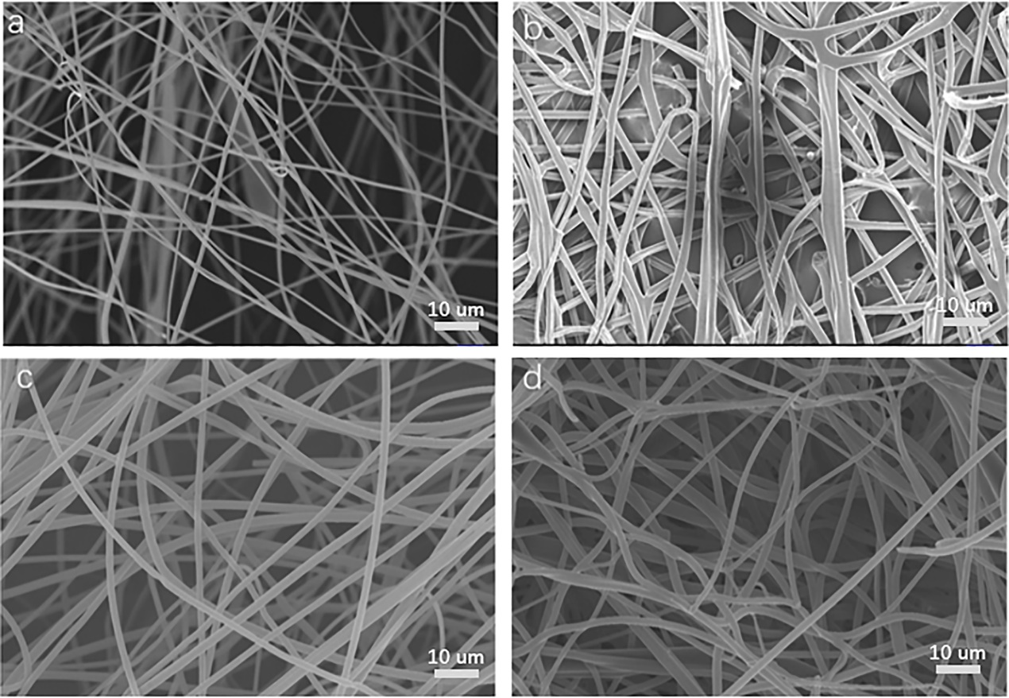
Figure S3 (a) SEM image of PSF under room temperature, (b) SEM image of PSF under 150℃, (c) SEM image of PI nanofibers under room temperature, (d) SEM image of PI nanofibers under 150℃.

Table S2 Nitrogen physisorption characterization of PSF under different temperatures
Sample | SSAª  (m2 g⁻¹) | TPV^{b}  (cm³ g⁻¹) | V_{meso}^{c}  (cm³ g⁻¹) | V_{macro}^{d}  (cm³ g⁻¹) | APS^{e}  (nm)
PIF-a-150 | 36.25 | 0.09 | 0.07 | 0.02 | 31.2
PIF-a-200 | 36.18 | 0.09 | 0.07 | 0.02 | 31.2
PIF-a-250 | 36.21 | 0.09 | 0.07 | 0.02 | 31.2
PIF-a-300 | 9.13 | 0.04 | 0.01 | 0.03 | 60.4
ª Specific surface area (SSA) is calculated by the Brunauer-Emmett-Teller (BET) method.
^{b} TPV means the total pore volume.
^{c} V_{meso} indicates the mesopore (2–50 nm) volume calculated by the BJH method.
^{d} V_{macro} indicates the macropore (>50 nm) volume calculated by the BJH method.
^{e} APS indicates the adsorption average pore width calculated by the BET method (4V/A by BET).

