Supporting Information for
Climate change induces rapid growth of dead ice in Asian glaciers

Qiong Wang^{1,2}, Xin Wang^{1*}, Keqin Duan², Shiyin Liu³, Yongsheng Yin⁴, Qiao Liu⁴, Jinping He², Yong Zhang¹, Junfeng Wei¹, Zongli Jiang¹

*Xin Wang (wangx@hnust.edu.cn)

This PDF file includes:

Figure S1
Table S1

Supporting Figure
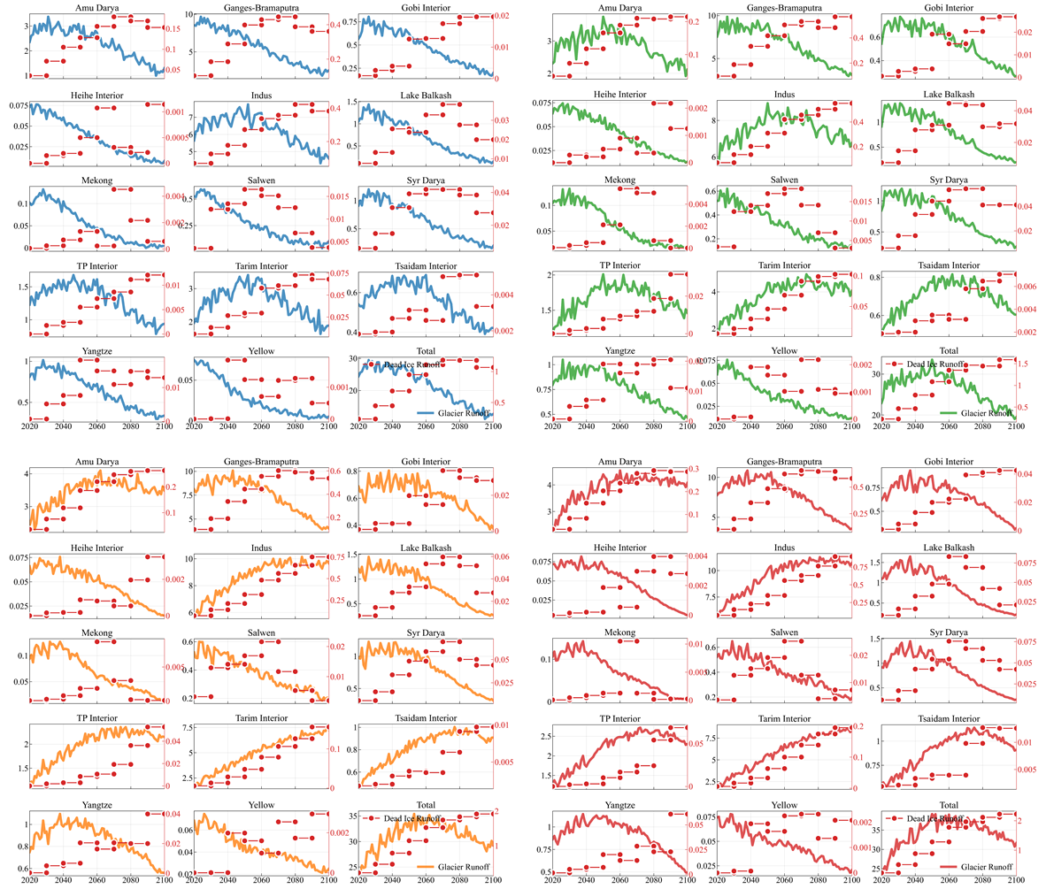
Figure S1. Runoff variation of glacier (blue: SSP1-2.6, green: SSP2-4.5, orange: SSP3-7.0, red: SSP5-8.5) and dead ice (red lollipop) in HMA under different SSPs. The black axis is the runoff of glacier (unit: Gt), and the red axis is the runoff of dead ice (unit: Gt).

Supporting Table
Table S1. CMIP6 GCMs ensemble information
No. | GCM | Institution | Lon × Lat | Country
1 | ACCESS-CM2 | CSIRO-ARCCSS | 1.8°×1.2° | Australia
2 | ACCESS-ESM1.5 | CSIRO | 1.8°×1.2° | Australia
3 | AWI-CM 1.1 MR | AWI | 0.9°×0.9° | Germany
4 | BCC-CSM 2 MR | BCC | 1.1°×1.1° | China
5 | CanESM5 | CCCma | 2.8°×2.8° | Canada
6 | CanESM5 | CCCma | 2.8°×2.8° | Canada
7 | CAS-ESM2-0 | CAS | 1.4°×1.4° | China
8 | CESM2-WACCM | NCAR | 1.3°×1.0° | America
9 | CMCC-CM2-SR5 | CMCC | 0.9°×0.9° | Europe
10 | CMCC-ESM2 | CMCC | 1.3°×0.9° | Europe
11 | EC-Earth3 | EC-Earth-Cons | 0.7°×0.7° | Europe
12 | EC-Earth3-LR | EC-Earth-Cons | 0.7°×0.7° | Europe
13 | EC-Earth3-Veg | EC-Earth-Cons | 0.7°×0.7° | Europe
14 | FGOALS-f3-L | CAS | 2.3°×2.0° | China
15 | FGOALS-g3 | CAS | 2.3°×2.0° | China
16 | GFDL-ESM4 | NOAA-GFDL | 1.3°×1.0° | America
17 | IITM-ESM | CCCR-IITM | 1.9°×1.9° | India
18 | INM-CM4-8 | INM | 2.0°×1.5° | Russia
19 | INM-CM5-0 | INM | 2.0°×1.5° | Russia
20 | IPSL-CM6A-LR | IPSL | 2.5°×1.3° | France
21 | KACE-1.0-G | NIMS-KMA | 2.2°×2.2° | South Korea
22 | MIROC6 | MIROC | 1.4°×1.4° | Japan
23 | MPI-ESM1.2-HR | DKRZ | 0.9°×0.9° | Germany
24 | MPI-ESM1.2-LR | MPI-M | 2.0°×2.0° | Germany
25 | MRI-ESM2.0 | MRI | 1.1°×1.1° | Japan
26 | NorESM2-LM | NCC | 2.5°×1.9° | Norway
27 | NorESM2-MM | NCC | 0.9°×0.9° | Norway
28 | TaiESM1 | AS-RCEC | 0.9°×1.3° | China

