Supplementary material

Contents
Appendix A: Inclusion and exclusion criteria 2
Appendix B: Candidate vaccine 3
Peptide selection 3
Appendix C: Assessment of adverse events 4
Assessment of causality 4
Definition of Adverse Event of Special Interest (AESI) 4
Definition of Serious Adverse Event (SAE) 4
Definition of Suspected Unexpected Serious Adverse Reaction (SUSAR) 5
Appendix D: Immunological analysis methods 6
Vaccine-specific antibody response using Luminex 6
Cell mediated immunity 6
Covid19 peptides 6
Dextramers 7
HLA-typing 7
Covid-19–specific CD8⁺ T cells by AIM (activation-induced markers) 7
Dextramer+ CD8+ T cells 8
Memory subsets 8
Appendix E: Results 11
Serology anti-SARS-CoV-2 12
AIM 13
HLA typing 16
Dextramers 17
Covid19 Memory CD8 18
Baseline profile 22
Appendix F: References 24

Appendix A: Inclusion and exclusion criteria
This study included healthy men and healthy, non-pregnant, non-breastfeeding women between the ages of 18 and 45 years old who were living in Switzerland.
Inclusion Criteria | An individual must fulfil all of the following criteria in order to be eligible for trial enrolment:  - Aged 18 to 45 years on the day of inclusion  - Participant signed informed consent  - Living in Switzerland
Exclusion Criteria | An individual fulfilling any of the following criteria was excluded from enrolment:  - Participant is pregnant, lactating, or of childbearing potential*  - Participation in the 4 weeks preceding the first trial vaccination or planned participation  during the present trial period in another clinical trial investigating a vaccine, drug, medical device, or medical procedure  - Receipt of any vaccine (including vaccination against COVID) in the 4 weeks preceding the first trial vaccination (excepting influenza vaccination, which may be received up to 2 weeks before first study vaccine) or planned receipt of any vaccine in the 4 weeks following each trial vaccination  - Documented COVID-19 in the 4 weeks preceding the first trial injection  - Receipt of immunoglobulins, blood or blood-derived products in the past 3 months  - Known or suspected congenital or acquired immunodeficiency; or receipt of immunosuppressive therapy**  - Self-reported or documented seropositivity for human immunodeficiency virus (HIV), hepatitis B natural infection (HBcAb positive serology), or hepatitis C  - Known systemic hypersensitivity to any of the vaccine components (e.g., gold), or history of a life-threatening reaction to vaccines  - Current alcohol abuse or drug addiction (reported or suspected)  - Chronic illness that, in the opinion of the investigator, is at a stage where it might interfere with trial conduct or completion (i.e., any risk factor for severe COVID-19 including BMI > 30 kg/m²)  - Thrombocytopenia or any coagulation disorder  - Identified as an Investigator or employee of the Investigator or study center with direct involvement in the proposed study, or identified as an immediate family member (i.e., parent, spouse, natural or adopted child) of the Investigator or employee with direct involvement in the proposed study (i.e., in the employment of the Tropivac clinic or DFRI unit at Unisanté)  - Refusal to be informed in the event that relevant results concerning the participant's health are revealed

* An individual who does not have childbearing potential is defined as a female who is:
- Pre-menarche or post-menopausal for at least 1 year
- Surgically sterile
- Using an effective method of contraception from at least 4 weeks prior to the first vaccination until at least 10 weeks after the last vaccination (up to day 90). Effective contraception methods are defined as established oral, injected or implanted hormonal methods (for more than 1 month), placement of an intra-uterine device (for more than 1 month), barrier methods of contraception (condom or occlusive cap with spermicide), male (partner) or female (self sterilization) or abstinence of heterosexual intercourses.
- Has no heterosexual intercourses

** Such as anti-cancer chemotherapy or radiation therapy, within the preceding 6 months; or long-term systemic corticosteroid therapy (prednisone or equivalent for more than 2 consecutive weeks within the past 3 months)
Exclusion Criteria at the Time of Vaccination  (where delayed administration is possible) | The following events constituted contraindications to the administration of the investigational product on the day of planned vaccination.  The participant must have been followed until resolution of the event as with any medical event and may have been considered for vaccination at a later date (maximum 14 days later) or withdrawn at the discretion of the Investigator. Delays due to these events did not constitute a protocol deviation.  - Temperature of >37.5°C at the time of vaccination  - “Acute disease”*** at the time of vaccination  - If there was a clinical suspicion of COVID-19 (according to the clinician’s judgement), the clinical team would have needed to wait for the result of the PCR test for SARS-CoV-2, even if the rapid test was negative, and the vaccination would have been delayed until the result came back negative, the symptoms had resolved, and 4 weeks had elapsed since the first positive test result.

***“Acute disease” is defined as the presence of a moderate or severe illness with or without fever according to the investigator’s judgment. All vaccines can be administered to persons with a minor illness such as diarrhea, mild upper respiratory infection, with or without low-grade febrile illness, i.e., axillary temperature of ≤37.5°C.

Appendix B: Candidate vaccine

Peptide selection
For an accelerated pathway due to the ongoing pandemic at the time, the coronavirus peptides were selected via homology. SARS-CoV-1 virus-derived T cell epitopes associated with long-term memory were mapped to the SARS-CoV-1 virus proteome and then aligned to the SARS-CoV-2 sequence. SARS-CoV-2 homologues were confirmed to be present in the SARS-CoV-2 MHC class I expression library and tested for recognition by T cells of SARS-CoV-2-convalescent individuals. A vaccine candidate was subsequently designed, with eight peptides chosen for inclusion in the final construct, with certain criteria considered during the selection process, e.g., multi-target pathogen recognition, strain cross-reactivity (peptides from internal proteins that are better conserved), high population coverage (inclusion of epitopes binding particular HLA supertypes) and ease of manufacture. The vaccine was designed to enable universal protection against Betacoronavirus family members. The sequences of the eight peptides are described in table A1.

Appendix C: Assessment of adverse events

Assessment of causality
The relationship assessment criteria used in this trial are adapted from the International Conference on Harmonisation E2A guidelines.

Not related | No Relationship | No temporal relationship to study product and  Alternate etiology (clinical state, environmental or other interventions)  and  Does not follow known pattern of response to study product
Related | Possible | Reasonable temporal relationship to study product; or  Event not readily produced by clinical state, environmental or other interventions; or  Similar pattern of response to that seen with other vaccines
Related | Probable | Reasonable temporal relationship to study product; and  Event not readily produced by clinical state, environment, or other interventions or  Known pattern of response seen with other vaccines
Related | Definite | Reasonable temporal relationship to study product; and  Event not readily produced by clinical state, environment, or other interventions; and  Known pattern of response seen with other vaccines

Definition of Adverse Event of Special Interest (AESI)

The list of AEs considered of special interest is adapted from the D2.3 Priority List of Adverse Events of Special Interest: COVID-19 document, published by the SPEAC (Safety Platform for Emergency vACcines), version 2.0, issued on 25th May 2020.
AESIs include (exhaustive list):
- Generalized convulsion
- Guillain-Barré Syndrome (GBS)
- Acute disseminated encephalomyelitis (ADEM)
- Thrombocytopenia
- Anaphylaxis
- Vasculitis
- AE grade 3

Definition of Serious Adverse Event (SAE)

A SAE is an AE that results in any of the following outcomes, whether considered related to the study intervention or not.
- Death
- Life-threatening event (i.e., the volunteer was, in the view of the Investigator, at immediate risk of death from the event that occurred).
- This does not include an AE that, if it occurred in a more severe form, may have caused death.
- Persistent or significant disability or incapacity (i.e., substantial disruption of one’s ability to carry out normal life functions).
- Hospitalisation, regardless of length of stay, even if it is a precautionary measure for continued observation, or prolongation of existing hospitalisation. Hospitalisation (including inpatient or outpatient hospitalisation for an elective procedure) for a pre-existing condition that has not worsened unexpectedly does not constitute a SAE.
- An important medical event (that may not cause death, be life threatening, or require hospitalisation) that may, based upon appropriate medical judgement, jeopardise the volunteer and/or require medical or surgical intervention to prevent one of the outcomes listed above.
- Examples of such medical events include allergic reaction requiring intensive treatment in an emergency room or clinic, blood dyscrasias, or convulsions that do not result in inpatient hospitalisation.
- Congenital anomaly or birth defect. Rigorous testing, counselling and medical history taking worked to best ensure that pregnancies did not occur within the timeframe of this study.

Definition of Suspected Unexpected Serious Adverse Reaction (SUSAR)
A SUSAR was defined as an event thought to be possibly, probably or definitely related to the investigational product and both serious and unexpected. No category of SAE had been defined as “expected”.

Appendix D: Immunological analysis methods

Vaccine-specific antibody response using Luminex
The humoral immune response induced by the candidate vaccine PepGNP-Covid19 was measured at IAL-CHUV by Luminex against the Spike protein (S) and the nucleoprotein (N) at Day 0, 21, 35, 90 and 180 in sera from all volunteers.
The method used for the diagnostic is semi-quantitative. Analysis of anti-S and anti-N IgG is performed on sera at a dilution of 1:300 and gives the results as the ratio of sample MFI on control MFI, with a positivity cut-off of 6 and a negative cut-off of 4 [1]. We added standard curves using monoclonal IgG and IgM anti-S and anti-N (huIgG anti-S P5C3 [1]; huIgM anti-S CR3022 from InvivoGen; hu anti-N CR3018 from Absolute antibody) and additional serial dilution of sera to convert the MFI signal to μg/mL of anti-S IgG , anti-S IgM and anti-N IgM or AU/mL of anti-N IgG.

Cell mediated immunity
For AIM analyses, the frequency of CD8+ cells expressing the activation co-markers CD137+CD69+ and/or CD107a+CD25+ was measured upon stimulation of peripheral blood mononuclear cells (PBMCs) with PepGNP-Covid19, pooled SARS-CoV-2 peptides present in PepGNP-Covid19 (table A1), Vehicle-GNP or unstimulated. For dextramer analyses, the response to SARS-CoV-2 peptides was assessed individually using eight fluorochrome-labelled COVID-19 dextramers (table A2). Additionally, we used anti-CD3, CD8, CD4, CCR7, CD45RA, CD95, and CXCR3 antibodies for phenotyping of antigen-specific cells (table A3).

Covid19 peptides
Eight peptides of nine to ten amino acids, from SARS-CoV-2 and present in the PepGNP-Covid19 formulation, were synthesized by JPT and supplied by Immudex (table A1). Covid19 peptides were pooled for in vitro stimulation of PBMC and assessment of AIM+CD8+ T cells (pep-C-specific responses).

Table A1. Covid19 peptides
Peptide identifier | Sequence | Viral origin | Virus protein | Position |  | HLA type
LLL | LLLDRLNQL | SARS-CoV-2 | N | 222 | 230 | A*02
QFA | QFAPSASAFF | SARS-CoV-2 | N | 306 | 315 | A*24
APS | APSASAFFGM | SARS-CoV-2 | N | 308 | 317 | B*07
MEV | MEVTPSGTW | SARS-CoV-2 | N | 322 | 330 | B*44
VTP | VTPSGTWLTY | SARS-CoV-2 | N | 324 | 333 | A*01, A*29, A*30
TPS | TPSGTWLTY | SARS-CoV-2 | N | 325 | 333 | A*11, B*35
LLN | LLNKHIDAYK | SARS-CoV-2 | N | 352 | 361 | A*03, A*30
RLN | RLNEVAKNL | SARS-CoV-2 | S | 1185 | 1193 | A*02
N, nucleoprotein; S; Spike protein.

Dextramers
Eight Covid19 dextramers and 14 control dextramers (CMV, EBV and Flu as positive controls), labeled in PE or APC (MHC Dextramer®, Immudex, DK) were used for this series of analysis (table A2).

Table A2. Dextramers
Target | Protein | Sequence | HLA | Fluorochrome | Acronym
Covid19-dextramers, C-dextramers
SARS-CoV-2 | N | LLLDRLNQL | A*0201 | APC | LLL
SARS-CoV-2 | S | RLNEVAKNL | A*0201 | APC | RLN
SARS-CoV-2 | N | LLNKHIDAYK | A*0301 | APC | LLN
SARS-CoV-2 | N | QFAPSASAFF | A*2402 | APC | QFA
SARS-CoV-2 | N | VTPSGTWLTY | A*2902 | APC | VTP
SARS-CoV-2 | N | VTPSGTWLTY | A*0101 | PE | VTP
SARS-CoV-2 | N | APSASAFFGM | B*0702 | PE | APS
SARS-CoV-2 | N | TPSGTWLTY | B*3501 | PE | TPS
Control dextramers
CMV | PP65 | NLVPMVATV | A*0201 | APC | NLV
EBV | BRLF1 | GLCTLVAML | A*0201 | APC | GLC
CMV | IE-1 | KLGGALQAK | A*0301 | APC | KLG
EBV | EMNA 3A | RLRAEAQVK | A*0301 | APC | RLR
EBV | LMP-2 | TYGPVFMCL | A*2402 | APC | TYG
CMV | pp65 | QYDPVAALF | A*2402 | APC | QYD
CMV | UL44 | VTEHDTLLY | A*0101 | PE | VTE
Flu | NP | CTELKLSDY | A*0101 | PE | CTE
CMV | pp65 | TPRVTGGGAM | B*0702 | PE | TPR
EBV | EBNA 3A | RPPIFIRRL | B*0702 | PE | RPP
CMV | PP65 | IPSINVHHY | B*3501 | PE | IPS
EBV | EBNA 1 | HPVGEADYFEY | B*3501 | PE | HPV
neg |  |  |  | APC | neg
neg |  |  |  | PE | neg
N, nucleoprotein; S; Spike protein. APC, allophycocyanin. PE, R-phycoerythrin.

HLA-typing
Class I HLA typing was performed by RT-PCR, using the kit LinkSeq HLA ABCDRDQDP SABR (Linkage Bioscience).

Covid-19–specific CD8⁺ T cells by AIM (activation-induced markers)
The cell-mediated immune (CMI) response induced by the candidate vaccine PepGNP-Covid19 was determined by cytometry assessment of the induction of Activation induced markers (AIM) [2,3]. The frequency of peripheral blood mononuclear cells (PBMC) positive for CD69, CD107a, CD137, CD25 in response to in vitro stimulation using vaccine synthetic free peptides or whole vaccine at Day 0, 21, 35, 90 and 180 (visits 2, 6, 9, 11 and 12) was assessed in all participants.
After thawing, PBMC were distributed in U bottom plates, in duplicate, 1 to 2 million cells per stimulation. Cells were stimulated with a pool of eight Covid19 peptides (2 µg/ml) present in vaccine PepGNP-Covid19 (Covid19 peptides), 0.6 µM of PepGNP-Covid19, an equivalent concentration of Vehicle-GNP (3.6 µg/ml of gold), 5 µg/ml of staphylococcal enterotoxin B (SEB, S4881, Sigma, as positive control) or unstimulated (X-vivo-15), in the presence of anti-CD107a-PE (eBiosciences, 1:100). After 24h of culture, cells were transferred to a V-bottom plate and washed in PBS 0.1% BSA 2mM EDTA. Cells were stained with Live/dead, anti-CD3, anti-CD4, anti-CD8, anti-CD137, anti-CD25, anti-CD69, anti-CCR7 and anti-CD45RA (table A3) in the presence of 50 μg/ml of human IgG (Privigen, CSL Behring) for 20 min at 4°C. After washing, cells were resuspended in FACS Lysing buffer (BD) (10 min, at RT) then resuspended in PBS 0.1% BSA 2mM EDTA and stored at 4°C before acquisition. Acquisition was performed on a LSR Fortessa and analysis performed on Flow-Jo v10.8.1 (RRID:SCR_008520). Gating strategy is shown in figure A1. Results are expressed as frequencies of CD8+ T cells expressing 1) the co-markers CD107a+CD25+, 2) the co-markers CD137+CD69+ or 3) at least one of the two co-marker combinations; stimulated minus negative control (unstimulated for Covid19 peptides, Vehicle-GNP and SEB; Vehicle-GNP for PepGNP-Covid19). Individual change from baseline was defined as the delta post minus pre i.e., frequency of specific T cells post-vaccination minus frequency of specific T cells pre-vaccination (D0). Responders had a positive delta post-pre response and a T cell response above a cut-off defined as the mean Covid-specific response in all uninfected volunteers at D0 + 2 SD (n=15). A differential cut-off defined as the mean Covid-specific response in all previously infected volunteers at D0 + 2 SD (n=11) was calculated for the analysis shown in table A6.

Dextramer+ CD8+ T cells
The panel of SARS-CoV-2 and control dextramers was used according to the HLA type of volunteers.
The kinetics of the specific CD8+ T cell response to seven Covid19 peptides were assessed individually at D0, D35 and D180 using eight Covid19 dextramers (C-dextr) labelled with PE or APC and described in table A2. After thawing, PBMCs taken at various time-points were distributed in 96-well V bottom plates, 3 million cells per well, one to 3 wells per time-point, depending on the HLA type of the individual. For each volunteer, a pool of PBMCs from different time-points was used for positive and negative control wells. First, cells were incubated (30 min at 37°C) with 25 µL of dasatinib 50nM. Then, 55 µL of PBS-0.5% BSA containing one or two C-dextr in two fluorochromes, two negative dextramers (PE and APC) or two to six positive control dextramers were added and cells stained for 10 min at RT. Pools of dextramers were buffered with PBS 10x and completed with 1·78 µM biotin. Finally, 20 µL of a 5x concentrated surface staining mix containing Live/Dead, anti-CD3, anti-CD8, anti-CCR7, anti-CD45RA, anti-CD95, anti-CXCR3 (table A3) in the presence of 50 µg/mL of human IgG (Privigen, CSL Behring) was added per well (final volume of 100 µL per well). Cells were stained for 20 min at 4°C. After washing, cells were fixed (BD Cell Fix) for 5 min at RT then resuspended in PBS 0.1% BSA 2mM EDTA and stored at 4°C before acquisition. Acquisition was performed on an LSR Fortessa and analysis performed on Flow-Jo v10.8.1 (RRID:SCR_008520). Gating strategy is shown in figure A2. For results expressed as frequencies of CD8+ T cells dextramer positive (number per 10⁵ CD8 T cells), change from baseline was defined as the ratio of post-vaccination on pre-vaccination response, and a cut-off for positive responses with a high likelihood ratio was defined based on a ROC analysis between negative and positive control dextramers. Volunteers with a ratio post/pre vaccination above 1.2 and a frequency of C-dextr+CD8+ above the cut-off (112.2 dextr+CD8+ / 10⁵ CD8+ T cells) were identified as responders. For results expressed as frequencies of C-dextr+CD8+ T cells minus frequency of negative control dextr+ CD8+ T cells (number per 10⁵ CD8 T cells), change from baseline was defined as the delta of post-vaccination minus pre-vaccination response.

Memory subsets
As part of an exploratory analysis, vaccine-induced AIM+ or dextr+CD8+ T cells were further characterized by examining naïve (CD45RA+CCR7+CD95-), stem cell (Tscm, CD45RA+CCR7+CD95+), central (Tcm, CD45RA-CCR7+), effector (Tem, CD45RA-CCR7-), and terminally differentiated (TemRA, CD45RA+CCR7-) memory subsets.

Table A3. List of markers for flow cytometry
Marker | Clone | Fluorophore | Supplier | cat # | RRID | Dilution
CD3 | UCHT1 | A700 | BD | 557943 | AB_396952 | 20
CCR7 | 150503 | FITC | R&D | FAB197F | AB_2259847 | 32
CD45RA | HI100 | BV711 | BD | 563733 | AB_2738392 | 100
LiveDead |  | vivid aqua | Thermo Fisher Scientific | L34957 |  | 800
AIM staining
CD8 | SK1 | BV605 | BD | 564116 | AB_2869551 | 100
CD4 | RPA-T4 | PB | BD | 558116 | AB_397037 | 50
CD137 | 4B4-1 | APC | biolegend | 309810 | AB_830672 | 100
CD69 | L78 | PerCP | BD | 340548 | AB_400054 | 20
CD25 | M-A251 | PE-CY7 | BD | 557741 | AB_396847 | 20
CD107a | H4A3 | PE | eBioscience | 12-179-42 | AB_10853326 | 100
Dextramer staining
CD8 | RPA-T8 | PB | BD | 558207 | AB_397058 | 20
Dextramer |  | PE | Immudex
Dextramer |  | APC | Immudex
CD95 | DX2 | PE-cy7 | BD | 561633 | AB_10894384 | 50
CXCR3 | g025h7 | PE/Dazzle 594 | biolegend | 353736 | AB_2564288 | 50

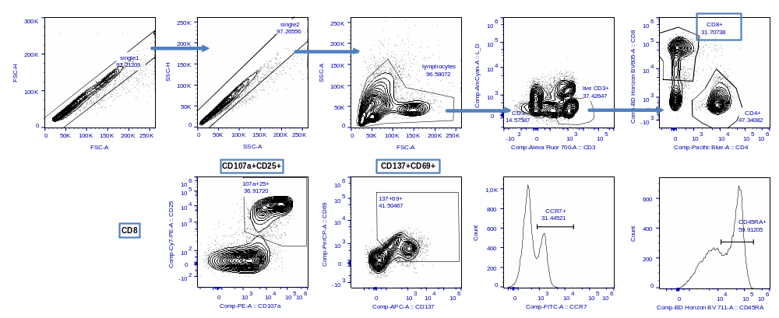
Figure A1. Gating strategy, AIM analysis. PBMC stimulated with SEB

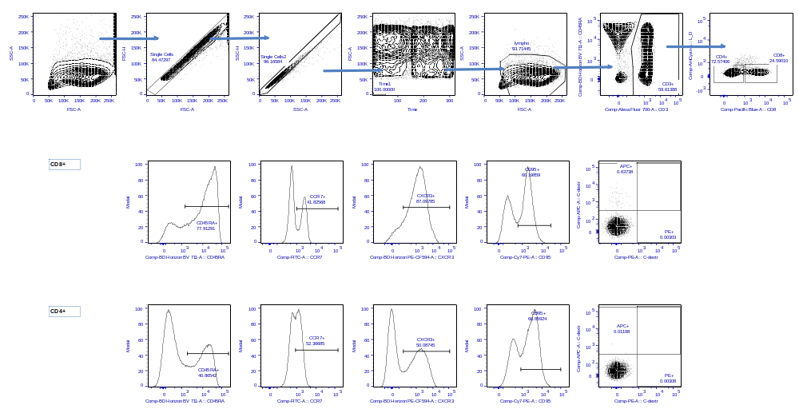
Figure A2. Gating strategy, dextramer analysis. PBMC stained with positive control class-I dextramers labelled with APC.

Appendix E: Results

Safety

Table A4: Safety profile

 | LD vehicle-GNP  (n=3) | LD PepGNP-Covid19  (n=10) | HD vehicle-GNP  (n=3) | HD PepGNP-Covid19  (n=10)
Solicited related local AE*
Mild (Grade 1) | 3/3 (100%) | 10/10 (100%) | 3/3 (100%) | 10/10 (100%)
Moderate (Grade 2) | - | - | - | 1/10 (10%)
Severe (Grade 3) | - | - | - | -
Solicited related systemic AE**
Mild (Grade 1) | 2/3 (67%) | 9/10 (90%) | 2/3 (67%) | 8/10 (80%)
Moderate (Grade 2) | 1/3 (33%) | 2/10 (20%) | 2/3 (67%) | 5/10 (50%)
Severe (Grade 3) | - | 1/10 (10%) | - | 1/10 (10%)
Unsolicited related local AE#
Mild (Grade 1) | 3/3 (100%) | 8/10 (80%) | 3/3 (100%) | 10/10 (100%)
Moderate (Grade 2) | - | - | - | -
Severe (Grade 3) | - | - | - | -
Unsolicited related systemic AE#
Mild (Grade 1) | 3/3 (100%) | 8/10 (80%) | 1/3 (33%) | 9/10 (90%)
Moderate (Grade 2) | - | 1/10 (10%) | - | 2/10 (20%)
Severe (Grade 3) | - | - | - | -
Adverse event of special interest related# | - | 1/10 (10%) | - | 1/10 (10%)
Serious adverse event# | - | - | - | -
Death# | - | - | - | -
Includes participants with at least one clinical or laboratory adverse event. Data are n (%). *Within 7 days of any injection. **Within 14 days of any injection. #During the 180-day study follow-up. LD=low-dose; HD=high-dose; GNP=gold nanoparticles.

Serology anti-SARS-CoV-2

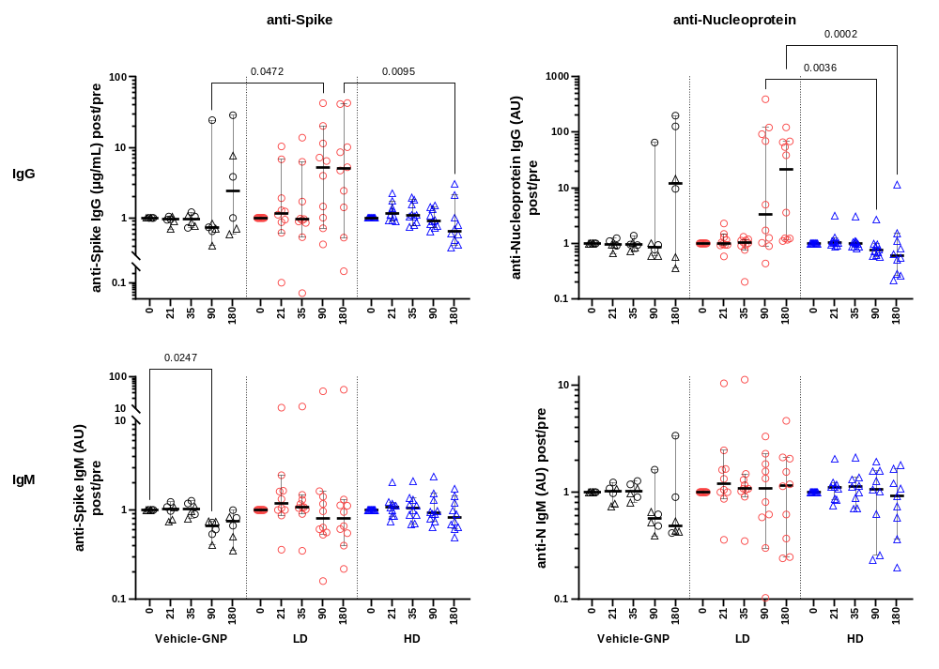
Figure A3. Change from baseline of anti-Covid19 serology.
Kinetics of anti-Spike (left panels) and anti-Nucleoprotein (right panels) IgG (top) and IgM (bottom) levels are shown in groups Vehicle-GNP (n=6), LD-PepGNP-Covid19 (n=10) and HD-PepGNP-Covid19 (n=10). Results are expressed as fold change from baseline, from D0 to D180. Bars indicate medians and 95% CI. Intra-group comparisons using Friedman tests. Inter-group comparison using Kruskal-Wallis tests at each time-point. p values <0.05 are indicated.

AIM

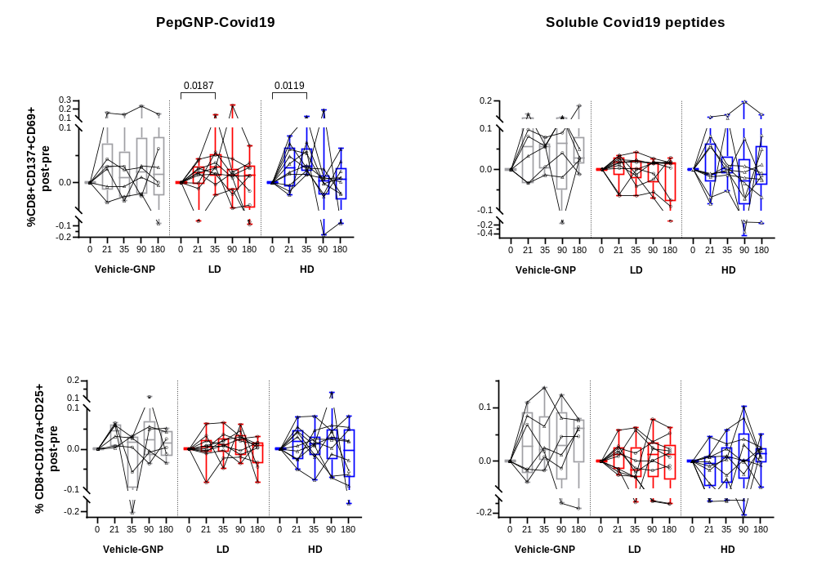
Figure A4. Change from baseline of PepGNP-Covid19-elicited specific CD8 T cells using AIM. Kinetics of CD8 responses were evaluated in groups Vehicle-GNP (n=6), LD-PepGNP-Covid19 (n=10) and HD-PepGNP-Covid19 (n=10). Results are expressed as change from baseline as the delta of post- minus pre-vaccination response of Covid-specific CD8+ over total CD8+, stimulated minus Vehicle-GNP/unstimulated, specific CD8+ defined as expressing co-markers CD137+CD69+ (top) or CD107a+CD25+ (bottom) upon stimulation with PepGNP-Covid19 (left) or Covid19 peptides (right). Intra-group comparison with D0 using Friedman tests; inter group comparisons using Kruskal-Wallis tests. Bars or boxes indicate medians and interquartiles. p values <0.05 are indicated.

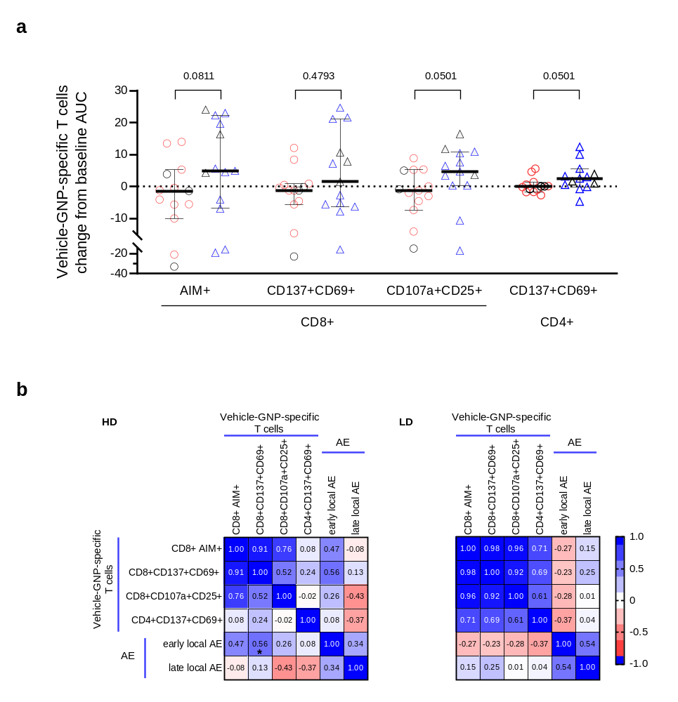
Figure A5. Vehicle-GNP-specific T cell response according to GNP dose. Kinetics of CD8 and CD4 responses were evaluated using AIM in LD GNP group, LD-PepGNP-Covid19 (red circle, n=10) and LD-Vehicle-GNP (black circle, n=3), and HD GNP group, HD-PepGNP-Covid19 (blue triangle, n=10) and HD-Vehicle-GNP (black triangle, n=3). (a) Results are expressed as the AUC of the change from baseline as the delta of post- minus pre-vaccination frequency of specific CD8+ or CD4+ over total population. Specific T cells were defined as expressing co-markers CD137+CD69+, CD107a+CD25+ or at least one of the two co-markers (AIM+) upon stimulation with Vehicle-GNP, stimulated minus unstimulated. Co-marker CD107a+CD25+ was not used for CD4+ T cells since subsets of CD4 constitutively express CD25. Inter group comparisons used Mann-Whitney tests. Bars indicate medians and 95% CI. (b) Spearman correlations between Vehicle-GNP-specific T cell responses (AUC) and number of vaccine-related local adverse events (AE), erythema and swelling, that occurred early (D0-D7) or late (D8-D180) in HD and LD GNP groups, * p=0.051.

Table A5. Covid19-specific responders in AIM, ITT analysis
Group | Vehicle-GNP, n=6 |  |  |  |  | LD PepGNP-Covid19, n=10 |  |  |  |  | HD PepGNP-Covid19, n=10
Day | 21 | 35 | 90 | 180 | any§ | 21 | 35 | 90 | 180 | any | 21 | 35 | 90 | 180 | any
CD8+CD107a+CD25+ | 2 | 3 | 1 | 1 | 4 | 1 | 0 | 2 | 0 | 2 | 2 | 1 | 3 | 1 | 6
CD8+CD137+CD69+ | 3 | 2 | 3 | 3 | 4 | 0 | 2 | 1 | 0 | 3 | 4 | 4 | 3 | 1 | 7
At least one co-marker$ | 3 | 4 | 3 | 2 | 5 | 0 | 2 | 1 | 0 | 3 | 4 | 3 | 4 | 1 | 7
Any marker+ | 4 | 4 | 3 | 3 | 5 | 1 | 2 | 2 | 0 | 4 | 5 | 5 | 4 | 1 | 7
Numbers of responders per group are indicated for each Covid19-specific CD8 T cell parameter measured by AIM upon stimulation with pep-C or GNPC. Responders had a response above the cut-off and a positive change from baseline. Cut-off calculated based on mean response of uninfected volunteers at D0 (n=15). § at any time post vaccination. $ CD107a+CD25+ and/or CD137+CD69+. ITT analysis

Table A6. Covid19-specific responders in AIM, differential cut-off, ITT analysis
Group | Vehicle-GNP, n=6 |  |  |  |  | LD PepGNP-Covid19, n=10 |  |  |  |  | HD PepGNP-Covid19, n=10
Day | 21 | 35 | 90 | 180 | any§ | 21 | 35 | 90 | 180 | any | 21 | 35 | 90 | 180 | any
CD8+CD107a+CD25+ | 2 | 2 | 1 | 1 | 4 | 1 | 0 | 2 | 0 | 2 | 2 | 0 | 2 | 1 | 5
CD8+CD137+CD69+ | 3 | 2 | 3 | 3 | 4 | 0 | 2 | 1 | 0 | 3 | 1 | 2 | 1 | 0 | 3
At least one co-marker$ | 3 | 3 | 3 | 2 | 4 | 0 | 2 | 1 | 0 | 3 | 1 | 1 | 1 | 0 | 2
Any marker+ | 4 | 3 | 3 | 3 | 5 | 1 | 2 | 2 | 0 | 4 | 3 | 2 | 2 | 1 | 6
Numbers of responders per group are indicated for each Covid19-specific CD8 T cell parameter measured by AIM upon stimulation with pep-C or GNPC. Responders had a response above the cut-off and a positive change from baseline. Differential cut-offs were applied for those not infected at D0 (n=15) and for those Covid19-infected before D0 (n=11). § at any time post vaccination. $ CD107a+CD25+ and/or CD137+CD69+. ITT analysis

HLA typing
Table A7. HLA Typing
HLA I | Total | Vehicle-GNP | LD PepGNP-Covid19 | HD PepGNP-Covid19
 | 26 | 6 | 10 | 10
A*01 | 5 | 1 | 1 | 3
A*02 | 14 | 2 | 6 | 6
A*03 | 8 | 0 | 5 | 3
A*24 | 7 | 2 | 2 | 3
A*29 | 1 | 0 | 1 | 0
A*30 | 1 | 0 | 1 | 0
B*07 | 7 | 0 | 4 | 3
B*35 | 5 | 1 | 1 | 3
B*44 | 5 | 1 | 2 | 1
(-) dextramer | 1 | 1 | 0 | 0
Results expressed as number of participants. In bold, results considered for dextramer assessment of Covid19-specific CD8+ T cells, restricted to HLA-A*01, A*02, A*03, A*24, A*29, B*07 and B*35. For the AIM evaluation, all participants presented at least one HLA susceptible to bind one peptide from PepGNP- Covid19, i.e., HLA-A*01, A*02, A*03, A*11, A*24, A*29, A*30, B*07, B*35 and B*44.

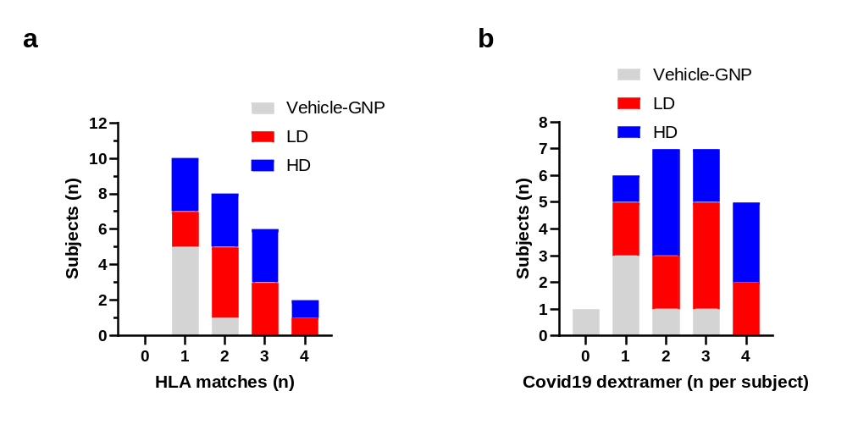
Figure A6. HLA-A and HLA-B allele results
(a) HLA-A and HLA-B matches. For each subject in the PepGNP-Covid19 LD and HD (n=10 each) or in Vehicle-GNP (n=6), the number of HLA-A and HLA-B alleles with known/potential binding to vaccine peptides was determined and the number of subjects with zero to four HLA matches plotted as a distribution chart. (b) Number of HLA-class I Covid19 dextramers (table A2) evaluated per volunteer according to their HLA typing. One to four Covid19 dextramers were evaluated per volunteer. HLA class I typing was performed by RT-PCR on blood samples drawn on Day 0. HLA, human leukocyte antigen; RT-PCR=reverse transcription polymerase chain reaction; LD=low-dose; HD=high-dose; GNP=gold nanoparticles.

Dextramers

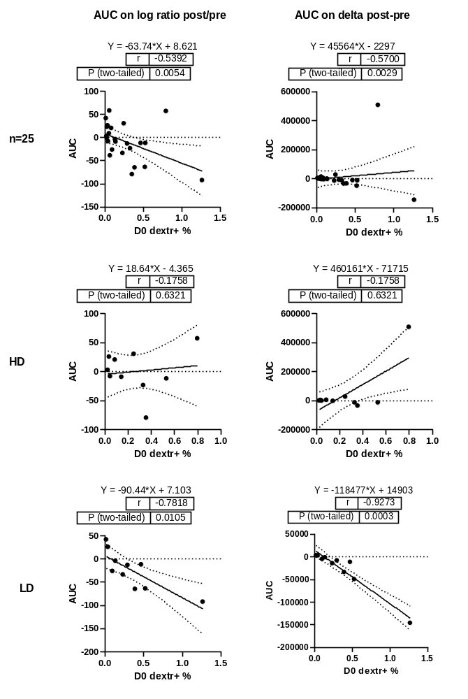
Figure A7. C-dextr+CD8+ responses: correlation between AUC and baseline.
Peptide-specific responses were assessed in volunteers from group Vehicle-GNP (n=5), LD-PepGNP-Covid19 (n=10) and HD-PepGNP-Covid19 (n=10), using HLA class I-compatible Covid19 dextramers. Spearman correlation between AUC of response over time (D0 to D180) and baseline frequency of dextr+CD8 was performed. AUC was calculated on change from baseline response using the log of post/pre ratio and post- pre delta

Covid19 Memory CD8
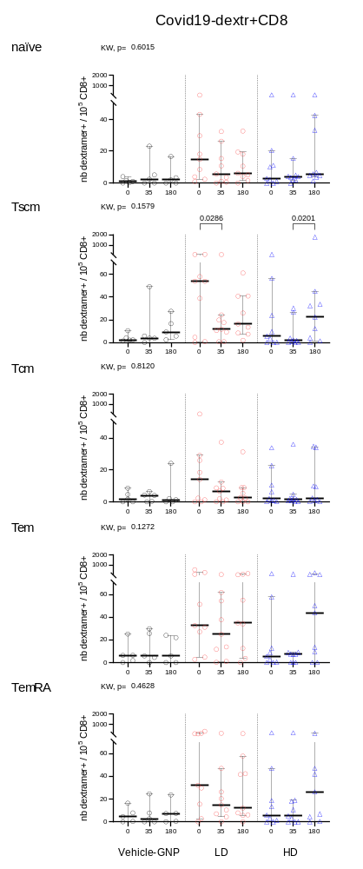
Figure A8. Covid19-dextramer+ CD8+ memory subsets (PP analysis). Covid19-specific responses were assessed in volunteers from group Vehicle-GNP (n=5), LD-PepGNP-Covid19 (n=9) and HD-PepGNP-Covid19 (n=9), at D0, D35 and D180, by measuring the frequency of specific HLA class I compatible Covid19 dextramers from a list of eight combinations. Results are expressed as number of subsets of C-dextramer+ CD8+ T cells + over 10⁵ total CD8+ T cells for each volunteer. CD8+ T cells subsets were defined as naïve (CD45RA+CCR7+CD95-), stem cell memory (Tscm, CD45RA+CCR7+CD95+), central memory (Tcm, CD45RA-CCR7+), effector memory (Tem, CD45RA-CCR7-) and differentiated effector memory (TemRA, CD45RA+CCR7-). Responses to one to four C-dextramers minus negative control were summed per volunteer. Intra-group comparison with D0 used Friedman tests. Inter-group comparison used Kruskal-Wallis tests. p values <0.05 are indicated. Bars indicate medians and 95% CI.

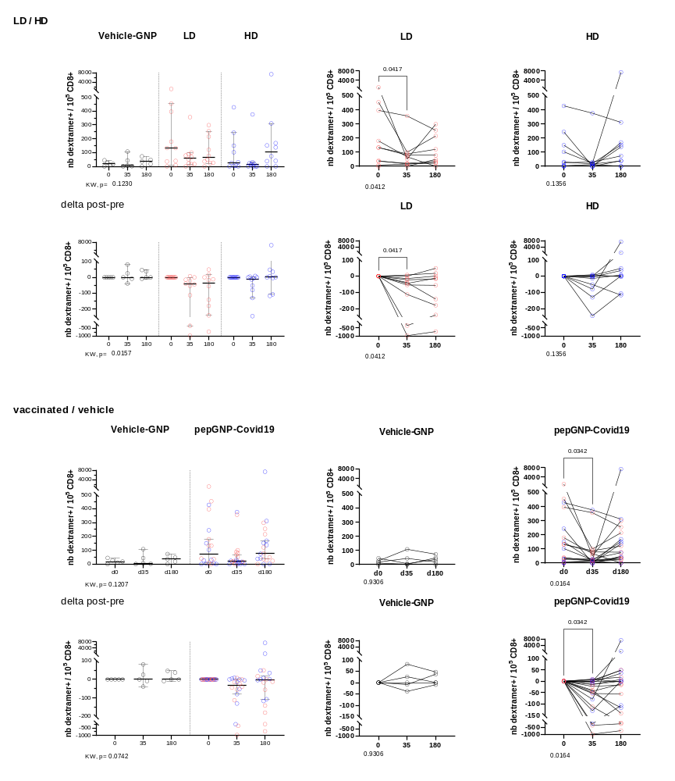

Figure A9. All memory C-dextr+CD8+. Comparisons LD- vs HD-PepGNP-Covid19 groups and PepGNP-Covid19 (vaccinees, n=20) vs Vehicle-GNP (n=5). Tscm, Tcm, Tem and TemRA subsets were summed. Results are expressed as number of C-dextr+ memory CD8+ T cells over 10⁵ total CD8+ T cells for each volunteer (n=19). Left panels, inter-group comparison using Kruskal-Wallis tests. Bars indicate medians and 95% CI. Panels on the right, comparison with D0 using Friedman tests and Dunn’s post tests; p values <0.05 are indicated.

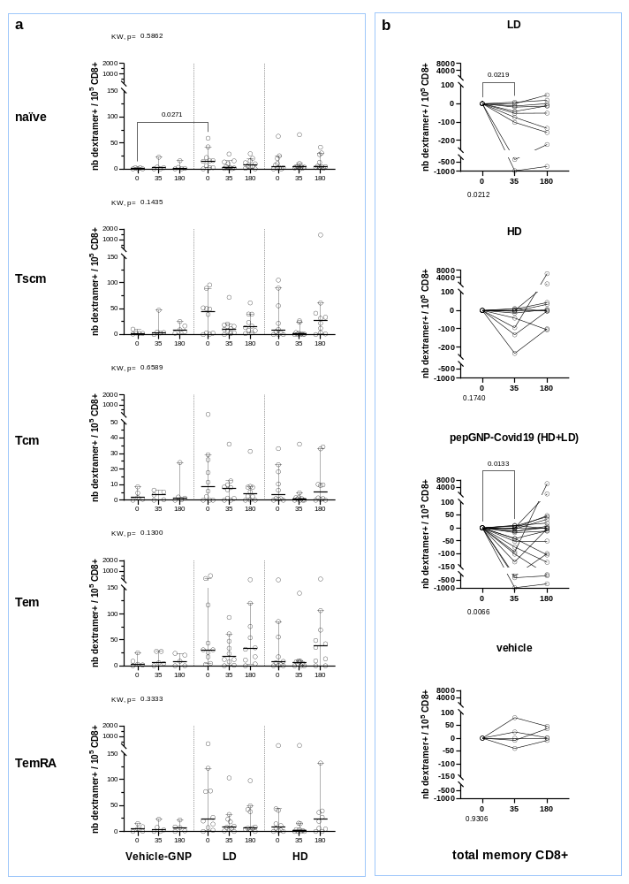
Figure A10. CXCR3+C-dextr+CD8+ memory subsets. Covid19-specific responses were assessed in volunteers from group Vehicle-GNP (n=5), LD-PepGNP-Covid19 (n=10) and HD-PepGNP-Covid19 (n=10), using HLA class I compatible Covid19 dextramers from a list of eight peptide-fluorochrome combinations. Results are expressed as number of CXCR3+ C-dextramer+CD8+ T cells from various subsets of CD8 + over 10⁵ total CD8+ T cells for each volunteer. (a) memory subsets of dextr+CD8. (b) total memory dextr+ CD8 change from baseline (delta post-pre vaccination). CD8+ T cells subsets were defined as naïve (CD45RA+CCR7+CD95-), stem cell memory (Tscm, CD45RA+CCR7+CD95+), central memory (Tcm, CD45RA-CCR7+), effector memory (Tem, CD45RA-CCR7-) and differentiated effector memory (TemRA, CD45RA+CCR7-). Responses to one to four C-dextramers minus negative control were summed per volunteer. Intra-group comparison with d0 using Friedman tests; inter-group comparison using Kruskal-Wallis tests. p values <0.05 are indicated. Bars indicate medians and 95% CI.

Baseline profile

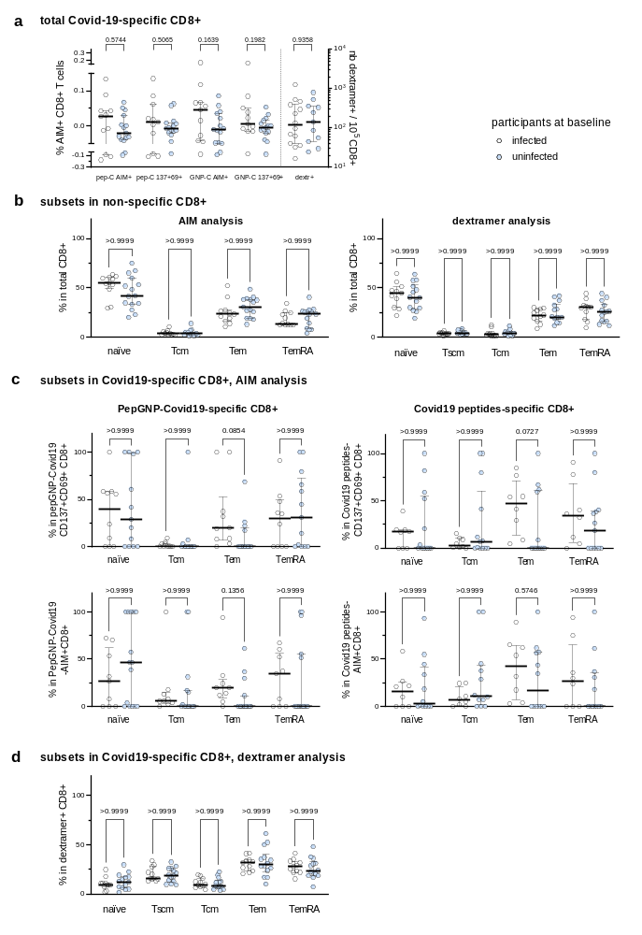
Figure A11. Frequency and profile of Covid19-specific CD8+ T cells in infected and uninfected participants at baseline. Covid19-specific responses were assessed at D0 in volunteers previously Covid19-infected (n=11, white circles) or uninfected (n=15, blue circles) using AIM (panels a, b, c) or C-dextramer (panels a, b and d) to identify Covid19-specific cells. (a) Results expressed as frequency of Covid-specific CD8+. (b) Percentage of subsets over total CD8+, in AIM (unstimulated cells) or during dextramer staining. (c) Percentage of subsets over Covid-specific CD8+ using AIM, CD137+CD69+ or CD107a+CD25+ and/or CD137+CD69+ (AIM+) upon stimulation with PepGNP-Covid19 or Covid19 peptides, stimulated minus control. (d) Percentage of subsets over C-dextramer CD8+, using HLA class I compatible Covid19 dextramers from a list of eight combinations. (b-d) CD8+ T cells subsets were defined as naïve (CD45RA+CCR7+CD95-), stem cell memory (Tscm, CD45RA+CCR7+CD95+), central memory (Tcm, CD45RA-CCR7+), effector memory (Tem, CD45RA-CCR7-) and differentiated effector memory (TemRA, CD45RA+CCR7-). For the profile of response, only volunteers with responses are presented. Inter-group comparison using Mann-Whiney (a) and Kruskal-Wallis tests (b-d). p values are indicated. Bars indicate medians and 95% CI.

Appendix F: References

1. Fenwick, C.; Turelli, P.; Perez, L.; Pellaton, C.; Esteves-Leuenberger, L.; Farina, A.; Campos, J.; Lana, E.; Fiscalini, F.; Raclot, C.; et al. A Highly Potent Antibody Effective against SARS-CoV-2 Variants of Concern. Cell Rep. 2021, 37, 109814, doi:10.1016/j.celrep.2021.109814.
2. Bowyer, G.; Rampling, T.; Powlson, J.; Morter, R.; Wright, D.; Hill, A.; Ewer, K. Activation-Induced Markers Detect Vaccine-Specific CD4+ T Cell Responses Not Measured by Assays Conventionally Used in Clinical Trials. Vaccines 2018, 6, 50, doi:10.3390/vaccines6030050.
3. Grifoni, A.; Weiskopf, D.; Ramirez, S.I.; Mateus, J.; Dan, J.M.; Moderbacher, C.R.; Rawlings, S.A.; Sutherland, A.; Premkumar, L.; Jadi, R.S.; et al. Targets of T Cell Responses to SARS-CoV-2 Coronavirus in Humans with COVID-19 Disease and Unexposed Individuals. Cell 2020, 181, 1489-1501.e15, doi:10.1016/j.cell.2020.05.015.

