Supplementary information for

Revealing Atomic-Scale Ionic Stability and Transport around Grain
Boundaries of Garnet Li₇La₃Zr₂O₁₂ Solid Electrolyte

Supplementary Methods

It has been proved that LLZO crystallized in the cubic phase shows a higher conductivity compared to tetragonal LLZO.¹ The cubic LLZO (c-LLZO) has been selected. In c-LLZO, the Li are randomly distributed at 24d and 96h Wyckoff sites.² The c-LLZO structure with low-energy Li configuration obtained in former work has been adopted.³ The lattice constant of the optimized structure is 13.03 Å, which is in good agreement with the experimental value (13.00 Å)².
The stabilities of the investigated GBs were calculated using GB formation energy (γ), which is defined as
$γ=\frac{1}{2A}(E_{model}-nE_{bulk})$, (S1)
where $E_{model}$ and $E_{bulk}$ represent the total energies of the GB model and bulk in a formula unit (f.u.). n is the number of the f.u. in the GB model. A is the area of the GB plane.
To understand the Li⁺ diffusion at GB, the diffusion coefficient (D) was calculated based on the time average mean squared displacement (MSD) of Li⁺ over a time t
$D=\frac{1}{2Ndt}\sum_{i=1}^{N}{〈{\left[r_{i}(t+t_{0})-r_{i}(t_{0})\right]}^{2}〉}$ , (S2)
where N and d refer to the total number of Li⁺ and the dimensionality in the system, respectively. t₀ is the initial time, and r_{i}(t) represents the displacement of the i-th Li⁺ at time t.
To understand the defect chemistry at LLZO GB, the defect formation energies (E_{f}) were calculated using,
$E_{f}\left(X\right)=E_{total}\left(X\right)-E_{Bulk}-\sum_{i}{n_{i}μ_{i}}$, (S3)
where $E_{f}\left(X\right)$ and $E_{Bulk}$ are the total energies of supercell with and without defect X, respectively. $n_{i}$ is the number of removed ($n_{i}$ < 0) or added ($n_{i}$ > 0) i-type atoms in the supercell. $μ_{i}$ is the chemical potential of neutral atomic species, i, which can be represented using the energy of stable elemental structure, $E_{i}$,
$μ_{i}=∆μ_{i}+E_{i}$ . (S4)
Here we have selected a reducing environment in the calculation of E_{f}, where Li₂O and Li metal were used as the reference structures. The adopted ${∆μ}_{Li}$and ${∆μ}_{O}$ are 0 and -3.13 eV, respectively.

Table S1 Selected Li occupations (OP) of 24d and 96h sites in Σ1(110) and Σ3(112) GB models of LLZO.
 |  | 24d | 96h
Σ1(110) | OP(1) | 20 | 92
Σ1(110) | OP(2) | 24 | 88
Σ3(111) | OP(1) | 30 | 138
Σ3(111) | OP(2) | 32 | 136
Σ3(111) | OP(3) | 34 | 134

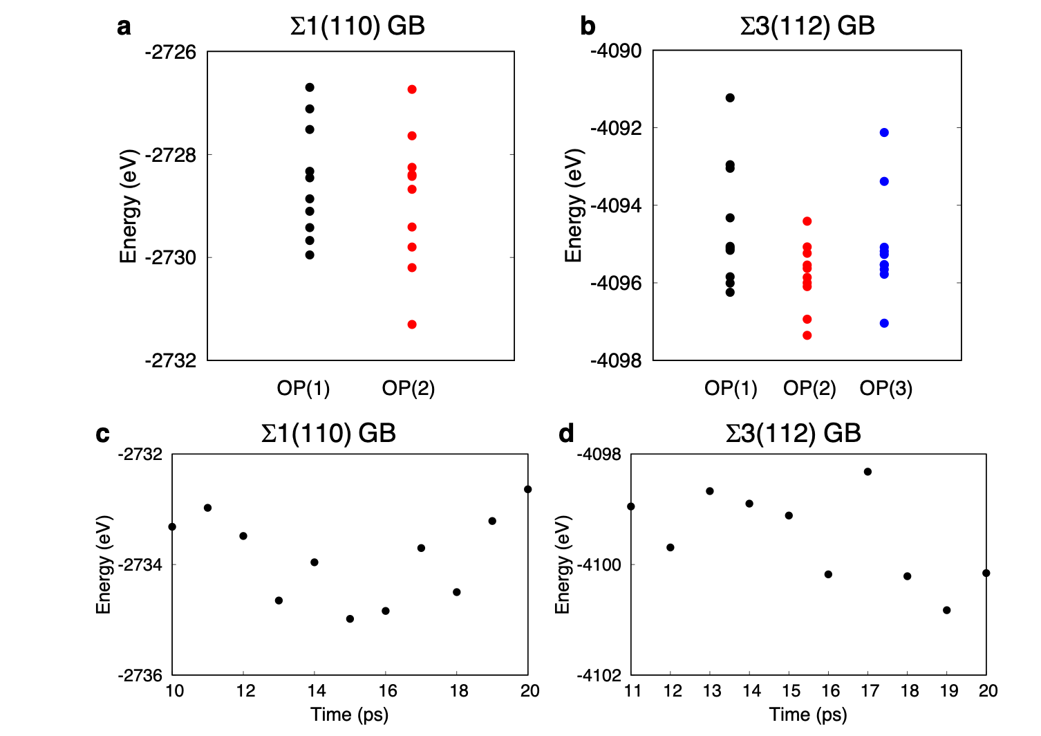
Figure S1 Calculated total energies of the optimized Σ1(110) (a) and Σ3(112) (b) GB models corresponding to the occupations in Table S1. Calculated total energies of the optimized Σ1(110) (c) and Σ3(112) (d) GB models sampled in the MD simulations at 1000K.

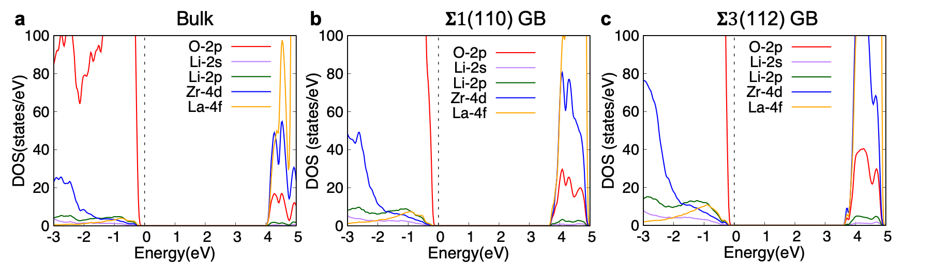
Figure S2 Calculated PDOSs of LLZO bulk (a), and Σ1(110) (b) and Σ3(112) (c) GB models. The dashed lines indicate the Fermi level.

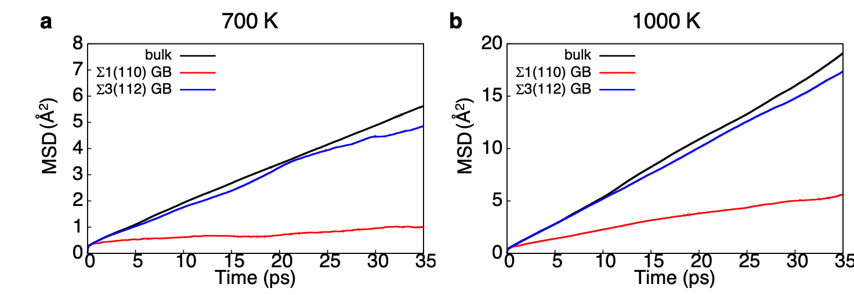
Figure S3 Time average MSDs of Li for bulk, and Σ1(110) and Σ3(112) GB models at temperatures of (a) 700 and (b) 1000 K.
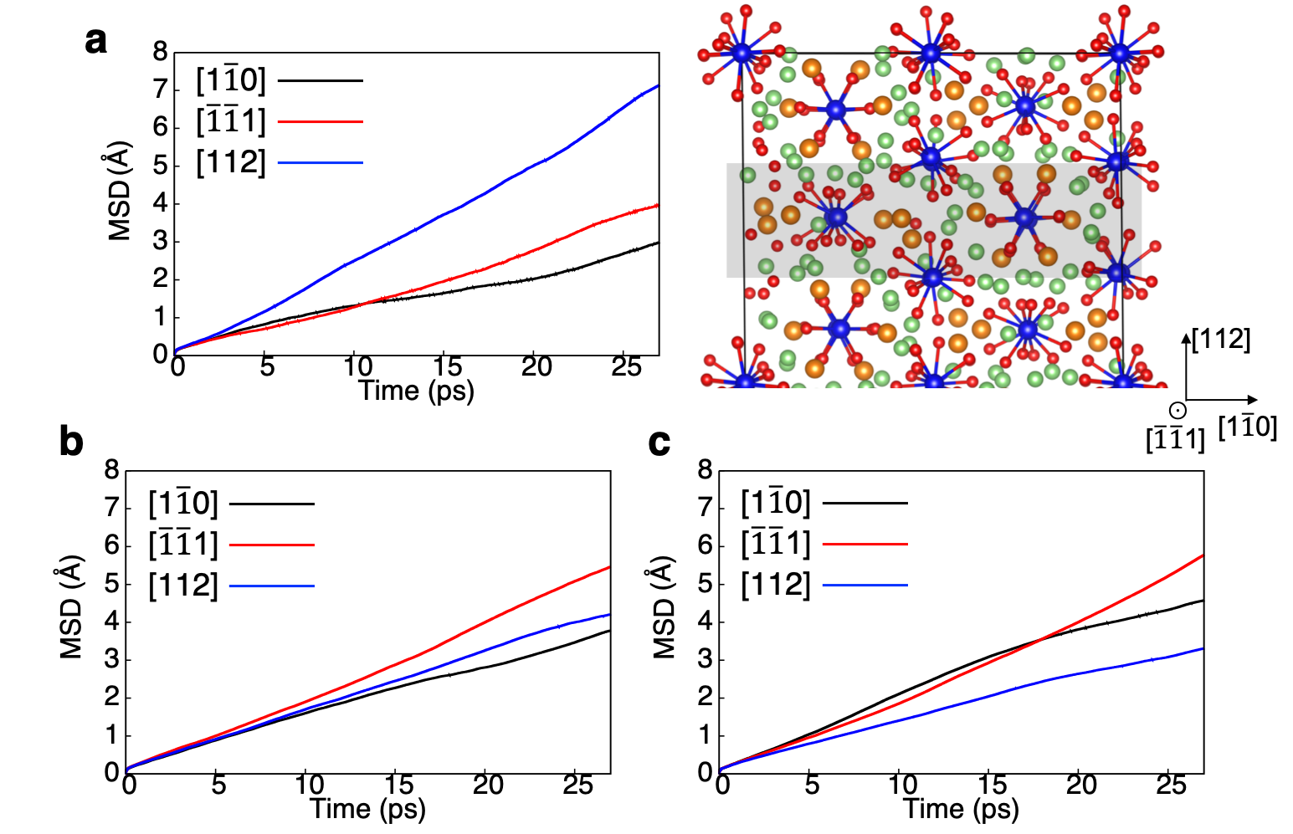

Figure S4 (a) Projected time average MSDs at the temperature of 1000K for Li-ions in the Σ3(112) GB region. The GB region is depicted as the grey area in the right panel. (b, c) Projected time average MSDs at the temperature of 1000K averaged from the total Li ions in the (b) Σ3(112) GB model and (c) the cell of bulk. In a and b, the [1$\overline{1}0$] and [11$\overline{1}$] directions are within the GB plane, while the [112] direction is across the GB plane.

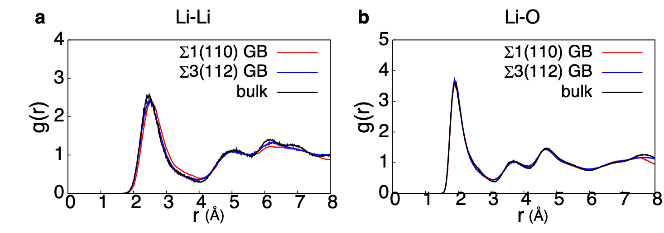
Figure S5 Calculated Li-Li (a) and Li-O (b) RDFs averaged from the total atoms in the cells in the time range from 5 to 40 ps in the MD simulation at 1000 K for bulk, and Σ1(110) and Σ3(112) GB models.

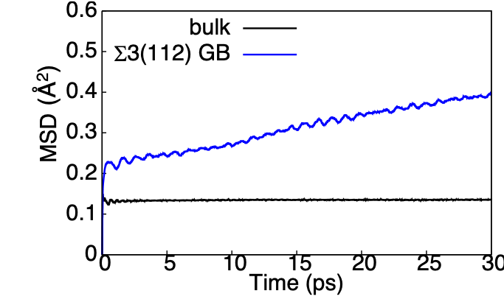
Figure S6 Time average MSD of O in the bulk and Σ3(112) GB region at temperatures of 1000 K.

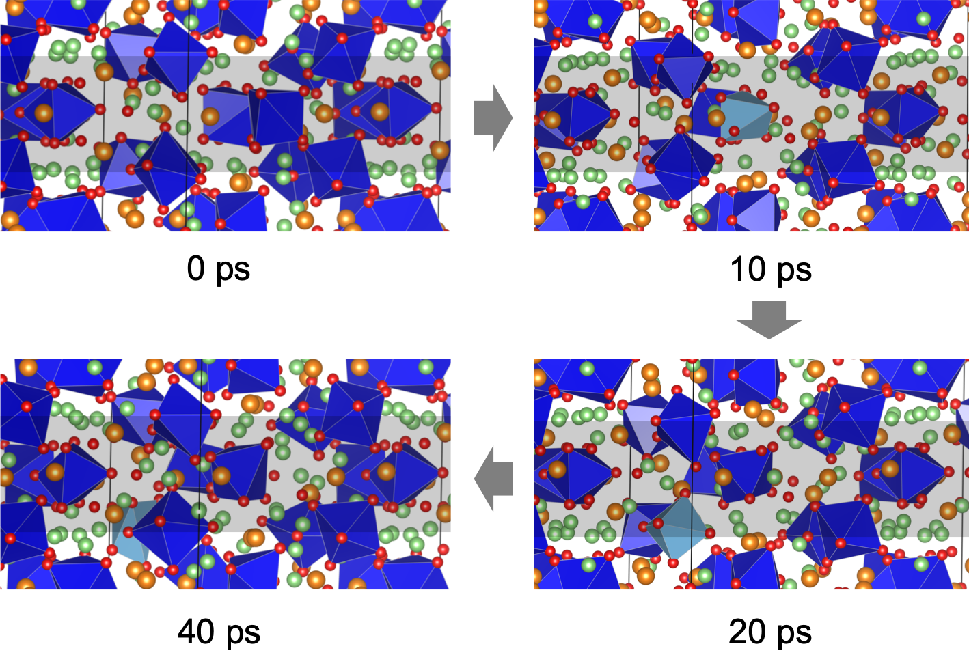
Figure S7 Snapshots at 0, 10, 20, and 40 ps in the MD simulation at 1000 K for Σ3(112) GB model. The grey areas indicate regions of GB. The green, orange, and red spheres represent the Li, La, and O atoms, respectively. The dark and light blue polyhedrons refer to the ZrO₆ and ZrO₅ units, respectively.
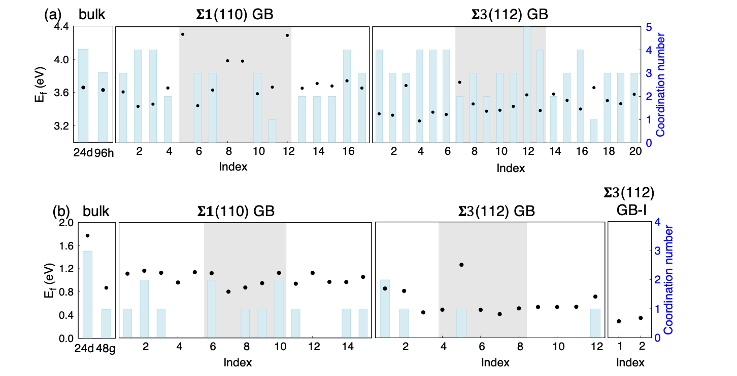
Figure S8 Calculated E_{f} (black dot) and Li-Li coordination number (light-blue column) for (a) $V_{Li}^{×}$, (b) ${Li}_{i}^{×}$ in bulk, and Σ1(110) and Σ3(112) GB models. The cut-off radiuses for Li-Li coordination numbers are 2.7 and 2.2 Å in a and b, respectively. In the panels of Σ1(110) and Σ3(112) GB models, the grey areas indicate the GB regions.

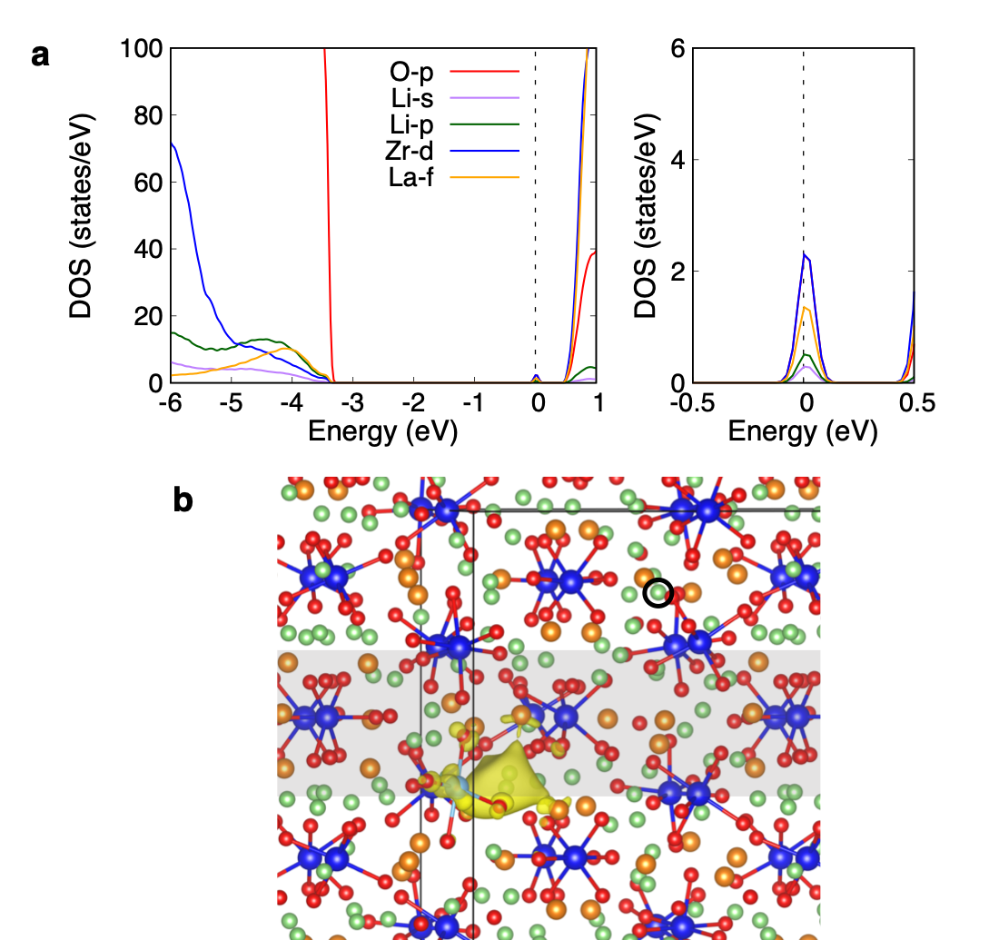
Figure S9 (a) (left panel) Calculated PDOS of Σ3(112) GB model with a Li interstitial site at bulk region. (right panel) enlarged PDOS around Fermi level. The dashed line indicates the Fermi level. (b) partial charge density associated with the states in the energy range from -0.1 to 0.1 eV. The isosurface is set to 0.005 e/bohr³, and the atom in the black circles refers to the ${Li}_{i}^{×}$ site. The grey area indicates the GB region.

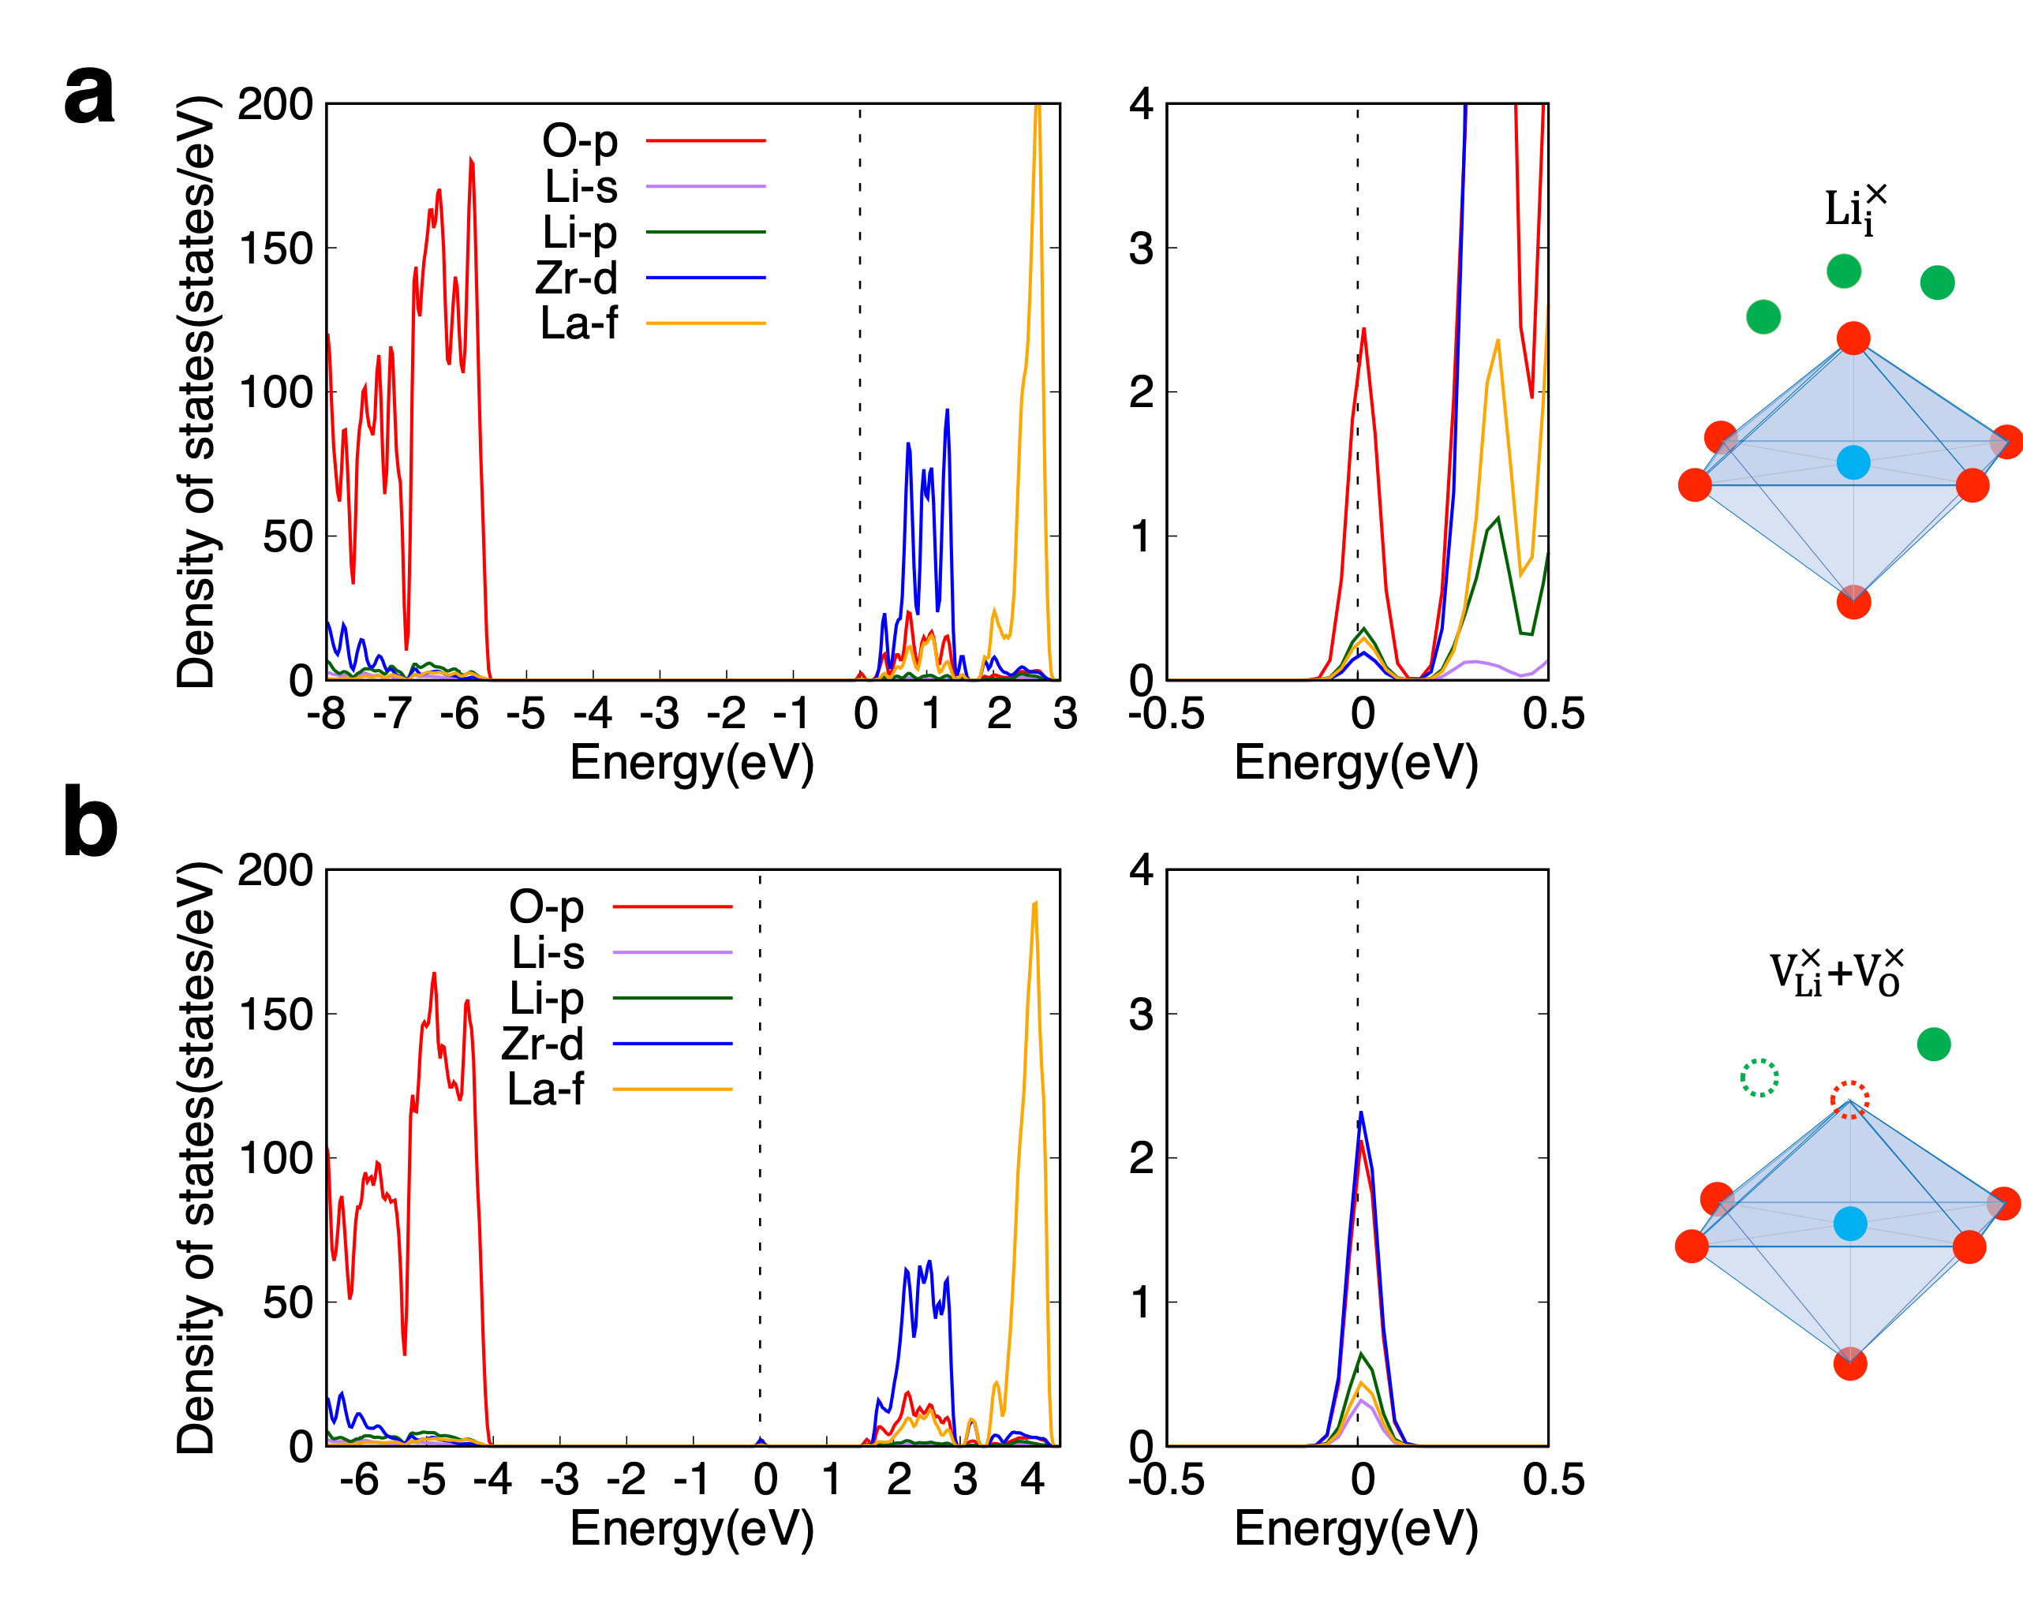
Figure S10 Calculated PDOSs of LLZO bulks with (a) a ${Li}_{i}^{×}$ at 48g Wyckoff position and (b) a defect consisting of one $V_{Li}^{×}$ and one $V_{O}^{×}$ based on the screened hybrid functional HSE06. The enlarged PDOSs around the Fermi levels and the illustration of the defects are depicted in the middle and right panel, respectively.

References:
1. Murugan, R., Thangadurai, V. & Weppner, W. Fast Lithium Ion Conduction in Garnet-Type Li₇La₃Zr₂O₁₂. Angew. Chem. Int. Ed. 46, 7778–7781 (2007).
2. Xie, H., Alonso, J. A., Li, Y., Fernández-Díaz, M. T. & Goodenough, J. B. Lithium Distribution in Aluminum-Free Cubic Li₇La₃Zr₂O₁₂. Chem. Mater. 23, 3587–3589 (2011).
3. Gao, B., Jalem, R. & Tateyama, Y. Surface-Dependent Stability of the Interface between Garnet Li₇La₃Zr₂O₁₂ and the Li Metal in the All-Solid-State Battery from First-Principles Calculations. ACS Appl. Mater. Interfaces 12, 16350–16358 (2020).

