Table 1
Top 12 contributing countries that published more than 3 papers.
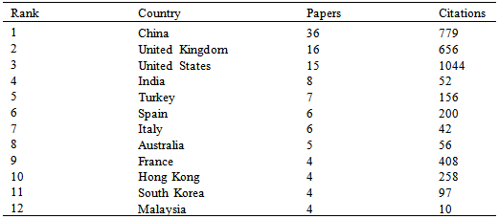
Table 2
Top 12 most productive institutes according to the number of publications and number of citations
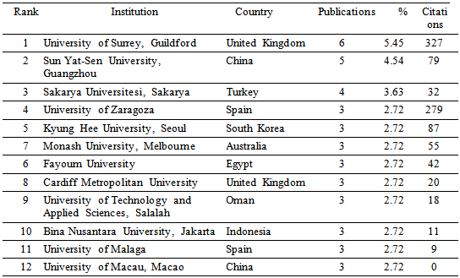

Table 3
Distribution of publications based on the number of authors
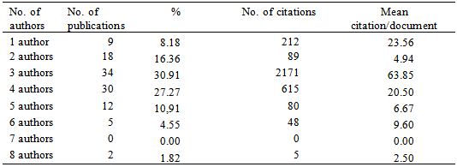

Table 4
Most-productive authors according to the number of citations
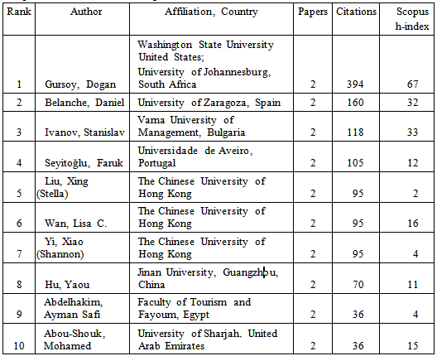

Table 5
Top 10 highly cited papers
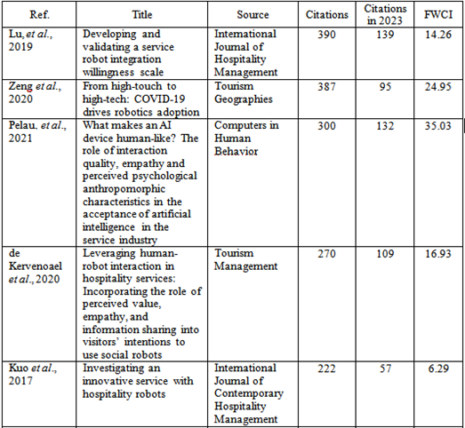
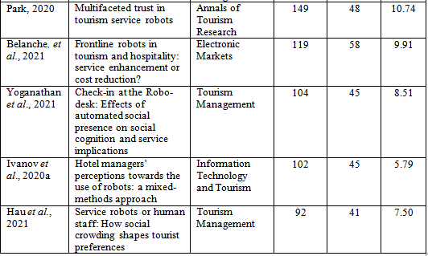

Table 6
Top 10 most active publications (journals and conference proceedings).
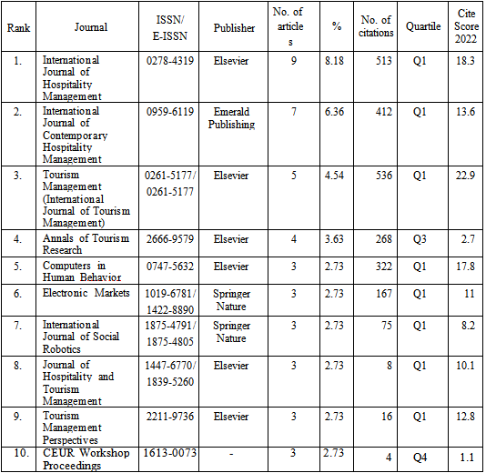

Table 8
The top 10 subject areas
