SUPPLEMENTARY INFORMATION

This file includes:

Supplementary Tables
Supplementary Tables 1-8 were provided as Excel files.

Supplementary Methods

Supplementary Figures
Supplementary Figure 1
Supplementary Figure 2
Supplementary Figure 3
Supplementary Figure 4
Supplementary Figure 5

Supplementary Tables
Supplementary Table 1.
The alteration frequencies of cancer associated genes, the co-occurrence analysis of ARID1A, TP53 and PTEN in diffuse-type gastric carcinoma and gastric signet ring cell carcinoma samples from the cBioPortal dataset, as well as the SRCC signature gene list, related to Figure 1, Figure 3, Figure 5.
Supplementary Table 2.
The sequences of sgRNAs, PCR and RT-qPCR primer, related to Figure 2, Figure 4, Figure 5, Supplementary Figure 1, Supplementary Figure 4 and Supplementary Figure 5.
Supplementary Table 3.
Differential expression genes in premalignant, tumor organoids with sgScr or sgArid1a, and tumor organoids treated with DMSO or dBRD9, related to Figure 1-5 and Supplementary Figure 1-5.
Supplementary Table 4.
The expression levels of mucin genes in ITGC and SRCC patients from the TCGA-STAD cohort, the Korea University cohort (GSE26899) and the CCLE database, related to Figure 2 and Supplementary Figure 2.
Supplementary Table 5.
Differential genome accessible regions between TPA and TP gastric organoids, related to Figure 3, Figure 5 and Supplementary Figure 3.
Supplementary Table 6.
The protein mass spectrometry analysis results of SRCC and ITGC gastric tumor tissues, related to Figure 3.
Supplementary Table 7.
ARID1A binding regions in TP gastric organoids, related to Figure 4 and Supplementary Figure 4.
Supplementary Table 8.
Differential BRD9 binding regions between TPA and TP gastric organoids, related to Figure 5.

Supplementary Methods
H&E and Immunohistochemistry staining. Tumor tissues and organoids were fixed with 4% paraformaldehyde overnight, then subjected to gradient dehydration, embedded in paraffin, and preserved at room temperature. The standard protocol was performed in H&E and immunohistochemistry staining. Imaging was performed by Pannoramic MIDI.
Western blotting. Organoid lysates were extracted in RIPA buffer (Beyotime, Cat# P0013) supplemented with protease inhibitors (Beyotime, Cat# P1045), followed by SDS–PAGE gel electrophoresis and blotted onto PVDF membranes (Millipore). Primary antibodies were applied in 5% non-fatty milk and incubated overnight at 4 ℃. HRP-conjugated secondary antibodies were applied at 1:10000 dilution. Images were obtained by NcmECL Ultra Reagent (NCM biotech).
RNA extraction and RT-qPCR. Total RNA extraction using TRIzol reagent (Thermo Fisher Scientific, Cat# 15596026) and complementary DNA (cDNA) synthetization using HiScript-III RT SuperMix kit (Vazyme, Cat# R323-01) were performed under the manufacturer’s instructions. Real-time quantitative PCR (RT-qPCR) was performed using Fast SYBR Green MasterMix (Vazyme, Cat# Q711-02/03) on the StepOne Real-Time PCR System (Thermo Fisher Scientific, Applied Biosystems QuantStudio 3), Muc1, Muc20, Muc5ac, and Scin gene primers for RT-qPCR were listed in Supplementary Table 2.
Organoid proliferation assay. Organoids were digested into single cells by TrypLETM (GIBCO, Cat# 12605-028). 2,000 cells were seeded in a well of 96-well plates. After 5 of days culture, organoids were photographed (Olymp IX73P2F). The size of organoids was measured using Image J (Version 1.51).
Antibodies. Antibodies of Recombinant Anti-MUC1 (Cat# ab45167, RRID: AB_776552) were from Abcam; ARID1A/BAF250A (D2A8U) Rabbit mAb (Cat# 12354, RRID: AB_2637010), E-Cadherin (4A2) Mouse mAb (Cat# 14472, RRID: AB_2728770) were from Cell Signaling Technology. BRD9 polyclonal antibody (Cat# A303-781A, RRID: AB_ 11218396) was from Thermo Fisher Scientific.
In Vitro Treatment. The tumor organoids of TP and TPA mice were dissociated using TrypLETM and seeded into 96-well plates at a density of 2000 cells per well. After 24 hours of culturing, the organoids were treated with varying concentrations of dBRD9 (0, 0.01, 0.1, 1, 10, and 100 mM). After 48 hours of treatment, the organoids were photographed and quantified using CCK8. The ratio of diffuse-like organoids to total organoids was calculated from at least three independent areas. The viability was determined by normalizing to the DMSO group.
Protein Extraction and Digestion. Protein extraction and digestion were performed on SRCC and ITGC (n = 5) tumor tissues using RIPA buffer (composed of 150 mM NaCl, 50 mM Tris (pH = 7.5), 1% NP-40 (v/v), 0.5% sodium deoxycholate (w/v), 25 mM nicotinamide, 10 mM sodium butyrate, 1× cocktail, 1× phosphatase inhibitors), followed by homogenization with gentleMACS Dissociators (Miltenyi Biotec GmbH) using the "protein 01. 01" protocol. The crude lysates were subsequently sonicated (model JY92-IIN, 227.5 W, 3 s on 10 s off, 5 min) and centrifuged (20,000g, 4 °C, 20 min). The protein concentration of each sample was quantified via the Bradford protein assay (Bio-Rad). Next, fifty micrograms of protein from each sample were reduced with 10 mM of tris (2-carboxyethyl) phosphine at 56 °C for 1 h, alkylated with 20 mM of iodoacetamide for 30 min to block free cysteine residues, and precipitated using a methanol/chloroform/water system. The enzymatic digestion was carried out overnight with trypsin at 37 °C, in a 1:50 (w/w, trypsin/protein) ratio.
Isobaric Labeling. Tandem mass tag (TMT) reagents were equilibrated to the room temperature and solubilized in anhydrous acetonitrile (ACN). Subsequently, the peptides were labeled with 10-plex TMT reagents as per the manufacturer's instructions (Thermo Scientific). Following a 1h incubation period at room temperature, 5% hydroxylamine was added to terminate the reaction. The peptides, labeled with distinct TMT labels, were combined and dried using a SpeedVac. The peptides were then reconstituted with 0.1% trifluoroacetic acid (TFA), desalted using a C18 solid-phase extraction (SPE) column (Phenomenex), and fractionated via high-performance liquid chromatography (HPLC).
Peptide Fractionation. TMT-labeled peptides, which were previously desalted, underwent fractionation through high-performance liquid chromatography (HPLC) on a reversed-phase C18 column (HPH-C18 4 μM, 4.6 × 250 mm, Poroshell, Agilent) measuring 25 cm in length, at a temperature of 40°C, and with ultraviolet detection set at 214 nm. The separation was carried out at a flow rate of 1 ml/min using two mobile phase buffers, namely buffer A (consisting of 98% water, 2% acetonitrile, 10 mM ammonium formate, and pH adjusted to 10) and buffer B (comprising 90% acetonitrile, 10% water, 10 mM ammonium formate, and pH adjusted to 10). A 120-min standard gradient was employed, with the following elution steps: 0 to 90 min, 3% to 35% buffer B; 90 to 105 minutes, 35% to 60% buffer B; 105 to 115 min, 60% to 100% buffer B; and 115 to 120 minutes, 100% to 3% buffer B. The resulting 120 fractions were combined into 20 aliquots, which were subsequently subjected to vacuum centrifugation and desalted with a C18 ZipTip prior to LC-MS/MS analysis.
MS Analysis. After desalting, the peptide samples were loaded onto a 100 μm (inner diameter) × 2 cm (length) trap column and a 75 μm (inner diameter) × 15 cm (length) analytical column, which were packed with C18 resin (DIKMA) in-house. LC-MS/MS analysis was performed using an EASY-nLC 1000 nanoflow LC instrument coupled to a Q Exactive Plus Quadrupole-Orbitrap mass spectrometer (Thermo Fisher Scientific). Peptide samples were subjected to a 65-min gradient from 6 to 95% buffer B (95% ACN and 0.1% formic acid) at a flow rate of 300 nl/min. The data-dependent acquisition was performed in a positive-ion mode, and survey full-scan MS spectra (from m/z 350–1600) were acquired in the Orbitrap with a resolving power of 70,000 at m/z = 200. The automatic gain control value setting was adjusted to 3e6, with maximum fill times of 20 ms. For MS/MS scans, the top 15 most intense parent ions were selected with a 0.6 m/z isolation window and fragmented with a normalized collision energy of 30%. The automatic gain control value for MS/MS was set to a target value of 1e5, with a resolution of 35,000 and a maximum fill time of 100 ms. Parent ions with a charge state of z = 1 or 8 or with unassigned charge states were excluded for fragmentation, and a dynamic exclusion period of 50 s was used for the data-dependent scan.
Mass spectrometry (MS) data analysis. The raw data were subjected to a thorough search against the Swiss-Prot mouse protein sequence database using MaxQuant software (version 1.6.2.3). A precursor peptide mass tolerance of 10 ppm and a fragment ion mass tolerance of 0.02 Da were utilized in the search. To ensure the accuracy of the quantification, the reporter precursor intensity fraction was set to a minimum of 75%. Additionally, peptides shorter than 6 amino acids were discarded, and a maximum of two missed trypsin cleavages were allowed. Peptides that were part of a larger peptide were also excluded from the analysis. Fixed modification of cysteine carbamidomethylation was applied, while oxidation of methionine and protein N-terminal acetylation were considered variable modifications. Only proteins with an FDR <1% at both protein and peptide levels and that had at least 2 peptides were selected for further analysis.
Constructing ATAC-Seq libraries. Organoids (5×10⁴ cells/each group) were harvested to construct ATAC-Seq libraries using a Chromatin Profile Kit (Novoprotein, Cat. N248-01A). 1ml ice-cold PBS suspended organoids, then centrifuged at 500g at 5min. The supernatant was removed and 50μl lysis buffer gently resuspended organoids. Tubes were placed on ice for 5 min and added into 950μl wash buffer, then gently blown 5 times, which was centrifuged at 500g for 5min at 4°C. The sediment was added into a 40μl fragmented mixture and transferred to PCR tubes for 30min at 37°C. Then 10ul stop buffer was used to end the reaction for 5min at 55°C. The DNA extracted beads were used for purifying fragments. Transposed DNA fragments were amplified using the PCR system from this kit. PCR conditions: 72 °C for 3 min, 98 °C for 30 s, followed by 9-18 cycles of 98 °C for 15 s, 60°C for 15 s and 72 °C for 10 s, 72 °C for 2min. Amplified libraries were purified with the DNA Clean Beads.
Constructing CUT&Tag-Seq libraries. Organoids (3-10×10⁴ cells/each group) were harvested in 1.5ml tubes for CUT&Tag assay using NOovoNGS CUT&Tag 3.0 High-Sensitivity Kit (Novoprotein, Cat. N259-YH01-01A). 10μl ConA beads were added into a tube and incubated with cells for 10min at 25°C. The supernatant was removed and added primary antibody buffer with proper primary antibody was for 2h at 25°C or overnight at 4°C. The supernatant was removed and added secondary antibody buffer for 1h at 25°C. Beads were washed 2 times. The chromatin was combined with ChiTag TM2.0 Transposome, then fragmented using Tagmentation Buffer for 1h at 37°C. ChIP DNA was purified using DNA Clean Beads and amplified using the PCR system from this kit. PCR conditions: 72 °C for 3 min, 98 °C for 30 s, followed by 10-25 cycles of 98 °C for 15 s, 60°C for 15 s and 72 °C for 10 s, 72 °C for 2min. Amplified libraries were purified with the DNA Clean Beads. The purified ChIP DNA was used for library preparation.
Referred SRCC patient transcriptome data analysis. We analyzed the genetic alteration data of 171 diffuse gastric carcinoma samples (including 144 diffuse-type adenocarcinomas and 27 signet ring cell carcinoma) obtained from the cBioPortal (https://www.cbioportal.org/) dataset. Subsequently, we investigated the occurrence of genetic alterations in ARID1A, TP53, and PTEN, encompassing various types of mutations (truncating, in-frame, missense, and splice site mutations), copy number variations (shallow deletions, deep deletions, gains, and amplifications), as well as structural variations in this dataset of individuals. Transcriptome data and corresponding clinical information of GC patients (SRCC, n = 12; Intestinal, n = 74) were obtained from the The Cancer Genome Atlas Stomach Adenocarcinoma (TCGA-STAD) project. Transcriptome data of gastric cancer cell lines were acquired from the Cancer Cell Line Encyclopedia (CCLE) database (SRCC, n = 5; other types, n = 14), microarray data and corresponding Lauren classifications were acquired from GSE26899 (SRCC, n = 21; Intestinal, n = 59). We performed GSEA to identify significantly enriched pathways between SRCC and ITGC patients. The preranked function was performed to clarify the overall transcriptome similarity between mouse models and tumor samples of GC patients. In order to elucidate the molecular characteristics of SRCC, we implemented the DESeq2 standard pipeline to identify genes exhibiting significantly elevated expression levels in SRCC relative to intestinal-type samples (p < 0.05 and log₂foldchange > 1). These genes were subsequently designated as the SRCC signature genes. And significant levels were determined by the Likelihood-ratio test.
Data visualization. The R packages ggpubr(), ggplot2() and ggpaired() were used to create box plots to visualize differences in gene expression and chromatin accessibility levels. Heatmaps of differentially expressed genes were generated using the pheatmap() package, with criteria for differential expression set as log₂-fold change > 0.5 or < -0.5 and p < 0.05 (Wald test). GO enrichment results were presented using bar plots and dot plots created with ggplot2(). To visualize histone modifications and chromatin accessibility levels, deepTools was used. Matrix computations of differential modification and accessibility peaks were performed using the “ComputeMatrix reference-point –referencePoint center -b 3000 -a 3000 –skipZeros” option. Gene networks of hemopoiesis lineage differentiation pathways and crucial genes were presented using clusterProfiler.

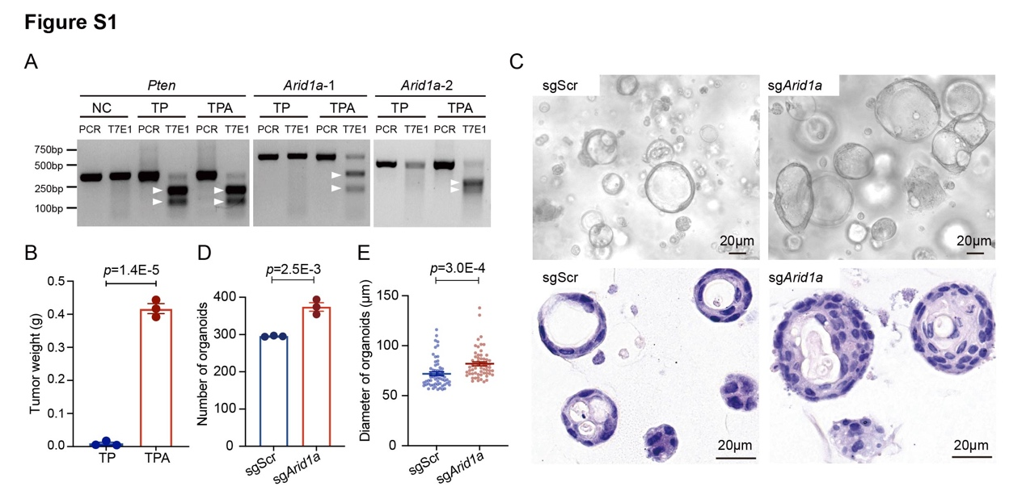
Supplementary Figures

Supplementary Figure 1. Arid1a loss promotes SRCC phenotype.
(A) T7 endonuclease I assay on Pten (left), Arid1a-1 (middle) and Arid1a-2 (right) in gastric organoids. Cleaved bands were pointed by white arrowheads. (B) The weight of TP and TPA subcutaneous tumors (n = 3). Data presented as the means ± the SEM, p-value was calculated by unpaired t-test. (C) Representative bright-field (top), H&E (bottom) in sgScr and sgArid1a gastric organoids. Scale bar, 20μm. (D) The number of sgScr and sgArid1a gastric organoids (n = 3). Data presented as the means ± the SEM, p-value was calculated by unpaired t-test. (E) The diameters of sgScr and sgArid1a gastric organoids. Data presented as the means ± the SEM, p-value was calculated by unpaired t-test.
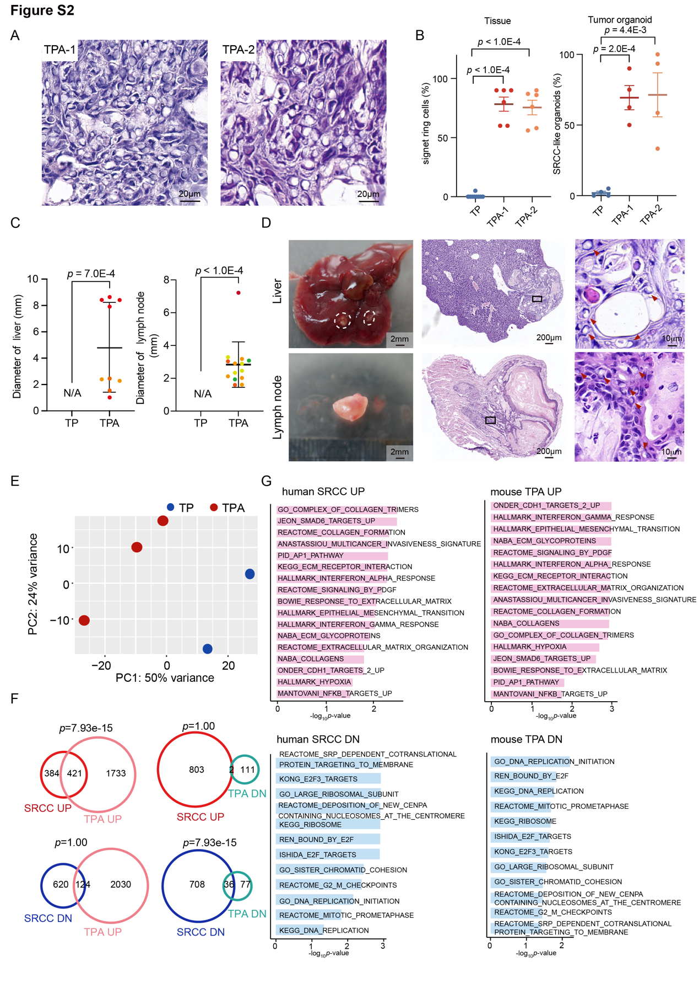
Supplementary Figure 2. The orthotopic SRCC model accurately recapitulated the histological, pathological, and molecular characteristics in human SRCC.
(A) Representative H&E image of mouse TPA signet ring cell carcinoma. Scale bar, 20μm. (B) The percentage of signet ring cells in TP and TPA tumor tissues (n = 6, left) and SRCC-like in TP and TPA tumor organoids (n = 4, right). Data presented as the means ± the SEM, p-values were calculated by unpaired t-test. (C) The diameters of TP (transplanted mice n = 9, mice with metastatic tumor = 0) and TPA (transplanted mice n = 12, mice with liver metastases = 3 and lymph node metastases = 4) mice showing visible liver (left) and lymph node (right) metastases. Each dot indicates a metastasis locus, each color indicates the same mouse. Data presented as the means ± the SD, p value was calculated by unpaired t test. (D) Representative bright-field (left) and H&E (middle and right) staining of liver (top) and lymph node (bottom) metastases in orthotopic TPA mice. Scale bars, 2mm (left), 200μm (middle) and 10μm (right). Box areas showing higher magnifications. (E) The dot plot showing principal component analysis result of RNA-seq data from TP and TPA tumor organoids. (F) Venn diagrams illustrating the overlap between SRCC upregulated (UP) and TPA upregulated (UP) pathways, SRCC UP and TPA downregulated (DOWN) pathways, SRCC downregulated (DOWN) and TPA UP pathways, as well as SRCC DOWN and TPA DOWN pathways, as analyzed by RNA-seq. P values were determined by hypergeometric distribution. (G) GSEA results of human SRCC up-regulated and TPA up-regulated pathways, human SRCC down-regulated and TPA down-regulated pathways compared to human ITGC and TP mice, respectively.
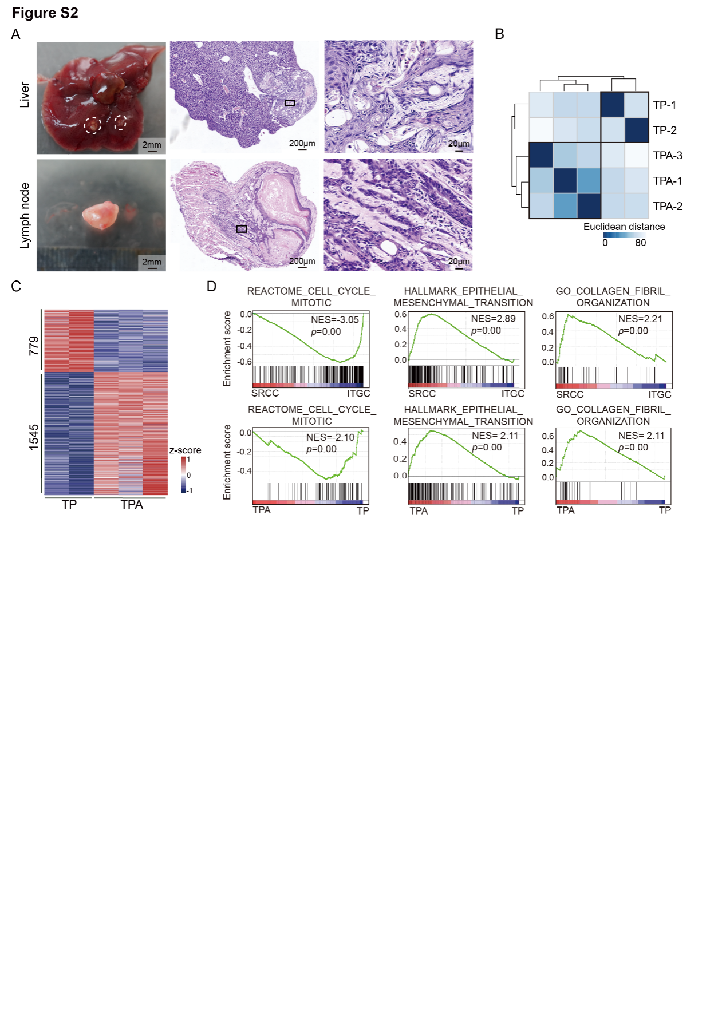

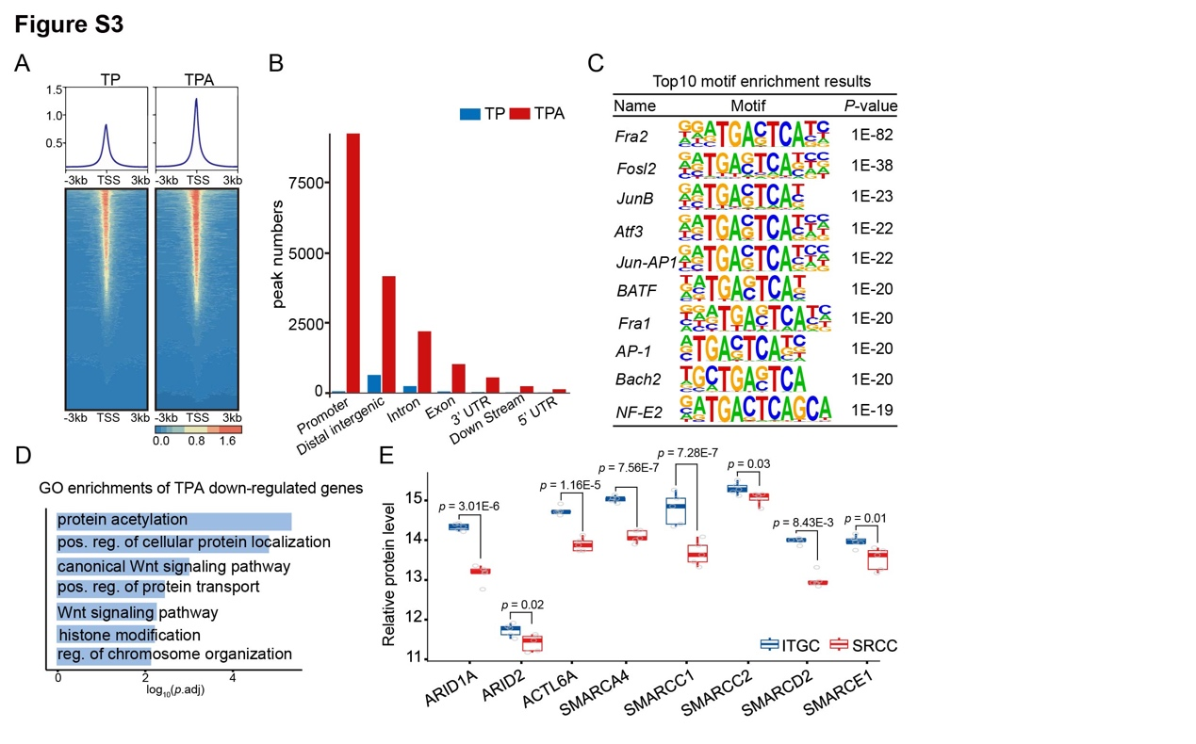
Supplementary Figure 3. Arid1a deficiency resulted in widespread changes in the epigenome.
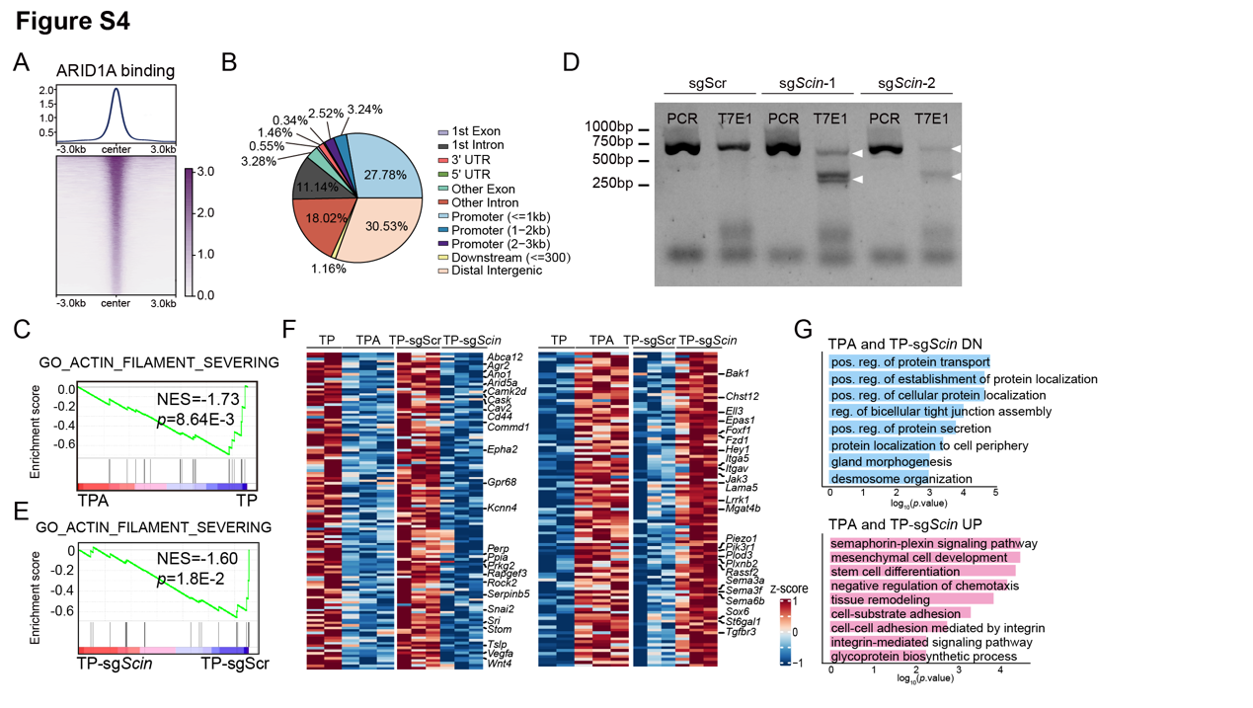
(A) Average intensity curves (top) and tornado plots (bottom) showing the genome accessibility levels at TSS regions in TP and TPA gastric organoids. (B) The bar plots showing the absolute numbers of differentially accessible peaks in TP and TPA gastric organoids, respectively. (C) Top10 motif enrichments in TPA gastric organoids significantly highly accessible regions, compared with TP ones. (D) Gene ontology enrichment results of the TPA down-regulated genes compared with TP tumor organoids (p-value < 0.05 and absolute log₂fold-change > 0.5). (E) The box plot showing the protein levels of BAF complex related genes between ITGC and SRCC tumors detected by MS proteomics.
Supplementary Figure 4. The loss of Scin partially mimics the SRCC phenotype caused by Arid1a deficiency.
(A) Average intensity curve (top) and tornado plot (bottom) showing the signal levels of ARID1A binding regions in TP gastric organoids. (B) The pie chart showing the distribution of ARID1A binding peaks in annotated regions of the genome in TP gastric organoids. (C) GSEA showing the negative enrichment of the GO_ACTIN_FILAMENT_SEVERING gene set (NES = -1.73; p = 8.64E-3) in TPA compared with TP gastric organoids. (D) T7 endonuclease I assay on Scin in TP tumor organoids. Cleaved bands were pointed by white arrowheads. (E) GSEA showing the negative enrichment of the GO_ACTIN_FILAMENT_SEVERING gene set (NES = -1.60; p = 1.8E-2) in TP-sgScin compared with TP-sgScr tumor organoids. (F) Heatmap showing the downregulated (left) and upregulated (right) gene sets in TPA and TP-sgScin tumor organoids compared to TP and TP-sgScr organoids, respectively. (G) Gene ontology enrichment results of the TPA and TP tumor-sgScin down-regulated (top), and up-regulated (bottom) pathways compared with TP and TP-sgScr tumor organoids, respectively.

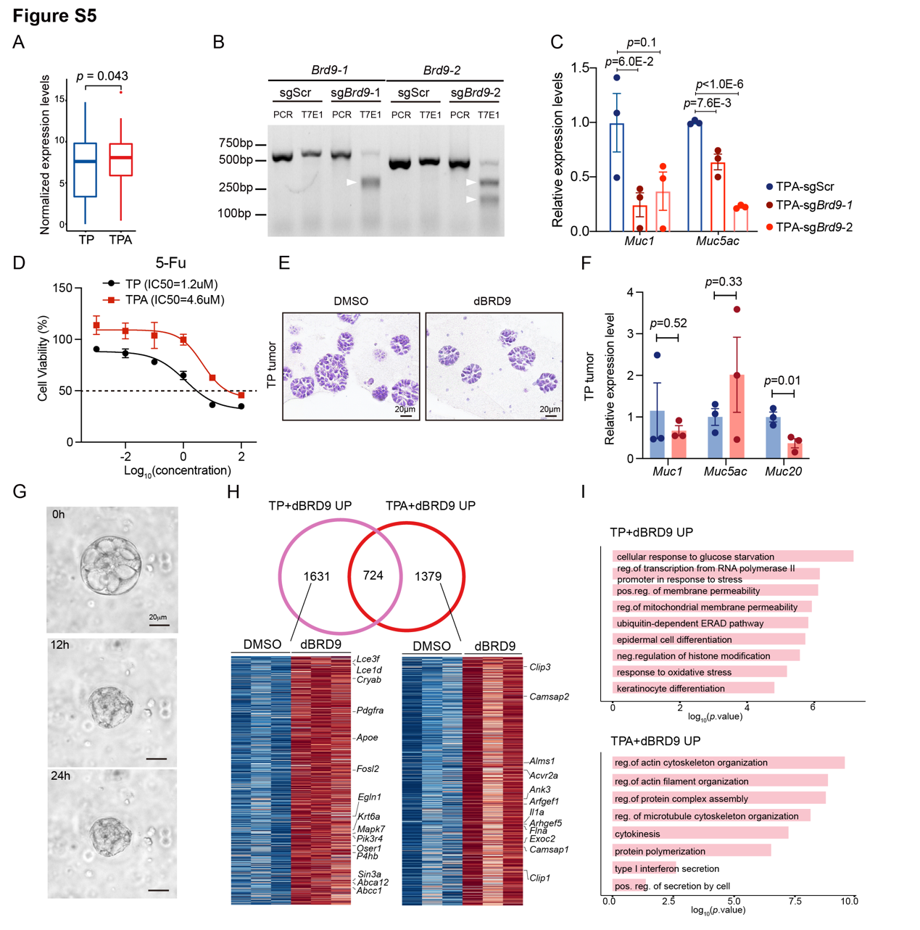
Supplementary Figure 5. BRD9 inhibition reverses the SRCC phenotype caused by Arid1a deficiency.
(A) The box plot showing the expression levels of genes with significantly increased BRD9 binding levels in TPA tumor organoids compared to TP ones. (B) T7 endonuclease I assay on Brd9 in TPA tumor organoids. Cleaved bands were pointed by white arrowheads. (C) The relative mRNA levels of Muc1 and Muc5ac in TPA tumor organoids with sgScr or sgBrd9, measured by RT-qPCR (n = 3). Data presented as the means ± the SEM, p-value was calculated by unpaired t-test. (D) Dose-response curves of TP and TPA tumor organoids treated with 5-Fu. (E) Representative H&E staining of TP tumor organoids treated with DMSO or 10μM dBRD9. Scale bar, 20μm. (F) The relative mRNA levels of Muc1, Muc5ac, and Muc20 in TP tumor organoids treated with DMSO or 10μM dBRD9, measured by RT-qPCR (n = 3). Data presented as the means ± the SEM, p-value was calculated by unpaired t-test. (G) The representative picture of single TPA tumor organoid with 0.01μM dBRD9 treatment. Scale bar, 20μm. (H) The Venn diagrams illustrate the overlap and uniquely upregulated genes in dBRD9-treated TP and TPA tumor organoids compared to DMSO-treated controls (top). The heatmaps display the distinct sets of upregulated genes in TP and TPA tumor organoids following dBRD9 treatment relative to their respective DMSO-treated counterparts (bottom). (I) GO enrichment analysis of pathways specifically upregulated in dBRD9-treated TP (top) and TPA (bottom) tumor organoids, compared to DMSO-treated TP and TPA organoids, respectively.

