Degradation of Epoxy Resins in Water for Recovery of Small Organic Molecules: The Use of Platinum Catalyst under Hydrothermal Conditions
Yumeng Liao,^{a†} Satomi Hosokawa,^{b†} Kohei Takahashi,^{a*} Shintaro Nakagawa,^{c} Naoko Yoshie,^{c} Yuki Yamasaki^{d*} and Kyoko Nozaki^{a*}
ªDepartment of Chemistry and Biotechnology, Graduate School of Engineering, The University of Tokyo, Bunkyo-ku, 113-8656 Tokyo, Japan.
^{b}Research and Development Center, Hosei University, 4342 Aiharamachi, Machida City, 194-0298 Tokyo, Japan.
^{c}Institute of Industrial Science, The University of Tokyo, Meguro-ku, 153-8505, Tokyo, Japan.
^{d}Department of Economics, Hosei University, 4342 Aiharamachi, Machida City, 194-0298 Tokyo, Japan.
†Equal contribution
*Corresponding author. Email: takahashi-k@g.ecc.u-tokyo.ac.jp, yyuki@hosei.ac.jp, nozaki@chembio.t.u-tokyo.ac.jp

Table of contents
1. General information S2
2. Experimental set up for hydrothermal reactions S3
3. Experimental procedures S5
4. SEM analysis of recovered and raw carbon fibers S9
5. NMR spectra S11
6. References S13

1. General information
Dinitrogen was purchased from KENIS LIMITED. Water used in degradation reaction was purified by using a Elix® Essential 3 water purification system before use. Fe(acac)₃, FeCl₂(H₂O)₄, FeSO₄(H₂O)₇, [Ru(p-cymene)Cl₂]₂, Co(acac)₃, CoCl₂(H₂O)₆, Ni(dme)Cl₂, Ni(OAc)₂(H₂O)₄, NiSO₄(H₂O)₆, Pd(cod)Cl₂, Pt(cod)Cl₂, CuCl, CuCl₂, CuSO₄(H₂O)₅, AgOTf, AuCl, Sc(OTf)₃, Yb(OTf)₃, In(OTf)₃, conc. HCl aq, (NH₄)₂SO₄, PtCl₂, PtBr₂, PtI₂, PtCl₄, H₂PtCl₆(H₂O)₆, Na₂PtCl₆(H₂O)₆, K₂PtCl₄, PtO₂, Pt(PPh₃)₄, Pt₂(dba)₃, bisphenol A diglycidyl ether (BADGE), bis(4-aminocyclohexyl)methane, trimethylenetetramine, isophoronediamine, 4,4’-diaminodiphenylmethane, 4,4’-diaminodiphenylsulfone, N,N,N’,N’-tetraglycidyl-4,4’-diaminodiphenylmethane, acetone, dichloromethane, triethylamine, chloroform-d₁ (CDCl₃), bisphenol A, 4-isopropylphenol, phenol、1,1,2,2-tetrachloroethane, formic acid, aqueous formaldehyde (37wt%) and n-dodecane were purchased from TCI, Aldrich, Kanto, Fujifilm-Wako or AGC and used as received. EP-1, Cemedine (1500), ThreeBond, (2023/2106G) and Loctite (EA E-30CL) resins were prepared as described previously.¹ model-1,¹ model-3,¹ and 3-aminopropyl 4-tert-butylphenyl ether² were prepared by the literature methods. EP-2 (ethylenediamine/BADGE), EP-5 (bis(4-aminophenyl)methane/BADGE), EP-6 (bis(4-aminophenyl)sulfone/BADGE) and EP-8 (cis-1,2-Cyclohexanedicarboxylic Anhydride/BADGE) were kindly provided by a collaborator. Silica gel column chromatography was conducted on a Biotage Isolera One flush chromatography system using Purif-Pack-EX cartridge column. Silica Gel 60N (Kanto Chemical Co., Inc.) was used for other flash column chromatography. Merck Kieselgel 60 F254 (0.25 mm thickness, coated on glass 20×20 cm²) plate was used for analytical thin layer chromatography (TLC). Preparative thin layer chromatography (PTLC) was conducted by using Merck PLC Silica gel 60 F₂₅₄, 0.5 mm. NMR spectra were recorded on a BRUKER Ascend 500 (¹H: 500 MHz, ¹³C: 126 MHz) spectrometer at ambient temperature. Chemical shift values for ¹H NMR spectra are referenced to the residual proton resonances of CDCl₃ (δ: 7.26 ppm). Chemical shift values for ¹³C NMR spectra are referenced to the carbon resonances of CDCl₃ (δ: 77.16 ppm). For the analyses of amine containing substrates, trace amounts of acids were removed from CDCl₃ by passing through short pad of basic alumina. Stainless autoclaves equipped with a Teflon inside vessel were purchased from omlabotech. Yamato DH610 electric furnace was used for heating reaction mixtures. Gas chromatography (GC) analysis was conducted on Shimadzu GC-2022 equipped with an InertCap 5ms/Sil 0.25 mm × 0.25 μm × 30 m (GL science) capillary column and flame induced detector with dinitrogen as a carrier gas. Mass spectra (MS) were taken with an electron spray ionization time-of-flight (ESI-TOF) method on a Waters Xevo G2-XS QTOF spectrometer. Infrared (IR) spectra were recorded on a Cary 630 FTIR spectrometer (Agilent Technologies, Germany) with an attenuated total reflection (ATR) unit. SEM analysis was conducted on a JEOL JCM-6000PLUS operated at an acceleration voltage of 5 kV. The samples were placed on a carbon tape and observed as-is without coating.

2. Experimental set up for hydrothermal reactions
a) b)
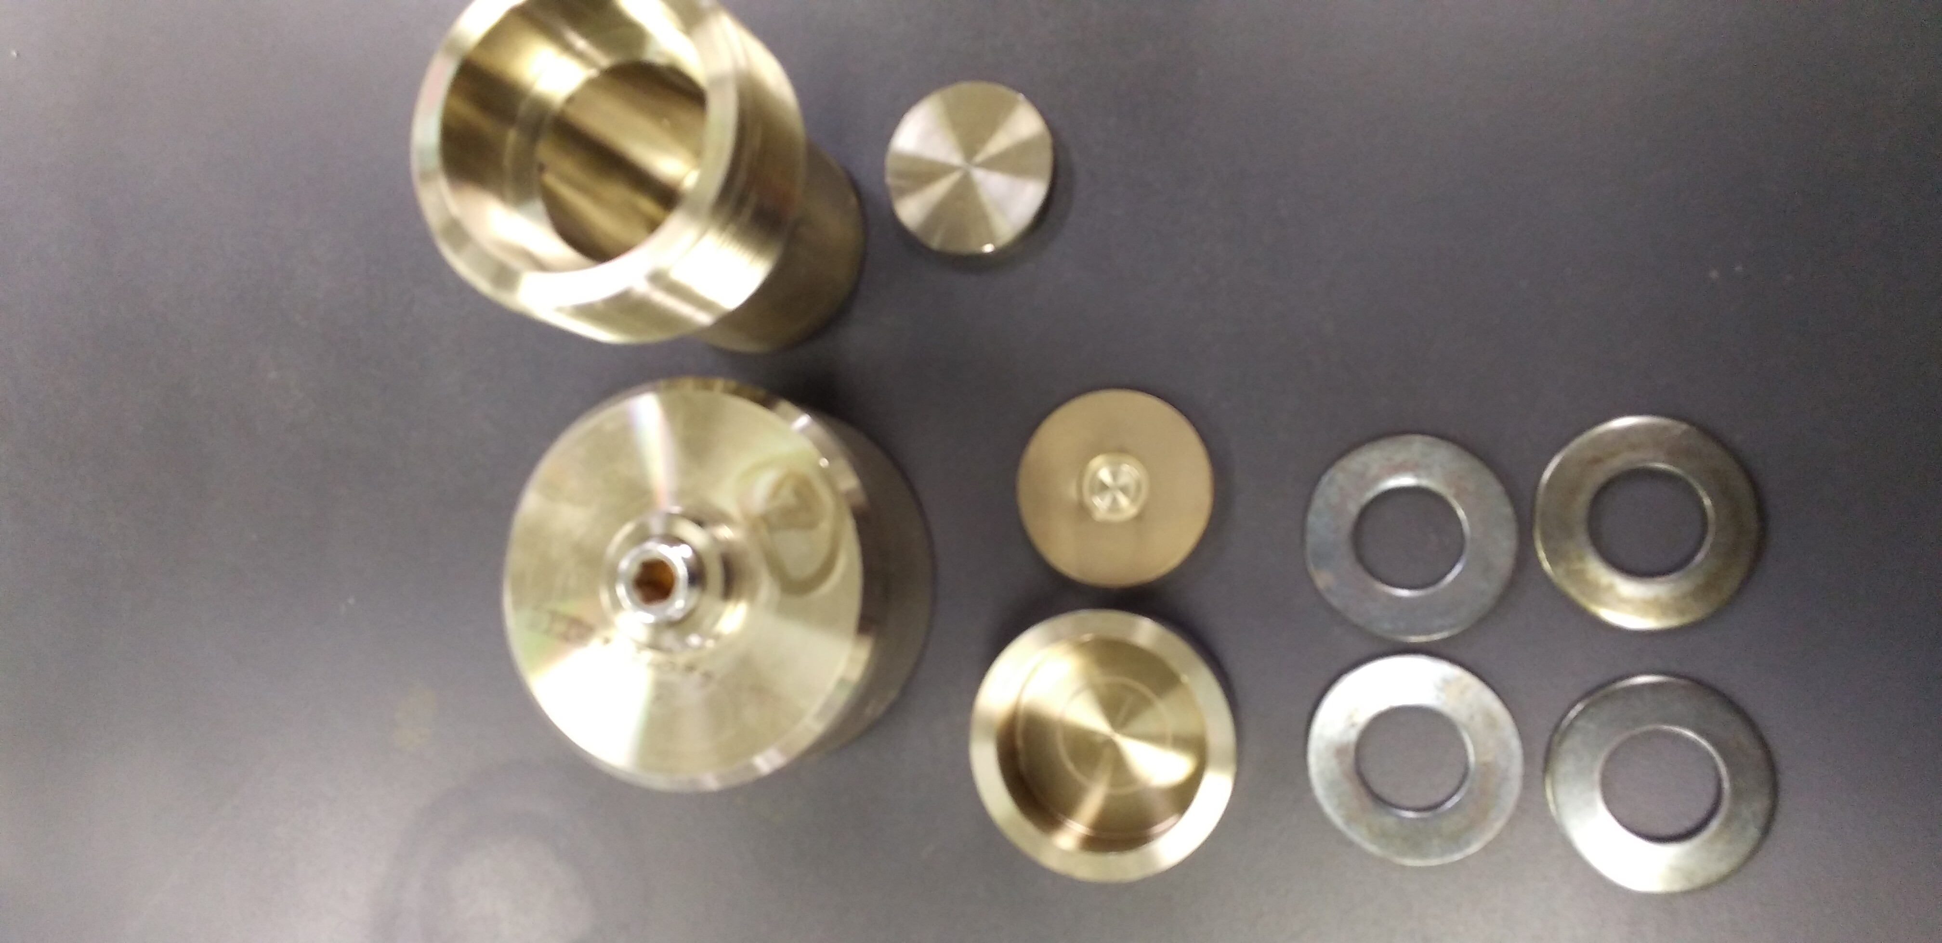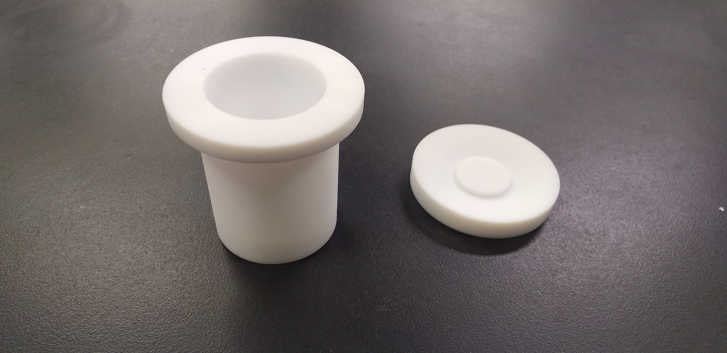
c) d)
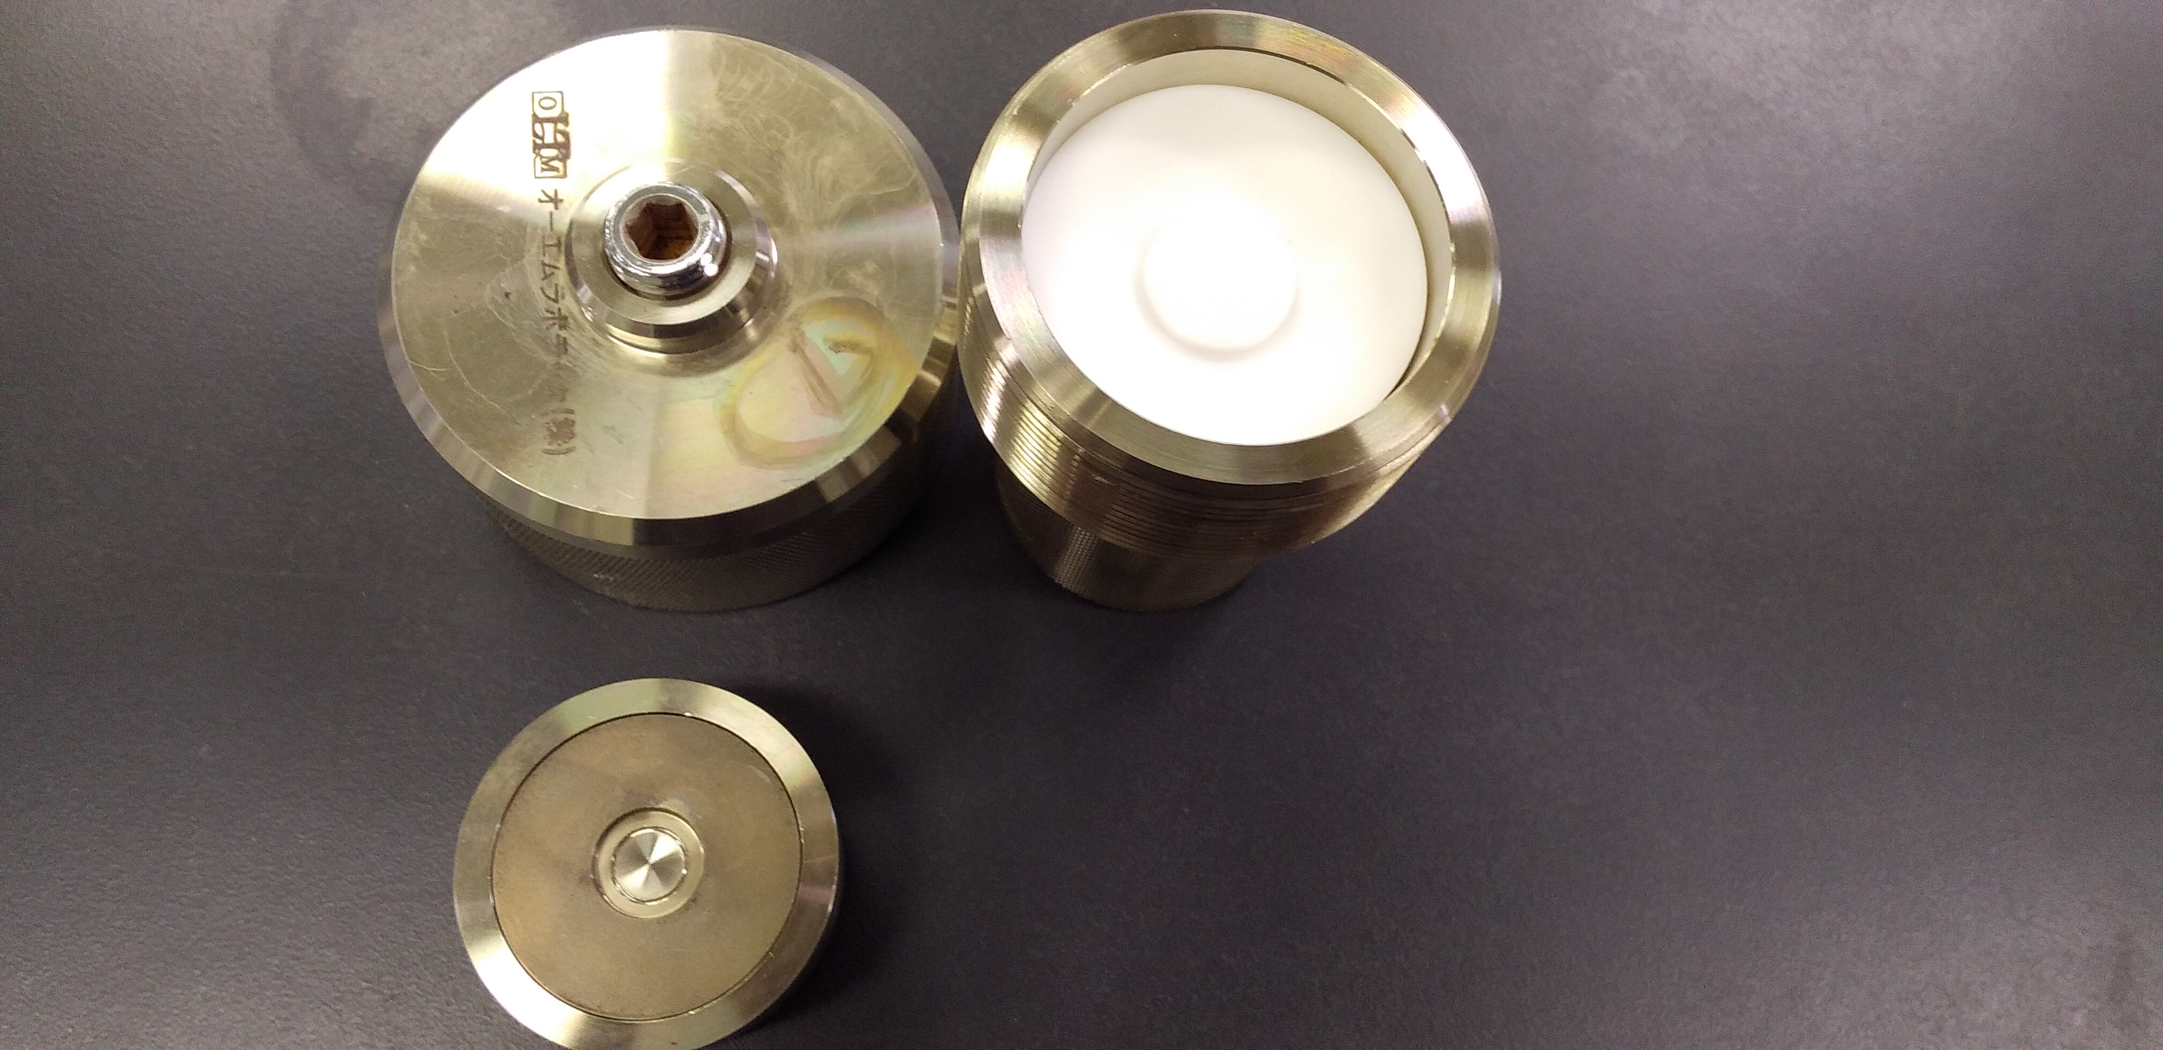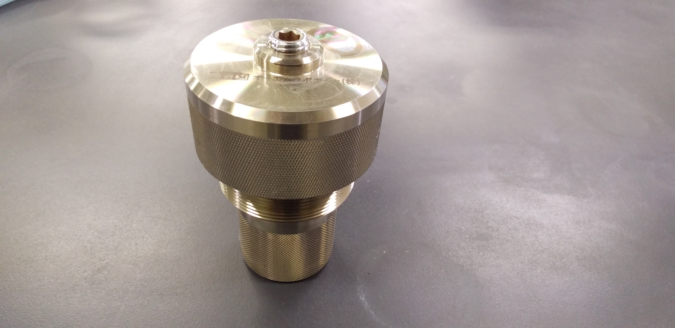
e)
Fig. 1 | a)-d) appearance of the stainless autoclave used in this work and e) size of inner Teflon vessel (values in mm).

a) b)
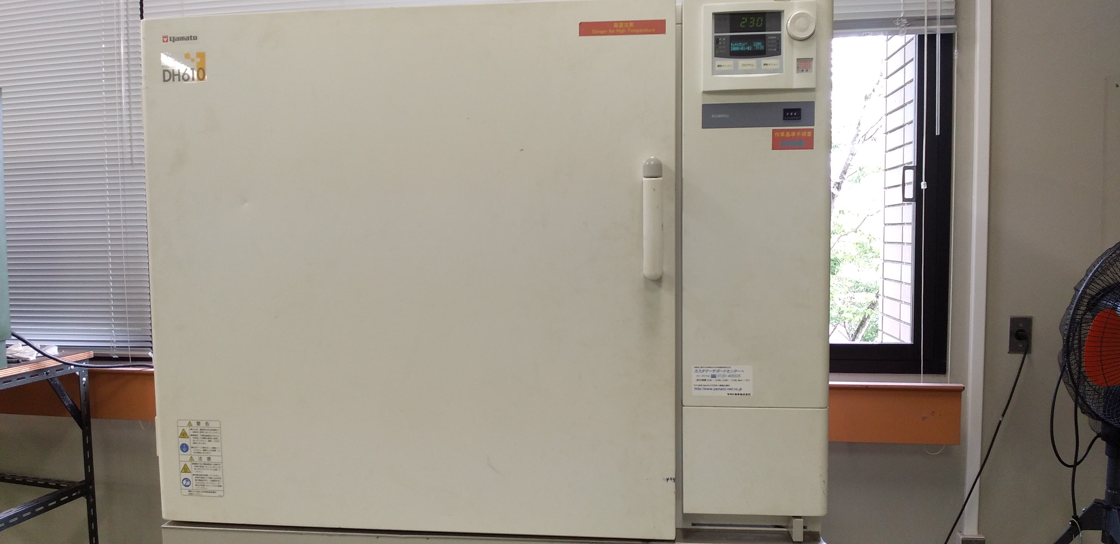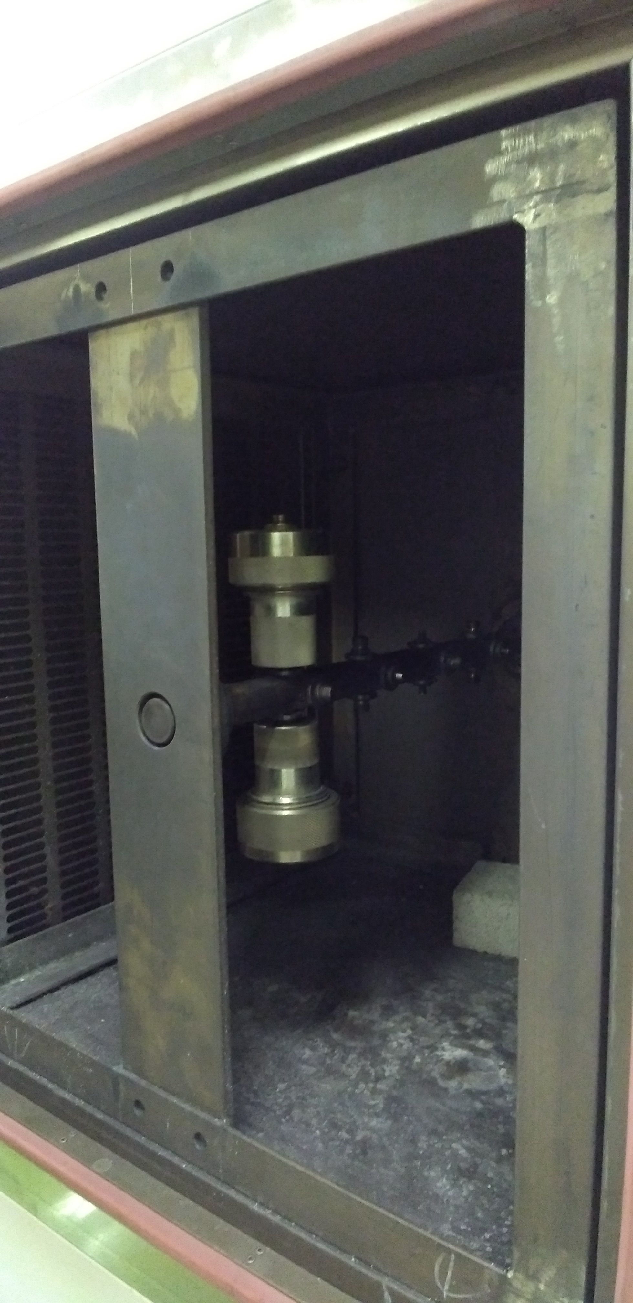
Fig. 2 | a) Appearance of electrical furnace (Yamato DH610) and b) how to set autoclaves inside of it (a set of autoclaves were set for balancing).

3. Experimental procedures
General procedure for the reactions of epoxy resin

In air, to a 20 mL Teflon vessel were added epoxy resin substrate (0.500 mmol of bisphenol A units), catalyst (12.5 μmol of metal atom) and water (10 mL, degassed by N₂ bubbling prior to use). The Teflon vessel was purged with N₂ before closing with a Teflon cap. The Teflon vessel was put in a stainless autoclave and the autoclave was tightly closed. The autoclave was put on the rotation axis in the electric furnace pre-heated at desired temperature and heated at the temperature with the stirring rate of 100 rpm. After cooling to room temperature, resulting components were taken up with water and acetone. The remaining solid was separated by filtration and washed with acetone and dichloromethane. The resulting solid was dried under vacuum at 80 ºC and the amount of insoluble fraction was determined by the weight. From the residue, acetone and dichloromethane were evaporated. To the mixture was added water and the organic fraction was extracted three times with dichloromethane. The combined dichloromethane fraction was washed with brine, followed by drying over Na₂SO₄. After removal of Na₂SO₄ by filtration, the solvent was evaporated to give soluble fraction and the amount was determined by the weight. Dodecane was added to the fraction, diluted with acetone and subjected to GC analysis. Yields of each products were described based on the aromatic units derived from BPA (For example, yield of 0.100 mmol of phenol corresponds to 0.100/(0.500 × 2) = 10%).

General procedure for the reactions of model compounds
In air, to a 20 mL Teflon vessel were added a model compound (0.500 mmol of bisphenol A units), Pt(cod)Cl₂ (12.5 μmol of metal atom) and water (10 mL, degassed by N₂ bubbling prior to use). The Teflon vessel was purged with N₂ before closing with a Teflon cap. The Teflon vessel was put in a stainless autoclave and the autoclave was tightly closed. The autoclave was put on the rotation axis in the electric furnace pre-heated at 230 °C and heated at the temperature with the stirring rate of 100 rpm. After cooling to room temperature, resulting components were taken up with water and acetone. After evaporation of acetone, to the mixture was added water and the organic fraction was extracted three times with ethyl acetate. The combined ethyl acetate fraction was washed with water and brine, followed by drying over Na₂SO₄. After removal of Na₂SO₄ by filtration, the solvent was evaporated. The NMR yield was determined by using CDCl₃ as a solvent and 1,1,2,2-tetrachloroethane (10.0 μL) as an internal standard. The recovery of ArOR units (several doublets at 6.98-6.89 ppm) and the yields of 4-tert-butylphenol (6.76 ppm, doublet, J = 8.8 Hz) and model-3’ (1.19, t, J = 7.6 Hz) (if needed) were determined by the corresponding characteristic signals.

General procedure for the preparation of epoxy resin (EP-3, EP-4)
The synthesis of diamine-cured epoxy resin was performed following a modified procedure from reported literature. To a 50 mL glass vial, were added bisphenol A diglycidylether and an amine. The resulting mixture was casted on a Teflon sheet and treated under vacuum at room temperature for 30 minutes, 80 °C for 2 hours then 150 °C for 2 hours. The resulting solid was ground with a metal file to give powdered epoxy resin.

Preparation of EP-7
To a 50 mL glass vial, were added bis(4-aminophenyl)sulfone, 4,4′-Methylenebis(N,N-diglycidylaniline) (1 : 1 molar ratio). The resulting mixture was stirred at 120 °C for several minutes. The resulting mixture was casted on a Teflon sheet and treated under vacuum at 140 °C for overnight then 200 °C for 4 hours. The resulting solid was ground with a metal file to give powdered epoxy resin EP-7.

Synthesis of 3-dimethylaminopropyl 4-tert-butylphenyl ether (mode-2)
To a 50 mL round bottomed flask were added 3-aminopropyl 4-tert-butylphenyl ether (2.078 g, 10.02 mmol), aqueous formaldehyde (37 wt%, 5,5 mL) and formic acid (5.5 mL). The resulting mixture was heated at 100 ºC for 1 hour and basify with solid K₂CO₃ in an ice/water bath. To the mixture was added water and extracted three times with ethyl acetate, washed with water and brine and dried over Na₂SO₄. After separation of Na₂SO₄ by filtration, the solvent was evaporated and the resulting mixture was purified by passing through silica gel short column (φ = 4 cm × 2 cm, eluted with c.a. 100 mL of CH₂Cl₂ : MeOH : NEt₃= 80 : 20 : 1) to give desired compound (1.780 g, 7.563 mmol, yield 75%).
¹H NMR (500 MHz, CDCl₃): δ = 7.29 (d, J = 9.0 Hz, 2H), 6.84 (d, J = 9.0 Hz, 2H), 4.00 (t, J = 6.5 Hz, 2H), 2.45 (t, J = 7.5 Hz, 2H), 2.25 (s, 6H), 1.94 (quint, J = 7.0 Hz, 2H), 1.30 (s, 9H).
¹³C NMR (125 MHz, CDCl₃): δ = 156.9, 143.3, 126.3, 114.1, 66.3, 56.6, 45.7, 34.2, 31.7, 27.8.
IR: ν̃ = cm⁻¹ 2952, 2904, 2866, 2818, 2766, 1610, 1513, 1461, 1390, 1364, 1293, 1245, 1182, 1115, 1100, 1059, 1040, 1036, 954, 828.
HRMS (ESI): m/z calcd for C₁₅H₂₆NO⁺ [M + H]⁺: 236.2009 found: 236.2014

Characterization of mode-3’
The reaction product in the reaction of model-3 without catalyst (Scheme 1e) was subjected to preparative thin layer chromatography to give model-3’ with some impurities.

¹H NMR (500 MHz, CDCl₃): δ = 7.29 (d, J = 8.5 Hz, 2H), 6.85 (d, J = 9.0 Hz, 2H), 4.20-4.10 (m, 1H), 4.05-3.90 (m, 2H), 2.93 (dd, J = 12.0, 3.5 Hz, 1H), 2.83 (dd, J = 12, 8.5 Hz, 1H), 2.81-2.71 (m, 2H), 1.29 (s, 9H), 1.19 (t, J = 7.0 Hz, 3H).

The signals on the ¹H NMR spectrum were assigned as follows.

4. SEM Image of recovered and raw carbon fibers
a) (× 20) b) (× 100)
c) (× 500) d) (× 2000)
Fig. S3 | SEM images of recovered carbon fiber (Fig. 4)

a) (× 20) b) (× 100)
c) (× 500) d) (× 2000)
Fig. S4 | SEM images of raw carbon fiber used to make the CFRP of Fig. 4.

5. NMR spectra
Fig. 5 | ¹H NMR spectrum of model-2
Fig. 6 | ¹³C NMR spectrum of model-2

Fig. 7 | ¹H NMR spectrum of model-3’ with some impurities.

6. References
1. Liao, Y.; Takahashi, K.; Nozaki, K. Nickel-Catalyzed C(sp³)–O Hydrogenolysis via a Remote-Concerted Oxidative Addition and Its Application to Degradation of a Bisphenol A-Based Epoxy Resin. J. Am. Chem. Soc. 146, 2419–2425 (2024).
2. Durmaz, M.; Tataroglu, A.; Yilmaz, H.; Sirit, A. Calixarene-derived chiral tertiary amine-thiourea organocatalyzed asymmetric Micheal additions of acetyl acetone and dimethyl malonate to nitroolefins. Tetrahedron: Asymm. 27, 148-156 (2016).

