Supplementary Results.

Aged Pu-erh tea reduced oxidative stress-mediated inflammation in DSS-induced colitis mice by regulating intestinal microbes
Shanshan Hu, Shi Li, Yan Liu, Kang Sun, Liyong Luo, Liang Zeng*

Figure S1. Pu-erh tea pre-experiment and part of the FMT experiment
Figure S2. FMT reduced the oxidative stress of DSS-induced colitis
Figure S3. FMT inhibited oxidative stress-mediated inflammatory signaling pathway transduction
Figure S4. FMT improved intestinal immunity in colitis mice
Figure S5. Effects of long-term Pu-erh tea drinking on gut microbes
Figure S6. Multi-group comparison among different treatment groups

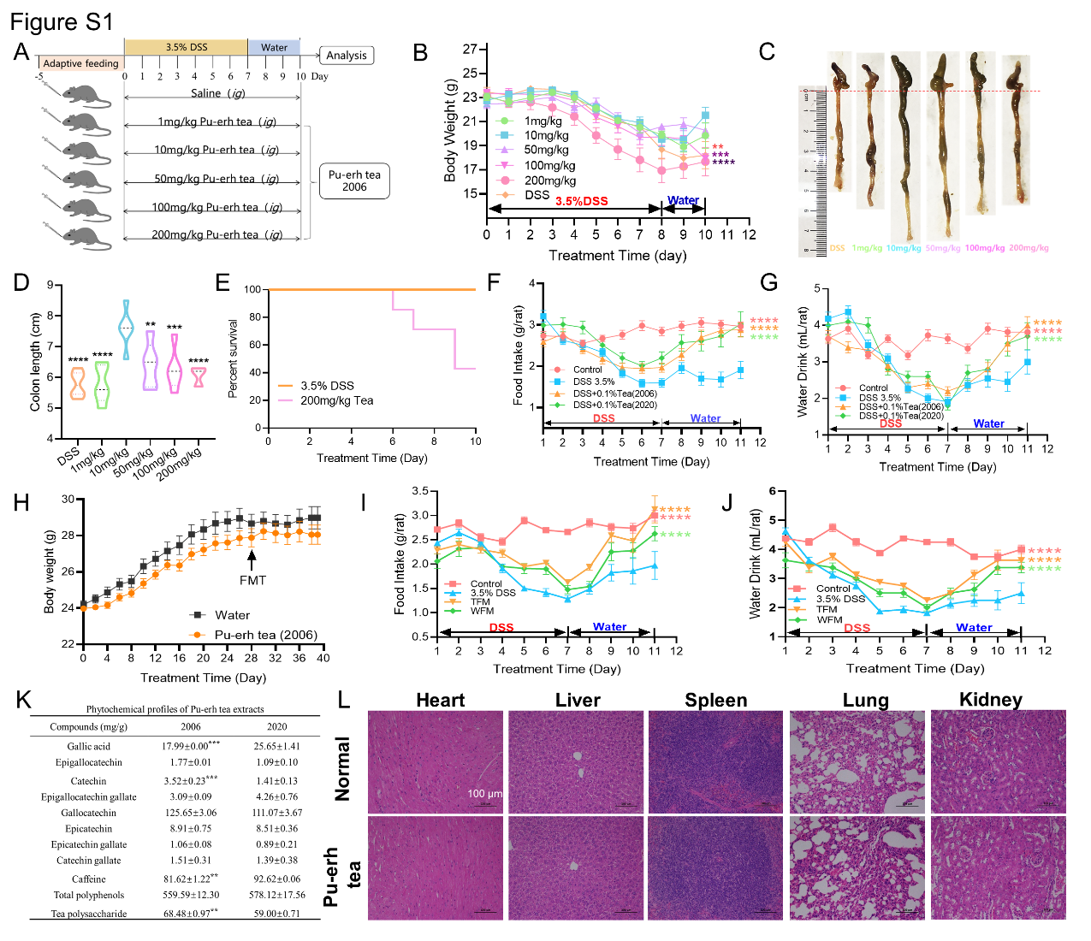
Figure S1. Pu-erh tea pre-experiment and part of the FMT experiment
(A) Schematic diagram of the preliminary experimental design. (B) Body weighed (n=6), (C) representative colon image (n=6), (D) colon lengths (n=6), (E) and percent survival of pre-experiment mice. (F and G) Food and water intake of experimental mice (n=6). (H) Body weight of donor mice (n=15), (I) food (n=6), and (J) water intake in FMT experiment (n=6). (K) Phytochemical profiles of Pu-erh tea extracts. (L) Representative H+E stained sections of the heart, liver, spleen, lung, kidney, in FMT experiment (n=3). Data are mean ± SEM.*p < 0.05, **p < 0.01, ***p < 0.005, ****p < 0.001, determined by Student’s t test and one-way ANOVA with Bonferroni’s multiple comparison test.

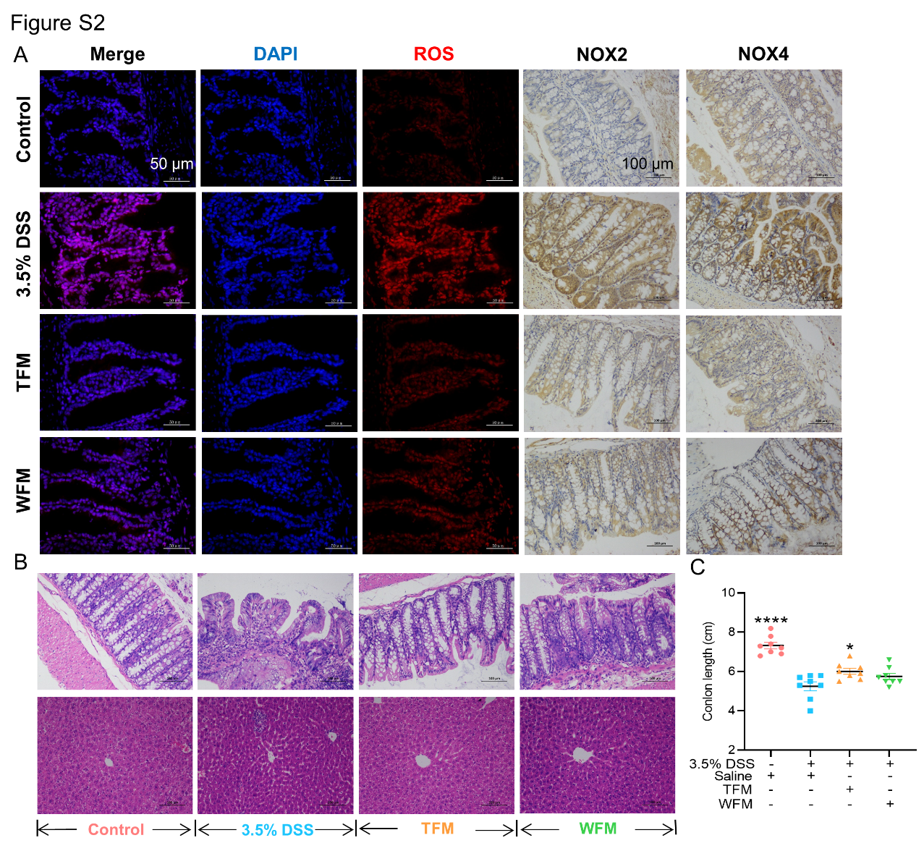
Figure S2. FMT reduced the oxidative stress of DSS-induced colitis
(A) Immunofluorescence analysis of reactive oxygen species (ROS). Scale bar, 50 μm.; Immunohistochemical analysis of expressions of NADPH oxidase 2 (NOX2) and NADPH oxidase 4 (NOX4). Scale bar, 100 μm. (B) Representative H+E stained sections of the colon and liver in FMT experiment. Scale bar, 100 μm. (C) Colon Length Statistics in FMT experiment. (n=8). Data are mean ± SEM.*p < 0.05, **p < 0.01, ***p < 0.005, ****p < 0.001 vs the DSS group. #p < 0.05, ##p < 0.01, ###p < 0.005, ####p < 0.001 vs the DSS + 0.1% Tea (2020) group, determined by Student’s t test and one-way ANOVA with Bonferroni’s multiple comparison test.
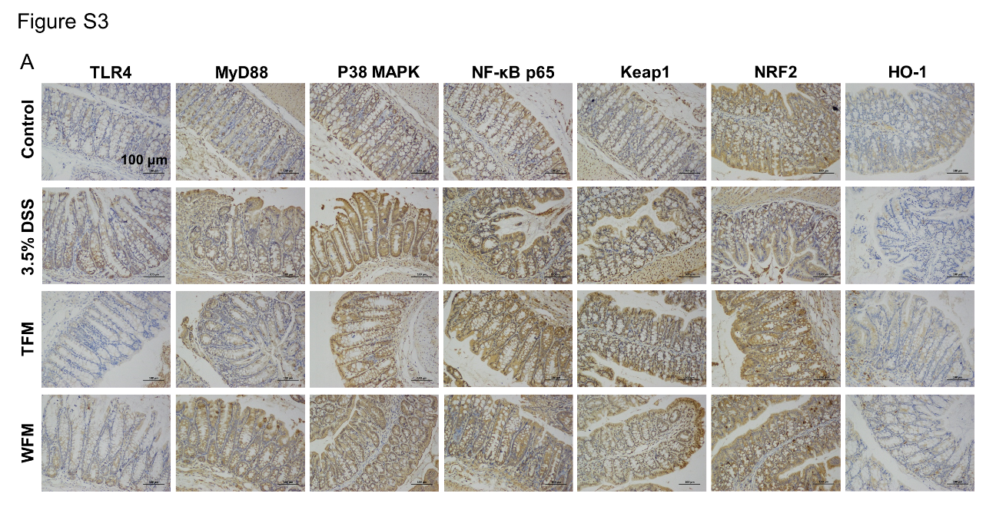
Figure S3. FMT inhibited oxidative stress-mediated inflammatory signaling pathway transduction
(A) Immunohistochemical analysis of expressions of inflammatory signaling pathway proteins (TLR4/MyD88/P38 MAPK/NF-kB P65); Immunohistochemical analysis of expressions of antioxidant signaling pathway proteins (Keap1/Nrf2/HO-1) in FMT experiment. Scale bar, 100 μm.

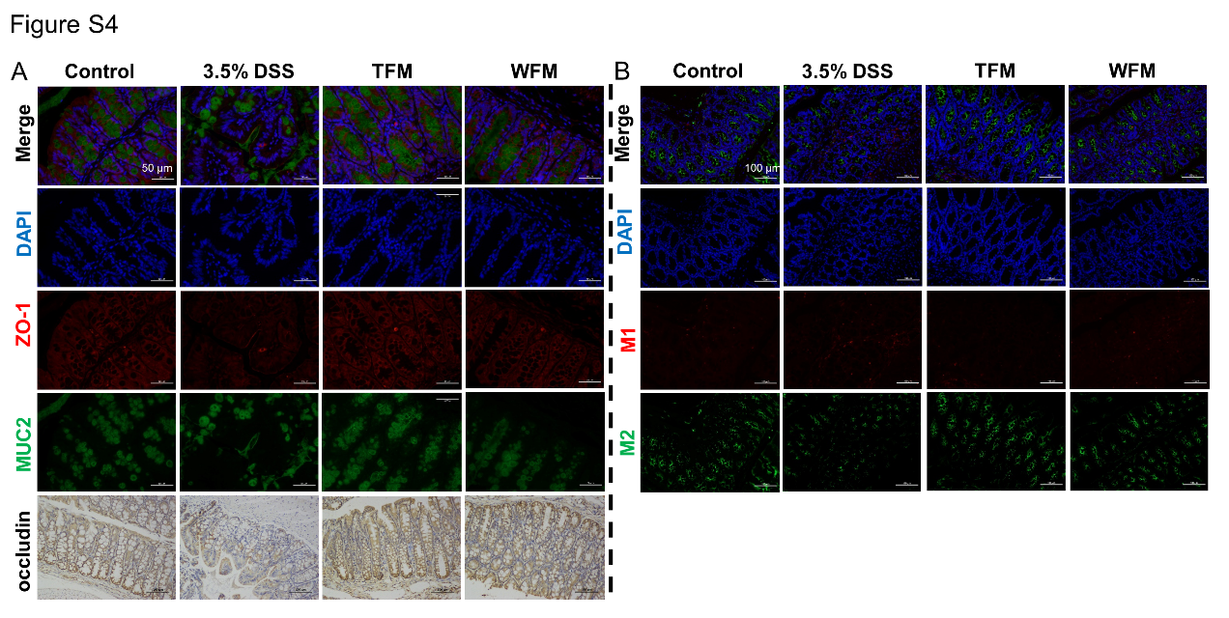
Figure S4. FMT improved intestinal immunity in colitis mice
(A) Immunofluorescence analysis of Zonula occludens 1 (ZO-1) and mucoprotein 2 (MUC2) in colon; Immunohistochemical analysis of expressions of occludin. Scale bar, 50 μm. (B) Immunofluorescence analysis of M1 and M2 in colon. Scale bar, 100 μm.

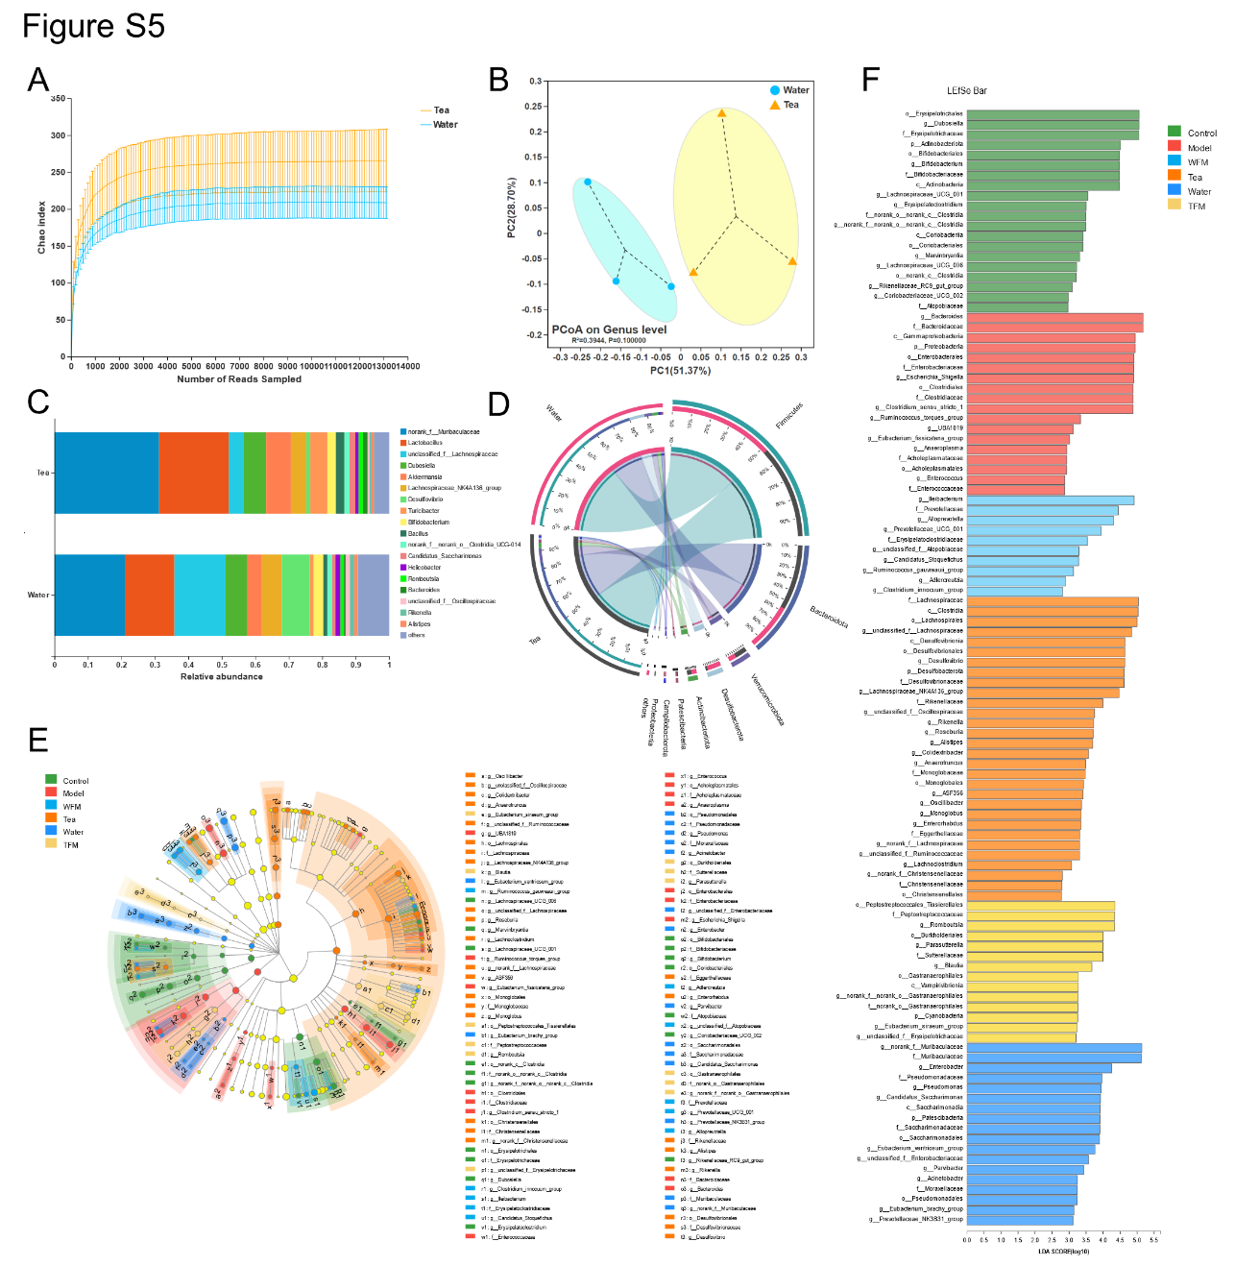
Figure S5. Effects of long-term Pu-erh tea drinking on gut microbes
(A) Evaluation the species α - diversity of mice treated with water and Pu-erh tea (P2006) for a long time by Chao index (n=3). (B) Principal co-ordinates analysis (PCOA) plot of the gut microbiota of long-term water and tea treated mice based on Bray−Curtis matrixes (n=3). (C and D) Gut microbiota composition at genus level (C) and phylum level (D) with relative abundance of more than 1%. (E and F) Linear discriminant analysis of the microflora of mice treated with different treatments and its influencing factors.
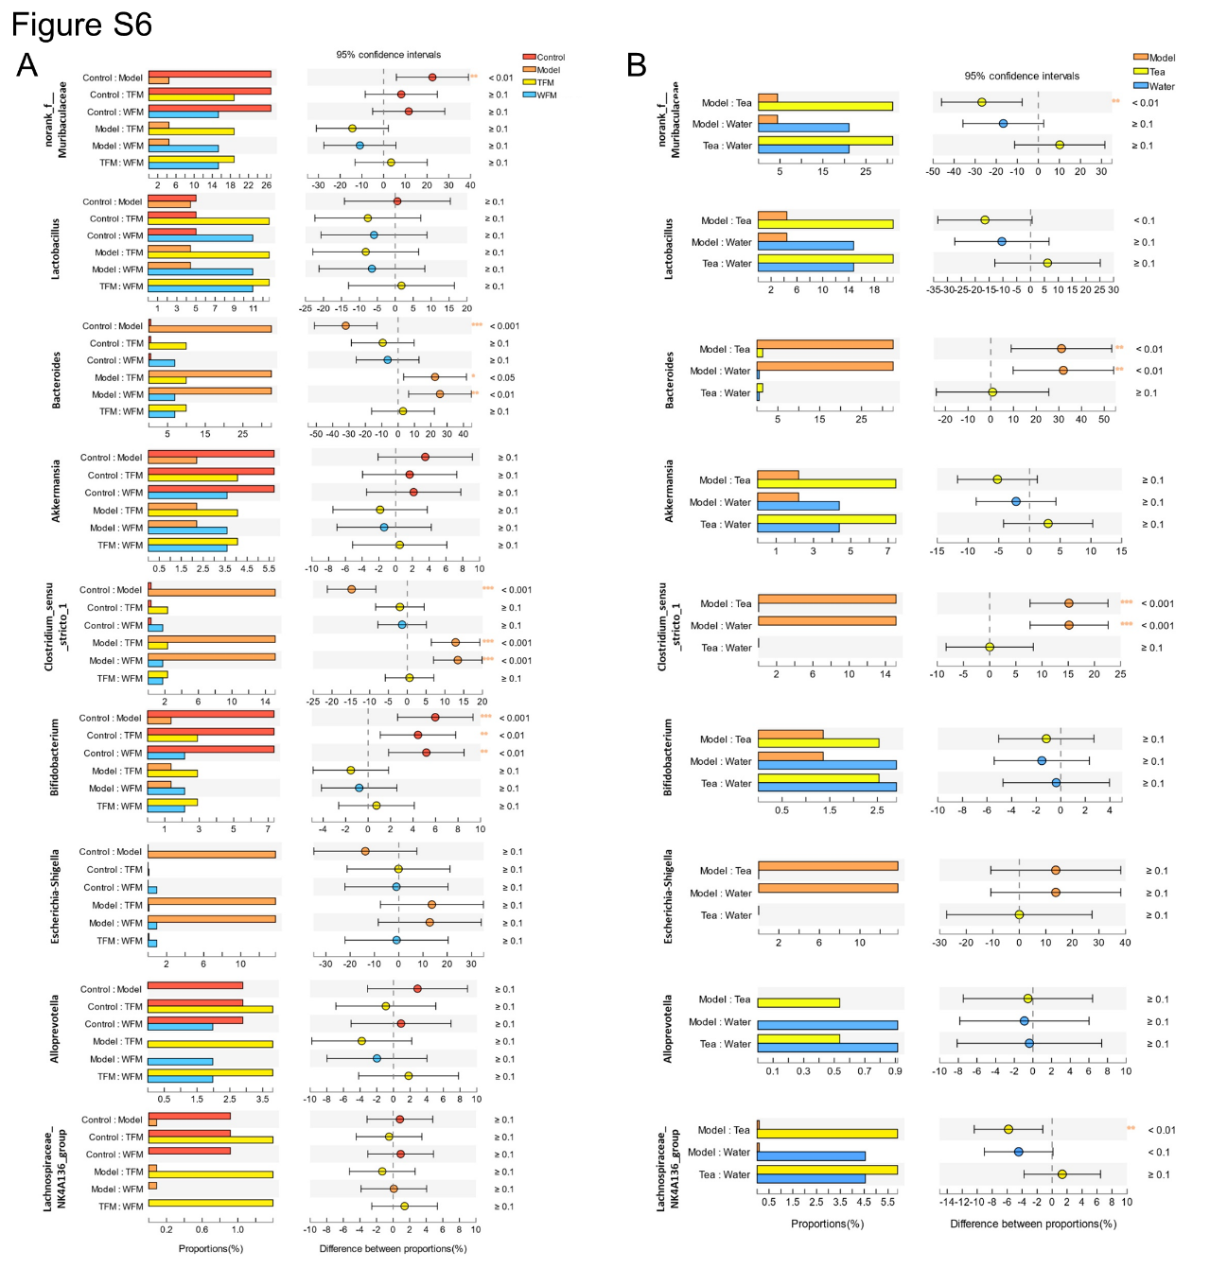
Figure S6. Multi-group comparison among different treatment groups
(A) Multi-group comparison based on genera level (Control, Model, TFM, WFM)
(B) Multi-group comparison based on genera level (Model, Tea, Water)

