Peptide Derived from Bungarus caeruleus Proteome Binds with Higher Affinity to Ethionamide Resistance Regulator of Mycobacterium tuberculosis than Isoniazid
Priyanka Singh, Gurunathan Jayaraman*
School of Biosciences and Technology, Vellore Institute of Technology, Vellore, Tamil Nadu, India
Corresponding author email Id:
G. Jayaraman
School of Biosciences and Technology
Vellore Institute of Technology
Vellore 632014, India
Email: gjayaraman@vit.ac.in

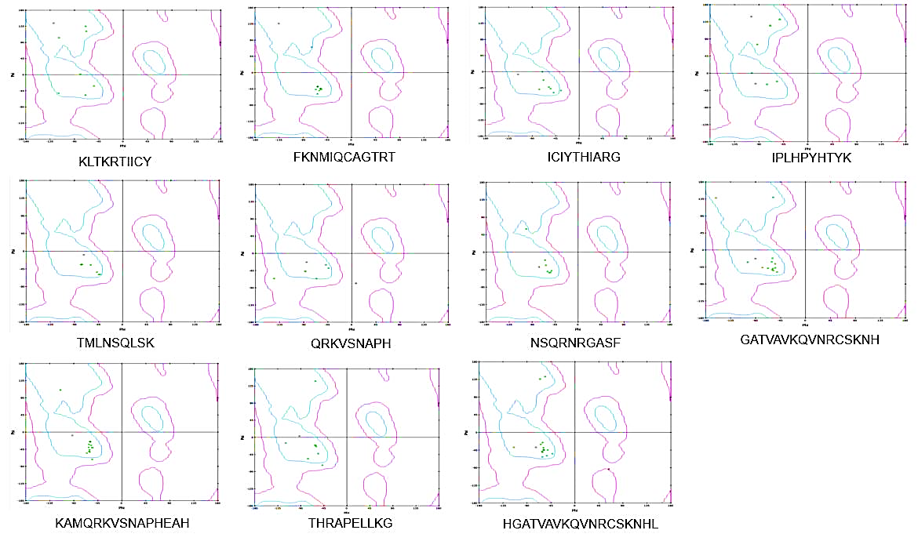Fig. 1 Ramachandran plot for the different predicted antimicrobial peptides representing the secondary structure property
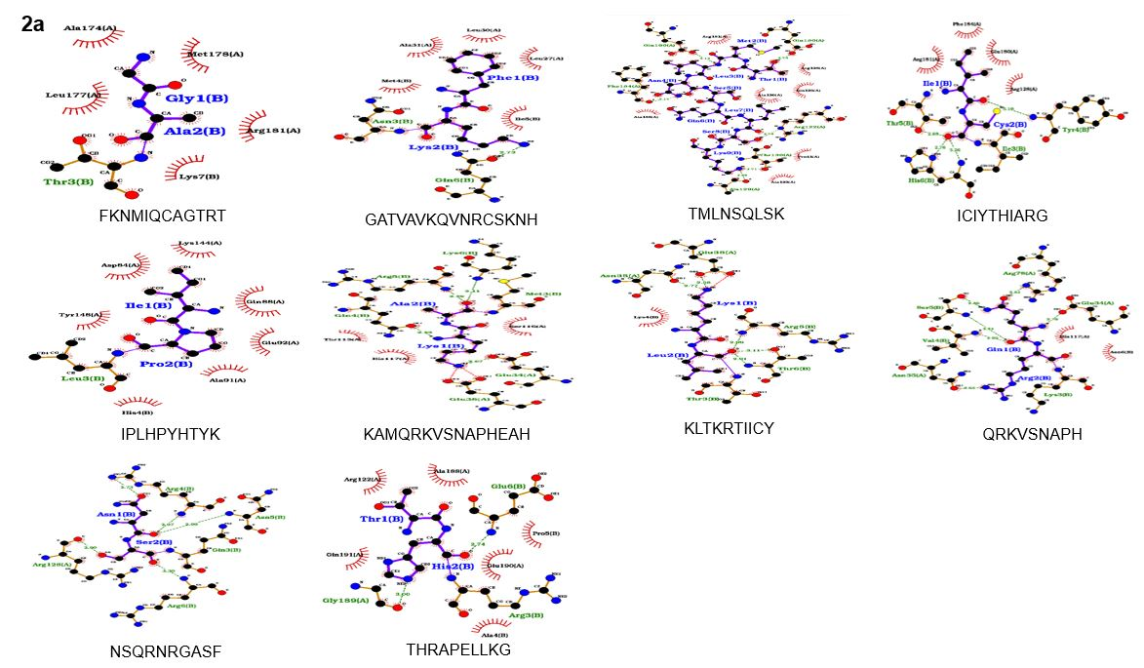
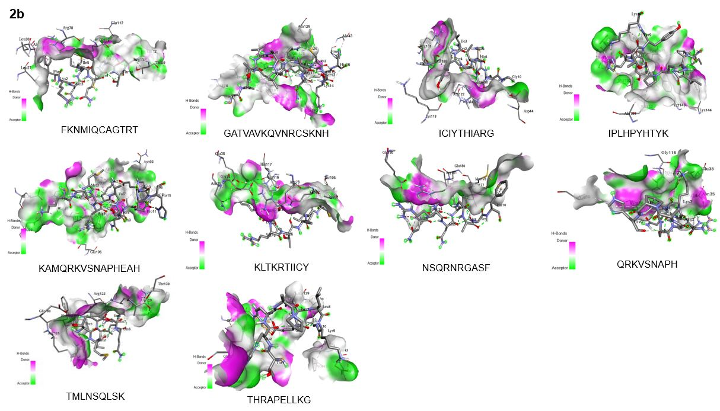

Fig. 2 a Different interactions of peptides with the EthR protein such as H bond, charges, hydrophobicity, ionizability, SAS in the pocket were represented using BIOVIA Discovery studio software, b 2-D representation of the protein-peptide complex with all peptides that have the maximum binding affinity towards the EthR protein (UniProt Id – P9WMC1)

