Supplementary Figures:
Intrahost dynamics, together with genetic and phenotypic effects predict the success of viral mutations
Cedric CS Tan^{1*}, Marina Escalera-Zamudio¹, Alexei Yavlinsky², Lucy van Dorp¹, Francois Balloux¹
¹ UCL Genetics Institute, University College London, Gower St, London, WC1E 6BT, UK.
² Institute of Health Informatics, University College London, Gower St, London, WC1E 6BT, UK.
Correspondence: C.C.S.T (cedriccstan@gmail.com)

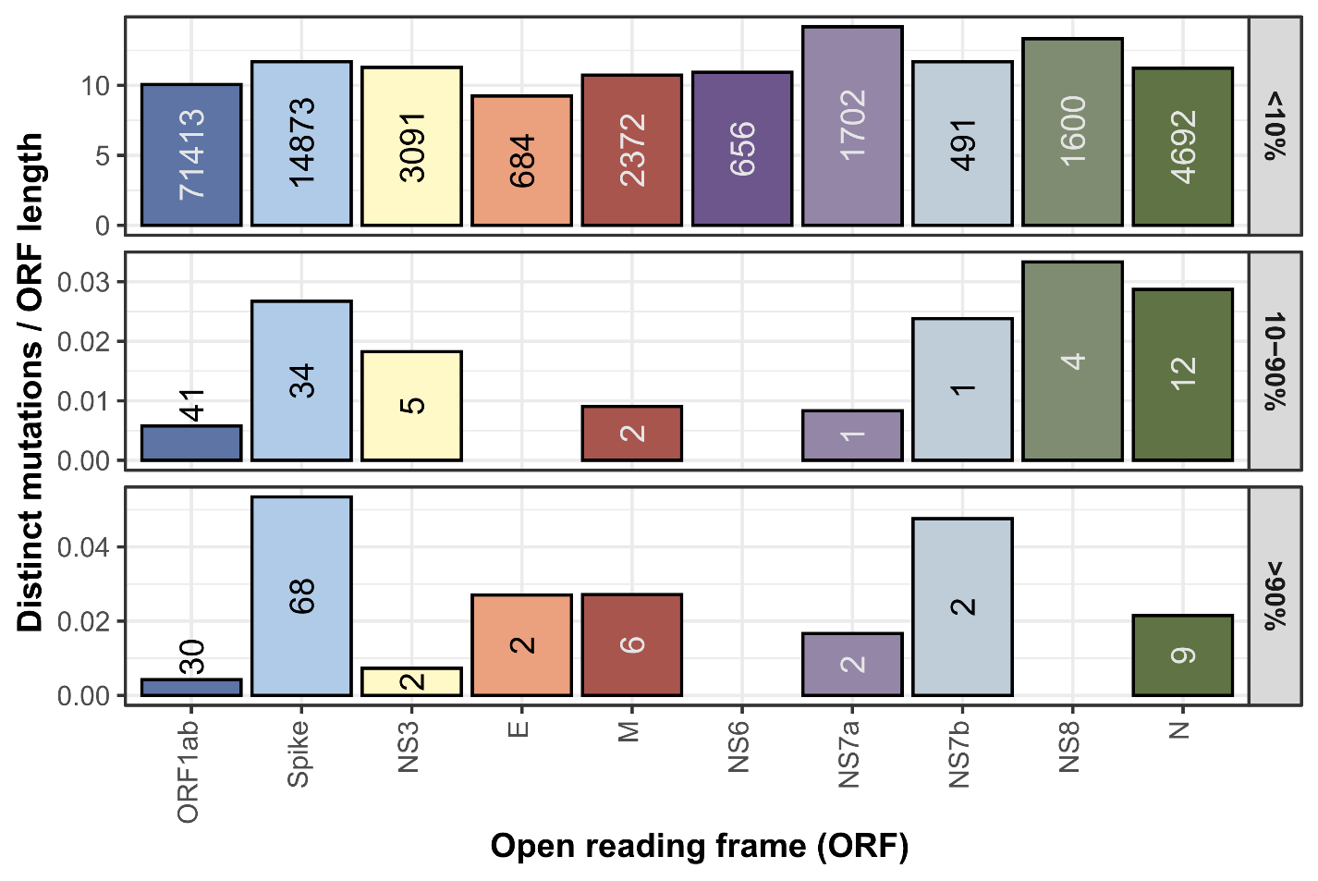

Extended Data Figure 1. Distribution of mutations observed in the consensus genomes of our GISAID dataset. Number of distinct single amino acid variants (SAVs) observed across the pandemic stratified by open reading frame (ORF) and normalised by ORF length. Based on the metadata for all complete genomes deposited on the GISAID database from the first submitted sequence up till 8th July 2024.

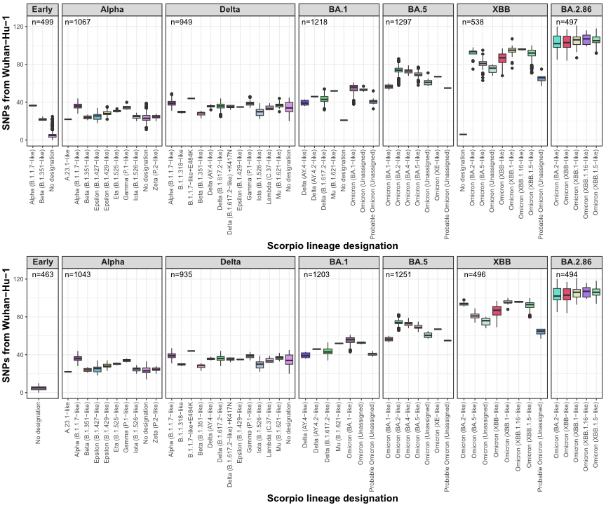

Extended Data Figure 2. Quality control of sequencing libraries. Distributions of SNPs per PANGO lineage (PANGO v1.2.6) before and after removing libraries that were outliers in terms of the number of SNPs to Wuhan-Hu-1. Alpha and Beta libraries in the ‘Early’ dataset were excluded as these lineages were likely misannotated given they were not observed during the first four months of the COVID-19 pandemic. Libraries with no lineage assignments in the XBB dataset were excluded as they had much lower number of SNPs compared to other lineages in circulation within the timeframe of the dataset.

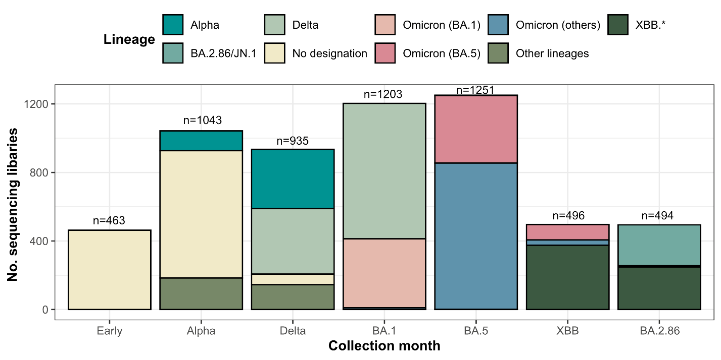

Extended Data Figure 3. Sequencing datasets used in this study. Lineage assignment was performed using PANGO v1.2.6, PUSHER v1.26 and SCORPIO v0.1.12 on consensus genomes that were re-assembled as part of this study.

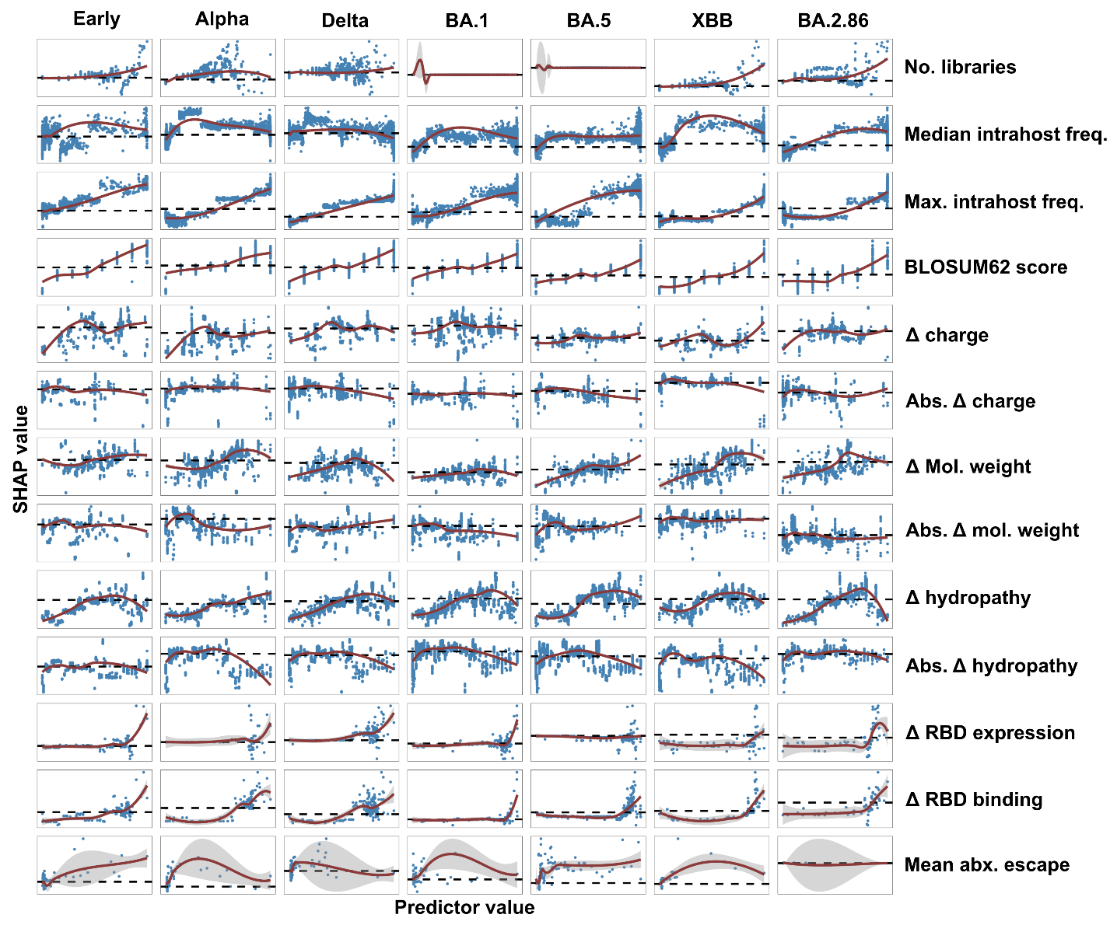

Extended Data Figure 4. Relationships between predictors and predicted fitness of SAVs. Scatter plots of predictors and their corresponding SHAP values showing the relationships inferred by the XGBoost regression algorithm. Each point represents the relative contributions of each predictor to the predicted fitness of each SAV (i.e., SHAP value). The red curves and black horizontal dotted lines indicate the LOESS regression smooths and SHAP=0, respectively.

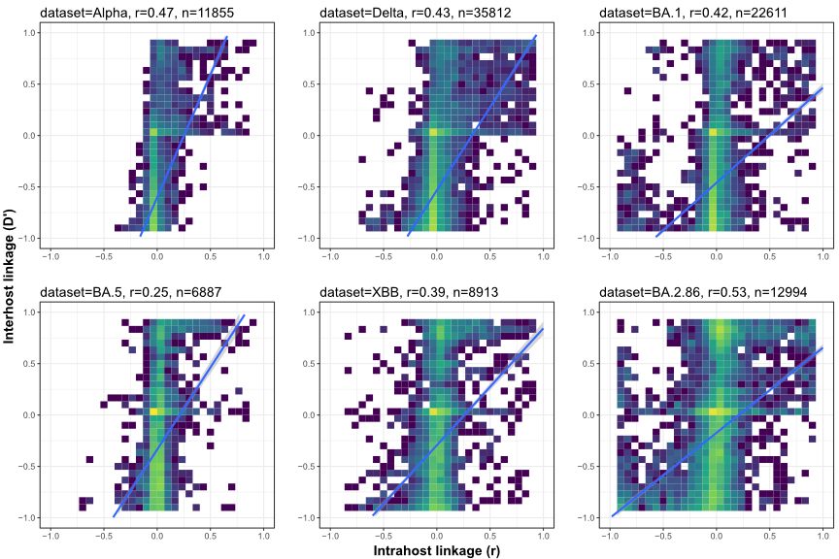

Extended Data Figure 5. Correlation between linkage observed at the intrahost and interhost level. Scatter plots showing the strong positive relationships between the linkage of SAVs at the intrahost level for SAV pairs within each dataset.

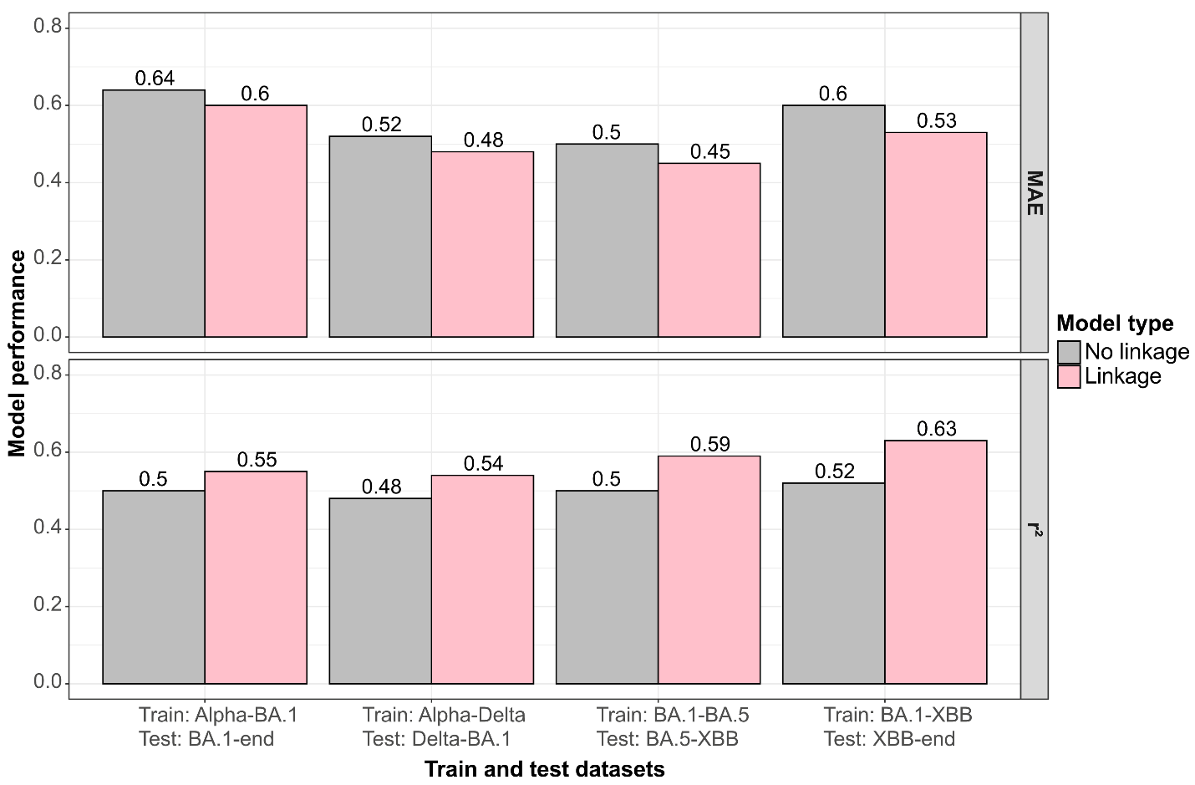

Extended Data Figure 6. Model performance when training and testing on different datasets. Barplots showing the mean absolute error (MAE) and coefficient of determination (r²) of models trained on various datasets and tested on other datasets, with or without linkage predictors. The future fitness values of SAVs were estimated across various timeframes. For example, Alpha-BA.1 refers to the dataset comprising samples collected during the Alpha wave (February 2021) and the fitness values were calculated by considering consensus genomes collected after the Alpha dataset and before the BA.1 dataset (December 2021) with a one-month buffer (i.e., April 2021-October 2021). The timepoint denoted ‘end’ refers to the most recent collection month of our dataset (i.e., July 2024).

