Supplementary Information

Dema Almasri^{a,b}, Yehia Manawi^{b}, Suhde Makki^{c}, Nafia Tasneem^{c}, Simjo Simson^{b}, Iman Abdel-Hadi^{d}, John Agcaoili^{e}, Jenny Lawler^{b}, Viktor Kochkodan^{b*}
ª Earthna-Center for a Sustainable Future, Qatar Foundation, P.O. Box 5825, Doha, Qatar
^{b} Qatar Environment and Energy Research Institute, Hamad Bin Khalifa University, P.O. Box 34110, Doha, Qatar
^{c} Chemical Engineering Program, Texas A&M University at Qatar, Education City, Doha 23874, Qatar
^{d} Division of Sustainable Development, College of Science and Engineering, Hamad Bin Khalifa University, Qatar Foundation, Doha, Qatar
^{e} HBKU Core Labs, Hamad Bin Khalifa University, Qatar Foundation, PO Box, 34110, Doha, Qatar

*Corresponding authors:
Dema Almasri
E-mail: delmasri@hbku.edu.qa
Viktor Kochkodan
E-mail: vkochkodan@hbku.edu.qa

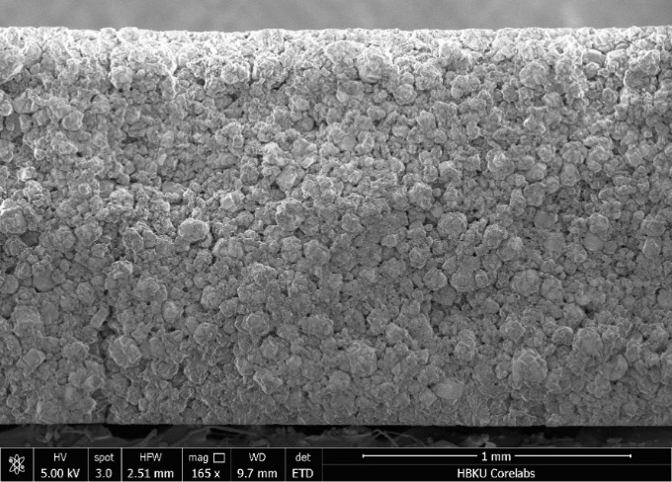
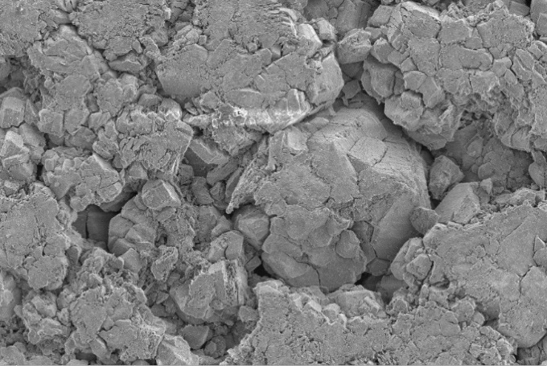
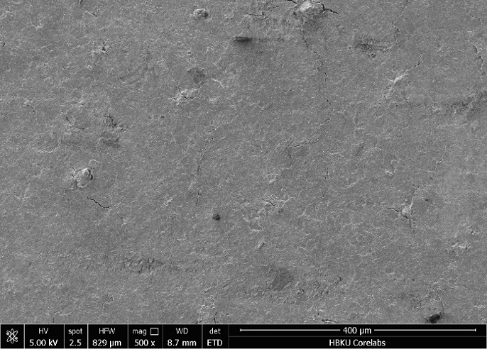
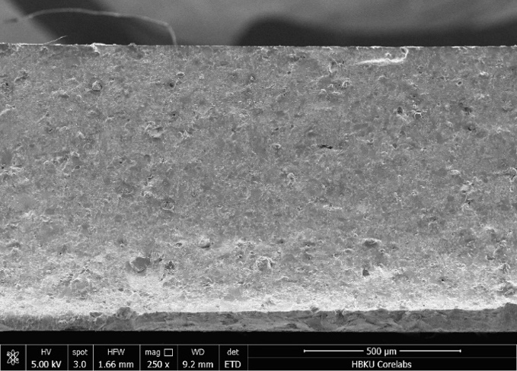
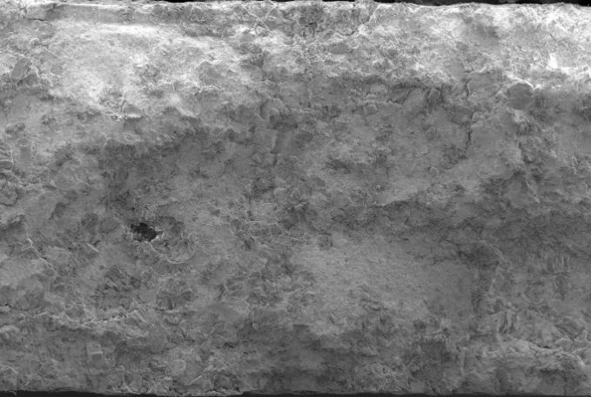
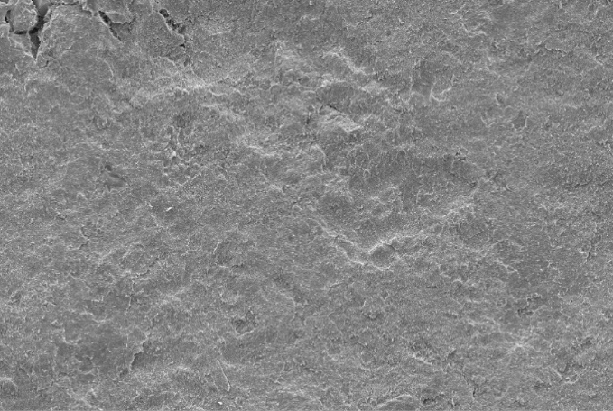
500 𝝁m
100 𝝁m
500 𝝁m
250 𝝁m
500 𝝁m
50 𝝁m
(a)
(b)
(c)
(d)
(e)
(f)

Figure S1: SEM images showing cross section (a) and top view (b) of M1, cross section (c) and top view (d) of M2 as well as cross section (e) and top view (f) of M7.

