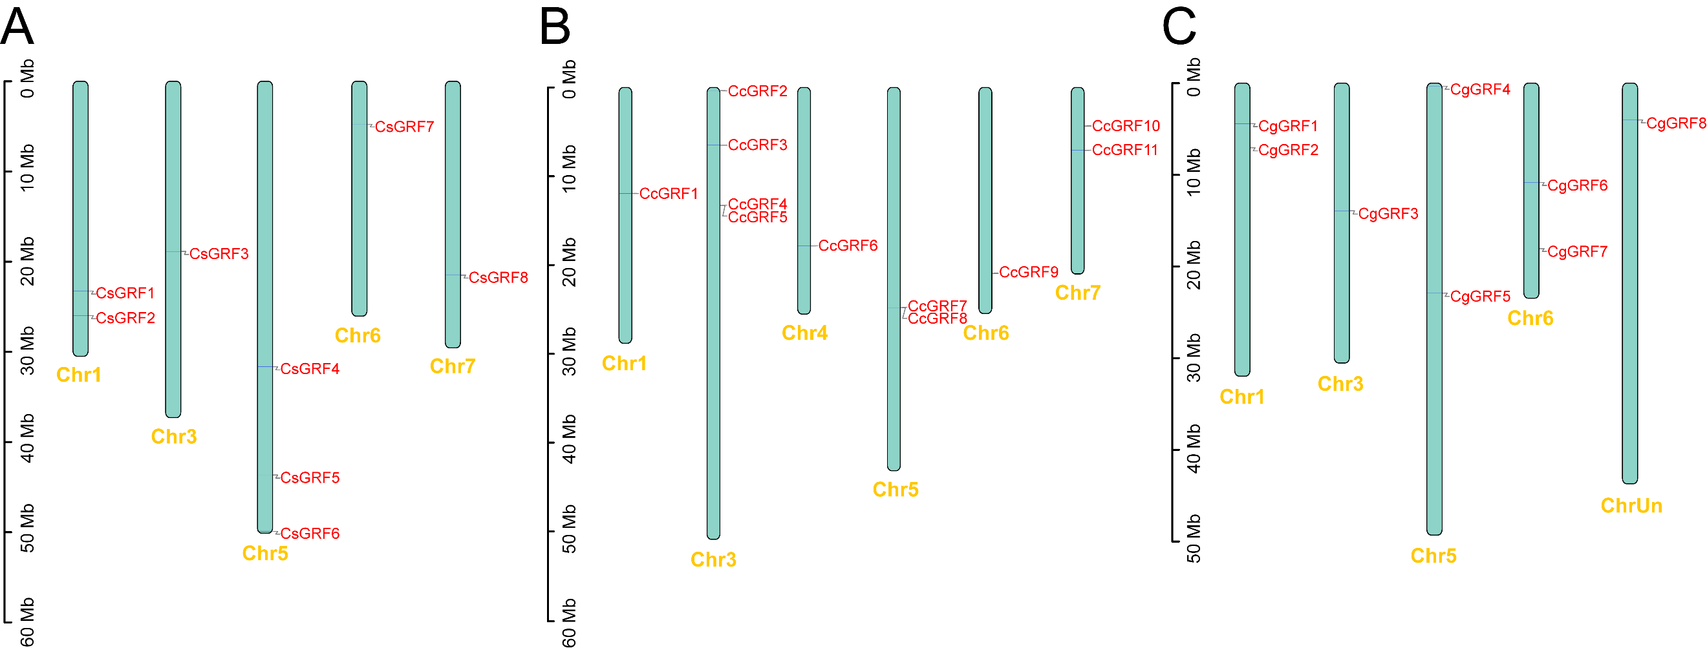
Fig. S1 Position of the citrus GRF genes on the chromosome. (A) C. sinensis. (B) C. clementina. (C) C. grandis.

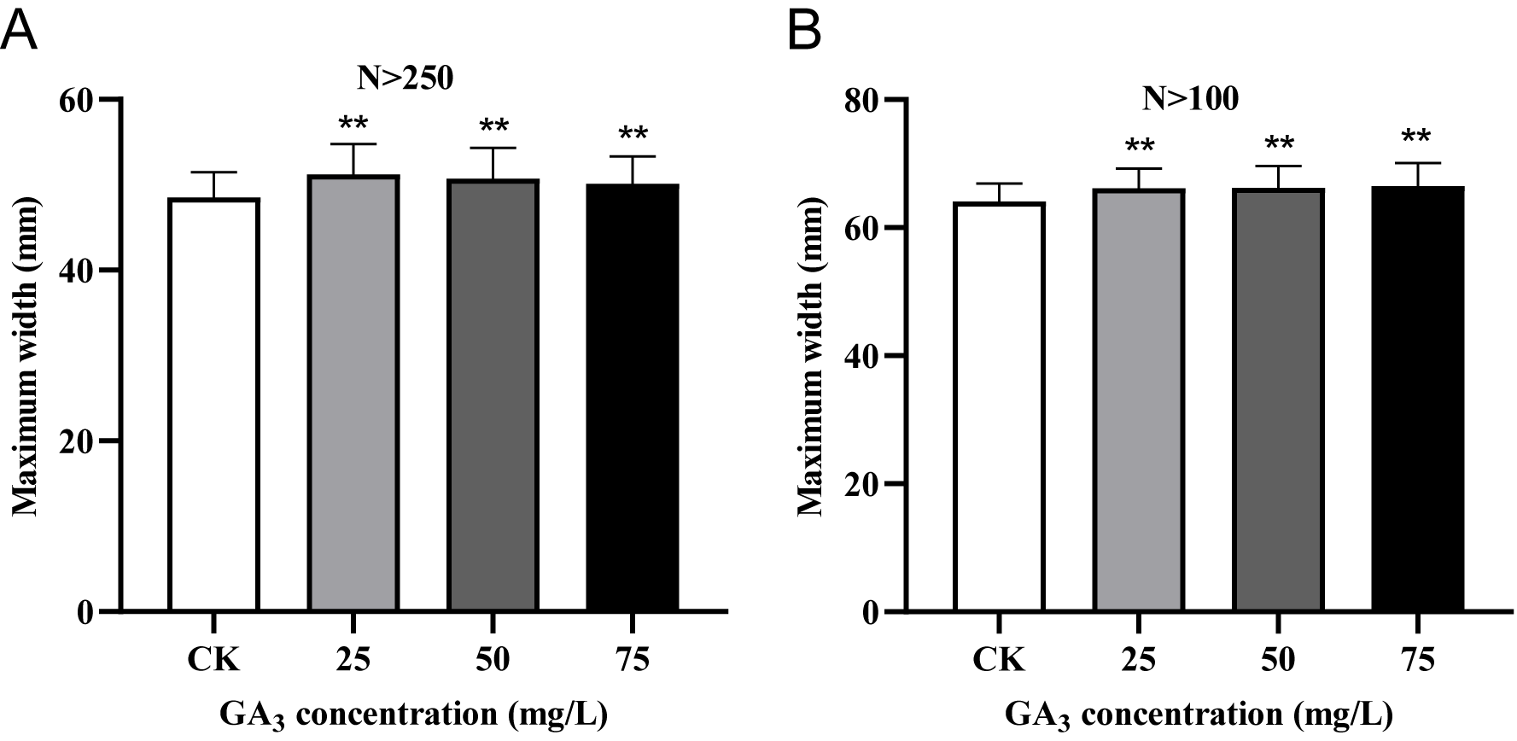
Fig. S2 Effects of gibberellin on ‘Zaomi’ fruit maximum width. (A) The maximum width of fruits at the expansion stage was randomly determined, and the number of fruits measured per treatment was more than 250 (N>250). (B) The maximum width of fruits at the maturity stage was randomly determined, and the number of fruits measured per treatment was more than 100 (N>100). Error bars, mean SD. Data were compared by two-tailed Student’s t-test, *P < 0.05. **P < 0.01.
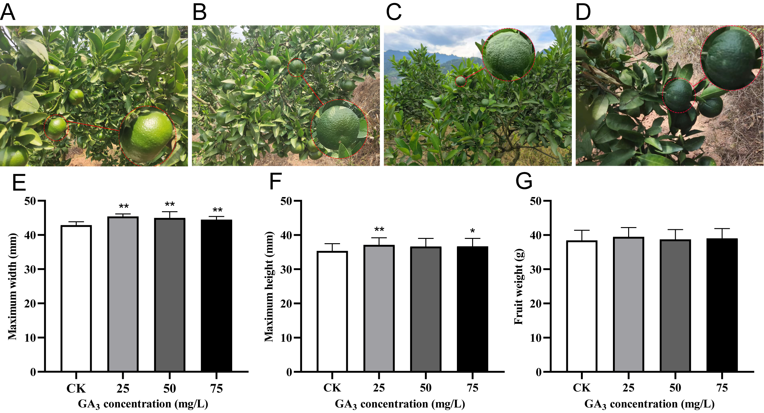
Fig. S3 Effects of GA₃ on ‘Zaomi’ fruit at the late expansion stage. A-D The appearance of peel changes under normal growing condition (control) and GA₃ treatments, including control (A), 25mg/L GA₃ (B), 50mg/L GA₃ (C), 75mg/L GA₃ (D). E-G Quantitative study on fruit phenotype of ‘Zaomi’ treated with CK and 25, 50 and 75mg/L GA₃ (N>30), including fruit maximum width (E), fruit maximum height (F), fruit weight (G). Error bars, mean SD. Data were compared by two-tailed Student’s t-test, *P < 0.05. **P < 0.01.

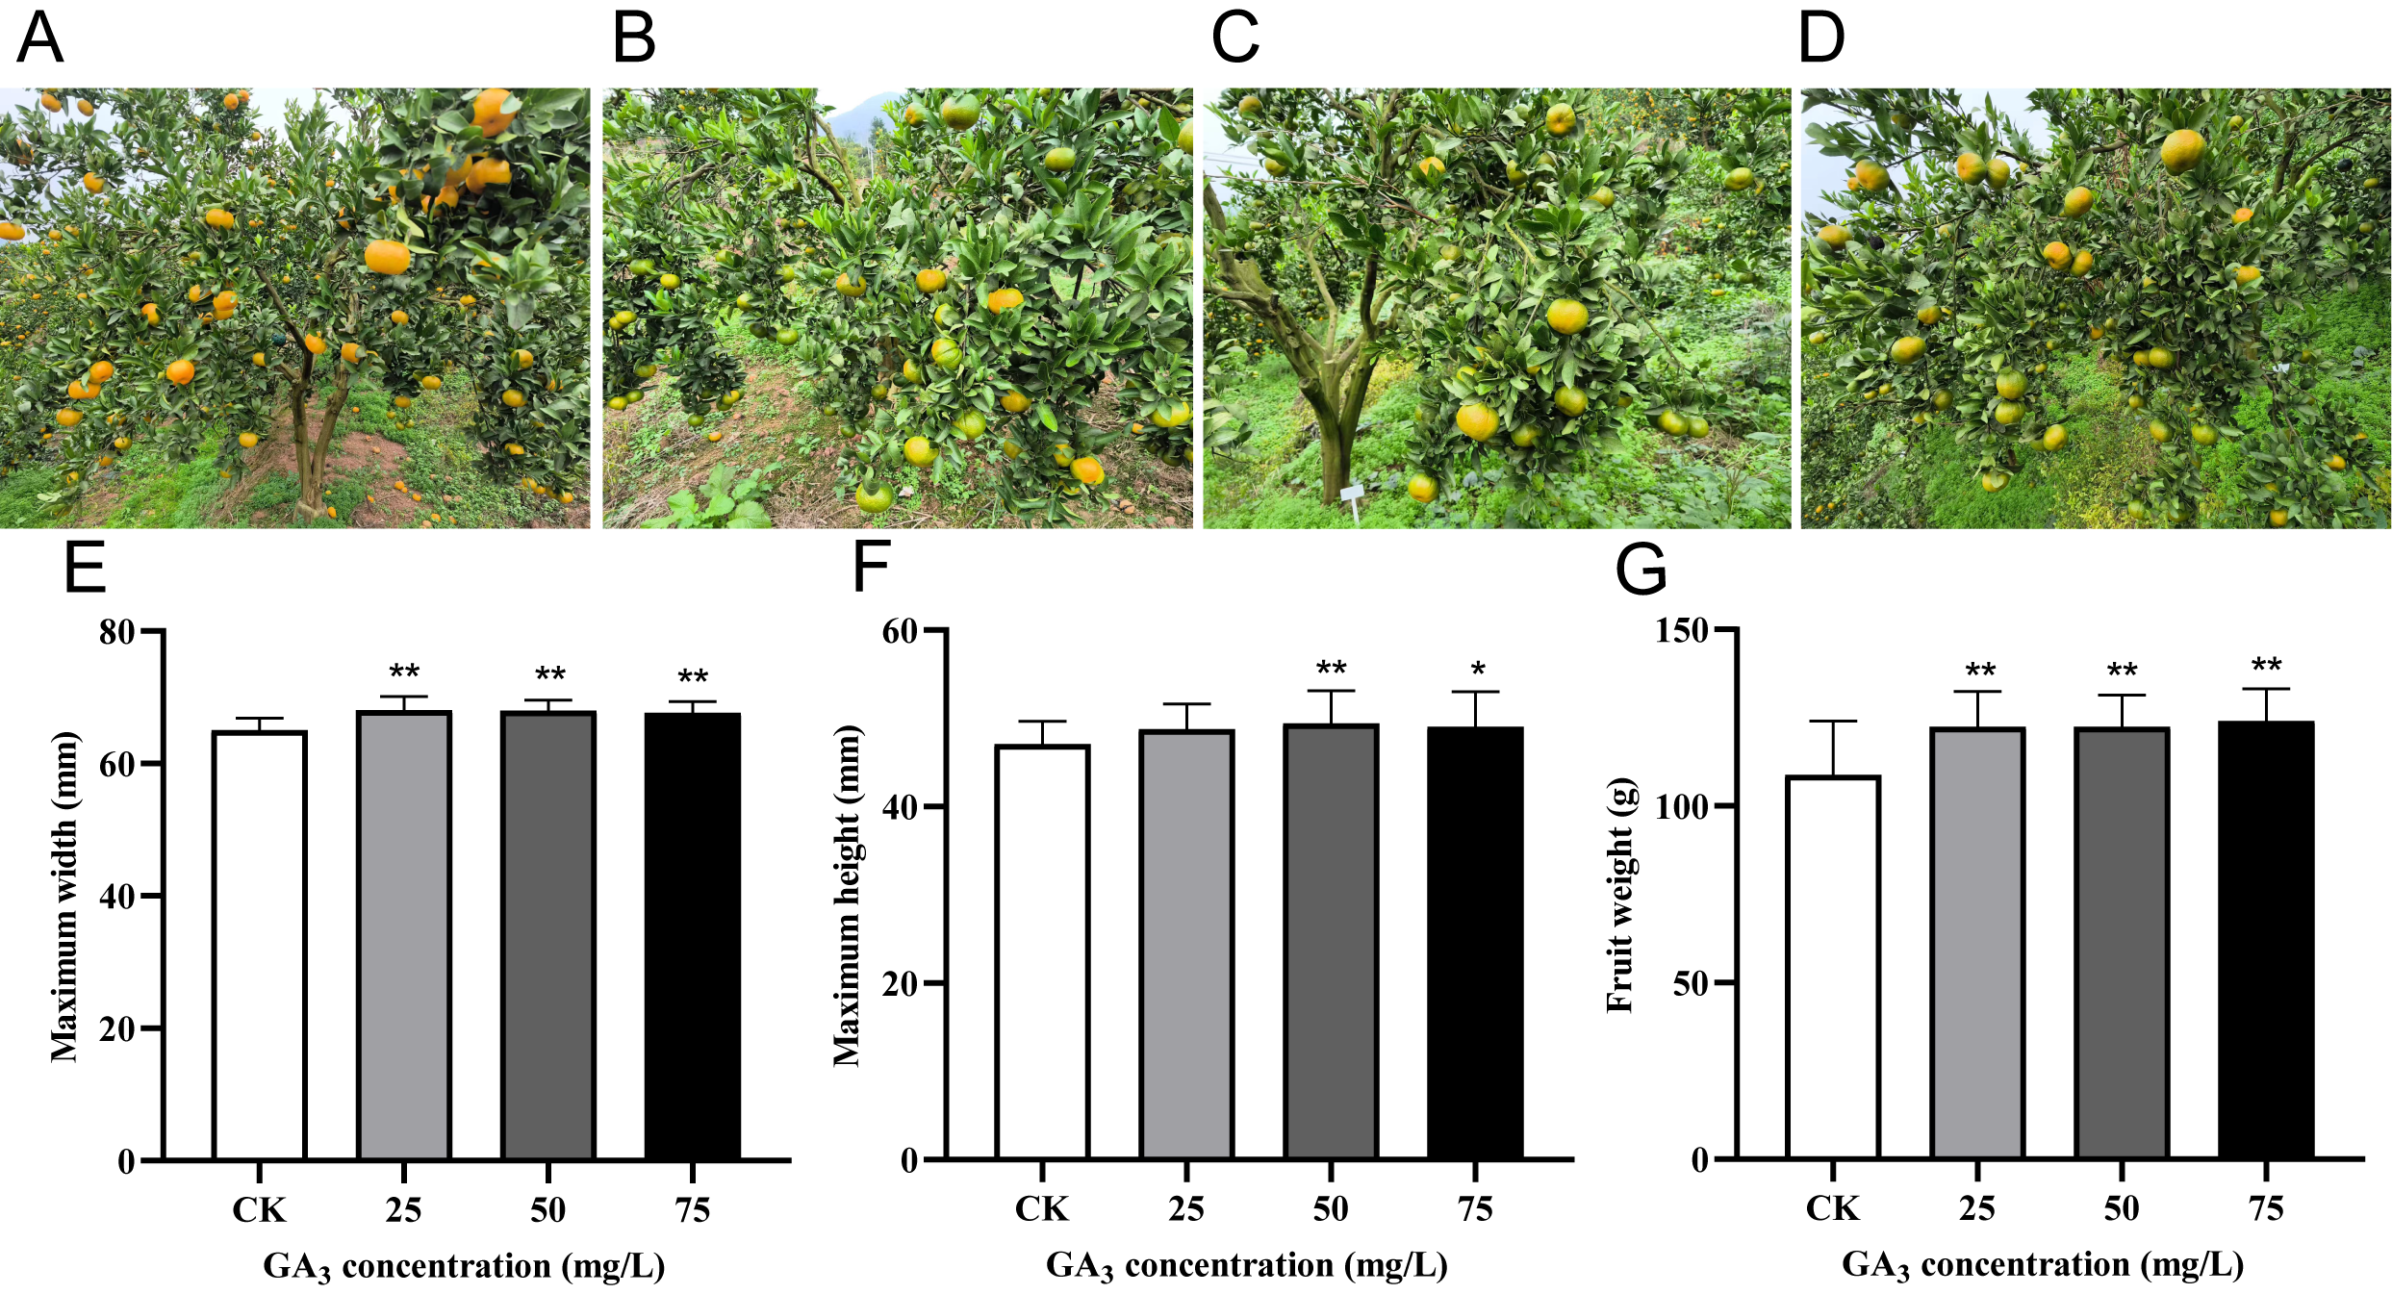
Fig. S4 Effects of GA₃ on ‘Zaomi’ fruit at maturation stage. A-D The appearance of peel changes under normal growing condition (control) and gibberellins treatments, including control (A), 25mg/L GA₃ (B), 50mg/L GA₃ (C), 75mg/L GA₃ (D). E-G Quantitative study on fruit phenotype of ‘Zaomi’ treated with CK and 25, 50 and 75mg/L GA₃ (N>30), including fruit maximum width (E), fruit maximum height (F), fruit weight (G). Error bars, mean SD. Data were compared by two-tailed Student’s t-test, *P < 0.05. **P < 0.01.
Supplementary Table 1. Detailed information for all identified citrus GRFs.
Gene ID | Rename | Chromosomal location | Intron | Encoded protein |  |  | Subcellular localization
 |  |  |  | Nu.of aa | PI | Mw（KDa） | Subcellular localization
Cs_ont_1g019360.1 | CsGRF1 | 1 | 3 | 380 | 8.46 | 42.09 | Nucleus
Cs_ont_1g023250.2 | CsGRF2 | 1 | 3 | 600 | 7.27 | 65.05 | Nucleus
Cs_ont_3g022280.2 | CsGRF3 | 3 | 3 | 361 | 9.08 | 39.76 | Nucleus
Cs_ont_5g030480.2 | CsGRF4 | 5 | 1 | 554 | 5.48 | 60.23 | Nucleus
Cs_ont_5g041030.1 | CsGRF5 | 5 | 2 | 232 | 9.75 | 25.26 | Nucleus
Cs_ont_5g050440.1 | CsGRF6 | 5 | 3 | 496 | 6.72 | 53.35 | Nucleus
Cs_ont_6g007580.1 | CsGRF7 | 6 | 3 | 407 | 8.49 | 44.68 | Nucleus
Cs_ont_7g017420.1 | CsGRF8 | 7 | 3 | 332 | 8.88 | 36.57 | Nucleus
Ciclev10008922m.1 | CcGRF1 | 1 | 3 | 322 | 8.96 | 36.50 | Nucleus
Ciclev10019828m.1 | CcGRF2 | 3 | 3 | 498 | 6.59 | 53.38 | Nucleus
Ciclev10022033m.1 | CcGRF3 | 3 | 2 | 232 | 9.79 | 25.40 | Nucleus
Ciclev10019529m.1 | CcGRF4 | 3 | 1 | 561 | 5.83 | 61.05 | Nucleus
Ciclev10019723m.1 | CcGRF5 | 3 | 2 | 521 | 6.13 | 56.14 | Nucleus
Ciclev10032065m.1 | CcGRF6 | 4 | 3 | 332 | 8.88 | 36.57 | Nucleus
Ciclev10001613m.1 | CcGRF7 | 5 | 3 | 361 | 9.08 | 39.76 | Nucleus
Ciclev10001641m.1 | CcGRF8 | 5 | 3 | 357 | 9.09 | 39.32 | Nucleus
Ciclev10011856m.1 | CcGRF9 | 6 | 3 | 412 | 8.49 | 44.96 | Nucleus
Ciclev10025209m.1 | CcGRF10 | 7 | 3 | 600 | 6.95 | 65.17 | Nucleus
Ciclev10025855m.1 | CcGRF11 | 7 | 3 | 378 | 8.61 | 41.78 | Nucleus
Cg1g006870.1 | CgGRF1 | 1 | 3 | 600 | 7.27 | 65.05 | Nucleus
Cg1g010470.1 | CgGRF2 | 1 | 3 | 416 | 8.59 | 45.88 | Nucleus
Cg3g007390.1 | CgGRF3 | 3 | 3 | 361 | 9.08 | 39.79 | Nucleus
Cg5g000370.1 | CgGRF4 | 5 | 3 | 495 | 6.39 | 53.16 | Nucleus
Cg5g019440.1 | CgGRF5 | 5 | 2 | 520 | 5.98 | 56.06 | Nucleus
Cg6g007650.1 | CgGRF6 | 6 | 3 | 312 | 8.52 | 34.98 | Nucleus
Cg6g016120.1 | CgGRF7 | 6 | 3 | 406 | 8.49 | 44.32 | Nucleus
CgUng001270.4 | CgGRF8 |  | 2 | 318 | 8.79 | 36.22 | Nucleus

Supplementary Table 2. The collinear correspondence.
Duplicated gene1 | Duplicated gene2 | Duplicated gene1 | Duplicated gene2
CsGRF1 | CcGRF11 | CsGRF1 | AtGRF5
CsGRF2 | CcGRF10 | CsGRF2 | AtGRF1
CsGRF3 | CcGRF7 | CsGRF2 | AtGRF2
CsGRF4 | CcGRF2 | CsGRF4 | AtGRF7
CsGRF4 | CcGRF4 | CsGRF5 | AtGRF9
CsGRF5 | Ciclev10023829m | CsGRF6 | AtGRF8
CsGRF5 | CcGRF3 | CsGRF6 | AtGRF7
CsGRF6 | CcGRF4 | CsGRF7 | AtGRF3
CsGRF6 | CcGRF2 | CsGRF7 | AtGRF4
CsGRF7 | CcGRF9 | CsGRF8 | AtGRF2
CsGRF8 | CcGRF6 | Cs_ont_5g002070 | AtGRF9
Cs_ont_5g002070 | CcGRF3 | CcGRF1 | AtGRF6
CsGRF1 | CgGRF2 | CcGRF2 | AtGRF7
CsGRF2 | CgGRF1 | CcGRF2 | AtGRF8
CsGRF3 | CgGRF3 | CcGRF3 | AtGRF9
CsGRF4 | CgGRF4 | CcGRF4 | AtGRF7
CsGRF4 | CgGRF5 | CcGRF9 | AtGRF3
CsGRF6 | CgGRF4 | CcGRF9 | AtGRF4
CsGRF7 | CgGRF7 | CcGRF10 | AtGRF1
CsGRF8 | CgGRF6 | CcGRF10 | AtGRF2
CcGRF2 | CgGRF4 | CcGRF11 | AtGRF5
CcGRF4 | CgGRF5 | CgGRF1 | AtGRF1
CcGRF4 | CgGRF4 | CgGRF1 | AtGRF2
CcGRF6 | CgGRF6 | CgGRF2 | AtGRF5
CcGRF7 | CgGRF3 | CgGRF4 | AtGRF8
CcGRF9 | CgGRF7 | CgGRF4 | AtGRF7
CcGRF10 | CgGRF1 | CgGRF7 | AtGRF3
CcGRF11 | CgGRF2 | CgGRF7 | AtGRF4

Supplementary Table 3. Protein blast results of CsGRFs with SlGRF4.
query acc.ver | subject acc.ver | % identity | alignment length | mismatches | gap opens | q. start | q. end | s. start | s. end | evalue | bit score
SlGRF4 | CsGRF8 | 41.52 | 342 | 150 | 11 | 11 | 342 | 25 | 326 | 7.59E-68 | 206
SlGRF4 | CsGRF1 | 77.876 | 113 | 25 | 0 | 9 | 121 | 20 | 132 | 3.53E-59 | 185
SlGRF4 | CsGRF3 | 33.702 | 362 | 182 | 10 | 11 | 341 | 13 | 347 | 4.53E-50 | 161
SlGRF4 | CsGRF2 | 33.628 | 339 | 171 | 9 | 1 | 331 | 155 | 447 | 1.21E-45 | 154
SlGRF4 | CsGRF7 | 52.899 | 138 | 52 | 4 | 8 | 134 | 73 | 208 | 3.10E-41 | 139
SlGRF4 | CsGRF4 | 50.382 | 131 | 56 | 2 | 2 | 132 | 139 | 260 | 1.17E-38 | 134
SlGRF4 | CsGRF6 | 51.724 | 116 | 52 | 2 | 9 | 122 | 135 | 248 | 1.40E-32 | 116
SlGRF4 | CsGRF5 | 51.818 | 110 | 50 | 2 | 28 | 134 | 73 | 182 | 4.61E-31 | 107

Supplementary Table 4. Corresponding blast gene mappings.
Citrus sinensis v3.0 | Citrus clementina v1.0 | Citrus sinensis v2.0 | Citrus sinensis v1.0
Cs_ont_1g019360(CsGRF1) | Ciclev10025855m | Cs1g_pb016580 | Cs1g17560
Cs_ont_1g023250(CsGRF2) | Ciclev10025209m | Cs1g_pb018790 | Cs1g21350
Cs_ont_3g022280(CsGRF3) | Ciclev10001613m | Cs3g_pb009170 | orange1.1t03122
Cs_ont_5g030480(CsGRF4) | Ciclev10019529m | Cs5g_pb019860 | orange1.1t02555
Cs_ont_5g041030(CsGRF5) | Ciclev10022033m | Cs5g_pb006400 | Cs5g09850
Cs_ont_5g050440(CsGRF6) | Ciclev10019828m | Cs5g_pb014920 | Cs5g01380
Cs_ont_6g007580(CsGRF7) | Ciclev10011856m | Cs6g_pb011420 | Cs6g15330
Cs_ont_7g017420(CsGRF8) | Ciclev10032065m | Cs7g_pb011260 | Cs7g15220

Supplementary Table 5. Expression pattern of CsGRFs in leaves ovule, and roots.
ID | 1_year_leaf | mature_leaf | early-stage ovules | late-stage ovules | seedling; root tips | ten years; root
CsGRF1 | 1.78 | 0 | 50.61 | 23.43 | 0.03 | 0
CsGRF2 | 18.62 | 0.75 | 212.26 | 245.85 | 13.03 | 0.31
CsGRF3 | 17.00 | 2.49 | 33.57 | 23.86 | 5.44 | 1.05
CsGRF4 | 9.13 | 1.05 | 14.77 | 37.64 | 1.04 | 0.00
CsGRF5 | 39.90 | 1.74 | 244.76 | 225.91 | 3.80 | 0.00
CsGRF6 | 66.53 | 0.57 | 89.25 | 41.27 | 2.99 | 0.11
CsGRF7 | 0.35 | 0.26 | 18.34 | 15.84 | 1.20 | 0.00
CsGRF8 | 28.64 | 4.64 | 16.63 | 31.61 | 2.95 | 0.00

Supplementary Table 6. Primers used in this study
Gene names | Forward primer (5'->3') | Reverse primer (5'->3')
CsGRF1 | CATCATCCACAGCATCAA | TAGGCATAGAGTTCAGGAG
CsGRF2 | CTCTTGTGTCTCCTGATAA | GAAGGTAAGTGCTGGTAA
CsGRF3 | TCAGAGAGCCAATAAGAG | TTGTCCATAGAGGTATCC
CsGRF4 | ACTGTGAGCGTCATCTGC | GGATGTGGGTATTGAGTGA
CsGRF5 | CCTGTGCCCTCTCAACTTGT | TCGCCACTGAGACCTGAAAC
CsGRF6 | CTGTGGAATTACCAGCCCAC | TCATGAACCATTCCAAGCTTCT
CsGRF7 | GGAGAGACCAGCAGCATGAG | GGGCAGATGACCCAGATGAC
CsGRF8 | GACAGTGCATGGCCTCTGAT | GTTGCCGAGAAGTCGGATGA
Csactin | TGACTGATGAGAACTGCCAGAAG | CCAATTCTCTCTTGAACCTGTCCTT

