Figure7：Dendrogram of enterobacterial repetitive intergenic consensus–polymerase chain reaction using NTSYS software. The alphabet C before the number means that the strain isolated from clinical infection samples, and the alphabet F means that the strain isolated from fecal survey samples.

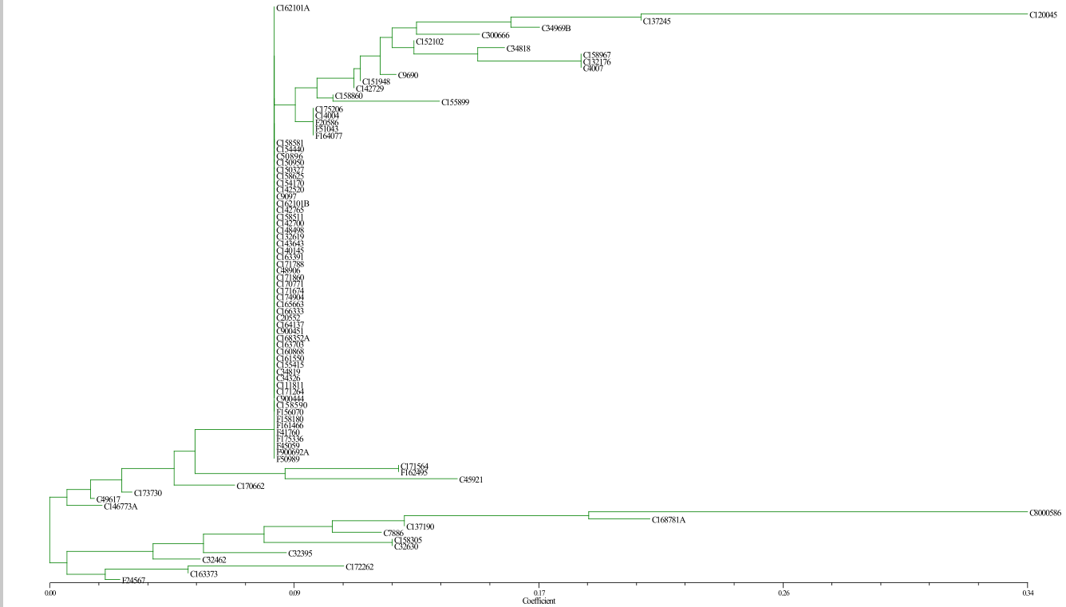
Carbapenem-resistant K. pneumoniae

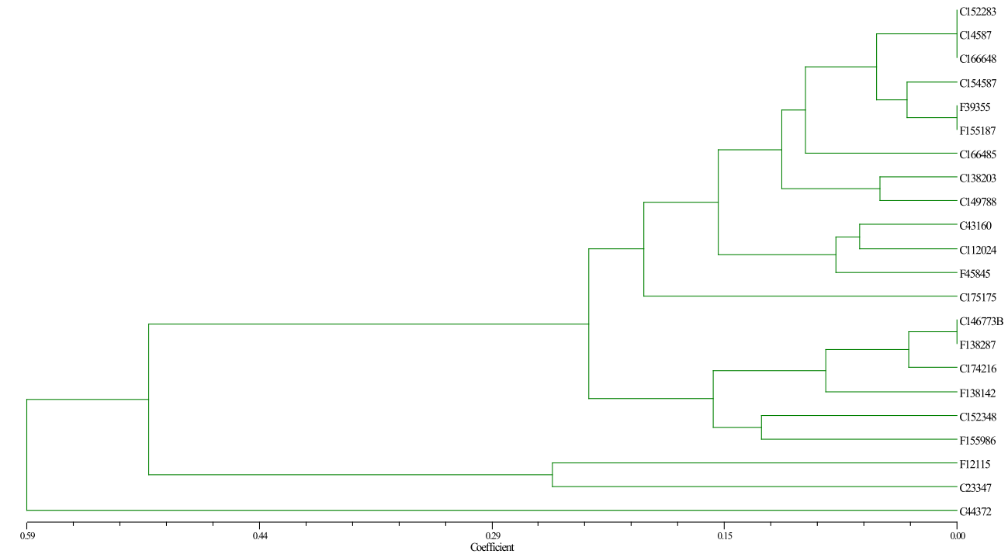
Carbapenem-resistant E. cloacae

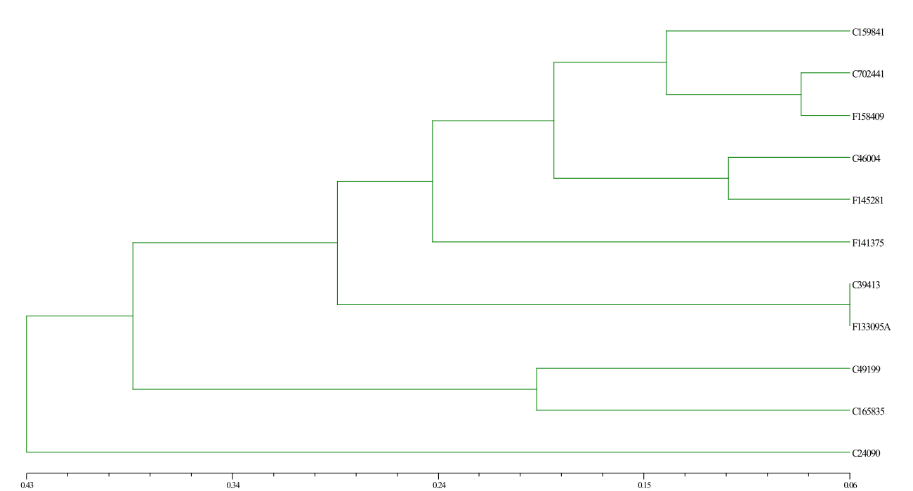
Carbapenem-resistant E. coli

