Supplementary figure 1: The structure of GIs and prophage in p156070-KPC(a) and p158590-KPC(b).

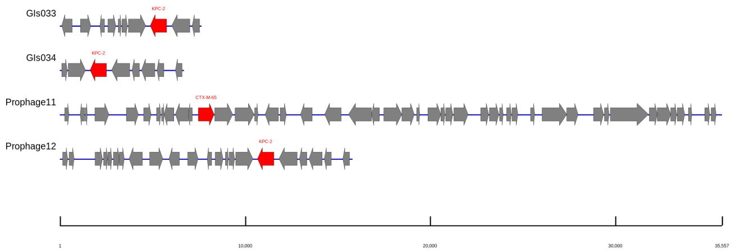 (a)
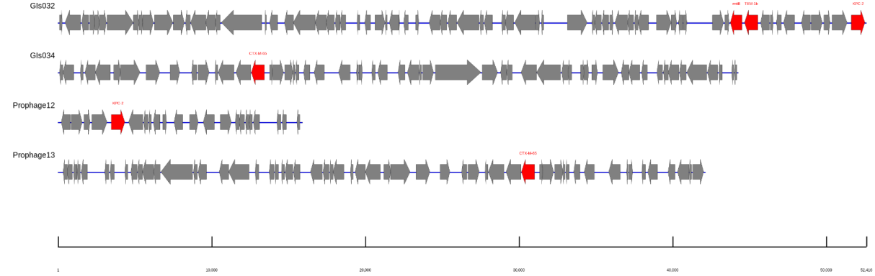
(b)

