Supporting information

S1Fig.The change trends of the cancer-related disease burden by age groups from 1990 to 2035:(A) The ASDR of gastric cancer. (B). The ASIR of gastric cancer
A
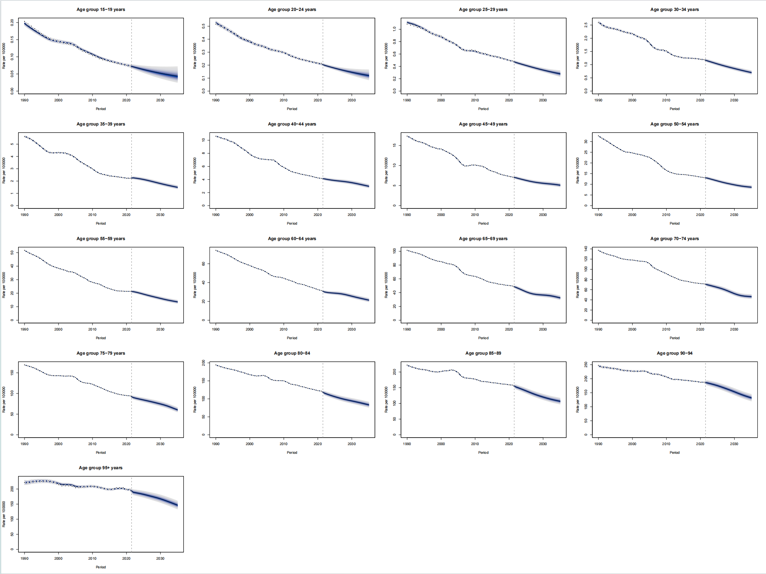

B
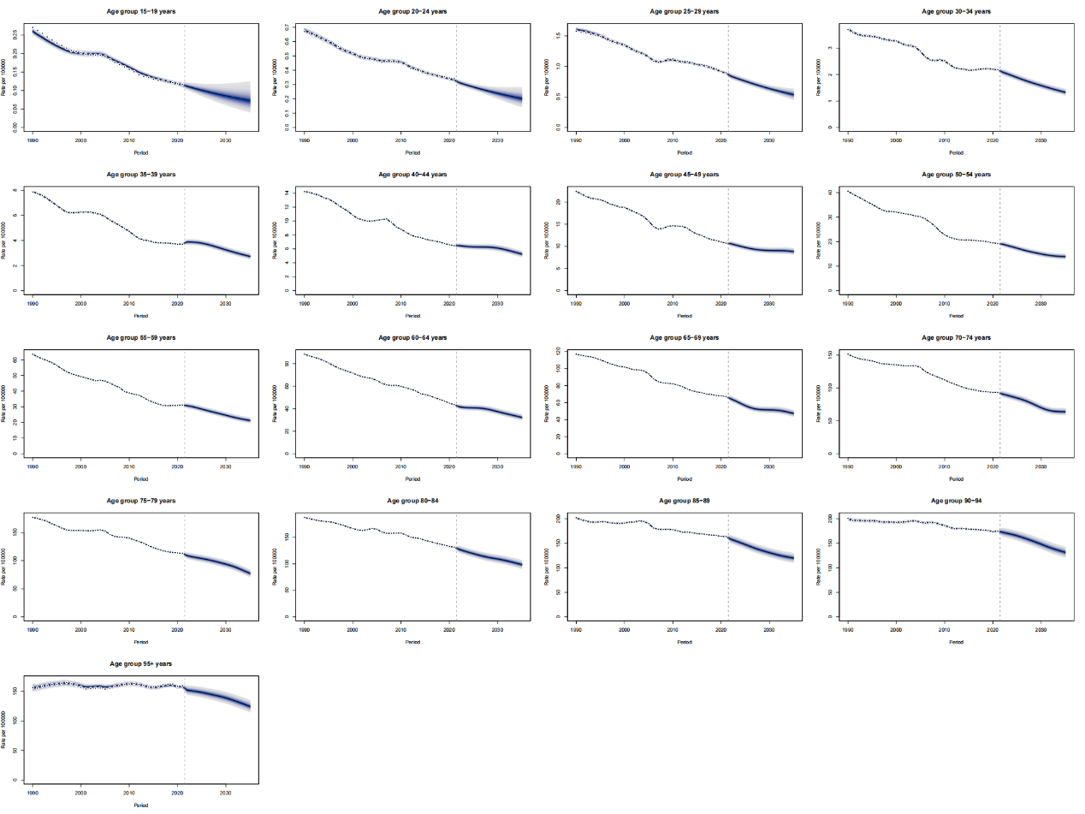

S1Fig.The change trends of the cancer-related disease burden by age groups from 1990 to 2035:(A) The ASDR of gastric cancer. (B). The ASIR of gastric cancer

