Supplementary material
Adsorption and degradation behavior of six herbicides in different agricultural soils.
Umrbek Sharipov ª*, Martin Kočárek ª, Miroslav Jursík ^{b}, Antonín Nikodem ª, Luboš Borůvka ª

Soil profile pictures from three locations.

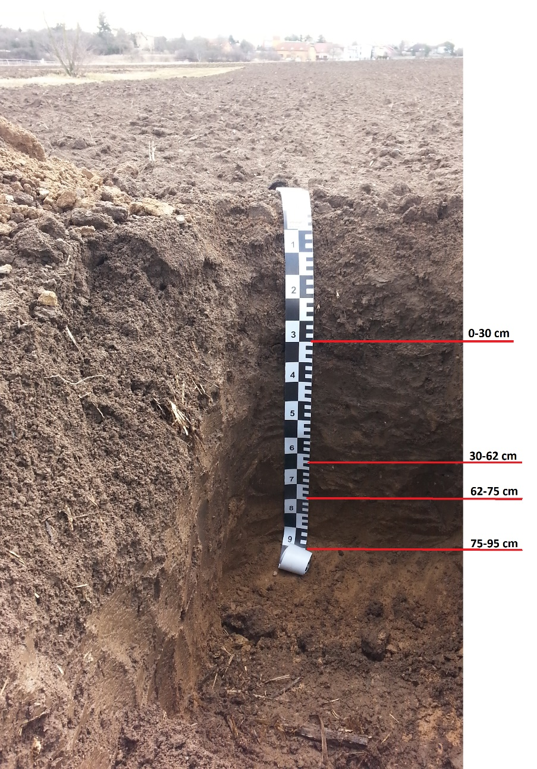
Ap 0-30 cm; dark reddish brown (7,5YR 2/3) silty loam; medium granular structure; 10% gravel; plant residues and roots; moderately decomposed; weakly alkaline; abrupt irregular boundary.
Ac 30-62 cm; dark brown (7,5YR 3/2) silty clay loam; subangular blocky structure; compacted layer; 15% gravel; weakly alkaline; abrupt irregular boundary.
A/C 62-75 cm; grayish brown (7,5YR 3/3) silty clay loam; subangular blocky structure; 5% gravel; weakly alkaline; abrupt irregular boundary.
Ck 75-95 cm; dull brown (7,5YR 5/4) silty clay loam; layer rich in CaCO₃; weakly alkaline; groundwater was not detected.

Picture S1. Suchdol – Haplic Chernozem

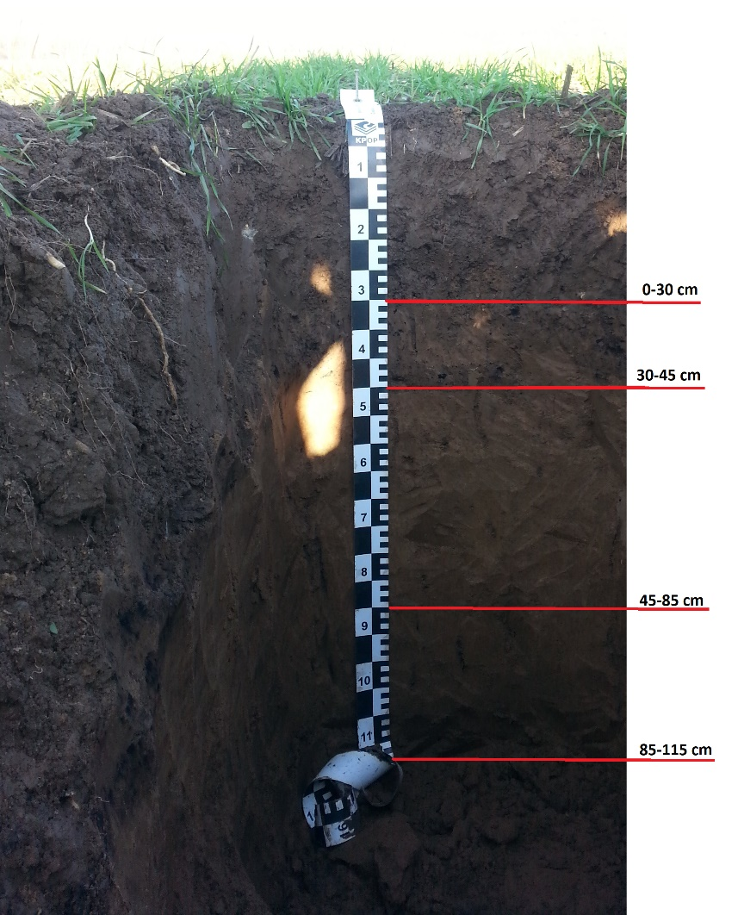
Ap 0-30 cm; very dark gray (7,5YR 3/1) loam; medium granular structure; 15% gravel; plant roots; moderately decomposed; weakly alkaline; abrupt irregular boundary.
Ap/Mg 30-45 cm; dark gray 75%, and dark grayish brown 25% (7,5YR 3/2) +(10YR 3/2) loam; granular structure; 10% gravel; few plant roots; weakly alkaline; abrupt irregular boundary.
Mg 45-85 cm; dark yellowish brown (10YR 4/4) loam; weak fine granular structure; weakly alkaline; abrupt irregular boundary.
MgC 85-115 cm; very dark brown (10YR 2/2) loam; weak fine granular structure; weakly alkaline; groundwater was not detected.

Picture S2. Dobroměřice – Haplic Fluvisol

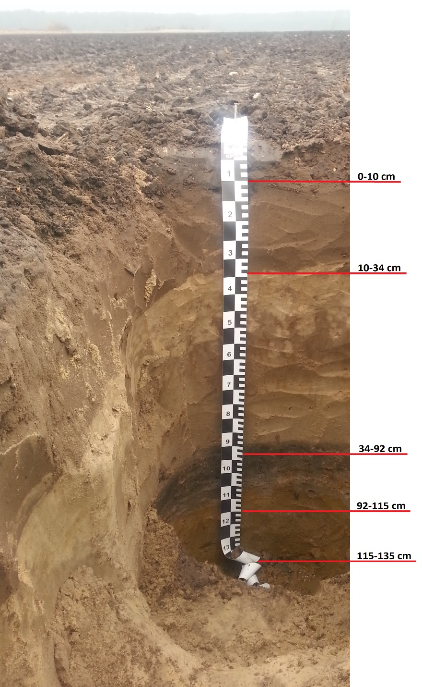
Ap1 0-10 cm; dark grayish (10YR 2/1) sandy loam; layer dominated by organic matter, clay and CaCO₃; medium fine granular structure; moderately decomposed; weakly alkaline; plant residues; abrupt irregular boundary.
Ap2 10-34 cm; brownish black (10YR 3/2) loamy sand; weak granular structure; weakly acidic; low organic matter and carbonate; few fine roots; clear boundary.
C 34-92 cm; dominated color is yellowish brown (10YR 4/2) fine sand; single grained structure; weakly acidic; clear boundary.
Cg 92-115 cm; brownish black (10YR 3/1) very fine sand; single grained structure; weakly alkaline; abrupt irregular boundary.
Gro 115-135 cm; dark yellowish brown (10YR 4/1) very fine sand; oxidized layer; high iron oxides; single grained structure; weakly alkaline; groundwater detected.

Picture S3. Volárna – Arenic Regozem

S1. HPLC conditions and herbicides’ calibration lines
The samples from adsorption and degradation studies were analyzed by HPLC (Dionex, USA), using a PDA-100 photodiode array detector equipped with a P680 HPLC pump and ASI-100 automated sample injector. The guard columns (Security Guard Cartridge AQ C18 4 x 2.00 mm) pre-column, connected to a Kinetex 2.6µ, C18, 100 A column, 50 × 4.6 mm (Phenomex) was used for separation of the studied herbicides. The injection volume (μL), retention time (min), and detection wavelengths (nm) for each herbicide shown in Table S1. The flow rate of the mobile phase was 1 mL min⁻¹ and the column temperature was set at 25 °C. The mobile phase was prepared separately for each herbicide by mixing acetonitrile, redistilled water, and formic acid. For pendimethalin, 700 mL of acetonitrile, 300 mL of water and 1 mL L⁻¹ of formic acid, for aclonifen 850 mL of acetonitrile, 150 mL of water and 1 mL L⁻¹ of formic acid, for flurochloridone, 800 mL of acetonitrile, 200 mL of water and 1 mL L⁻¹ of formic acid,- for s-metolachlor 500 mL of acetonitrile, 500 mL of water and 1 mL L⁻¹ of formic acid, for pethoxamid, 900 mL of acetonitrile, 100 mL of water and 1 mL L⁻¹ of formic acid, for dimethenamid-p 525 mL of acetonitrile, 475 mL of water and 1 mL L⁻¹ of formic acid. The herbicides’ limits of detection (LOD) were determined as the lowest injected concentrations of the pesticides yielding signal-to-noise ratios of 3. The herbicides’ limits of quantification (LOQ) were determined based on the standard deviation (STD) of the UV detector response and the slope of the calibration line (s) (LOQ = 10 STD/s). The tested herbicides’ recovery was ranged from 84.9% to 118.1.6% for all herbicides respectively.

Table S1. Parameters from the HPLC reading for the herbicides, wavelength, (nm), retention time (min), injection volume (µL).
Herbicides | Parameters
Herbicides | Wavelength | Retention time | Injection volume
Flurochloridone | 252 | 2.13 | 10
Pendimethalin | 240 | 2.39 | 10
Aclonifen | 225 | 1.90 | 10
Dimethenamid-p | 210 | 1.88 | 10
S-Metolachlor | 220 | 1.59 | 10
Pethoxamid | 245 | 1.97 | 10

S2. Herbicides’ distribution coefficient (K_{d}), and the organic carbon coefficient (K_{oc})

The distribution coefficient (K_{d}) for all soils were calculated as follows:

$K_{d}={\frac{OM\%}{1.724 x 100}K}_{oc}$ [1]

where Koc is the organic carbon coefficient and is calculated by the K_{f} value as:

$K_{oc}=\frac{K_{f x }100 }{OM \%}$ [2]

Results are given in Table S2.

Table S2. The distribution coefficient (K_{d}), and the organic carbon coefficient (K_{oc}) of herbicides in three soils

Soil type | Dimethenamid-p |  | Pethoxamid |  | S-Metholachlor |  | Flurochloridone |  | Aclonifen |  | Pendimethalin
Soil type | K_{d} | K_{oc} | K_{d} | K_{oc} | K_{d} | K_{oc} | K_{d} | K_{oc} | K_{d} | K_{oc} | K_{d} | K_{oc}
Haplic Chernozem | 1.6 | 102.3 | 3.1 | 200.7 | 3.3 | 215.9 | 15.8 | 1034.6 | 42.4 | 2781.8 | 82.1 | 5379.6
Haplic Fluvisol | 2.4 | 119.8 | 5.6 | 279.2 | 5.3 | 264.9 | 27.2 | 1359.2 | 81.1 | 4050.6 | 134.8 | 6734.6
Arenic Regozem | 1.1 | 82.0 | 1.9 | 143.7 | 2.3 | 176.3 | 12.8 | 974.5 | 27.0 | 2063.0 | 73.4 | 5597.7

Figure S1. The calculated dissipation half-lives, DT₅₀ (day), of six herbicides in three soils (Suchdol, Dobroměřice, and Volárna).

