Table 1A - Patients’ Primary Demographics and Clinical Characteristics
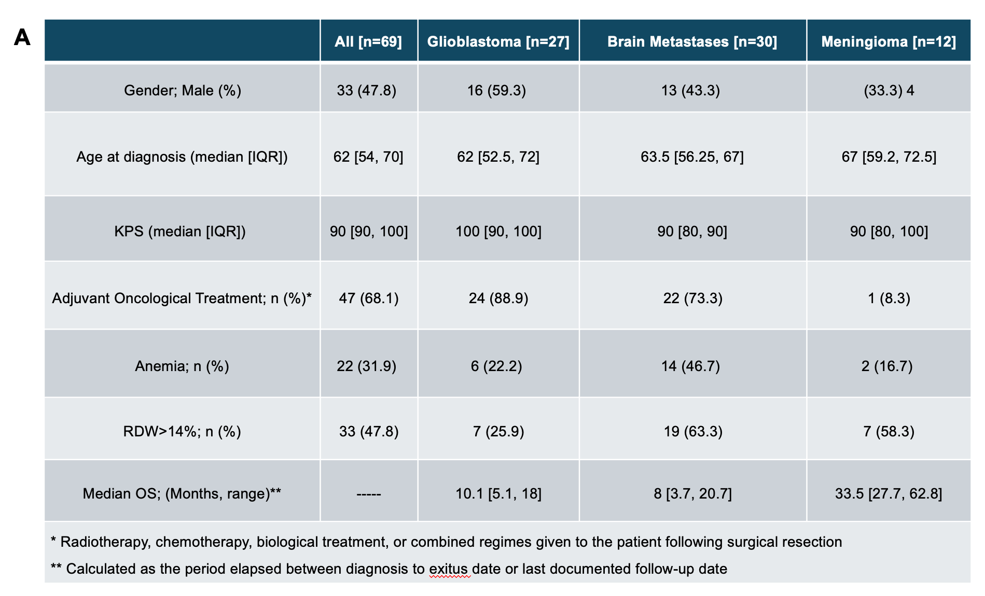

Table 1B - Patients’ Main Imagery Characteristics
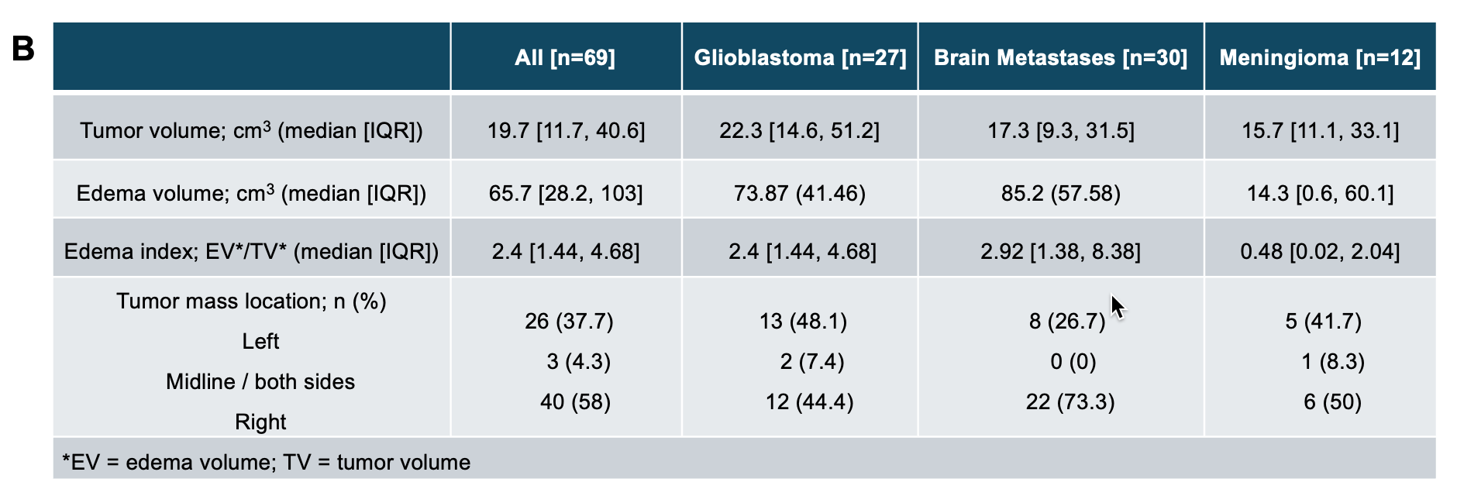

Table 1C - Glioblastoma and Brain Metastases Patients’ Cohort Sub-analysis
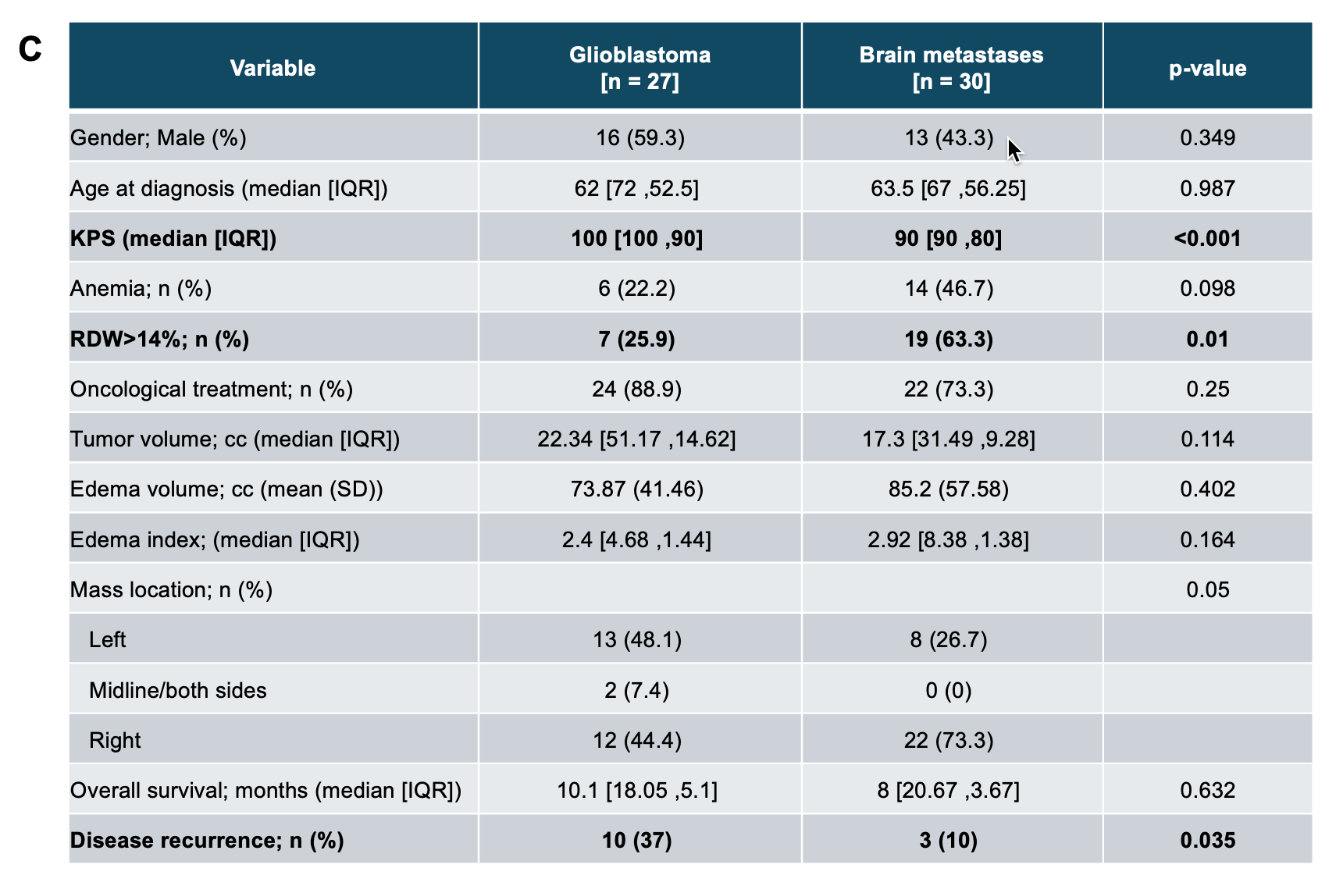

Table 1D - Newly Diagnosed Versus Recurrent Glioblastoma Patients’ Cohort Sub-analysis
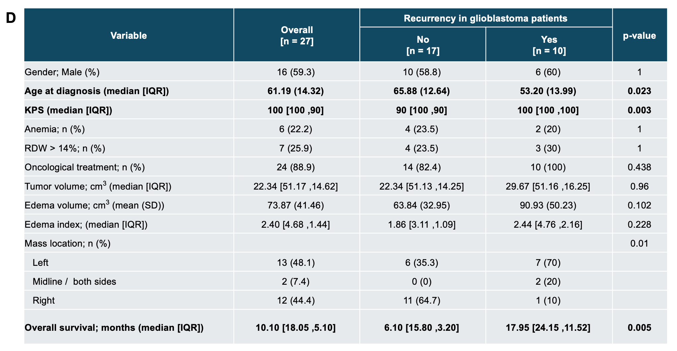

Table 2A - Patients’ Cohort Clinical Parameters Univariate Analysis
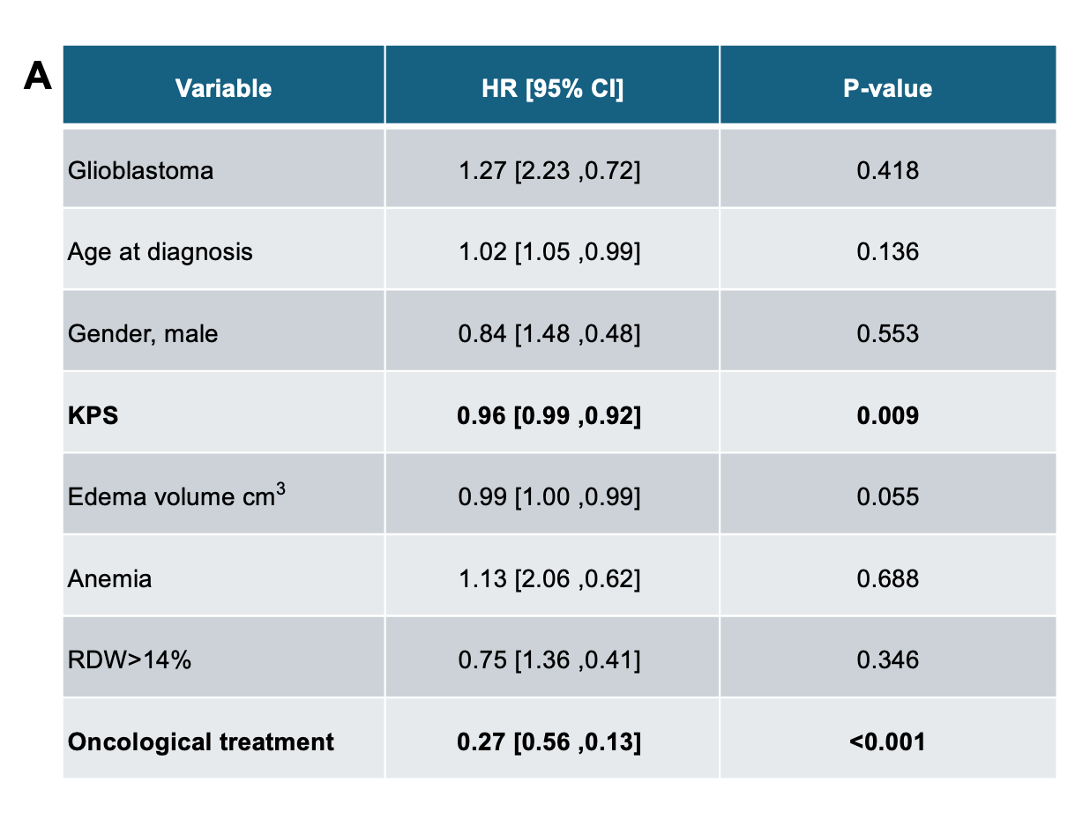

Table 2B - Patients’ Cohort Univariate and Multivariate Analysis

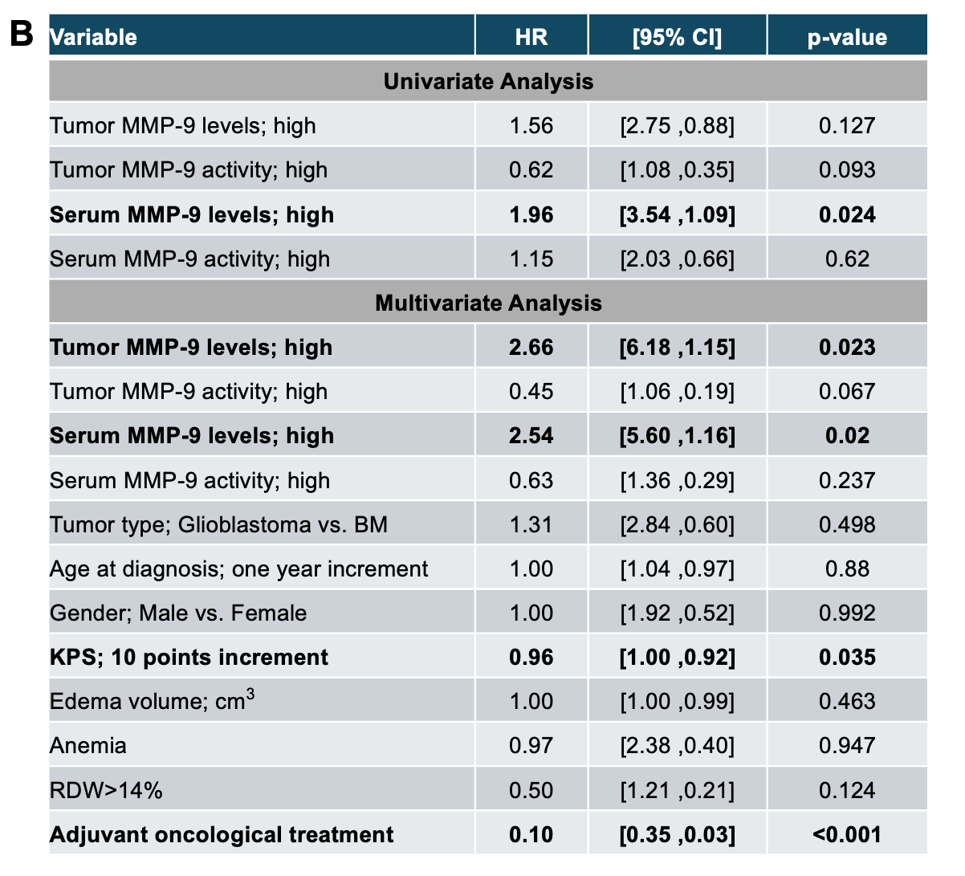

Table 2C - Patients’ Cohort OS Analysis
