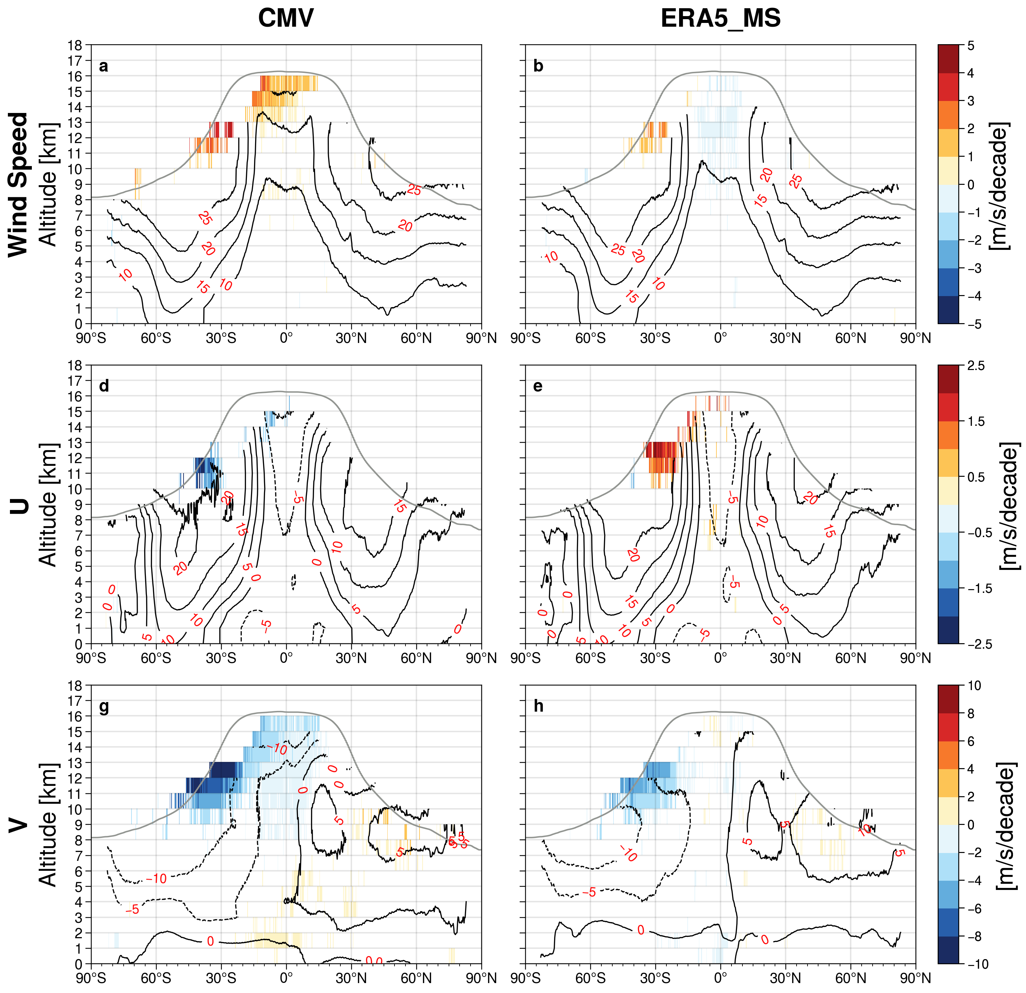

Extended Data Fig. 1 This figure is identical to Fig.1 for CMV (a,d,g) and ERA5_MS (b,e,h) except it shows only those regions where trends derived from CMV differ significantly from ERA5-MS trends at greater than 95% confidence level accessed using a standard Z-test during 2000–2020. The mean and trend values of wind speed and their zonal (U; positive eastward) and meridional (V, positive northward) components for CMV (a,d,g) and ERA5-MS (b,e,h). The black contour lines represent the mean values in m s⁻¹ averaged over the 21-year MISR record. The trends in m s⁻¹ decade⁻¹ are colored and use a different color scale for each variable. The trends are calculated with deseasonalized monthly CMV anomalies that have passed the tightened False Discovery Rate (FDR) correction at the 5% level. The grey lines represent the mean tropopause heights averaged between 2000 and 2020. See Methods for details.

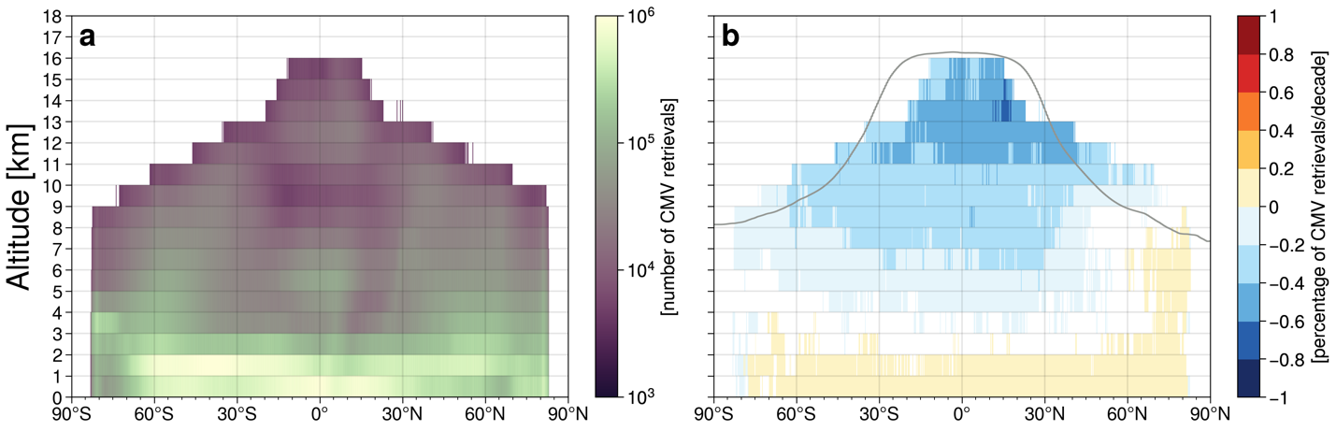

Extended Data Fig. 2 (a) The total number of CMV retrievals obtained during 2000–2020, and (b) their trends in percentage decade⁻¹. The bins with the total number of retrieves less than 5000 are shown as white. The trends are calculated using deseasonalized monthly anomalies of CMV retrievals that have passed the tightened False Discovery Rate (FDR) correction at the 5% level. The grey lines represent the mean tropopause heights averaged between 2000 and 2020. See Methods for details.

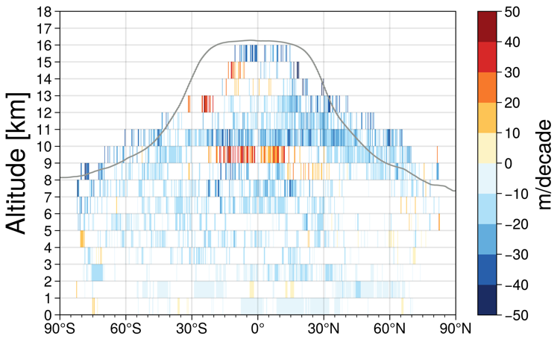

Extended Data Fig. 3 Vertical and latitudinal distribution of trends in cloud top height within each bin from the MISR CMV product during 2000–2020. Trends (in m decade⁻¹) are calculated using deseasonalized monthly anomalies of cloud top heights that have passed the tightened False Discovery Rate (FDR) correction at the 5% level. The grey lines represent the mean tropopause heights averaged between 2000 and 2020. See Methods for details.

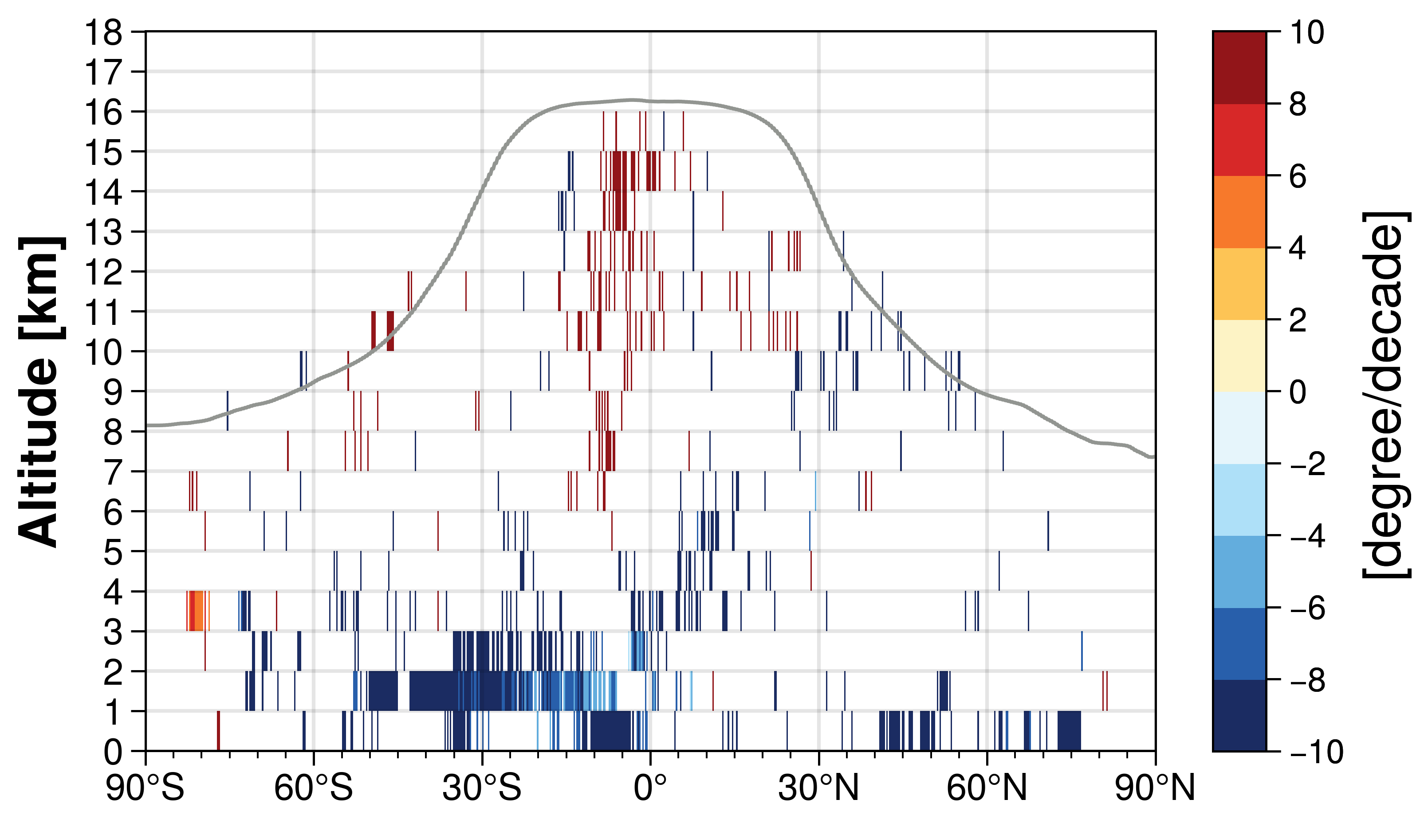

Extended Data Fig. 4 Trends in the centroid of the longitudinal distributions of the CMV samples during 2000-2020. Only values passing the tightened False Discovery Rate (FDR) correction at the 5% level are shown. The grey lines represent the mean tropopause heights averaged between 2000 ad 2020.

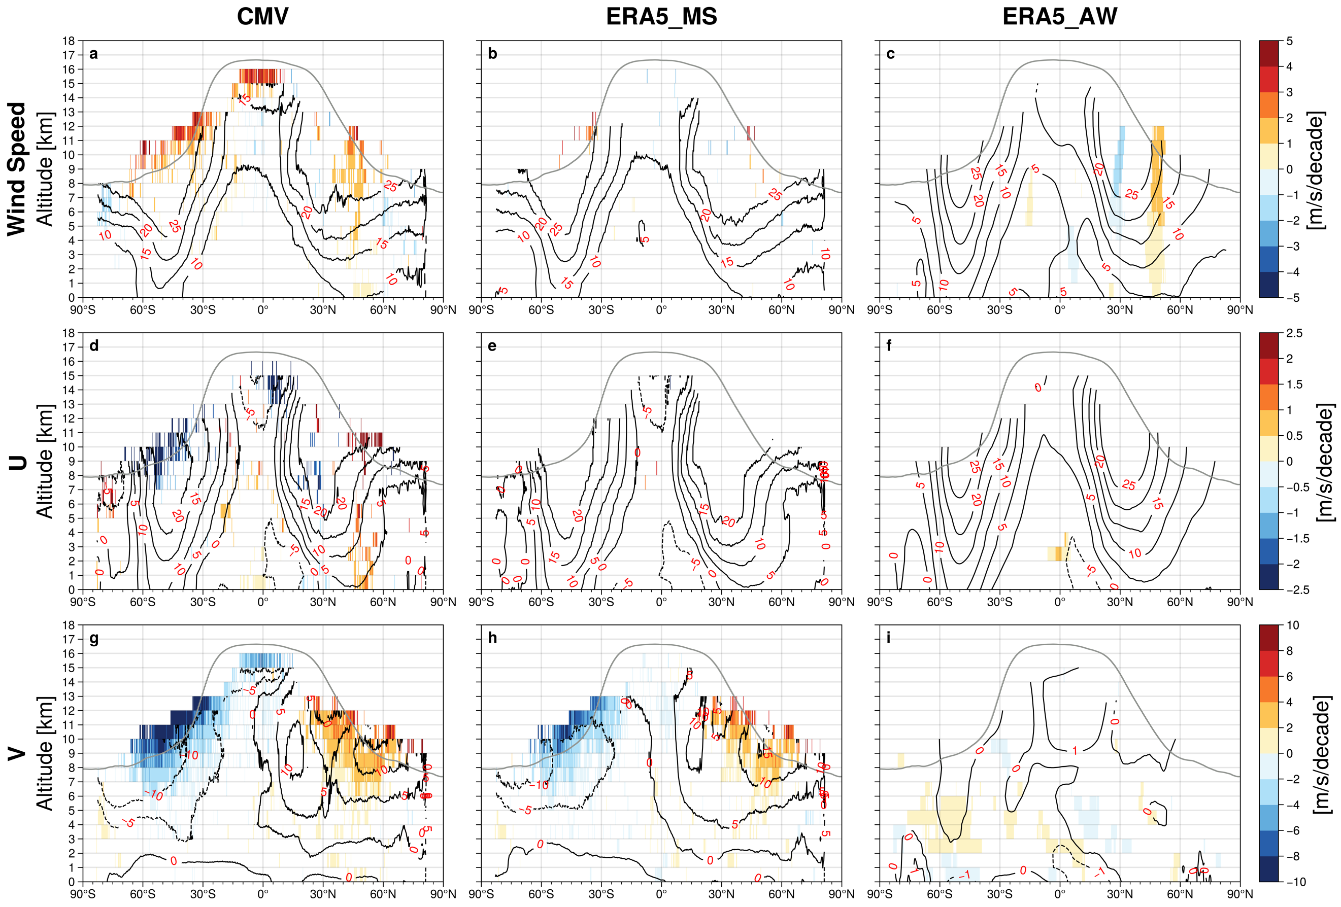
Extended Data Fig. 5 The mean and trend values of wind speed and their zonal (U; positive eastward) and meridional (V, positive northward) components for CMV (a,d,g), ERA5_MS (b,e,h), and ERA5_AW (c,f,i) for December, January, and February only over the 2000-2020 period. The black contour lines represent the mean values in m s⁻¹ averaged over the 21-year MISR record. The trends in m s⁻¹ decade⁻¹ are colored and use a different color scale for each variable. The trends are calculated with deseasonalized monthly CMV anomalies that have passed the tightened False Discovery Rate (FDR) correction at the 5% level. The grey lines represent the mean tropopause heights averaged between 2000 and 2020. See Methods for details.
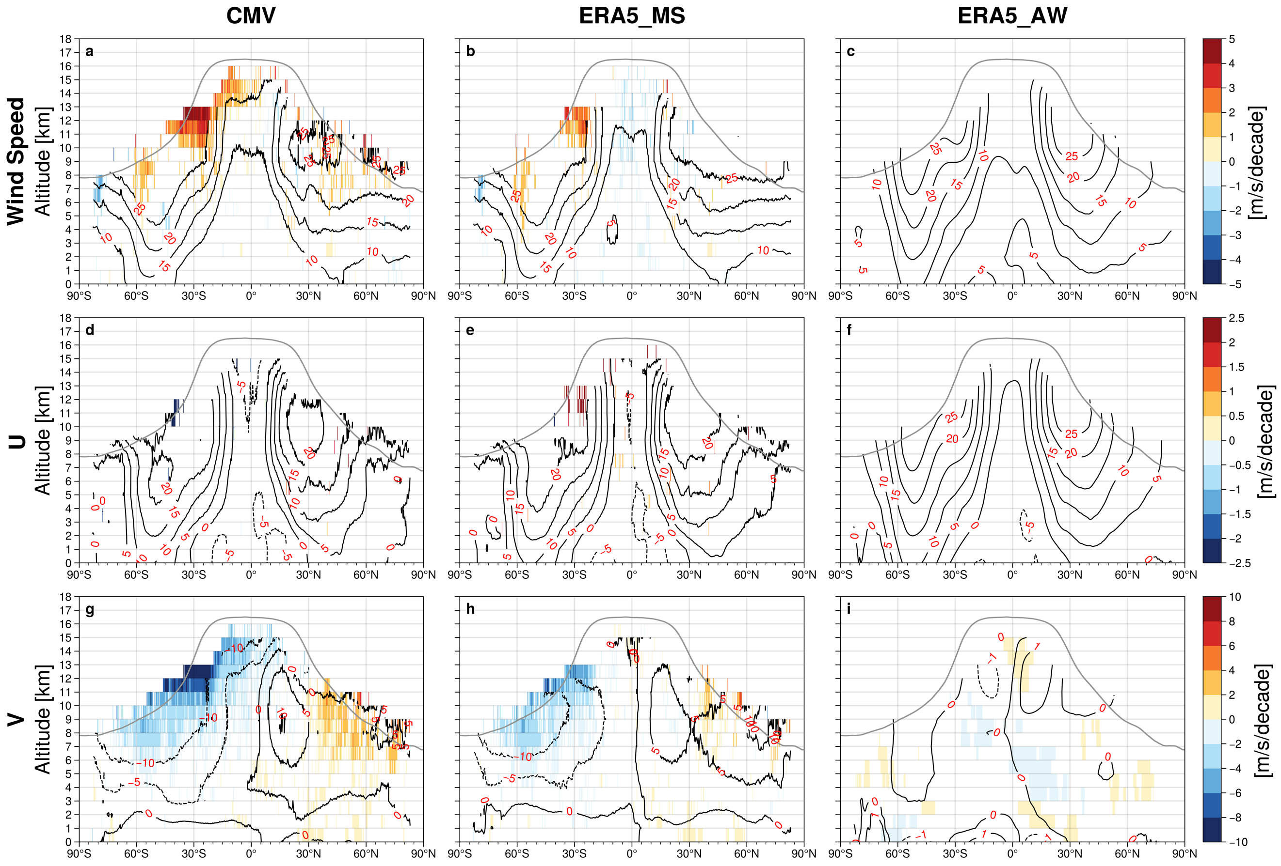

Extended Data Fig. 6 The mean and trend values of wind speed and their zonal (U; positive eastward) and meridional (V, positive northward) components for CMV (a,d,g), ERA5_MS (b,e,h), and ERA5_AW (c,f,i) for March, April, and May only over the 2000-2020 period. The black contour lines represent the mean values in m s⁻¹ averaged over the 21-year MISR record. The trends in m s⁻¹ decade⁻¹ are colored and use a different color scale for each variable. The trends are calculated with deseasonalized monthly CMV anomalies that have passed the tightened False Discovery Rate (FDR) correction at the 5% level. The grey lines represent the mean tropopause heights averaged between 2000 and 2020. See Methods for details.

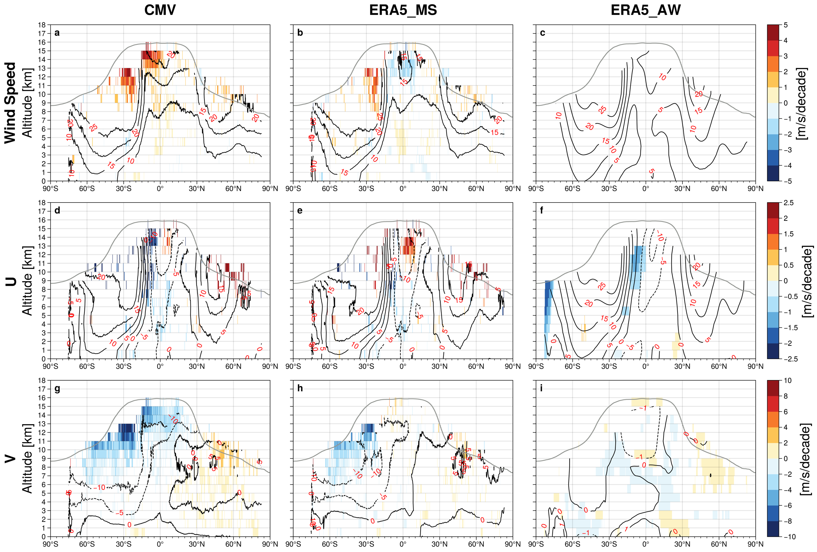

Extended Data Fig. 7 The mean and trend values of wind speed and their zonal (U; positive eastward) and meridional (V, positive northward) components for CMV (a,d,g), ERA5_MS (b,e,h), and ERA5_AW (c,f,i) for June, July and August only over the 2000-2020 period. The black contour lines represent the mean values in m s⁻¹ averaged over the 21-year MISR record. The trends in m s⁻¹ decade⁻¹ are colored and use a different color scale for each variable. The trends are calculated with deseasonalized monthly CMV anomalies that have passed the tightened False Discovery Rate (FDR) correction at the 5% level. The grey lines represent the mean tropopause heights averaged between 2000 and 2020. See Methods for details.

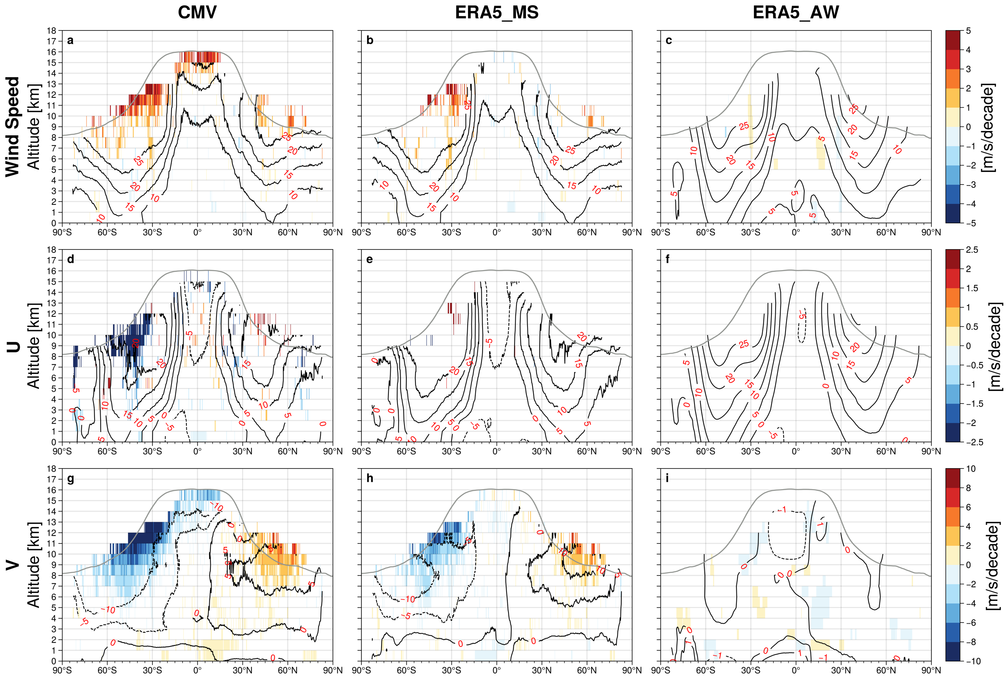

Extended Data Fig. 8 The mean and trend values of wind speed and their zonal (U; positive eastward) and meridional (V, positive northward) components for CMV (a,d,g), ERA5_MS (b,e,h), and ERA5_AW (c,f,i) for September, October and November only over the 2000-2020 period. The black contour lines represent the mean values in m s⁻¹ averaged over the 21-year MISR record. The trends in m s⁻¹ decade⁻¹ are colored and use a different color scale for each variable. The trends are calculated with deseasonalized monthly CMV anomalies that have passed the tightened False Discovery Rate (FDR) correction at the 5% level. The grey lines represent the mean tropopause heights averaged between 2000 and 2020. See Methods for details.

