Search Strategy

PUBMED 09/01/2024 | Population | Intervention | Comparison | Outcome
 |  | "Finerenone"[Mesh] |  | "Cardiovascular Diseases"[Mesh]
Total studies |  | 221 |  | 2,811,723

Combined Mesh terms: ("Finerenone" [Supplementary Concept]) AND "Cardiovascular Diseases"[Mesh]: 89 studies

EMBASE 09/01/2024 | Population | Intervention | Comparison | Outcome
 |  | Finerenone | Placebo | Cardiovascular Disease
Total studies =
Combined Embase search | 116

Total studies: 89 (Pubmed) + 116 (EMBASE) = 205
- Pubmed exclusions with filters: 70 excluded
  - Filters applied: Randomized clinical trial

Duplicates: 10 removed
Total remaining assessed for eligibility:135
- Reason for exclusions: did not used intervention, did not have the same control, different populations, or different endpoints (n = 132)
- Studies to be analyzed: 3
- FIDALIO-DKD
- FIGARO-DKD
- FINEARTS-HF

Risk of Bias (RoB 2.0)

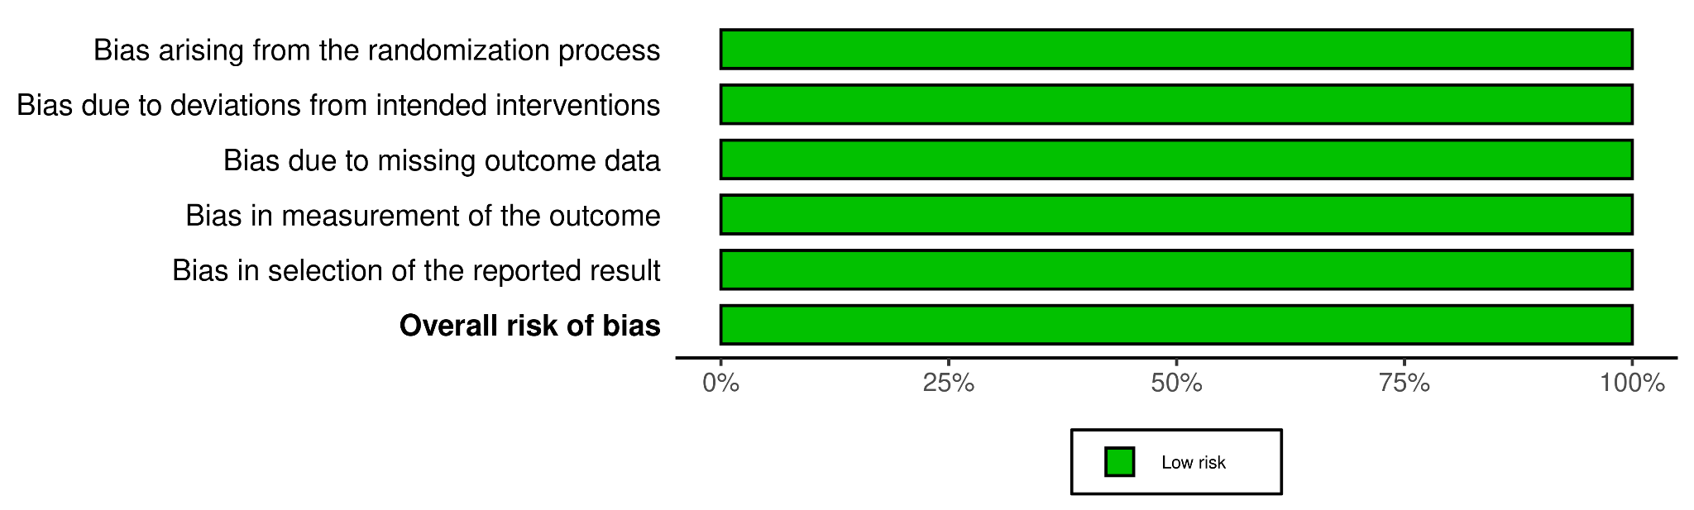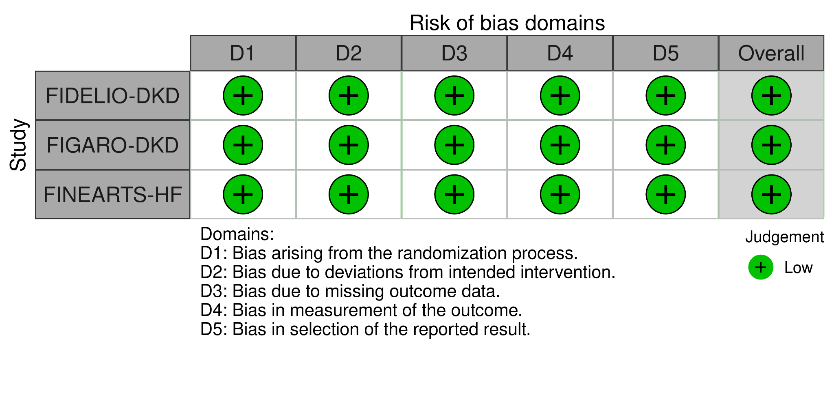

GRADE (certainty of evidence)

Outcomes | Effect Size  (95% CI) | Number of Trials | Certainty of the evidence  (GRADE)
Death from CV causes | 0.91  (0.82 to 1.01) | 3 RCTs | ⨁⨁⨁⨁ª  High
Hospitalization for heart failure | 0.80  (0.72 to 0.90) | 3 RCTs | ⨁⨁⨁⨁ª  High
Kidney failure | 1.05  (0.65 to 1.68) | 3 RCTs | ⨁⨁⨁◯^{b}  Moderate
Death from any cause | 0.86  (0.77 to 0.97) | 3 RCTs | ⨁⨁⨁⨁ª  High

- Low heterogeneity (I2=0%)
- High heterogeneity (I2>60%)

