Supplementary Material
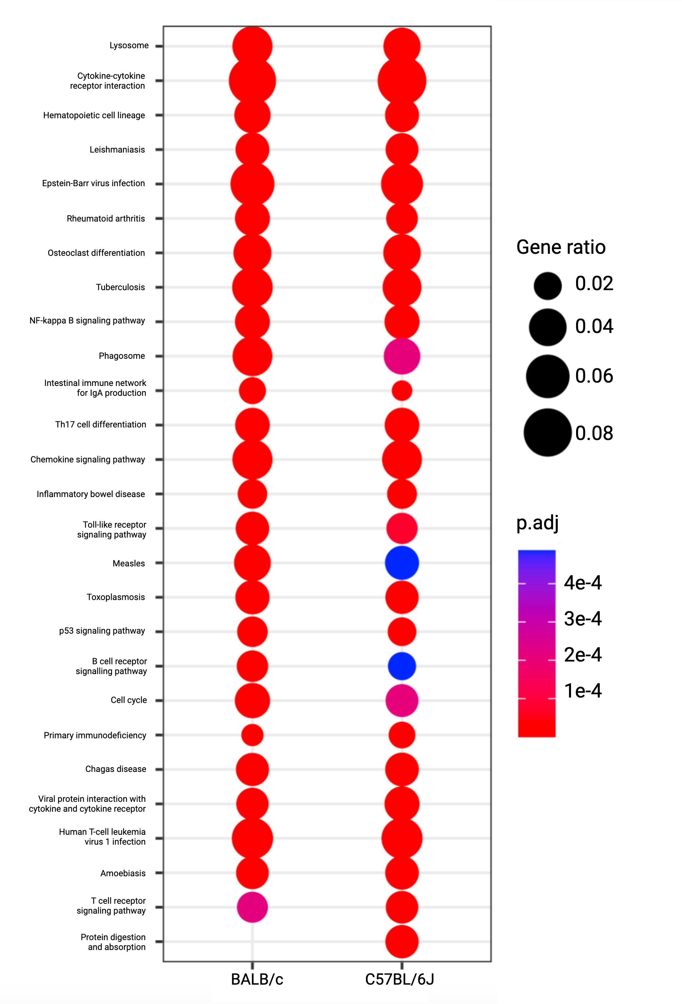
Supplementary Fig. 1 Many KEGG processes are commonly enriched among the upregulated genes of each strain (BALB/c and C57BL/6), including several previously correlated with fibrosis progression: Dots are coloured by significance (p.adj) from red (more significant) to blue (less significant) and size scaled by gene ratio (BALB/c: n=10; C57BL/6J: n=12).

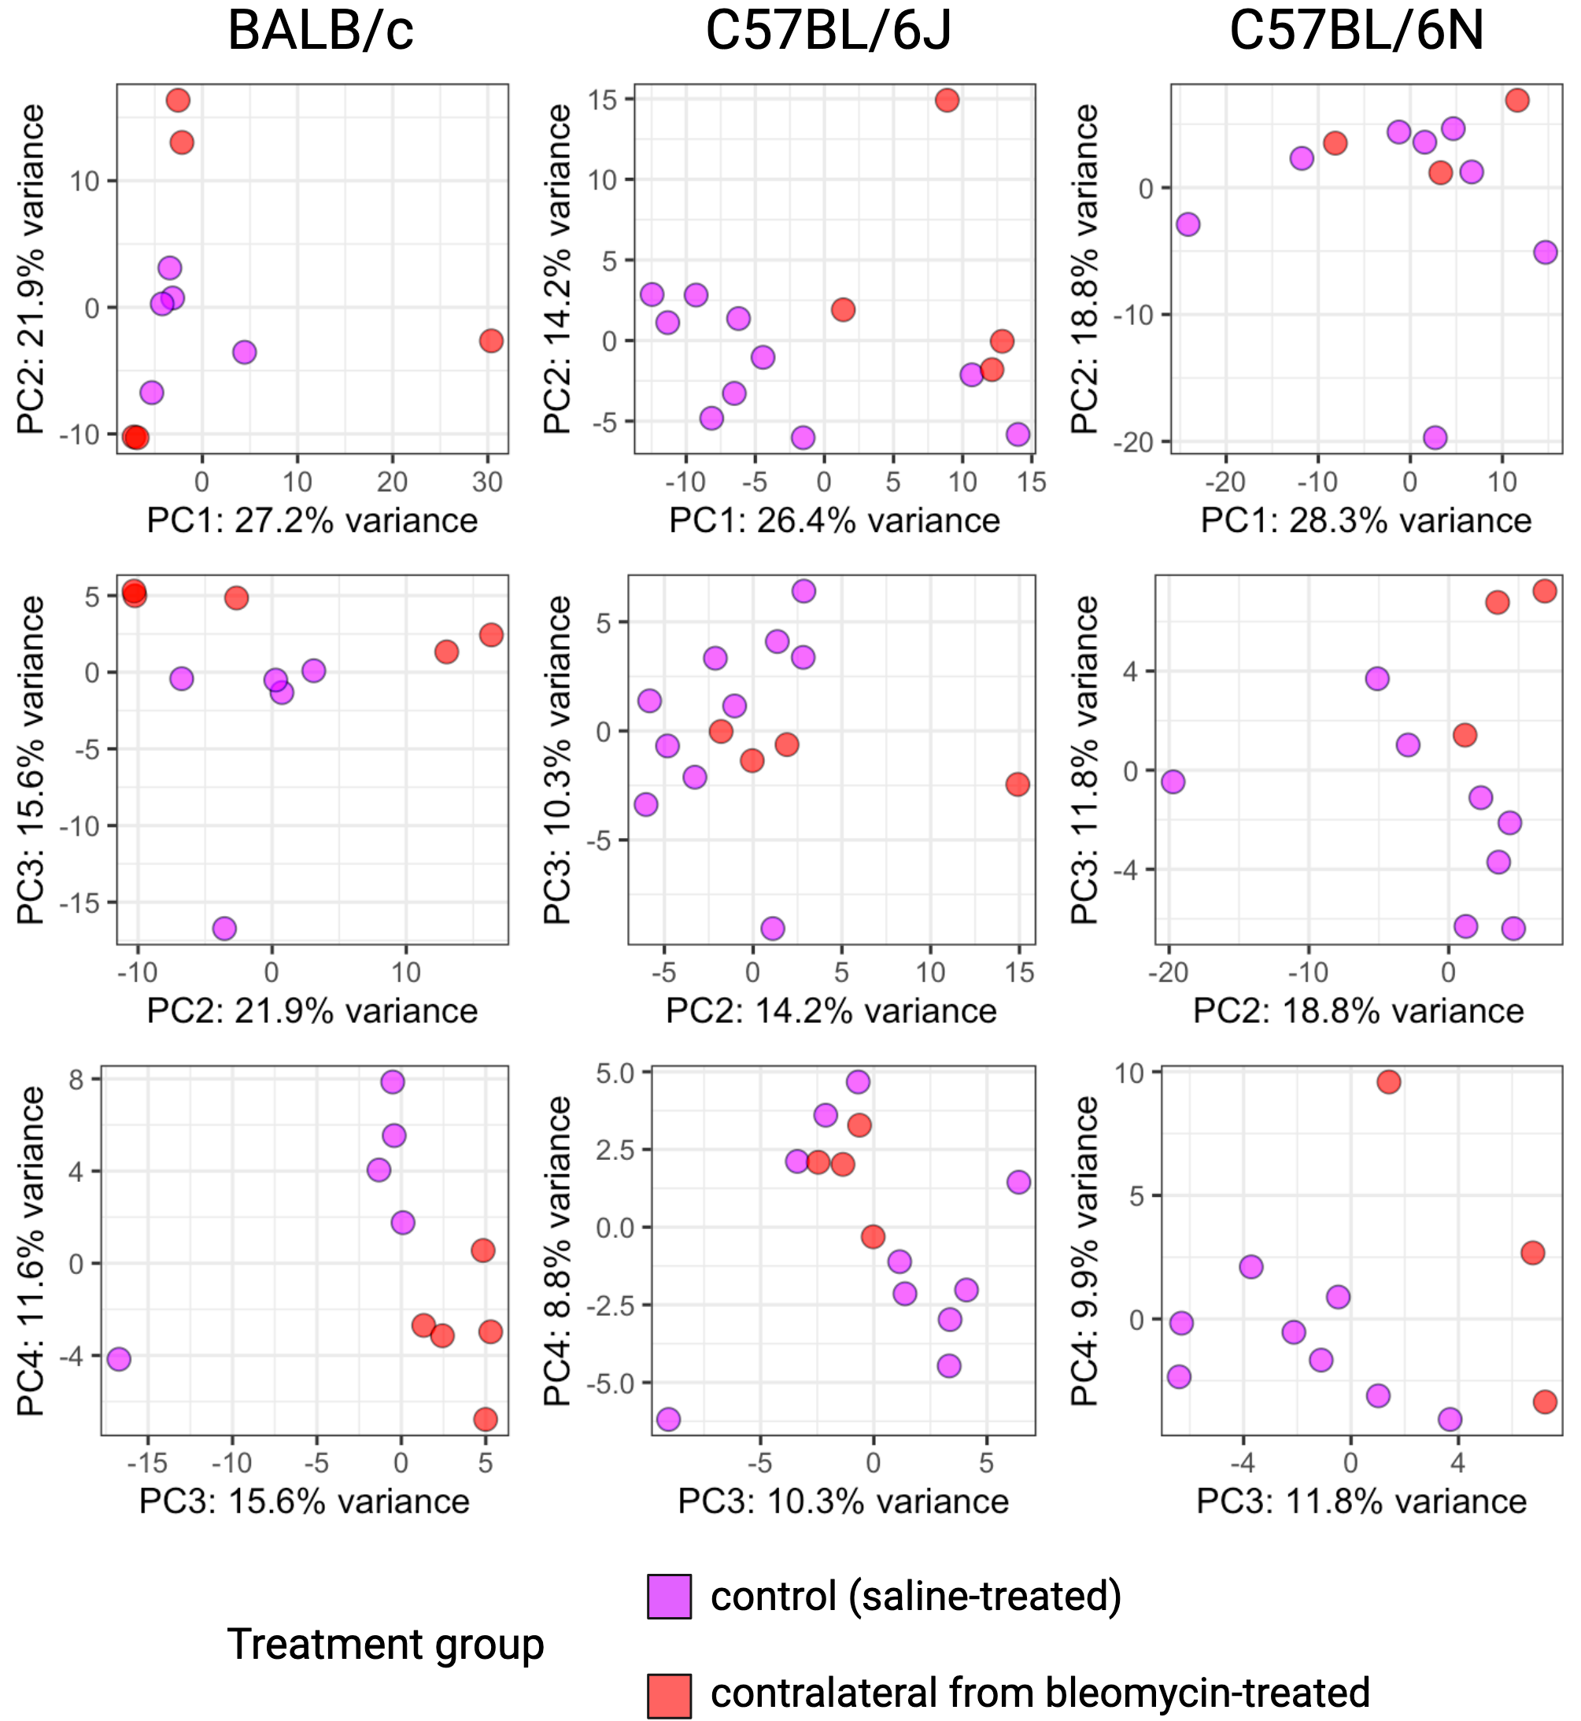
Supplementary Fig. 2 Contralateral lung transcriptomes overlap substantially with healthy tissue: Samples of of saline-treated (control) and contralateral tissue from each of BALB/c (n=5), C57BL/6N (n=7), and C57BL/6J (n=4) do not separate by treatment under PC1-4 of each strain.

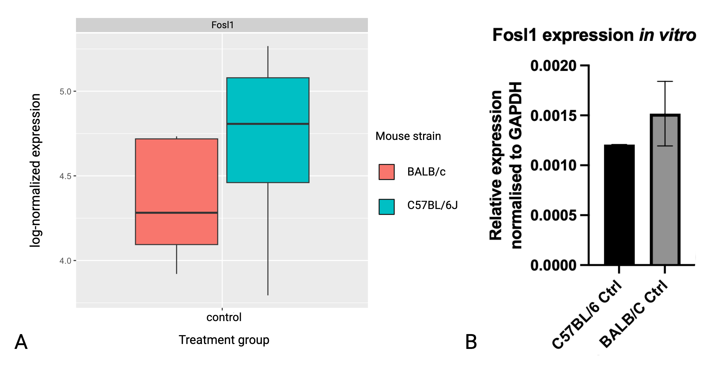
Supplementary Fig. 3 Fosl1 is expressed at similar levels in healthy BALB/c versus C57BL/6 lungs: (A) Fosl1 transcript levels are not significantly different between BALB/c (n=5) versus C57BL/6 (n=8) saline-treated lungs in vivo (B) nor between the two strains’ in vitro controls (n=1, 2 technical replicates, shown as means +-SD).

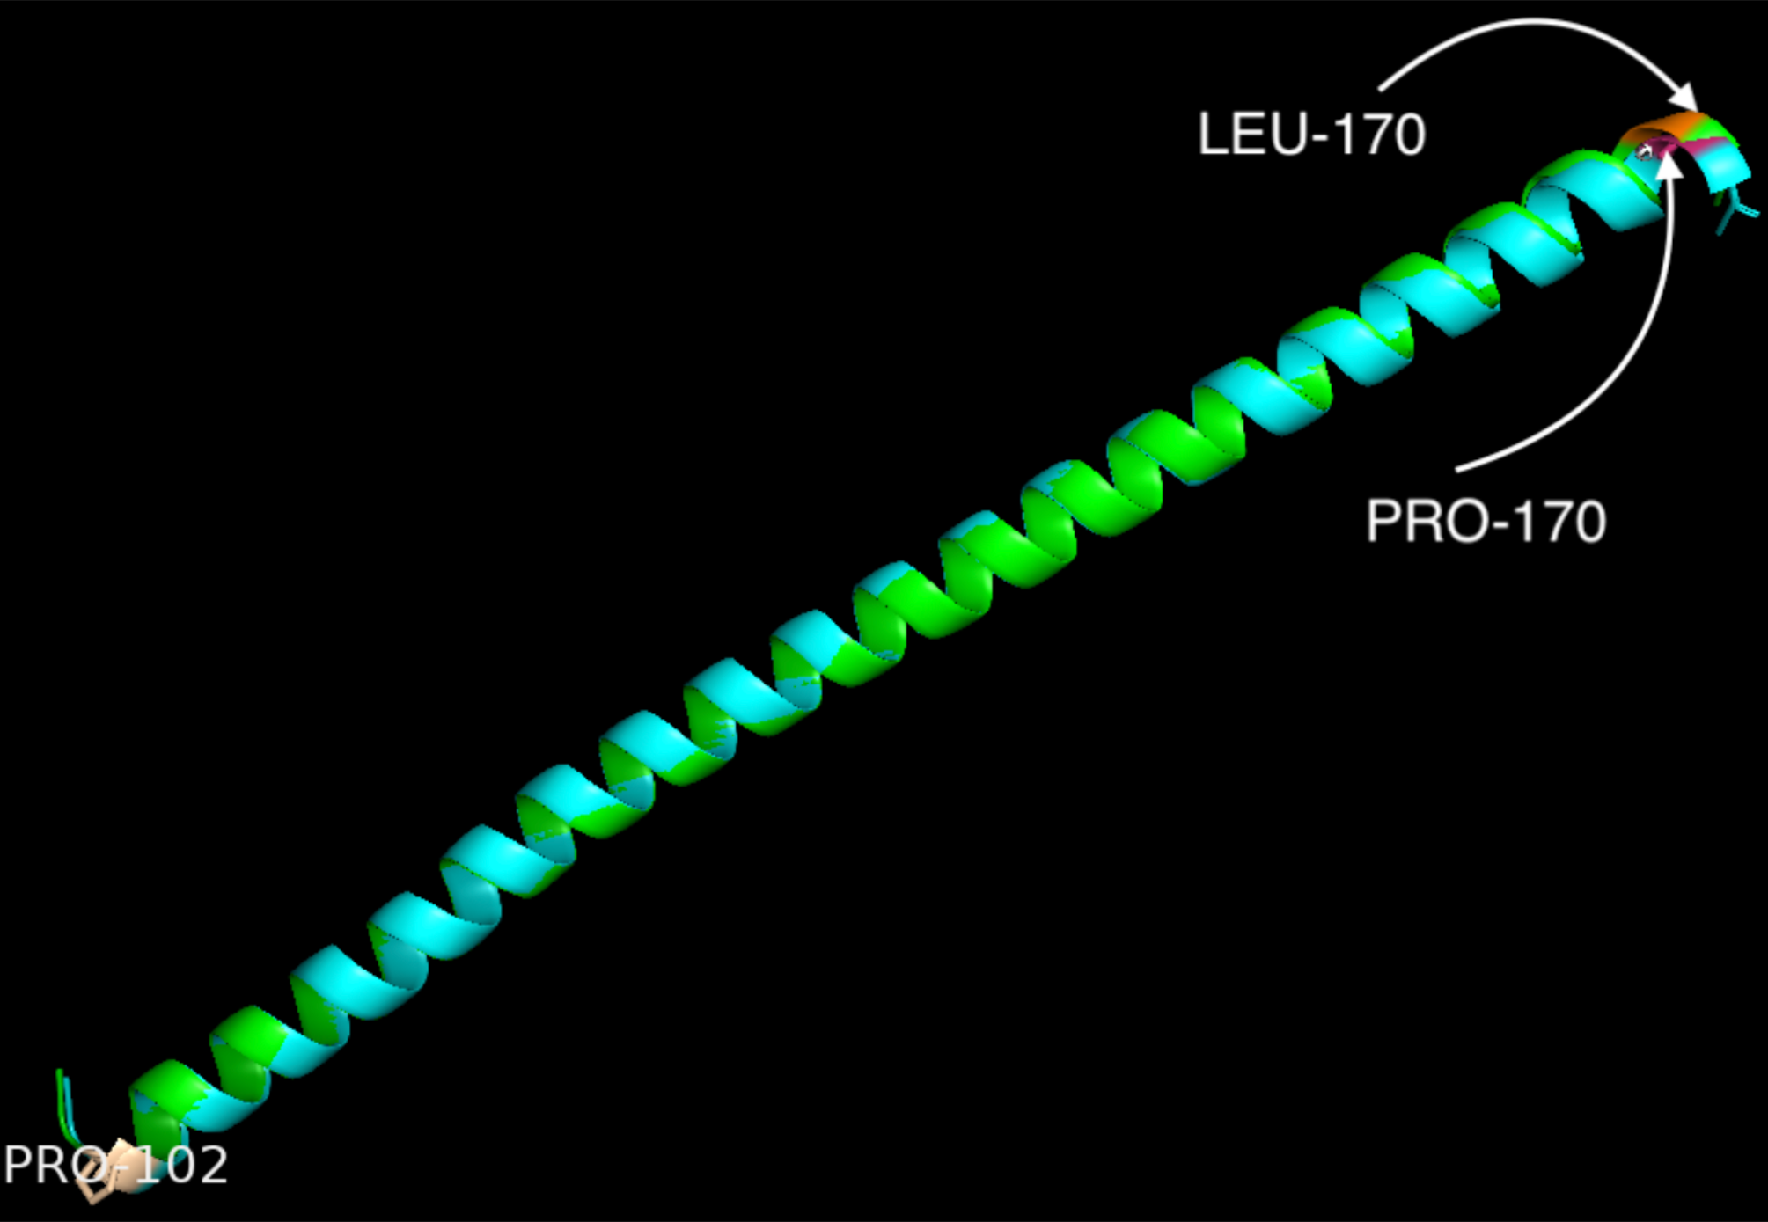

Supplementary Fig. 4 BALB/c Fosl1 helical domain may be altered by a P170L mutation: In C57BL/6J (cyan), this bZIP domain is capped at each end by prolines (Pro-102, pale pink; Pro-170, hot pink); in BALB/c (green), the C-terminal end has mutated (Leu-170, orange).

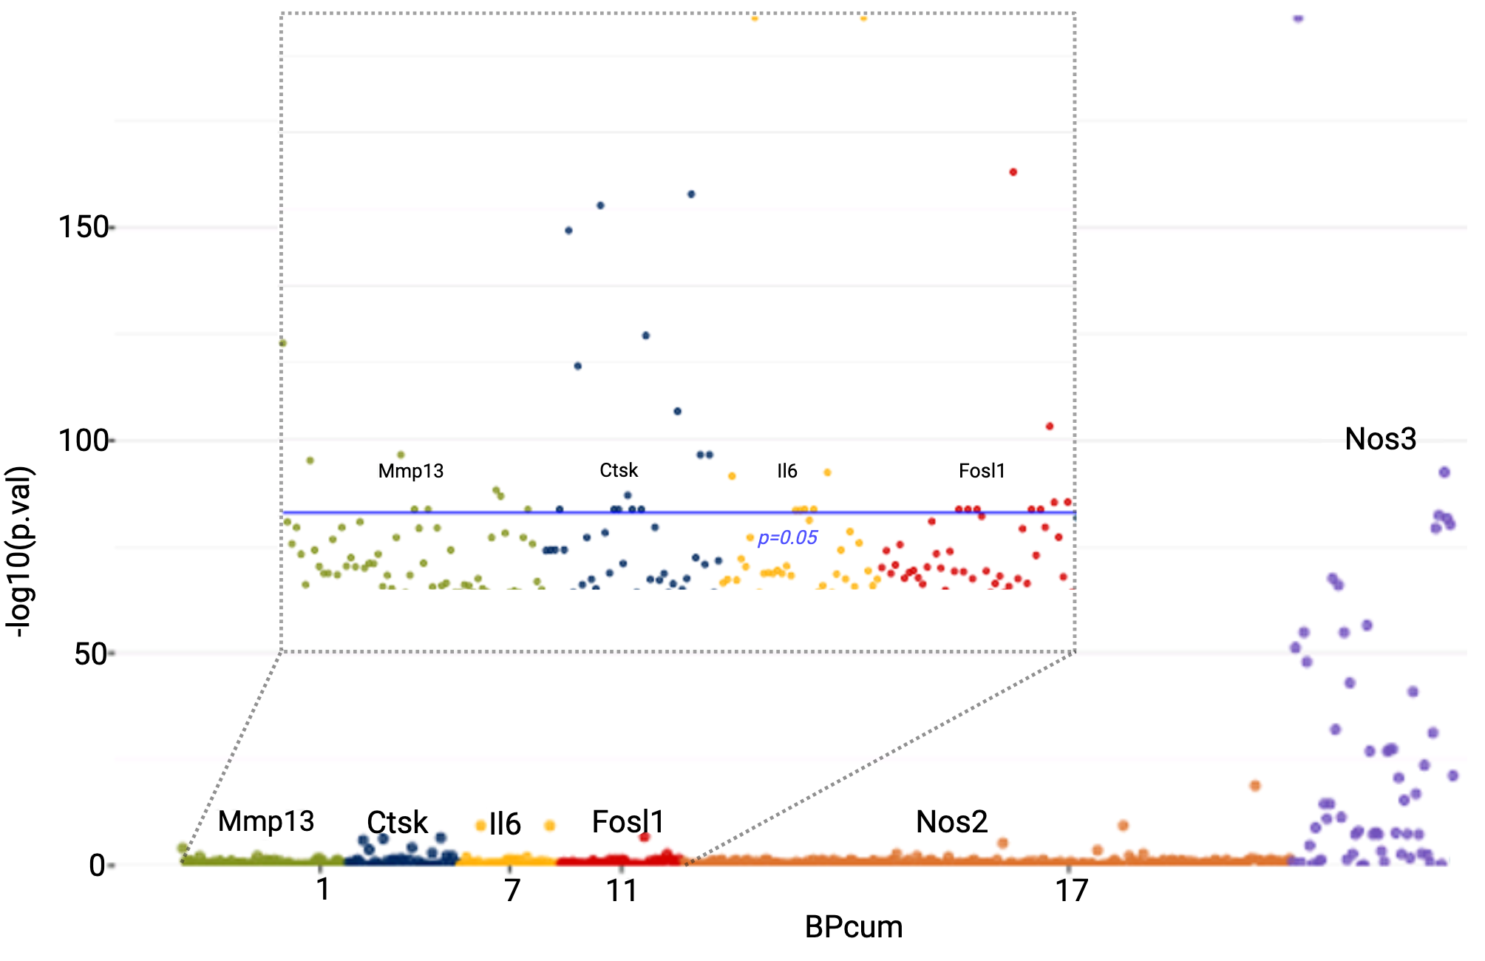
Supplementary Fig. 5 Whole-genome sequencing of a familial pulmonary fibrosis (FPF) cohort identifies fibrosis-associated FOSL1 variants in humans: Manhattan plot used to visualise the statistical significance (p.val), log-transformed for convenience (y-axis), of SNP association with FPF over the cumulative length in base-pairs (BPcum, x-axis) of Mmp13, Ctsk, Il6, Fosl1, Nos2, and Nos3. SNPs where p<0.05 (inset) were tabulated for reference (Supplementary).

Supplementary Table 1 SNPs in human Fosl1 significantly associated with familial pulmonary fibrosis

Position | p-value | Frequency
65898202 | 0.000000 | A G  CT 5440 560  PF 274 4
65899653 | 0.001954 | T G  CT 6000 0  PF 276 2
65900325 | 0.033732 | A G  CT 2435 3565  PF 135 147
65899678 | 0.033953 | G C  CT 2456 3544  PF 132 146
65896552 | 0.044282 | T C  CT 6000 0  PF 277 1
65897098 | 0.044282 | T C  CT 6000 0  PF 277 1
65897098 | 0.044282 | C G  CT 6000 0  PF 277 1
65897327 | 0.044282 | T C  CT 6000 0  PF 277 1
65899323 | 0.044282 | T C  CT 6000 0  PF 277 1

Supplementary Table 2 SNPs in human Ctsk significantly associated with familial pulmonary fibrosis

Position | p-value
150802853 | 0.000000
150807279 | 0.000000
150799227 | 0.000001
150805038 | 0.000065
150800137 | 0.000203
150807048 | 0.001118
150807923 | 0.005690
150808127 | 0.005690
150804616 | 0.026040
150796269 | 0.044282
150803328 | 0.044282
150803419 | 0.044282
150804857 | 0.044282
150804992 | 0.044282

Supplementary Table 3 SNPs in human Mmp13 significantly associated with familial pulmonary fibrosis

Position | p-value
102943189 | 0.000086
102948971 | 0.000000
102945015 | 0.000001
102952903 | 0.000065
102953094 | 0.000203
102949328 | 0.001118
102949814 | 0.005690
102954665 | 0.005690

Supplementary Table 4 SNPs in human Nos2 significantly associated with familial pulmonary fibrosis

Position | p-value
27783172 | 0.000263
27767755 | 0.001954
27787426 | 0.001954
27785981 | 0.005690
27769698 | 0.006172
27772764 | 0.009415
27797038 | 0.021747
27800492 | 0.044281

Supplementary Table 5 SNPs in human Il6 significantly associated with familial pulmonary fibrosis

Position | p-value
22727566 | 0.000000
22730939 | 0.000000
22729678 | 0.011049
22726627 | 0.012710
22728719 | 0.044282
22729065 | 0.044282
22728600 | 0.044282
22728630 | 0.044282

