Supplementary Information

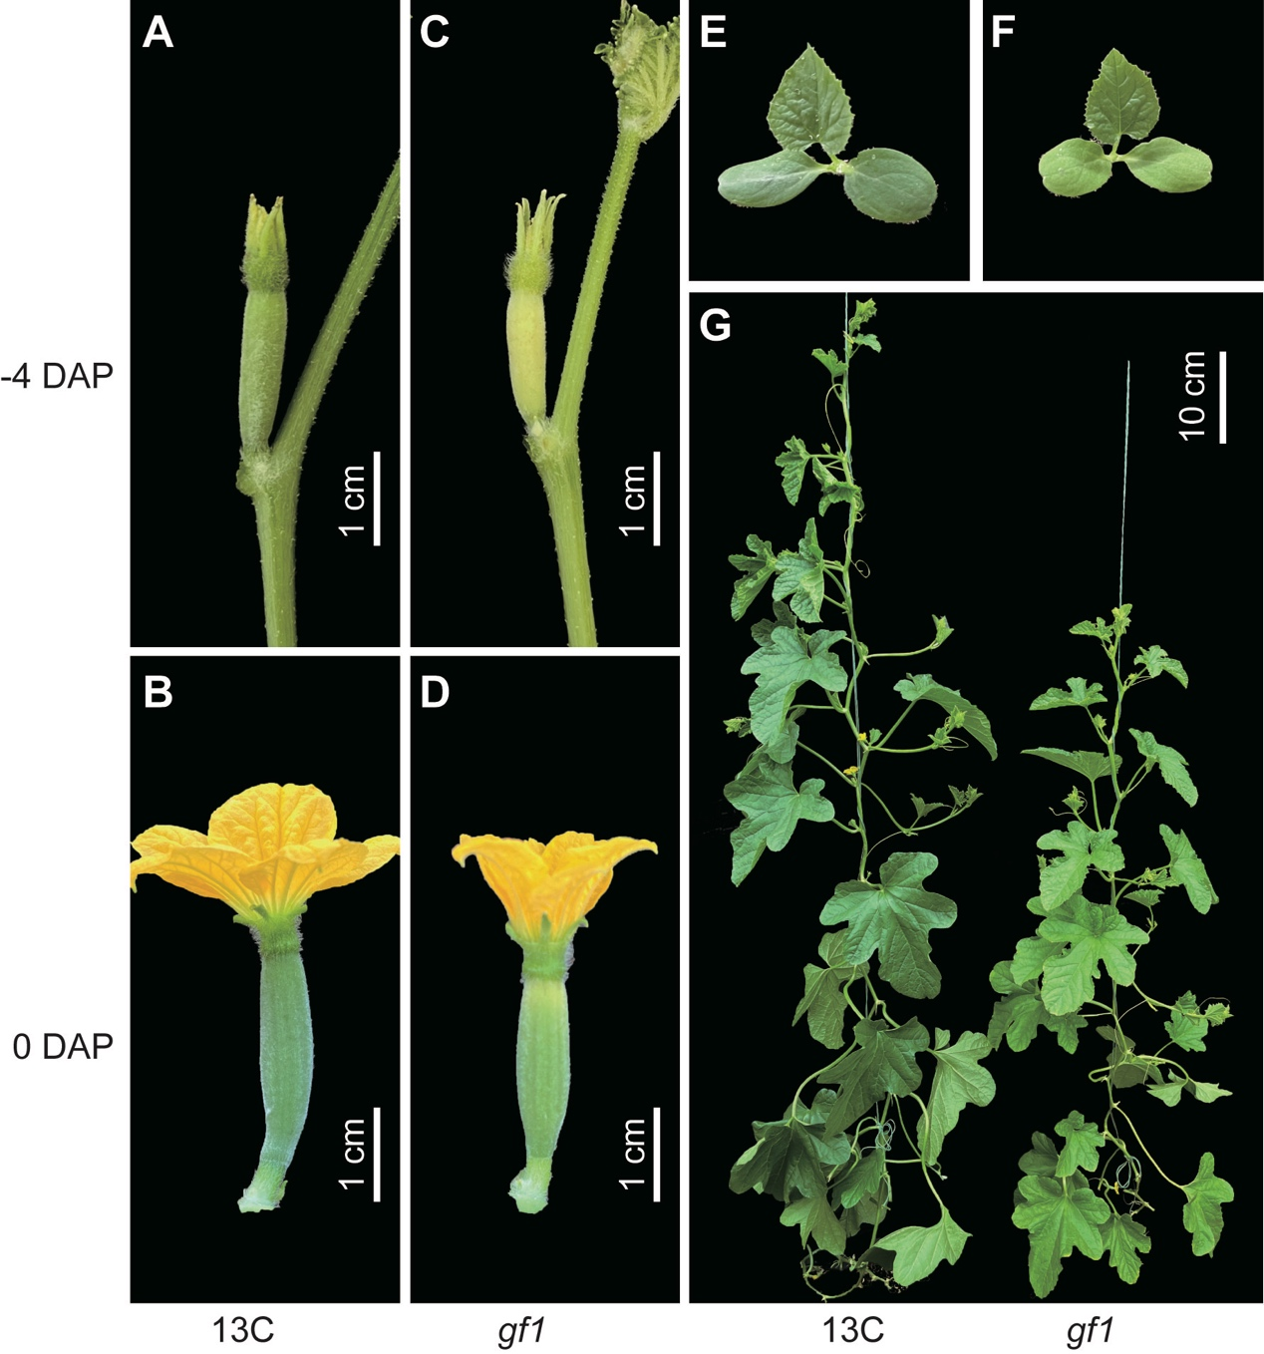

Supplementary Fig. S1 Phenotype analysis of gf1 fruit and plant. Phenotype of 13C (A-B) and gf1 (C-D) fruit in early stages. Phenotype of 13C (E) and gf1 (F) plant in seedling stage and adult stage (G).

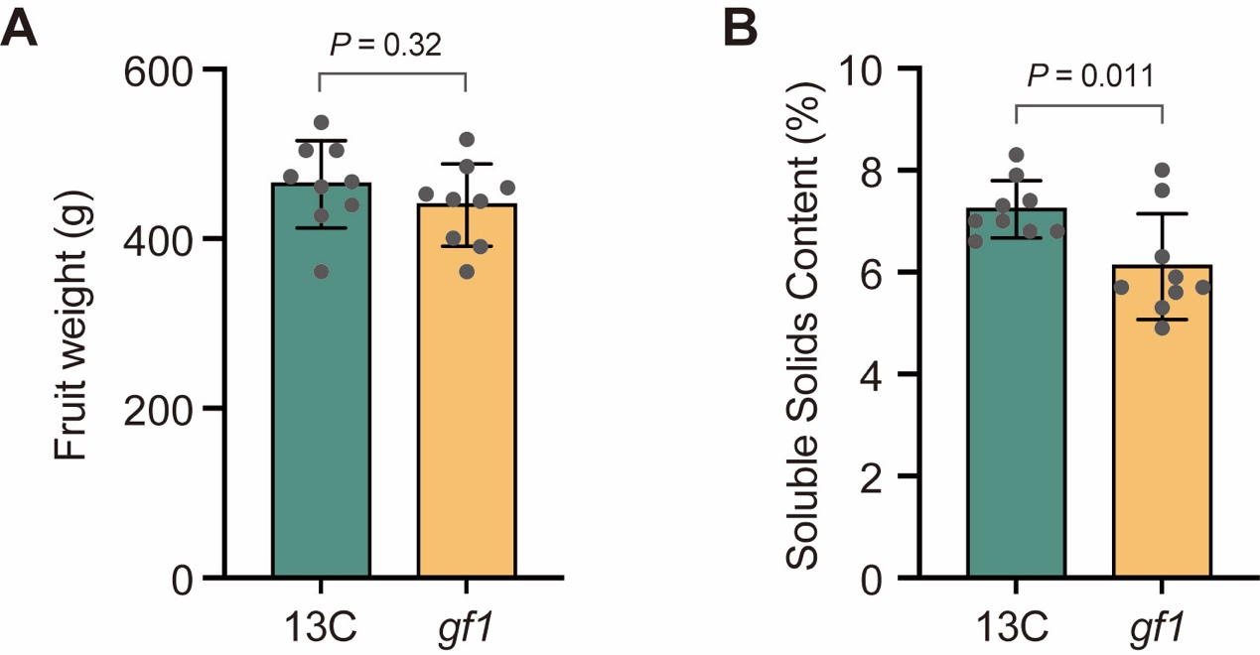

Supplementary Fig. S2 Comparison of fruit weight (A) and soluble solids content (B) in 13C and gf1.

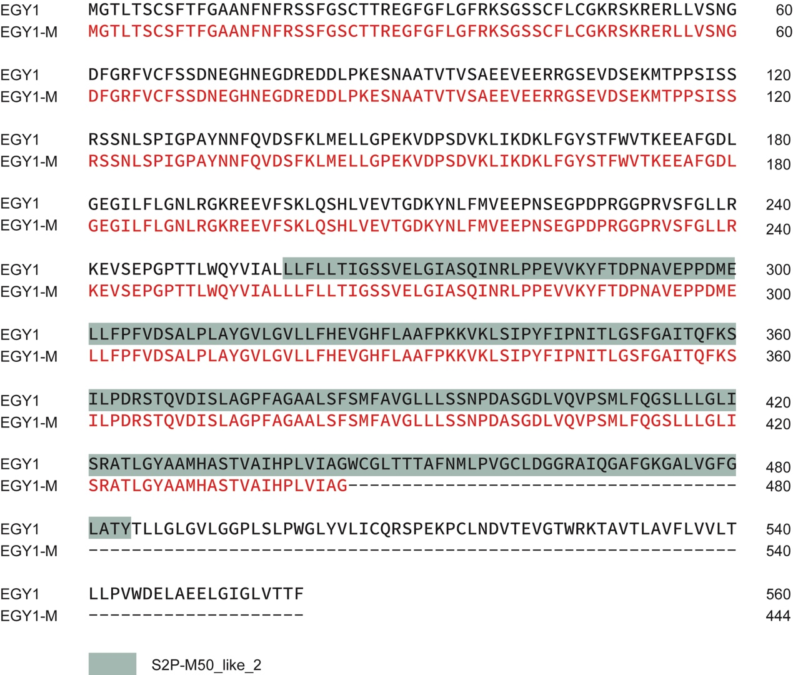

Supplementary Fig. S3 Protein sequence alignment of CmEGY1 in gf1 and 13C

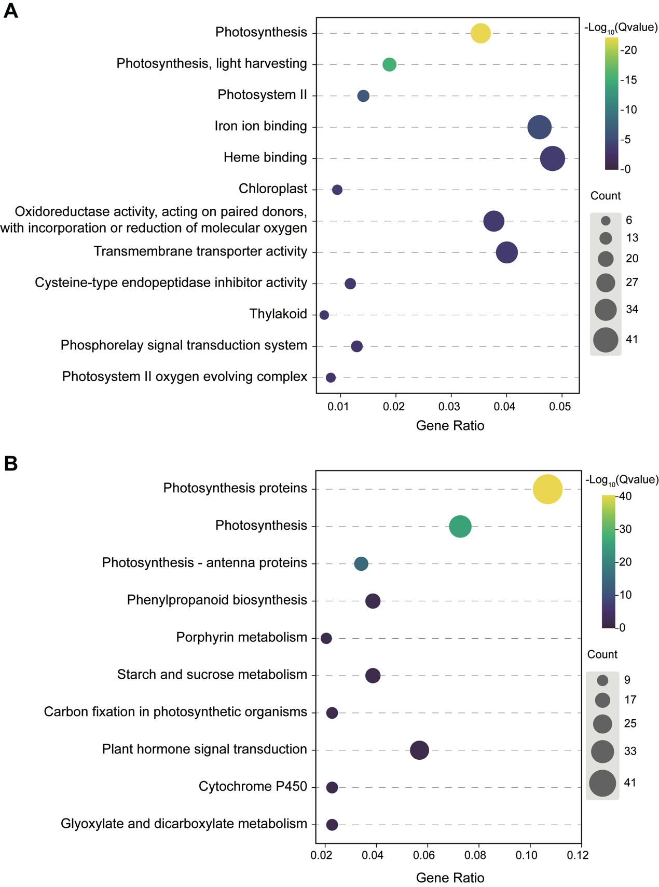

Supplementary Fig. S4 GO (A) and KEGG (B) analysis of DEGs between gf1 and 13C
Supplementary Table S1. Primers used in this study
Analysis | Primer name | Sequence (5' to 3')
Physical map | CAPS-1-SpeI-F | GATTCTGGTGCAACCCATAACTTC
Physical map | CAPS-1-SpeI-R | TCGAAACTCATAATGCCCATACCT
Physical map | CAPS-2-DdeI-F | TCATGTTCCAATAATTTGGGATTTTCA
Physical map | CAPS-2-DdeI-R | AAAATCAAGGAGCAACATCCAAGC
Physical map | CAPS-3-Hpy188I-F | CTCAACTGTTGCAATTCATCCTCT
Physical map | CAPS-3-Hpy188I-R | TGGCAACCAAATTGCCATTCTAAA
Physical map | CAPS-4-HinfI-F | TGTAGTTTTAGGTGGTGTGACTGT
Physical map | CAPS-4-HinfI-R | CTACTGGAAATCGGTAACTGGGAA
Physical map | dCAPS-5-EcoRV-F | TCGTCCAAGTGGGAGTTTGTTGGAATTGAT
Physical map | dCAPS-5-EcoRV-R | CACGTTTATGTCTCTACATAAAGT
Physical map | CAPS-6-MseI-F | TCACTTTTAGACGAGACACAACCT
Physical map | CAPS-6-MseI-R | AATTGAATTGAGCCTTGACCAGAC
Physical map | CAPS-7-MnlI-F | GGGAGGTCAAAGTTGGTCAAGATA
Physical map | CAPS-7-MnlI-R | CGAAAACCAAAACAATCAATTTTGCC
CRISPR | CsEGY1-Target1-F | TCGAAGTAGTGATTGGAAAAGAGGTCTCCGAACCGTTTTAGAGCTAGAAATAGC
CRISPR | CsEGY1-Target2-R | TTCTAGCTCTAAAACTCCATCGATTTCTTCAAGGCAATCTCTTAGTCGACTCTAC
Verification of gene editing | CsEGY1-g102F | GGGGTTTAAGAGGTTGAGGAGTT
Verification of gene editing | CsEGY1-g1730R | AAGTGATACACAAGCTTGCACTG

Supplementary Table S2. Gene ID for phylogenetic tree analysis.
Species | Gene ID | Family | CDD
Arabidopsis thaliana | AT1G17870 | EGY1-like - IPR044838 | S2P-M50 superfamily
Arabidopsis thaliana | AT5G35220 | EGY1-like - IPR044838 | S2P-M50_like_2
Arabidopsis thaliana | AT5G05740 | EGY1-like - IPR044838 | S2P-M50_like_2
Citrullus lanatus | Cla97C04G071230 | EGY1-like - IPR044838 | S2P-M50_like_2
Citrullus lanatus | Cla97C10G193050 | EGY1-like - IPR044838 | S2P-M50 superfamily
Citrullus lanatus | Cla97C11G213190 | EGY1-like - IPR044838 | S2P-M50_like_2
Cucumis melo | MELO3C008288 | EGY1-like - IPR044838 | S2P-M50_like_2
Cucumis melo | MELO3C018023 | EGY1-like - IPR044838 | S2P-M50_like_2
Cucumis melo | MELO3C008847 | EGY1-like - IPR044838 | S2P-M50_like_2
Cucumis sativus | CsaV3_4G000080 | EGY1-like - IPR044838 | S2P-M50 superfamily
Cucumis sativus | CsaV3_4G012000 | EGY1-like - IPR044838 | S2P-M50_like_2
Cucumis sativus | CsaV3_6G001740 | EGY1-like - IPR044838 | S2P-M50_like_2
Lotus japonicus | Lj0g3v0153649 |  | S2P-M50_like_2
Lotus japonicus | Lj0g3v0362119 | EGY1-like - IPR044838
Lotus japonicus | Lj1g3v3979280 |  | S2P-M50_like_2
Lotus japonicus | Lj3g3v2187010 | EGY1-like - IPR044838 | S2P-M50 superfamily
Oryza sativa | Os01g003770 | EGY1-like - IPR044838 | S2P-M50_like_2
Oryza sativa | Os03g044950 | EGY1-like - IPR044838 | S2P-M50_like_2
Oryza sativa | Os03g050280 | EGY1-like - IPR044838 | S2P-M50_like_2
Setaria italica | Seita.5G097600 | EGY1-like - IPR044838 | S2P-M50_like_2
Setaria italica | Seita.9G060500 | EGY1-like - IPR044838 | S2P-M50_like_2
Setaria italica | Seita.9G108100 | EGY1-like - IPR044838 | S2P-M50_like_2
Vitis vinifera | Vitvi13g00021 | EGY1-like - IPR044838 | S2P-M50_like_2
Vitis vinifera | Vitvi03g00717 | EGY1-like - IPR044838 | S2P-M50 superfamily
Vitis vinifera | Vitvi08g00113 | EGY1-like - IPR044838 | S2P-M50_like_2

