Supplemental Video 1
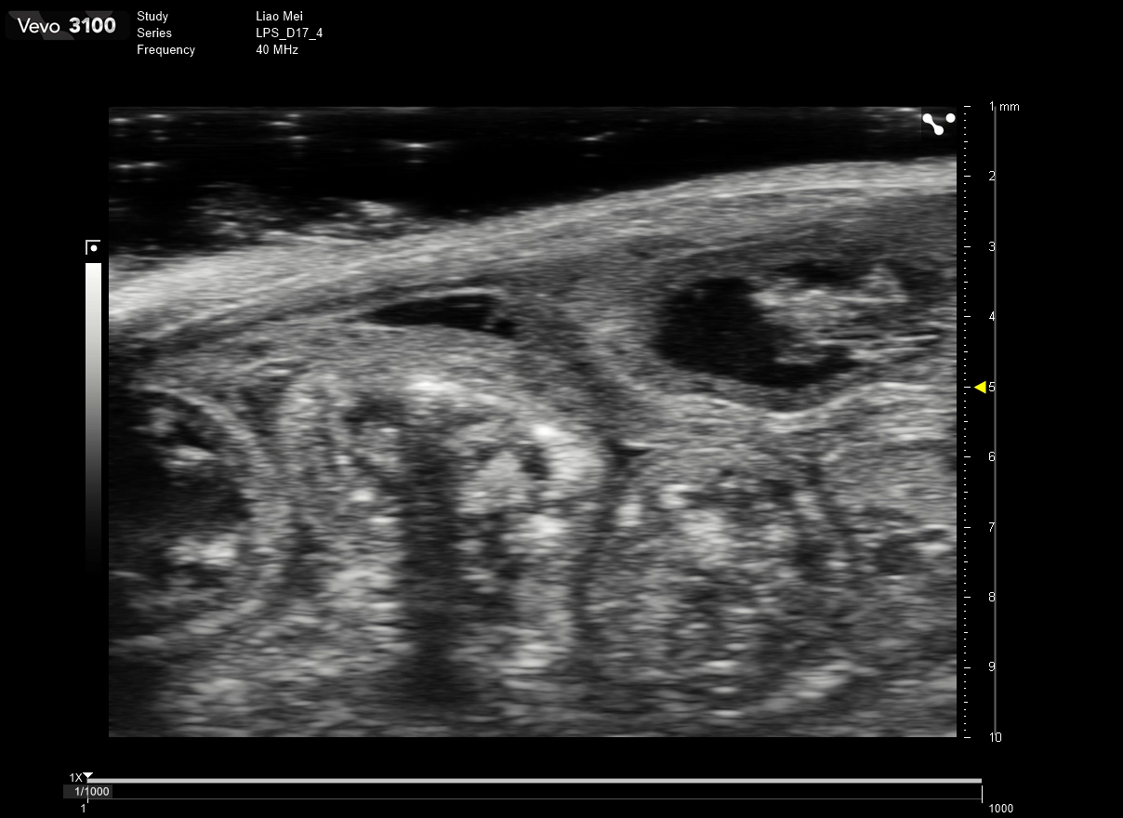
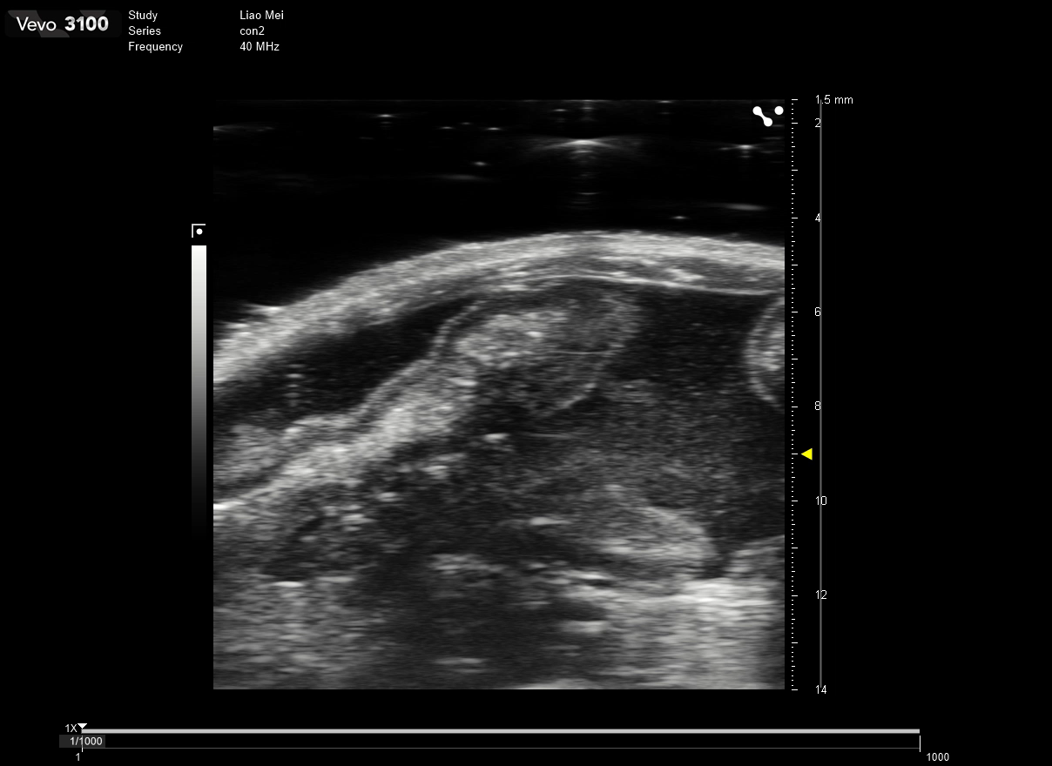
B
A

(A) Video 1A showed a smooth peritoneal surface, normal intestinal lumen, and physiological gastrointestinal motility in Saline mice.
(B) A dynamic video of EPS mice vividly illustrated the rigid nature of the “cauliflower intestine loop”, as evidenced by the immobility despite the application of probe pressure or attempts to dislodge the bowel loops, signifying strong adhesions.
Supplemental table 1. Scoring items of abdominal adhesion.
Scoring item | Scoring item
Dullness of liver margin | Stiff appearance of intestines, like "rubber tube"
Adhesions between liver and intestine | En bloc adhesions among the gastro-intestinal tracts
Adhesions among liver lobes | Contraction of mesentery
Adhesions between liver and diaphragm | Adhesions between intraperitoneal viscera and abdominal wall
Adhesions between right liver lobe and right kidney | Adhesions between omentum and intestine
Adhesions between liver and stomach | Adhesions between omentum and spleen
Adhesions between intestine and spleen | Adhesions between omentum and left kidney
Score 0: No adhesions. Score 1: Presence of 1-3 distinct adhesions. Score 2: More than three distinct adhesions. Score 3: Extensive, sheet-like adhesions.
Terms | Forward (5’-3’) | Reverse (5’-3’)
CCL2 | TAAAAACCTGGATCGGAACCAAA | GCATTAGCTTCAGATTTACGGGT
IL-1β | GCCAGTGAAATGATGGCTTATT | AGGAGCACTTCATCTGTTTAGG
IL-6 | CGGGAACGAAAGAGAAGCTCTA | GAGCAGCCCCAGGGAGAA
TNF-α | CCCAGGGACCTCTCTCTAATCA | GCTACAGGCTTGTCACTCGG
β-actin | CGCCGCCAGCTCACCATG | CACGATGGAGGGGAAGACGG
Supplemental table 2. Primers for qRT‒PCR (human)

Supplemental figure 1

Supplemental figure 1. Gross observation showed a typical abdominal cocoon in EPS group, rendering it impossible to separate the individual organs.

Supplemental figure 2
Supplemental figure 2. Immunohistochemistry showed the increased expression of VEGF in parietal peritoneum of EPS mice, indicating a more intense angiogenesis and macrophage infiltration. Scale bar, 100 μm.

Supplemental figure 3
Supplemental figure 3. Immunohistochemistry showed the increased expression of F4/80 in parietal peritoneum of EPS mice, indicating a more intense angiogenesis and macrophage infiltration. Scale bar, 100 μm.

Supplemental figure 4
Supplemental figure 4. Volcano plot showed macrophage-associated genes such as Marco and Csf3r, along with chemokine-related genes, exhibited significant upregulation in the EPS group, underscoring the inflammatory nature of the disease.

