Supplementary Information
Supplementary Table S1 Nutrient content of rice bran and common feed.
Nutrient content | Rice bran feed(g/kg) | Common feed (g/kg)
Moisture | 100 |  | 96
Crude protein | 130 |  | 188
Crude fat | 180 |  | 52.6
Crude fibre | 290 |  | 30.6
Soluble dietary fiber | 40 |  | -
Ash | 80 |  | 54.9
Inositol | 15 |  | -
Oryzanol | 2.45 |  | -

Supplementary Table S2 Histopathology scoring system for colonic sections
Feature graded | Grade | Description
inflammation | 0 | normal
 | 1 | minimal infiltration of lamina propria, focal to multifocal
 | 2 | mild infiltration of lamina propria, multifocal, mild gland separation
 | 3 | moderate to mixed infiltration, multifocal with minimal edema
 | 4 | marked mixed infiltration into submucosa and lamina propria with extensive areas of gland separation, enlarged Peyer's patches, edema
epithelium | 0 | normal
 | 1 | minimal: focal mucosal hyperplasia
 | 2 | mild: multifocal tufting of rafts of epithelial cells with increased numbers of goblet cells
 | 3 | moderate: multifocal to locally extensive epithelial attenuation or erosion with goblet cell hyperplasia
 | 4 | marked: locally extensive to subtotal erosion or ulceration
glands | 0 | normal
 | 1 | minimal: rare gland dilatation
 | 2 | mild: multifocal gland dilatation
 | 3 | moderate: multifocal gland dilatation with abscessation and occasional loss of glands
depth of lesion | 0 | none
 | 1 | mucosa
 | 2 | mucosa and submucosa
 | 3 | transmural
extent of section | 0 | none
affected | 1 | minimal: <10%
 | 2 | mild: 10-25%
 | 3 | moderate: 26-50%
 | 4 | marked: >50%

Supplementary Table S3 Primers for RT-PCR
genes | forward (5′-3′) | reverse (5′-3′)
IL-10 | GTGGAGCAGGTGAAGAGTGAT | GTCCAGCAGACTCAATACACAC
IL-1β | TGTCTTTCCCGTGGACCTTC | ATGGGAACGTCACACACCAG
IL-6 | CCCAATTTCCAATGCTCTCCT | CGCACTAGGTTTGCCGAGTA
Ocludin | GACTGGGCTGAACACTCCAA | ACATCACAGCTCACACCAGG
Claudin-1 | CCACCATTGGCATGAAGTGC | CCACTAATGTCGCCAGACCT
Claudin-5 | CAGTTAAGGCACGGGTAGCA | GGCACCGTCGGATCATAGAA
ZO-1 | GGAGATGTTTATGCGGACGG | CATTGCTGCTCTTAGCGG
MUC-2 | GGCACCTGCACCAACAATAC | TAAGCGAAAGCCCTGGTGTC
MUC-1 | TCAAGTTCAGGTCAGGCTCC | GGGAGGGAACTGCATGTCAT

Supplementary Table S4 Alpha diversity of fecal flora in mice.
Group | Shannon | Simpson | ACE | Chao | Coverage (%)
CN | 3.41±0.09ª | 0.07±0.01ª | 290.10±9.7ª | 292.47±15.31ª | 99.84±0.01ª
DSS | 2.88±0.21^{b} | 0.13±0.03^{b} | 289.12±21.65ª | 251.04±9.13ª | 99.84±0.02ª
SU+DSS | 2.94±0.10^{b} | 0.12±0.01^{b} | 287.89±5.10ª | 270.36±18.50ª | 99.86±0.02ª
RB+DSS | 3.20±0.14^{ab} | 0.09±0.01^{ab} | 276.79±13.14ª | 273.43±15.48ª | 99.86±0.01ª

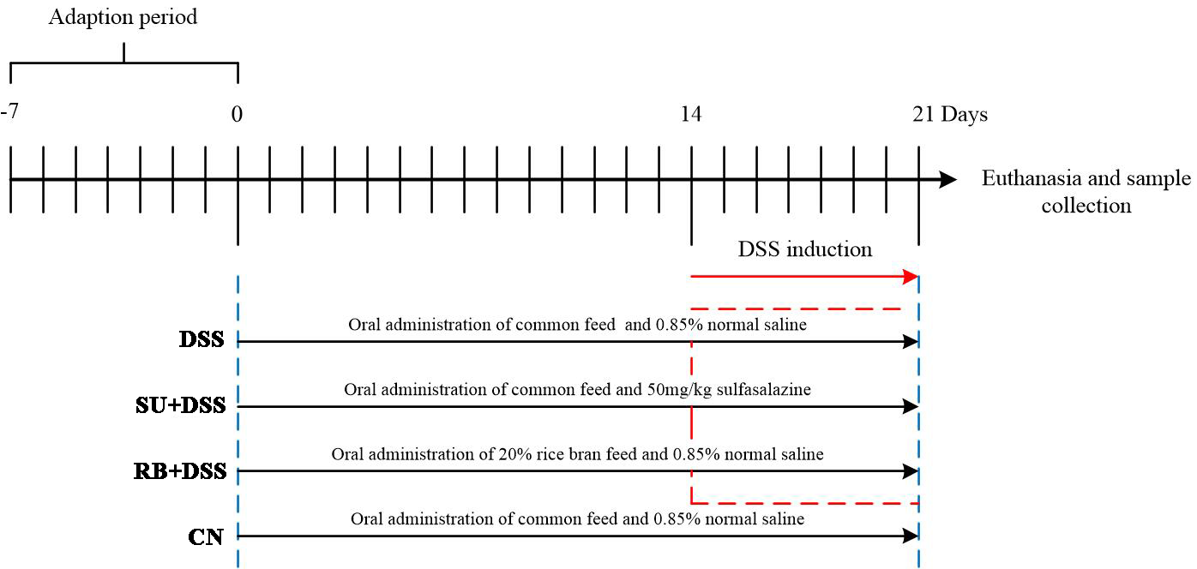
Supplementary Fig. S1 The animal experimental procedure.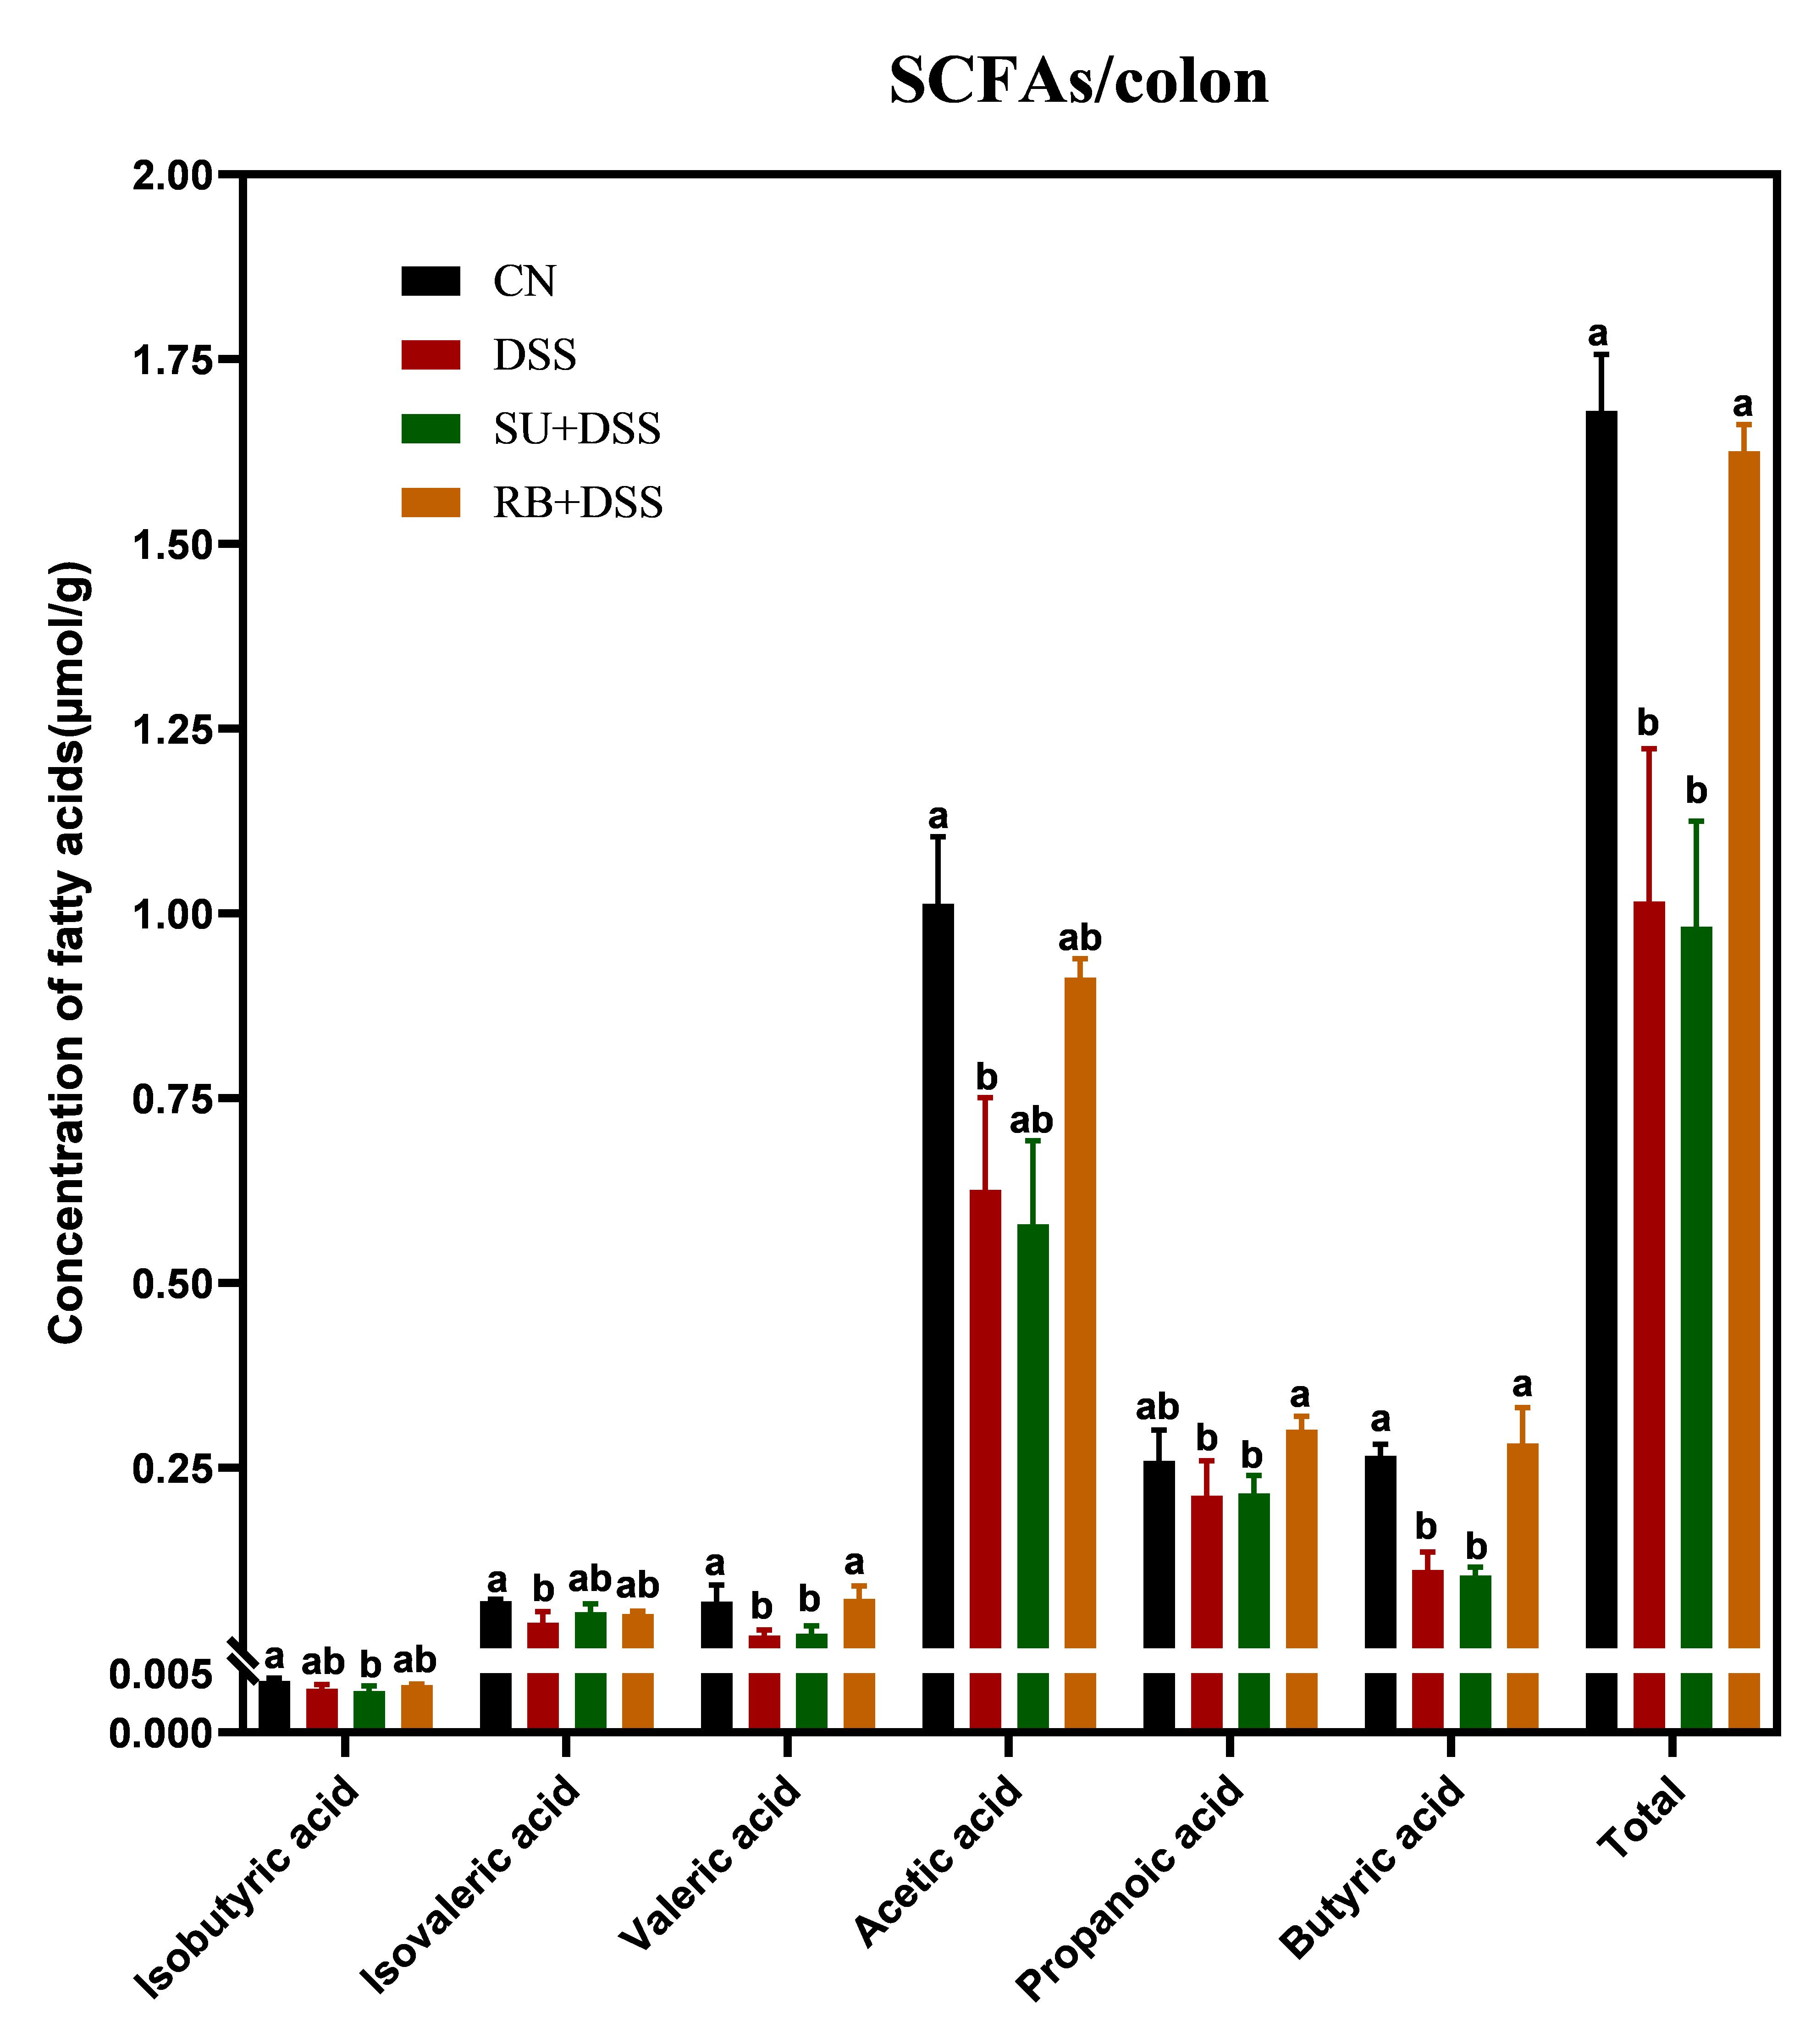
Supplementary Fig. S2 SCFAs

