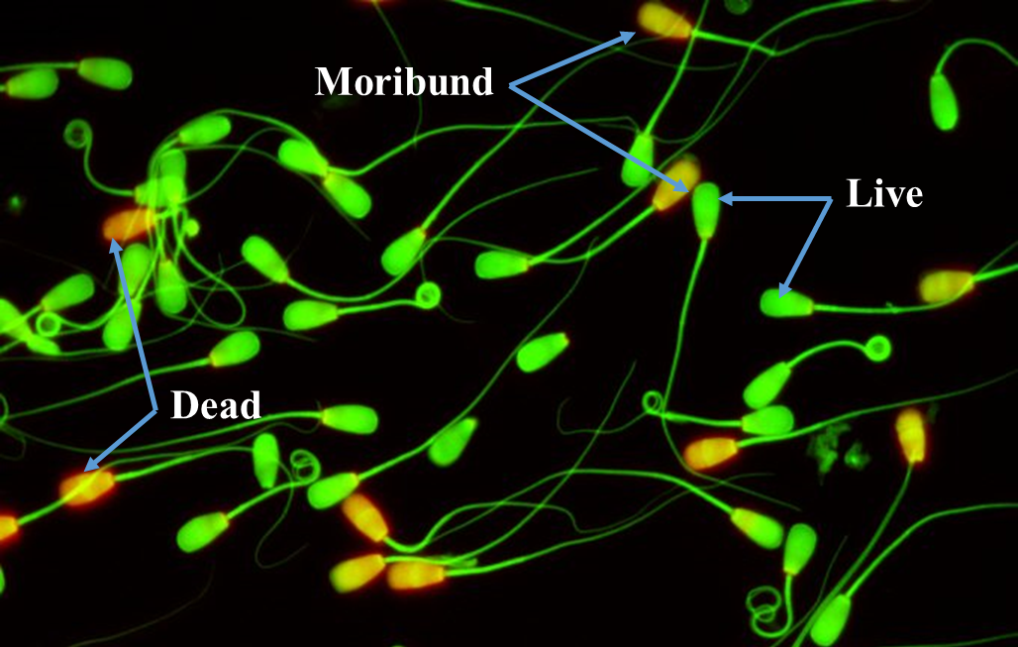
Supplm. Fig. 1. Post-thaw sperm membrane integrity (CFDA-PI)

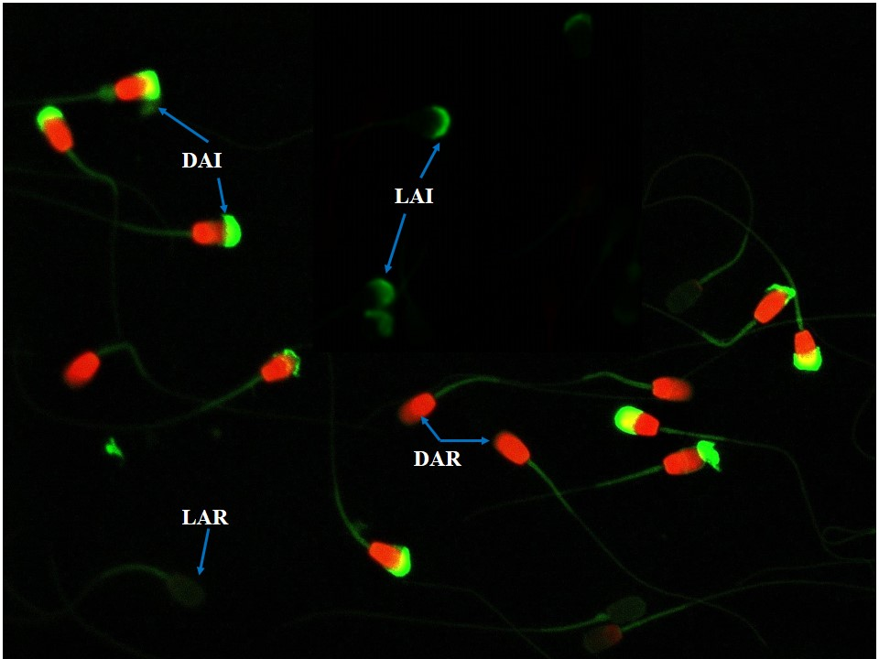
Supplm. Fig. 2. Post-thaw acrosome integrity (FITC-PNA and PI) showing (a) LAI (live acrosome intact), (b) LAR (live acrosome reacted), (c) DAI (dead acrosome intact) and (d) DAR (dead acrosome reacted)

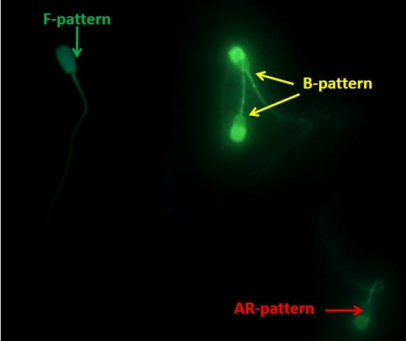
Supplm. Fig. 3. Post-thaw sperm capacitation (CTC assays) showing (a) Green arrow: F-pattern, (b) Yellow arrow: B-pattern and (c) Red arrow: AR -pattern

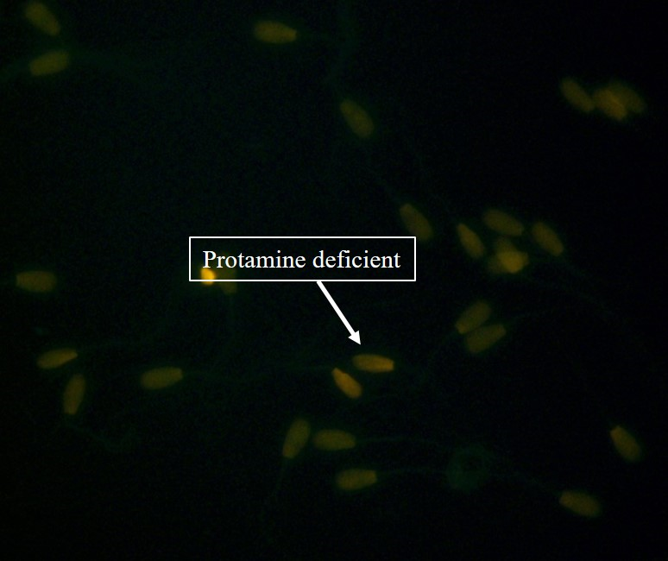
Supplm. Fig. 4. Post-thaw sperm protamine deficiency (CMA₃ assay)

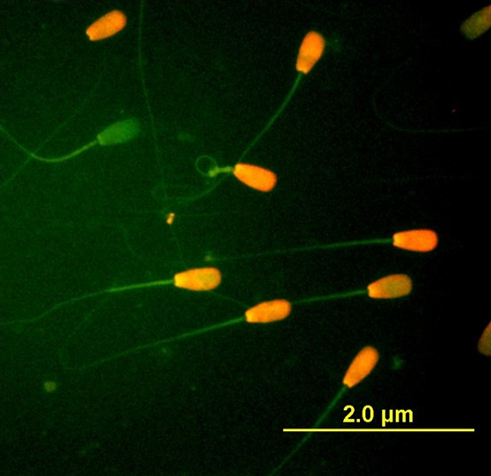

Supplm. Fig. 5. Post-thaw sperm apoptosis (Annexin-V assay)

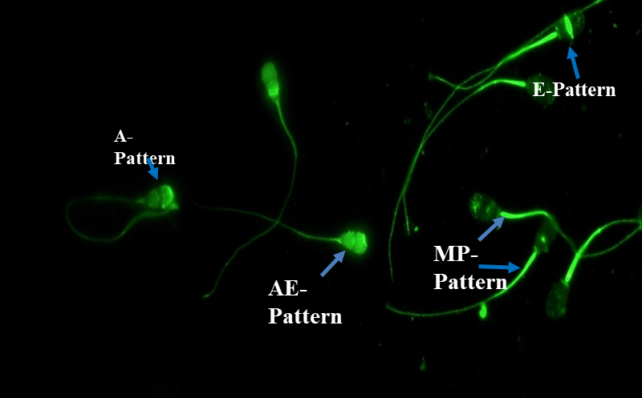
Supplm. Fig. 6. Post-thaw protein tyrosine phosphorylation (PTP) showing (a) A-Pattern (Acrosome pattern), (b) AE -Pattern (Acrosome and equatorial pattern), (c) E (Equatorial pattern) and (d) MP-Pattern (Mid piece pattern)

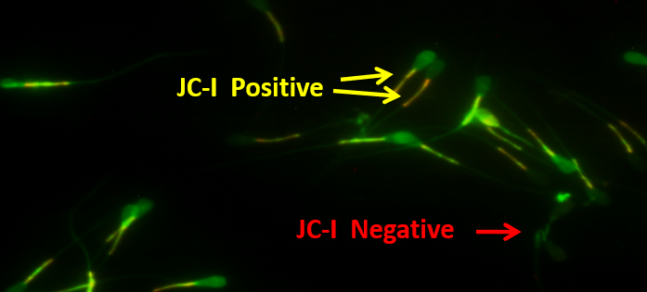
Supplm. Fig. 7. Post-thaw sperm mitochondrial membrane potential (JC-1)

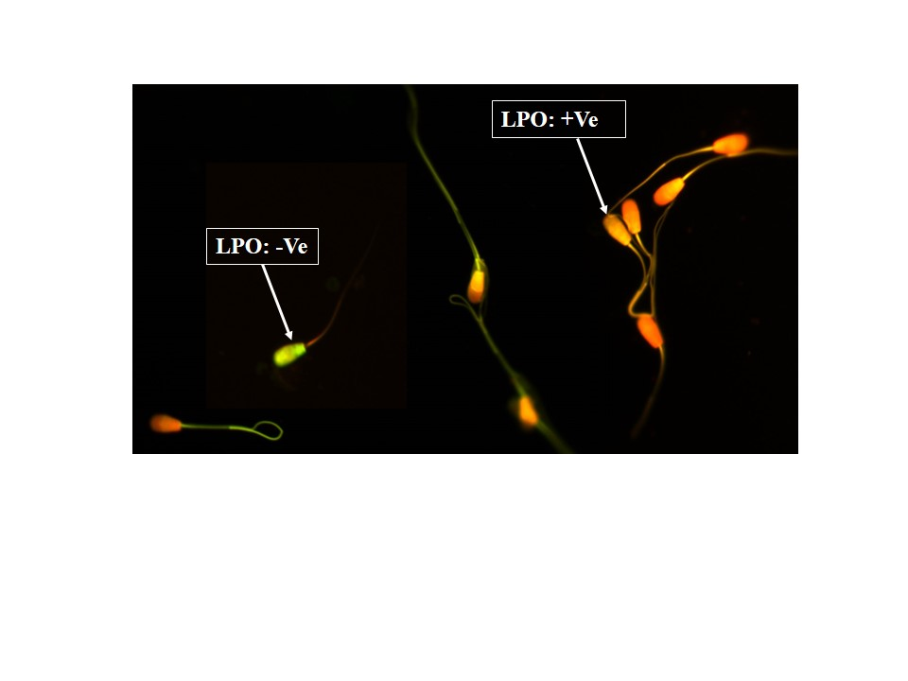
Supplm. Fig. 8. Post-thaw sperm lipid peroxidation (C¹¹BODIPY)

