SUPPLEMENTARY MATERIALS
Elevated salinity and water table drawdown significantly affect greenhouse gas emissions in soils from contrasting land-use practices in the prairie pothole region
Shayeb Shahariar¹*, Richard Farrell¹, Raju Soolanayakanahally², Angela Bedard-Haughn¹
- Department of Soil Science, College of Agriculture and Bioresources, University of Saskatchewan, 51 Campus Drive, Saskatoon SK S7N 5A8 Canada
- Indian Head Research Farm, Agriculture and Agri-Food Canada, Indian Head SK S0G 2K0 Canada
Corresponding Author Name and Address:
Shayeb Shahariar, Department of Soil Science, College of Agriculture and Bioresources, University of Saskatchewan, 51 Campus Drive, Saskatoon SK S7N 5A8 Canada
E-mail: shayeb.shahariar@usask.ca; Phone: +1 306 966 4299
Funding information:
Natural Sciences and Engineering Research Council of Canada (NSERC)
Agriculture and Agri-Food Canada (AAFC)

Supplementary Table 1 Physicochemical characteristics of soil used for microcosm experiment.
Site | Land-use  practice | pH | EC  (mS cm⁻¹) | Soil  texture | Clay  (%) | Bulk  density  (g cm⁻³) | CEC  (cmol_{c} kg⁻¹) | TSC  (%) | SOC  (%) | WEOC  (mg C kg⁻¹) | TN  (%) | NH₄⁺-N  (mg kg⁻¹) | NO₃⁻-N  (mg kg⁻¹) | WEON  (mg N kg⁻¹) | C/N  ratio | PO₄³⁻-P  (mg kg⁻¹) | SO₄²⁻-S  (mg kg⁻¹)
Site A | AC | 8.4 | 1.4 | CL | 33.0 | 1.4 | 36.7 | 4.1 | 2.2 | 3.5 | 0.2 | 4.3 | 25.1 | 8.1 | 11.3 | 24.9 | 82.1
Site A | PA | 7.8 | 0.6 | CL | 34.0 | 1.3 | 43.9 | 3.4 | 2.9 | 5.2 | 0.3 | 6.7 | 7.0 | 3.7 | 11.6 | 28.5 | 98.2
Site A | SRW | 8.0 | 1.9 | SCL | 27.0 | 1.3 | 37.4 | 3.7 | 2.2 | 5.2 | 0.2 | 6.0 | 12.5 | 5.1 | 10.8 | 21.3 | 641.5
Site B | AC | 7.8 | 1.0 | CL | 33.0 | 1.3 | 48.7 | 3.1 | 2.5 | 5.9 | 0.2 | 6.0 | 17.0 | 4.5 | 9.8 | 30.0 | 2353.2
Site B | PA | 8.0 | 2.6 | CL | 32.0 | 1.2 | 42.5 | 4.9 | 2.7 | 4.6 | 0.3 | 5.2 | 33.4 | 8.1 | 10.8 | 31.2 | 274.4
Site B | SRW | 7.8 | 2.8 | CL | 30.0 | 1.4 | 45.9 | 2.8 | 2.4 | 6.2 | 0.3 | 6.3 | 13.9 | 4.3 | 9.4 | 37.8 | 3496.2
† AC = annual crop, PA = pasture, SRW = short rotation willow, EC = electrical conductivity, CL = clay loam, SCL = sandy clay loam, CEC = cation exchange capacity, TSC = total soil carbon, SOC = soil organic carbon, WEOC = water-extractable organic carbon, TN = total nitrogen, WEON = water-extractable organic nitrogen, C/N ratio = carbon and nitrogen ratio.

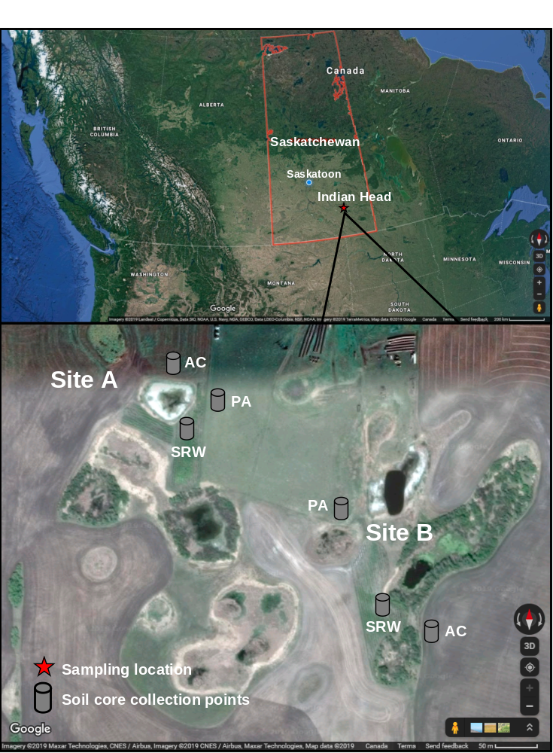
Supplementary Figure 1 Location map of study sites at Indian Head, SK from where intact soil cores collected. (Source: Google Imagery ©2019)
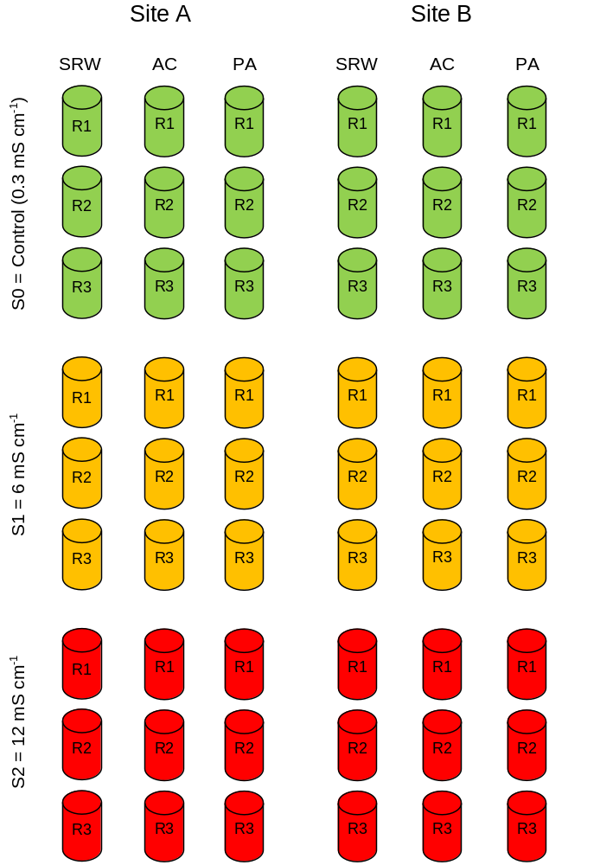
Supplementary Figure 2 Experimental layout for microcosm incubation experiment in the greenhouse using intact soil cores (Note: diagram is not to scale).
† AC = annual crop, PA = pasture, SRW = short rotation willow, R = replication.
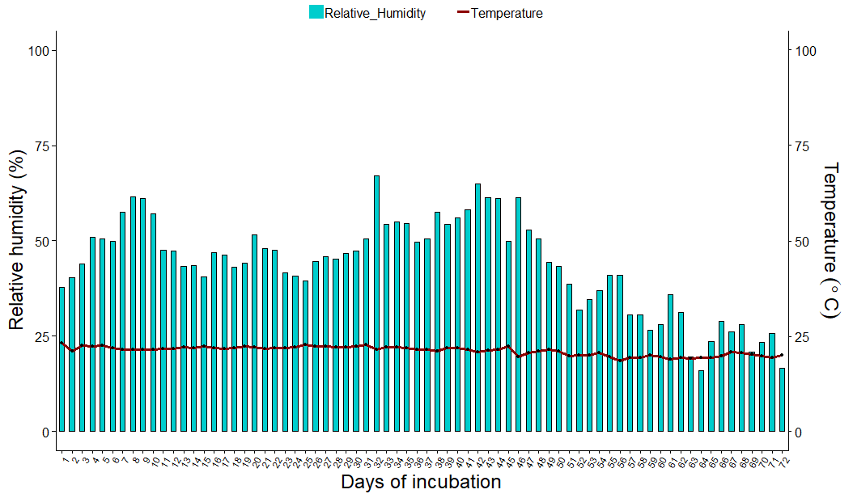
Supplementary Figure 3 Temperature and relative humidity of the greenhouse chamber used for microcosm incubation study.
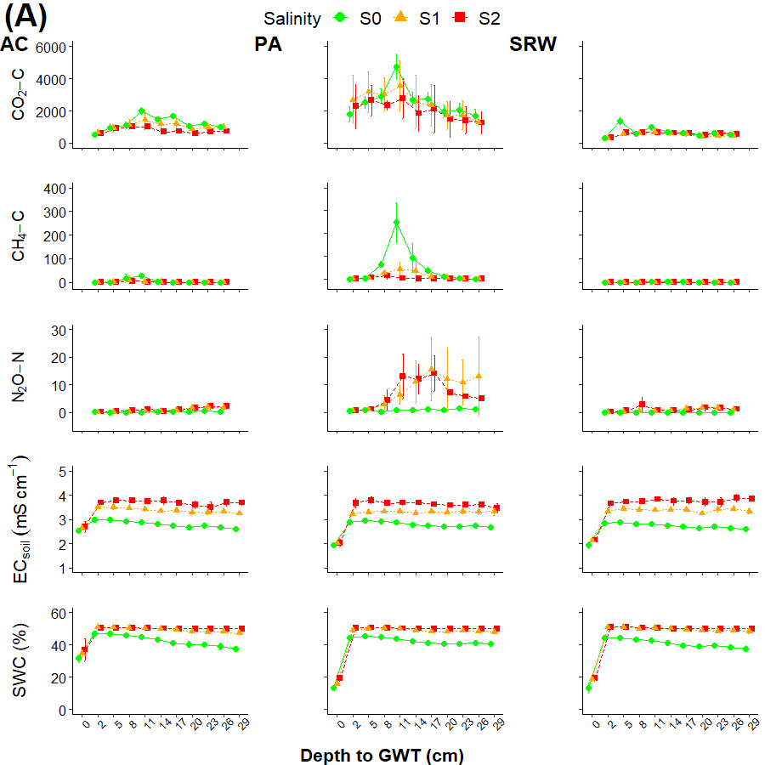
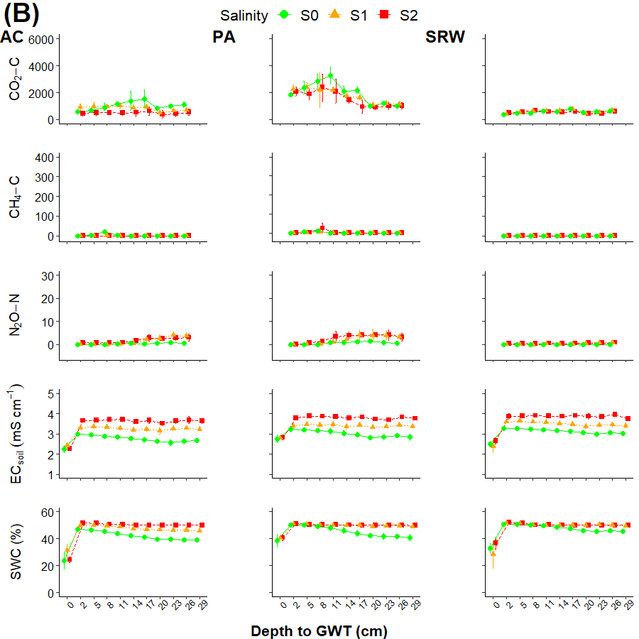`
Supplementary Figure 4 Time series (mean ± SD) of GHG emissions (mg m⁻² d⁻¹), soil EC, and VSWC measured weekly with their equivalent depth to groundwater table and salinity treatments from core soils collected from different land-use practices from A) site A, and B) site B.
† Error bar stands for standard deviations (± SD).
†† GHG = greenhouse gas, AC = annual crop, PA = pasture, SRW = short rotation willow, EC = electrical conductivity, VSWC = volumetric soil water content, GWT = groundwater table, S0 = control, S1 = 6 mS cm⁻¹, S2 = 12 mS cm⁻¹
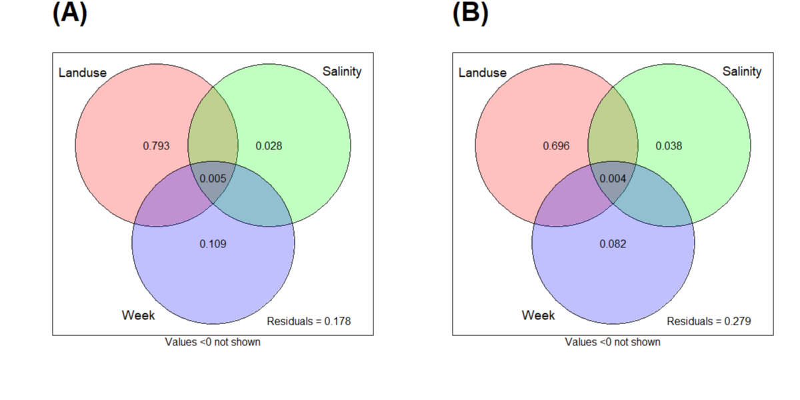
Supplementary Figure 5 Venn’s diagram showing variation partitioning analysis (VPA) illustrates the contribution of land-use practices, salinity, and groundwater table depth to variation in GHG from A) site A, and B) site B.

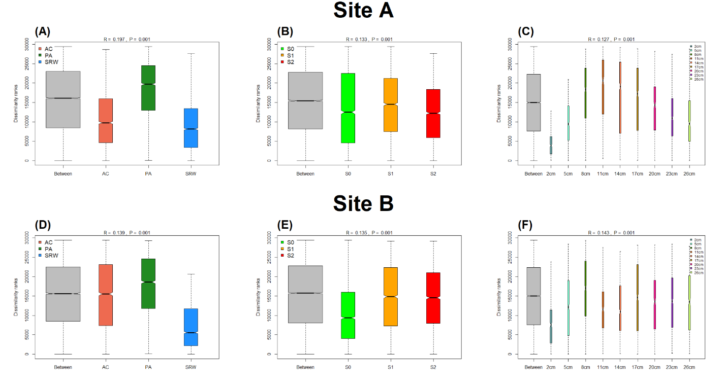
Supplementary Figure 6 Analysis of similarities (ANOSIM) with dissimilarity ranks between and within soil GHG (CO₂, CH₄, N₂O) measured weekly with their equivalent groundwater table depths during the incubation period in the core soils collected from three different land-use practices, under groundwater salinity treatments and from two sites.
† R-value (i.e., the strength of the factors on the samples) varies between 0 and 1 (a value close to 1 indicates the high separation between levels of a factor, while R-value close to 0 indicates no separation between levels of a factor).

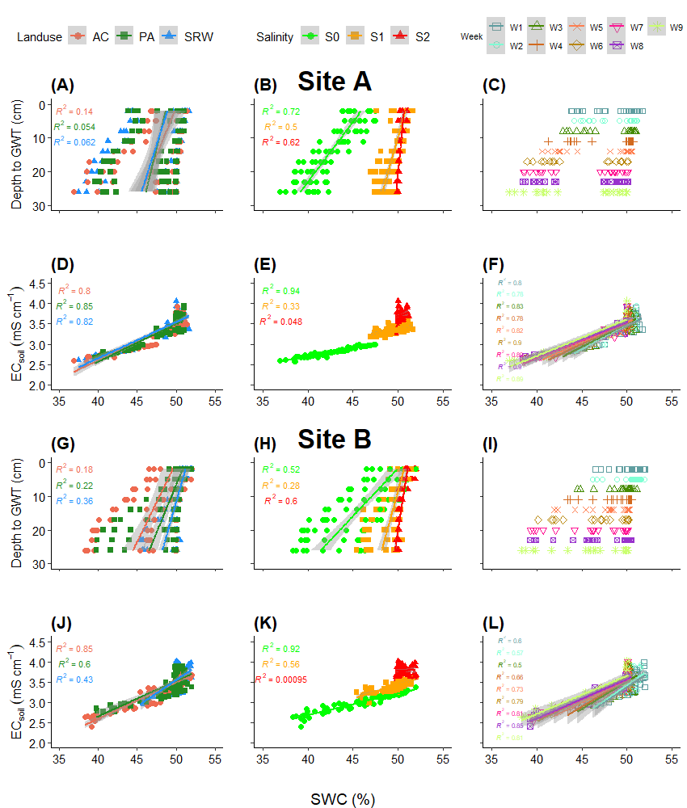
Supplementary Figure 7 Relationship between declining groundwater table depths (GWT), volumetric soil water content (VSWC), and soil electrical conductivity (EC) in soil cores from three land-use practices, salinity, and groundwater table depths treatments two sites.
† The line shows linear regression of the change in VSWC and soil EC measured during the experiment against groundwater and salinity treatments; shaded area shows 95% of the confidence interval, R² gives values for individual regression lines, and p-values indicates the level of significance.
†† p-values ≤ 0.05 indicates a significant difference, whereas p-values > 0.05 are not significantly different.
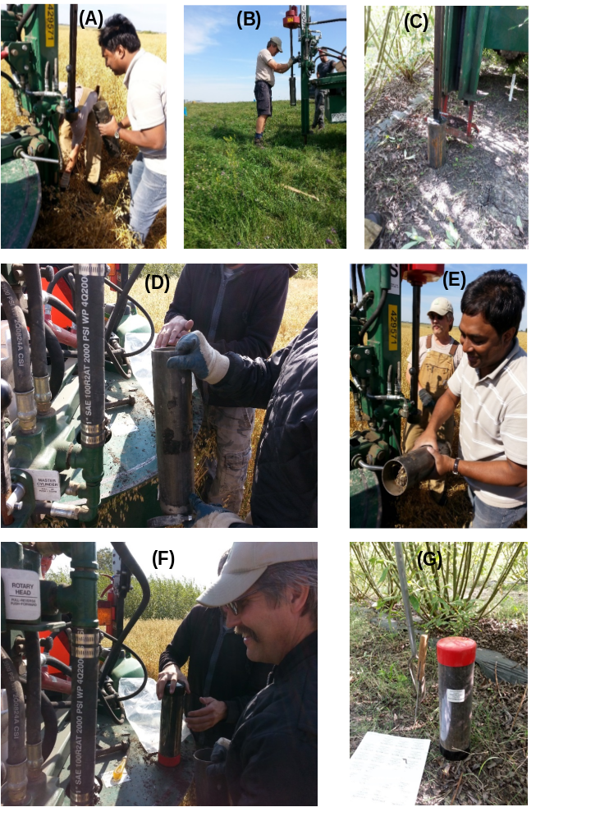
Supplementary Figure 8 Photographs of intact soil core samples collected from the experimental field: A) from the annual crop, B) from pasture, C) from short rotation willow, D) empty soil corer ready to mount with punch truck, E) soil corer unmounted from the punch truck after soil samples collection, F) soil core samples capped both sides and ready to transfer into the greenhouse, and G) an individual intact soil core sample.
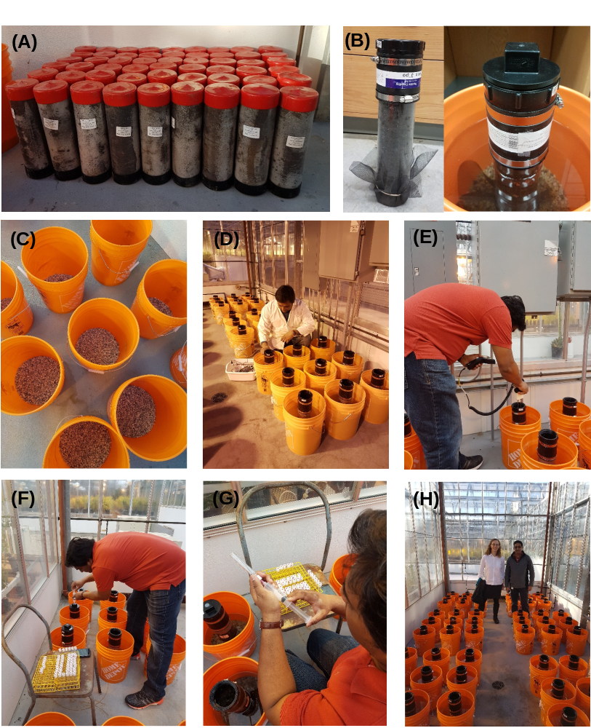
Supplementary Figure 9 Photographs of some activities from the microcosm incubation experiment: A) intact soil cores collected from the field, B) an individual experimental unit with and without the headspace, C) bucket filled with gravels, D) groundwater salinity measurements, E) volumetric soil water content and soil electrical conductivity measurements in the cores, F) gas samples collected from the headspaces, G) transfer of gas samples into the vials, and H) arrangement of the incubation experiment in the greenhouse.

