Supplementary figures and tables
Variation of HLA-DPB1 gene in hepatitis B infection infection
Running title: HLA-DPB1 gene variation and HBV infection
Guojin Ou^{1,2}, Xiao Liu³, Haixia Xu^{4,5}, Xin Ji^{4,5}, Xiaojuan Liu^{1,2}*, Jue Wang^{4,5}*
1. Department of laboratory medicine, West China second university hospital, Chengdu, Sichuan, China.
2. Key laboratory of birth defects and related diseases of women and children (Sichuan University), Ministry of Education.
3. Deyang people’s hospital, Deyang, Sichuan, China.
4. Clinical blood transfusion research center, Institute of Blood Transfusion, CAMS & PUMC, Chengdu, Sichuan, China.
5. Key laboratory of transfusion adverse reactions, CAMS & PUMC, Chengdu, Sichuan, China.
*Correspondence
Xiaojuan Liu
Department of laboratory medicine, West China second university hospital, Chengdu, Sichuan, China. And Key laboratory of birth defects and related diseases of women and children (Sichuan University), Ministry of Education Chengdu, Sichuan, China.
Address: No. 20, Section 3, Ren Min Nan Lu, Chengdu, Sichuan 610041, China Email: Liuxiaojuantg@163.com
Jue Wang
Clinical Blood Transfusion Research Center, Institute of Blood Transfusion, CAMS & PUMC, Chengdu, Sichuan China. And Key laboratory of transfusion adverse reactions, CAMS & PUMC, Chengdu, Sichuan, China.
Address: No. 26 Hua-Cai Road, Chenghua District, Chengdu, Sichuan Provence, 610052, China. E-mail: wjue007@qq.com

Table 1 The characteristic of the participates
 | Age (years) | Male | ALT(IU/L) | AST(IU/L) | ALB(g/dl) | TB(mg/dl)
HBV carriers(N=259) | 52.2±8 | 144(55.6%) | 23.4±4.3 | 23.1±2.8 | 4.3±1.0 | 1.4±0.6
HC group(N=442) | 55.4±13 | 258(58.4%) | 22.5±3.3 | 23.9±4.4 | 3.6±0.9 | 1.2±0.7

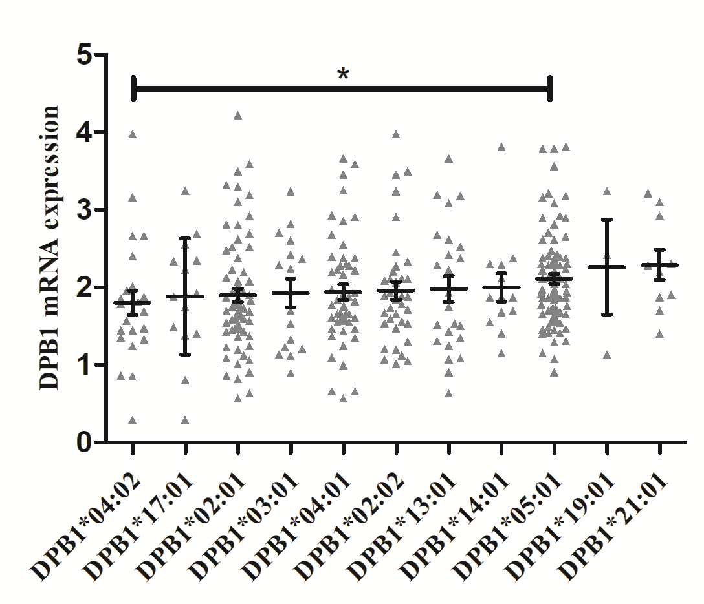
Figure 1 The mRNA expression of different HLA-DPB1alleles in healthy control group.

Table 2 Distribution of the HLA-DPB1 polymorphism in HBV susceptible
First author (year) | HLA-DPB1 alleles |  |  |  |  |  |  |  |  |  | Refs
First author (year) | 201 | 202 | 301 | 401 | 402 | 501 | 901 | 1301 | 1401 | 1701
Donaldson PT(2001) |  |  |  |  |  |  |  |  |  |  | [1]
Case, n | 36 | 20 | 14 | 7 | - | 77 | - | 24 | - | -
Control, n | 17 | 17 | 8 | 5 | - | 98 | - | 20 | - | -
Kamatani Y(2009) |  |  |  |  |  |  |  |  |  |  | [2]
Case, n | 237 | 35 | 56 | 30 | 55 | 574 | 153 | 26 | 17 | 3
Control, n | 407 | 76 | 61 | 86 | 172 | 694 | 221 | 31 | 25 | 2
Nishida N (2014) |  |  |  |  |  |  |  |  |  |  | [3]
Case, n | 182 | 30 | 48 | 20 | 38 | 456 | 153 | 19 | 15
Control, n | 227 | 37 | 40 | 54 | 92 | 358 | 81 | 12 | 12
Nishida N (2014) |  |  |  |  |  |  |  |  |  |  | [3]
Case, n | 96 | 20 | 10 | 20 | 14 | 270 | 20 | 37 | 6 | 7
Control, n | 67 | 18 | 11 | 11 | 36 | 103 | 5 | 21 | 1 | 5
Nishida N (2014) |  |  |  |  |  |  |  |  |  |  | [3]
Case, n | 50 | 37 | 22 | 22 | - | 309 | 56 | 12 | 7 | 8
Control, n | 52 | 30 | 12 | 15 | - | 150 | 23 | 5 | 5 | 4
Nishida N (2014) |  |  |  |  |  |  |  |  |  |  | [3]
Case, n | 62 | 46 | 39 | 48 | 13 | 266 | 8 | 162 | 26 | 7
Control,n | 26 | 12 | 16 | 29 | 6 | 78 | 4 | 28 | 6 | 4
Nishida N (2015) |  |  |  |  |  |  |  |  |  |  | [4]
Case, n | 504 | 76 | 123 | 61 | 126 | 1276 | 391 | 61 | 48 | 8
Control,n | 595 | 88 | 108 | 137 | 221 | 941 | 239 | 39 | 42 | 0
Nishida N (2016) |  |  |  |  |  |  |  |  |  |  | [5]
Case, n | 302 | 47 | 84 | 36 | 90 | 741 | 262 | 27 | 12 | 0
Control, n | 1111 | 155 | 197 | 246 | 425 | 1756 | 454 | 81 | 60 | 3
Zhu M (2016) |  |  |  |  |  |  |  |  |  |  | [6]
Case, n | 310 | 103 | 73 | 100 | 59 | 926 | 41 | 94 | 37 | 79
Control, n | 415 | 111 | 88 | 137 | 78 | 802 | 20 | 74 | 35 | 65

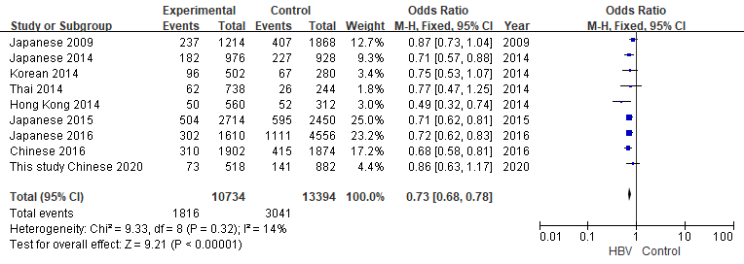
Figure 2 Meta-analysis of correlation of the HLA- DPB1*02:01 allele polymorphism in HBV susceptibility
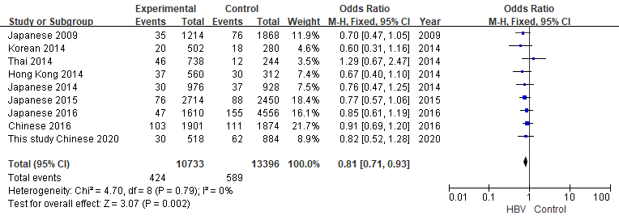
Figure 3 Meta-analysis of correlation of the HLA- DPB1*02:02 allele polymorphism in HBV susceptibility
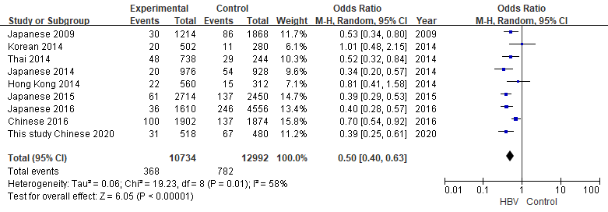
Figure 4 Meta-analysis of correlation of the HLA- DPB1*04:01 allele polymorphism in HBV susceptibility
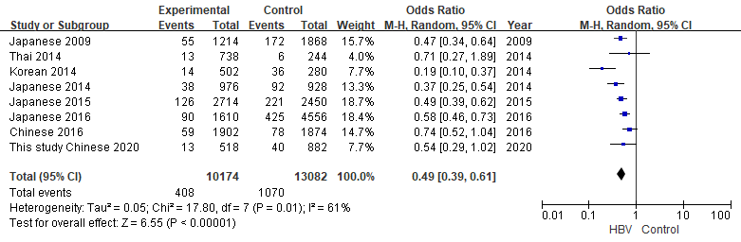
Figure 5 Meta-analysis of correlation of the HLA- DPB1*04:02 allele polymorphism in HBV susceptibility
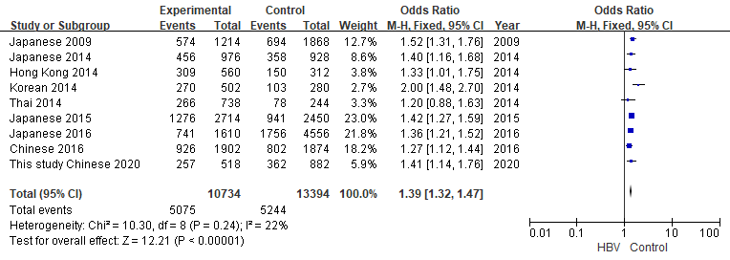
Figure 6 Meta-analysis of correlation of the HLA- DPB1*05:01 allele polymorphism in HBV susceptibility
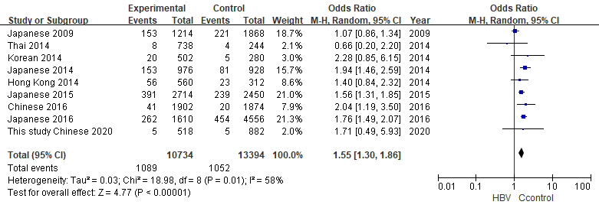

Figure 7 Meta-analysis of correlation of the HLA- DPB1*09:01 allele polymorphism in HBV susceptibility

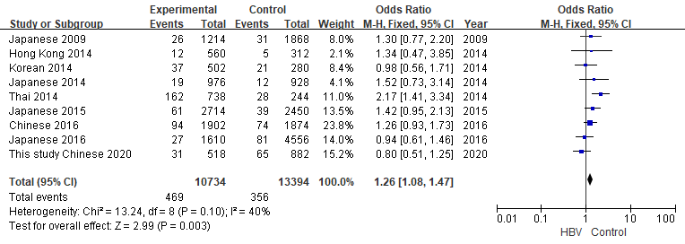
Figure 8 Meta-analysis of correlation of the HLA- DPB1*13:01 allele polymorphism in HBV susceptibility
Table 3 Distribution of the HLA-DPB1 polymorphism in HBV spontaneous clearance
First author (year) | HLA-DPB1 alleles |  |  |  |  |  |  |  |  |  | Refs
First author (year) | 201 | 202 | 301 | 401 | 402 | 501 | 901 | 1301 | 1401 | 1701
Koreans (2008) |  |  |  |  |  |  |  |  |  |  | [7]
Case, n | 32 | 7 | 6 | 9 | 11 | 51 | 10 | 5 | 2 | 4
Control, n | 144 | 26 | 27 | 36 | 40 | 264 | 26 | 50 | 17 | 17
Americans (2012) |  |  |  |  |  |  |  |  |  |  | [8]
Case, n |  |  |  | 249
Control, n |  |  |  | 117
Japanese (2014) |  |  |  |  |  |  |  |  |  |  | [3]
Case, n | 254 | 44 | 51 | 50 | 109 | 464 | 119 | 20 | 11 | -
Control, n | 182 | 30 | 48 | 20 | 38 | 456 | 153 | 15 | 15 | -
Korean (2014) |  |  |  |  |  |  |  |  |  |  | [3]
Case, n | 59 | 6 | 11 | 20 | 24 | 62 | 6 | 13 | 1 | 6
Control, n | 96 | 20 | 10 | 20 | 14 | 270 | 20 | 37 | 6 | 7
Hong Kong (2014) |  |  |  |  |  |  |  |  |  |  | [3]
Case, n | 22 | 20 | 5 | 16 | 3 | 72 | 3 | 6 | 2 | 4
Control, n | 50 | 37 | 22 | 22 | 3 | 309 | 4 | 56 | 12 | 7
Thai (2014) |  |  |  |  |  |  |  |  |  |  | [3]
Case, n | 30 | 13 | 19 | 25 | 6 | 64 | 2 | 30 | 5 | 3
Control, n | 62 | 46 | 39 | 48 | 13 | 266 | 8 | 162 | 26 | 7
Turkey (2017) |  |  |  |  |  |  |  |  |  |  | [9]
Case, n | 33 | - | 5 | 11 | 13 | 2 | - | 5 | 7 | 7
Control, n | 21 | - | 3 | 18 | 25 | - | - | 7 | 6 | 10

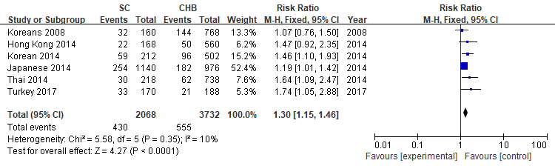
Figure 9 Meta-analysis of correlation of the HLA-DPB1*02:01 allele polymorphism in HBV spontaneous clearance
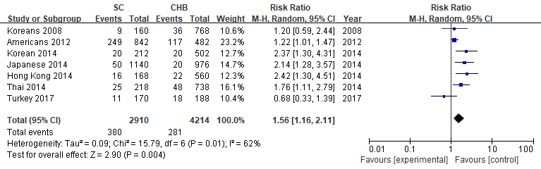
Figure 10 Meta-analysis of correlation of the HLA-DPB1*04:01 allele polymorphism in HBV spontaneous clearance
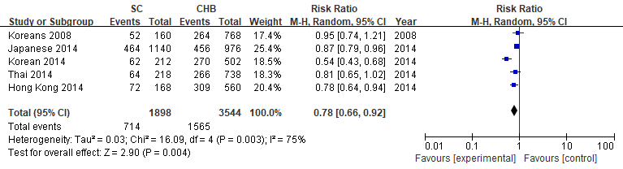
Figure 11 Meta-analysis of correlation of the HLA-DPB1*05:01 allele polymorphism in HBV spontaneous clearance
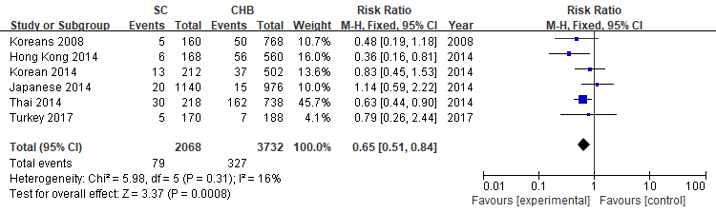
Figure 12 Meta-analysis of correlation of the HLA-DPB1*13:01 allele polymorphism in HBV spontaneous clearance

1. Donaldson PT, Ho S, Williams R, Johnson PJ: HLA class II alleles in Chinese patients with hepatocellular carcinoma. Liver 2001, 21:143-148.
2. Kamatani Y, Wattanapokayakit S, Ochi H, Kawaguchi T, Takahashi A, Hosono N, Kubo M, Tsunoda T, Kamatani N, Kumada H, et al: A genome-wide association study identifies variants in the HLA-DP locus associated with chronic hepatitis B in Asians. Nat Genet 2009, 41:591-595.
3. Nishida N, Sawai H, Kashiwase K, Minami M, Sugiyama M, Seto WK, Yuen MF, Posuwan N, Poovorawan Y, Ahn SH, et al: New susceptibility and resistance HLA-DP alleles to HBV-related diseases identified by a trans-ethnic association study in Asia. PLoS One 2014, 9:e86449.
4. Nishida N, Ohashi J, Sugiyama M, Tsuchiura T, Yamamoto K, Hino K, Honda M, Kaneko S, Yatsuhashi H, Koike K, et al: Effects of HLA-DPB1 genotypes on chronic hepatitis B infection in Japanese individuals. Tissue Antigens 2015, 86:406-412.
5. Nishida N, Ohashi J, Khor SS, Sugiyama M, Tsuchiura T, Sawai H, Hino K, Honda M, Kaneko S, Yatsuhashi H, et al: Understanding of HLA-conferred susceptibility to chronic hepatitis B infection requires HLA genotyping-based association analysis. Sci Rep 2016, 6:24767.
6. Zhu M, Dai J, Wang C, Wang Y, Qin N, Ma H, Song C, Zhai X, Yang Y, Liu J, et al: Fine mapping the MHC region identified four independent variants modifying susceptibility to chronic hepatitis B in Han Chinese. Hum Mol Genet 2016, 25:1225-1232.
7. Cho SW, Cheong JY, Ju YS, Oh DH, Suh YJ, Lee KW: Human leukocyte antigen class II association with spontaneous recovery from hepatitis B virus infection in Koreans: analysis at the haplotype level. J Korean Med Sci 2008, 23:838-844.
8. Thomas R, Thio CL, Apps R, Qi Y, Gao X, Marti D, Stein JL, Soderberg KA, Moody MA, Goedert JJ, et al: A novel variant marking HLA-DP expression levels predicts recovery from hepatitis B virus infection. J Virol 2012, 86:6979-6985.
9. Katrinli S, Nilay Karatas Erkut G, Ozdil K, Yilmaz Enc F, Ozturk O, Kahraman R, Tuncer I, Dinler Doganay G, Doganay L: HLA DPB1 15:01 Allele Predicts Spontaneus Hepatitis B Surface Antigen Seroconversion. Acta Gastroenterol Belg 2017, 80:351-355.

