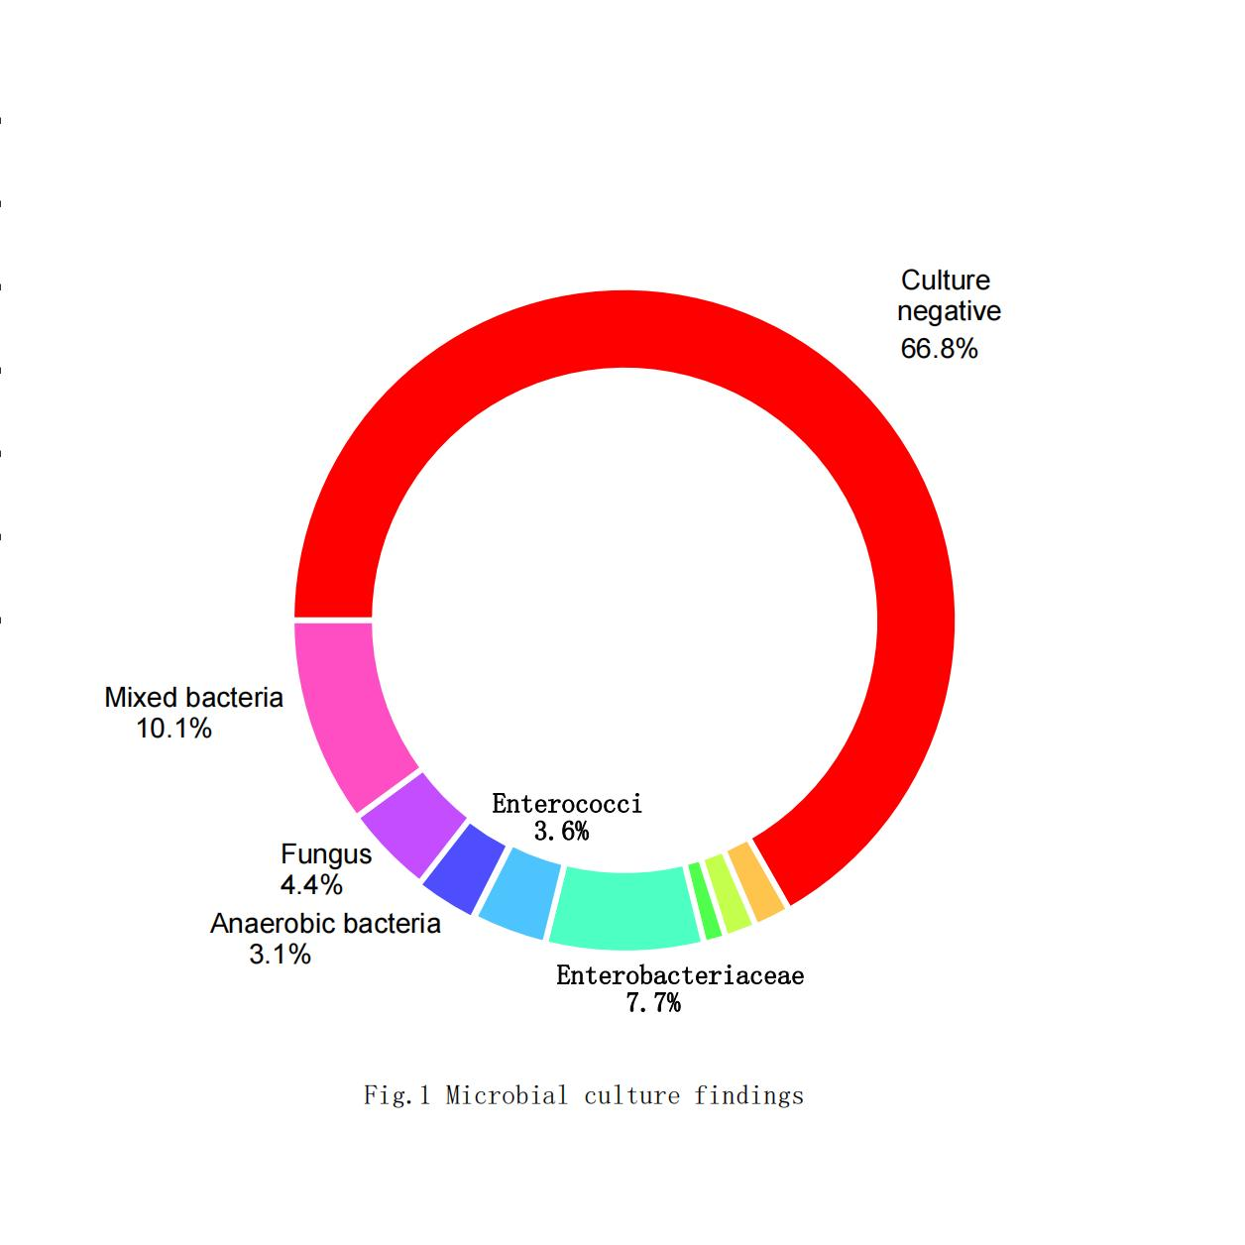
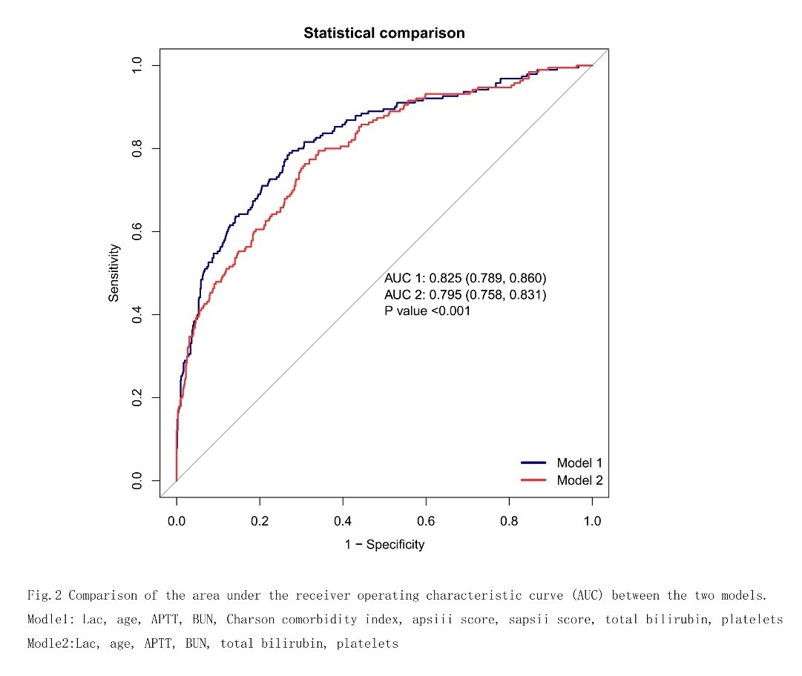

Table 1.Baseline characteristics of participants.
Patient characteristic | Before multiple imputation |  |  | After multiple imputation
Patient characteristic | Survival group  (n = 1036) | Death group  (n = 264) | p | Survival group  (n = 1036) | Death group  (n = 264) | p
Male sex,n (%) | 582 (56.2) | 132 (50) |  | 582 (56.2) | 132 (50)
age, (years) | 64.0 ± 16.3 | 69.7 ± 14.7 | < 0.001 | 64.0 ± 16.3 | 69.7 ± 14.7 | < 0.001
ICU stay, （days） | 7.4 ± 9.4 | 9.5 ± 11.9 | 0.002 | 7.4 ± 9.4 | 9.5 ± 11.9 | 0.002
hospital stay,（days） | 15.7 (9.0, 26.1) | 11.9 (4.1, 22.4) | < 0.001 | 15.7 (9.0, 26.1) | 11.9 (4.1, 22.4) | < 0.001
race, n (%) |  |  | 0.019 |  |  | 0.019
BLACK | 79 (7.6) | 15 (5.7) |  | 79 (7.6) | 15 (5.7)
WHITE | 736 (71) | 170 (64.4) |  | 736 (71) | 170 (64.4)
ASIAN | 30 (2.9) | 8 (3) |  | 30 (2.9) | 8 (3)
OTHER | 191 (18.4) | 71 (26.9) |  | 191 (18.4) | 71 (26.9)
Heart rate, (bpm) | 94.4 ± 17.4 | 97.0 ± 17.8 | 0.031 | 94.4 ± 17.4 | 96.9 ± 17.8 | 0.035
MAP (mmHg) | 77.5 ± 11.1 | 73.2 ± 10.5 | < 0.001 | 77.5 ± 11.1 | 73.2 ± 10.5 | < 0.001
Respiratory rate, (bpm) | 20.1 ± 4.2 | 21.9 ± 4.4 | < 0.001 | 20.1 ± 4.2 | 21.9 ± 4.4 | < 0.001
Temperature, （℃） | 37.7 ± 0.8 | 37.5 ± 0.9 | < 0.001 | 37.7 ± 0.8 | 37.4 ± 0.9 | < 0.001
Hemoglobin (g/L) | 9.8 ± 2.1 | 9.3 ± 2.2 | < 0.001 | 9.8 ± 2.1 | 9.3 ± 2.2 | < 0.001
ALB (g/l) | 2.8 ± 0.7 | 2.6 ± 0.8 | 0.006 | 2.8 ± 0.7 | 2.6 ± 0.7 | < 0.001
calcium,(mg/dl) | 7.6 ± 0.8 | 7.5 ± 1.2 | 0.058 | 7.6 ± 0.8 | 7.5 ± 1.2 | 0.045
sodium,(mmol/L) | 139.5 ± 4.9 | 140.0 ± 6.0 | 0.197 | 139.5 ± 4.9 | 140.0 ± 6.0 | 0.192
potassium, (mmol/L) | 4.5 ± 0.8 | 4.9 ± 1.0 | < 0.001 | 4.5 ± 0.8 | 4.9 ± 1.0 | < 0.001
Comorbidity, n (%)
myocardial infarct, n (%) | 93 (9) | 39 (14.8) | 0.005 | 93 (9) | 39 (14.8) | 0.005
congestive heart failure, n (%) | 183 (17.7) | 57 (21.6) | 0.142 | 183 (17.7) | 57 (21.6) | 0.142
peripheral vascular disease, n (%) | 98 (9.5) | 45 (17) | < 0.001 | 98 (9.5) | 45 (17) | < 0.001
cerebrovascular disease, n (%) | 58 (5.6) | 17 (6.4) | 0.601 | 58 (5.6) | 17 (6.4) | 0.601
chronic pulmonary disease, n (%) | 230 (22.2) | 66 (25) | 0.333 | 230 (22.2) | 66 (25) | 0.333
peptic ulcer disease, n (%) | 109 (10.5) | 29 (11) | 0.827 | 109 (10.5) | 29 (11) | 0.827
diabetes, n (%) | 245 (23.6) | 59 (22.3) | 0.656 | 245 (23.6) | 59 (22.3) | 0.656
renal disease, n (%) | 180 (17.4) | 54 (20.5) | 0.245 | 180 (17.4) | 54 (20.5) | 0.245
malignant cancer, n (%) | 170 (16.4) | 53 (20.1) | 0.158 | 170 (16.4) | 53 (20.1) | 0.158
metastatic solid tumor, n (%) | 73 (7) | 39 (14.8) | < 0.001 | 73 (7) | 39 (14.8) | < 0.001
Early AKI, n (%) | 742 (71.6) | 236 (89.4) | < 0.001 | 742 (71.6) | 236 (89.4) | < 0.001
location, n (%) |  |  | 0.022 |  |  | 0.014
Peritoneal abscess | 421 (40.6) | 105 (39.8) |  | 421 (40.6) | 105 (39.8)
Colorectum | 178 (17.2) | 68 (25.8) |  | 178 (17.2) | 68 (25.8)
Gastroduodenal | 79 (7.6) | 23 (8.7) |  | 79 (7.6) | 23 (8.7)
Pancreas | 305 (29.4) | 58 (22) |  | 305 (29.4) | 58 (22)
Hepatobiliary | 35 (3.4) | 8 (3) |  | 35 (3.4) | 8 (3)
Appendix | 18 (1.7) | 2 (0.8) |  | 18 (1.7) | 2 (0.8)
source control, n (%) |  |  | 0.009 |  |  | 0.009
No source control | 333 (32.1) | 110 (41.7) |  | 333 (32.1) | 110 (41.7)
Percutaneous drainage | 67 (6.5) | 15 (5.7) |  | 67 (6.5) | 15 (5.7)
Laparotomy | 491 (47.4) | 117 (44.3) |  | 491 (47.4) | 117 (44.3)
Laparoscopic | 145 (14) | 22 (8.3) |  | 145 (14) | 22 (8.3)
Ascites culture, n (%) |  |  | 0.006 |  |  | 0.006
Culture negative | 700 (67.6) | 168 (63.6) |  | 700 (67.6) | 168 (63.6)
Gram-positive cocci | 15 (1.4) | 8 (3) |  | 15 (1.4) | 8 (3)
Gram-positive bacilli | 11 (1.1) | 9 (3.4) |  | 11 (1.1) | 9 (3.4)
Gram-negative bacteria | 12 (1.2) | 2 (0.8) |  | 12 (1.2) | 2 (0.8)
Enterobacteriaceae | 87 (8.4) | 13 (4.9) |  | 87 (8.4) | 13 (4.9)
Enterococci | 34 (3.3) | 13 (4.9) |  | 34 (3.3) | 13 (4.9)
Anaerobic bacteria | 36 (3.5) | 4 (1.5) |  | 36 (3.5) | 4 (1.5)
Fungus | 39 (3.8) | 18 (6.8) |  | 39 (3.8) | 18 (6.8)
Mixed bacteria | 102 (9.8) | 29 (11) |  | 102 (9.8) | 29 (11)
glucose(mg/dl) | 131.3 (109.8, 161.2) | 138.5 (109.4, 173.5) | 0.174 | 131.3 (109.7, 161.3) | 137.9 (109.4, 173.7) | 0.180
Platelet (k/ul) | 186.0 (123.5, 270.0) | 139.0 (75.5, 217.5) | < 0.001 | 185.5 (123.8, 269.5) | 139.5 (75.8, 219.2) | < 0.001
wbc,(k/ul) | 14.1 (10.0, 20.1) | 15.2 (10.3, 22.2) | 0.153 | 14.1 (10.0, 20.1) | 15.2 (10.3, 22.1) | 0.158
creatinine (mg/dl) | 1.2 (0.8, 1.9) | 1.7 (1.1, 2.8) | < 0.001 | 746.3 (30.4, 1371.3) | 616.0 (20.8, 1314.8) | 0.213
APTT,(Seconds) | 33.1 (28.6, 42.3) | 44.7 (33.7, 65.7) | < 0.001 | 33.0 (28.6, 42.1) | 43.3 (32.6, 65.3) | < 0.001
bun, (mg/dl) | 24.0 (16.0, 37.0) | 36.5 (23.0, 55.0) | < 0.001 | 24.0 (16.0, 37.0) | 36.5 (23.0, 55.0) | < 0.001
ALT, (IU/L) | 34.0 (18.0, 97.0) | 41.0 (19.0, 152.0) | 0.128 | 34.0 (18.0, 99.2) | 40.0 (18.8, 153.2) | 0.187
ALP, (IU/L) | 88.0 (61.0, 152.0) | 92.0 (63.5, 161.2) | 0.440 | 84.5 (58.0, 144.2) | 88.0 (61.0, 156.2) | 0.124
AST, (IU/L) | 52.0 (28.0, 128.0) | 72.0 (33.0, 284.0) | < 0.001 | 49.0 (27.0, 121.0) | 63.5 (33.0, 245.2) | < 0.001
Total bilirubin,(mg/dl) | 1.1 (0.6, 2.7) | 1.6 (0.7, 4.5) | < 0.001 | 1.0 (0.6, 2.4) | 1.4 (0.7, 3.9) | < 0.001
PH | 7.3 ± 0.1 | 7.2 ± 0.2 | < 0.001 | 7.3 ± 0.1 | 7.2 ± 0.2 | < 0.001
lactate,(mmol/L) | 2.3 (1.5, 4.0) | 4.5 (2.5, 8.1) | < 0.001 | 2.2 (1.4, 3.6) | 3.7 (2.0, 6.4) | < 0.001
PO₂, (mmHg) | 86.0 (70.0, 113.0) | 70.0 (57.0, 92.0) | < 0.001 | 86.0 (71.0, 114.0) | 71.0 (57.0, 93.2) | < 0.001
base excess,(mmol/L) | -4.0 (-8.0, 0.0) | -8.0 (-13.0, -3.0) | < 0.001 | -3.0 (-8.0, 0.0) | -7.0 (-13.0, -3.0) | < 0.001
Charlson Comorbidity Index | 5.0 (3.0, 7.0) | 6.0 (5.0, 9.0) | < 0.001 | 5.0 (3.0, 7.0) | 6.0 (5.0, 9.0) | < 0.001
apsiii score | 55.0 (41.0, 73.0) | 86.0 (64.0, 107.0) | < 0.001 | 55.0 (41.0, 73.0) | 86.0 (64.0, 107.0) | < 0.001
sapsii score | 39.0 (31.0, 49.0) | 54.0 (43.0, 62.2) | < 0.001 | 39.0 (31.0, 49.0) | 54.0 (43.0, 62.2) | < 0.001
sofa score | 3.0 (2.0, 4.0) | 4.0 (2.0, 6.0) | < 0.001 | 3.0 (2.0, 4.0) | 4.0 (2.0, 6.0) | < 0.001

