Supplementary Materials for
3D K-space sphere analysis enables Cascaded Wave-Guide (CWG)

Shanwen Zhang¹, Jiajia Qin¹, Yongfang Xie¹, Qiang Song^{2, *}, Jing Wang², Zhiming Cheng³, Dejiao Hu⁴, Huigao Duan², Changhe Zhou¹
¹College of Physics & Optoelectronic Engineering, Jinan University, Guangzhou, 510632, Guangdong, China.
²Greater Bay Area Institute for Innovation, Hunan University, Guangzhou, 511300, China.
³Sunny OmniLight Technology Co., Ltd., 66-68 Fengle Road, Yangming Street, Yuyao, Zhejiang, China. ⁴Nika Optics (Tianjin) Co., Ltd, Tianjin, 300301, China.

This file includes:
Supplementary Text
Fig. S1- Fig. S12
In these Supplementary Materials, we provide additional data to support the key findings presented in the main manuscript. First, we offer an alternative CWG layout structure. Second, we analyze the rainbow effect using the 3D k-sphere. Third, the electric field energy distribution and the phase distribution of the grating are shown. Finally, the optimized methods for the CWG are discussed.
Supplementary Note 1: An alternative design for the CWG
To verify the viability of the CWG design method, we constructed a CWG layout with the same FOV, wavelengths, and eyebox in the main manuscript as illustrated in Fig.S1. Fig.S2 illustrates the corresponding 3D k-sphere. The critical angle θ_{c} is set to 29°, the period of the two gratings is 375 nm, the angle between the reflected surface of the in-coupling and the x-axis is 0°, the angle between the grating vector and the x-axis is -121° and the opposite diffraction orders are employed for gratings. This layout structure is capable of propagating the light.
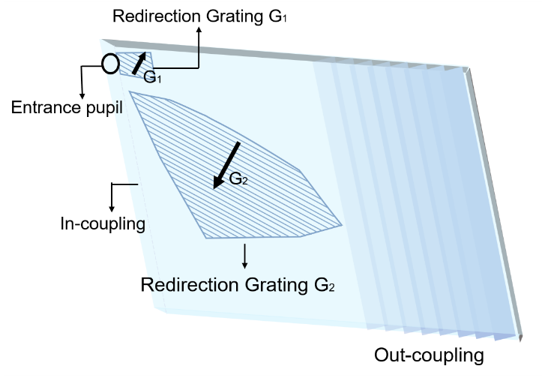
Fig.S1 An alternative design for the CWG
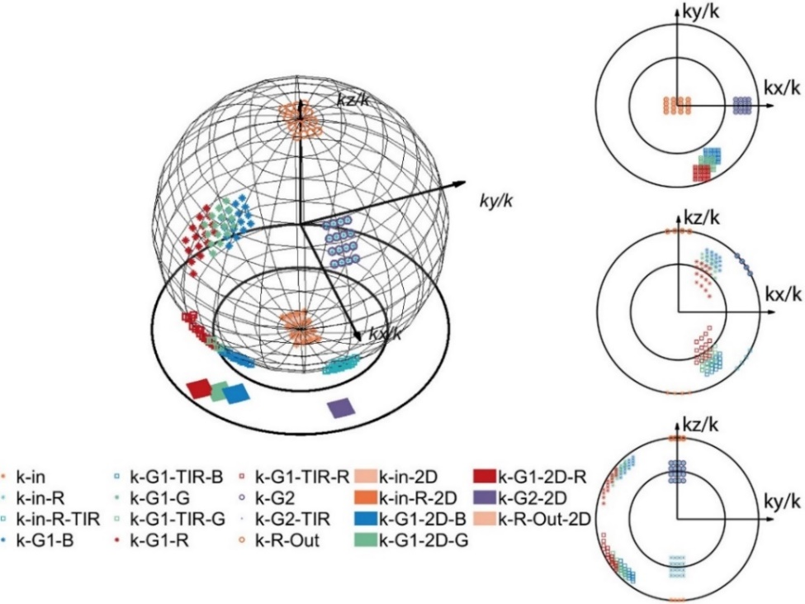
Fig.S2 The corresponding 3D k-sphere of Fig.S1
Supplementary Note 2: The Rainbow effect in the 3D k-sphere
The 3D k-sphere is a valuable tool for understanding light propagation in optical waveguides and for analyzing the rainbow effect in diffractive optical waveguides. The rainbow effect occurs when light emitted from an external light source is diffracted by the out-coupling of a diffractive optical waveguide¹. The diffraction causes a rainbow streak of lights within the user's FOV, potentially impacting the user experience. As demonstrated in Fig.S3, the light from an external source having a large angle interacts with the out-coupling, bringing the stray light into the user's FOV. The light in the environment encompasses all FOV and all wavelengths, therefore the light from the external source can occupy the entire sphere of the 3D k-sphere.
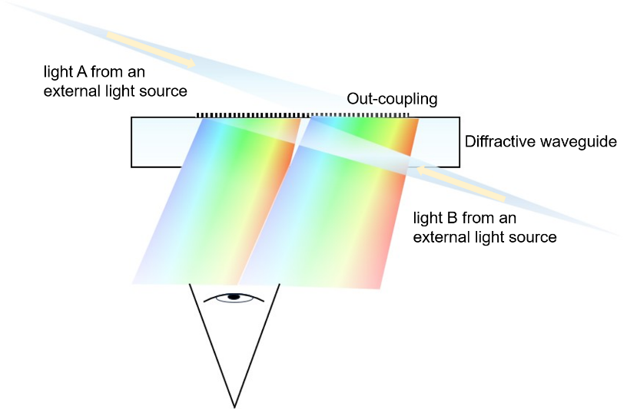
Fig.S3 The sources of the rainbow effect
It is assumed that the grating has been exposed on the front surface of the diffractive optical waveguide. If the external light comes from the front, referred to as light A, the out-coupling acts as a transmission grating bringing stray light denoted by the red square point in Fig.S4. If the external light comes from the opposite side, referred to as light B, the out-coupling acts as a reflective one with stray light represented by the blue square point in Fig.S4. At this stage, lights A and B exhibit the same normalized k-vector at different wavelengths. The normalized k-vector of the light is shifted according to equation 4 when the out-coupling diffracts the light. This movement depends on the wavelength of the light, the grating period, and the diffraction order. In the k-sphere, the sphere's radius corresponds to the material's refractive index. When the normalized k-vector falls on the sphere's surface, it indicates that light is propagating within the material. The individually colored circular dots on the outer rim of the sphere, as shown in Fig.S5, represent the normalized k-vectors of different wavelengths of light propagating in the diffractive optical waveguide after being diffracted by the grating.
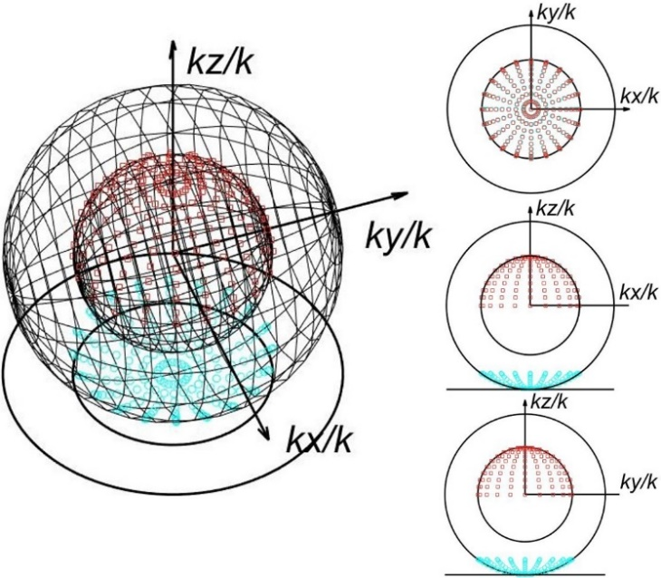
Fig.S4 The incident lights A and B in the 3D k-sphere
As Equation 6 illustrates, the normalized k-vectors of incident light at different wavelengths exhibit distinct movements, so the normalized k-vectors no longer coincide. One portion of the light is propagated within the diffractive optical waveguide by the total reflection condition, and the other portion of the light is emitted from the diffractive optical waveguide and incident upon the human eye, where the normalized k-vector is located on the surface of the inner sphere.
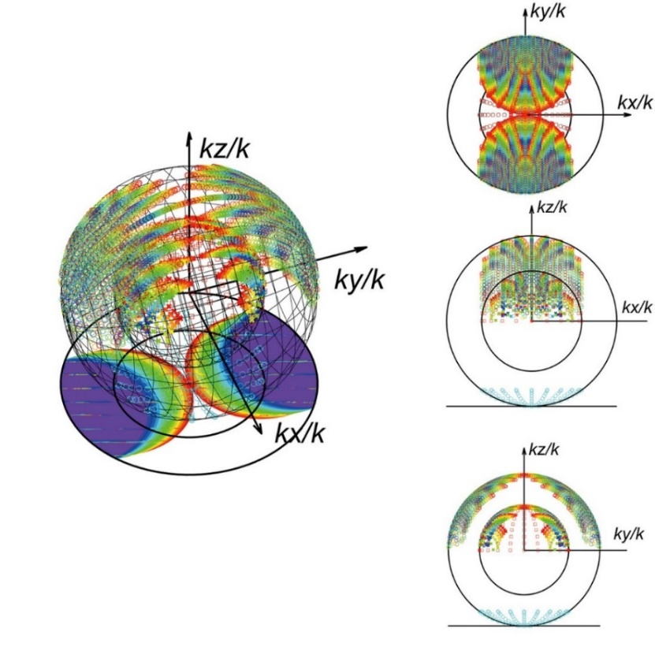
Fig.S5 The Rainbow effect in the 3D k-sphere
As shown in Fig.S5, if the grating period is 400 nm, a considerable proportion of the stray light, say the rainbow, falls within the FOV of the human eye. So the grating period should be set smaller to provide a larger movement to the k-vector of the stray light and allow the normalized k-vector of the stray light to become invisible to the human eye.
Supplementary Note 3: The optimized methods of the CWG
The evaluation of AR optical waveguides is primarily based on assessing illumination uniformity, which can be further classified into two distinct parameters: exit pupil uniformity and angular uniformity. Exit pupil uniformity is the energy uniformity of different exit pupil positions under the same angle. Angular uniformity is the energy uniformity of different angles at the same exit pupil position. In the EPE process, light repeatedly interacts with G₂, causing a gradual decrease in energy that affects both uniformities. It is important to note that, according to the cosine-fourth-power law, the illumination of a virtual image projected by a waveguide display gradually decreases from the center to the periphery. This results in a darkening effect near the edges and corners of the image. The G₂ region is divided into several sub-regions with the same period but different microstructure parameters. This design ensures light is deflected into the out-coupling region with the same energy. This is a common method for optimizing uniformity in diffractive optical waveguides. In previous studies, a typical approach to dividing grating regions involved aligning them along the principal direction of light. However, this method allows for greater flexibility. For example, a Voronoi diagram can be used to divide G2 into sub-regions, as shown in Fig.S10a. An alternative method of division is to utilize a vertex on the boundary of G2 as the center of a circle, employing a gradually varying radius to delineate an irregular region with a free curve as the boundary, as illustrated in Fig.S10b.
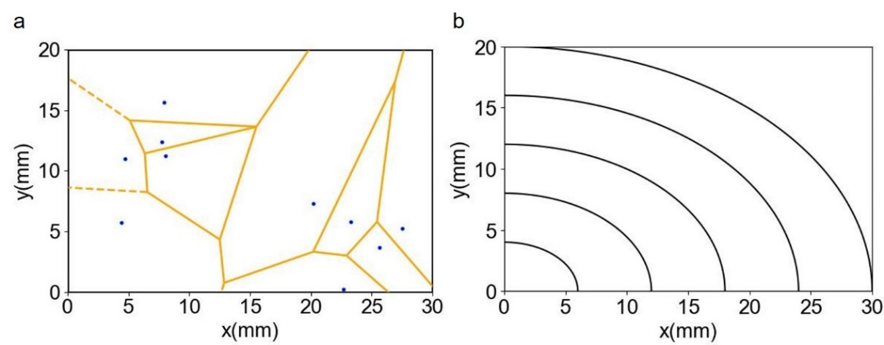
Fig.S10 The method of dividing: a Voronoi diagram. b A free curve as the boundary of the sub-region
The optimization process of the CWG is similar to that of a diffractive optical waveguide. To achieve improved uniformity, it is crucial to optimize the efficiency of the G2 sub-region and the partially reflective mirrors used in the out-coupling. As our summary reveals, the optimization process can be divided into two distinct types. The first optimization method is presented in the main manuscript, as shown in Fig.S12. The second method involves selecting the appropriate type of grating for the coupling, followed by utilizing the position of the G2 sub-regions, the grating parameters associated with each sub-region, and the reflectivity of the out-coupling as optimization variables. Additionally, the exit pupil uniformity at a specific angle is employed as the optimization objective function. Ultimately, the positions of the G2 sub-regions, the grating parameters corresponding to these sub-regions, and the reflectivity of partially reflective mirrors are obtained directly, as shown in Fig.S13.
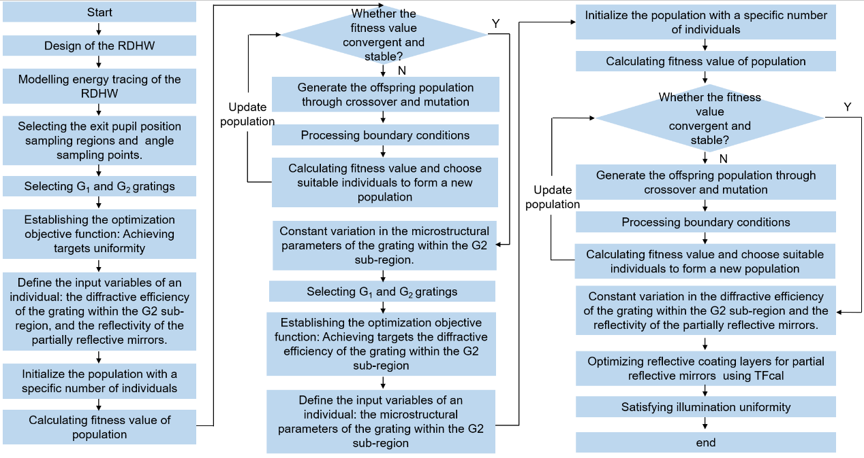
Fig.S11 Flowchart for optimization of the main manuscripts
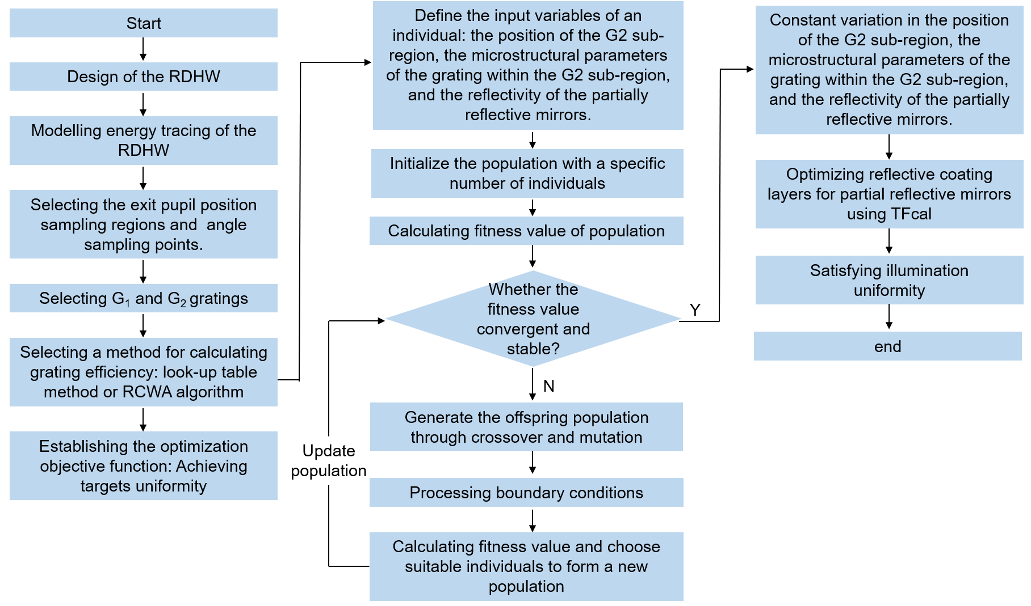
Fig.S12 Flowchart of the second optimization method
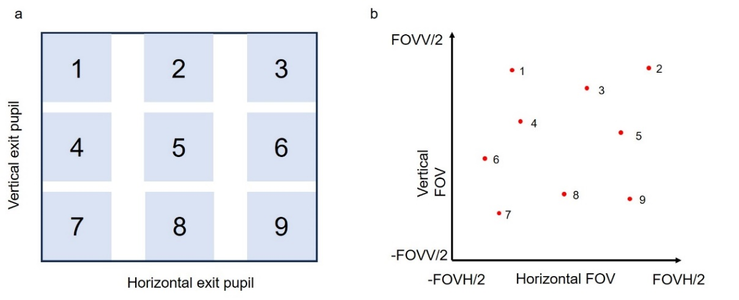
Fig.S13 Sampling a Schematic of the region selected for calculating exit pupil uniformity. b Schematic of the angle selected for calculating angular uniformity
For exit pupil uniformity, nine regions in the eyebox plane, each measuring 2 mm×2 mm, are selected and numbered from 1 to M. The N-tested angles are also selected and numbered from 1 to N. The illustration in Fig.S14 determines the number of test angles.
E_{p_max} and E_{p_min} represent the maximum and minimum energies at the Mth position for the same angle, respectively. U_{P} denotes exit pupil uniformity while A_{p_max} and A_{p_min} represent the maximum and minimum energies at the Nth angle for the same position in the eyebox plane, respectively. U_{A} denotes the angular uniformity. U_{P_aim} and U_{A_aim} represent the optimization objective values whereas U_{P_e} and U_{A_e} denotes the optimization objective functions for pupil exit uniformity and angular uniformity, respectively. They are defined by the following equation²:
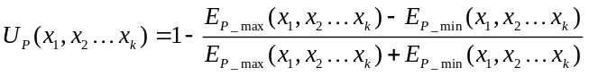
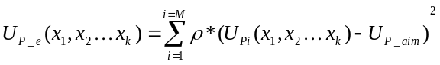
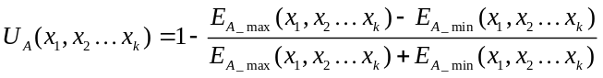
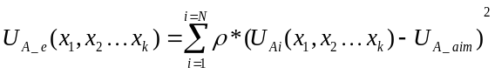
where x₁, x₂⋯x_{k} are taken as the optimization variables. ρ is the weight coefficient.
Supplementary Note 5: The simulation results of the CWG at three wavelengths
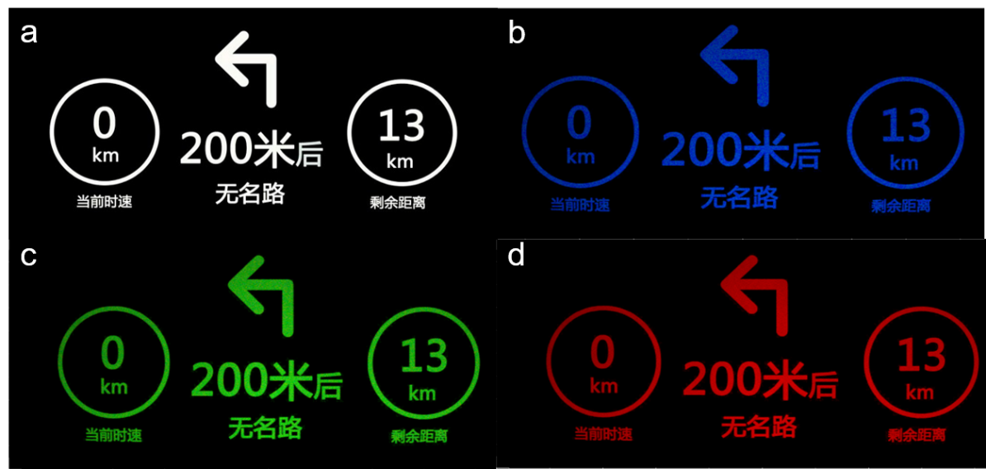
Fig.S 14 The simulation results of the CWG at three wavelengths. a. original image, b. 460 nm, c. 532 nm, and d. 616 nm
Reference
- Y. Ding, Q. Yang, Y. Li, Z. Yang, Z. Wang, H. Liang, S. T. Wu, Waveguide-based augmented reality displays: perspectives and challenges. eLight. 3, 24 (2023).
- D. Ni, D. Cheng, Y. Liu, X. Wang, C. Yao, T. Yang, Y. Wang, Uniformity improvement of two-dimensional surface relief grating waveguide display using particle swarm optimization. Opt Express 30, 24523-24543 (2022).

