Supporting Information

Effect of the heterocyclic ring-fusion on the photochemical reactivity of 1,4-dihydropyridines, polyhydroquinolines, and decahydroacridine-1,8-diones
Fatemeh S. Hosseininasab, Hamid R. Memarian* and Mehrnoosh Asgari
Department of Chemistry, University of Isfahan, 81746-73441 Isfahan, Iran.
.Corresponding author
E-mail address: memarian@sci.ui.ac.ir (H.R. Memarian)
Title | Page
Fig. S1 The UV-vis reaction spectra of the photoreaction of DHP 1b in three solvents chloroform, acetonitrile, and ethanol, and their corresponding extinction (at 395 nm) time diagrams. The spectra are obtained at 15, 15, and 20 minute time intervals, respectively in the CHCl₃, CH₃CN, and C₂H₅OH solutions | S5
Fig. S2 The UV-vis reaction spectra of the photoreaction of PHQ 3d in three solvents chloroform, acetonitrile, and ethanol, and their corresponding extinction (at 387 nm) time diagrams. The spectra are obtained at 3, 10, and 15 minute time intervals, respectively in the CHCl₃, CH₃CN, and C₂H₅OH solutions | S6
Fig. S3 The imposed 17.1° deviation of the ortho-methoxy group from co-planarity orientation with the C₄-aryl ring in PHQ 3g, as compared to the co-planar orientations of the meta-methoxy (1.0°) and para-methoxy (0.3°) groups in PHQs 3f and 3e respectively in their B3LYP/6-311++G(d,p) optimized geometries. The intramolecular electrostatic interaction of its oxygen atom with the C₄–H hydrogen atom is highlighted by dotted line segments | S7
Fig. S4 The co-planar orientations of the para-methoxy (0°) and meta-methoxy (0.5°) and ortho-methoxy (0°) groups in DHACs 5c, 5d, and 5e respectively in their B3LYP/6-311++G(d,p) optimized geometries | S8
Fig. S5 The imposed 37.6 ° deviation of the ortho-nitro group from co-planarity orientation with the C₄-aryl ring in PHQ 3j, as compared to the co-planar orientations of the meta-nitro (2.30°) and para-nitro (0.5°) groups in PHQs 3i and 3h in their B3LYP/6-311++G(d,p) optimized geometries. The intramolecular electrostatic interaction of one of its oxygen atoms with the C₄–H hydrogen atom is highlighted by dotted line segments | S9
Fig. S6 The imposed 55.1° deviation of the ortho-nitro group from co-planarity orientation with the C₉-aryl ring in DHAC 5h, as compared to the co-planar orientations of the meta-nitro (0°) and para-nitro (0°) groups in DHACs 5g and 5f in their B3LYP/6-311++G(d,p) optimized geometries | S10
Fig. S7 The B3LYP/6311++G(d,p)-calculated torsion potential for the rotation of the C₂=C₃–C₁₅=O₁₆ dihedral angle around the C₃–C₁₅ single bond of PHQ 3d | S11
Fig. S8 Changes in the N₁–C₂, C₂=C₃, C₃–C₁₅, and C₁₅=O₁₆ bond lengths (left) and N₁–C_{8a}, C_{8a}=C_{4a}, C_{4a}–C₅, and C₅=O₁₇ bond lengths (right) by the rotation of the 3-CO group around the C₃–C₁₅ single bond of PHQ 3d | S12
Fig. S9 Synperiplanar (sp, left) and antiperiplanar (ap, right) orientations of 2-methoxyphenyl (up) and 2-nitrophenyl (down) substituent in 3g and 3j respectively and deviation of 2-methoxy and 2-nitro groups from co-planarity according to the DFT optimized structures of PHQs 3g (up) and 3j (down) respectively | S13
Fig. S10 Antiperiplanar (ap, left) and synperiplanar (sp, right) orientations of 2-methoxyphenyl (up) and 2-nitrophenyl substituents (down) in DHACs 5e and 5h respectively | S14
Table S1 Comparison of the UV-vis maximum absorption wavelength λ_{max} (nm) of 1,4-dihydropyridines (1a-h) with those of the corresponding aromatic pyridines (2a-h) in CHCl₃ solution | S15
Table S2 Comparison of the UV-vis maximum absorption wavelength λ_{max} (nm) of polyhydroquinolines (3a-j) with those of the corresponding 5-oxo-tetrahydroquinolines (4a-j′) in CHCl₃ solution | S15
Table S3 Comparison of the UV-vis maximum absorption wavelength λ_{max} (nm) of decahydroacridine-1,8-diones (5a-o) with those of the corresponding octahydroacridine-1,8-diones (6a-o′) in CHCl₃ solution | S16
Table S4 Characteristic bond lengths (Å), dihedral angles (°), and bond angles (°), of 1,4-dihydropyridines (DHPs), dihydropyridine radical cation (DHPs^{•+}), and hydropyridyl radical (HPs•) intermediates obtained by B3LYP/6-311++G(d,p) computations for s-cis/s-cis conformation all compounds and s-cis/s-trans for 1f in gas phase | S17
Table S5 Characteristic bond lengths (Å), dihedral angles (°), and bond angles (°), of polyhydroquinolines (PHQs), polyhydroquinoline radical cation (PHQs^{•+}), and polyhydroquinolyl radical (PHQs•) intermediates obtained by B3LYP/6-311++G(d,p) computations for s-trans/s-cis conformation all compounds in gas phase | S18
Table S6 Characteristic bond lengths (Å), dihedral angles (°), and bond angles (°), of symmetrical and unsymmetrical decahydroacridine-1,8-diones (DHACs), decahydroacridine radical cation (DHACs^{•+}) and nonahydroacridyl radical (NHACs•) intermediates obtained by B3LYP/6-311++G(d,p) computations in gas phase | S19,S20
Table S7 Characteristic bond lengths (Å), dihedral angles (°), and bond angles (°), in the optimized structures of the substituted DHPs (1b-h) having s-cis/s-cis, s-trans/s-cis and s-trans/s-trans orientation of 3-CO and 5-CO groups obtained from the B3LYP/6-311++G(d,p) calculations in gas phase | S21
Table S8 Characteristic bond lengths (Å), dihedral angles (°), and bond angles (°), in the optimized structures of the substituted PHQs (3d-j) having a cisoid or transoid orientation of 3-CO groups obtained from the B3LYP/6-311++G(d,p) calculations in gas phase | S22
Table S9 NBO atomic charges of the neutral molecule (PHQ), radical cation (PHQ^{•+}), and radical (PHQ•) intermediates obtained using B3LYP/6-311G(d,p) calculation in gas phase | S23
Table S10 NBO atomic charges of the neutral molecule (DHAC), radical cation (DHAC^{•+}), and radical (NHAC•) intermediates obtained using B3LYP/6-311G(d,p) calculation in gas phase | S24,S25
IR, ¹H NMR, ¹³C NMR and UV-vis Spectra of 4a | S26-S31
IR, ¹H NMR, ¹³C NMR and UV-vis Spectra of 4b | S32-S37
IR, ¹H NMR, ¹³C NMR and UV-vis Spectra of 4c | S38-S43
IR, ¹H NMR, ¹³C NMR and UV-vis Spectra of 4d | S44-S49
IR, ¹H NMR, ¹³C NMR and UV-vis Spectra of 4e | S50-S55
IR, ¹H NMR, ¹³C NMR and UV-vis Spectra of 4f | S56-S61
IR, ¹H NMR, ¹³C NMR and UV-vis Spectra of 4g | S62-S67
IR, ¹H NMR, ¹³C NMR and UV-vis Spectra of 4h | S68-S73
IR, ¹H NMR, ¹³C NMR and UV Spectra of 4i | S74-S79
IR, ¹H NMR, ¹³C NMR and UV-vis Spectra of 4j′ | S80-S85
IR, ¹H NMR, ¹³C NMR and UV Spectra of 4j | S86-S91
IR, ¹H NMR, ¹³C NMR and UV-vis Spectra of 6a | S92-S97
IR, ¹H NMR, ¹³C NMR and UV-vis Spectra of 6b | S98-S103
IR, ¹H NMR, ¹³C NMR and UV-vis Spectra of 6c | S104-S108
IR, ¹H NMR, ¹³C NMR and UV-vis Spectra of 6d | S109-S114
IR, ¹H NMR, ¹³C NMR and UV-vis Spectra of 6e | S115-S120
IR, ¹H NMR, ¹³C NMR and UV-vis Spectra of 6f | S121-S125
IR, ¹H NMR, ¹³C NMR, UV-vis and Mass Spectra of 6g | S126-S132
IR, ¹H NMR, ¹³C NMR, UV-vis and Mass Spectra of 6h′ | S133-S138
IR, ¹H NMR, ¹³C NMR, UV-vis and Mass Spectra of 6h | S139-S146
IR, ¹H NMR, ¹³C NMR and UV-vis Spectra of 6i | S147-S152
IR, ¹H NMR, ¹³C NMR and UV-vis Spectra of 6j | S153-S158
IR, ¹H NMR, ¹³C NMR and UV-vis Spectra of 6k | S159-S164
IR, ¹H NMR, ¹³C NMR and UV-vis Spectra of 6l | S165-S170
IR, ¹H NMR, ¹³C NMR and UV-vis Spectra of 6m | S171-S176
IR, ¹H NMR, ¹³C NMR and UV-vis Spectra of 6n | S177-S182
IR, ¹H NMR, ¹³C NMR and UV-vis Spectra of 6o′ | S183-S188
IR, ¹H NMR, ¹³C NMR and UV-vis Spectra of 6o | S189-S194

Fig. S1 The UV-vis reaction spectra of the photoreaction of DHP 1b in three solvents chloroform, acetonitrile, and ethanol, and their corresponding extinction (at 395 nm) time diagrams. The spectra are obtained at 15, 15, and 20 minute time intervals, respectively in the CHCl₃, CH₃CN, and C₂H₅OH solutions

Fig. S2 The UV-vis reaction spectra of the photoreaction of PHQ 3d in three solvents chloroform, acetonitrile, and ethanol, and their corresponding extinction (at 387 nm) time diagrams. The spectra are obtained at 3, 10, and 15 minute time intervals, respectively in the CHCl₃, CH₃CN, and C₂H₅OH solutions

Fig. S3 The imposed 17.1° deviation of the ortho-methoxy group from co-planarity orientation with the C₄-aryl ring in PHQ 3g, as compared to the co-planar orientations of the meta-methoxy (1.0°) and para-methoxy (0.3°) groups in PHQs 3f and 3e respectively in their B3LYP/6-311++G(d,p) optimized geometries. The intramolecular electrostatic interaction of its oxygen atom with the C₄–H hydrogen atom is highlighted by dotted line segments

Fig. S4 The co-planar orientations of the para-methoxy (0°) and meta-methoxy (0.5°) and ortho-methoxy (0°) groups in DHACs 5c, 5d, and 5e respectively in their B3LYP/6-311++G(d,p) optimized geometries
Fig. S5 The imposed 37.6 ° deviation of the ortho-nitro group from co-planarity orientation with the C₄-aryl ring in PHQ 3j, as compared to the co-planar orientations of the meta-nitro (2.30°) and para-nitro (0.5°) groups in PHQs 3i and 3h respectively in their B3LYP/6-311++G(d,p) optimized geometries. The intramolecular electrostatic interaction of one of its oxygen atoms with the C₄–H hydrogen atom is highlighted by dotted line segments

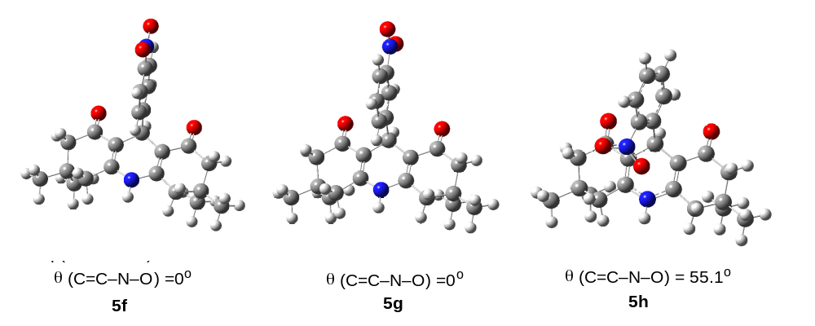
Fig. S6 The imposed 55.1° deviation of the ortho-nitro group from co-planarity orientation with the C₉-aryl ring in DHAC 5h, as compared to the co-planar orientations of the meta-nitro (0°) and para-nitro (0°) groups in DHACs 5g and 5f in their B3LYP/6-311++G(d,p) optimized geometries

Fig. S7 The B3LYP/6311++G(d,p)-calculated torsion potential for the rotation of the C₂=C₃–C₁₅=O₁₆ dihedral angle around the C₃–C₁₅ single bond of PHQ 3d

Fig. S8 Changes in the N₁–C₂, C₂=C₃, C₃–C₁₅, and C₁₅=O₁₆ bond lengths (left) and N₁–C_{8a}, C_{8a}=C_{4a}, C_{4a}–C₅, and C₅=O₁₇ bond lengths (right) by the rotation of the 3-CO group around the C₃–C₁₅ single bond of PHQ 3d

Fig. S9 Synperiplanar (sp, left) and antiperiplanar (ap, right) orientations of 2-methoxyphenyl (up) and 2-nitrophenyl (down) substituent in 3g and 3j respectively and deviation of 2-methoxy and 2-nitro groups from co-planarity according to the DFT optimized structures of PHQs 3g (up) and 3j (down) respectively

Fig. S10 Antiperiplanar (ap-left) and synperiplanar (sp-right) orientations of 2-methoxyphenyl (up) and 2-nitrophenyl substituents (down) in DHACs 5e and 5h respectively

Table S1 Comparison of the UV-vis maximum absorption wavelength λ_{max} (nm) of 1,4-dihydropyridines (1a-h) with those of the corresponding aromatic pyridines (2a-h) in CHCl₃ solution
1 | Ar | R | λ_{max} in nm (log ε) | 2 | λ_{max} in nm (log ε)
1a | C₆H₅‒ | OEt | Tailed to 393, 342 (3.69), 241 (4.03) | 2a | Tailed to 303, 272 (sh, 3.65), 240 (3.95)
1b | C₆H₅‒ | CH₃ | Tailed to 435, 365 (3.82), 249 (4.11) | 2b | Tailed to 327, 284 (sh, 3.45), 241 (4.11)
1c | 4-CH₃OC₆H₄‒ | CH₃ | Tailed to 433, 365 (3.85), 267 (4.02), 250 (sh,4.05), 239 (4.08) | 2c | Tailed to 339, 272 (4.10), 244 (4.05)
1d | 3-CH₃OC₆H₄‒ | CH₃ | Tailed to 443, 364 (3.83), 246 (4.13) | 2d | Tailed to 333, 280 (3.76), 243 (4.11)
1e | 2-CH₃OC₆H₄‒ | CH₃ | Tailed to 429, 352 (3.86), 264 (sh, 3.98), 255 (4.02) | 2e | Tailed to 336, 279 (3.79), 240 (3.99)
1f | 4-NO₂C₆H₄‒ | CH₃ | Tailed to 430, 366 (3.58), 271 (sh, 4.09), 249 (4.17) | 2f | Tailed to 363, 265 (sh, 3.99), 245 (4.07)
1g | 3-NO₂C₆H₄‒ | CH₃ | Tailed to 443, 365 (3.89), 248 (4.19) | 2g | Tailed to 374, 269 (sh, 3.65), 241 (3.83)
1h | 2-NO₂C₆H₄‒ | CH₃ | Tailed to 453, 365 (3.73), 249 (4.27) | 2h | Tailed to 403, 282 (3.67), 243 (4.02)

Table S2 Comparison of the UV-vis maximum absorption wavelength λ_{max} (nm) of polyhydroquinolines (3a-j) with those of the corresponding 5-oxo-tetrahydroquinolines (4a-j′) in CHCl₃ solution
3 | Ar | R¹ | R² | λ_{max} in nm (log ε) | 4 | λ_{max} in nm (log ε)
3a | C₆H₅‒ | H | OEt | Tailed to 403, 349 (3.44), 240 (3.76) | 4a | Tailed to 433, 279 (3.70), 240 (3.92)
3b | C₆H₅‒ | CH₃ | OEt | Tailed to 413, 354 (3.89), 241 (4.21) | 4b | Tailed to 391, 279 (3.76), 240 (4.00)
3c | C₆H₅‒ | H | CH₃ | Tailed to 423, 359 (3.81), 246 (4.10) | 4c | Tailed to 380, 278 (3.85), 241 (4.10)
3d | C₆H₅‒ | CH₃ | CH₃ | Tailed to 418, 360 (3.66), 246 (4.25) | 4d | Tailed to 385, 279 (4.36), 249 (4.40)
3e | 4-CH₃OC₆H₄‒ | CH₃ | CH₃ | Tailed to 433, 363 (3.82), 264 (3.92), 248 (sh, 3.82), 243 (sh, 3.78) | 4e | Tailed to 390, 282 (sh, 3.98), 242 (4.18)
3f | 3-CH₃OC₆H₄‒ | CH₃ | CH₃ | Tailed to 423, 365 (3.88), 245 (4.18), 240 (sh, 4.17). | 4f | Tailed to 400, 278 (3.85), 240 (4.13)
3g | 2-CH₃OC₆H₄‒ | CH₃ | CH₃ | Tailed to 424, 364 (3.81), 263 (sh, 3.96), 248 (4.11) | 4g | Tailed to 400, 278 (3.75), 243 (4.03)
3h | 4-NO₂C₆H₄‒ | CH₃ | CH₃ | Tailed to 423, 368 (3.73), 286 (sh, 4.08), 267 (sh, 4.14), 247 (4.26) | 4h | Tailed to 398, 285 (sh, 3.92), 242 (4.14)
3i | 3-NO₂C₆H₄‒ | CH₃ | CH₃ | Tailed to 423, 363 (3.76), 248 (4.32), 238 (sh, 3.58), | 4i | Tailed to 376, 286 (sh, 3.87), 243 (4.11)
3j | 2-NO₂C₆H₄‒ | CH₃ | CH₃ | Tailed to 413, 362 (3.55), 248 (4.12) | 4j | Tailed to 375, 285 (sh, 3.96), 243 (4.19)
3j | 2-NO₂C₆H₄‒ | CH₃ | CH₃ | Tailed to 413, 362 (3.55), 248 (4.12) | 4j′ª | Tailed to 408, 320 (sh, 3.24), 283 (3.49), 239 (3.63)
ª In this reaction 2-nitrosophenyl group is located on the C₄-position of the heterocyclic ring

Table S3 Comparison of the UV-vis maximum absorption wavelength λ_{max} (nm) of decahydroacridine-1,8-diones (5a-o) with those of the corresponding octahydroacridine-1,8-diones (6a-o′) in CHCl₃ solution
5 | Ar | R¹ | R² | λ_{max} in nm (log ε) | 6 | λ_{max} in nm (log ε)
5a | C₆H₅‒ | H | H | Tailed to 403, 350 (3.87), 256 (sh, 4.06), 241 (4.22) | 6a | Tailed to 412, 286 (3.73), 241 (4.17)
5b | C₆H₅‒ | CH₃ | CH₃ | Tailed to 415, 358 (3.87), 258 (sh, 4.56), 242 (4.21) | 6b | Tailed to 420, 287 (3.75), 243 (4.15)
5c | 4-CH₃OC₆H₄‒ | CH₃ | CH₃ | Tailed to 419, 356 (3.83), 284 (sh, 3.44), 256 (sh, 3.95), 241 (4.14) | 6c | Tailed to 448, 283 (3.83), 240 (4.16)
5d | 3-CH₃OC₆H₄‒ | CH₃ | CH₃ | Tailed to 413, 358 (3.89), 255 (sh, 4.10), 242 (4.22) | 6d | Tailed to 421, 282 (3.77), 242 (4.13)
5e | 2-CH₃OC₆H₄‒ | CH₃ | CH₃ | Tailed to 413, 364 (4.00), 293 (sh, 3.39), 244 (4.32) | 6e | Tailed to 436, 283 (3.79), 241 (4.19)
5f | 4-NO₂C₆H₄‒ | CH₃ | CH₃ | Tailed to 406, 360 (3.80), 285 (4.11), 244 (4.29) | 6f | Tailed to 413, 293 (4.13), 240 (4.14)
5g | 3-NO₂C₆H₄‒ | CH₃ | CH₃ | Tailed to 413, 358 (3.82), 281 (sh, 3.84), 243 (4.39) | 6g | Tailed to 408, 274 (4.07), 242 (4.28)
5h | 2-NO₂C₆H₄‒ | CH₃ | CH₃ | Tailed to 415, 362 (3.72), 242 (4.22) | 6h | Tailed to 400, 279 (3.96), 241 (4.30)
5h | 2-NO₂C₆H₄‒ | CH₃ | CH₃ | Tailed to 415, 362 (3.72), 242 (4.22) | 6h′ª | Tailed to 433, 282 (3.98), 245 (4.13)
5i | C₆H₅‒ | CH₃ | H | Tailed to 403, 354 (3.79), 258 (sh, 3.97), 242 (4.15) | 6i | Tailed to 409, 287 (3.64), 243 (4.05)
5j | 4-CH₃OC₆H₄‒ | CH₃ | H | Tailed to 403, 354 (3.72), 258 (sh, 3.83), 241 (4.05) | 6j | Tailed to 446, 284 (3.77), 243 (4.11)
5k | 3-CH₃OC₆H₄‒ | CH₃ | H | Tailed to 400, 353 (3.82), 252 (sh, 4.07), 241 (4.16) | 6k | Tailed to 403, 283 (3.80), 241 (4.18)
5l | 2-CH₃OC₆H₄‒ | CH₃ | H | Tailed to 413, 360 (3.66), 257 (sh, 3.79), 242 (4.02) | 6l | Tailed to 423, 284 (3.47), 240 (3.90)
5m | 4-NO₂C₆H₄‒ | CH₃ | H | Tailed to 406, 358 (3.29), 284 (3.58), 241 (3.84) | 6m | Tailed to 403, 291 (3.99), 240 (4.05)
5n | 3-NO₂C₆H₄‒ | CH₃ | H | Tailed to 411, 349 (3.40), 276 (sh, 3.43), 241 (3.96) | 6n | Tailed to 410, 283 (3.85), 244 (4.22)
5o | 2-NO₂C₆H₄‒ | CH₃ | H | Tailed to 423, 361 (3.87), 244 (4.32) | 6o | Tailed to 408, 285 (3.92), 242 (4.26)
5o | 2-NO₂C₆H₄‒ | CH₃ | H | Tailed to 423, 361 (3.87), 244 (4.32) | 6o′ª | Tailed to 445, 290 (4.03), 242 (4.09)
ª In this reaction 2-nitrosophenyl group is located on the C₉-position of the heterocyclic ring

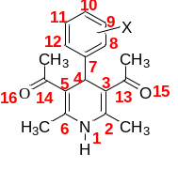
Table S4 Characteristic bond lengths (Å), dihedral angles (°), and bond angles (°), of 1,4-dihydropyridines (DHPs), dihydropyridine radical cation (DHPs^{•+}), and hydropyridyl radical (HPs•) intermediates obtained by B3LYP/6-311++G(d,p) computations for s-cis/s-cis conformation all compounds and s-cis/s-trans for 1f in gas phase
Comp. | N₁-C₂ | C₂=C₃ | C₃-C₄ | C₄-C₅ | C₅=C₆ | N₁-C₆ | C₃-C₁₃ | C₁₃=O₁₅ | C₅-C₁₄ | C₁₄₌O₁₆ | C₄-C₇ | α | αʹ | β | βʹ | γ | γʹ
1b | 1.3855 | 1.3635 | 1.5325 | 1.5325 | 1.3635 | 1.3855 | 1.4792 | 1.2261 | 1.4792 | 1.2261 | 1.5372 | -10.7 | 10.6 | 117.2 | 62.7 | 8.0 | -8.0
1b^{•+} | 1.3725 | 1.3792 | 1.5043 | 1.5043 | 1.3792 | 1.3725 | 1.5117 | 1.2127 | 1.5117 | 1.2127 | 1.5613 | -33.3 | 33.5 | 116.5 | 63.7 | 4.3 | -4.4
1b• | 1.3765 | 1.3756 | 1.4607 | 1.4346 | 1.3693 | 1.3976 | 1.4956 | 1.2227 | 1.5173 | 1.2106 | 1.4738 | -41.2 | 83.0 | 141.0 | 129.4 | 3.0 | -1.8
1c | 1.3855 | 1.3638 | 1.5326 | 1.5326 | 1.3638 | 1.3855 | 1.4787 | 1.2264 | 1.4787 | 1.2264 | 1.5355 | -9.1 | 9.1 | 117.2 | 62.7 | 8.3 | -8.3
1c^{•+} | 1.3593 | 1.3908 | 1.5046 | 1.5104 | 1.3658 | 1.3906 | 1.5071 | 1.2140 | 1.5046 | 1.2149 | 1.5547 | -32.3 | 22.2 | 108.0 | 55.7 | 9.0 | -3.2
1c• | 1.3888 | 1.3686 | 1.4696 | 1.4696 | 1.3703 | 1.3873 | 1.4966 | 1.2216 | 1.4949 | 1.2219 | 1.4462 | -41.54 | 40.2 | 2.5 | -6.5 | 6.5 | -6.7
1d | 1.3849 | 1.3639 | 1.5324 | 1.5324 | 1.3639 | 1.3849 | 1.4787 | 1.2264 | 1.4787 | 1.2264 | 1.5381 | -9.1 | 9.1 | 117.3 | 62.7 | 8.4 | -8.4
1d^{•+} | 1.3720 | 1.3793 | 1.5043 | 1.5043 | 1.3793 | 1.3722 | 1.5114 | 1.2130 | 1.5114 | 1.2130 | 1.5626 | -31.7 | 31.7 | 116.5 | 63.5 | 4.7 | -4.7
1d• | 1.3887 | 1.3737 | 1.4470 | 1.4471 | 1.3737 | 1.3886 | 1.5038 | 1.2189 | 1.5037 | 1.2189 | 1.5011 | -47.7 | 47.7 | 99.6 | 80.3 | 0.9 | -0.9
1e | 1.3867 | 1.3627 | 1.5321 | 1.5321 | 1.3627 | 1.3867 | 1.4796 | 1.2263 | 1.4796 | 1.2263 | 1.5416 | -16.9 | 16.9 | 117.7 | 62.3 | 8.0 | -8.0
1e^{•+} | 1.3729 | 1.3770 | 1.5038 | 1.5038 | 1.3770 | 1.3729 | 1.5135 | 1.2124 | 1.5135 | 1.2124 | 1.5582 | -38.9 | 38.9 | 116.6 | 63.4 | 4.1 | -4.1
1e• | 1.3897 | 1.3746 | 1.4453 | 1.4453 | 1.3746 | 1.3897 | 1.5050 | 1.2193 | 1.5049 | 1.2193 | 1.4961 | -47.3 | 47.3 | 97.3 | 82.7 | 0.8 | -0.8
1f | 1.3899 | 1.3617 | 1.5219 | 1.5342 | 1.3635 | 1.3869 | 1.4820 | 1.2250 | 1.4793 | 1.2268 | 1.5372 | -0.1 | -179.4 | 150.9 | 95.4 | 7.5 | -11.2
1f^{•+} | 1.3650 | 1.3870 | 1.4980 | 1.5058 | 1.3663 | 1.3842 | 1.5122 | 1.2132 | 1.5167 | 1.2124 | 1.5563 | -32.0 | -136.3 | 132.5 | 79.9 | 4.2 | -1.6
1f• | 1.3838 | 1.3732 | 1.4437 | 1.4437 | 1.3731 | 1.3838 | 1.5115 | 1.2152 | 1.5115 | 1.2152 | 1.4577 | -59.1 | -59.1 | 138.8 | 138.7 | 2.6 | 2.6
1g | 1.3845 | 1.3649 | 1.5320 | 1.5320 | 1.3649 | 1.3845 | 1.4789 | 1.2252 | 1.4789 | 1.2252 | 1.5372 | -8.7 | 8.7 | 117.4 | 62.6 | 8.6 | -8.6
1g^{•+} | 1.3726 | 1.3798 | 1.5058 | 1.5058 | 1.3798 | 1.3726 | 1.5112 | 1.2122 | 1.5112 | 1.2122 | 1.5613 | -32.5 | 32.5 | 116.8 | 63.2 | 5.3 | -5.3
1g• | 1.3725 | 1.3781 | 1.4612 | 1.4359 | 1.3688 | 1.3949 | 1.4947 | 1.2219 | 1.5178 | 1.2103 | 1.4694 | -37.0 | 83.2 | 143.8 | 131.3 | 4.1 | -2.2
1h | 1.3885 | 1.3610 | 1.5343 | 1.5285 | 1.3644 | 1.3854 | 1.4838 | 1.2240 | 1.4830 | 1.2256 | 1.5498 | -30.5 | 14.1 | 94.0 | 42.7 | 9.8 | -6.6
1h^{•+} | 1.3729 | 1.3756 | 1.5076 | 1.5065 | 1.3722 | 1.3736 | 1.5140 | 1.2120 | 1.5207 | 1.2113 | 1.5499 | -45.4 | 55.7 | 109.3 | 60.0 | 0.1 | 0.5
1h• | 1.3847 | 1.3694 | 1.4428 | 1.4412 | 1.3772 | 1.3745 | 1.5143 | 1.2137 | 1.5066 | 1.2184 | 1.4686 | -125.1 | 48.5 | 56.8 | 49.3 | 1.7 | -1.9
α(C₂=C₃–C₁₃=O₁₅), α'(C₆=C₅–C₁₄=O₁₆), β(C₃–C₄–C₇=C₈), β'(C₅–C₄–C₇=C₁₂), γ(N₁–C₂–C₃–C₄), γ'(N₁–C₆–C₅–C₄)

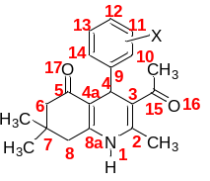
Table S5 Characteristic bond lengths (Å), dihedral angles (°), and bond angles (°), of polyhydroquinolines (PHQs), polyhydroquinoline radical cation (PHQs^{•+}), and polyhydroquinolyl radical (PHQs•) intermediates obtained by B3LYP/6-311++G(d,p) computations for s-trans/s-cis conformation all compounds in gas phase
Comp. | N₁-C₂ | C₂=C₃ | C₃-C₄ | C₄-C_{4a} | C_{4a}=C_{8a} | N₁-C_{8a} | C₃-C₁₅ | C₁₅=O₁₆ | C_{4a}-C₅ | C₅₌O₁₇ | C₄-C₉ | α | αʹ | β | βʹ | γ | γʹ
3d | 1.3919 | 1.3641 | 1.5274 | 1.5219 | 1.3554 | 1.3808 | 1.4820 | 1.2260 | 1.4650 | 1.2250 | 1.5385 | -4.1 | -171.4 | 146.7 | 89.9 | 7.3 | -7.1
3d^{•+} | 1.3689 | 1.3897 | 1.4987 | 1.4948 | 1.3664 | 1.3761 | 1.5121 | 1.2139 | 1.4945 | 1.2142 | 1.5648 | -26.5 | -164.5 | 132.2 | 78.3 | 4.3 | -5.5
3d• | 1.4045 | 1.3817 | 1.4196 | 1.4691 | 1.3771 | 1.3626 | 1.5182 | 1.2138 | 1.4780 | 1.2227 | 1.4808 | -66.2 | 166.9 | 123.2 | 127.4 | 3.1 | 3.1
3e | 1.3921 | 1.3643 | 1.5280 | 1.5217 | 1.3553 | 1.3805 | 1.4816 | 1.2263 | 1.4634 | 1.2252 | 1.5373 | -2.9 | -175.1 | 149.3 | 92.6 | 7.4 | -8.22
3e^{•+} | 1.3677 | 1.3899 | 1.5093 | 1.5060 | 1.3538 | 1.3869 | 1.5039 | 1.2165 | 1.4769 | 1.2197 | 1.5409 | -23.6 | -178.2 | 128.7 | 77.6 | 5.4 | -4.4
3e• | 1.3970 | 1.3674 | 1.4655 | 1.4751 | 1.3726 | 1.3743 | 1.50314 | 1.2207 | 1.4763 | 1.2238 | 1.4547 | -38.4 | -159.7 | 163.9 | 147.0 | 4.0 | -8.5
3f | 1.3917 | 1.3640 | 1.5270 | 1.5222 | 1.3557 | 1.3805 | 1.4818 | 1.2261 | 1.4646 | 1.2251 | 1.5388 | -1.7 | -171.5 | 147.5 | 90.8 | 7.6 | -7.2
3f^{•+} | 1.3779 | 1.3820 | 1.5045 | 1.4990 | 1.3690 | 1.3716 | 1.5053 | 1.2163 | 1.4910 | 1.2162 | 1.5672 | -12.7 | -165.6 | 147.7 | 91.9 | 5.4 | -8.1
3f• | 1.4049 | 1.3821 | 1.4189 | 1.4684 | 1.3769 | 1.3628 | 1.51837 | 1.2135 | 1.4779 | 1.2225 | 1.4817 | -65.3 | 166.9 | 122.1 | 126.7 | 3.1 | 3.1
3g | 1.3938 | 1.3623 | 1.5327 | 1.5226 | 1.3561 | 1.3798 | 1.4835 | 1.2258 | 1.4650 | 1.2239 | 1.5374 | -16.8 | -177.7 | 123.0 | 65.2 | 7.0 | -6.5
3g^{•+} | 1.3674 | 1.3873 | 1.5010 | 1.5028 | 1.3608 | 1.3813 | 1.5125 | 1.2137 | 1.4859 | 1.2171 | 1.5508 | -37.6 | 179.9 | 120.1 | 63.9 | 5.7 | -2.5
3g• | 1.4022 | 1.3796 | 1.4235 | 1.4635 | 1.3752 | 1.3688 | 1.5127 | 1.2154 | 1.4802 | 1.2220 | 1.4808 | -57.4 | 163.7 | 120.5 | 120.9 | 2.2 | 1.5
3h | 1.3922 | 1.3649 | 1.5272 | 1.5218 | 1.3553 | 1.3800 | 1.4830 | 1.2249 | 1.4636 | 1.2252 | 1.5373 | -2.5 | -175.9 | 149.2 | 92.3 | 7.1 | -7.8
3h^{•+} | 1.3685 | 1.3899 | 1.5014 | 1.4984 | 1.3661 | 1.3763 | 1.5129 | 1.2132 | 1.4935 | 1.2149 | 1.5614 | -29.4 | -171.5 | 131.7 | 78.0 | 4.0 | -5.6
3h• | 1.3879 | 1.3712 | 1.4656 | 1.4710 | 1.3731 | 1.3727 | 1.5006 | 1.2203 | 1.4813 | 1.2213 | 1.4442 | -34.1 | -158.7 | 168.2 | 151.8 | 5.9 | -9.2
3i | 1.3911 | 1.3649 | 1.5274 | 1.5217 | 1.3562 | 1.3790 | 1.4828 | 1.2248 | 1.4637 | 1.2257 | 1.5373 | -3.2 | -173.9 | 143.5 | 86.3 | 7.6 | -6.4
3i^{•+} | 1.3684 | 1.3903 | 1.5011 | 1.4971 | 1.3664 | 1.3763 | 1.5120 | 1.2132 | 1.4946 | 1.2148 | 1.5611 | -28.3 | -167.1 | 130.1 | 75.1 | 5.0 | -4.9
3i^{•+} | 1.4022 | 1.3795 | 1.4227 | 1.4679 | 1.3779 | 1.3624 | 1.5187 | 1.2124 | 1.4786 | 1.2234 | 1.4794 | -65.1 | 169.8 | -53.0 | -54.8 | 2.7 | 2.37
3j | 1.3936 | 1.3609 | 1.5334 | 1.5259 | 1.3565 | 1.3767 | 1.4892 | 1.2245 | 1.4641 | 1.2237 | 1.5457 | -23.2 | -177.5 | 139.1 | 77.2 | 4.8 | -3.8
3j^{•+} | 1.3691 | 1.3815 | 1.5002 | 1.5018 | 1.3682 | 1.3751 | 1.5184 | 1.2123 | 1.4960 | 1.2139 | 1.5468 | -50.1 | -168.1 | 127.6 | 74.9 | 0.5 | 1.2
3j• | 1.3898 | 1.3804 | 1.4249 | 1.45743 | 1.37470 | 1.3640 | 1.5147 | 1.2150 | 1.4798 | 1.2219 | 1.4732 | -59.1 | 168.1 | 126.7 | 122.8 | 2.2 | 3.1
α(C₂=C₃–C₁₅=O₁₆), α'(C_{8a}=C_{4a}–C₅=O₁₇), β(C₃–C₄–C₉=C₁₀), β'(C_{4a}–C₄–C₉=C₁₄), γ(N₁–C₂–C₃–C₄), γ'(N₁–C_{8a}–C_{4a}–C₄)

Table S6 Characteristic bond lengths (Å), dihedral angles (°), and bond angles (°), of symmetrical and unsymmetrical decahydroacridine-1,8-diones (DHACs), decahydroacridine radical cation (DHACs^{•+}) and nonahydroacridyl radical (NHACs•) intermediates obtained by B3LYP/6-311++G(d,p) computations in gas phase
Comp. | N₁₀-C_{10a} | C_{10a}=C_{8a} | C_{8a}-C₉ | C₉-C_{9a} | C_{9a}=C_{4a} | N₁₀-C_{4a} | C_{8a}-C₈ | C₈=O₁₈ | C_{9a}-C₁ | C₁=O₁₇ | C₉-C₁₁ | α | αʹ | β | βʹ | γ | γʹ
5b | 1.3877 | 1.3556 | 1.5209 | 1.5207 | 1.3556 | 1.3877 | 1.4692 | 1.2222 | 1.4692 | 1.2222 | 1.5341 | 172.4 | -172.5 | 117.5 | 61.1 | 4.9 | -4.9
5b^{•+} | 1.3727 | 1.3753 | 1.4902 | 1.4903 | 1.3750 | 1.3731 | 1.4979 | 1.2125 | 1.4978 | 1.2126 | 1.5672 | 166.6 | -166.7 | 117.2 | 62.6 | 5.4 | -5.4
5b• | 1.3881 | 1.3741 | 1.4510 | 1.4512 | 1.3724 | 1.3868 | 1.4927 | 1.2164 | 1.4937 | 1.2158 | 1.4947 | 159.5 | -160.3 | 83.8 | 67.7 | 1.3 | -0.2
5c | 1.3878 | 1.3559 | 1.5208 | 1.5208 | 1.3559 | 1.3878 | 1.4691 | 1.2222 | 1.4691 | 1.2222 | 1.5327 | 172.0 | -172.0 | 118.2 | 61.8 | 4.9 | -4.9
5c^{•+} | 1.3793 | 1.3588 | 1.5298 | 1.5298 | 1.3588 | 1.3793 | 1.4590 | 1.2271 | 1.4590 | 1.2271 | 1.5151 | -177.9 | 177.9 | 118.1 | 61.9 | -6.6 | 6.6
5c• | 1.3882 | 1.3733 | 1.4495 | 1.4495 | 1.3733 | 1.3882 | 1.4929 | 1.21613 | 1.4929 | 1.2161 | 1.4953 | 160.1 | -160.1 | 97.3 | 82.7 | 0.7 | -0.7
5d | 1.3878 | 1.3558 | 1.5213 | 1.5206 | 1.3557 | 1.3877 | 1.4694 | 1.2220 | 1.4694 | 1.2219 | 1.5345 | 171.6 | -172.2 | 115.2 | 59.0 | 4.9 | -4.8
5d^{•+} | 1.3648 | 1.3767 | 1.5063 | 1.5086 | 1.3577 | 1.3901 | 1.4812 | 1.21940 | 1.4842 | 1.2174 | 1.5441 | 170.1 | -174.9 | 107.6 | 57.2 | 5.5 | -0.8
5d• | 1.3873 | 1.3739 | 1.4499 | 1.4499 | 1.3739 | 1.3873 | 1.4944 | 1.2156 | 1.4944 | 1.2156 | 1.4973 | 161.3 | -161.3 | 96.9 | 83.1 | 0.3 | -0.3
5e | 1.3838 | 1.3559 | 1.5212 | 1.5212 | 1.3559 | 1.3838 | 1.4668 | 1.2233 | 1.4668 | 1.2233 | 1.5346 | 171.2 | -171.3 | 117.0 | 62.9 | 4.6 | -4.6
5e^{•+} | 1.3702 | 1.3739 | 1.5021 | 1.5007 | 1.3673 | 1.3750 | 1.4926 | 1.2151 | 1.4850 | 1.2166 | 1.5489 | 164.4 | -173.6 | 103.6 | 51.0 | 6.4 | -1.9
5e• | 1.3860 | 1.3746 | 1.4515 | 1.4515 | 1.3746 | 1.3860 | 1.4944 | 1.2162 | 1.4944 | 1.2162 | 1.4917 | 177.2 | -177.1 | 89.9 | 90.0 | -1.2 | 1.2
5f | 1.3865 | 1.3559 | 1.5212 | 1.5212 | 1.3559 | 1.3865 | 1.4691 | 1.2223 | 1.4691 | 1.2224 | 1.5322 | 173.5 | -173.5 | 118.2 | 61.9 | 3.9 | -3.9
5f^{•+} | 1.3727 | 1.3754 | 1.4933 | 1.4933 | 1.3754 | 1.3727 | 1.4985 | 1.2128 | 1.4985 | 1.2128 | 1.5606 | 167.3 | -167.3 | 117.1 | 62.9 | 4.7 | -4.7
5f• | 1.3857 | 1.3746 | 1.4505 | 1.4505 | 1.3746 | 1.3857 | 1.4938 | 1.2164 | 1.4938 | 1.2164 | 1.4956 | 168.4 | -168.4 | 93.7 | 86.3 | -0.3 | 0.3
5g | 1.3866 | 1.3558 | 1.5213 | 1.5212 | 1.3558 | 1.3866 | 1.4695 | 1.2220 | 1.4695 | 1.2219 | 1.5337 | 174.1 | -174.1 | 61.7 | -118.3 | 3.9 | -3.9
5g^{•+} | 1.3727 | 1.3754 | 1.4934 | 1.4934 | 1.3754 | 1.3727 | 1.4989 | 1.2124 | 1.4989 | 1.2125 | 1.5604 | 167.0 | -166.9 | 116.8 | 63.2 | 4.1 | -4.1
5g• | 1.3859 | 1.3746 | 1.4502 | 1.4502 | 1.3746 | 1.3859 | 1.4947 | 1.2165 | 1.4947 | 1.2165 | 1.4951 | -168.2 | 168.2 | 86.7 | 93.2 | 0.2 | -0.3
5h | 1.3794 | 1.3575 | 1.5247 | 1.5206 | 1.3573 | 1.3785 | 1.4653 | 1.2251 | 1.4680 | 1.2234 | 1.5434 | 169.8 | -172.0 | 99.8 | 42.2 | 4.6 | -3.8
5h^{•+} | 1.3616 | 1.3807 | 1.5008 | 1.5017 | 1.3720 | 1.3721 | 1.4954 | 1.2145 | 1.4979 | 1.2138 | 1.5555 | 161.8 | -164.1 | 107.6 | 55.7 | 2.4 | -1.4
5h• | 1.3844 | 1.3733 | 1.4477 | 1.44975 | 1.3729 | 1.3810 | 1.4907 | 1.2183 | 1.4909 | 1.2183 | 1.4905 | 164.7 | -163.4 | 85.4 | 70.3 | 0.9 | -0.6
5i | 1.3876 | 1.3573 | 1.5213 | 1.5208 | 1.3556 | 1.3881 | 1.4717 | 1.2216 | 1.4692 | 1.2222 | 1.5342 | 174.5 | -172.2 | 120.7 | 64.1 | 4.7 | -4.9
5i^{•+} | 1.3799 | 1.3701 | 1.4928 | 1.4894 | 1.3812 | 1.3663 | 1.4980 | 1.2124 | 1.4999 | 1.2122 | 1.5663 | 170.9 | -165.2 | 121.9 | 66.1 | 4.5 | -6.5
5i• | 1.3877 | 1.3746 | 1.4495 | 1.4514 | 1.3736 | 1.3874 | 1.4971 | 1.2150 | 1.4928 | 1.2163 | 1.4959 | 161.1 | -159.8 | 107.5 | 93.5 | -0.1 | -0.9
5j | 1.3880 | 1.3573 | 1.5213 | 1.5205 | 1.3556 | 1.3882 | 1.4718 | 1.2216 | 1.4690 | 1.2221 | 1.5330 | 173.9 | -171.9 | 119.3 | 62.7 | 4.5 | -4.9
5j^{•+} | 1.3780 | 1.3606 | 1.5312 | 1.5302 | 1.3583 | 1.3795 | 1.4610 | 1.2268 | 1.4595 | 1.2270 | 1.5155 | -175.5 | 177.5 | 118.2 | 61.8 | -6.3 | 6.4
5j• | 1.3888 | 1.3759 | 1.4507 | 1.4519 | 1.3720 | 1.3871 | 1.4955 | 1.2158 | 1.4938 | 1.2158 | 1.4930 | 160.2 | -159.4 | 82.7 | 66.5 | 0.9 | -0.4
5k | 1.3879 | 1.3571 | 1.5212 | 1.5210 | 1.3554 | 1.3882 | 1.4720 | 1.2214 | 1.4695 | 1.2219 | 1.5348 | 174.1 | -171.9 | 121.4 | 64.5 | 4.9 | -4.9
5k^{•+} | 1.3894 | 1.3587 | 1.5111 | 1.5081 | 1.3757 | 1.3653 | 1.4854 | 1.2173 | 1.4796 | 1.2201 | 1.5430 | 178.3 | -170.2 | 128.9 | 69.0 | 0.2 | -5.3
5k• | 1.3884 | 1.3768 | 1.4484 | 1.4515 | 1.3730 | 1.3863 | 1.4985 | 1.2147 | 1.4946 | 1.2156 | 1.4970 | 162.9 | -160.9 | 91.6 | 78.2 | -0.2 | -0.3
5l | 1.3835 | 1.3575 | 1.5222 | 1.5211 | 1.3558 | 1.3839 | 1.4693 | 1.2228 | 1.4669 | 1.2232 | 1.5351 | 173.2 | -171.1 | 117.5 | 63.4 | 4.6 | -4.7
5l^{•+} | 1.3763 | 1.3668 | 1.5031 | 1.5037 | 1.3739 | 1.3697 | 1.4851 | 1.2166 | 1.4921 | 1.2155 | 1.5473 | 177.9 | -165.1 | 131.6 | 75. 8 | 1.6 | -6.5
5l• | 1.3788 | 1.3751 | 1.4556 | 1.4411 | 1.3750 | 1.3927 | 1.4926 | 1.2174 | 1.4977 | 1.2147 | 1.4841 | -159.2 | -154.8 | 64.7 | 66.4 | -4.9 | -2.7
5m | 1.3866 | 1.3573 | 1.5216 | 1.5214 | 1.3555 | 1.3870 | 1.4718 | 1.2217 | 1.4692 | 1.2224 | 1.5325 | 176.2 | -173.6 | 122.0 | 65.3 | 3.9 | -4.3
5m^{•+} | 1.3756 | 1.3740 | 1.4945 | 1.4925 | 1.3779 | 1.3696 | 1.5008 | 1.2119 | 1.4992 | 1.2126 | 1.5616 | 169.8 | -167.1 | 118.9 | 64.6 | 4.3 | -5.3
5m• | 1.3841 | 1.3738 | 1.4525 | 1.4518 | 1.3748 | 1.3861 | 1.4968 | 1.2155 | 1.4933 | 1.2166 | 1.4913 | 162.8 | -163.0 | 114.2 | 102.1 | -0.3 | -1.2
5n | 1.3866 | 1.3574 | 1.5218 | 1.5212 | 1.3553 | 1.3870 | 1.4721 | 1.2213 | 1.4695 | 1.2220 | 1.5339 | 176.3 | -174.0 | 120.7 | 64.3 | 3.7 | -4.1
5n^{•+} | 1.3749 | 1.3742 | 1.4946 | 1.4927 | 1.3774 | 1.3702 | 1.5009 | 1.2116 | 1.4996 | 1.2122 | 1.5612 | 169.3 | -167.0 | 118.1 | 64.14 | 4.4 | -4.6
5n• | 1.3790 | 1.3739 | 1.4568 | 1.4440 | 1.3769 | 1.3892 | 1.4937 | 1.2175 | 1.4988 | 1.2155 | 1.4857 | -159.3 | -158.5 | 61.1 | 65.3 | -4.3 | -2.2
5o | 1.3793 | 1.3589 | 1.5260 | 1.5207 | 1.3571 | 1.3785 | 1.4675 | 1.2246 | 1.4681 | 1.2234 | 1.5436 | 171.1 | -171.8 | 100.9 | 43.2 | 4.5 | -3.6
5o^{•+} | 1.3634 | 1.3799 | 1.5019 | 1.5008 | 1.3737 | 1.3701 | 1.4977 | 1.2137 | 1.4986 | 1.2136 | 1.5561 | 163.2 | -163.9 | 107.9 | 56.0 | 2.4 | -1.5
5o• | 1.3860 | 1.3716 | 1.4496 | 1.4479 | 1.3761 | 1.3803 | 1.4944 | 1.2169 | 1.4917 | 1.2177 | 1.4882 | 163.6 | 173.9 | 104.1 | 106.1 | 1.2 | 1.6
α(C_{10a}=C_{8a}–C₈=O₁₈), α'(C_{4a}=C_{9a}–C₁=O₁₇), β(C_{8a}–C₉–C₁₁=C₁₂), β'(C_{9a}–C₉–C₁₁=C₁₆), γ(N₁₀–C_{10a}–C_{8a}–C₉), γ'(N₁₀–C_{4a}–C_{9a}–C₉)

Table S7 Characteristic bond lengths (Å), dihedral angles (°), and bond angles (°), in the optimized structures of the substituted DHPs (1b-h) having s-cis/s-cis, s-trans/s-cis and s-trans/s-trans orientation of 3-CO and 5-CO groups obtained from the B3LYP/6-311++G(d,p) calculations in gas phase
DHP | N₁-C₂ | C₂=C₃ | C₃-C₄ | C₄-C₅ | C₅=C₆ | N₁-C₆ | C₃-C₁₃ | C₁₃=O₁₅ | C₅-C₁₄ | C₁₄=O₁₆ | C₄-C₇ | α | αʹ | β | βʹ | γ | γʹ
1b¹ | 1.3855 | 1.3635 | 1.5325 | 1.5325 | 1.3635 | 1.3855 | 1.4792 | 1.2261 | 1.4792 | 1.2261 | 1.5372 | -10.7 | 10.6 | 117.2 | 62.7 | 8.0 | -8.0
1b² | 1.3896 | 1.3611 | 1.5227 | 1.5341 | 1.3632 | 1.3873 | 1.4809 | 1.2261 | 1.4791 | 1.2268 | 1.5386 | 1.2 | -176.9 | 148.6 | 93.3 | 7.7 | -11.1
1b³ | 1.3913 | 1.3601 | 1.5299 | 1.5256 | 1.3596 | 1.3920 | 1.4833 | 1.2238 | 1.4849 | 1.2228 | 1.5343 | 177.9 | 178.9 | 104.5 | 51.6 | 8.8 | -8.1
1c¹ | 1.3855 | 1.3638 | 1.5326 | 1.5326 | 1.3638 | 1.3855 | 1.4787 | 1.2264 | 1.4787 | 1.2264 | 1.5355 | -9.1 | 9.1 | 117.2 | 62.7 | 8.3 | -8.3
1c² | 1.3896 | 1.3612 | 1.5228 | 1.5340 | 1.3633 | 1.3874 | 1.4807 | 1.2263 | 1.4786 | 1.2271 | 1.5369 | 0.9 | -177.3 | 147.7 | 92.1 | 7.7 | -11.2
1c³ | 1.3910 | 1.3606 | 1.5305 | 1.5249 | 1.3599 | 1.3919 | 1.4822 | 1.2243 | 1.4848 | 1.2227 | 1.5331 | 179.1 | 178.2 | 99.1 | -134.8 | 9.8 | -8.2
1d¹ | 1.3849 | 1.3639 | 1.5324 | 1.5324 | 1.3639 | 1.3849 | 1.4787 | 1.2264 | 1.4787 | 1.2264 | 1.5381 | -9.1 | 9.1 | 117.3 | -117.3 | 8.4 | -8.4
1d² | 1.3895 | 1.3612 | 1.5225 | 1.5336 | 1.3630 | 1.3877 | 1.4809 | 1.2263 | 1.4797 | 1.2263 | 1.5389 | 1.6 | -175.6 | 147.9 | -86.7 | 7.7 | -11.1
1d³ | 1.3899 | 1.3610 | 1.5317 | 1.5234 | 1.3598 | 1.3915 | 1.4819 | 1.2243 | 1.4844 | 1.2225 | 1.5362 | 177.6 | 176.8 | 91.7 | -142.5 | 10.3 | -8.4
1e¹ | 1.3867 | 1.3627 | 1.5321 | 1.5321 | 1.3627 | 1.3867 | 1.4796 | 1.2263 | 1.4796 | 1.2263 | 1.5416 | -16.9 | 16.9 | 117.7 | -117.7 | 8.0 | -8.0
1e² | 1.3913 | 1.3592 | 1.5287 | 1.5333 | 1.3633 | 1.3866 | 1.4831 | 1.2260 | 1.4805 | 1.2251 | 1.5379 | -18.6 | 179.9 | 117.3 | -117.5 | 7.6 | -8.6
1e³ | 1.3904 | 1.3603 | 1.5325 | 1.5324 | 1.3602 | 1.3904 | 1.4841 | 1.2220 | 1.4841 | 1.2220 | 1.5355 | -176.9 | 176.9 | 117.3 | -117.3 | 8.6 | -8.6
1f¹ | 1.3857 | 1.3640 | 1.5323 | 1.5323 | 1.3639 | 1.3857 | 1.4801 | 1.2251 | 1.4801 | 1.2250 | 1.5360 | -9.6 | 9.8 | 117.4 | -117.3 | 7.9 | -7.9
1f² | 1.3899 | 1.3617 | 1.5219 | 1.5342 | 1.3635 | 1.3869 | 1.4820 | 1.2250 | 1.4793 | 1.2268 | 1.5372 | -0.1 | -179.4 | 150.9 | -83.7 | 7.5 | -11.2
1f³ | 1.3904 | 1.3606 | 1.5309 | 1.5248 | 1.3593 | 1.3917 | 1.4833 | 1.2241 | 1.4853 | 1.2225 | 1.5331 | -179.2 | 174.2 | 99.6 | -134.3 | 9.0 | -7.5
1g¹ | 1.3845 | 1.3649 | 1.5320 | 1.5320 | 1.3649 | 1.3845 | 1.4789 | 1.2252 | 1.4789 | 1.2252 | 1.5372 | -8.7 | 8.7 | 117.4 | -117.4 | 8.6 | -8.6
1g² | 1.3894 | 1.3619 | 1.5219 | 1.5335 | 1.3626 | 1.3881 | 1.4819 | 1.2253 | 1.4807 | 1.2259 | 1.5393 | -0.6 | -178.9 | 151.9 | -82.7 | 7.5 | -11.1
1g³ | 1.3891 | 1.3606 | 1.5292 | 1.5263 | 1.3601 | 1.3902 | 1.4820 | 1.2245 | 1.4838 | 1.2236 | 1.5331 | -176.1 | 175.2 | 107.3 | -126.5 | 8.9 | -8.1
1h¹ | 1.3885 | 1.3610 | 1.5343 | 1.5285 | 1.3644 | 1.3854 | 1.4838 | 1.2240 | 1.4830 | 1.2256 | 1.5498 | -30.5 | 14.1 | 93.9 | -142.5 | 9.8 | -6.6
1h² | 1.3915 | 1.3589 | 1.5299 | 1.5370 | 1.3626 | 1.3842 | 1.4883 | 1.2247 | 1.4788 | 1.2243 | 1.5456 | -22.5 | 171.9 | 137.1 | -98.8 | 5.7 | -8.8
1h³ | 1.3855 | 1.3612 | 1.5379 | 1.5314 | 1.3524 | 1.3931 | 1.4812 | 1.2232 | 1.4925 | 1.2168 | 1.5379 | -170.4 | 146.1 | 106.9 | -127.9 | 6.9 | -4.9699
¹ Scis-scis conformation,² Strans-scis conformation,³ Strans-strans conformation.

Table S8 Characteristic bond lengths (Å), dihedral angles (°), and bond angles (°), in the optimized structures of the substituted PHQs (3d-j) having a cisoid or transoid orientation of 3-CO groups obtained from the B3LYP/6-311++G(d,p) calculations in gas phase
PHQ | N₁-C₂ | C₂=C₃ | C₃-C₄ | C₄-C_{4a} | C_{4a}=C_{8a} | N₁-C_{8a} | C₃-C₁₅ | C₁₅=O₁₆ | C_{4a}-C₅ | C₅₌O₁₇ | C₄-C₉ | α | αʹ | β | βʹ | γ | γʹ
3d¹ | 1.3919 | 1.3641 | 1.5274 | 1.5219 | 1.3554 | 1.3808 | 1.4820 | 1.2260 | 1.4650 | 1.2250 | 1.5385 | -4.1 | -171.4 | 146.7 | -88.8 | 7.3 | -7.1
3d² | 1.3946 | 1.3627 | 1.5293 | 1.5190 | 1.3533 | 1.3832 | 1.4857 | 1.2227 | 1.4663 | 1.2229 | 1.5351 | -177.9 | -176.6 | 138.7 | -96.5 | 7.9 | -7.5
3e¹ | 1.3921 | 1.3643 | 1.5280 | 1.5217 | 1.3553 | 1.3805 | 1.4816 | 1.2263 | 1.4634 | 1.2252 | 1.5373 | -2.9 | -175.1 | 149.3 | -86.1 | 7.4 | -8.2
3e² | 1.3947 | 1.3628 | 1.5304 | 1.5183 | 1.353 | 1.3835 | 1.4855 | 1.2230 | 1.4666 | 1.2230 | 1.5329 | 179.4 | -176.8 | 133.7 | -101.3 | 8.0 | -7.0
3f¹ | 1.3917 | 1.3640 | 1.5270 | 1.5222 | 1.3557 | 1.3805 | 1.4818 | 1.2261 | 1.4646 | 1.2251 | 1.5388 | -1.7 | -171.5 | 147.5 | -87.9 | 7.6 | -7.2
3f² | 1.3945 | 1.3629 | 1.5280 | 1.5194 | 1.3536 | 1.3826 | 1.48545 | 1.2226 | 1.4660 | 1.2232 | 1.5364 | -177.1 | -176.2 | 145.8 | -89.5 | 8.4 | -7.9
3g¹ | 1.3938 | 1.3623 | 1.5327 | 1.5226 | 1.3561 | 1.3798 | 1.4835 | 1.2258 | 1.4650 | 1.2239 | 1.5374 | -16.8 | -177.7 | 123.0 | -113.1 | 7.0 | -6.5
3g² | 1.3934 | 1.3622 | 1.5355 | 1.5219 | 1.3538 | 1.3833 | 1.4850 | 1.2221 | 1.4687 | 1.2214 | 1.5348 | -174.2 | -177.6 | 122.7 | -113.1 | 8.3 | -6.4
3h¹ | 1.3922 | 1.3649 | 1.5272 | 1.5218 | 1.3553 | 1.3800 | 1.4830 | 1.2249 | 1.4636 | 1.2252 | 1.5373 | -2.5 | -175.9 | 149.2 | -86.3 | 7.1 | -7.8
3h² | 1.3944 | 1.3624 | 1.5285 | 1.5194 | 1.3532 | 1.3831 | 1.4861 | 1.2226 | 1.4665 | 1.2231 | 1.5335 | -174.1 | -177.1 | 140.9 | -94.2 | 7.5 | -6.8
3i¹ | 1.3911 | 1.3649 | 1.5274 | 1.5217 | 1.3562 | 1.3790 | 1.4828 | 1.2248 | 1.4637 | 1.2257 | 1.5373 | -3.2 | -173.9 | 143.5 | -91.9 | 7.6 | -6.4
3i² | 1.3927 | 1.3647 | 1.5297 | 1.5171 | 1.3527 | 1.3821 | 1.4836 | 1.2241 | 1.4663 | 1.2236 | 1.5337 | -176.8 | -177.8 | 136.4 | -98.4 | 6.5 | -6.8
3j¹ | 1.3936 | 1.3609 | 1.5334 | 1.5259 | 1.3565 | 1.3767 | 1.4892 | 1.2245 | 1.4641 | 1.2237 | 1.5457 | -23.2 | -177.5 | 139.1 | -97.7 | 4.8 | -3.8
3j² | 1.3903 | 1.3613 | 1.5403 | 1.5241 | 1.3533 | 1.3825 | 1.4840 | 1.2220 | 1.4720 | 1.2193 | 1.5399 | -167.9 | 174.5 | 106.5 | -129.3 | 7.0 | -2.8
¹ Cisoid conformation, ² Tranisoid conformation

Table S9 NBO atomic charges of the neutral molecule (PHQ), radical cation (PHQ^{•+}), and radical (PHQ•) intermediates obtained using B3LYP/6-311G(d,p) calculation in gas phase
PHQ | N₁ |  | C₂ |  | C₃ |  |  | C₄ |  | C_{4a} |  | C_{8a} |  | O₁₆ |  | O₁₇ |  | $$O_{{OCH}_{3}}$$ |  | ΔQ₁ |  | ΔQ₂ |  | Q_{total}
3d | -0.5697 |  | 0.2728 |  | -0.1601 |  |  | -0.2609 |  | -0.1834 |  | 0.2834 |  | -0.5907 |  | -0.5945 |  |  |  |  |  |  |  | -0.6179
3d^{•+} | -0.4597 |  | 0.2720 |  | 0.0288 |  |  | -0.3027 |  | -0.0320 |  | 0.2820 |  | -0.5087 |  | -0.5026 |  |  |  | 0.1100 |  |  |  | -0.2116
3d• | -0.5520 |  | 0.3119 |  | -0.2044 |  |  | -0.0344 |  | -0.1386 |  | 0.1985 |  | -0.5683 |  | -0.5513 |  |  |  |  |  |  |  | -0.4190
3e | -0.5761 |  | 0.2691 |  | -0.1629 |  |  | -0.2667 |  | -0.1715 |  | 0.2715 |  | -0.5926 |  | -0.5955 |  | -0.5266 |  |  |  |  |  | -0.6366
3e^{•+} | -0.4643 |  | 0.2618 |  | -0.0513 |  |  | -0.3139 |  | -0.0021 |  | 0.2834 |  | -0.5321 |  | -0.5272 |  | -0.4664 |  | 0.1118 |  | 0.0602 |  | -0-2864
3e• | -0.5520 |  | 0.3119 |  | -0.2043 |  |  | -0.0344 |  | -0.1386 |  | 0.1985 |  | -0.5900 |  | -0.5845 |  | -0.5231 |  |  |  |  |  | -0.4189
3f | -0.5706 |  | 0.2720 |  | -0.1602 |  |  | -0.2614 |  | -0.1836 |  | 0.2823 |  | -0.5909 |  | -0.5948 |  | 0.5295 |  |  |  |  |  | -0.6215
3f^{•+} | -0.4408 |  | 0.2598 |  | -0.0083 |  |  | -0.3172 |  | 0.0156 |  | 0.2826 |  | -0.5286 |  | -0.5199 |  | -0.4917 |  | 0.1298 |  | 0.0378 |  | -0.2083
3f• | -0.5517 |  | 0.3122 |  | -0.2044 |  |  | -0.0357 |  | -0.1393 |  | 0.1988 |  | -0.5675 |  | -0.5502 |  | -0.5258 |  |  |  |  |  | -0.4201
3g | -0.5709 |  | 0.2730 |  | -0.1594 |  |  | -0.2595 |  | -0.1819 |  | 0.2804 |  | -0.5824 |  | -0.5938 |  | -0.5372 |  |  |  |  |  | -0.6183
3g^{•+} | -0.4899 |  | 0.2659 |  | -0.0834 |  |  | -0.3004 |  | -0.0559 |  | 0.3025 |  | -0.5229 |  | -0.5101 |  | -0.5239 |  | 0.0810 |  | 0.0133 |  | -0.3612
3g• | -0.5616 |  | 0.2949 |  | -0.2003 |  |  | -0.0070 |  | -0.1869 |  | 0.2616 |  | -0.5675 |  | -0.5502 |  | -0.5258 |  |  |  |  |  | -0.3993
3h | -0.5709 |  | 0.2854 |  | -0.1876 |  |  | -0.2655 |  | -0.1649 |  | 0.2793 |  | -0.5886 |  | -0.5928 |  |  |  |  |  |  |  | -0.6242
3h^{•+} | -0.4391 |  | 0.2842 |  | 0.0191 |  |  | -0.3173 |  | -0.0134 |  | 0.2661 |  | -0.4945 |  | -0.5108 |  |  |  | 0.1256 |  |  |  | -0.2004
3h• | -0.5478 |  | 0.2827 |  | -0.1898 |  |  | 0.0171 |  | -0.1968 |  | 0.2975 |  | -0.5771 |  | -0.5775 |  |  |  |  |  |  |  | -0.3371
3i | -0.5677 |  | 0.289 |  | -0.1879 |  |  | -0.2596 |  | -0.1659 |  | 0.2796 |  | -0.5881 |  | -0.5935 |  |  |  |  |  |  |  | -0.6125
3i^{•+} | -0.4377 |  | 0.2864 |  | 0.0174 |  |  | -0.3154 |  | -0.0123 |  | 0.2639 |  | -0.4934 |  | -0.5111 |  |  |  | 0.1300 |  |  |  | -0.1977
3i• | -0.5482 |  | 0.2093 |  | -0.1384 |  |  | -0.0417 |  | -0.2036 |  | 0.3154 |  | -0.5407 |  | -0.5709 |  |  |  |  |  |  |  | -0.4071
3j | -0.5746 |  | 0.2767 |  | -0.1701 |  |  | -0.2685 |  | -0.1757 |  | 0.2682 |  | -0.5847 |  | -0.5878 |  |  |  |  |  |  |  | -0.6440
3j^{•+} | -0.4502 |  | 0.2699 |  | -0.0346 |  |  | -0.3349 |  | 0.0147 |  | 0.2712 |  | -0.5178 |  | -0.4931 |  |  |  | 0.1244 |  |  |  | -0.2639
3j• | -0.5354 |  | 0.3111 |  | -0.1727 |  |  | 0.0008 |  | -0.1487 |  | 0.2384 |  | -0.5742 |  | -0.5588 |  |  |  |  |  |  |  | -0.3066
ΔQ₁ = Q(N₁)PHQ^{•+} - Q(N₁)PHQ, ΔQ₂ = Q(O)_{OCH3}PHQ^{•+} - Q(O)_{OCH3}PHQ
Table S10 NBO atomic charges of the neutral molecule (DHAC), radical cation (DHAC^{•+}), and radical (NHAC•) intermediates obtained using B3LYP/6-311G(d,p) calculation in gas phase
DHAC |  | N₁₀ |  | C_{10a} |  | C_{8a} | C₉ |  | C_{9a} |  | C_{4a} |  | O₁₇ |  | O₁₈ |  | $$O_{{OCH}_{3}}$$ |  | ΔQ₁ |  | ΔQ₂ |  | Q_{total}
5a |  | -0.5816 |  | 0.2571 |  | -0.1573 | -0.2603 |  | -0.1573 |  | 0.2571 |  | -0.5706 |  | -0.5708 |  |  |  |  |  |  |  | -0.6423
5a^{•+} |  | -0.4423 |  | 0.2591 |  | 0.0081 | -0.3169 |  | 0.0081 |  | 0.2591 |  | -0.4895 |  | -0.4895 |  |  |  | 0.1393 |  |  |  | -0.2248
5a• |  | -0.5696 |  | 0.2564 |  | -0.1785 | -0.0187 |  | -0.1779 |  | 0.2561 |  | -0.5417 |  | -0.5410 |  |  |  |  |  |  |  | -0.4322
5b |  | -0.5694 |  | 0.2774 |  | -0.1586 | -0.2542 |  | -0.1586 |  | 0.2774 |  | -0.5712 |  | -0.5716 |  |  |  |  |  |  |  | -0.5860
5b^{•+} |  | -0.4665 |  | 0.2855 |  | -0.0374 | -0.2973 |  | -0.0289 |  | 0.2811 |  | -0.4936 |  | -0.4936 |  |  |  | 0.1029 |  |  |  | -0.2635
5b• |  | -0.5680 |  | 0.2652 |  | -0.1735 | -0.0135 |  | -0.1735 |  | 0.2652 |  | -0.5405 |  | -0.5464 |  |  |  |  |  |  |  | -0.3981
5c |  | -0.5795 |  | 0.2639 |  | -0.1573 | -0.2598 |  | -0.1574 |  | 0.2637 |  | -0.5714 |  | -0.5714 |  | -0.5272 |  |  |  |  |  | -0.6264
5c^{•+} |  | -0.4409 |  | 0.2666 |  | 0.0102 | -0.3167 |  | 0.0097 |  | 0.2662 |  | -0.5210 |  | -0.5210 |  | -0.4474 |  | 0.1386 |  | 0.0798 |  | -0.2049
5c• |  | -0.5677 |  | 0.2630 |  | -0.1761 | -0.0191 |  | -0.1798 |  | 0.2642 |  | -0.5429 |  | -0.5429 |  | -0.5288 |  |  |  |  |  | -0.4155
5d |  | -0.5796 |  | 0.2637 |  | -0.1564 | -0.2587 |  | -0.1574 |  | 0.2634 |  | -0.5694 |  | -0.5705 |  | -0.5236 |  |  |  |  |  | -0.6250
5d^{•+} |  | -0.5000 |  | 0.2968 |  | -0.0677 | -0.2846 |  | -0.0893 |  | 0.2627 |  | -0.5296 |  | -0.5246 |  | -0.4497 |  | 0.0796 |  | 0.0739 |  | -0.3821
5d• |  | -0.5684 |  | 0.2627 |  | -0.1767 | -0.0207 |  | -0.1767 |  | 0.2627 |  | -0.5408 |  | -0.5408 |  | -0.5274 |  |  |  |  |  | -0.4171
5e |  | -0.5797 |  | 0.2615 |  | -0.1565 | -0.2577 |  | -0.1565 |  | 0.2615 |  | -0.5770 |  | -0.5770 |  | -0.5428 |  |  |  |  |  | -0.6274
5e^{•+} |  | -0.5618 |  | 0.3060 |  | -0.1761 | -0.2643 |  | -0.1761 |  | 0.3060 |  | -0.5059 |  | -0.5211 |  | -0.5226 |  | 0.0179 |  | 0.0202 |  | -0.5663
5e• |  | -0.5684 |  | 0.2622 |  | -0.1778 | -0.0164 |  | -0.1779 |  | 0.2622 |  | -0.5438 |  | -0.5438 |  | -0.5330 |  |  |  |  |  | -0.4161
5f |  | -0.5709 |  | 0.2764 |  | -0.1554 | -0.2542 |  | -0.1554 |  | 0.2764 |  | -0.5715 |  | -0.5715 |  |  |  |  |  |  |  | -0.5832
5f^{•+} |  | -0.4387 |  | 0.2702 |  | 0.0095 | -0.3191 |  | 0.0095 |  | 0.2702 |  | -0.4929 |  | -0.4929 |  |  |  | 0.1322 |  |  |  | -0.1984
5f• |  | -0.5647 |  | 0.2700 |  | -0.1771 | -0.0386 |  | -0.1771 |  | 0.2700 |  | -0.5423 |  | -0.5423 |  |  |  |  |  |  |  | -0.4175
5g |  | -0.5714 |  | 0.2749 |  | -0.1551 | -0.2512 |  | -0.1552 |  | 0.2749 |  | -0.5688 |  | -0.5688 |  |  |  |  |  |  |  | -0.5832
5g^{•+} |  | -0.4374 |  | 0.2714 |  | 0.0100 | -0.3158 |  | -0.00673 |  | 0.2625 |  | -0.4907 |  | -0.4907 |  |  |  | 0.1340 |  |  |  | -0.2159
5g• |  | -0.5630 |  | 0.2715 |  | -0.1755 | -0.0329 |  | -0.1755 |  | 0.2715 |  | -0.5436 |  | -0.5436 |  |  |  |  |  |  |  | -04039
5h |  | -0.5788 |  | 0.2676 |  | -0.1625 | -0.2586 |  | -0.1626 |  | 0.2676 |  | -0.5756 |  | -0.5895 |  |  |  |  |  |  |  | -0.6273
5h^{•+} |  | -0.4391 |  | 0.2698 |  | 0.0084 | -0.3175 |  | -0.0084 |  | 0.2609 |  | -0.5048 |  | -0.5040 |  |  |  | 0.1397 |  |  |  | -0.2171
5h• |  | -0.5647 |  | 0.2699 |  | -0.1772 | -0.0346 |  | -0.1772 |  | 0.2699 |  | -0.5508 |  | -0.5533 |  |  |  |  |  |  |  | -0.4139
5i |  | -0.5701 |  | 0.2769 |  | -0.1585 | -0.2544 |  | -0.1591 |  | 0.2714 |  | -0.5703 |  | -0.5717 |  |  |  |  |  |  |  | -0.5938
5i^{•+} |  | -0.4732 |  | 0.2881 |  | -0.0442 | -0.2945 |  | -0.0420 |  | 0.2740 |  | -0.4919 |  | -0.5736 |  |  |  | 0.0969 |  |  |  | -0.2918
5i• |  | -0.5663 |  | 0.2451 |  | -0.1569 | -0.0164 |  | -0.1822 |  | 0.2728 |  | -0.5392 |  | -0.5453 |  |  |  |  |  |  |  | -0.4039
5j |  | -0.5805 |  | 0.2637 |  | -0.1567 | -0.2602 |  | -0.1582 |  | 0.2574 |  | -0.5706 |  | -0.5714 |  | -0.5272 |  |  |  |  |  | -0.6345
5j^{•+} |  | -0.4448 |  | 0.2767 |  | -0.0183 | -0.3152 |  | -0.0080 |  | 0.2512 |  | -0.5196 |  | -0.5217 |  | -0.4469 |  | 0.1357 |  | 0.0803 |  | -0.2584
5j• |  | -0.5686 |  | 0.2649 |  | -0.1771 | -0.0193 |  | -0.1788 |  | 0.2550 |  | -0.5456 |  | -0.5408 |  | -0.5283 |  |  |  |  |  | -0.4239
5k |  | -0.5807 |  | 0.2635 |  | -0.1561 | -0.2590 |  | -0.1576 |  | 0.2569 |  | -0.5690 |  | -0.5703 |  | -0.5236 |  |  |  |  |  | -0.6330
5k^{•+} |  | -0.5064 |  | 0.2986 |  | -0.0760 | -0.2813 |  | -0.0989 |  | 0.2570 |  | -0.5309 |  | -0.5268 |  | -0.4446 |  | 0.0743 |  | 0.0789 |  | -0.4070
5k• |  | -0.5693 |  | 0.2651 |  | -0.1777 | -0.0207 |  | -0.1756 |  | 0.2530 |  | -0.5393 |  | -0.5402 |  | -0.5276 |  |  |  |  |  | -0.4252
5l |  | -0.5809 |  | 0.2614 |  | -0.1561 | -0.2578 |  | -0.1572 |  | 0.2551 |  | -0.5765 |  | -0.5767 |  | -0.5430 |  |  |  |  |  | -0.6355
5l^{•+} |  | -0.5621 |  | 0.3049 |  | -0.1753 | -0.2645 |  | -0.1765 |  | 0.2986 |  | -0.5054 |  | -0.5240 |  | -0.5170 |  | 0.0188 |  | 0.0260 |  | -0.5749
5l• |  | -0.5693 |  | 0.2637 |  | -0.1802 | -0.0157 |  | -0.1763 |  | 0.2542 |  | -0.5512 |  | -0.5405 |  | -0.5355 |  |  |  |  |  | -0.4236
5m |  | -0.5617 |  | 0.2862 |  | -0.1647 | -0.2546 |  | -0.1817 |  | 0.2844 |  | -0.5699 |  | -0.5723 |  |  |  |  |  |  |  | -0.5921
5m^{•+} |  | -0.4396 |  | 0.2926 |  | 0.0163 | -0.3189 |  | 0.0019 |  | 0.2900 |  | -0.4903 |  | -0.4913 |  |  |  | 0.1221 |  |  |  | -0.1577
5m• |  | -0.5602 |  | 0.2620 |  | -0.1560 | -0.0179 |  | -0.1816 |  | 0.2750 |  | -0.5400 |  | -0.5473 |  |  |  |  |  |  |  | -0.3787
5n |  | -0.5614 |  | 0.2866 |  | -0.1644 | -0.2543 |  | -0.1814 |  | 0.2848 |  | -0.5677 |  | -0.5692 |  |  |  |  |  |  |  | -0.5901
5n^{•+} |  | -0.4350 |  | 0.2936 |  | 0.0195 | -0.3086 |  | -0.0113 |  | 0.2901 |  | -0.4880 |  | -0.4891 |  |  |  | 0.1264 |  |  |  | -0.1517
5n• |  | -0.5602 |  | 0.2625 |  | -0.1561 | -0.0162 |  | -0.1828 |  | 0.2774 |  | -0.5518 |  | -0.5394 |  |  |  |  |  |  |  | -0.3754
5o |  | -0.5798 |  | 0.2675 |  | -0.1617 | -0.2588 |  | -0.1632 |  | 0.2607 |  | -0.5755 |  | -0.5886 |  |  |  |  |  |  |  | -0.6353
5o^{•+} |  | -0.4401 |  | 0.2733 |  | 0.0142 | -0.3172 |  | 0.0008 |  | 0.2585 |  | -0.5033 |  | -0.5017 |  |  |  | 0.1397 |  |  |  | -0.2105
5o• |  | -0.5618 |  | 0.2580 |  | -0.1705 | -0.0302 |  | -0.1827 |  | 0.2782 |  | -0.5512 |  | -0.5525 |  |  |  |  |  |  |  | -0.409
ΔQ₁ = Q(N₁)DHAC ^{•+} - Q(N₁)DHAC, ΔQ₂ = Q(O)_{OCH3} DHAC^{•+} - Q(O)_{OCH3}DHAC

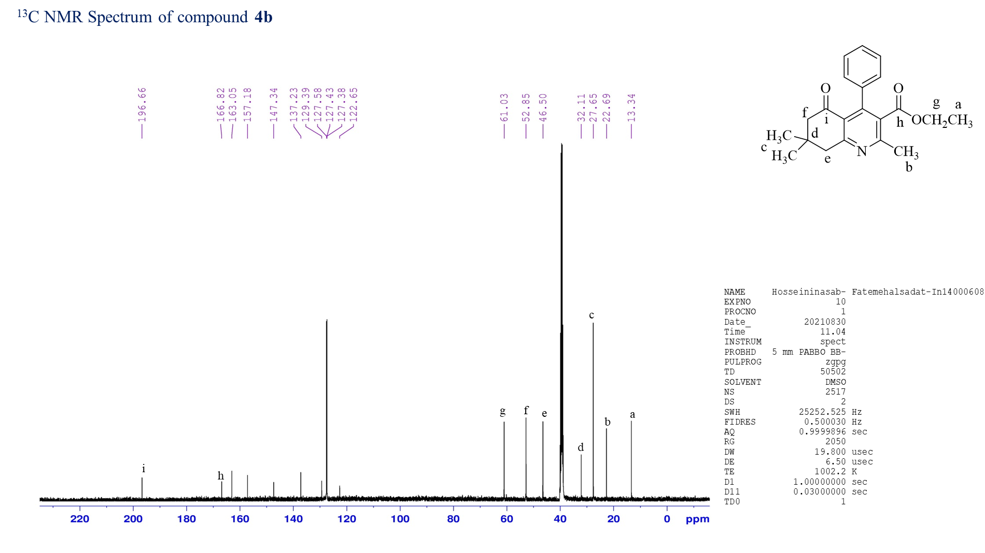

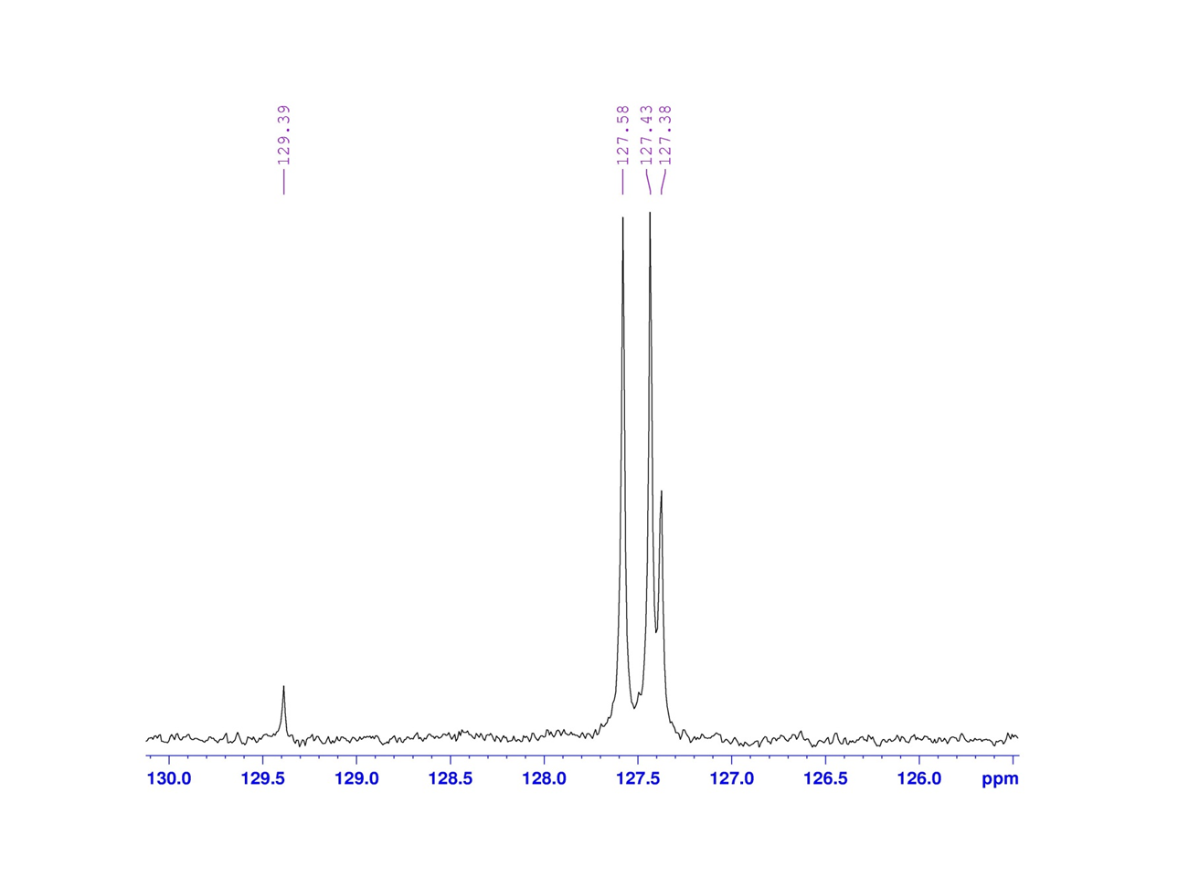
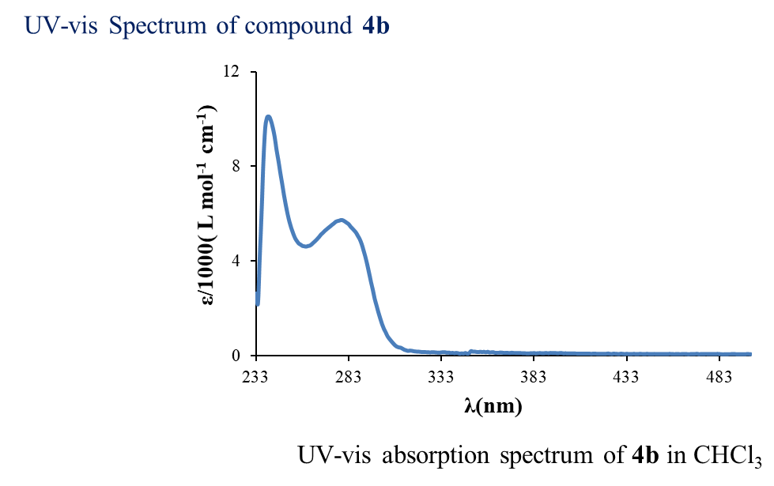

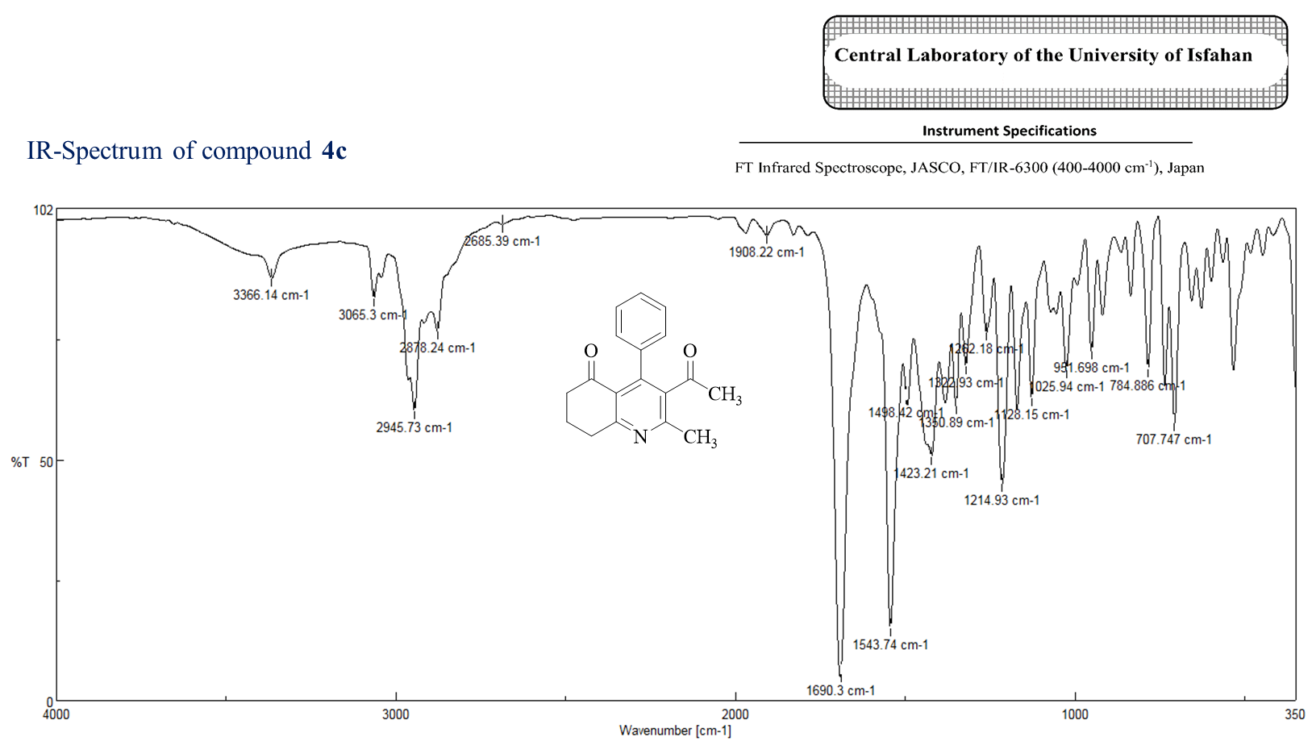

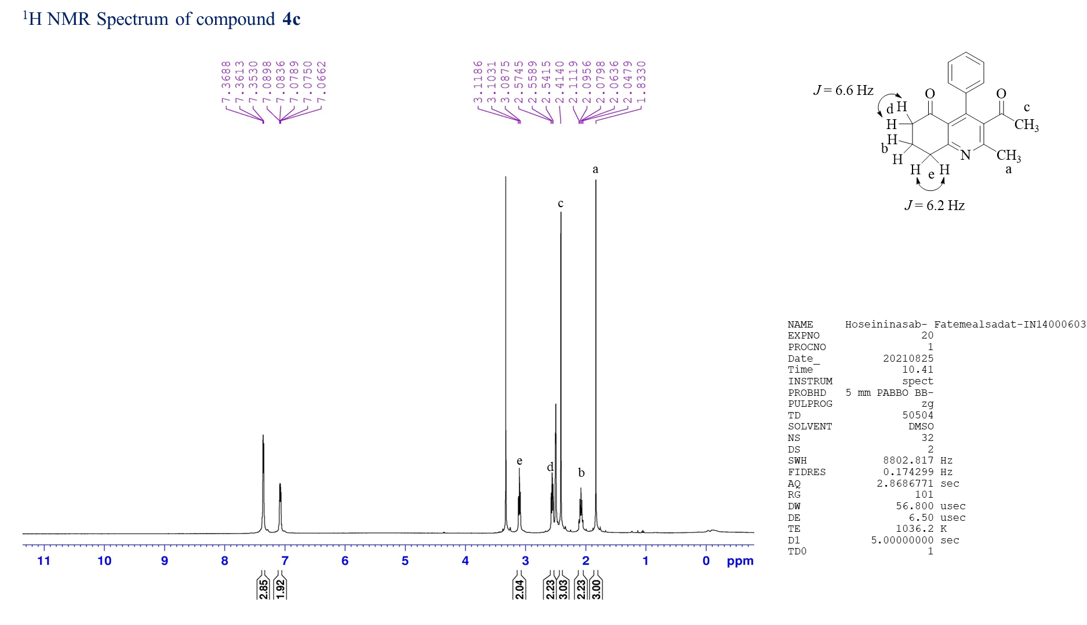

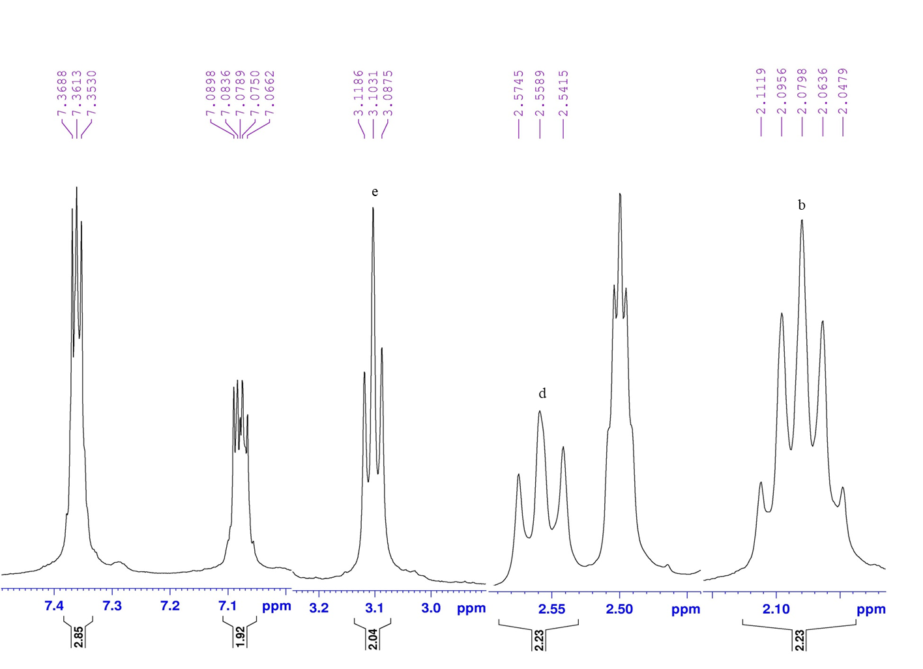

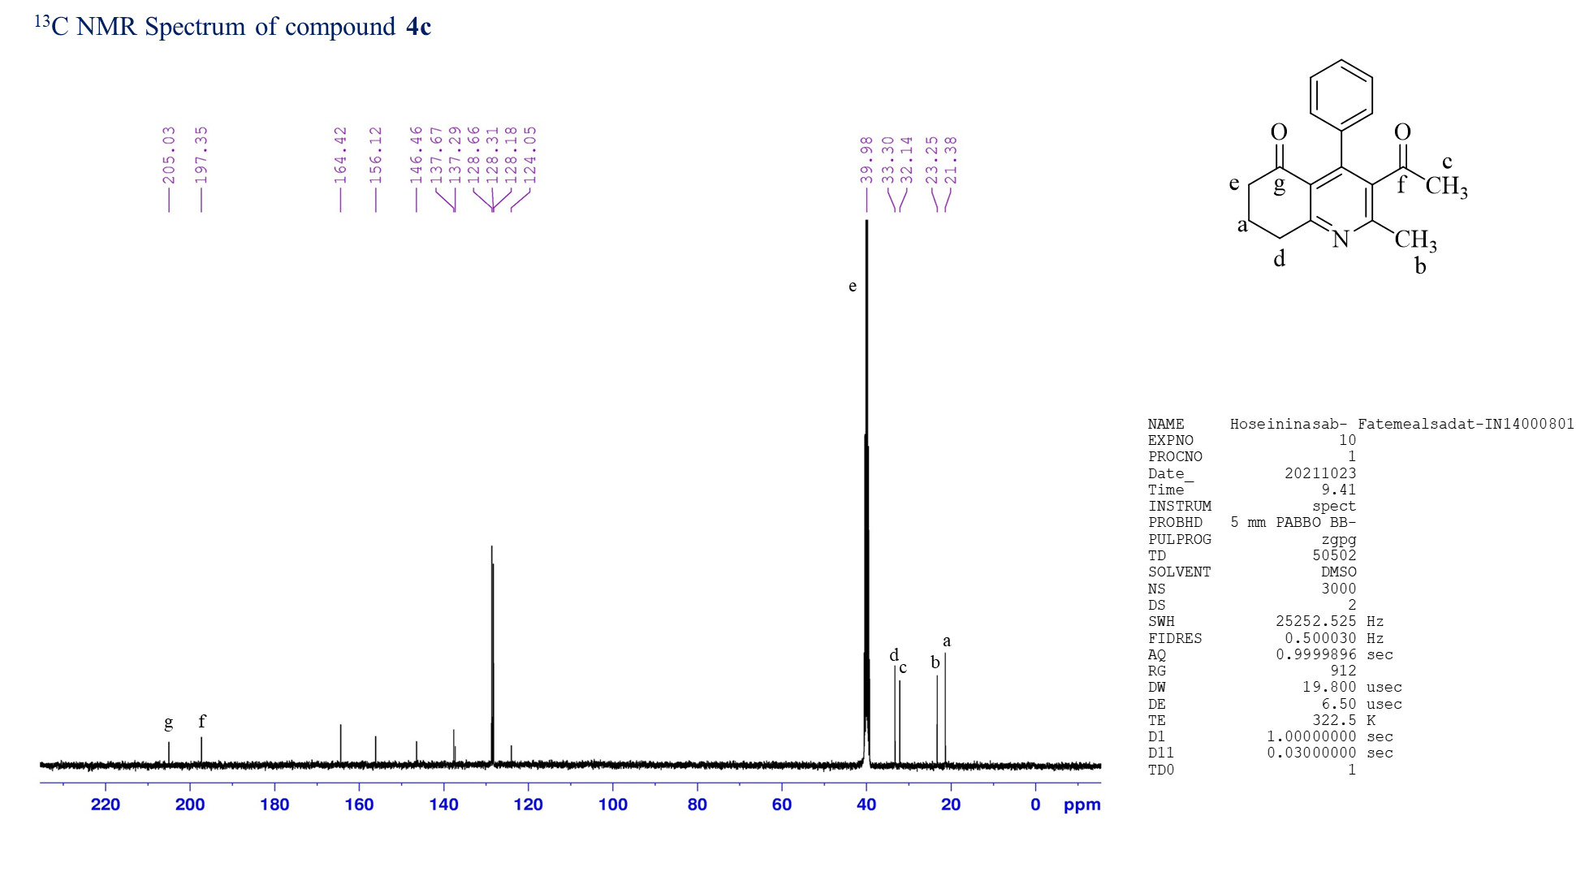
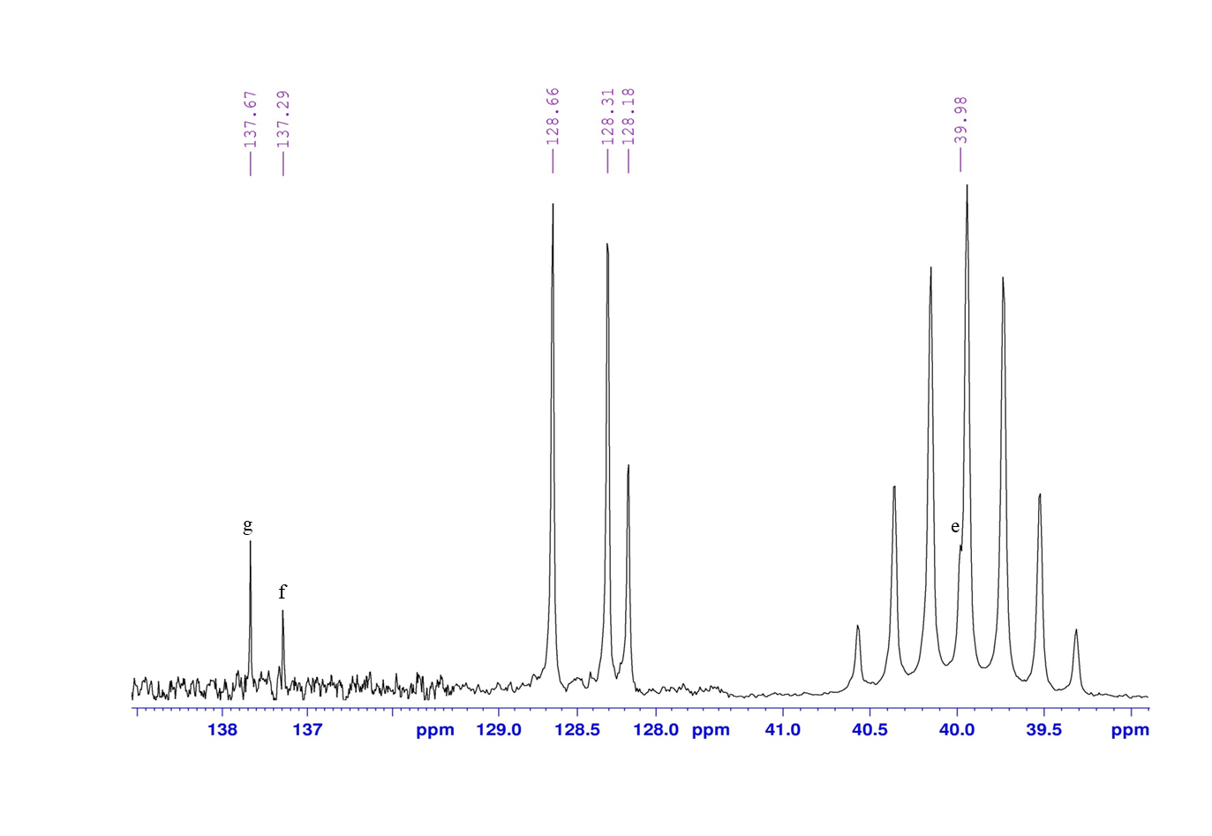

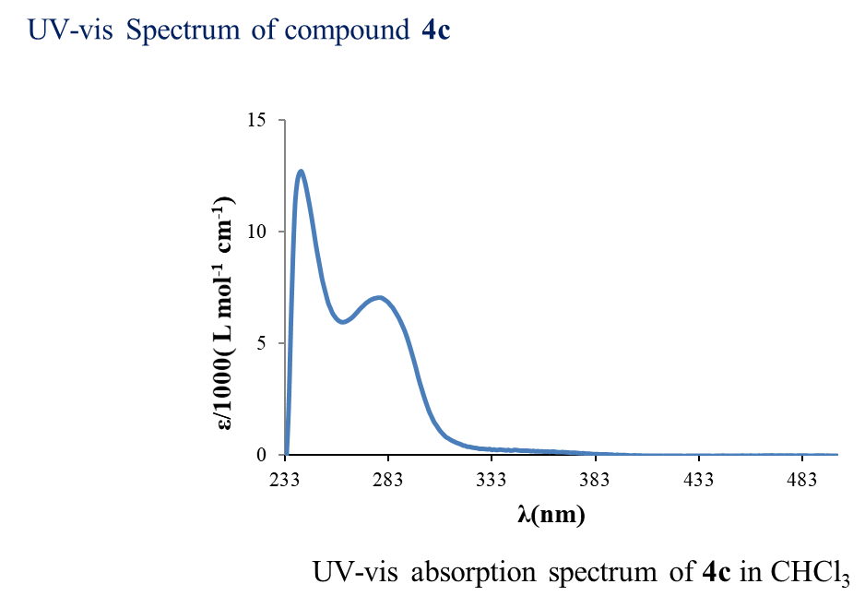

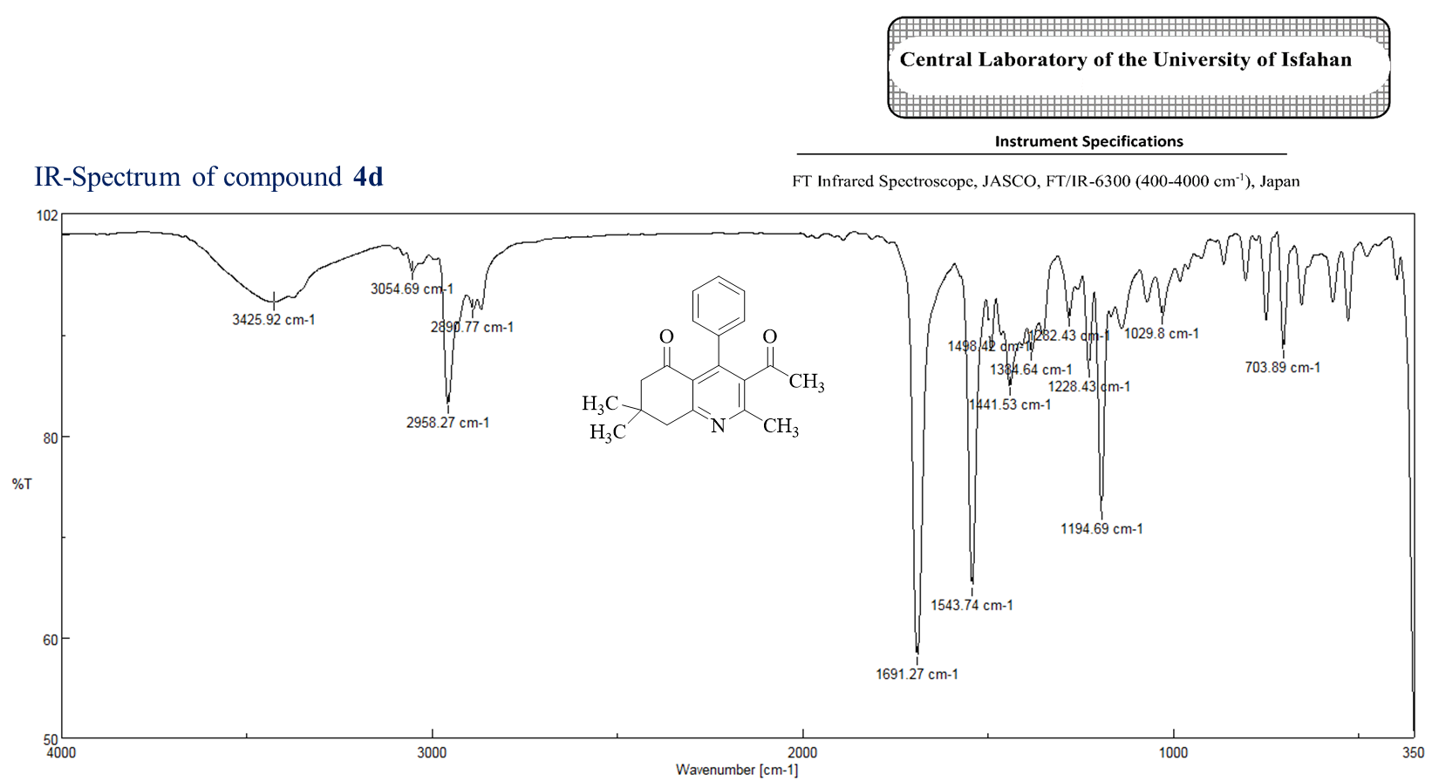

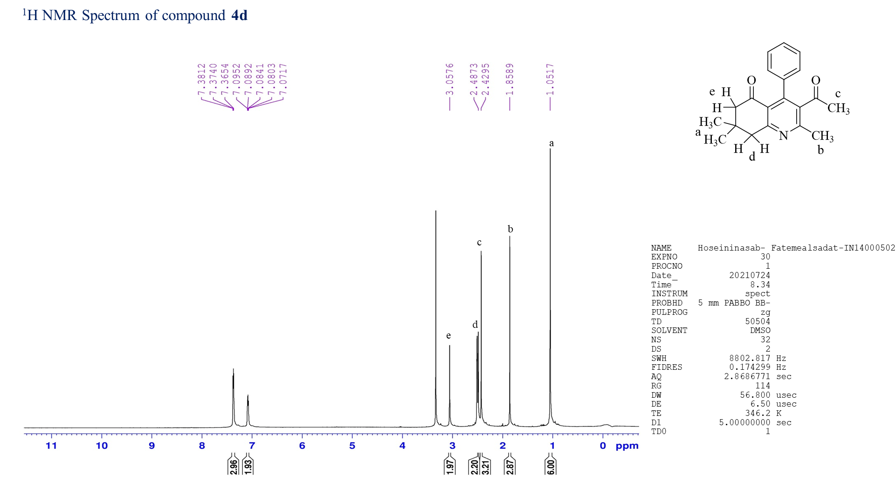

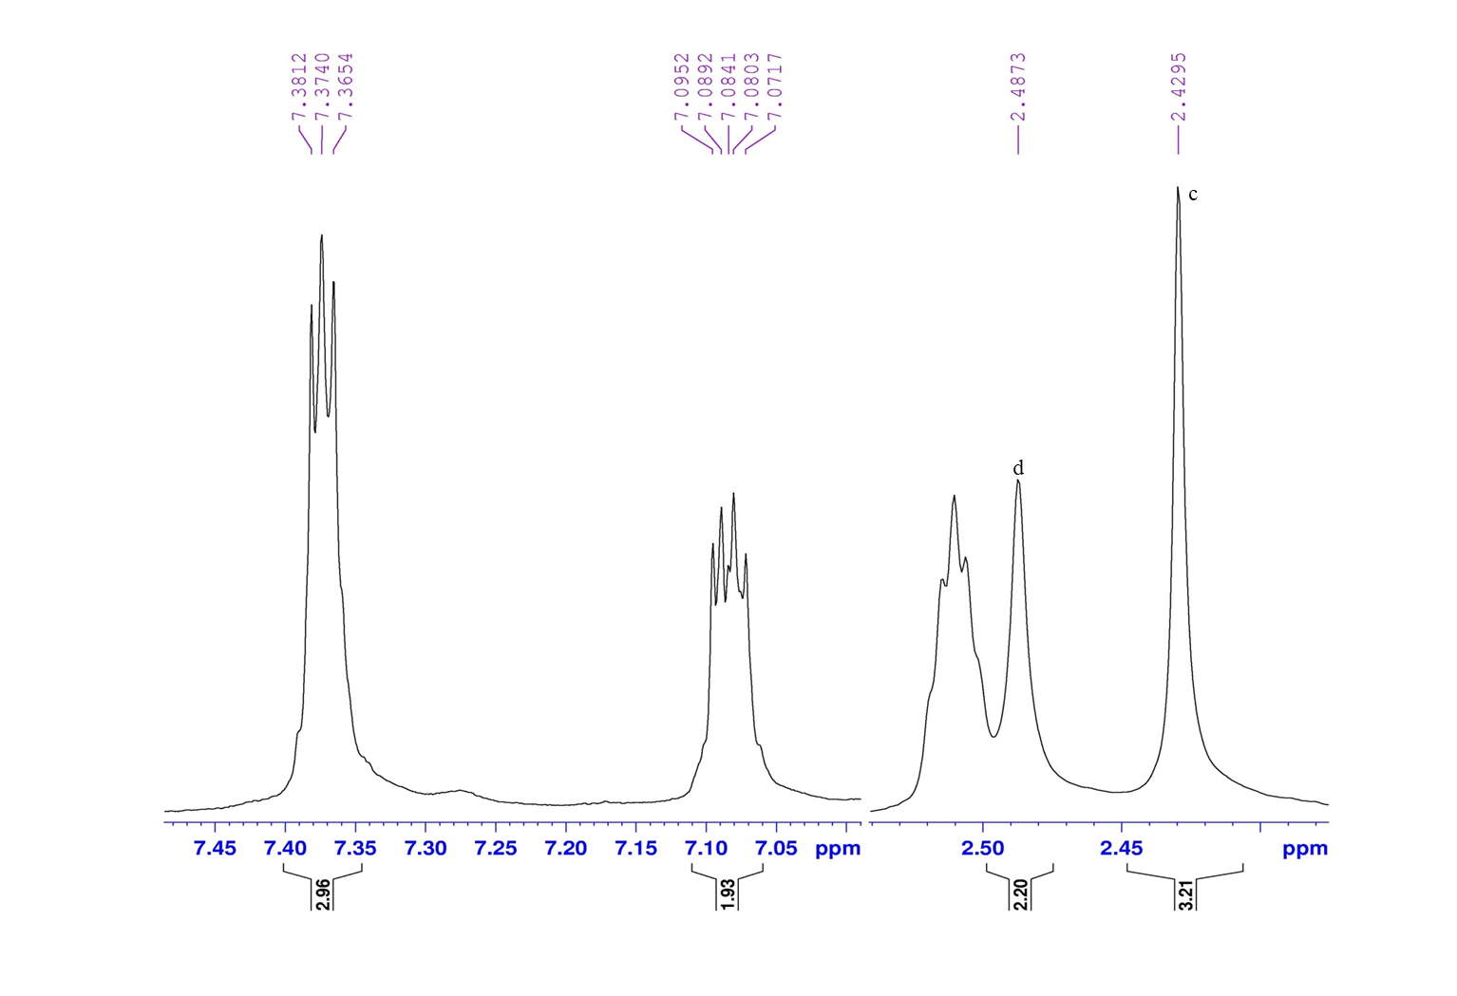

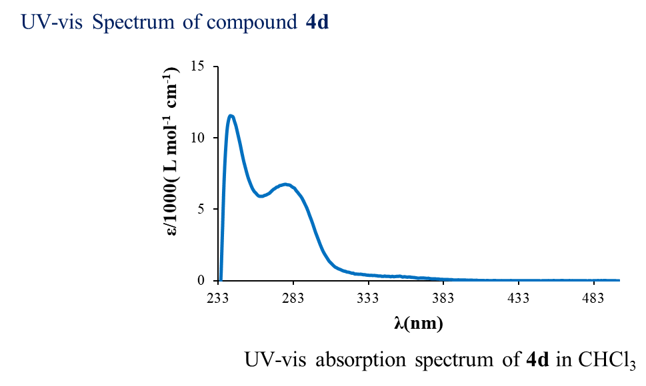

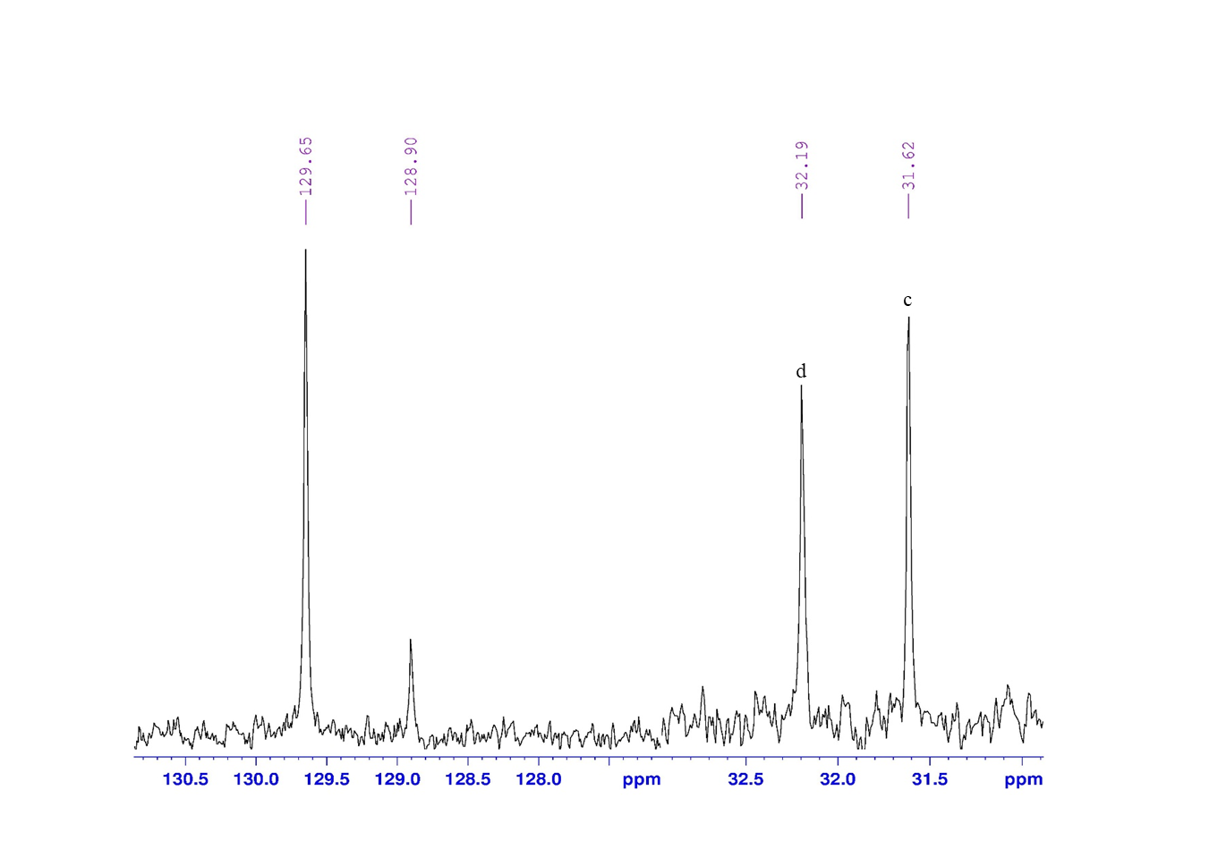

OCH₃
4CH₃

