Table 4. Comparison of the loss function of the proposed Bi-LSTM with other deep models
Models | Los Function
1st model | 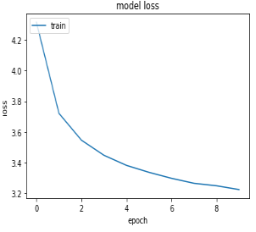
2nd model | 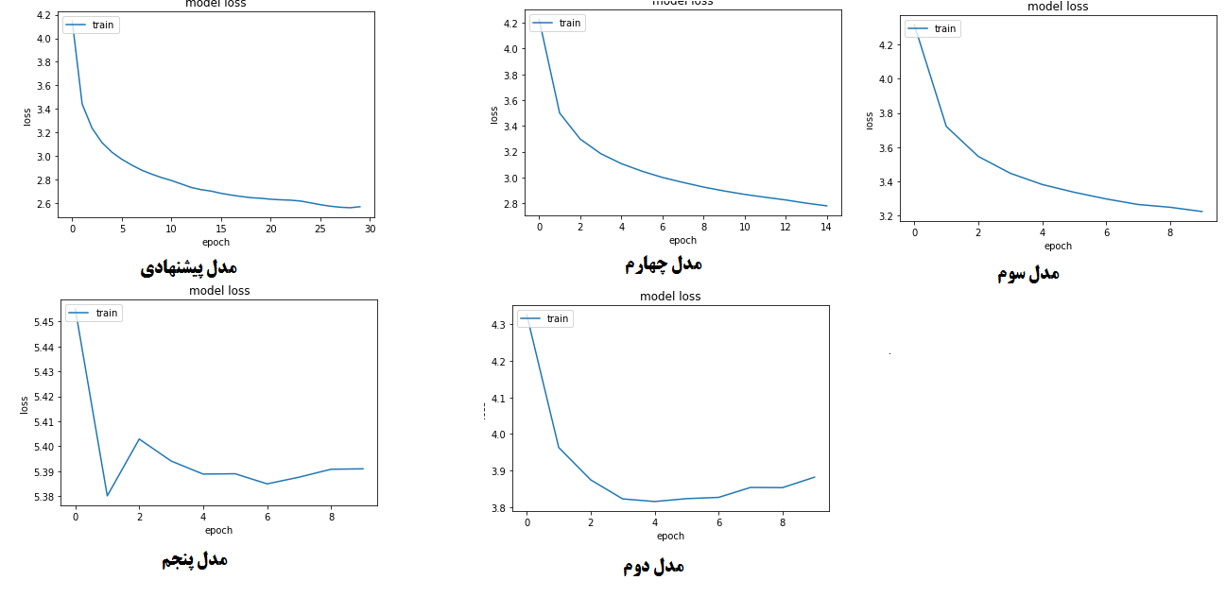
3rd model
4th model
5th model
The proposed model

Table 5. Examples of image captioning by the proposed Bi-LSTM neural network
True
True | 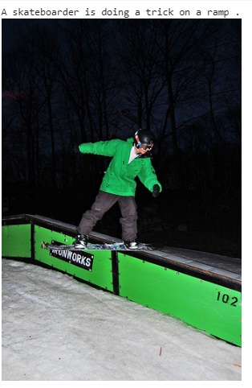
True | 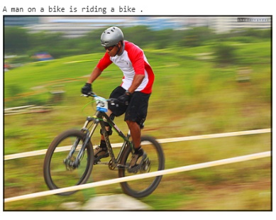
False | 