Liver transplantation in recipients with class Ⅲ obesity: post-transplant outcomes and weight gain

Daiki Soma¹, Yujin Park¹, Plamen Mihaylov¹, Burcin Ekser¹, Marwan Ghabril², Marco Lacerda², Naga Chalasani², Richard S Mangus¹, Chandrashekhar A Kubal¹

- Transplant Division, Department of Surgery, Indiana University School of Medicine, Indianapolis, Indiana, USA
- Transplant Hepatology, Division of Gastroenterology, Indiana University School of Medicine, Indianapolis, Indiana, USA

Corresponding Author
Dr. Daiki Soma, MD, Ph.D.
Clinical fellow
Department of Surgery, Division of transplantation
Indiana University
Indianapolis, 46202
Phone: 317 944 4370
Fax: 317 948 3268
Email: daiksoma@iu.edu

Abstract
Background
Over the past decades, there has been a dramatic increase in obesity in the United States. Several studies have reported conflicting results for the impact of obesity on outcomes of liver transplantation (LT). This study aims to assess severe obesity's impact on LT outcomes and changes in body mass index (BMI) after transplantation.
Methods
All adult LT performed at Indiana University Health University Hospital between July 2001 and December 2018 were reviewed. A retrospective analysis for identified 2024 patients was conducted. BMI of recipients is subdivided into underweight, normal, overweight, class Ⅰ obesity, class Ⅱ obesity, and class Ⅲ obesity (<18.5; 18.5-24.9; 25‐29.9; 30‐34.9; 35‐39.9; ≥40 kg/m2, respectively). Survival outcomes were compared between each group. Post-transplant BMI was followed up in a sub-group of patients receiving LT from January 2008 to December 2018. A retrospective analysis for identified 1004 patients was conducted.
Results
Among 2024 patients in the analytic cohort, 1.9% were underweight, 24.5% were normal, 32.6% were overweight, 25% were in class Ⅰ obesity, 9.3% were in class Ⅱ obesity, and 1.1% were in class Ⅲ obesity. There was no significant difference in patient and graft survival at 10-year follow-up with respect to recipient obesity. The 1, 3, 5, and 10-year graft and patient survivals in class Ⅲ obesity group were 97.0%, 92.1%, 87.0%, and 79.8% for patient survival and 94.4%, 85.1%, 79.8%, and 72.5% for graft survival.
Among 1004 patients identified in the sub-group, BMI of all groups except the underweight group declined in the first three months postoperatively. After the three months, the BMI of all groups except the class Ⅲ obesity group returned to the pre LT level by two years and reached a plateau by five years. In patients with class Ⅲ obesity, there was a significant increase in body weight after long-term follow-up.
Conclusion
In this study, class Ⅲ obesity is not associated with higher mortality. Obesity, including class Ⅲ obesity, should not be considered a contraindication to LT in the absence of other contraindications. Post-LT interventions are required to prevent significant weight gain in recipients with class Ⅲ obesity after transplantation.

Keyword
Liver transplantation outcome, body mass index, class Ⅲ obesity,

Background
Over the past decades, there has been a dramatic increase in obesity in the United States. In 2015 - 2016, the prevalence of obesity was 39.8 % in adults and 18.5 % in youth.¹
By 2030, estimates suggest that >50% of the US population will have a body mass index (BMI) ≥ 30 kg/m2.² Due to an increase in the prevalence of obesity, the number of obese patients undergoing liver transplantation (LT) and candidates awaiting LT is rising rapidly in the United States. The proportion of candidates with BMI ≥40 kg/m2 continued to increase, and approximately one in six candidates (17%) are with BMI ≥35 kg/m2.³
Several studies have reported conflicting results on the impact of severe obesity on outcomes of LT.^{4–15} Some centers and insurance payers have set a cutoff for BMI to list candidates at BMI >40 kg/m2. Currently, the American Association for the Study of Liver Disease considers morbid obesity (BMI ≥40 kg/m2) as a relative contraindication for liver transplantation since these patients are at higher risk of post‐transplant complications and mortality.¹⁶ The European Association for the Study of the Liver practice guidelines also recommends that a multidisciplinary team should carefully evaluate patients with a BMI ≥35 kg/m2 before listing.¹⁷ However, morbid obesity patients have higher waitlist mortality rates, and morbid obesity is an independent risk factor for acute-on-chronic liver failure.^{12,18,19} Based on this fact, some aggressive centers offer LT to carefully selected patients with morbid obesity.
Currently, the suitability of patients with morbid obesity for LT remains controversial. Furthermore, the post LT course of body weight in obese patients is not well characterized. The purpose of this study is to assess the impact of pre LT BMI on postoperative outcomes, including graft survival and patient survival and change in body weight post LT.

Method
Study population
This study was a single-center retrospective study. All adult LT, which were performed at Indiana University Health University Hospital between July 2001 and December 2018, were reviewed. Retrospective analysis of patient data from the transplant center database approved by the institutional review board. Pediatric recipients (<18 years), re-transplant candidates, and combined liver-kidney transplant recipients were excluded. Recipients were subdivided into six groups based on BMI at transplant: underweight, normal, overweight, class Ⅰ obesity, class Ⅱ obesity, and class Ⅲ obesity (<18.5; 18.5-24.9; 25‐29.9; 30‐34.9; 35‐39.9; ≥40 kg/m2, respectively). Post-transplant BMI was monitored in a sub-group of patients receiving LT from January 2008 to December 2018. BMI was not adjusted for ascites because the volume of ascites drained at the time of transplant did not differ significantly between groups.
Listing and preoperative management
Recipient listing for LT was according to standard criteria and protocols as established by our center and United Network for Organ Sharing. In our program, surgeons always evaluate pre-transplant patients carefully based on the body habitus and feasibility of liver transplantation from a surgical standpoint. Since obese patients have a higher risk of morbidity and mortality for the vascular disease after LT, all listed obese patients get coronary angiogram and stress test. In case of ≥50% stenosis in a major vessel (left anterior descending artery or right coronary artery) or critical disease defined as stenosis ≥ 70% in at least moderate-sized branch vessels, percutaneous coronary intervention was performed before LT.²⁰
Surgical procedure
Organ procurements for brain dead donor were performed using standard surgical techniques and cold preservations. The technique and optimization protocol of donor after cardiac death (DCD) liver procurement was previously described.^{21,22} The detail of recipient operation was described previously.²³ Briefly, our center applied the piggyback technique to preserve native vena cava without using a venovenous bypass.²⁴ During operation, we tried to maintain a central venous pressure less than 10mmHg. Before reperfusion, the liver grafts were routinely flushed with 3 L of albumin solution at room temperature through the portal vein. Hepatic artery anastomosis was performed after reperfusion of the portal vein. When the risk of coagulopathy was estimated to be high, or the sign of coagulopathy was seen during operation, aminocaproic acid (Amicar, 25mg/kg, 1-hour infusion) infusion was used²⁵ These patients were routinely sent to closed transplant intensive care unit (ICU).
Statistical analysis and endpoints
The primary endpoints were patient survival and graft survival after LT. The secondary outcomes were lengths of hospital and ICU stay. Kaplan-Meier method was used to estimate the graft and patient survival in each group. Log-rank test was used to analyze the differences in survival across groups. The association between BMI categories and patient survival and graft survival was assessed using multivariate Cox regression analysis. The multivariate Cox regression analysis included the potential confounding factors in the model (donor age, Model for end-stage liver disease (MELD) score, DCD, and year of transplant). The hazard ratio and its 95% confidence interval from both univariate and multivariate Cox proportional regression analysis are summarized and plotted. Mann-Whitney U test was used to analyze secondary outcomes between the class Ⅲ obesity group and others. Wilcoxon-Mann-Whitney test and Friedman test were used to compare the BMI changes among groups. P values were reported as statistically significant at <0.05 for all analyses. P values approximating 0.1 were described as a trend. All statistical analyses were conducted with SPSS MacOs version 26 (SPSS, Inc., Chicago, IL).

Results
Study population
A total of 2024 patients who underwent liver transplantation were included in the study. The percentages of patients in each BMI category were: 1.9% underweight, 24.5% normal, 32.6% overweight, 25% class Ⅰ obesity, 9.3% class Ⅱ obesity, and 1.1% class Ⅲ obesity. The median age was 55 years, 66.7 % were male, and the patients diagnosed with chronic hepatitis C, nonalcoholic steatohepatitis (NASH), and hepatocellular carcinoma (HCC) were 37%, 17%, and 20.5%. The median follow-up period was 5.5 years. The median length on the waitlist was 41 days. Demographics and clinical characteristics of patients at transplant are summarized in Table 1.
Table 1 Demographics and clinical characteristics of recipients
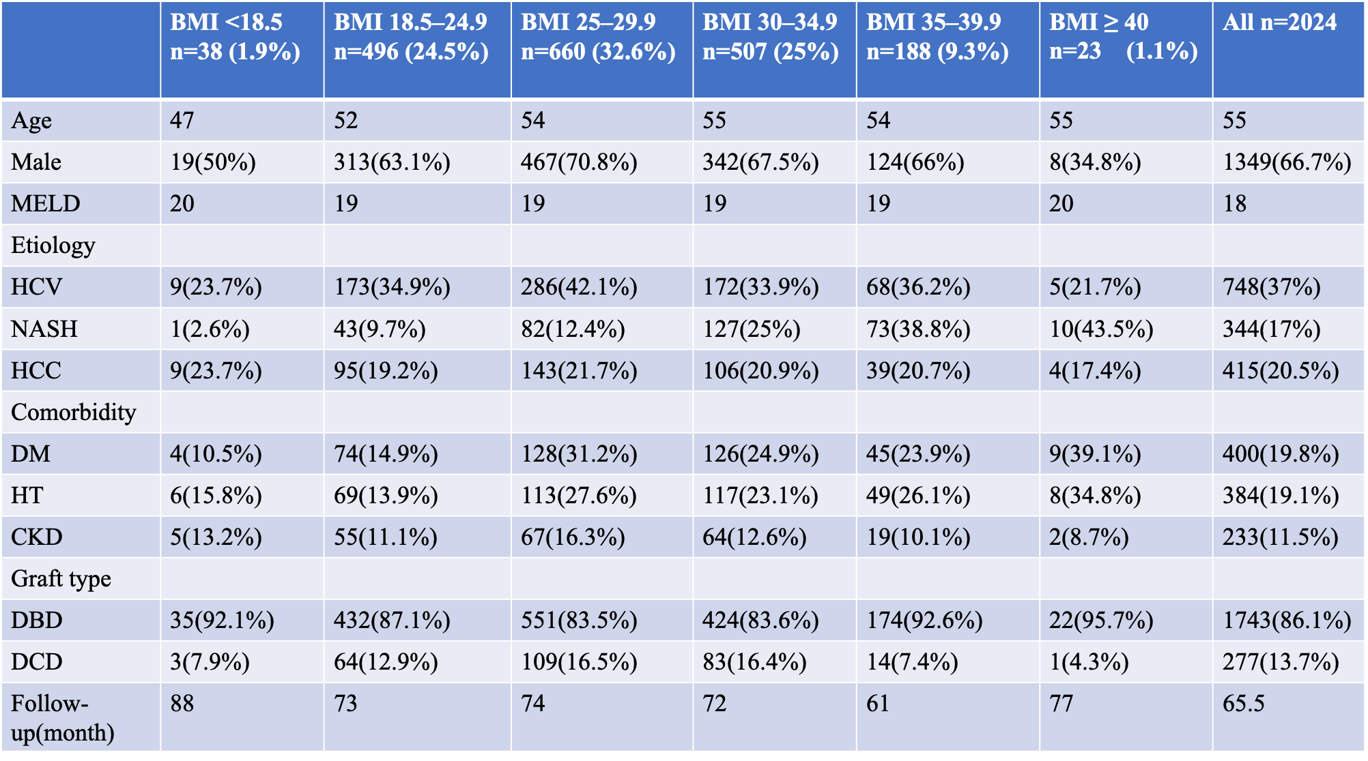
Legend
Continuous variables were expressed as a median. Abbreviations: BMI-body mass index; MELD-model for end-stage liver disease; HCV- hepatitis C virus; NASH-non-alcoholic steatohepatitis; HCC-hepatocellular carcinoma; HTN-arterial hypertension; DM-diabetes mellitus; CKD-chronic kidney disease; DBD-donor after brain death; DCD-donor after circulatory death

Impact of morbid obesity on the outcome of LT
Primary and secondary outcomes are summarized in Table 2. Patient and graft survival for recipients with class Ⅲ obesity were comparable with other groups (log-rank P=0.35 & 0.21, respectively). (Figure 1) Numerically, the patient survival for recipients with class Ⅲ obesity was 97.0%, 92.1%, 87.0%, and 79.8% at 1, 3, 5, and 10 years. The graft survival for recipients with class 3 obesity was 94.4%, 85.1%, 79.8%, and 72.5% at 1, 3, 5, and 10 years. By Cox regression analysis, there was no significant difference in patient and graft survival in each BMI group. The class Ⅲ obesity group had a similar length of hospital and ICU stay with other BMI groups (Man-Whitney U, Length of hospital stay: P=0.38, Length of ICU stay: P=0.13).
Table 2 Patient and graft survival
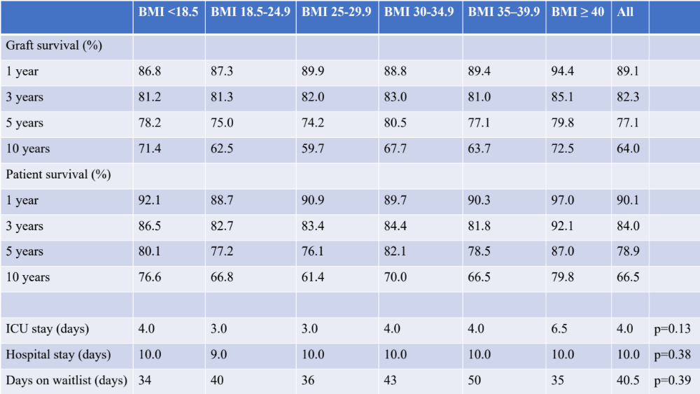
Legend
Continuous variables were expressed as a median. Abbreviations: BMI-body mass index; ICU-intensive care unit

Post LT weight gain
A total of 1004 patients were included in the sub-group analysis. The BMI follow-up data (Figure 2) showed that all groups' mean BMI except for the underweight group decreased significantly in the first three months after LT. After this initial three month period, all groups' BMI except the class Ⅲ obesity group returned to the pre LT level within two years and reached a plateau at 3 to 5 years. In patients with class Ⅲ obesity, there was a significant increase in the BMI at long-term follow up with BMI of 45.51 Kg/m2 from pre LT BMI of 41.3 Kg/m2; P=0.04).

Discussion
In this single-center study, we found out that morbid obesity is not associated with inferior post-liver transplantation survival outcomes when compared with non-obese patients. The 10-year patient survival for recipients with the class Ⅲ obesity group was 80%. Our study is the largest single-center studies in the US with long-term follow up. Contrary to our findings, Conzen et al reported recipients with BMI of >40 kg/m² had significantly reduced 5-year graft (49.0% versus 75.8%; P < 0.02) and patient (51.3% versus 78.8%; P < 0.01) survival.⁹ Their BMI of >40 kg/m² cohort includes 26 patients consisting of 3.3 % of their entire cohorts. Giorgakis et al. reported mean graft survival and patient survival of recipients with BMI <35 kg/m2 and BMI 35≥ kg/m2 were similar with 10-year follow-up. However, this study did not evaluate outcomes for recipients with BMI >40 kg/m².²⁶ Until now, many single-center studies and national database studies have evaluated the impact of obesity on outcomes after LT. Nevertheless, no other single-center study has evaluated the outcomes in recipients with class Ⅲ obesity undergoing LT. Moreover, national database studies are not ideal for addressing this specific issue due to the heterogeneity in listing and transplantation practices in obese patients.
At our center, class Ⅲ obese patients were carefully selected from a surgical standpoint. Surgeons examined the body habitus of patients with class Ⅲ obesity for operative suitability. All obese patients were encouraged to lose weight through dietary modifications and exercise. Transplant dieticians saw all obese and malnourished patients. However, a strict weight loss criterion for candidacy was not used. In general, obese patients with portal vein thrombosis or with anticipated complicated surgery were considered high risk. This careful selection criteria in obese candidates could have contributed to better outcomes in our study. Therefore, a selection bias may be present by which obese patients with other adverse factors may have been excluded and never added to the waiting list. Such a bias would have the effect of reducing the measured differences in outcome among BMI categories. In addition to the stricter criteria for listing, our center adopted aggressive coronary artery disease (CAD) screening with cardiac catheterization, which is associated with the low rate of myocardial infarction and cardiac mortality after LT.^{20,27} Since CAD is independent predictors of poor outcome after liver transplantation²⁸, these center specific valid patient screening and intervention prior LT could lead to a better outcome in class 3 obesity group.
About post LT weight gain, although we observed a BMI increase in our class Ⅲ obesity group, long-term graft and patient survival were comparable with other groups. The etiology of ESLD varied across the BMI groups. In our cohorts, NASH was dominant in the class Ⅲ obese group. Lattanzi et al. reported that patients' BMI transplanted for NASH increased progressively at 3-5 years after LT. On the other hand, the BMI of patients transplanted for other etiologies reached the pre-LT level at three years and plateaued after that.²⁹ Thus, the reason for remote BMI increase in our class Ⅲ obesity group can be explained by the dominancy of NASH etiology in this group. From previous studies, an increase of post-LT BMI in obese patients is associated with an inferior outcome. Patients with obesity tend to gain weight and develop metabolic syndrome after LT.³⁰ LT recipients who develop posttransplant metabolic syndrome have a higher risk of vascular-related morbidity and mortality.³¹ The increased incidence of posttransplant DM is associated with a worse outcome of LT.³² Currently, our institution manages post-LT obese patients with active weight loss programs, including standard lifestyle advice, dietary modification, and physical therapy. However, emerging evidence showed that office-based lifestyle intervention was ineffective in achieving weight loss in LT recipients.³³ Thus, even our study showed the long-term graft and patient survival of the class Ⅲ obesity group was comparable with other groups, we should consider more aggressive post LT intervention to prevent long-term BMI increase for the class Ⅲ obesity group.
This study has several limitations. First, this is a single-center study, and the number of recipients is small compared to national registry studies. It may be underpowered to detect smaller differences of outcome in each BMI group. These findings may also reflect our center-specific technique, management, and recipient selection process and may not be able to generalize to other centers. Second, we only studied BMI ≥ 40 Kg/m2 recipients that were transplanted since we had to have the outcomes of these transplants, and thus our results may not generalize to every potential BMI ≥ 40 Kg/m2 recipients. Third, the number of patients with BMI ≥ 40 Kg/m2 in our cohort consists of only 1.1 % of the whole cohort. Thus, the outcomes can be purely based on this bias.

Conclusion
This study showed that morbid obesity in cirrhotic patients is not associated with higher post-transplantation mortality. Obesity, including class Ⅲ obesity, should not be considered to be a contraindication to liver transplantation in the absence of other risk factors.

Abbreviations
LT, Liver transplantation
BMI, Body mass index
DCD, Donor after cardiac death
ICU, Intensive care unit
MELD, Model for end-stage liver disease
NASH, Nonalcoholic steatohepatitis
HCC, Hepatocellular carcinoma
CAD, Coronary artery disease

Declarations
Ethics approval and consent to participate
The Institutional Review Boards of the Indiana University Health University Hospital approved the study with written informed consent. (Protocol #: 1011003619R007)
Consent for publication
Written informed consents were obtained from the patients for publication of this
research article.
Availability of data and materials
The datasets used and analyzed during the current study are available from the corresponding author on reasonable request.
Competing interests
The authors declare that they have no competing interests.
Funding
No funding was received for the preparation of this manuscript.
Authors' contributions
DS: Participated in data collection, data analysis, and writing of the manuscript.
RSM: Participated in data collection and data analysis.
YP: Participated in collecting references and writing of the manuscript.
CK: Participated in data collection, data analysis, and writing of the manuscript.
PM, BE, MG, NG, ML: Involved in interpreting data and critical revision of the manuscript for valuable intellectual contents.
All authors have read and approved the manuscript.
Acknowledgments
Not applicable

References
1. Hales CM. Prevalence of Obesity Among Adults and Youth: United States, 2015–2016. 2017;(288):8.
2. Ward ZJ, Bleich SN, Cradock AL, et al. Projected U.S. State-Level Prevalence of Adult Obesity and Severe Obesity. N Engl J Med. 2019;381(25):2440-2450. doi:10.1056/NEJMsa1909301
3. Kwong A, Kim WR, Lake JR, et al. OPTN/SRTR 2018 Annual Data Report: Liver. Am J Transplant. 2020;20(s1):193-299. doi:10.1111/ajt.15674
4. Sawyer RG, Pelletier SJ, Pruett TL. Increased early morbidity and mortality with acceptable long-term function in severely obese patients undergoing liver transplantation. Clin Transplant. 1999;13(1pt2):126-130. doi:10.1034/j.1399-0012.1999.130111.x
5. Fujikawa T, Fujita S, Mizuno S, et al. Clinical and Financial Impact of Obesity on the Outcome of Liver Transplantation. Transplant Proc. 2006;38(10):3612-3614. doi:10.1016/j.transproceed.2006.10.188
6. Hakeem AR, Cockbain AJ, Raza SS, et al. Increased morbidity in overweight and obese liver transplant recipients: A single-center experience of 1325 patients from the United Kingdom. Liver Transpl. 2013;19(5):551-562. doi:10.1002/lt.23618
7. Perez-Protto SE, Quintini C, Reynolds LF, et al. Comparable graft and patient survival in lean and obese liver transplant recipients. Liver Transpl. 2013;19(8):907-915. doi:10.1002/lt.23680
8. Bambha KM, Dodge JL, Gralla J, Sprague D, Biggins SW. Low, rather than high, body mass index confers increased risk for post-liver transplant death and graft loss: Risk modulated by model for end-stage liver disease. Liver Transpl. 2015;21(10):1286-1294. doi:10.1002/lt.24188
9. Conzen KD, Vachharajani N, Collins KM, et al. Morbid obesity in liver transplant recipients adversely affects longterm graft and patient survival in a single-institution analysis. HPB. 2015;17(3):251-257. doi:10.1111/hpb.12340
10. Saab S, Lalezari D, Pruthi P, Alper T, Tong MJ. The impact of obesity on patient survival in liver transplant recipients: a meta-analysis. Liver Int. 2015;35(1):164-170. doi:10.1111/liv.12431
11. Singhal A, Wilson GC, Wima K, et al. Impact of recipient morbid obesity on outcomes after liver transplantation. Transpl Int. 2015;28(2):148-155. doi:10.1111/tri.12483
12. Schlansky B, Naugler WE, Orloff SL, Enestvedt CK. Higher Mortality and Survival Benefit in Obese Patients Awaiting Liver Transplantation. Transplantation. 2016;100(12):2648-2655. doi:10.1097/TP.0000000000001461
13. Shi Y, Huang B, Deng R, Ma Y. The Association of obesity with vascular complications after liver transplantation. BMC Gastroenterol. 2019;19(1):39. doi:10.1186/s12876-019-0954-8
14. Yu JW, Gupta G, Kang L, et al. Obesity does not significantly impact outcomes following simultaneous liver kidney transplantation: review of the UNOS database - a retrospective study. Transpl Int Off J Eur Soc Organ Transplant. 2019;32(2):206-217. doi:10.1111/tri.13352
15. Satapathy SK, Jiang Y, Agbim U, et al. Posttransplant Outcome of Lean Compared With Obese Nonalcoholic Steatohepatitis in the United States: The Obesity Paradox. Liver Transplant Off Publ Am Assoc Study Liver Dis Int Liver Transplant Soc. 2020;26(1):68-79. doi:10.1002/lt.25672
16. Martin P, DiMartini A, Feng S, Brown R, Fallon M. Evaluation for liver transplantation in adults: 2013 practice guideline by the American Association for the Study of Liver Diseases and the American Society of Transplantation. Hepatology. 2014;59(3):1144-1165. doi:10.1002/hep.26972
17. EASL Clinical Practice Guidelines: Liver transplantation. J Hepatol. 2016;64(2):433-485. doi:10.1016/j.jhep.2015.10.006
18. Kardashian AA, Dodge JL, Roberts J, Brandman D. Weighing the risks: Morbid obesity and diabetes are associated with increased risk of death on the liver transplant waiting list. Liver Int. 2018;38(3):553-563. doi:10.1111/liv.13523
19. Sundaram V, Jalan R, Ahn JC, et al. Class III obesity is a risk factor for the development of acute-on-chronic liver failure in patients with decompensated cirrhosis. J Hepatol. 2018;69(3):617-625. doi:10.1016/j.jhep.2018.04.016
20. Kutkut I, Rachwan RJ, Timsina LR, et al. Pre-Liver Transplant Cardiac Catheterization Is Associated With Low Rate of Myocardial Infarction and Cardiac Mortality. Hepatol Baltim Md. Published online November 7, 2019. doi:10.1002/hep.31023
21. Kubal C, Mangus R, Fridell J, et al. Optimization of Perioperative Conditions to Prevent Ischemic Cholangiopathy in Donation After Circulatory Death Donor Liver Transplantation. Transplantation. 2016;100(8):1699–1704. doi:10.1097/TP.0000000000001204
22. Mihaylov P, Mangus R, Ekser B, et al. Expanding the Donor Pool With the Use of Extended Criteria Donation After Circulatory Death Livers. Liver Transpl. Published online July 2, 2019:lt.25462. doi:10.1002/lt.25462
23. Mangus RS, Kinsella SB, Nobari MM, et al. Predictors of Blood Product Use in Orthotopic Liver Transplantation Using the Piggyback Hepatectomy Technique. Transplant Proc. 2007;39(10):3207-3213. doi:10.1016/j.transproceed.2007.09.029
24. Mangus RS, Fridell JA, Vianna RM, et al. Severe Hypernatremia in Deceased Liver Donors Does Not Impact Early Transplant Outcome. Transplantation. 2010;90(4):438–443. doi:10.1097/TP.0b013e3181e764c0
25. Mangus RS, Kinsella SB, Fridell JA, et al. Aminocaproic Acid (amicar) as an alternative to aprotinin (trasylol) in liver transplantation. Transplant Proc. 2014;46(5):1393-1399. doi:10.1016/j.transproceed.2014.04.006
26. Giorgakis E, Tedeschi M, Bonaccorsi-Riani E, et al. The Effect of Recipient Body Mass Index and Its Extremes on Survival and Graft Vascular and Biliary Complications After Liver Transplantation: A Single Center Retrospective Study. Ann Transplant. 2017;22:611-621. doi:10.12659/aot.903475
27. Maddur H, Bourdillon PD, Liangpunsakul S, et al. Role of cardiac catheterization and percutaneous coronary intervention in the preoperative assessment and management of patients before orthotopic liver transplantation. Liver Transplant Off Publ Am Assoc Study Liver Dis Int Liver Transplant Soc. 2014;20(6):664-672. doi:10.1002/lt.23873
28. Yoo HY, Molmenti E, Thuluvath PJ. The effect of donor body mass index on primary graft nonfunction, retransplantation rate, and early graft and patient survival after liver transplantation. Liver Transpl. 2003;9(1):72-78. doi:10.1053/jlts.2003.50006
29. Lattanzi B, D'Ambrosio D, Tavano D, et al. Weight Gain and De Novo Metabolic Disorders after Liver Transplantation. Nutrients. 2019;11(12):3015. doi:10.3390/nu11123015
30. Pagadala M, Dasarathy S, Eghtesad B, McCullough AJ. Posttransplant metabolic syndrome: an epidemic waiting to happen. Liver Transplant Off Publ Am Assoc Study Liver Dis Int Liver Transplant Soc. 2009;15(12):1662-1670. doi:10.1002/lt.21952
31. Laryea M, Watt KD, Molinari M, et al. Metabolic syndrome in liver transplant recipients: prevalence and association with major vascular events. Liver Transplant Off Publ Am Assoc Study Liver Dis Int Liver Transplant Soc. 2007;13(8):1109-1114. doi:10.1002/lt.21126
32. Watt KDS, Pedersen RA, Kremers WK, Heimbach JK, Charlton MR. Evolution of causes and risk factors for mortality post-liver transplant: results of the NIDDK long-term follow-up study. Am J Transplant Off J Am Soc Transplant Am Soc Transpl Surg. 2010;10(6):1420-1427. doi:10.1111/j.1600-6143.2010.03126.x
33. Patel SS, Siddiqui MB, Chadrakumaran A, et al. Office-Based Weight Loss Counseling Is Ineffective in Liver Transplant Recipients. Dig Dis Sci. Published online August 22, 2019. doi:10.1007/s10620-019-05800-6

Figure.1
Legend
Overall patient survival at10 years follow-up (A) and graft survival (B)
Figure.2
Legend
BMI trend after liver transplantation at 5 years follow-up

