Supplementary information
Stachys tibetica derived silver nanoparticles: A robust multifunctional material for enhanced biological activity and photocatalytic properties
Naseer Ahmad Dar, Parvaiz A Dar, Mahpara qadir, and Wajaht A. Shah^{a*}
ªDepartment of Chemistry, University of Kashmir, Hazratbal, Srinagar, 190006, Jammu and Kashmir`, India,
*Corresponding Author: Prof. Syed Wajaht Amin Shah
Department of Chemistry, University of Kashmir, Hazratbal, Srinagar 190006, Jammu and Kashmir, India,
E-mail: doctorwajaht@gmail.com Tel: +919419054484/ +917006191306


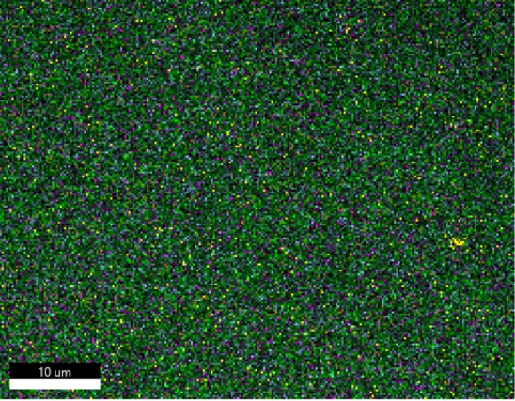

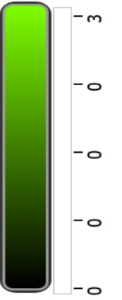
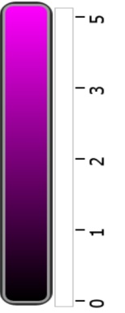
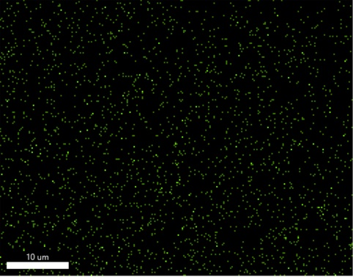
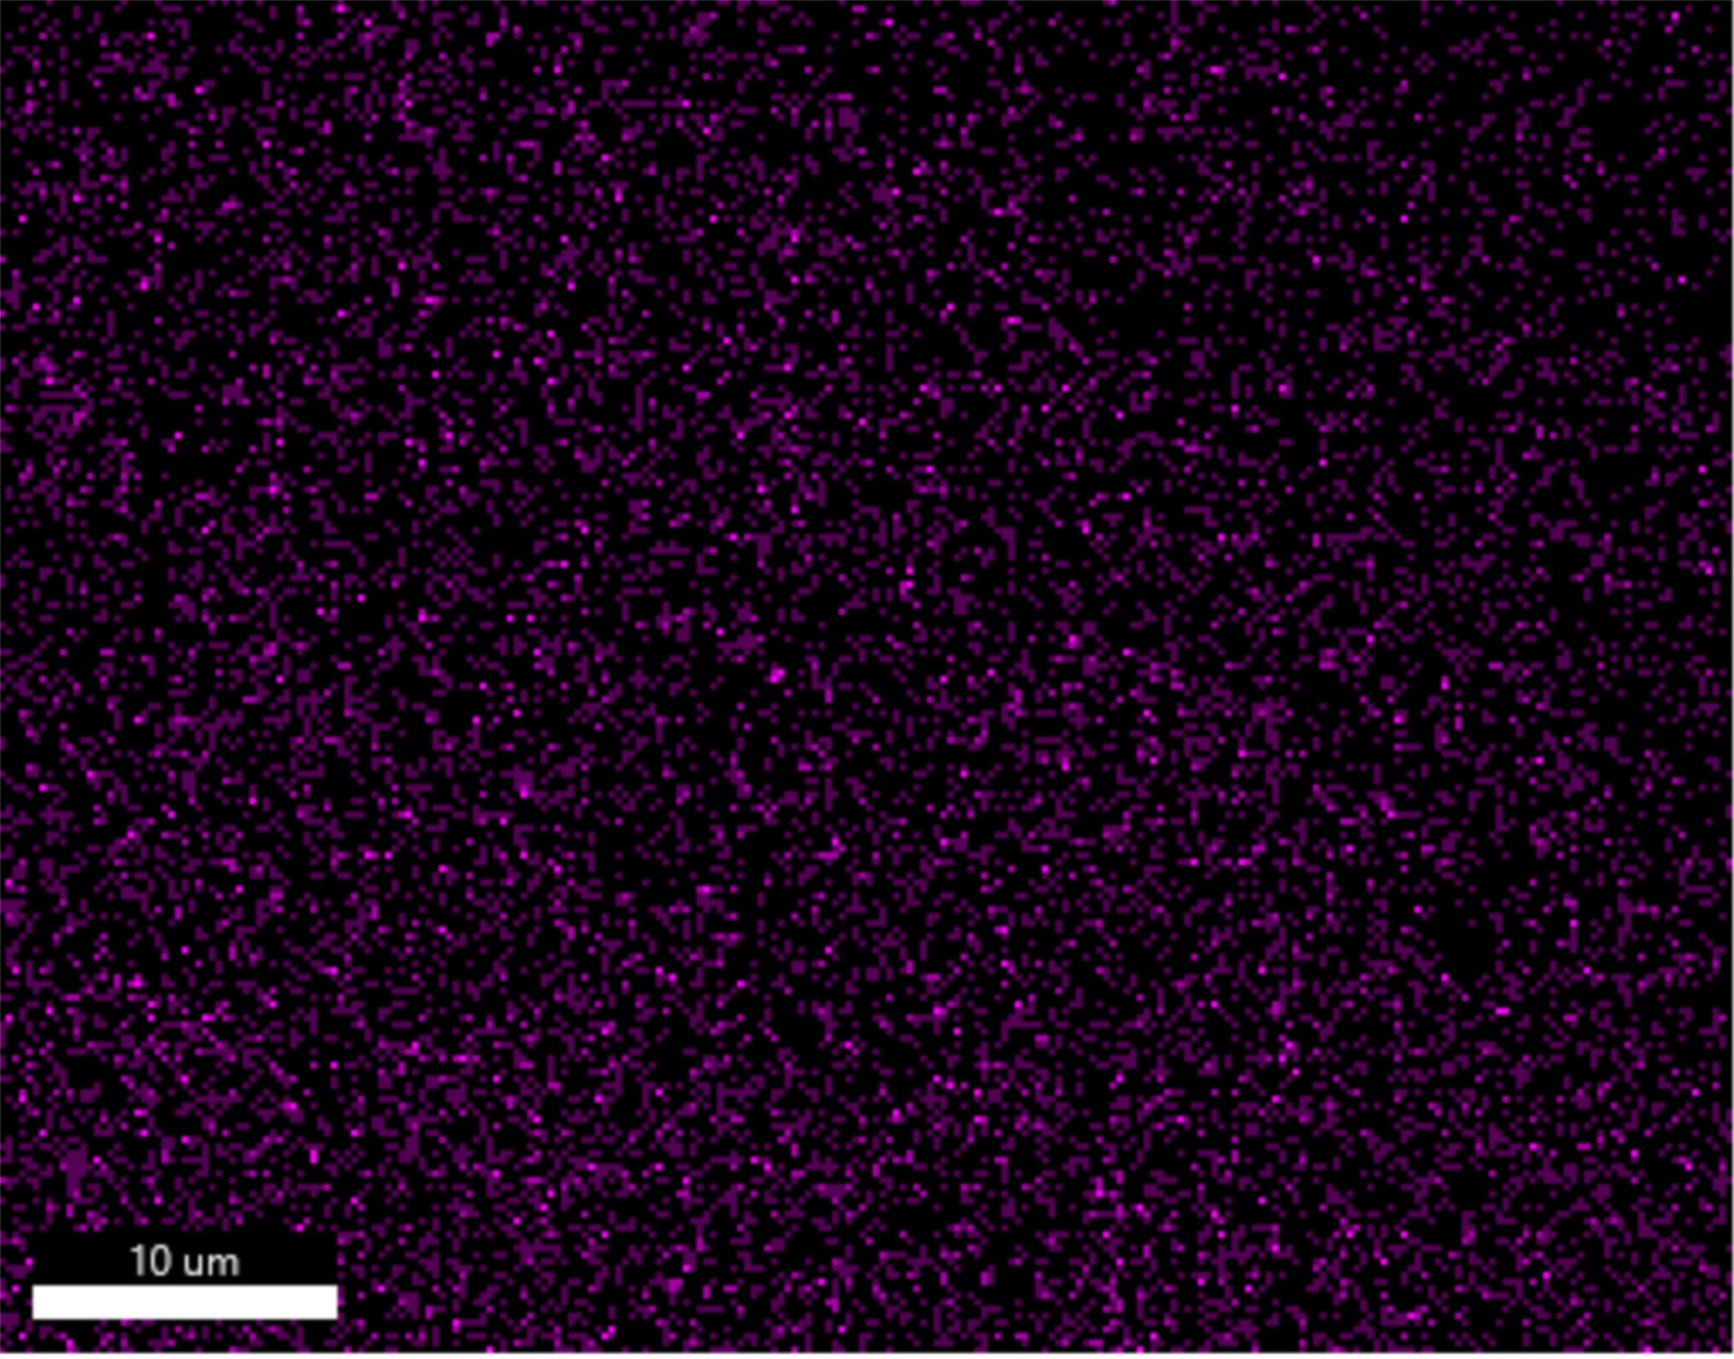
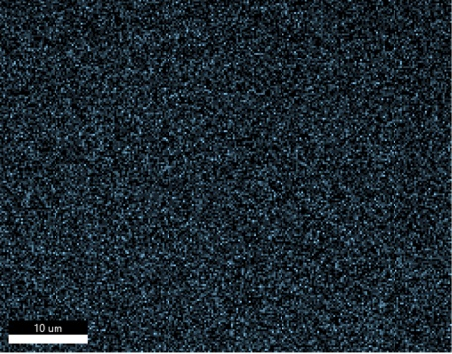
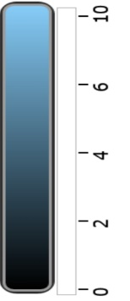
C K_ROI (5) N K_ROI (3)
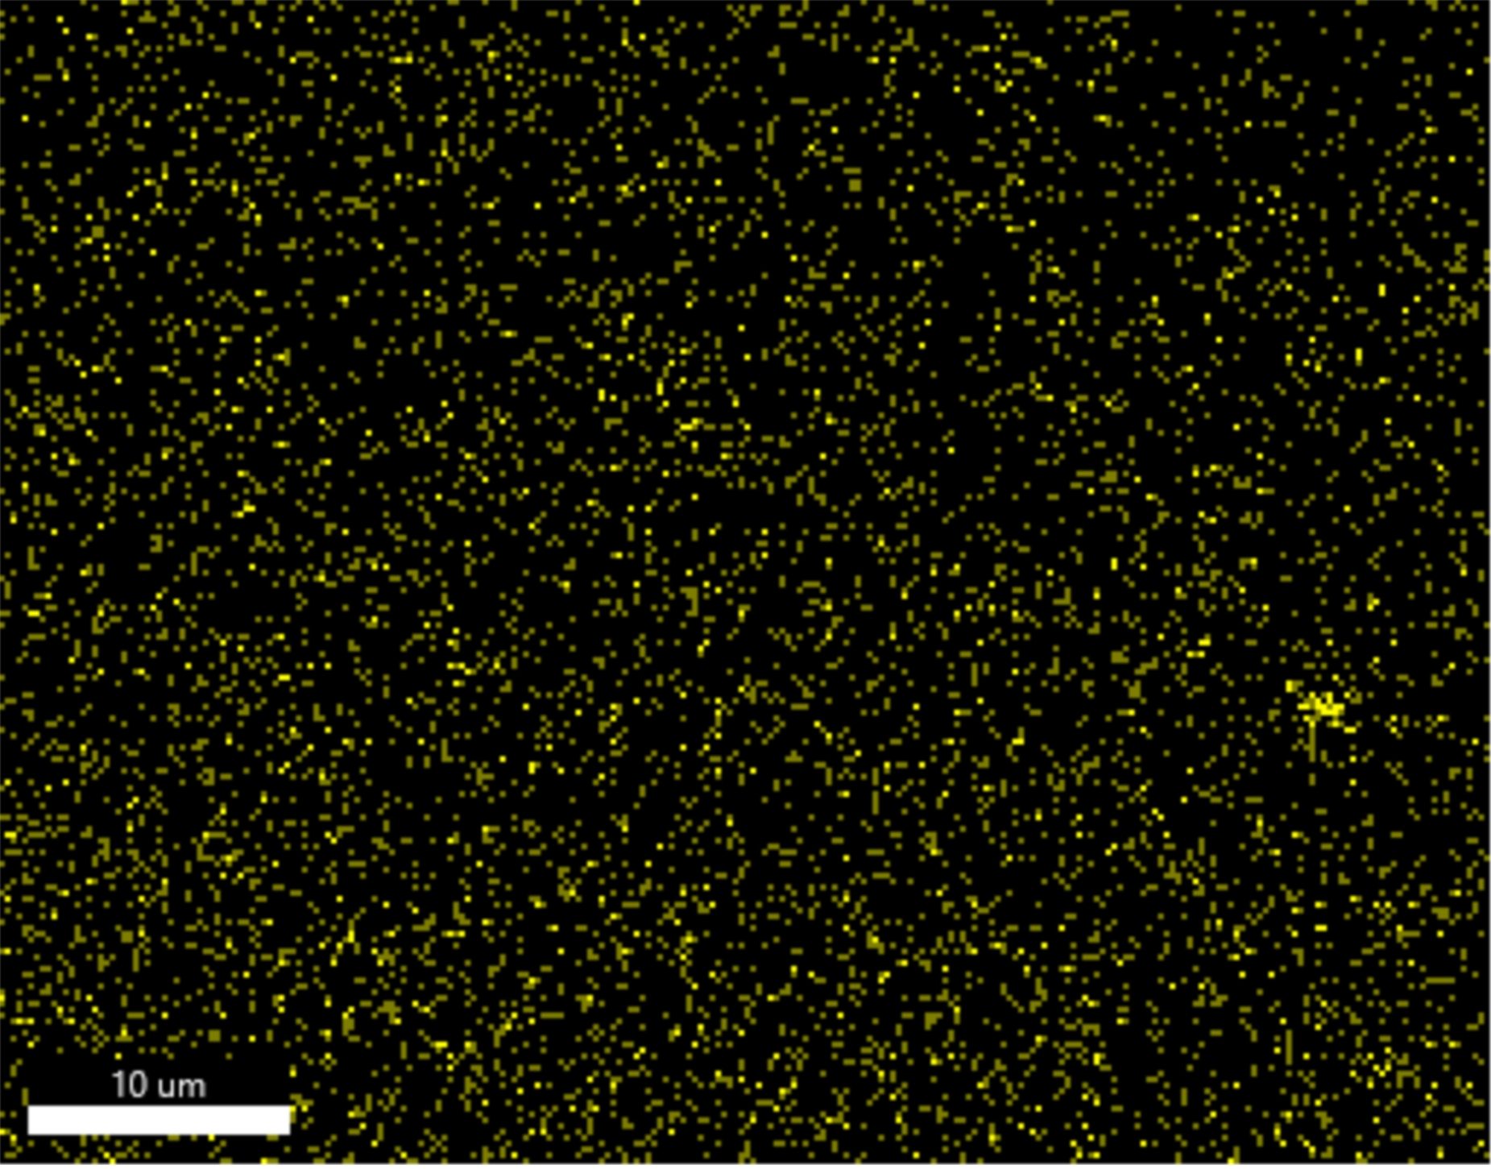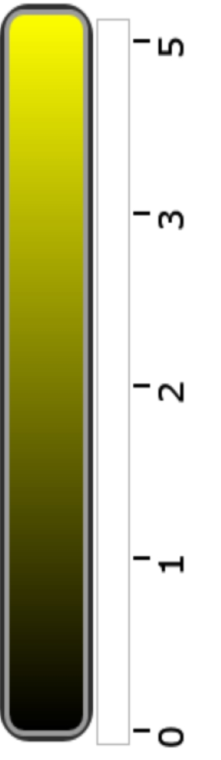
O K_ROI (5)
Cl K_ROI (10)
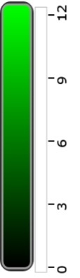
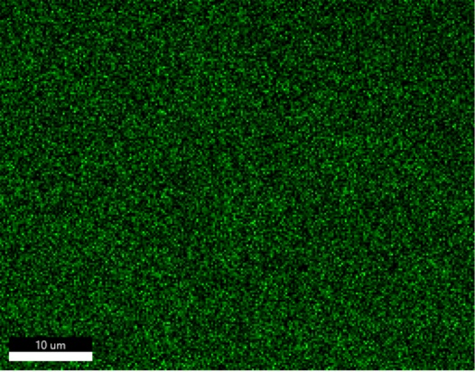

Ag l ROI (12)

S1. Elemental mapping images of Carbon,Nitrogen,Oxygen,Silver and chlorine.

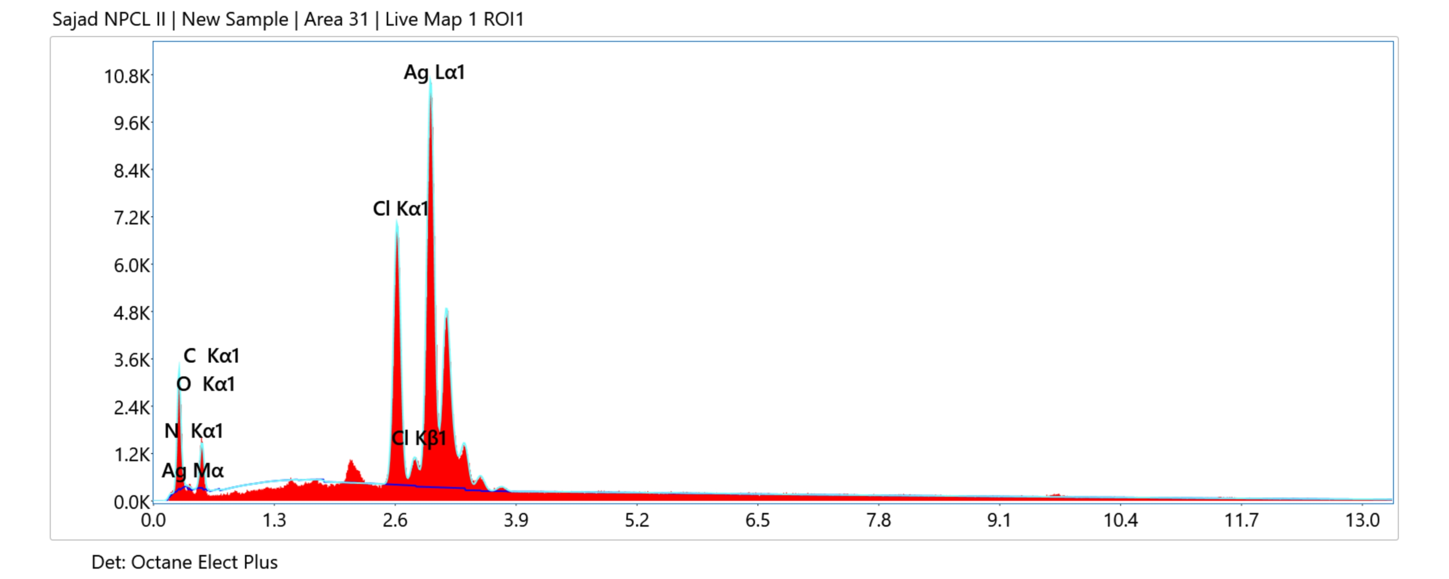
Element | Weight % | MDL | Atomic % | Net Int. | Error % | R | A | F
C K | 34.7 | 0.59 | 67.7 | 168.8 | 11.3 | 0.8238 | 0.0888 | 1.0000
N K | 0.7 | 0.74 | 1.2 | 3.3 | 64.2 | 0.8318 | 0.0423 | 1.0000
O K | 10.6 | 0.55 | 15.5 | 77.2 | 12.8 | 0.8384 | 0.0518 | 1.0000
Cl K | 8.9 | 0.10 | 5.9 | 722.1 | 3.7 | 0.8860 | 0.8087 | 1.0475
Ag L | 45.1 | 0.23 | 9.8 | 1250.9 | 3.3 | 0.8931 | 0.8164 | 1.0036
S2. EDAX results of AgNp and quantitave results.
S3. Radical scavenging activity of AgNp , Plant extract and ascorbic acid(results presented as average of three readings)
Sample | Concentration(µg/ml) | % inhibition
1.AgNp | 25 | 34.5
1.AgNp | 50 | 36.2
1.AgNp | 100 | 48.2
1.AgNp | 150 | 51.7
1.AgNp | 200 | 67.2
1.AgNp | 250 | 82.7
1.AgNp | 300 | 84.4
1.AgNp | 350 | 89.6
2.Plant Extract | 25 | 8
2.Plant Extract | 50 | 17.2
2.Plant Extract | 100 | 27.2
2.Plant Extract | 150 | 31
2.Plant Extract | 200 | 34.4
2.Plant Extract | 250 | 48.9
2.Plant Extract | 300 | 51.3
2.Plant Extract | 350 | 62
4. Ascorbic Acid | 25 | 32.4
4. Ascorbic Acid | 50 | 44.6
4. Ascorbic Acid | 100 | 62
4. Ascorbic Acid | 150 | 63.7
4. Ascorbic Acid | 200 | 68.4
4. Ascorbic Acid | 250 | 70.6
4. Ascorbic Acid | 300 | 72.4
4. Ascorbic Acid | 350 | 75.8

S4: (a and b) represent MIC determination of E.Coli(G-) and S. Aeureus (G +) bacteria.

S5. Antibacterial properties of AgNp(Stachys Tibetica) using Agar well diffusion method.
 | Percentage(%) inhibition(Average+SD)
 | AgNp | Plant Extract | Positive control  (Streptomycin) | Negative Control(DMSO)
Bacillus Cereus | 12.1±1 | 2±1 | 23.9±1 | 0±0
Pseudomonas | 11.8±1 | 1±1 | 20.8±1 | 0±0
Escherichia coli | 9.8±1 | 4±1 | 20.9±1 | 0±0
S.Aeureus | 7.2±1 | 5±1 | 10.1±1 | 0±0
(a) antibacterial activity of B. Cereus
(b) antibacterial activity of Pseudomonas
(d) antibacterial activity of E.Coli
(e) antibacterial activity of S.Aeureus

