Supplemental Information
Reuben G. Biel and Sally D. Hacker. Climate change alters the interaction of two invasive beachgrasses with implications for range shifts and coastal dune functions.

Table S1. Monthly mean daily maximum air temperature (°C) at meteorological observation stations along the US Pacific coast, including Westport, WA (NOAA Station WPTW1), Newport, OR (NOAA Station NWPO3), San Francisco, CA (NOAA Station FTPC1), and Santa Monica, CA (NOAA Station ICAC1). Date range: 2010-2016.
Month | Westport, WA | Newport, OR | San Francisco, CA | Santa Monica, CA
January | 9.4 | 11.0 | 13.7 | 18.4
February | 10.1 | 10.7 | 14.6 | 17.3
March | 11.2 | 11.0 | 14.9 | 16.8
April | 12.2 | 11.3 | 15.0 | 17.1
May | 13.9 | 12.5 | 14.9 | 17.6
June | 15.6 | 13.6 | 15.5 | 18.3
July | 16.5 | 14.2 | 15.7 | 19.7
August | 17.5 | 14.3 | 16.4 | 20.3
September | 17.8 | 15.6 | 17.8 | 21.3
October | 15.2 | 14.5 | 18.3 | 21.1
November | 11.3 | 12.4 | 16.1 | 20.0
December | 8.5 | 9.8 | 13.6 | 17.6

Table S2. Monthly mean daily maximum air and soil temperatures (°C) around or within heated or ambient planters at Hatfield Marine Science Center (HMSC), Newport, OR, USA, from May 2014 to August 2015. Air temperature measurements were obtained from the HMSC meteorological tower. Soil temperature measurements were recorded using a HOBO temperature data logger placed 4 cm below the soil surface, near the center of each sand-filled planter. Soil temperature differences were calculated as heated minus ambient. *prior to initiation of heat treatment.
Year | Month | Air Temperature | Soil Temperature (Ambient) | Soil Temperature (Heated) | Soil Temperature Difference (Heated-Ambient)
 | May | 18.5 | 24.6 | 25.4 | 0.8*
 | June | 18.0 | 23.6 | 24.5 | 0.9*
 | July | 19.8 | 27.0 | 29.7 | 2.7
2014 | August | 19.9 | 26.5 | 29.3 | 2.8
 | September | 21.1 | 23.7 | 25.7 | 2.0
 | October | 18.2 | 18.6 | 21.7 | 3.1
 | November | 19.2 | 12.4 | 14.5 | 2.1
 | December | 12.0 | 11.2 | 13.5 | 2.3
 | January | 14.6 | 12.1 | 14.4 | 2.3
 | February | 15.1 | 14.5 | 16.5 | 2.0
 | March | 15.2 | 15.8 | 18.1 | 2.3
 | April | 14.6 | 16.9 | 19.1 | 2.2
2015 | May | 15.7 | 20.0 | 22.4 | 2.4
 | June | 17.8 | 23.4 | 26.2 | 2.8
 | July | 21.1 | 27.2 | 30.2 | 3.0
 | August | 20.6 | 24.5 | 26.6 | 2.1

Table S3. A-priori hypothesized Ricker model variations for estimating log response ratios (i.e., log(final/initial)) of tiller density for Ammophila arenaria (AMAR) and A. breviligulata (AMBR) as a function of conspecific tiller density (N_{AMAR} and N_{AMBR}), heat, and sand burial treatments. The effects of heat and sand burial on tiller density could be unimportant (---), density independent, and/or density dependent.
N_{AMAR} | N_{AMBR} | Heat |  | Sand Burial
N_{AMAR} | N_{AMBR} | Density Independent | Density Dependent | Density Independent | Density Dependent
--- | --- | --- | --- | --- | ---
Yes | --- | --- | --- | --- | ---
--- | Yes | --- | --- | --- | ---
Yes | Yes | --- | --- | --- | ---
Yes | Yes | Yes | --- | --- | ---
Yes | Yes | --- | Yes (N_{AMAR}) | --- | ---
Yes | Yes | --- | Yes (N_{AMBR}) | --- | ---
Yes | Yes | Yes | Yes (N_{AMAR}) | --- | ---
Yes | Yes | Yes | Yes (N_{AMBR}) | --- | ---
Yes | Yes | Yes | --- | Yes | ---
Yes | Yes | --- | Yes (N_{AMAR}) | Yes | ---
Yes | Yes | --- | Yes (N_{AMBR}) | Yes | ---
Yes | Yes | Yes | Yes (N_{AMAR}) | Yes | ---
Yes | Yes | Yes | Yes (N_{AMBR}) | Yes | ---
Yes | Yes | --- | --- | Yes | ---
Yes | Yes | --- | --- | --- | Yes (N_{AMAR})
Yes | Yes | --- | --- | --- | Yes (N_{AMBR})
Yes | Yes | --- | --- | Yes | Yes (N_{AMAR})
Yes | Yes | --- | --- | Yes | Yes (N_{AMBR})
Yes | Yes | Yes | --- | --- | Yes (N_{AMAR})
Yes | Yes | Yes | --- | --- | Yes (N_{AMBR})
Yes | Yes | Yes | --- | Yes | Yes (N_{AMAR})
Yes | Yes | Yes | --- | Yes | Yes (N_{AMBR})

Table S4. Substantially supported models (based on AIC_{c} model comparison) of log response ratios (i.e., log(final/initial); LRR) for total biomass, aboveground biomass, and belowground biomass for Ammophila arenaria (AMAR) and A. breviligulata (AMBR) using the predictors conspecific tiller density (N_{AMAR} or N_{AMBR}), heat, and sand burial treatments.
Response Variables  Species | Fixed Predictors | df | L | AIC_{c} | ∆_{i} | W_{i}
A. LRR Total Biomass
AMAR | N_{AMBR} | 5 | -225.3 | 460.9 | 0.0 | 0.348
AMBR | N_{AMAR} + Sand | 6 | -165.9 | 344.3 | 0.0 | 0.214
 | N_{AMAR} + Sand + Heat | 7 | -165.3 | 345.2 | 0.9 | 0.135
 | N_{AMAR} | 5 | -167.4 | 345.2 | 1.0 | 0.133
B. LRR Aboveground Biomass
AMAR | N_{AMBR} | 5 | -237.0 | 484.4 | 0.0 | 0.230
 | N_{AMBR} + Heat + Sand + Heat:Sand | 8 | -234.2 | 485.2 | 0.9 | 0.149
 | N_{AMBR} + Sand | 6 | -236.5 | 485.5 | 1.1 | 0.130
AMBR | N_{AMAR} + Sand | 6 | -166.8 | 346.1 | 0.0 | 0.263
 | N_{AMAR} + Heat + Sand | 7 | -166.6 | 347.8 | 1.8 | 0.109
 | N_{AMAR} + Sand + N_{AMAR}:Sand | 7 | -166.6 | 347.9 | 1.8 | 0.105
C. LRR Belowground Biomass
AMAR | N_{AMBR} + Sand + Heat + Sand:Heat | 8 | -223.9 | 464.5 | 0.0 | 0.230
 | N_{AMBR} + Sand + Heat + Sand:Heat + Sand:N_{AMBR} | 9 | -223.2 | 465.3 | 0.8 | 0.153
 | N_{AMBR} + Sand + Heat + Sand:Heat + Heat:N_{AMBR} | 9 | -223.6 | 466.2 | 1.7 | 0.097
AMBR | N_{AMAR} + Heat | 6 | -190.8 | 394.1 | 0.0 | 0.254
 | N_{AMAR} + Heat + Heat:N_{AMAR} | 7 | -190.5 | 395.7 | 1.5 | 0.119
 | N_{AMAR} + Sand + Heat | 7 | -190.6 | 395.8 | 1.7 | 0.111

Table S5. Restricted maximum likelihood parameter estimates of log response ratios (i.e., log(final/initial); LRR) and their 95% confident intervals (CI), as well as back-transformed percent change, for the best supported model (based on AIC_{c} model comparison; Table S4) of total biomass, aboveground biomass, and belowground biomass for Ammophila arenaria (AMAR) and A. breviligulata (AMBR) as a function of conspecific tiller density (N_{AMAR} or N_{AMBR}), heat, and sand burial treatments.
Response Variables  Species | Fixed Predictors | LRR Estimates | 95% CI |  | Percent Change
Response Variables  Species | Fixed Predictors | LRR Estimates | Lower | Upper | Percent Change
A. LRR Total Biomass
AMAR | Intercept | 0.420 | 0.249 | 0.589 | 52
 | N_{AMBR} | -0.020 | -0.032 | -0.008 | –2
AMBR | Intercept | 1.392 | 1.143 | 1.617 | 302
 | N_{AMAR} | -0.011 | -0.018 | -0.004 | –1
 | Sand Burial | -0.168 | -0.363 | 0.001 | –15
B. LRR Aboveground Biomass
AMAR | Intercept | 0.239 | 0.055 | 0.421 | 27
 | N_{AMBR} | -0.021 | -0.035 | -0.009 | –2
AMBR | Intercept | 1.203 | 0.969 | 1.407 | 233
 | N_{AMAR} | -0.008 | -0.016 | -0.001 | –1
 | Sand Burial | -0.213 | -0.413 | -0.024 | –19
C. LRR Belowground Biomass
AMAR | Intercept | 0.702 | 0.428 | 0.954 | 102
 | N_{AMBR} | -0.023 | -0.035 | -0.010 | –2
 | Heat | 0.189 | -0.141 | 0.553 | 21
 | Sand Burial | 0.515 | 0.154 | 0.848 | 67
 | Heat:Sand Burial | -0.606 | -1.081 | -0.087 | –45
AMBR | Intercept | 2.205 | 1.945 | 2.471 | 807
 | N_{AMAR} | -0.018 | -0.026 | -0.010 | –2
 | Heat | -0.444 | -0.811 | -0.070 | –36

Table S6. Substantially supported Ricker model results (based on AIC_{c} model comparison) of log response ratios (i.e., log(final/initial); LRR) of tiller density for Ammophila arenaria (AMAR) and A. breviligulata (AMBR) using the predictors conspecific tiller density (N_{AMAR} or N_{AMBR}), heat, and sand burial treatments.
Response Variables | Fixed Predictors | df | L | AIC_{c} | ∆_{i} | W_{i}
LRR AMAR Tiller Density
 | N_{AMAR} + N_{AMBR} | 6 | -159.3 | 331.1 | 0.0 | 0.206
 | N_{AMAR} + N_{AMBR} + Sand | 7 | -159.1 | 332.9 | 1.7 | 0.086
 | N_{AMAR} + N_{AMBR} + N_{AMBR}:Sand | 7 | -159.2 | 330.0 | 1.8 | 0.082
LRR AMBR Tiller Density
 | N_{AMAR} + N_{AMBR} + Sand+ N_{AMBR}:Sand | 8 | -225.8 | 468.5 | 0.0 | 0.268
 | N_{AMAR} + N_{AMBR} + Heat + Sand + N_{AMBR}:Sand | 9 | -225.3 | 469.6 | 1.1 | 0.156
 | N_{AMAR} + N_{AMBR} + Sand | 7 | -227.6 | 469.8 | 1.3 | 0.137

Table S7. Restricted maximum likelihood parameter estimates of log response ratios (i.e., log(final/initial); LRR) and their 95% confident intervals (CI), as well as back-transformed percent change, for the best supported model (based on AIC_{c} model comparison; Table S6) of tiller densities for Ammophila arenaria (AMAR) and A. breviligulata (AMBR) as a function of conspecific tiller density (N_{AMAR} or N_{AMBR}), heat, and sand burial treatments.
Response Variables | Fixed Predictors | 95% CI
Response Variables | Fixed Predictors | LRR Estimates | Lower | Upper | Percent Change
LRR AMAR Tiller Density
 | Intercept | 0.268 | -0.015 | 0.546 | 31
 | N_{AMAR} | -0.017 | -0.027 | -0.007 | –2
 | N_{AMBR} | -0.012 | -0.021 | -0.003 | –1
LRR AMBR Tiller Density
 | Intercept | 1.869 | 1.303 | 2.439 | 548
 | N_{AMAR} | -0.010 | -0.021 | 0.000 | –1
 | N_{AMBR} | -0.065 | -0.093 | -0.037 | –6
 | Sand | -0.919 | -1.535 | -0.324 | –60
 | Sand:N_{AMBR} | 0.015 | 0.007 | 0.027 | 1

Table S8. Predicted mean intrinsic growth rate (r), carrying capacity (K), and competition coefficient (α) for Ammophila arenaria (AMAR; A) and A. breviligulata (AMBR; B) under warming (ambient and heated) and sand burial (low and high) treatments.
Warming Treatment | Sand Burial Treatment | Species | Intrinsic growth rate  (r) | Carrying capacity  (K) | Competition coefficient (α)
 | Low | AMAR | 0.27 | 15.9 | α_{AB} = 0.70
Ambient | Low | AMBR | 2.01 | 30.8 | α_{BA} = 0.16
Ambient | High | AMAR | 0.27 | 15.9 | α_{AB} = 0. 70
 | High | AMBR | 1.08 | 32.1 | α_{BA} = 0.31
Heated | Low | AMAR | 0.27 | 15.9 | α_{AB} = 0. 70
Heated | Low | AMBR | 1.74 | 26.6 | α_{BA} = 0. 16
Heated | High | AMAR | 0.27 | 15.9 | α_{AB} = 0. 70
 | High | AMBR | 0.81 | 24.1 | α_{BA} = 0. 31

Table S9. Substantially supported models (based on AIC_{c} model comparison) for tiller length, leaf width, and total leaf area for Ammophila arenaria (AMAR) and A. breviligulata (AMBR) using the predictors conspecific tiller density (N_{AMAR} or N_{AMBR}), heat, and sand burial.
 | Response Var.  Species | Fixed Predictors |  |  | df | L |  | AIC_{c} |  | ∆_{i} | W_{i}
Tiller Length
 | AMAR | N_{AMAR} + N_{AMBR} + Heat + N_{AMBR}:Heat |  |  | 9 | 611.5 |  | -1204.8 |  | 0.0 | 0.195
 |  | N_{AMAR} + N_{AMBR} + Heat |  |  | 8 | 609.8 |  | -1203.4 |  | 1.4 | 0.098
 |  | N_{AMAR} + N_{AMBR} + Heat + N_{AMBR}:Heat |  |  | 9 | 610.8 |  | -1203.3 |  | 1.5 | 0.093
 | AMBR | N_{AMBR} + Sand |  |  | 7 | 613.2 |  | -1212.3 |  | 0.0 | 0.222
 |  | N_{AMBR} + Sand + N_{AMAR} + Sand:N_{AMAR} |  |  | 9 | 614.6 |  | -1211.0 |  | 1.3 | 0.116
 |  | N_{AMBR} + Sand + N_{AMBR}:Sand |  |  | 8 | 613.3 |  | -1210.5 |  | 1.7 | 0.093
Leaf Width
 | AMAR | Sand + N_{AMAR} + Sand: N_{AMAR} |  |  | 8 | 288.8 |  | -561.5 |  | 0.0 | 0.346
 |  | Sand |  |  | 6 | 285.9 |  | -559.7 |  | 1.8 | 0.139
 |  | Heat + Sand + N_{AMAR} + Sand: N_{AMAR} |  |  | 9 | 288.9 |  | -559.5 |  | 2.0 | 0.127
 | AMBR | N_{AMBR} + Sand + Heat + N_{AMBR}:Heat |  |  | 9 | 74.1 |  | -130.0 |  | 0.0 | 0.242
 |  | N_{AMBR} + Sand + N_{AMBR}:Sand |  |  | 8 | 73.1 |  | -130.0 |  | 0.1 | 0.235
 |  | N_{AMBR} + Sand + Heat + N_{AMBR}:Heat + Sand:Heat |  |  | 10 | 74.2 |  | -128.2 |  | 1.8 | 0.097
Leaf Area
 | AMAR | Sand |  |  | 6 | -413.6 |  | 839.2 |  | 0.0 | 0.215
 |  | Sand + N_{AMAR} + Sand:N_{AMAR} |  |  | 8 | -411.8 |  | 839.7 |  | 0.5 | 0.166
 |  | Heat + Sand |  |  | 7 | -413.2 |  | 840.6 |  | 1.4 | 0.109
 | AMBR | N_{AMBR} + Sand + N_{AMBR}:Sand |  |  | 8 | -646.3 |  | 1308.8 |  | 0.0 | 0.184
 |  | Null model (intercept only) |  |  | 5 | -649.7 |  | 1309.5 |  | 0.7 | 0.127
 |  | N_{AMBR} + Sand |  |  | 7 | -647.9 |  | 1310.0 |  | 1.1 | 0.104
Table S10. Restricted maximum likelihood parameter estimates (log) and their 95% confident intervals (CI), as well as back-transformed percent change, for the best supported models (based on AIC_{c} model comparison; Table S9) for tiller length (cm), leaf width (mm), and leaf area (cm²) for Ammophila arenaria (AMAR) and A. breviligulata (AMBR) using the predictors conspecific tiller density (N_{AMAR} or N_{AMBR}), heat, and sand burial treatments.
Response Variables  Species | Fixed Predictors | Log  Estimates | 95% CI |  | Percent Change
Response Variables  Species | Fixed Predictors | Log  Estimates | Lower | Upper | Percent Change
Tiller Length
AMAR | Intercept | 4.320 | 4.264 | 4.377 | 75.2
 | N_{AMAR} | 0.002 | 0.000 | 0.003 | 0.2
 | N_{AMBR} | 0.002 | 0.000 | 0.004 | 0.2
 | Heat | 0.076 | 0.008 | 0.144 | 8.0
 | N_{AMBR}:Heat | -0.002 | -0.005 | 0.000 | –0.2
AMBR | Intercept | 4.427 | 4.380 | 4.474 | 83.7
 | N_{AMBR} | 0.004 | 0.002 | 0.006 | 0.4
 | Sand | -0.033 | -0.059 | -0.006 | –3.0
Leaf Width
AMAR | Intercept | 1.391 | 1.329 | 1.453 | 4.0
 | Sand | 0.204 | 0.118 | 0.289 | 23.0
 | N_{AMAR} | 0.002 | -0.001 | 0.004 | 0.2
 | Sand: N_{AMAR} | -0.004 | -0.008 | -0.001 | –0.4
AMBR | Intercept | 2.005 | 1.914 | 2.098 | 7.4
 | N_{AMBR} | -0.002 | -0.006 | 0.002 | –0.2
 | Sand | 0.125 | 0.077 | 0.173 | 13.0
 | Heat | -0.134 | -0.258 | -0.010 | –13.0
 | N_{AMBR}:Heat | -0.302 | –0.322 | –0.282 | –26
Leaf Area
AMAR | Intercept | 4.086 | 3.981 | 4.190 | 59.5
 | Sand | 0.131 | 0.036 | 0.225 | 14.0
AMBR | Intercept | 4.891 | 4.615 | 5.169 | 133.1
 | N_{AMBR} | -0.003 | -0.016 | 0.010 | –0.3
 | Sand | -0.156 | -0.476 | 0.162 | –14.0
 | N_{AMBR}:Sand | 0.015 | -0.002 | 0.032 | 2.0

Figure S1. Experimental design of beachgrass species interaction experiment at Hatfield Marine Science Center, Newport, OR, USA. Study design consisted of 8 whole plots (WP; columns), 64 subplots (bags), and 256 sub-subplots (quadrants). Heat treatments (heat tape in red) were applied to whole plots, such that all bags within a single whole plot are connected via a single heat tape circuit. Sand additions (grey boxes) were applied to individual bags, and grass species combinations were applied within quadrants. Text inside quadrants indicates initial beachgrass planting combinations: A6 = 6 Ammophila arenaria plants; B6 = 6 A. breviligulata plants; AB3 = 3 A. arenaria and 3 A. breviligulata plants; and AB6 indicates 6 A. arenaria and 6 A. breviligulata plants. Photo by R. Biel.
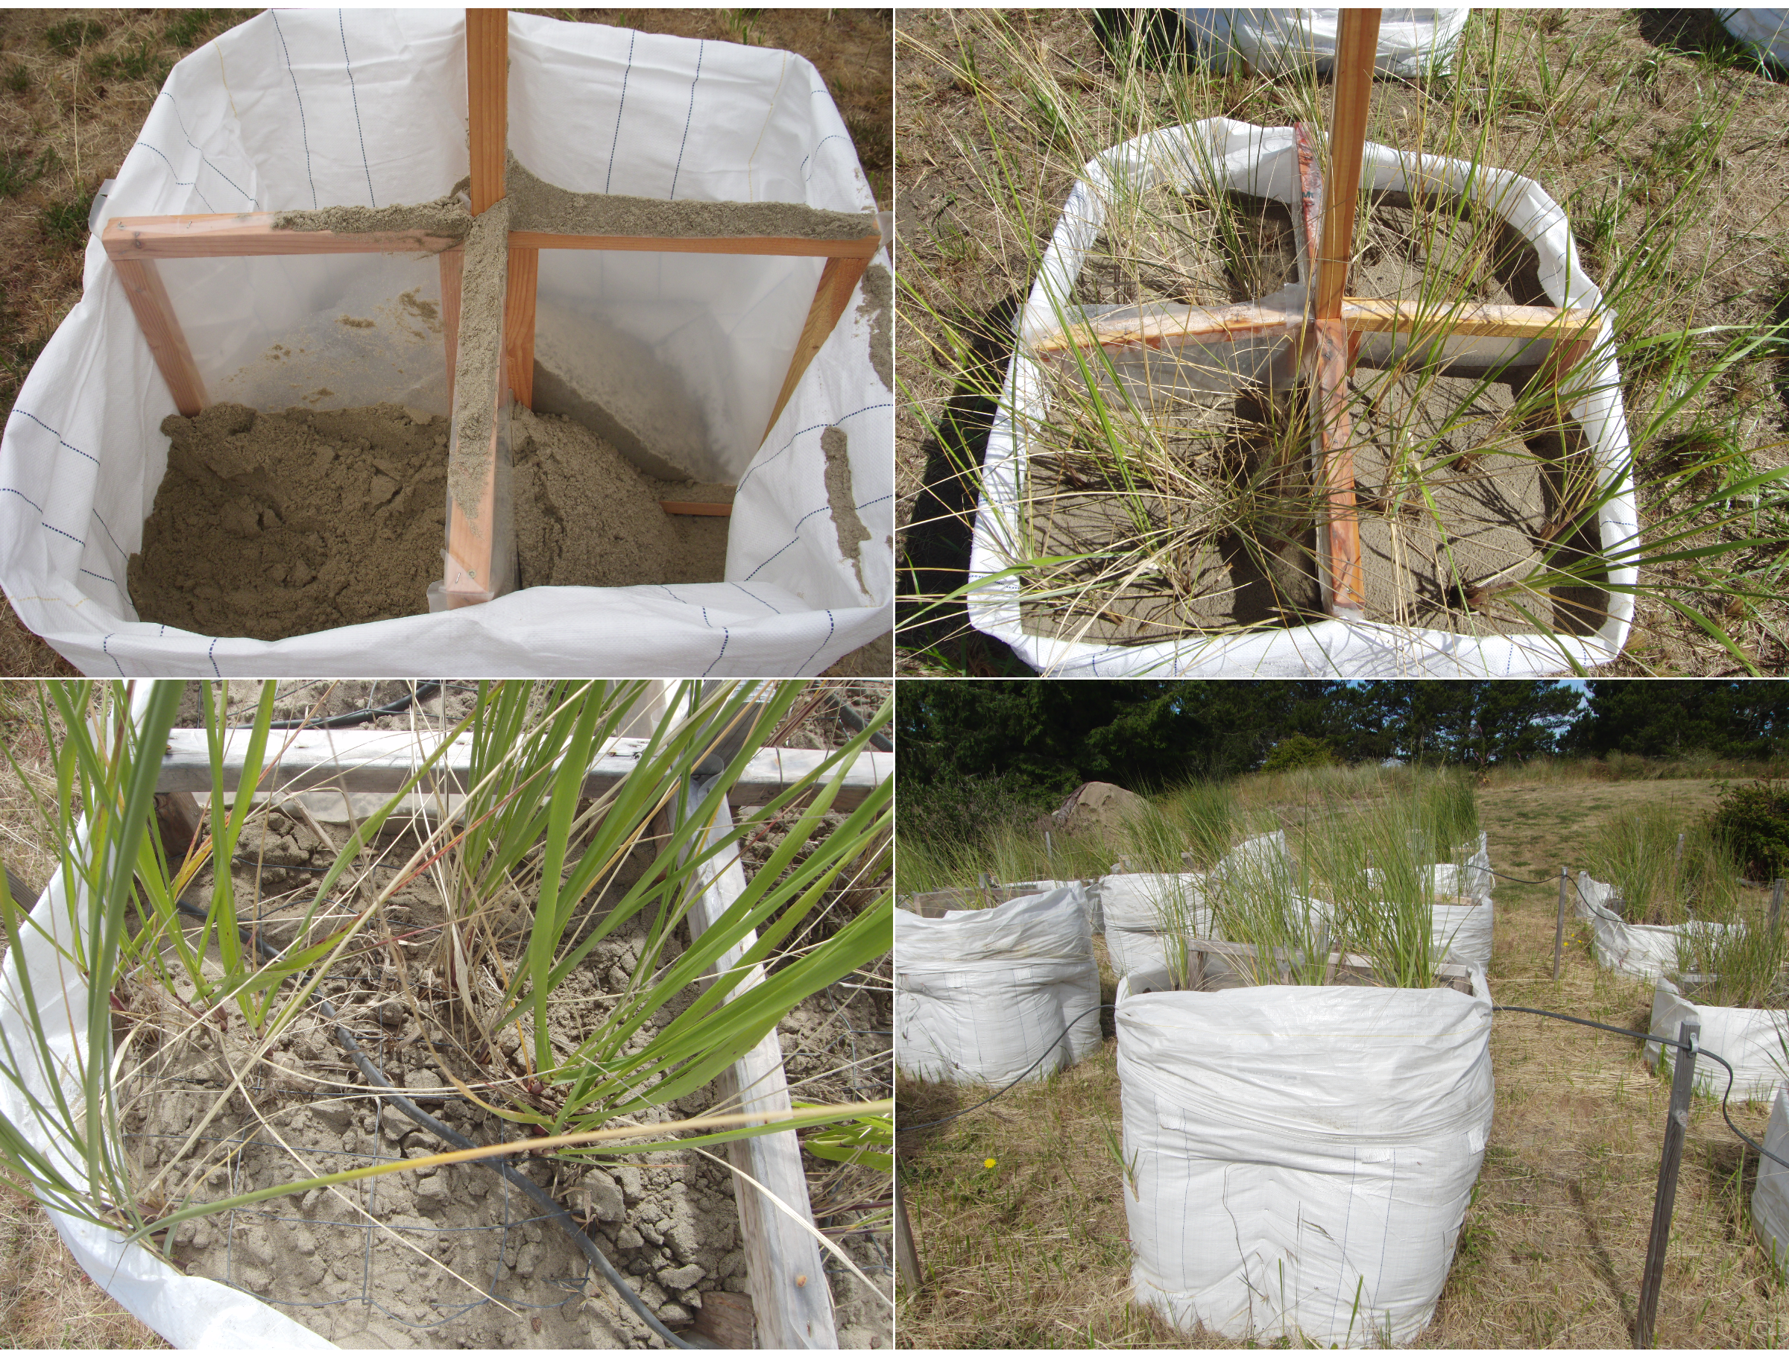
Figure S2. Photographs depicting geotextile bag construction and experimental treatments. (Top-left) Geotextile bag subdivided into four quadrants using greenhouse film. (Top-right) Bag receiving high sand burial treatment with different combinations of Ammophila arenaria and A. breviligulata within each quadrant. (Bottom-left) Heat tape woven through wire mesh, just prior to sand addition. Heat tape and wire mesh were buried beneath 4 cm of sand. (Bottom-right) Bags with heat and sand burial treatments. All heat treatments within a single whole plot (column of bags) are connected via a single electrical circuit of heat tape (black wire). Sand burial treatment levels are evident from the differing geotextile bag heights. Photo by R. Biel.
Figure S3. Initial A. arenaria (AMAR; white) and A. breviligulata (AMBR; gray) tiller densities per quadrant for each beachgrass plant density treatment combination. A6 = 6 Ammophila arenaria plants; AB3 = 3 A. arenaria and 3 A. breviligulata plants; and AB6 indicates 6 A. arenaria and 6 A. breviligulata plants; B6 = 6 A. breviligulata plants.

