Supplementary materials

Supplementary Figures 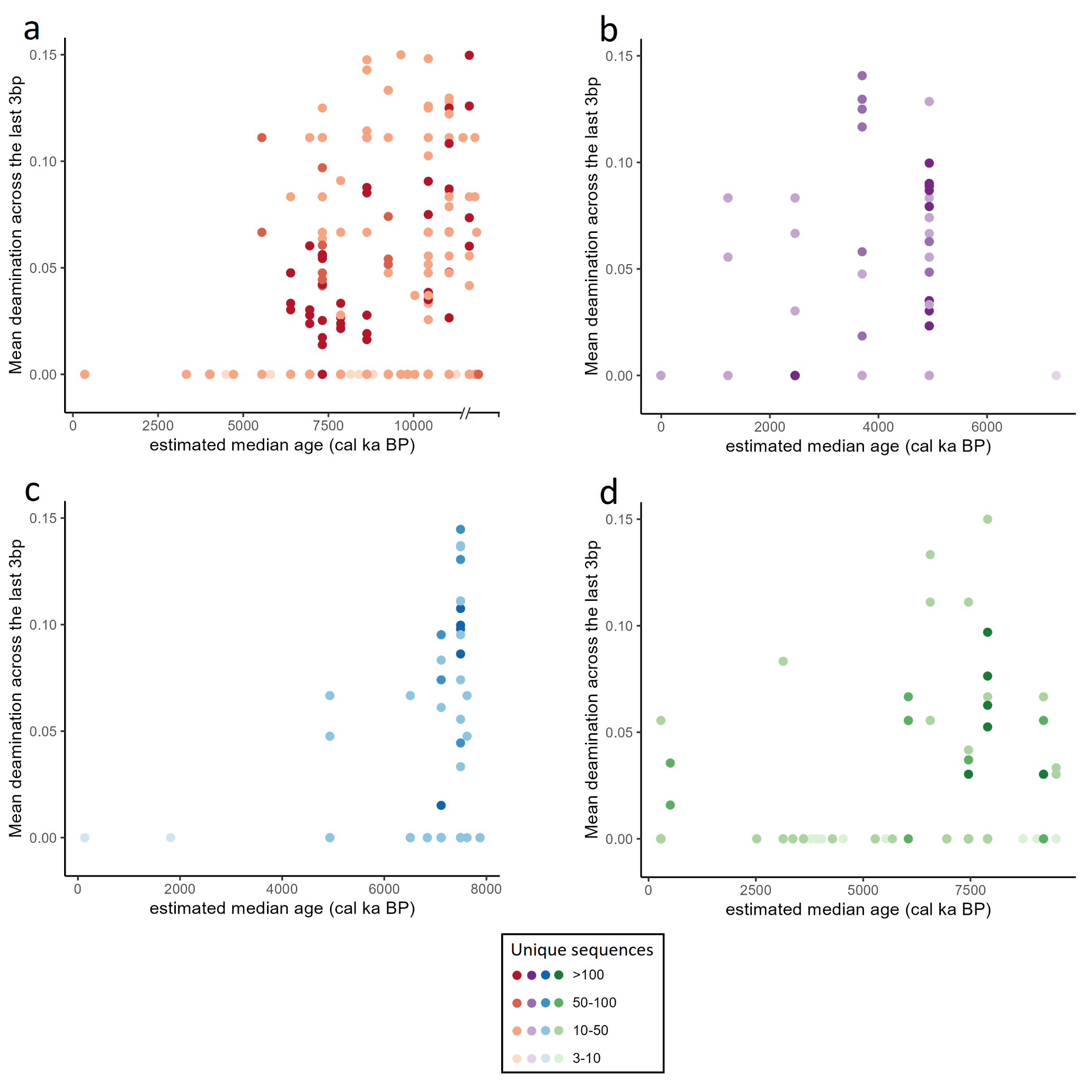Fig. S1 DNA damage in the shotgun and hybridization capture sequencing data. Mean nucleotide deaminations per taxon and estimated median age were calculated across the last 3bp of the forward and reverse strand. a Melville Bay 26G. b Hall Basin 24PC. c Lincoln Sea 12-GC. d North-East Greenland 73G. Colors indicate the number of unique sequences the nucleotide deamination calculations were based on.

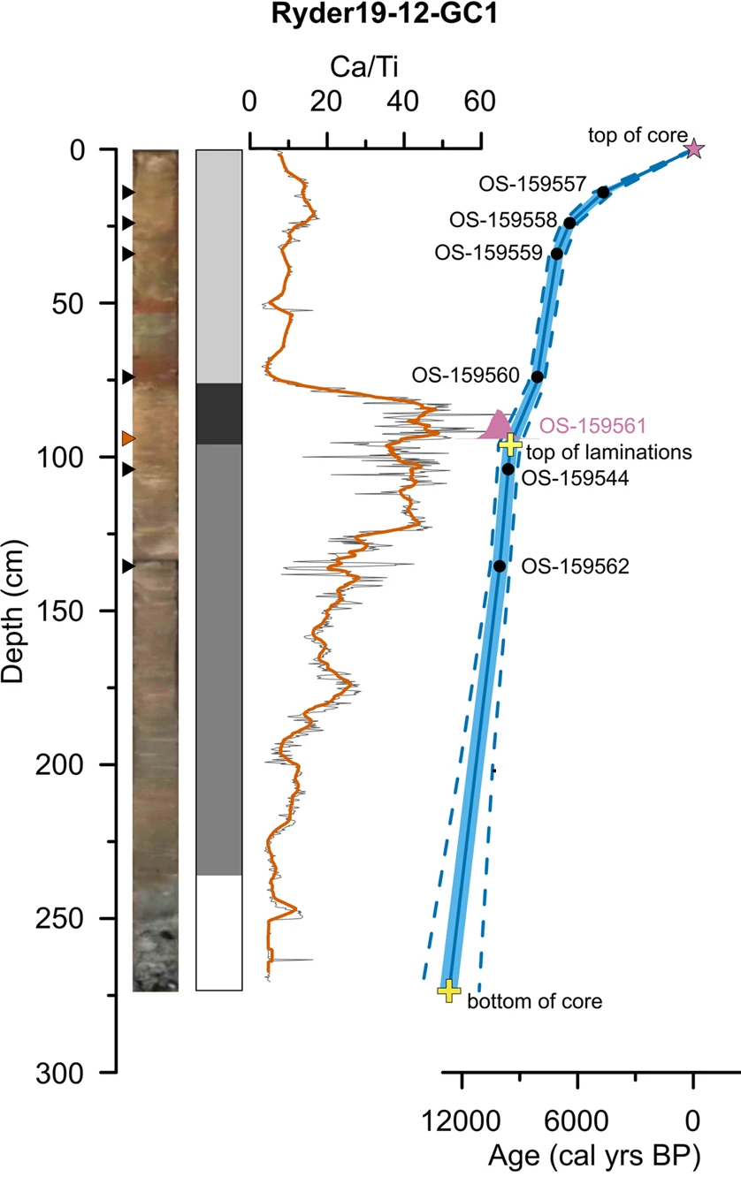
Fig. S2 Age-depth model of Lincoln Sea 12-GC (Ryder19-12-GC1). Reproduced from Detlef et al. (2023) with permission from the publisher under the Creative Commons Attribution 4.0 International License (creativecommons.org/licenses/by/4.0/).
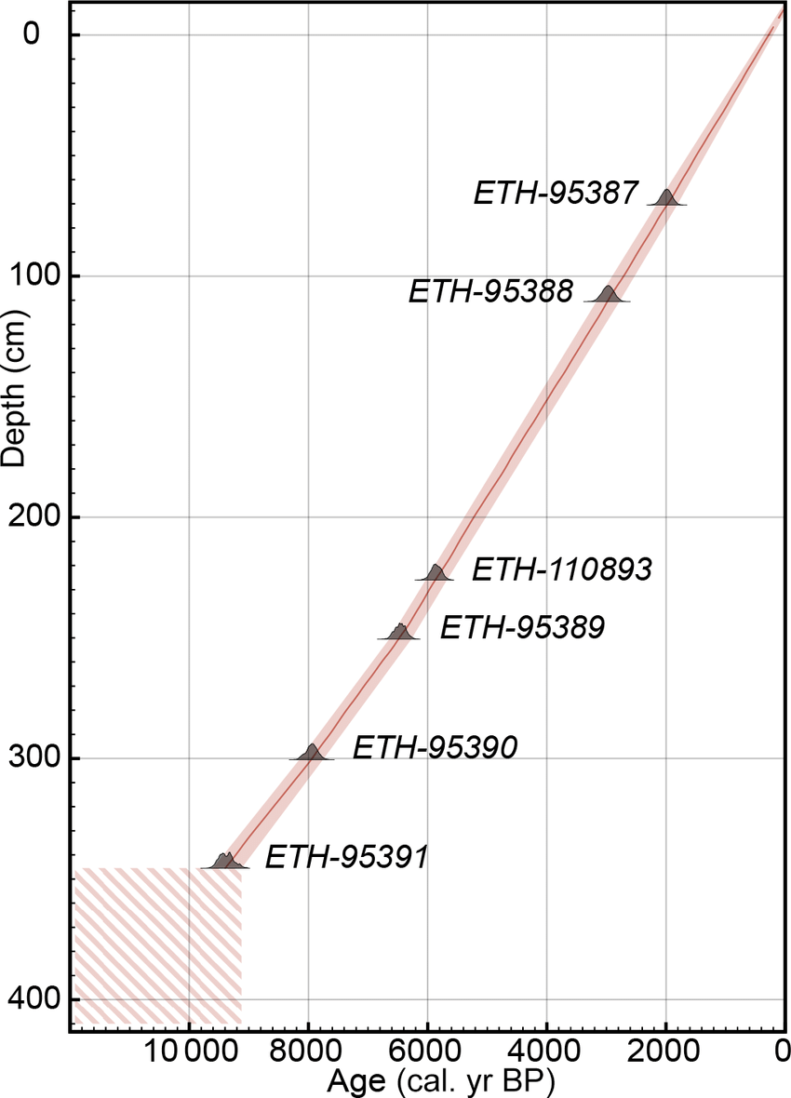
Fig. S3 Age-depth model of North-East Greenland 73G (DA17-NG-ST07-073G). Reproduced from Pados-Dibattista et al. (2022) with permission from the publisher under the Creative Commons Attribution 4.0 International License (creativecommons.org/licenses/by/4.0/).

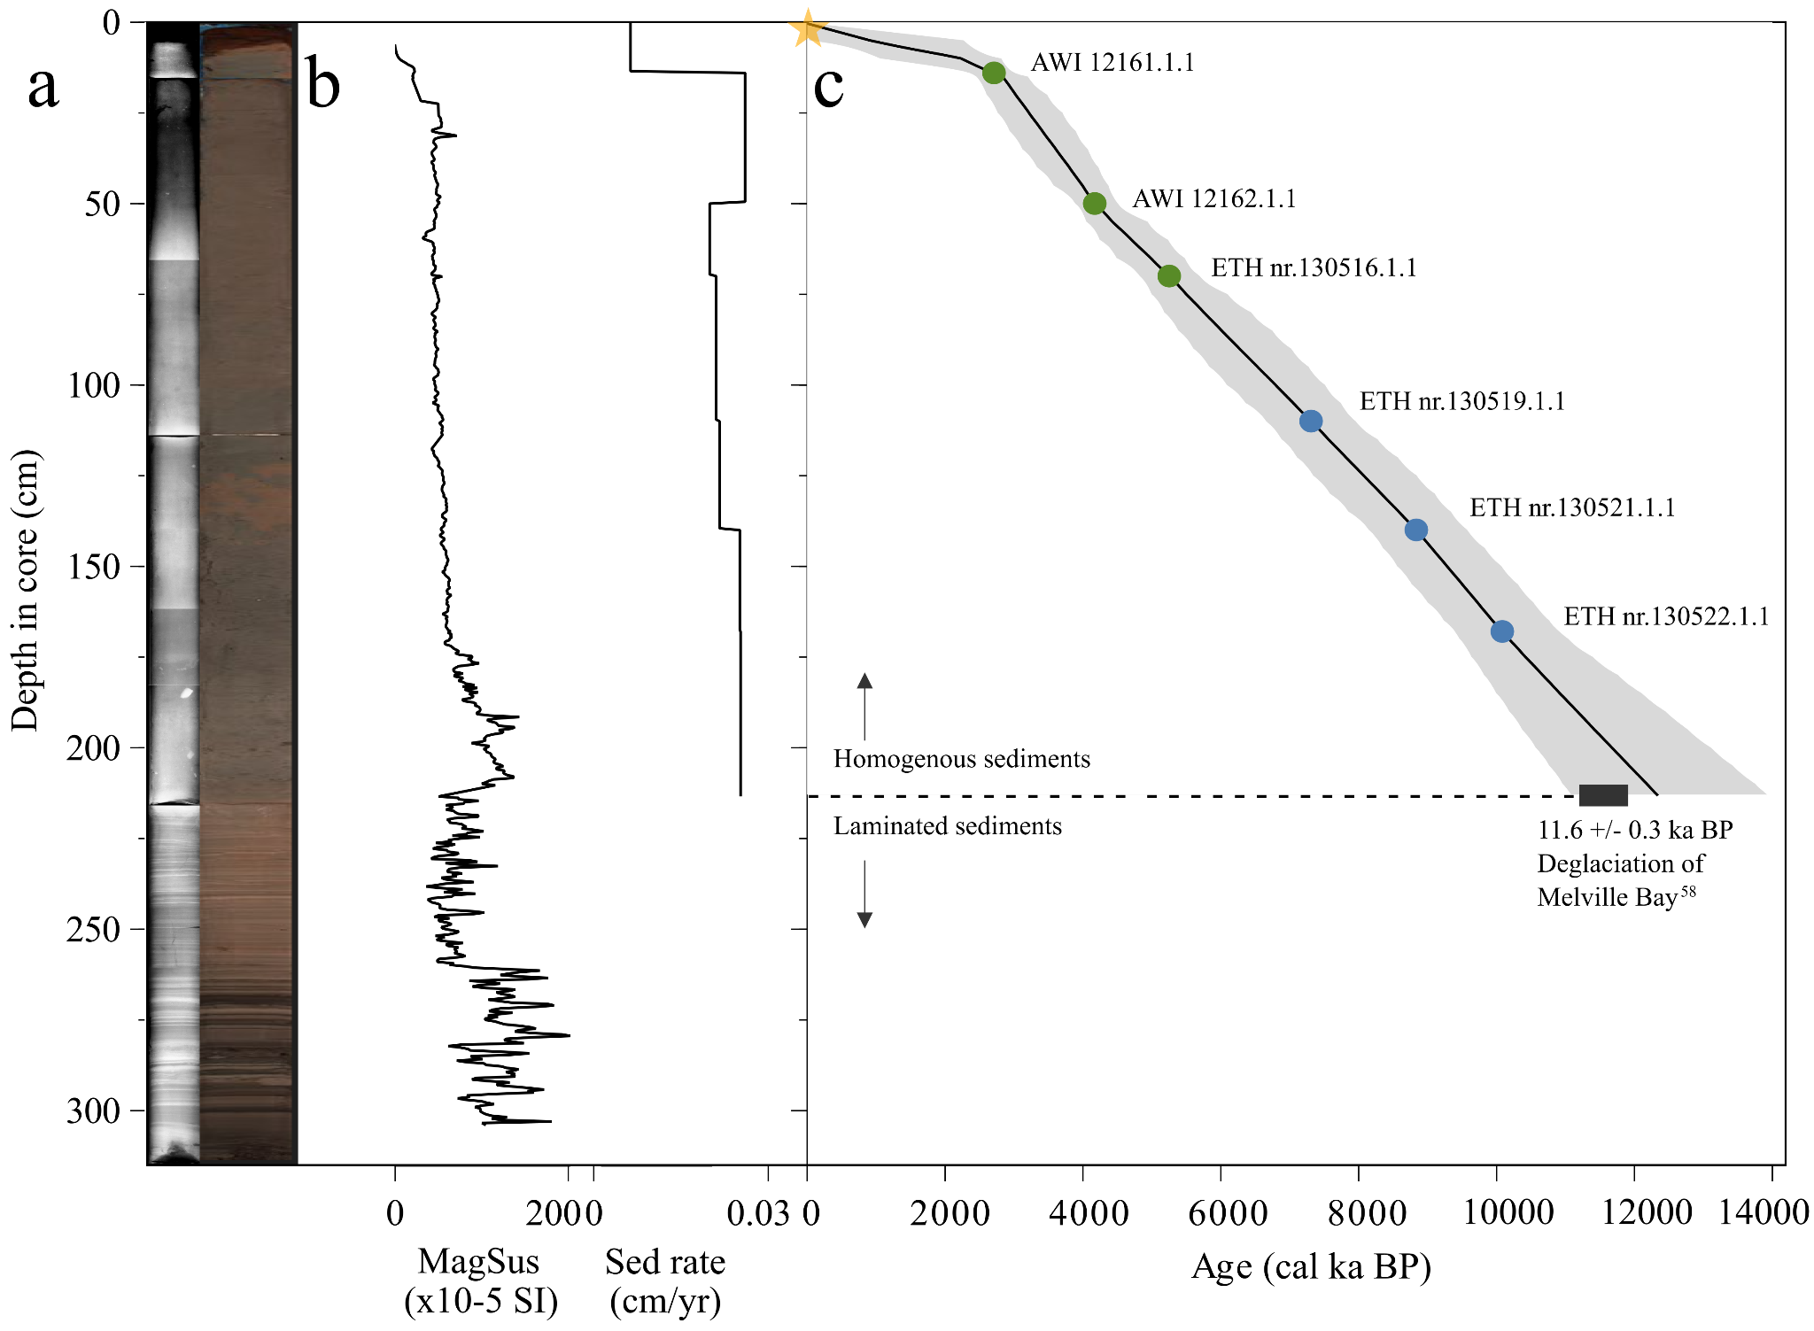
Fig. S4 Chronology of Melville Bay 26G (LK21-IC-st26-GC1). a X-ray and high resolution optical line scan images. b Magnetic susceptibility (MagSus, x10-6 SI) and sedimentation rate (cm yr⁻¹). c The age-depth model with green dots displaying ¹⁴C dates of three mixed planktonic foraminifera samples, blue dots displaying ¹⁴C dates of three mixed benthic foraminifera samples, and the gray envelope displaying the age-depth uncertainty range for the derived age model. The yellow star indicates an age constraint (as discussed in the Methods section).

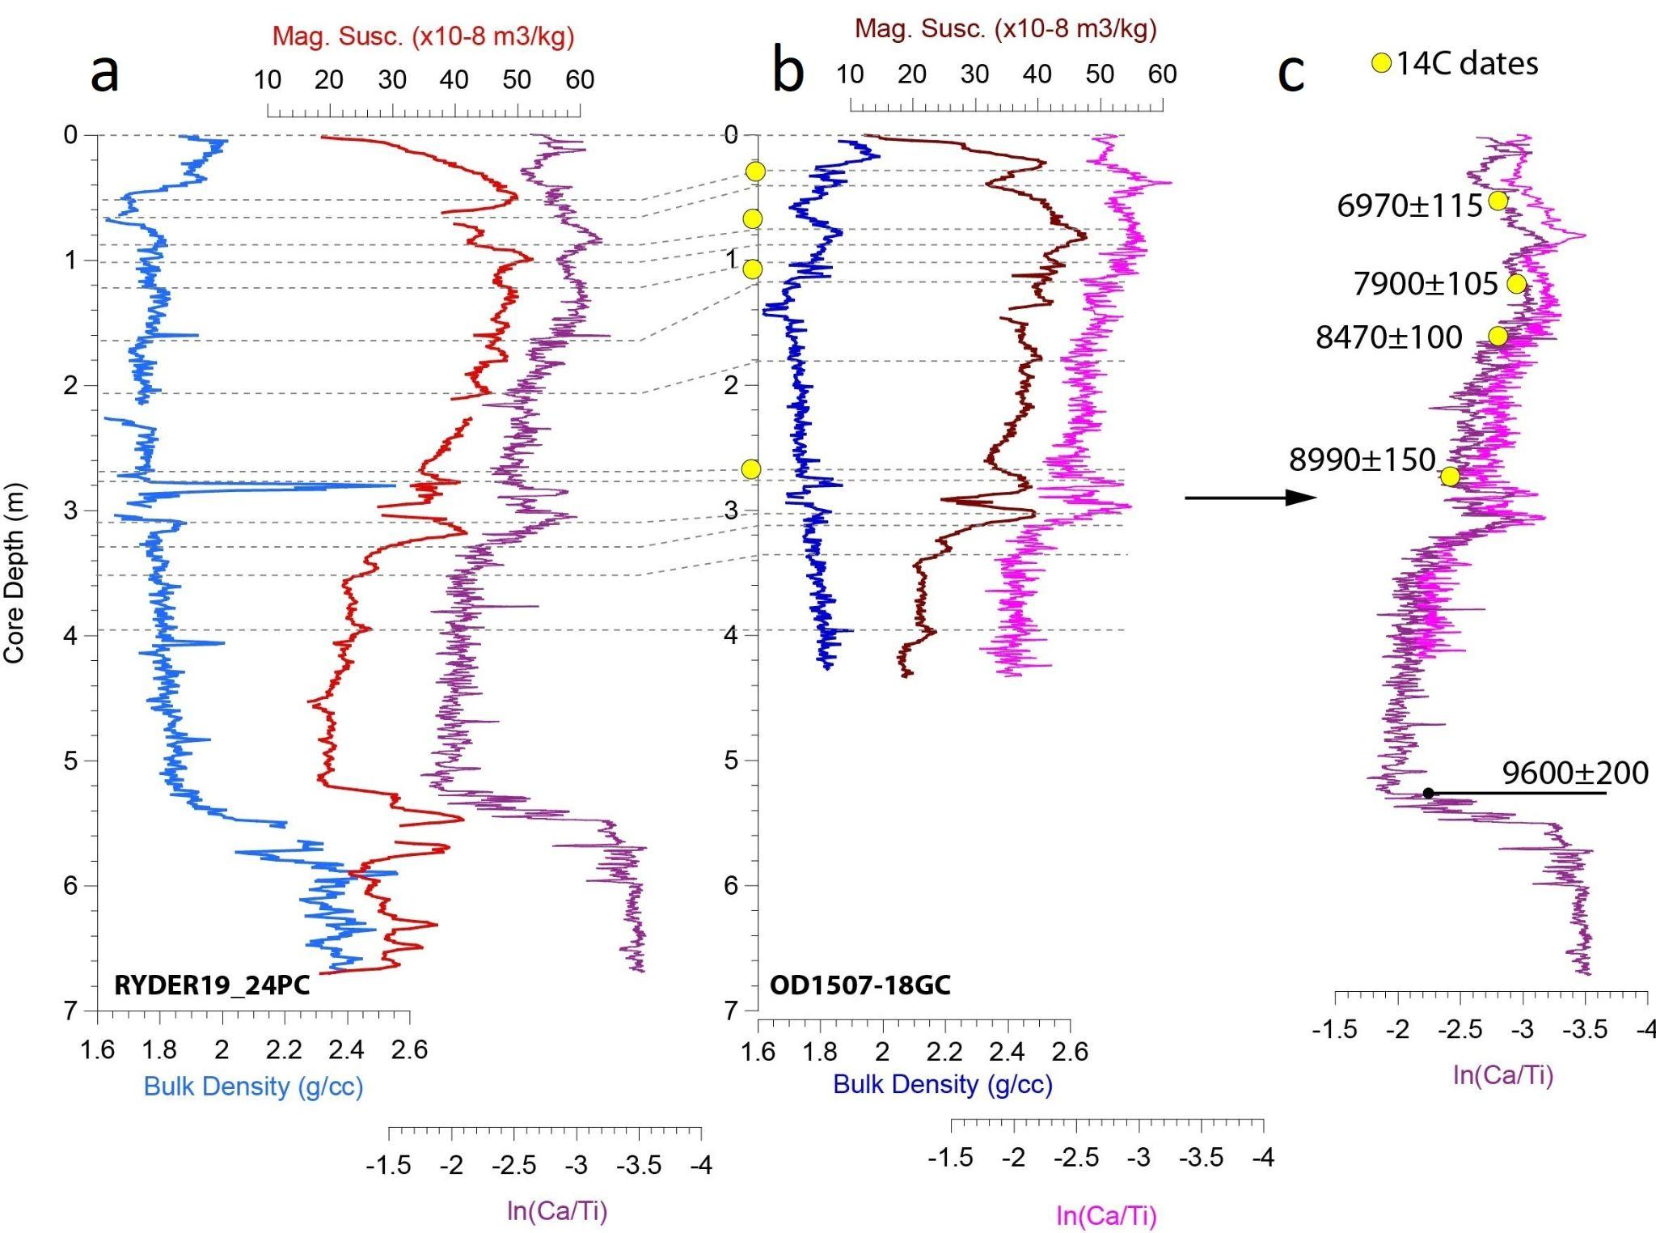

Fig. S5 Age-depth derivation of Hall Basin 24PC (Ryder19-24-PC1). a Bulk Density, Magnetic Susceptibility and XRF-scanning data of sediment core Ryder19-24PC. b Bulk Density, Magnetic Susceptibility and XRF-scanning data of sediment core OD1507-18GC (collected at the same station as Ryder19-24PC; Jennings et al., 2022). c The common age-depth scale based on correlating the XRF-scanning data of the two sediment cores (as discussed in the Materials and methods section).

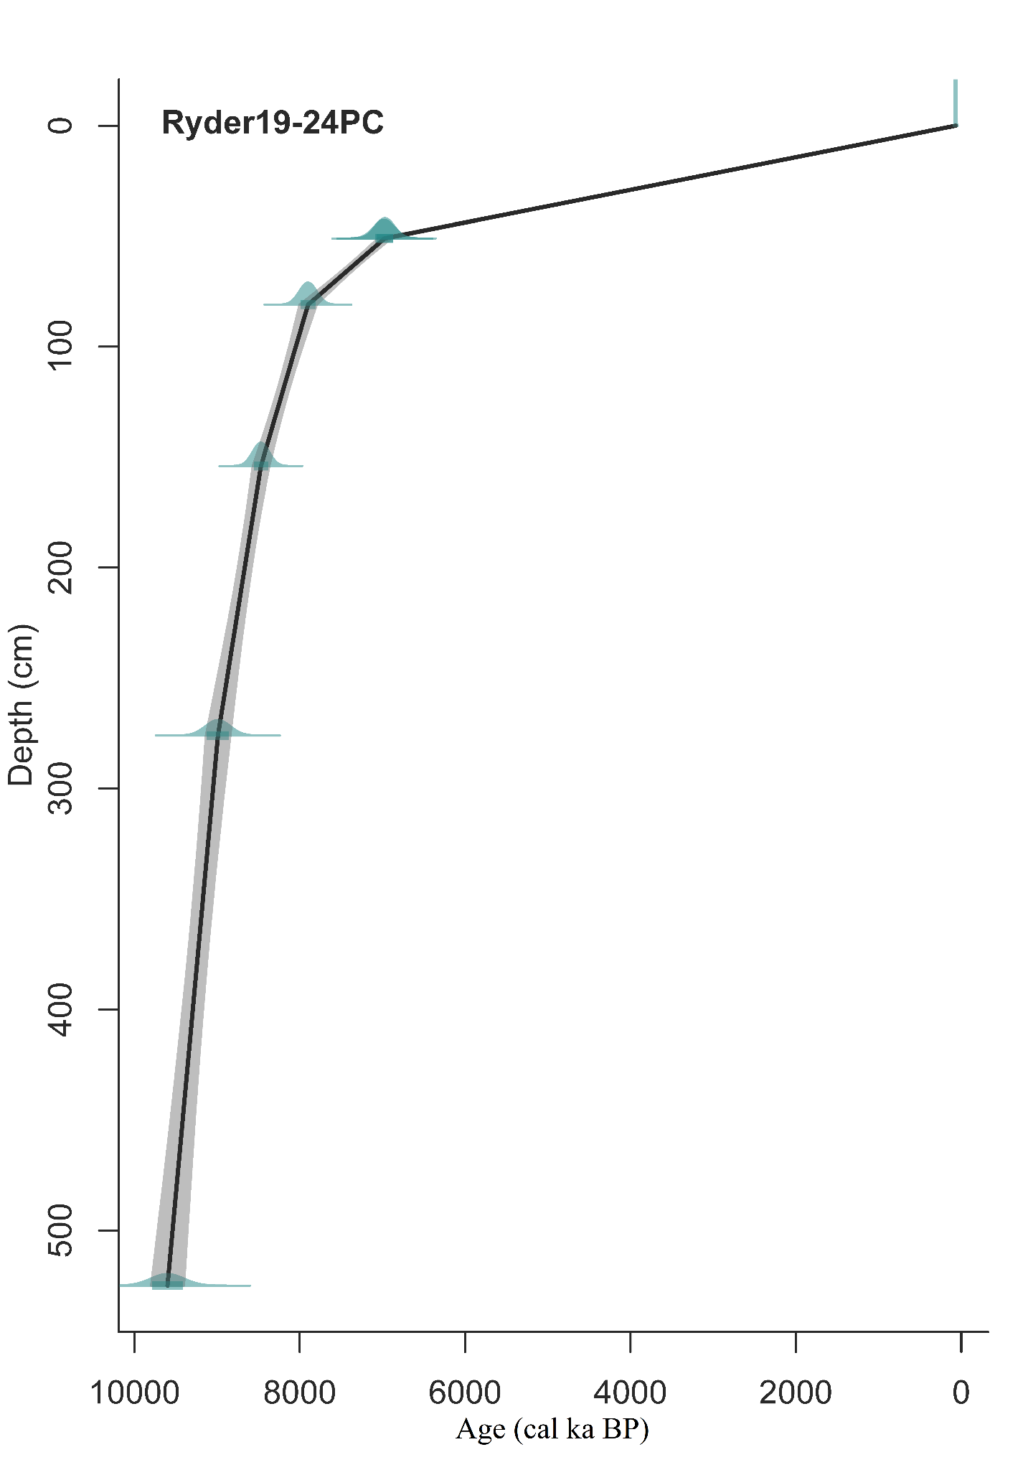Fig. S6 Age-depth model of Hall Basin 24PC (Ryder19-24-PC1). The age-depth model is based on a derivation of radiocarbon dates from the marine sediment core OD1507-18GC (Fig. S5; Jennings et al., 2022).
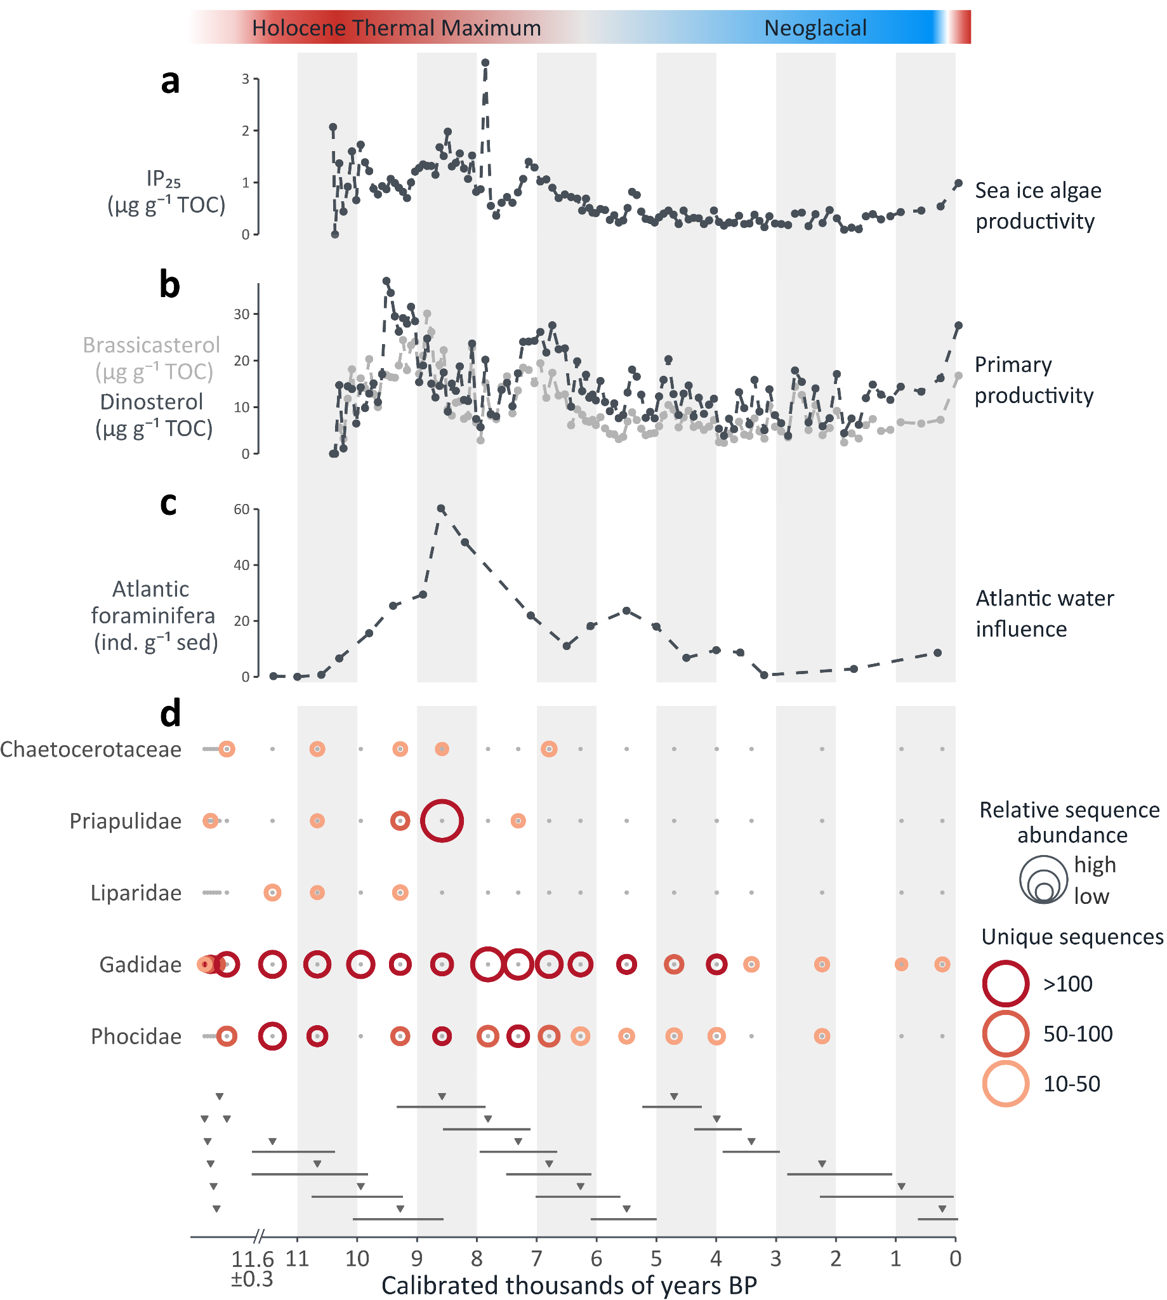
Fig. S7 Paleoceanographic reconstruction and DNA detections for Melville Bay 26G. a Sea-ice biomarker IP₂₅ indicates the intensity of sea ice algae productivity (GeoB19927-3; Saini et al., 2020). b Brassicasterol and dinosterol indicate primary productivity (GeoB19927-3; Saini et al., 2020). c high numbers of benthic foraminifera with preferred habitat of Atlantic-sourced waters indicate the influence of chilled Atlantic water, points representing counts per gram sediment (this study). d Eukaryote detections through shotgun sequencing. The triangles on the x-axis show estimated median ages of each DNA sample with lines indicating minimum and maximum ages. Samples with estimated median ages >11.6 ka BP likely represent a short time period at or just prior to the deglaciation of Melville Bay (estimated 11.6 ± 0.3 ka BP; Søndergaard et al., 2020).

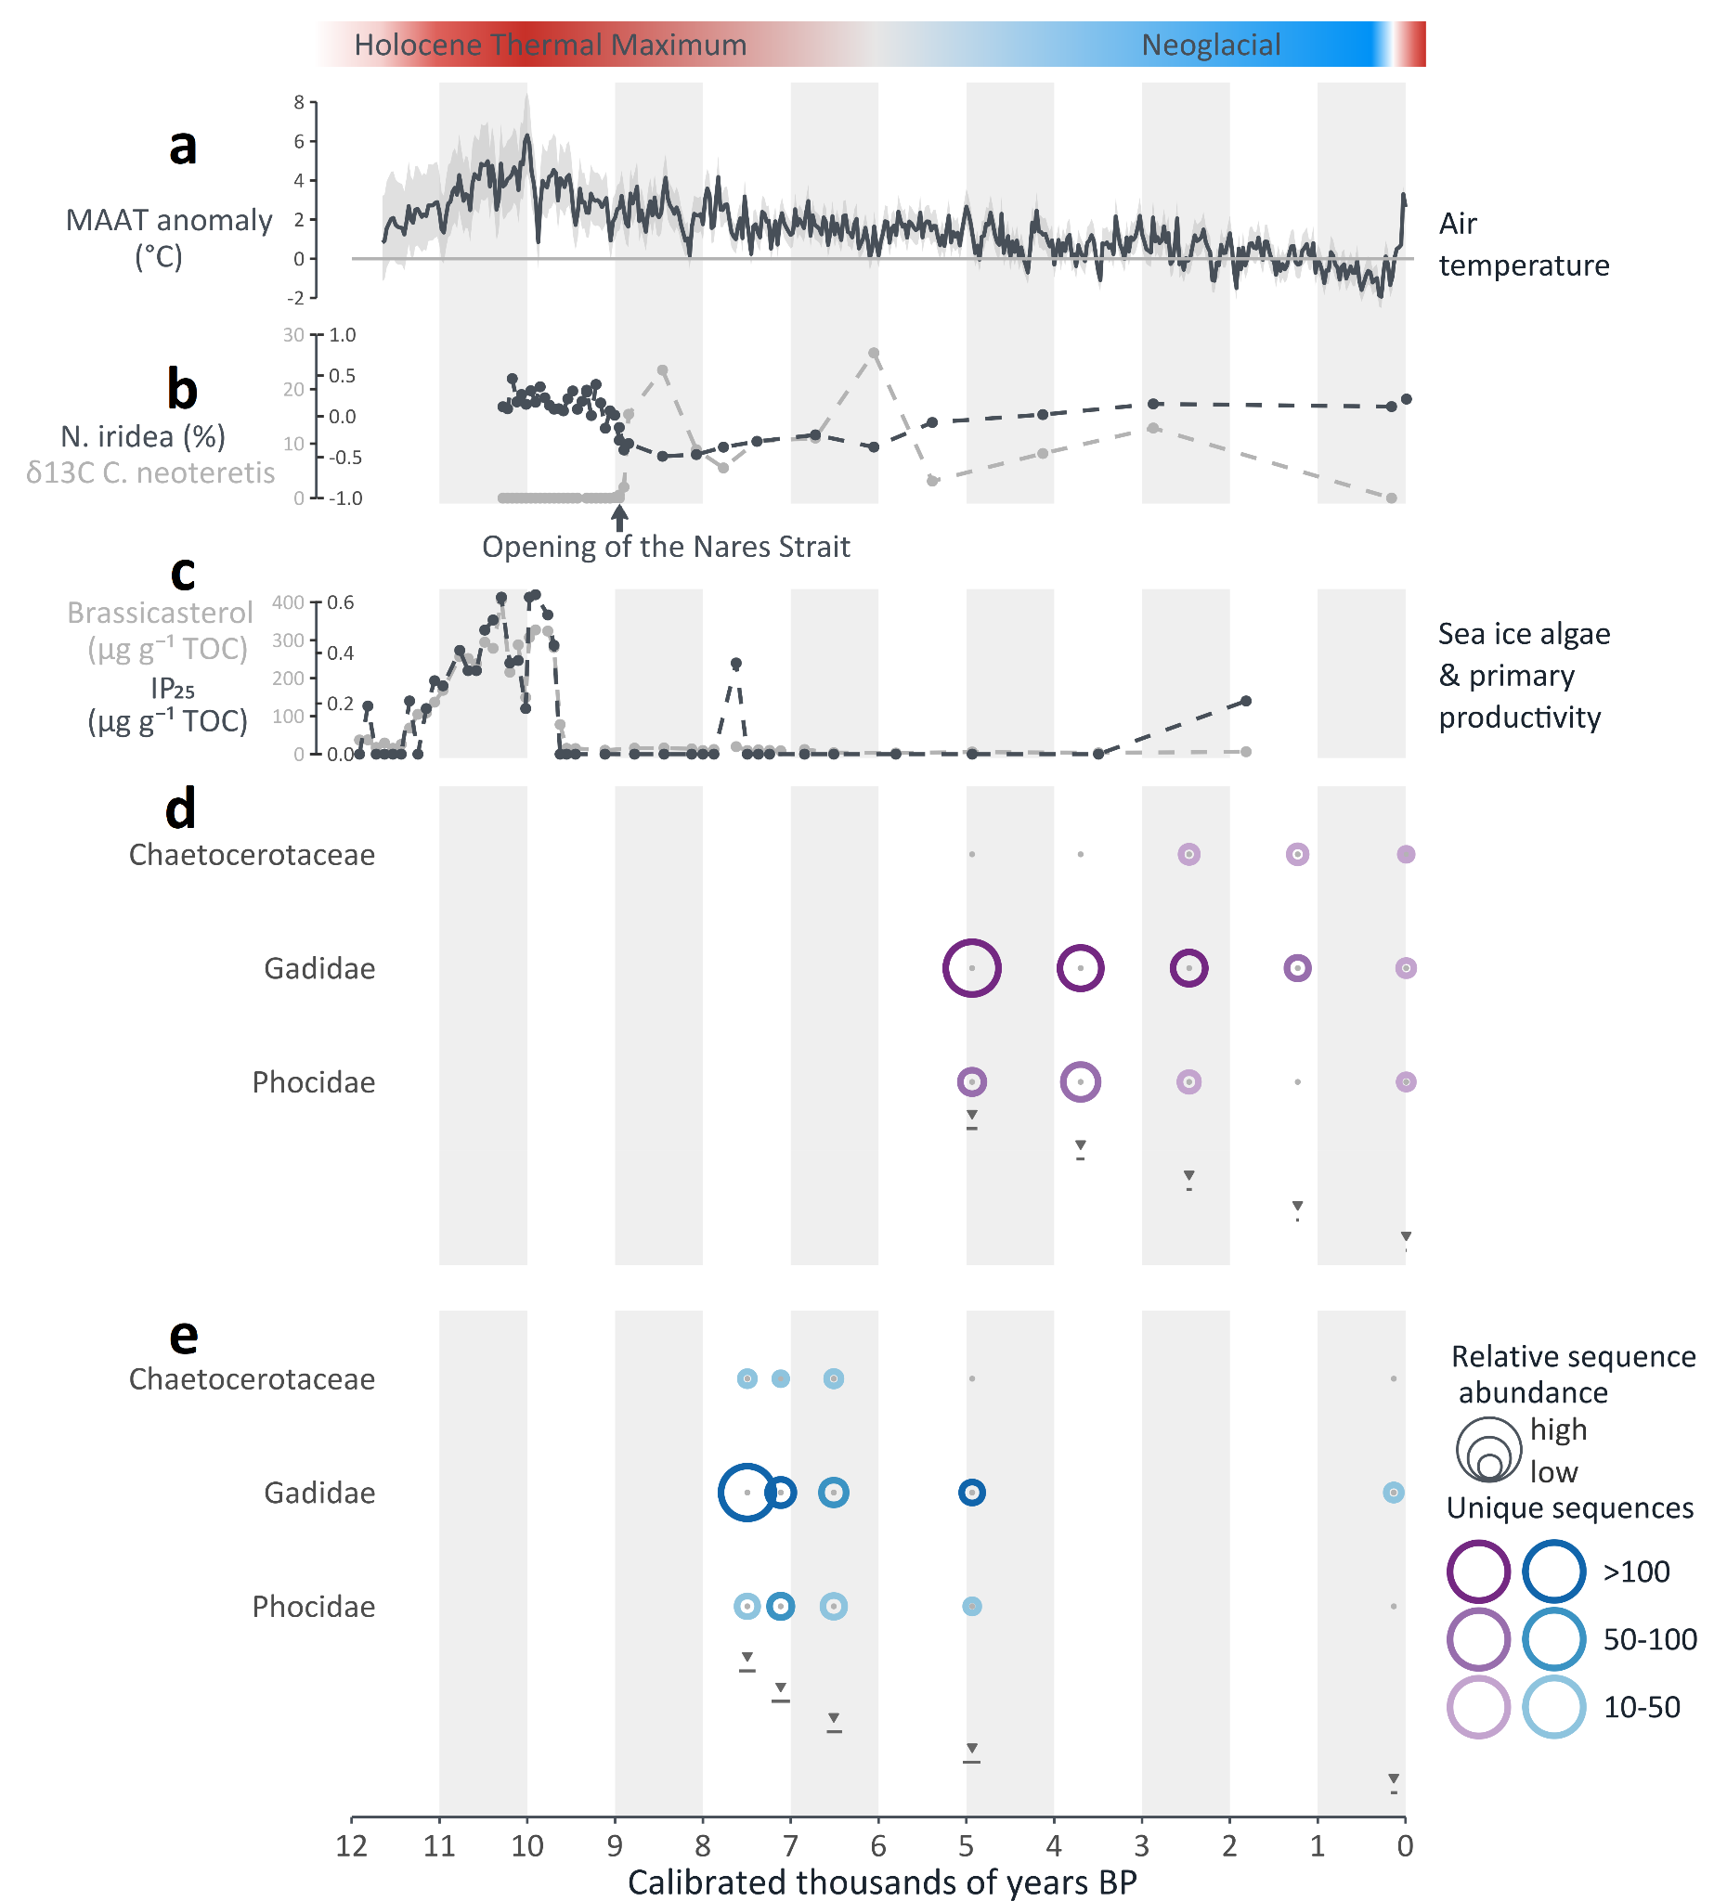Fig. S8 Paleoceanographic reconstruction and DNA detections for Hall Basin 24PC & Lincoln Sea 12-GC. a Temperature reconstruction based on the oxygen isotopic signature (δ¹⁸O) at the Agassiz ice cap as compared to the pre-industrial (1850-1900 CE) average (Detlef et al., 2023; Lecavalier et al., 2017). b Evidence for the opening of Nares Strait (HLY03-01-05GC; Jennings et al., 2011). c Sea-ice biomarker IP₂₅ indicates the intensity of sea ice algae productivity and brassicasterol indicates primary productivity (Lincoln Sea 12-GC; Detlef et al., 2023). d Eukaryote detections through shotgun sequencing for Hall Basin 24PC. e Eukaryote detections through shotgun sequencing for Lincoln Sea 12-GC. The triangles on the x-axis show estimated median ages of each DNA sample with lines indicating minimum and maximum ages.
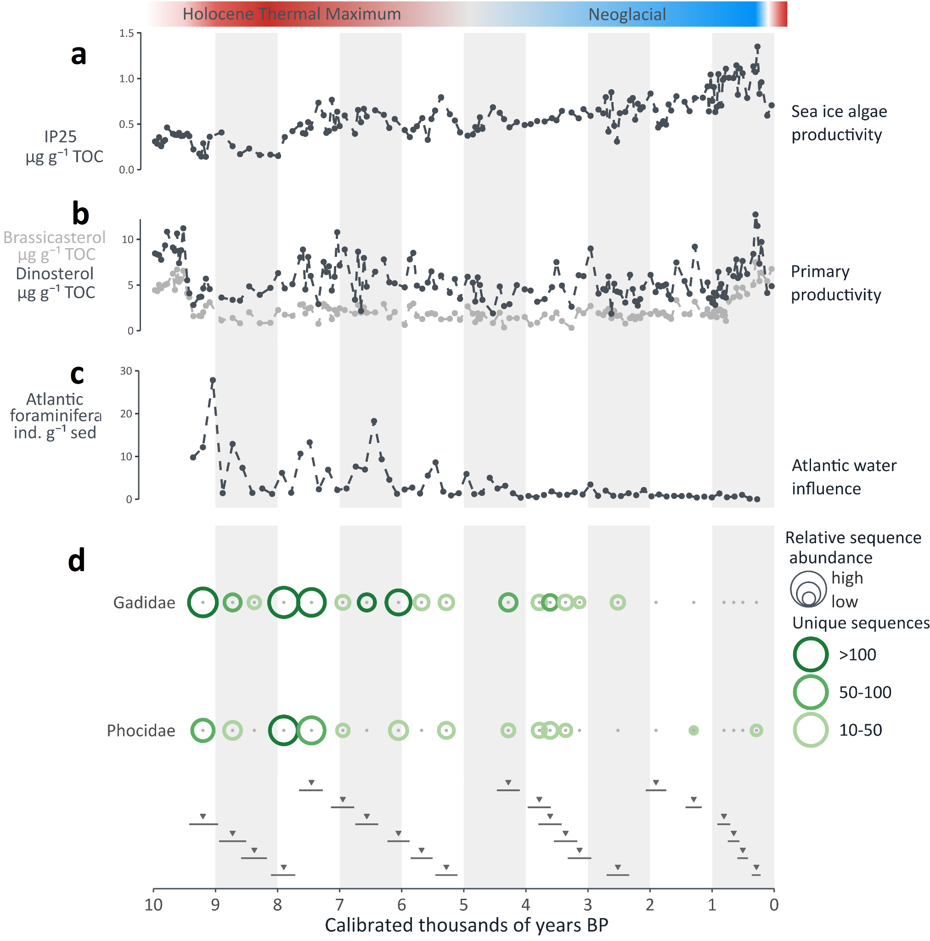
Fig. S9 Paleoceanographic reconstruction and DNA detections for North-East Greenland 73G. a Sea-ice biomarker IP₂₅ indicates the intensity of sea ice algae productivity (PS93/025-2; Syring et al., 2020). b Brassicasterol and dinosterol indicate primary productivity (PS93/025-2; Syring et al., 2020). c High numbers of benthic foraminifera with preferred habitat of Atlantic-sourced waters indicate the influence of Atlantic water, points representing counts per gram sediment (North-East Greenland 73G; Pados-Dibattista et al., 2022). d Eukaryote detections through shotgun sequencing. The triangles on the x-axis show estimated median ages of each DNA sample with lines indicating minimum and maximum ages.

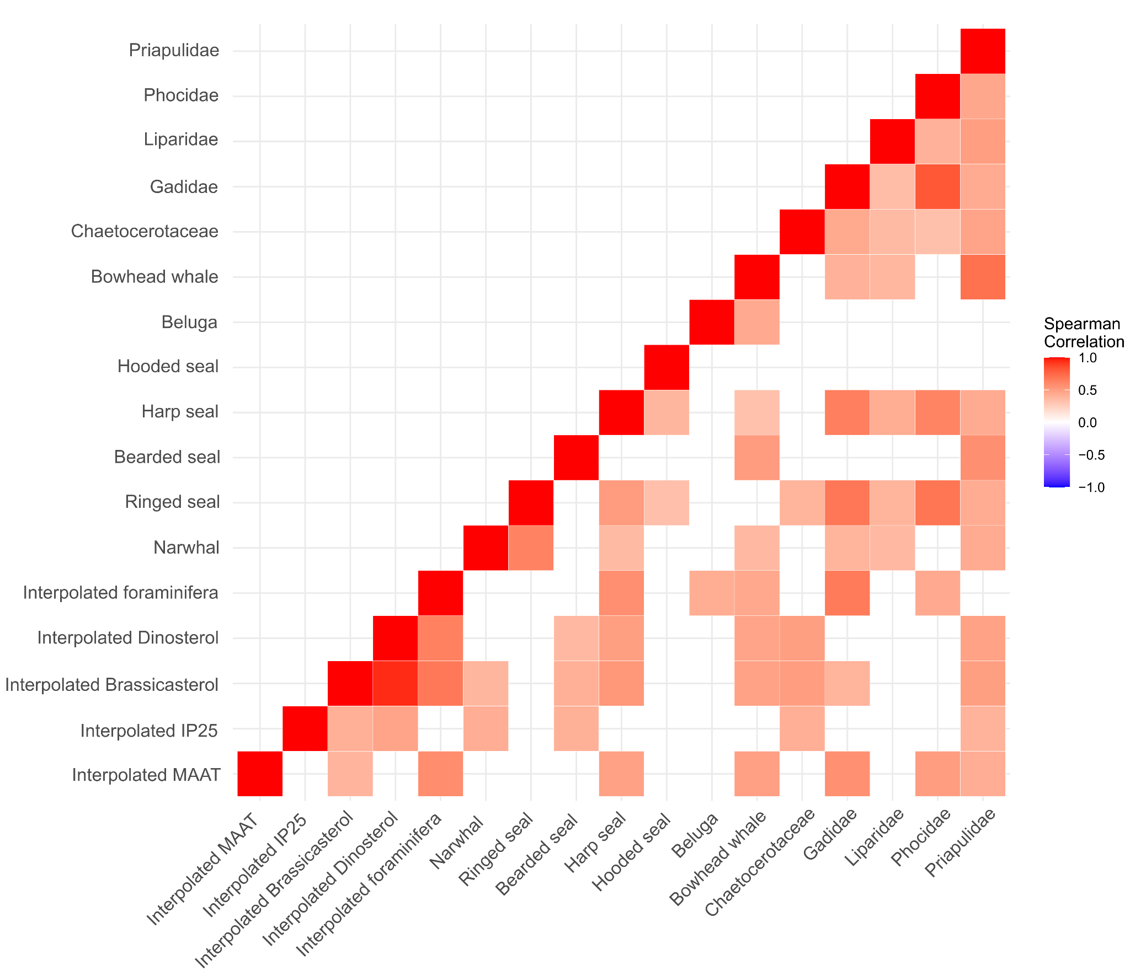
Fig. S10 Correlation matrix of DNA detections and interpolated paleoenvironmental proxies. For each sample and across sediment cores, DNA detections based on shotgun sequencing and hybridisation capture and linearly interpolated paleoenvironmental proxy measurements were compiled in a matrix. Pairwise Spearman’s rank correlation coefficients were then calculated and filtered for significant (p < 0.1) correlations.

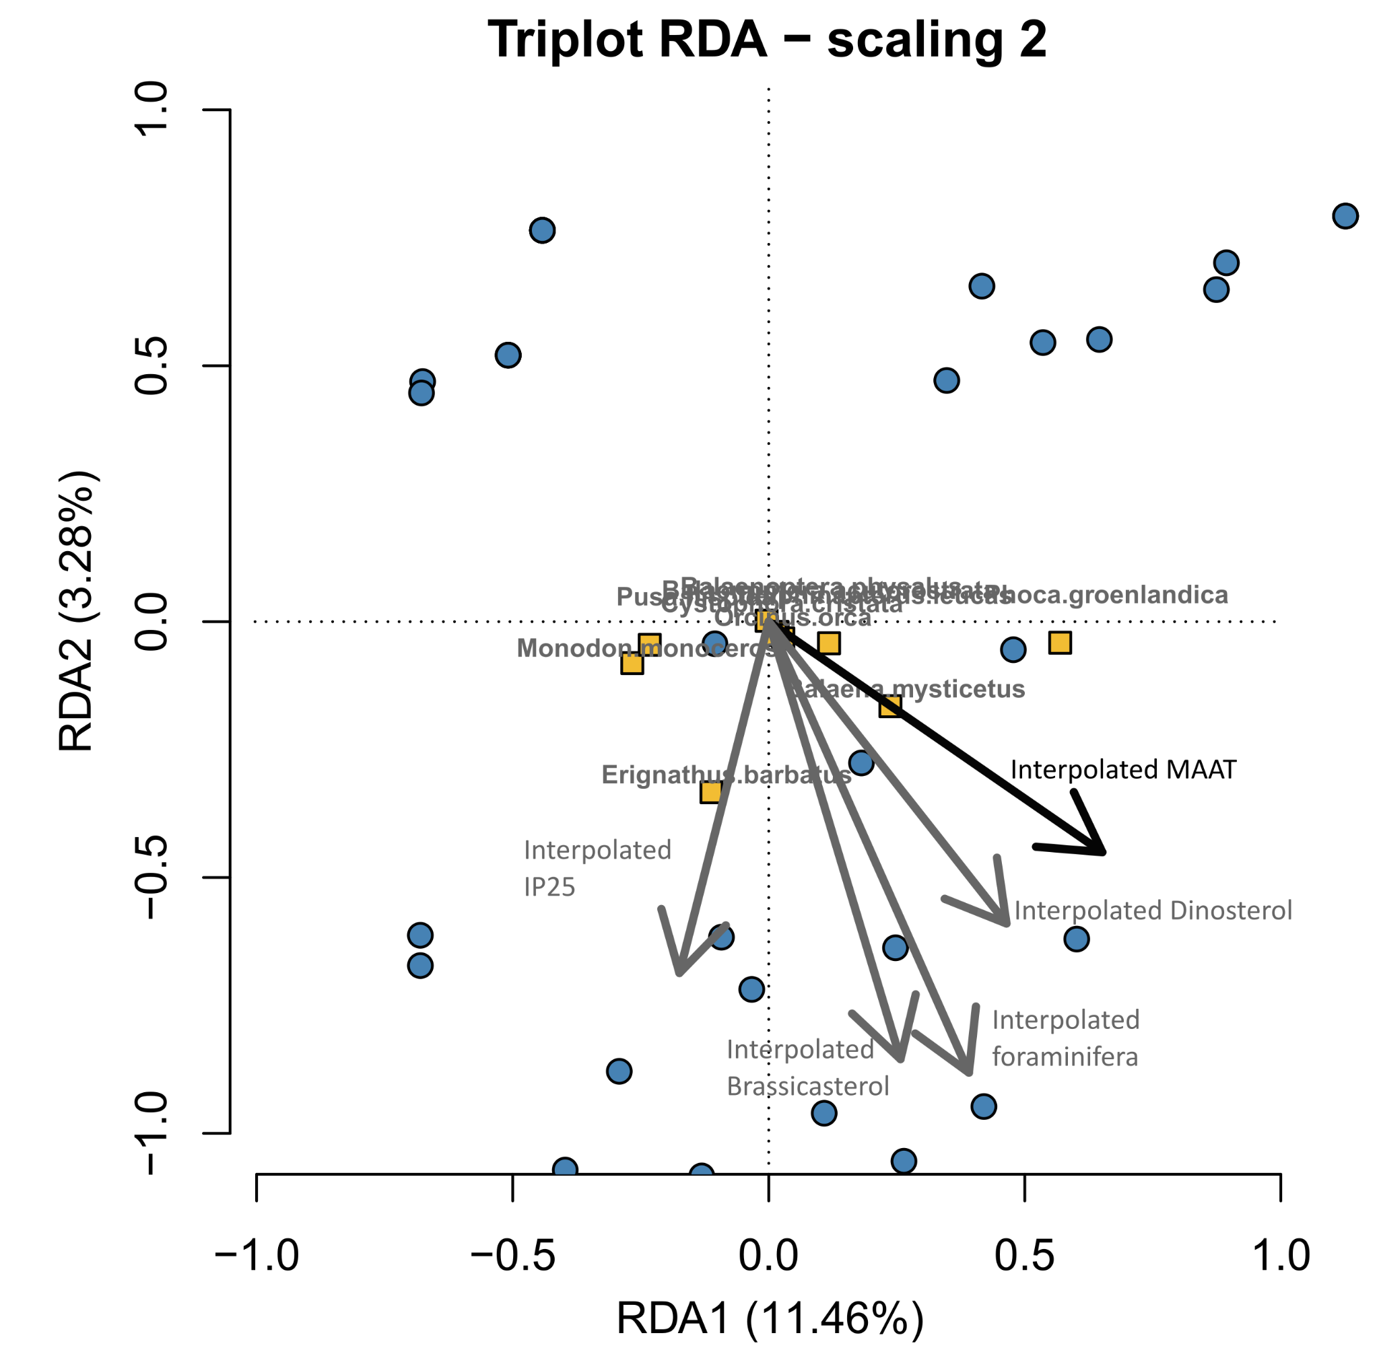
Fig. S11 Redundancy Analysis (RDA) of hybridisation capture detections for Melville Bay 26G and North-East Greenland 73G. For each sample and across the two sediment cores, species-level detections based on hybridisation capture and linearly interpolated paleoenvironmental proxy measurements were compiled in a matrix. A redundancy analysis (RDA) was performed followed by an ANOVA-like permutation test to identify variables that contributed significantly to explaining the diversity of the samples. The interpolated MAAT (Lecavalier et al., 2017) proved to be significant (Pr(>F)<0.1; black arrow and font), and all other (insignificant) variables are indicated by gray color.

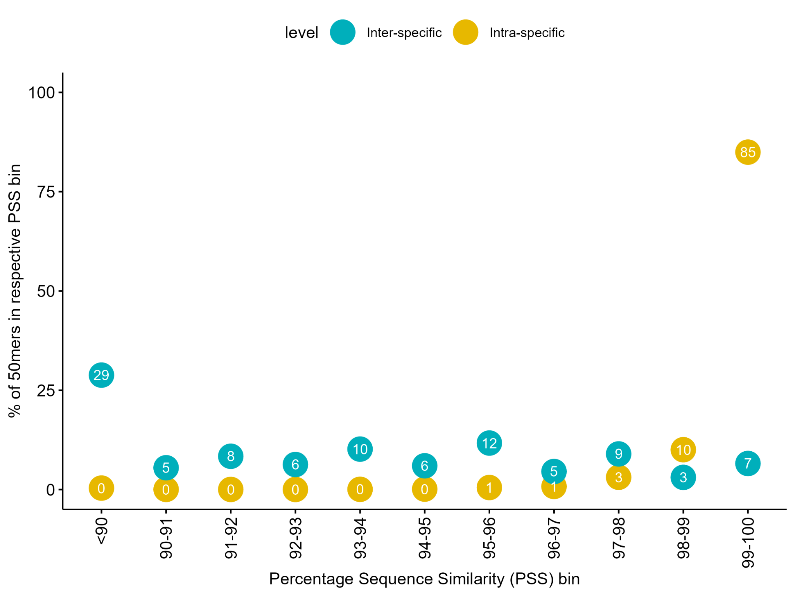Fig. S12 Pairwise sequence similarity calculations. Inter-specific pairwise sequence similarities (in blue) were calculated for mitochondrial reference genomes belonging to the target group of Arctic marine mammals and their closest relatives (i.e. other species belonging to the subfamilies Phocinae, Balaenidae, and Monodontidae). Intra-specific pairwise sequence similarities (in yellow) were calculated individually for each target species (e.g. all available mitochondrial reference genomes of bowhead whales, narwhals, etc.).

Supplementary tables
Table S1 Detectable ²¹⁰Pb measurements excess activity in the uppermost centimeter of the core

Depth (cm) | Age (yrs) | Error (yrs)
0.5 | 3 | 11
1.5 | 10 | 13
5.0 | 55 | 49
7.5 | 89 | 67
10.0 | 118 | 108

Table S2 Unmodeled and modeled radiocarbon dates of the marine sediment core Melville Bay 26G (LK21-IC-st26-GC1). For the modeled ages, unmodeled ages were corrected using the Marine20 calibration curve (Heaton et al., 2020) and a local reservoir correction (ΔR) of -49 ± 59 years (Pearce et al., 2023).

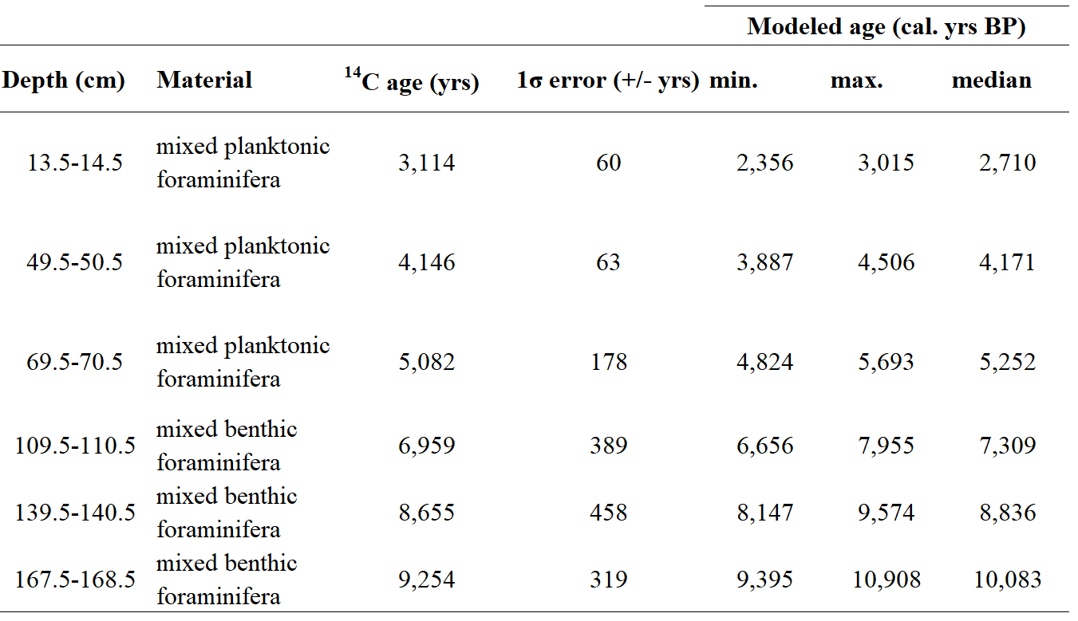

Table S3 Hybridization capture panel. The mitochondrial genomes of each species used to design the hybridization capture panel are indicated by the NCBI accession IDs. Seven of the species included in the capture panel are endemic to the Arctic and five are temperate species typically found at lower latitudes.
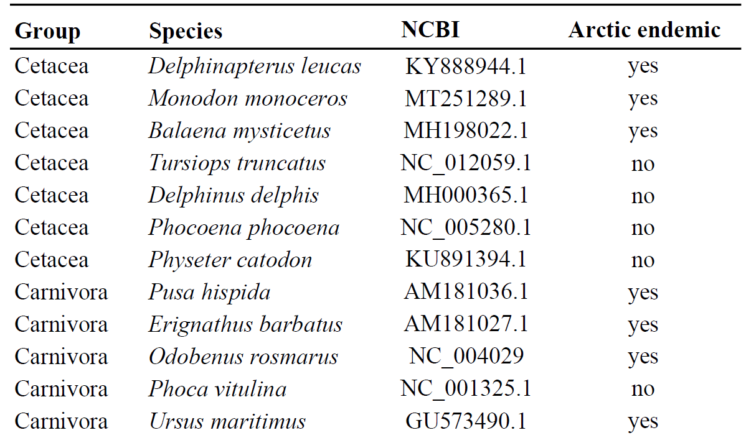

Table S4 Known spatial distribution of the detected marine mammal species. Bold font indicates year-round presence in the area; regular font indicates summer presence of the species. Question marks (?) indicate the expected presence of the species in the area, despite the absence of observational data, based on personal communication with experts from the Greenland Institute of Natural Resources (M.P. Heide-Jørgensen, 19th Jan. 2024 and A. Rosing-Asvid, 10th Jan. 2024).
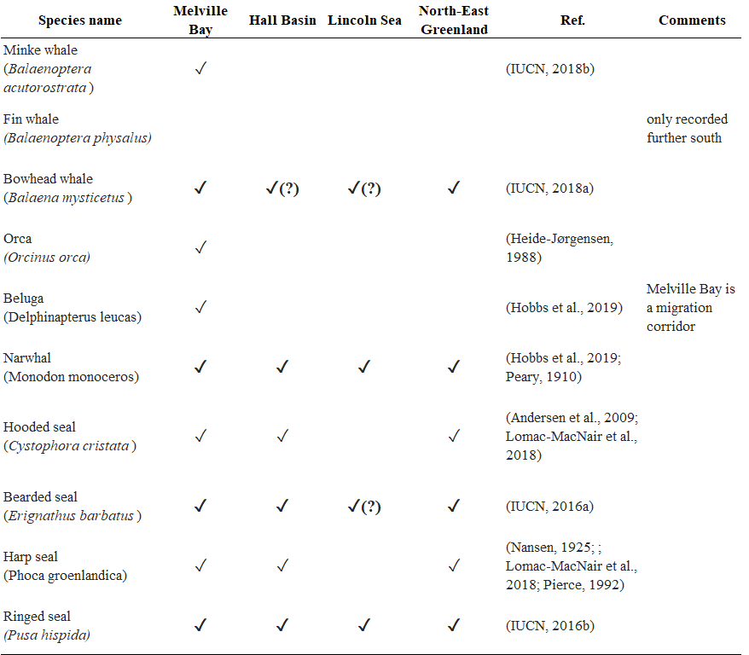

Supplementary references

Detlef, H., O’Regan, M., Stranne, C., Jensen, M. M., Glasius, M., Cronin, T. M., Jakobsson, M., & Pearce, C. (2023). Seasonal sea-ice in the Arctic’s last ice area during the Early Holocene. Communications Earth & Environment, 4(1), 86. https://doi.org/10.1038/s43247-023-00720-w
Heaton, T. J., Köhler, P., Butzin, M., Bard, E., Reimer, R. W., Austin, W. E. N., Bronk Ramsey, C., Grootes, P. M., Hughen, K. A., Kromer, B., Reimer, P. J., Adkins, J., Burke, A., Cook, M. S., Olsen, J., & Skinner, L. C. (2020). Marine20—The Marine Radiocarbon Age Calibration Curve (0–55,000 cal BP). Radiocarbon, 62(4), 779–820. https://doi.org/10.1017/RDC.2020.68
Jennings, A., Reilly, B., Andrews, J., Hogan, K., Walczak, M., Jakobsson, M., Stoner, J., Mix, A., Nicholls, K. W., O’Regan, M., Prins, M. A., & Troelstra, S. R. (2022). Modern and early Holocene ice shelf sediment facies from Petermann Fjord and northern Nares Strait, northwest Greenland. Quaternary Science Reviews, 283, 107460. https://doi.org/10.1016/j.quascirev.2022.107460
Jennings, A., Sheldon, C., Cronin, T., Francus, P., Stoner, J., & Andrews, J. (2011). The Holocene History of Nares Strait: Transition from Glacial Bay to Arctic-Atlantic Throughflow. Oceanography, 24(3), 26–41. https://doi.org/10.5670/oceanog.2011.52
Lecavalier, B. S., Fisher, D. A., Milne, G. A., Vinther, B. M., Tarasov, L., Huybrechts, P., Lacelle, D., Main, B., Zheng, J., Bourgeois, J., & Dyke, A. S. (2017). High Arctic Holocene temperature record from the Agassiz ice cap and Greenland ice sheet evolution. Proceedings of the National Academy of Sciences, 114(23), 5952–5957. https://doi.org/10.1073/pnas.1616287114
Pados-Dibattista, T., Pearce, C., Detlef, H., Bendtsen, J., & Seidenkrantz, M.-S. (2022). Holocene palaeoceanography of the Northeast Greenland shelf. Climate of the Past, 18(1), 103–127. https://doi.org/10.5194/cp-18-103-2022
Pearce, C., Özdemir, K. S., Forchhammer Mathiasen, R., Detlef, H., & Olsen, J. (2023). The marine reservoir age of Greenland coastal waters. Geochronology, 5(2), 451–465. https://doi.org/10.5194/gchron-5-451-2023
Saini, J., Stein, R., Fahl, K., Weiser, J., Hebbeln, D., Hillaire-Marcel, C., & De Vernal, A. (2020). Holocene variability in sea ice and primary productivity in the northeastern Baffin Bay. Arktos, 6(1–3), 55–73. https://doi.org/10.1007/s41063-020-00075-y
Søndergaard, A. S., Larsen, N. K., Lecavalier, B. S., Olsen, J., Fitzpatrick, N. P., Kjær, K. H., & Khan, S. A. (2020). Early Holocene collapse of marine-based ice in northwest Greenland triggered by atmospheric warming. Quaternary Science Reviews, 239, 106360. https://doi.org/10.1016/j.quascirev.2020.106360
Syring, N., Stein, R., Fahl, K., Vahlenkamp, M., Zehnich, M., Spielhagen, R. F., & Niessen, F. (2020). Holocene changes in sea-ice cover and polynya formation along the eastern North Greenland shelf: New insights from biomarker records. Quaternary Science Reviews, 231, 106173. https://doi.org/10.1016/j.quascirev.2020.106173

