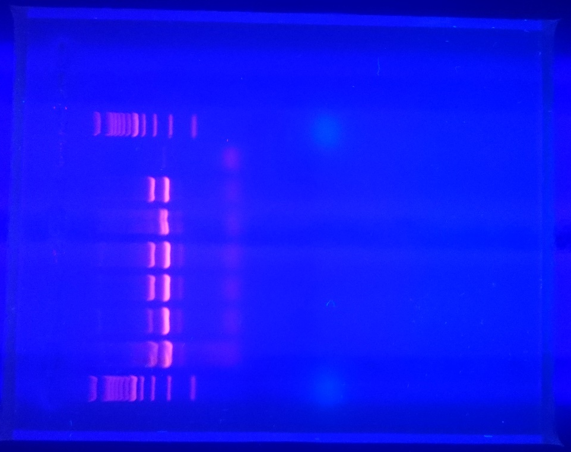

Additional figure 1. mRNA of GC-C (341 bp) is expressed in hypothalamus (H), midbrain (MB), cerebral cortex (Cx), and cerebellum (Cb) but not in astrocytes (A) (a). M–marker, In–intestine as positive control, Neg–negative control, GAPDH (235 bp) was used as cDNA control.

